
MACHINE LEARNING
ASSIGNMENT NO 03

July 27, 2025
AHSAN IFTIKHAR WAHLA
22P9280

TASK NO 01: Clustering Analysis on Carseats Dataset
Dataset Overview
The Carseats dataset contains the following features:
- CompPrice: Price charged by a competitor at each location
- Income: Community income level (in thousands of dollars)
- Advertising: Local advertising budget (in thousands of dollars)
- Population: Region population (in thousands)
- Price: The price the company charges for car seats at each site
- Age: Average age of the local population
- Education: Education level at each location

(a) K-Means Clustering
We applied K-Means clustering with user-defined k values (e.g., 2, 3, 4). The K-Means algorithm partitions the dataset into k clusters by minimizing the within-cluster sum of squared distances (inertia).
Implementation Highlights:
- StandardScaler was used for feature scaling.
- KMeans(n_clusters=k, random_state=0) was used to fit the model.
Pros:
- Fast and simple to implement.
- Performs well when clusters are spherical and evenly sized.
Cons:
- Sensitive to outliers.
- Requires the number of clusters k to be specified in advance.
- May converge to local minima.
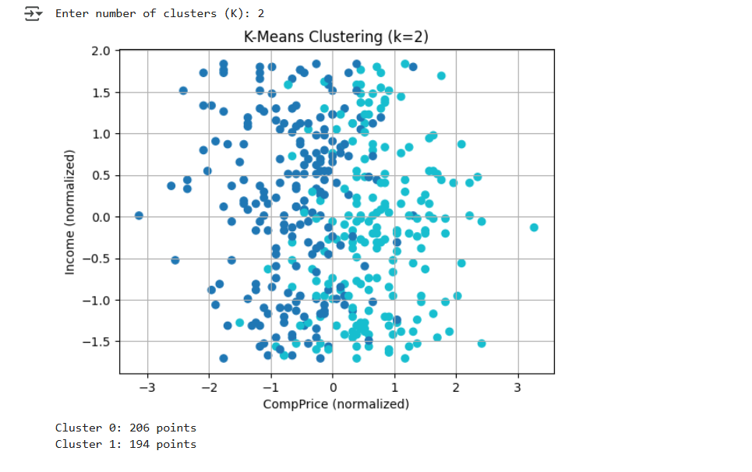

(b) K-Medoids Clustering
K-Medoids is a robust alternative to K-Means that selects actual data points (medoids) as cluster centers, reducing the impact of outliers.
Implementation Highlights:
- Distance metric = “manhattan”.
Pros:
- More robust to noise and outliers compared to K-Means.
- Medoids are interpretable since they are real data points.
Cons:
- Slower than K-Means.
- Performance may degrade on high-dimensional data.
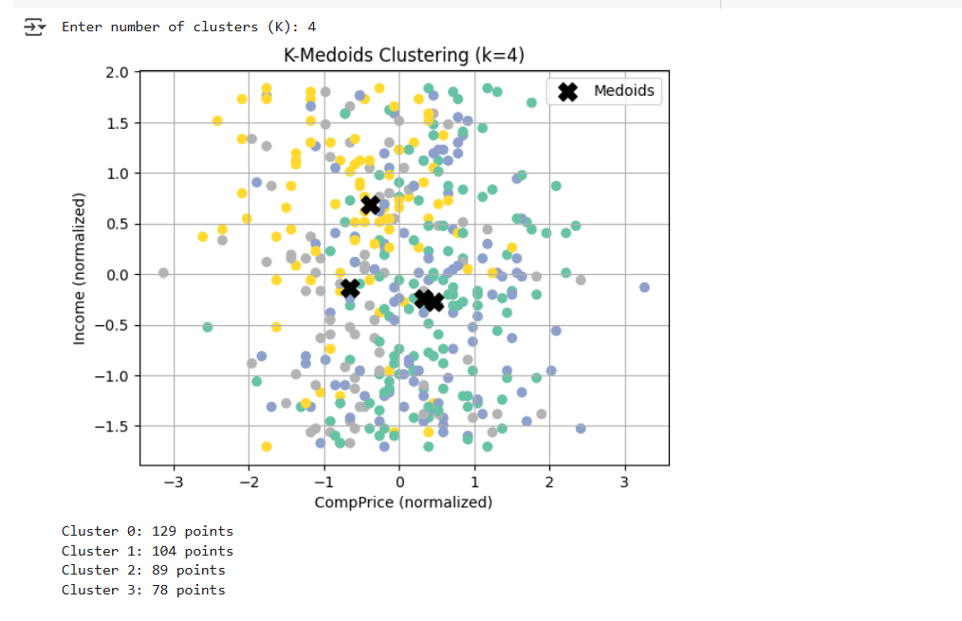

(c) K-Median Clustering
K-Median clustering minimizes the sum of Manhattan (L1) distances from points to their assigned cluster center, offering robustness to extreme values.
Implementation Highlights:
- We implemented a custom K-Median algorithm using Manhattan distance.
- Cluster centers updated using median values instead of mean.
Pros:
- Robust to outliers.
- Useful when the data has skewed distributions.
Cons:
- More computationally expensive.
- Non-differentiable median makes optimization harder.
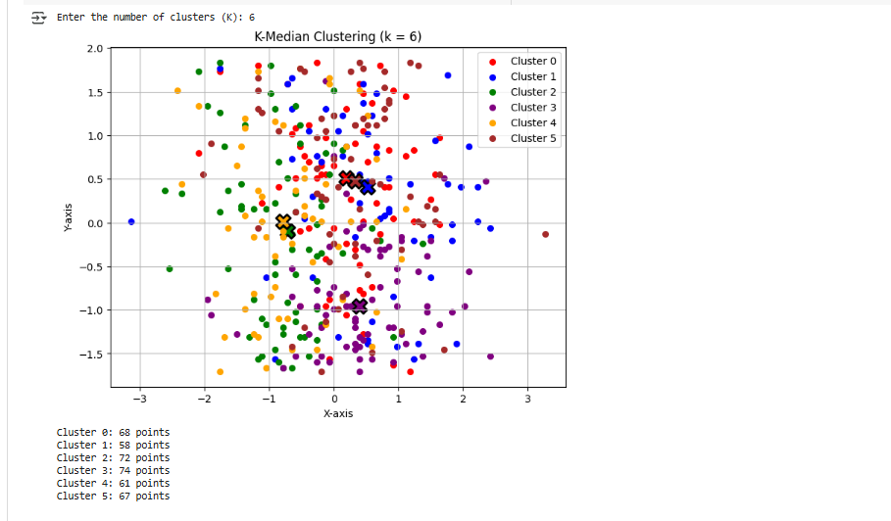

(d) Hierarchical Clustering
Agglomerative Clustering:
We applied bottom-up clustering using:
- Min-linkage (single)
- Max-linkage (complete)
- Average-linkage
Pros:
- No need to pre-specify k.
- Provides a full tree of clusters.
Cons:
- Time complexity is high: O(n² log n).
- Sensitive to noise and outliers.
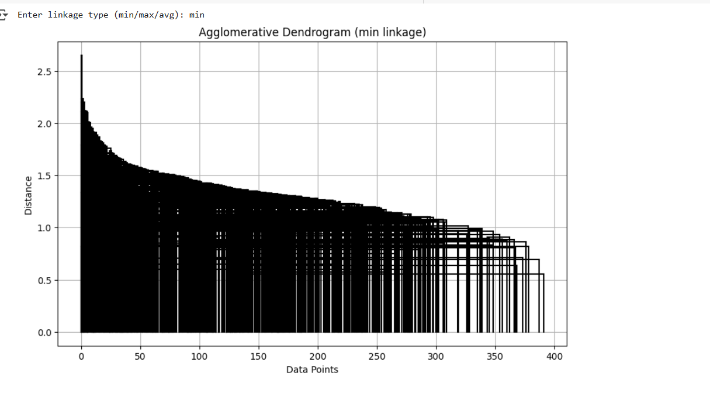
Divisive Clustering:
A top-down approach that recursively splits clusters.
- Implemented a divisive algorithm manually using maximum pairwise distances for initial split.
- Recursion continues until stopping condition (e.g., depth or min size) is met.
Pros:
- Captures global structure first.
- Can generate balanced trees.
Cons:
- Not available in standard libraries (custom implementation needed).
- Slower for large datasets.
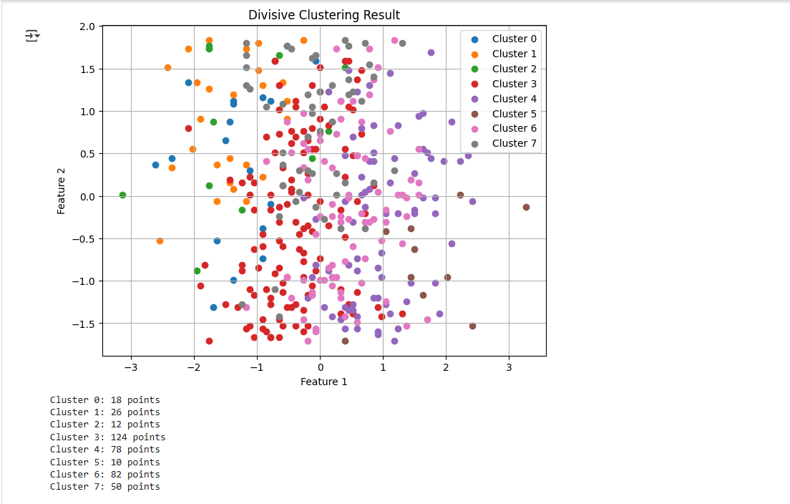

(e) Visualization of Clusters
Scatter plots were created for 2D projections (e.g., Income vs. Price), coloring each data point according to cluster membership:
- K-Means
- K-Medoids
- K-Median
Color-coded clusters clearly showed how each algorithm grouped similar data points. K-Medoids and K-Median were more robust to outliers compared to K-Means.

Comparative Analysis
Algorithm | Robustness | Speed | Interpretability | Best Use-case
K-Means | Low | Fast | Centroids are not real data | Well-separated, spherical clusters
K-Medoids | High | Moderate | Medoids are real data points | Noisy/outlier-prone datasets
K-Median | High | Slow | Not easily interpretable | Skewed data
Agglomerative | Moderate | Slow | Hierarchical tree | When tree-like structure is needed
Divisive | Moderate | Very Slow | Balanced splits | Smaller datasets requiring top-down view

Conclusion
- K-Means is efficient for clean, spherical data but sensitive to outliers.
- K-Medoids and K-Median offer better stability for real-world datasets with noise.
- Hierarchical methods are ideal when the relationship among clusters is as important as the clustering itself.
- Divisive methods provide a global view but are computationally heavy.

TASK NO 02:
SVM Classification Report (Linear vs. RBF Kernel) on MNIST Digits Dataset

Part (a): Load Data and Preprocessing
We began by loading the MNIST digits dataset .
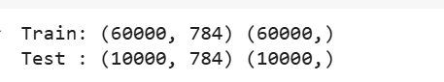

Part (b): Train Linear SVM
To prepare for training, we scaled the feature vectors using StandardScaler to standardize pixel intensity values. This step ensures faster convergence and better performance in Support Vector Machines (SVMs), which are sensitive to feature scale.
We then trained a Linear SVM using sklearn.svm.LinearSVC on the scaled data. The max_iter parameter was set to 10,000 to ensure sufficient convergence during training, especially since high-dimensional data like MNIST often requires more iterations.
Training Accuracy (Linear SVM): 97.83%
This high accuracy on training data indicates that the linear classifier fits well on the training subset. However, it may not capture complex class boundaries due to the linear nature of the decision surface.

Part (c): Train Non-linear SVM (RBF Kernel)
Next, we trained a non-linear SVM using the Radial Basis Function (RBF) kernel via sklearn.svm.SVC. The RBF kernel allows the classifier to learn non-linear decision boundaries, which are essential for distinguishing handwritten digits that cannot be separated linearly.
We used the same standardized training data from Part (b). The gamma='scale' argument was used (default behavior), which adjusts the influence of individual training points automatically based on feature variance.
Training Accuracy (RBF Kernel SVM): 98.38%
This slight increase in training accuracy shows the RBF model’s ability to better adapt to complex patterns compared to the linear model.


Part (d): Make Predictions + Comparative Analysis on Test Set
We evaluated both models on the first 2000 test images after applying the same standardization using the fitted scaler.
Test Accuracy:
- Linear SVM: 83.10%
- RBF Kernel SVM: 92.10%
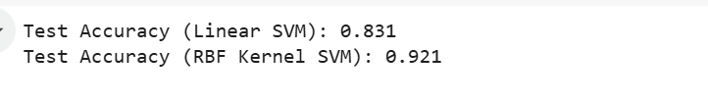
Comparative Analysis:
Model | Training Accuracy | Test Accuracy
Linear SVM | 97.83% | 83.10%
RBF Kernel SVM | 98.38% | 92.10%
- The Linear SVM performs well on training data but generalizes poorly on test data, indicating its limitations in capturing non-linear class separations.
- The RBF Kernel SVM outperforms the linear model on both training and test sets, showing superior generalization ability and better fit for this type of image classification task.
- The gap between training and test accuracy is lower for the RBF SVM, suggesting less overfitting.

Conclusion:
The experiment demonstrates that non-linear SVMs using the RBF kernel are more effective for handwritten digit classification tasks like MNIST. While Linear SVMs are faster and simpler, they fail to model the complex boundaries between digit classes. Hence, for real-world datasets with overlapping or non-linearly separable features, the RBF kernel should be preferred for achieving higher accuracy.

