BOOTCAMP2020
SURGE:21-june-2020

Commands:

Surge:
Used for creating account on surge and for creating domain name

surge token:
For generating access token

Installing surge using workflow:

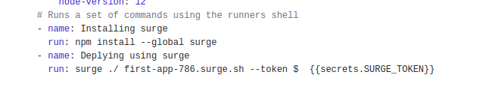

Git actions :
Web hook banayegy git action se wo code ko pick karega or automate kardyga surge se deploy karega:
Web hook event generate karegaa

Installing node using yml:
