DOCKER NOTES
DATE:19-April-2020

KEY POINTS:

INTRODUCTION:
- Docker Used to Deployed various different OS into One server.
- Managed the dependecies of different servers.
- Reduced server cost .
- VMWARE can be used .
- DEPENDENCIES: necessary parts to run an application
- Isolation: keeps all processes away from others

HYPER VISOR:
A hyper visor is a small software layer that enables multiple OS run on along side to each others. These OS comes as a VM’s That mimics the entire OS as VM’s that mimics the entire OS environment in a software.

CONTAINER:
Container Technology known as just Container is a method to package an application so it can be run with it’s dependencies ,isolated from other processes.
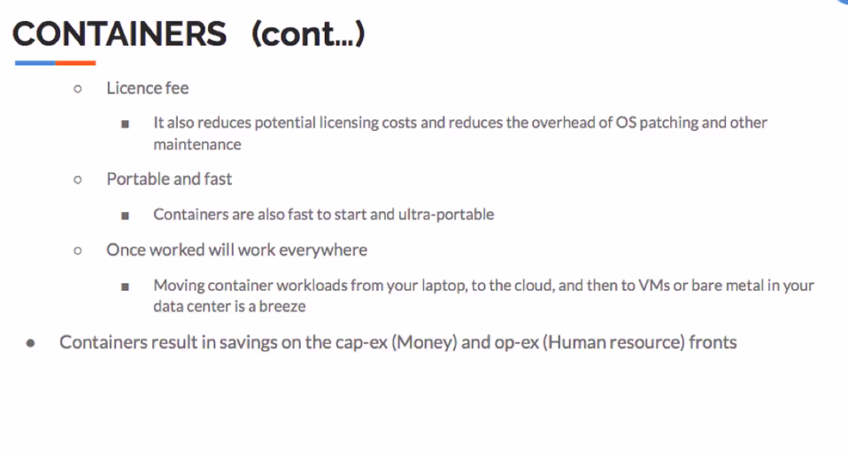

DEPENDENCIES:

