DERMATOLOGY ADVISOR



By

MUHAMMAD ISMAIL RAZA
(2020-ARID-3502)
AHSAN MANZOOR
(2020-ARID-3429)

Bachelor of Science in Information Technology
(BSIT)

Barani Institute of Information Technology,
PMAS Arid Agriculture University, Rawalpindi.

Fall, 2024
DERMATOLOGY ADVISOR

A report submitted in partial fulfillment of the Requirements for the degree of

Bachelor of Science in Information Technology (BSIT)

Submitted By
Muhammad Ismail Raza 2020-ARID-3502 Ahsan Manzoor 2020-ARID-3429

Supervised By
Dr. Hassan Nazeer Chaudry
Barani Institute of Information Technology,
PMAS Arid Agriculture University, Rawalpindi.
Fall, 2024

CERTIFICATE
It is certified that the contents and forms of thesis entitled “Dermatology Advisor” submitted by Muhammad Ismail Raza & Ahsan Manzoor have been found satisfactory for the requirements of the degree.

SUPERVISORY COMMITTEE

PROJECT SUPERVISOR ________________________________
Dr. Hassan Nazeer Chaudry

REPORT COORDINATOR _________________________________
Mr.Muhammad Khalid

WRITEUP COMMITTEE HEAD _________________________________
Mr. ------------

ACKNOWLEDGEMENT
First of all, I owe gratitude to Almighty Allah the most merciful, compassionate and beneficial whose favor made it possible for me to accomplish this project. His guidance and blessings have always been a source and encouragement for me and has gifted me with the unusual opportunities to reach up to this mile stone. I pay my heartiest tribute to my supervisor Dr. Hassan Nazeer Chaudry, my report coordinator Sir Adeel Sohail and write up committee head Ma’am Noor ul Ain for their valuable suggestions, positive criticism and guidance. Without that it would been impossible for me to accomplish this project successfully.
However, to the persons I give deeper and heartfelt gratitude are my teachers. No acknowledgement could ever adequately express my obligation to my friends who distinctly helped me in all aspects of this work. I owe cordial thanks for their untiring help and good company.
Finally, I am grateful to my parents who prayed for me, encouraged and supported me all the way.
May ALLAH bless all these people (Ameen)

ABSTRACT
The project entitled "Dermatology Advisor" is a cross-platform mobile application released for Android and iOS. This innovative app leverages AI technology to detect dermatology-related diseases by analyzing images provided by users. The AI model accurately predicts the disease, offering detailed descriptions, causes, and cures. For users seeking further assurance or additional medical advice, the app includes a feature to consult with virtual doctors. These healthcare professionals can examine cases and prescribe appropriate medications. Key features include AI-powered disease detection, comprehensive medical information, and virtual doctor consultations. Benefits include accessible and reliable dermatological care, data-driven insights, and personalized medical advice. Ultimately, Dermatology Advisor aims to provide users with a seamless, efficient, and accurate healthcare experience, empowering them to manage their dermatological health effectively.

TABLE OF CONTENTS
CONTENTS Page No.
CERTIFICATE I
ACKNOWLEDGEMENT II
ABSTRACT III
TABLE OF CONTENTS IV
LIST OFF FIGURES VI
LIST OF ANNEXURE VIII
CHAPTER 1-INTRODUCTION 1
1.1 Introductory Background 1
1.2 Problem Statement 4
1.3 Scope 4
1.4 Objectives 6
CHAPTER 2-LITRATURE REVIEW 8
2.1 Introduction 8
2.2 Related Projects 8
2.2.1 Skin Vision 9
Strength 9
Limitation 9
2.2.2 AYSA: 9
Strength 10
Limitation 10
2.2.3 First Dirm: 10
Strength 10
Limitation 11
2.3 Screenshots of Related Projects 11
2.3.1 Skin Vision App 11
2.3.2 AYSA 14
2.3.3 First Dirm 17

CHAPTER 3-CONCEPTUAL DESIGN 20
3.1 Requirement Elicitation 20
3.2 Requirement Specifications 21
3.2.1 Functional Requirements 21
3.2.2 Non-Functional Requirements 22
3.2.3 Domain Requirements 23
3.3 Conceptual Diagram 24
3.4 Data Flow Diagram 25
3.4.1 DFD Level 0 25
3.4.2 DFD Level 1 26
3.5 Entity Relationship Diagram 27
CHAPTER 4-IMPLEMENTATION 28
4.1 Tools and Technology 28
4.1.1 Figma 28
4.1.2 Android Studio 28
4.1.3 VS Code 29
4.1.4 PyCharm 29
4.1.5 Roboflow 29
4.1.6 SQL Server Management Studio 29
4.2 Pseudo Code 30
4.3 Graphical User Interface 34
4.3.1 Signup Screen 28
4.3.2 Login Screen 28
4.3.3 Patient's Home Screen 29
4.3.4 Camera Intent 29
4.3.5 Disease Detail Activity 29
4.3.6 Disease Cure Activity 29
4.3.7 Prescription provided by doctor 28
4.3.8 Patient's Profile 28
4.3.9 Doctor's Home Screen 29
4.3.10 Writing Prescription 29
4.3.11 Case needs to be rated 29
4.3.12 Rating a Case 29
4.3.13 Case Rating Review 28
4.3.14 Admin's Home Screen 28
4.3.15 Adding a Dermatologist 29
4.3.16 Updating Dermatologist 29
CHAPTER 5-CONCLUSION 50
5.1 Conclusion Remarks 50
5.2 Future Directions 50
5.3 Limitations 50
REFERENCES 52
ANNEXURE 53
PROJECT SUMMARY 53

LIST OF FIGURES

Figures Page no.

2.3.1 Select body point to scan of Skin Vision app………………………………….11

2.3.2 Risk Identification of Skin Vision App………………………………………..12

2.3.3 skin cancer information / articles of Skin Vision App………………..…….…13

2.3.4 case history of AYSA app….………………………..……..…………..……...14

2.3.5 Your case diagnosis of AYSA app…………………………..………..…….…15

2.3.6 Prediction detail of AYSA app….………………………..…….……..…….....16

2.3.7 Scan options of First Derm app…………………………..…………….….,…17

2.3.8 Detailed skin condition of FIrst Derm app….…….…..……………….…...…18

2.3.9 Case review of First Derm app…………………………..……..…….…….…19

3.3 Conceptual Diagram………………………….………………………...…….…24

3.4.1 Data Flow Diagram level 0.…………………..………………….…...….....…25

3.4.2 Data Flow Diagram level 1.………………….…..…………………..….….…26

3.5 Entity Relationship Diagram………………………….………………....…....…27

4.3.1 Signup……………………………………………………………….……...…34

4.3.2 Login…………………………………………………………………….….…35

4.3.3 Patient’s Home screen ……………………………………………….….…….37

4.3.4 Camera Intent..…………………………………………….……………..……37

4.3.5 Disease Detail Activity…………………………………………………..……38

4.3.6 Disease Cure Activity……………………………………….…...……………39

4.3.7 Doctor's Prescription …………………………………………...………..……40

4.3.8 Patient's Profile……………………………..…………………...……....…….41

4.3.9 Doctor's Home Screen………………………..………………………….…....42

4.3.10 Doctor Prescribing Patient………………………………...………..………..43

4.3.11 Cases needs to be rated ……………………………..……………….……....44

4.3.12 Rating a Case……………………………..……………………….…………45

4.3.13 Writing case review……………………………………………….………....46

4.3.14 Admin's home screen………………………………………………………...47

4.3.15 Adding a dermatologist………………………………………………………48

4.3.16 Updating a Dermatologist……………………………………………………49

LIST OF ANNEXURE

Annexure Page No.

Annexure A: Authentication and Login …………….……………………….…...…53

Annexure B: Patient Registration …………….…………………………...….…….53

Annexure C: Home Screen…………………………………………....…….………53

Annexure D: Patient's Home Screen…………….…………….……………....…….53

Annexure E: Doctor's Home Screen…………………………………….....………..53

Annexure F: Admin's Home Screen………………….………….…….…….….…..54

Annexure G: Disease Detail Activity………………………......………..……….….54

Annexure H: Patient profile Management…….……………….……...…..……..….54

Annexure I: Feedback Mechanism………………………...….……….….….….….54

Annexure J: Data Security and privacy…………………………….……..………...54

Annexure K: Scalability and future Enhancements………………………..……….54

CHAPTER 1

INTRODUCTION

1.1 Introductory Background
The Dermatology Advisor is an innovative and comprehensive cross-platform application designed to streamline the process of dermatological diagnosis and consultation for patients. This system aims to create a seamless platform where patients can receive accurate AI-based diagnoses of skin conditions, access detailed medical information, and consult with virtual doctors for personalized treatment. With distinct user roles for Patients, Doctors, and Admin, Dermatology Advisor ensures a tailored and user-friendly experience for each stakeholder.

Patient:
Patients can sign up, log in, and edit their profiles within the Dermatology Advisor app. They have the ability to get a diagnosis of their skin condition by uploading a picture of the affected area. The AI model will analyze the image and provide an accurate diagnosis, along with a detailed description, causes, and potential cures for the condition, Case history of each prompt will also be maintained for the patient, If patients seek further assurance or additional medical advice, they can consult with virtual doctors directly through the app. These healthcare professionals will examine the cases and prescribe appropriate treatments or medications, ensuring comprehensive and personalized care for each patient.

Doctor:
Doctors are added by the admin and can log in to the Dermatology Advisor app to provide personalized care to patients. They are responsible for prescribing medications and offering their observations for patients seeking further consultation beyond the AI-generated diagnosis. Doctors can also review and rate the AI-generated results on a scale of one to five stars. A five-star rating confirms the AI's diagnosis, while a lower rating prompts the doctor to provide an alternative diagnosis and detailed review of the patient's condition. This feedback loop ensures continuous improvement of the AI model and provides patients with accurate and reliable medical advice.

Admin:
The admin is responsible for managing the profiles of doctors within the Dermatology Advisor app. Admins can add and edit doctors' profiles using their email and personal details, enabling doctors to log in to the app. Admins ensure that only verified and qualified healthcare professionals are available for patient consultations, maintaining the integrity and reliability of the service provided.

AI-Powered Disease Diagnosis:
The Dermatology Advisor app utilizes a state-of-the-art AI model trained on YOLOv8 to analyze images of skin conditions submitted by patients. This advanced object detection model provides accurate disease predictions, delivering detailed descriptions, causes, and suggested cures for a wide range of dermatological conditions. YOLOv8’s robust performance ensures reliable and efficient diagnosis of skin issues.

Detailed Disease Information:
The app offers comprehensive information on various skin conditions, including detailed descriptions, causes, and recommended treatments. This feature helps patients gain a deeper understanding of their symptoms and explore effective management options for their health concerns.

Virtual Doctor Consultations:
Patients can request consultations with virtual doctors for personalized medical advice. Doctors can review patient cases, provide professional observations, prescribe medications, and recommend further treatments. This feature ensures patients receive expert medical guidance and a second opinion in addition to the AI-generated results.

AI Result Rating and Feedback:
Doctors can rate the accuracy of AI-generated results on a scale of one to five stars. If the rating is less than five stars, doctors are prompted to provide alternative diagnoses and detailed feedback. This feedback loop will help refine the YOLOv8 model and enhances its diagnostic capabilities in the future.

Patient Profile Management:
Patients can sign up, log in, and manage their profiles, including updating personal information and viewing their diagnostic history. This feature provides patients with easy access to their health data and previous interactions with doctors, ensuring a seamless user experience.

Dermatology Advisor is more than just a diagnostic tool; it is a comprehensive platform designed to provide accessible and reliable dermatological care. The application leverages a cutting-edge YOLOv8-based AI model to analyze skin condition images, delivering accurate diagnoses along with detailed descriptions, causes, and cures. Beyond automated diagnosis, the app offers patients the opportunity to consult with virtual doctors for personalized medical advice and treatment recommendations. By integrating advanced AI technology with expert medical consultations, Dermatology Advisor ensures a thorough and effective approach to managing skin health. The platform aims to bridge the gap between AI diagnostics and professional medical care, offering users a seamless and informative healthcare experience.

1.2 Problem Statement
In the real world, diagnosing dermatological conditions can be a complex and time-consuming process. Many individuals face difficulties accessing specialized dermatological care due to long wait times for appointments, high consultation costs, and the need for in-person visits. Traditional methods of diagnosis often rely on subjective visual examinations and can lead to delays in receiving accurate information and effective treatments.
Furthermore, patients frequently struggle to find reliable sources for preliminary diagnosis and detailed information about their skin conditions. While there are some online tools available, they often lack the accuracy and depth needed for effective self-assessment.
Dermatology Advisor addresses these challenges by providing a comprehensive, AI-powered solution for skin condition diagnosis and management. The app offers users an efficient way to receive accurate diagnoses through a YOLOv8-based AI model, provides detailed information about various skin conditions, and facilitates virtual consultations with medical professionals. This streamlined approach aims to reduce wait times, lower costs, and make dermatological care more accessible and effective for everyone.

1.3 Scope
The Dermatology Advisor project aims to transform dermatological care by offering a comprehensive digital platform for skin condition diagnosis and virtual medical consultations. The scope of this project includes the following key elements:
- AI-Powered Skin Condition Diagnosis:
- Disease Detection Utilizing a YOLOv8-based AI model to analyze images of skin conditions submitted by patients and provide accurate diagnoses.
- Delivering detailed information on detected skin conditions, including descriptions, causes, and recommended initial cure.
- Virtual Doctor Consultations:
- Offering patients the option to consult with virtual doctors for personalized medical evaluations, treatment recommendations, and prescriptions.
- Allowing doctors to review and rate AI-generated results, and provide alternative diagnoses and feedback for continuous improvement of the AI model..
- Patient Management and Support:
- Enabling patients to sign up, log in, and manage their profiles, including updating personal information and viewing diagnostic history.
- Allowing patients to request consultations with doctors for further medical advice and treatment.
- Doctor Management:
- Allowing admins to add and edit doctor profiles, ensuring that doctors are registered and can access the platform for patient consultations.
- Communication and Notifications:
- Keeping users informed about consultation requests, diagnostic results, and feedback updates.
- Data Security and Privacy:
- Implementing robust authentication and authorization mechanisms to ensure data security and protect user privacy.
- Scalability and Future Enhancements:
- Designing the platform to accommodate growing user numbers and evolving technological needs.
- Allowing for future enhancements and feature additions to expand the app’s capabilities and address emerging requirements in dermatological care.

By addressing these components, Dermatology Advisor seeks to provide a user-friendly and effective solution for diagnosing skin conditions and delivering professional dermatological care, ultimately enhancing accessibility and quality of healthcare for users.

1.4 Objectives
Objectives for Dermatology Advisor:
- User-Friendly Interface:
Develop a user-friendly and intuitive interface for all system users, ensuring easy navigation and accessibility of features for administrators, companies, students, and directors.

- AI-Powered Accurate Diagnosis:
Implement a robust YOLOv8-based AI model to accurately analyze skin condition images and provide reliable diagnoses and Offer detailed diagnosis with descriptions, causes, and cures for diagnosed skin conditions to enhance patients’ understanding and management of their health issues.

- Efficient Patient Management:
Enable patients to sign up, log in, and manage their profiles, including uploading images, viewing diagnosis results, and requesting virtual consultations.

- Effective Doctor Management:
Enable admins to add and edit doctors’ profiles, ensuring that doctors can access the platform and offer consultations.

- Streamlined Virtual Consultations:
Facilitate virtual consultations between patients and doctors, allowing for personalized medical advice, treatment recommendations, and prescriptions.

- AI Result Rating and Feedback:
Implement a system for doctors to rate AI-generated diagnoses and provide alternative disease identification and feedback to improve the AI model’s performance in the future.

- Data Security and Privacy:
Implement robust authentication and authorization mechanisms to ensure the security and privacy of user data and maintain compliance with data protection regulations..

- Integration of AI and Medical Expertise:
Combine AI technology with professional medical consultations to offer a balanced and effective approach to dermatological care, bridging the gap between automated diagnostics and expert medical advice.

- Scalability and Adaptability:
Design the system to be scalable and adaptable to accommodate changes in user requirements, event scale, and technological advancements, ensuring long-term viability and relevance for job fair management needs.

By achieving these objectives, Dermatology Advisor aims to revolutionize the dermatological care experience, making accurate diagnosis and professional medical support accessible and efficient for all users.

Chapter 2

LITERATURE REVIEW
- Introduction
This chapter provides a summary of the literature that has been researched by other scholars on dermatological diagnosis systems. The healthcare sector is constantly evolving, with numerous applications being developed to improve the diagnosis and treatment of various conditions. However, many existing dermatology apps have limitations, such as inadequate accuracy, lack of comprehensive information, and limited access to professional medical consultations.

In this chapter, we will review existing projects and applications related to dermatological diagnosis and care, highlighting their strengths and limitations. By understanding the current landscape, we can identify gaps and areas for improvement that the Dermatology Advisor aims to address. This literature review will also include previous projects developed by BIIT students, offering a comparative analysis to showcase the unique features and enhancements provided by our platform.

The Dermatology Advisor is designed to overcome the shortcomings of existing solutions by offering an accurate AI-powered diagnosis system, detailed medical information, and seamless access to virtual doctor consultations. Through this comprehensive approach, our platform aims to enhance the accessibility and quality of dermatological care.

  - Related Projects
There are already projects related to our Project that are available in the market. We will discuss those projects and discuss how we modify them in our Project. But we added some new functionality to this project.

2.2.1 Skin Vision:
SkinVision is a regulated medical service that empowers you to take charge of your skin health. With a smartphone app at the core of its service, SkinVision expands your ability to self-examine your skin and elevates your knowledge of when to act, how and why. It provides accurate and timely skin cancer detection, along with the most reliable personalised skin health advice and health path recommendation. At the center of the service is the Skin Vision app, which is a regulated medical device that merges AI technology with the expertise of skin health professionals and dermatologists. Skin Vision is a service of choice whether you want to address your most immediate concerns, learn what steps you should take next, understand your skin risk profile and introduce the most intelligent skin health regimen to your seasonal rhythm.

Strength
- Early Detection
- User-Friendly Interface
- Regular Monitoring
- Educational Content
- Validated Technology

Limitation
- Limited Scope
- No Detailed Descriptions
- No Virtual Consultations
- False Positives/Negatives
- Requires Internet Connection

2.2.2 AYSA:
Your skin is unique, skin conditions can look different from person to person. Aysa is built on the resources of VisualDx, the award-winning clinical decision support software focused on equity in medicine for over 20 years. Its curated library of more than 120,000 medical images includes every skin color and type, and what each of 200 skin conditions can look like at every stage. The workflow even allows you to select skin. Aysa is an AI-powered app that provides users with quick insights into their skin conditions by analyzing uploaded photos. It offers potential diagnoses and suggestions for next steps based on the analysis.

Strength
- AI-Powered Analysis
- Immediate Feedback
- Guidance
- User-Friendly
- Accessibility

Limitation
- Limited Database
- No Detailed Information
- No Direct Consultations
- Potential Inaccuracy
- Limited Updates

2.2.3 First Derm:
First Derm allows users to send photos of their skin issues to board-certified dermatologists and receive professional advice within 24 hours. It aims to provide convenient dermatological consultations without needing an in-person visit..

Strength
- Expert Review
- Convenience
- Quick Response
- Anonymity

Limitation
- No AI Assistance
- Delayed Response
- No Immediate Information
- Limited Interaction
- Paid Diagnosis

2.3 Screenshots of Related Projects

Skin Vision App:
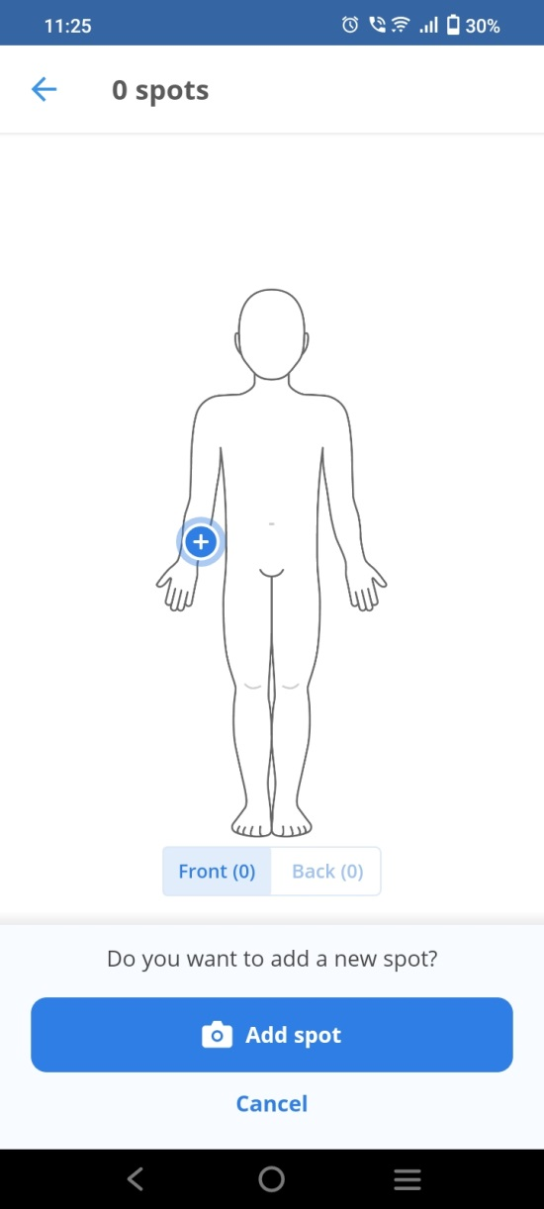
Figure 2.3.1 Select body point to scan

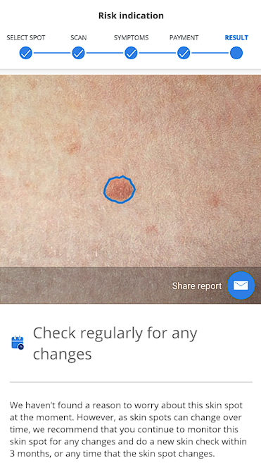
Figure 2.3.2 Risk Identification

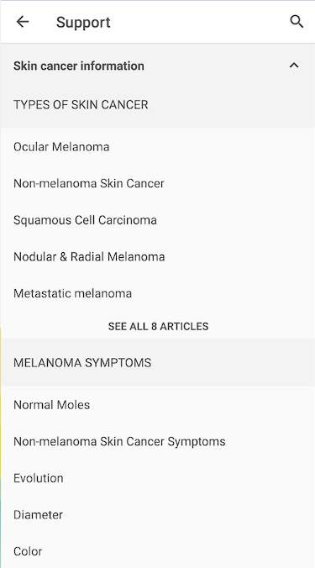
figure 2.3.3 skin cancer information / articles

AYSA:
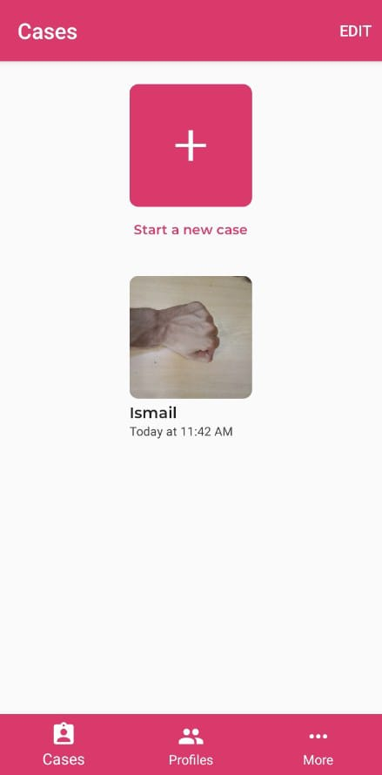
Figure 2.3.4 case history

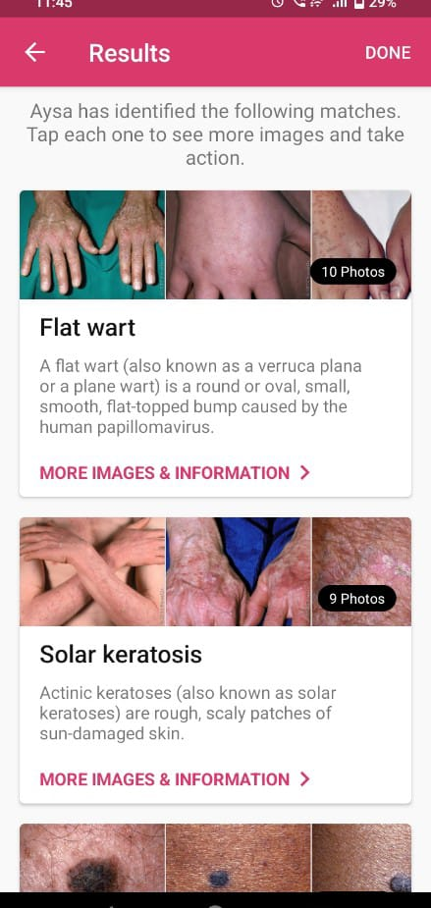
figure 2.3.5 your case diagnosis

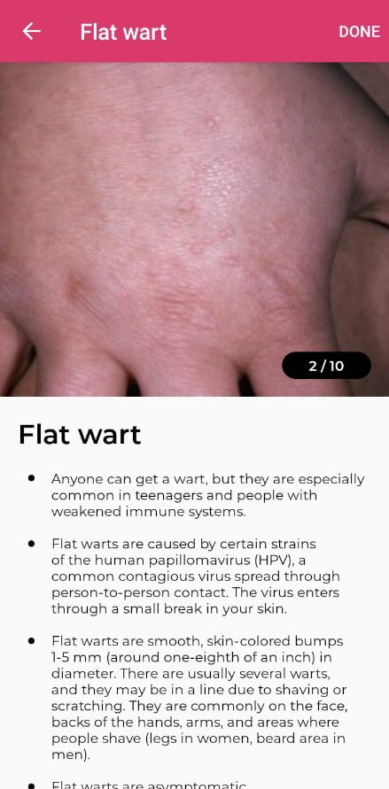
Figure 2.3.6 prediction detail

First Derm :

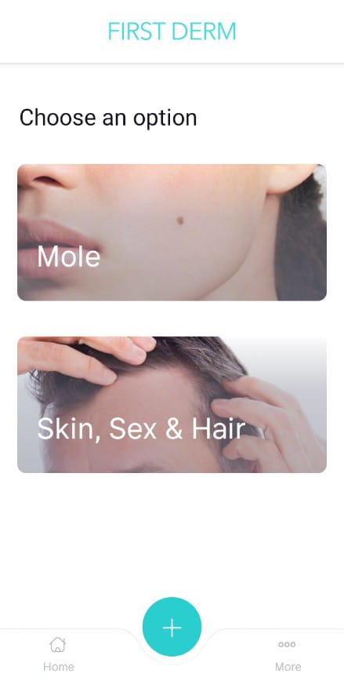
Figure 2.3.7 scan options

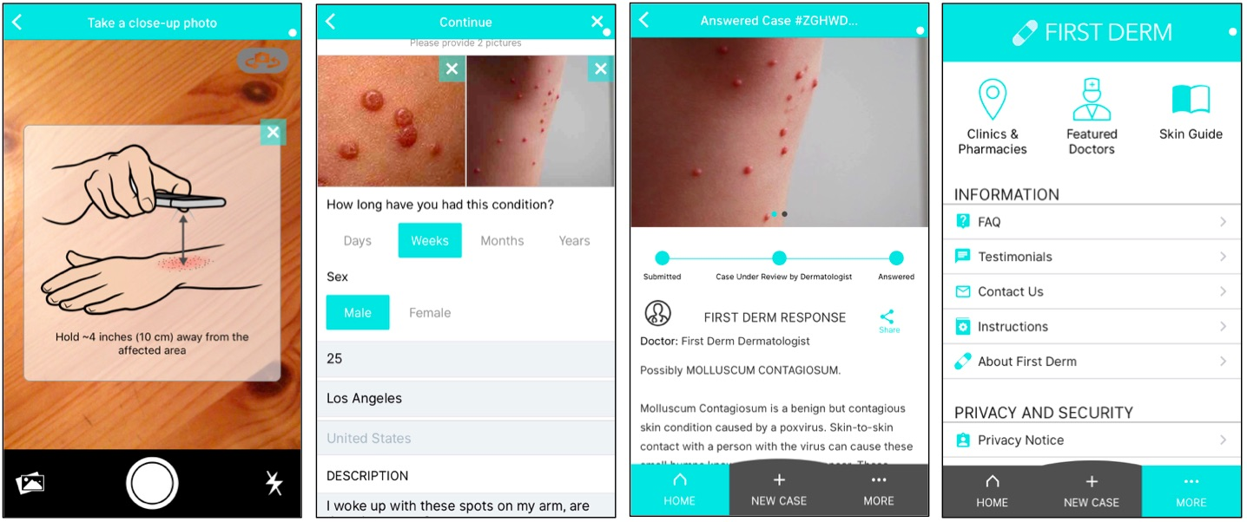
Figure 2.3.8 detailed skin condition

Figure 2.3.9 case review

Chapter 3

CONCEPTUAL DESIGN

In this chapter, we will discuss requirements gathering how we gather requirements and how we implement them. We tried to develop an enhanced version of the available same projects (software) in the market. Strength and deformation characteristics play an important role in the design of structures of the software.

3.1 Requirement Elicitation
Applications available on the internet for dermatological diagnosis and care often have weak points and limitations. While they address specific needs, they do not offer a comprehensive solution that integrates all essential services on a single platform.
For example, SkinVision focuses on early detection of skin cancer but does not cover other dermatological conditions. Its reliance on internet connectivity can restrict access, and it lacks direct medical consultations and comprehensive condition monitoring. Security concerns also exist regarding personal health data.
Similarly, Aysa uses AI for quick insights into skin conditions but has a limited database and lacks detailed information. The absence of direct consultations and the potential inaccuracy of AI analysis can lead to misdiagnosis. Security concerns and reliance on internet connectivity are additional drawbacks.
First Derm provides professional feedback within 24 hours by sending photos to dermatologists. However, it lacks AI assistance for immediate insights, has limited interaction with dermatologists, and depends on internet connectivity. Security concerns and potential costs for professional reviews also pose challenges.
Despite these limitations, these apps have improved dermatological care. However, Dermatology Advisor aims to address these gaps by offering a comprehensive platform with AI-powered diagnosis, detailed medical information, and virtual doctor consultations, while requiring internet connectivity to provide a complete and accessible dermatological care solution.

3.2 Requirement Specifications
Dermatology Advisor is an innovative application that redefines the dermatological care experience for patients, doctors, and administrators. With seamless navigation and tailored features, patients can upload images of their skin conditions, receive AI-powered diagnoses, access detailed medical information, and consult with virtual doctors, empowering them to make informed health decisions. The platform allows doctors to review patient cases, provide personalized care, and rate AI-generated diagnoses, streamlining the consultation process. Administrators benefit from robust management tools to oversee doctor profiles and ensure the integrity of the platform. Our commitment to integrating advanced AI technology with professional medical expertise fosters meaningful connections between patients and healthcare providers, creating a dynamic ecosystem where effective skin health management thrives. Through technology, we transform dermatological care into a streamlined, accessible process, driving health awareness and well-being. Join us on this transformative journey as we revolutionize dermatological care in the digital age, empowering individuals to achieve their health aspirations with clarity and confidence.

3.2.1 Functional Requirements
It is critical to identify the mobile platform and functional requirements for the Dermatology Advisor application. Functional requirements specify the behaviors or functions of the system.

Patient:
• Sign up and create a profile with personal information.
• Edit and Update personal information.
• Upload images of skin conditions for AI analysis.
• Receive AI-generated diagnoses with detailed descriptions, causes, and suggested treatments.
• Request virtual consultations with doctors for personalized medical advice.
• View their diagnostic history and feedback received from doctors.

Doctor:
• Log in to the system and access patient cases.
• Review AI-generated diagnoses and provide additional insights or alternative diagnoses.
• Rate AI-generated results and submit feedback for continuous improvement.
• Conduct virtual consultations with patients, providing prescriptions and treatment recommendations.

Admin:
• View and manage doctor profiles.
• Add or edit doctor’s profiles.
• Manage profiles for doctors.

3.2.2 Non-Functional Requirements
- The user interface is intuitive and easy to navigate, requiring minimal training for users to understand and use the app effectively.
- The system is able to handle multiple concurrent users without significant performance degradation.
- The application is designed to scale horizontally to accommodate increasing numbers of users, companies, and students
- User authentication and authorization mechanisms is robust to prevent unauthorized access to sensitive data
- Access controls is implemented to ensure that users can only view and modify data relevant to their roles.
- The application is compatible with a variety of devices and screen sizes, including desktops, laptops, tablets, and smartphones.
- Compatibility with different web browsers (e.g., Chrome, Firefox, Safari) is ensured to provide a consistent user experience across platforms.

3.2.3 Domain Requirements
Domain requirements pertain to the specific characteristics and constraints of the dermatological application domain. The domain requirements for the Dermatology Advisor system include:
- The application must be compatible with Android and iOS devices, ensuring a seamless user experience across both mobile platforms.
- A stable internet connection is required to fetch diagnostic data, access virtual consultations, and retrieve detailed medical information, as the app relies on real-time data processing and AI analysis.
- The AI model must be regularly updated and trained on diverse datasets to ensure accurate and reliable diagnoses for a wide range of dermatological conditions.

3.3 Conceptual Diagram
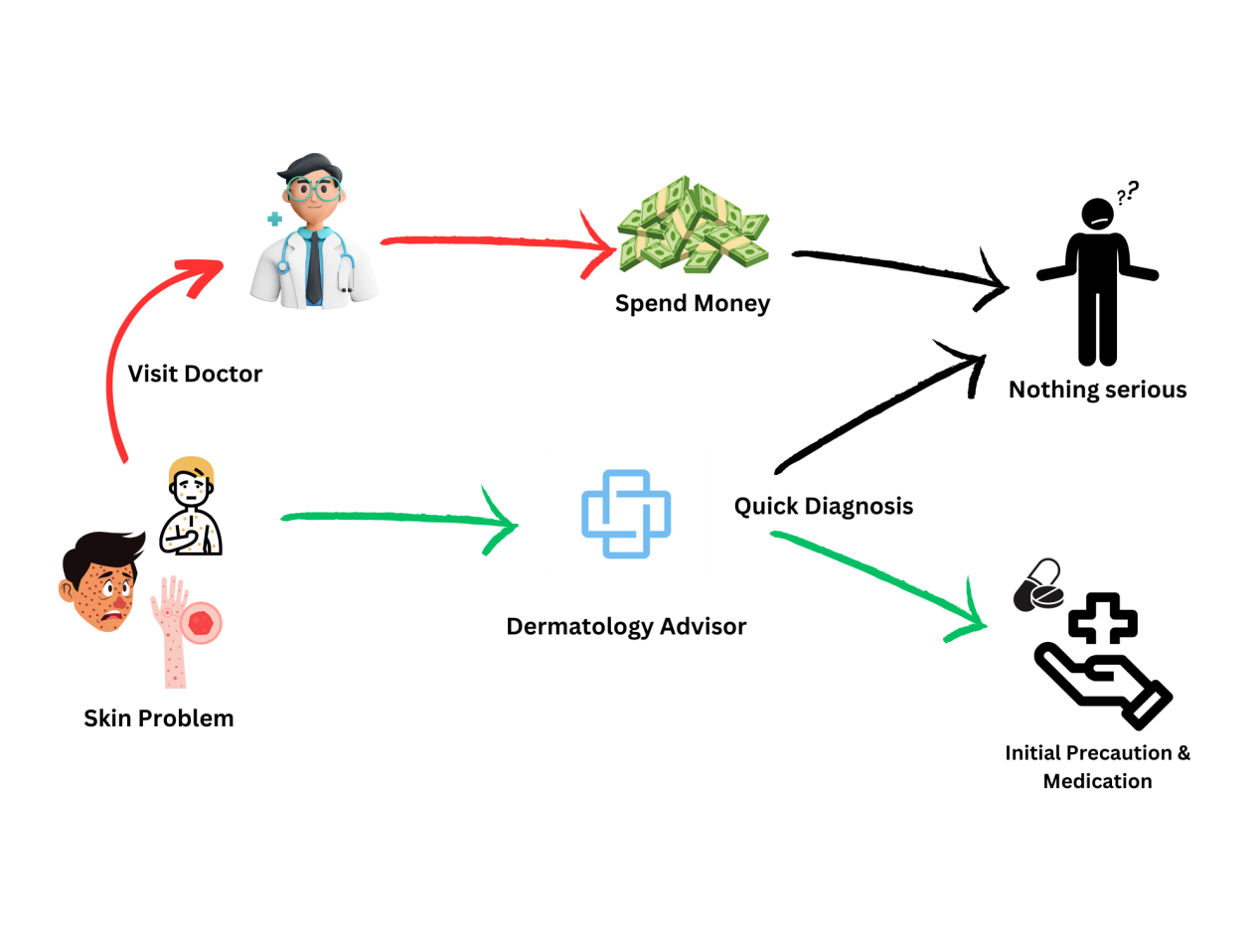
Figure 3.3: Conceptual Diagram

Approved by: Dr.Hassan Nazeer Chaudry

3.4 Data Flow Diagram
A Data Flow Diagram (DFD) visually represents the flow of data between different entities in the Dermatology Advisor system. It illustrates how patients, doctors, and admins interact with the system and the tasks they are permitted to perform.

3.4.1 DFD Level 0

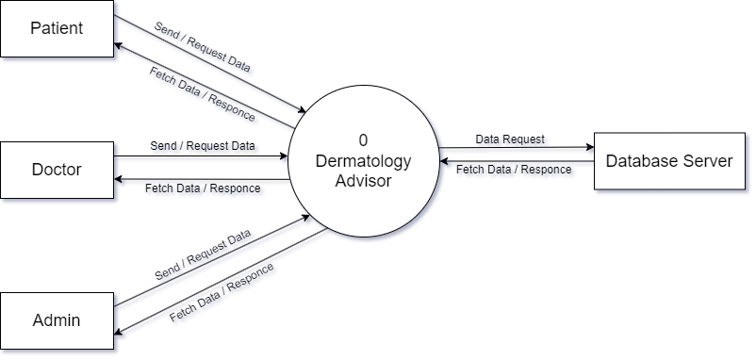
Figure 3.4.1: Data Flow Diagram – Level 0

Approved by: Dr.Hassan Nazeer Chaudry

3.4.2 DFD Level 1
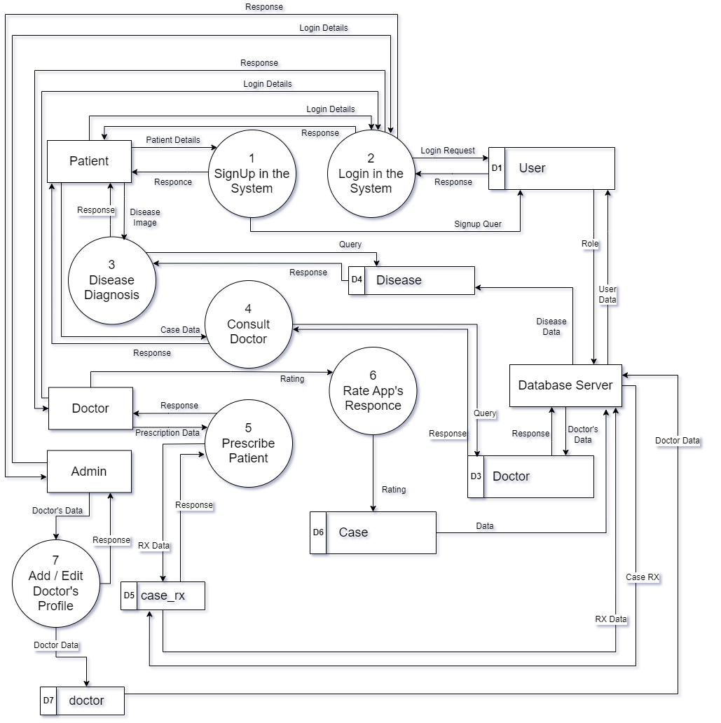
Figure 3.4.2: Data Flow Diagram – Level 1

Approved by: Dr.Hassan Nazeer Chaudry

3.4.2 DFD Level 2
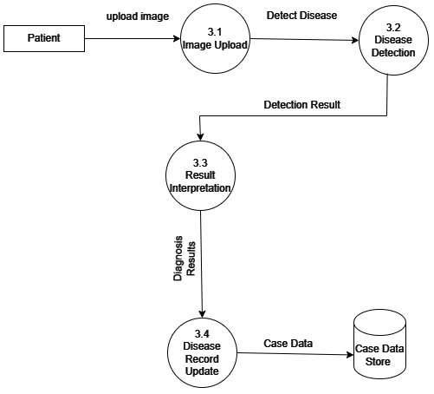

3.5 Entity Relationship Diagram
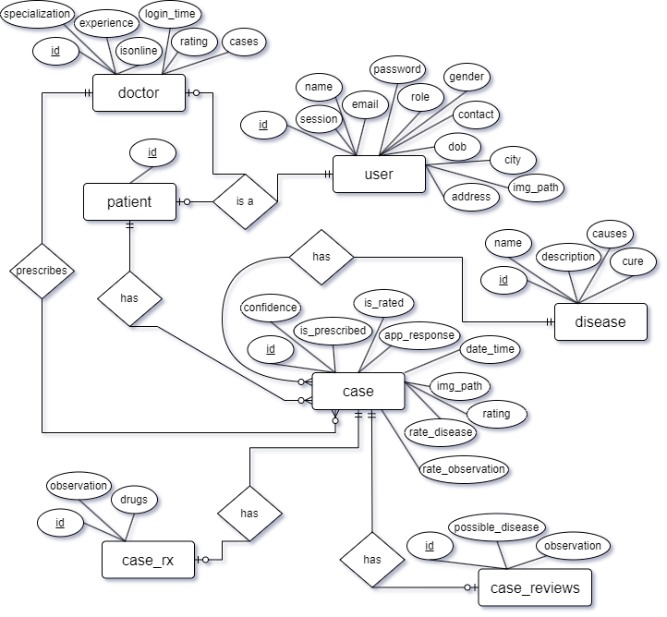
Figure 3.5: Entity Relationship Diagram

Approved by: Dr.Hassan Nazeer Chaudry

Chapter 4

IMPLEMENTATION

This chapter includes a discussion about the tools and technologies which have been used for designing this application. It also includes how the application has been designed through coding. Also, this chapter includes a discussion about the graphical user interface and this is shown through project screenshots.

  - Tools and Technology
Following tools are used to make Application:

    - Figma
Figma is a web-based design tool used for interface design and prototyping. It is widely recognized for its collaborative features, allowing multiple designers to work simultaneously on the same project in real-time. Figma's cloud-based nature makes it accessible from any device with an internet connection, making it a popular choice for teams working remotely or across different locations. We used it to brainstorm our App ideas and make prototype mockups for our App.

    - Android Studio
Android Studio is the official integrated development environment for Google's android operating system, built on JetBrains IntelliJ IDEA software and designed specifically for android development. For developing android native app we have used Android Studio. We can also use it for Flutter Mobile App Development.

    - VS Code
Visual Studio Code, also commonly referred to as VS Code, is a source-code editor made by Microsoft with the Electron Framework, for Windows, Linux and macOS. Features include support for debugging, syntax highlighting, intelligent code completion, snippets, code refactoring, and embedded Git. We have used this tool for Flutter Mobile App Development. After installation we have installed plugin of flutter.
    - PyCharm
PyCharm is an integrated development environment (IDE) developed by JetBrains specifically for Python programming. It is designed to provide a comprehensive and efficient environment for Python developers by offering a wide range of tools and features that facilitate coding, debugging, and testing. PyCharm was first released in 2010 and has since become one of the most popular Python IDEs. It supports various Python frameworks and libraries, making it a versatile tool for different types of Python development. We used it do build our API in flask and Train model for YOLOV8.

    - Roboflow
Roboflow is a powerful platform designed to streamline the process of developing computer vision models. It assists developers and data scientists in managing, preprocessing, augmenting, and labeling datasets, as well as training and deploying machine learning models. Roboflow aims to simplify the complexities involved in computer vision projects, making it accessible for both beginners and experts. We used it to annotate and augment our dataset fot YoloV8 Model training.

    - SQL Server Management Studio
Microsoft SQL Server Management Studio is a software application developed by Microsoft that is used for configuring, managing, and administering all components within Microsoft SQL Server. First launched with Microsoft SQL Server 2005, it is the successor to the Enterprise Manager in SQL 2000 or before. Query for our project database creation mentioned below.
  - Psudo code

Sign Up (Patient Registeration)
When user installs the application he or she can signup to our app, Data will be filled in and saved, i.e, full name, email, password, gender, city.

if (all fields are not valid)
Display message : all fields are required
else
if (email is valid)
signup
else
Display message : use correct email

Login
When user visit the App, He will see the login screen with sign up button on it. If he entered the valid account credentials, user will successfully login to application and land to its Home page according to the role.
Otherwise user has the option to go to signup page.
if (credentials are valid)
Login (email, password)
else
Display message : Enter correct credentials

Home Screen
User will be redirected to Home screen after login according to it’s role.
if (login as Patient)
show Patient’s Home screen
else if (login as doctor)
show doctor’s Home screen
else if (login as admin)
show admin’s Home screen

Patient’s Home Screen
Patient’s home screen will have a history of its previous scans if there is any and user can navigate to it’s profile’s info open up the camera to scan disease.
if (previous scans exists)
Display history of previous scans
If (profile putton is clicked)
Display patient’s profile page
“Users can edit and update there personal information in this page and also can logout through this page”
If (logout button is clicked)
Logout user
If (update button is clicked)
Update user information: (Fullname,contact,DOB,city,address,image)
If (camera icon is clicked)
Open camera intent
If (ok button is clicked)
Send image to ML model for result
Else
Go back to home screen

After processing disease detail activity will open containing information about disease detail and a button to navigate to see cure for the disease.

If (button see cure for this is pressed)
Open Disease cure intent
This activity will contain information about cure of the disease with a button “consult a doctor”
If (“Consult a doctor” button is pressed)
Assign case to online doctor ( )
When a doctor prescribes the case it will appear on the home screen of the app
If (case is clicked)
Open disease detail intent ( )
If (button “See cure” is clicked)
Open disease cure intent ( )
If (button “See prescription” is clicked)
View doctor’s prescription ( )

Doctor’s Home Screen
This screen will contain the case doctor has to prescribe and has prescribed along with cases to rate in there respective tab, also this screen will have a toggle button which doctor can switch to accept incoming cases and a logout button.
if (toggle button is pressed)
update accept case flag ( 0 0r 1 ) // for true or false
if (logout button is pressed)
logout user ( )
swipe screen to switch between Prescribed and Rate Cases tab.

When (on Prescribed tab)
Cases that needs prescription and that are prescribed will be displayed
If (case is clicked)
Show case details ( )
This will be same as disease detail on patient’s screen on disease cure a button will be there to write prescription.
If (Write Prescription button is clicked)
Open Write Prescription intent ( )
This screen will allow you to write observation and add drug prescription
If (write prescription button is clicked)
Update prescription in DB (observation,drugs)

When (on Rate Cases tab)
Cases that needs to be rated will show up here
If (case is clicked)
Show case details ( )
If (button “see cure” is pressed)
Show cure screen ( )
If (button “Rate case” is pressed)
Show rating popup ( )
If (rating = 5)
Rate case ( 5stars )
Else
Open rate observation activity ( )
If (button “Rate” is clicked)
Rate case (possible disease, observation, stars)

Admin’s Home screen
Admin’s only responsibility is to add and update doctor details.
Display already enrolled doctors ( )
If ( button “logout” is pressed )
Logout ( )
if (button “Add new Dermatologist is pressed”)
Open add doctor intent ( )
If ( button “save” is pressed )
Add doctor ( image, fullname, password,gender, contact, DOB, city, address, specialization, experience )
If ( button “edit” is pressed )
Open edit doctor intent ( )
If (button “save” is pressed)
Update doctor info ( image, full name, password,gender, contact, DOB, city, address, specialization, experience )

  - Graphical User Interface (GU)
    - Signup Screen
User enter his credentials and Signup in to the system.
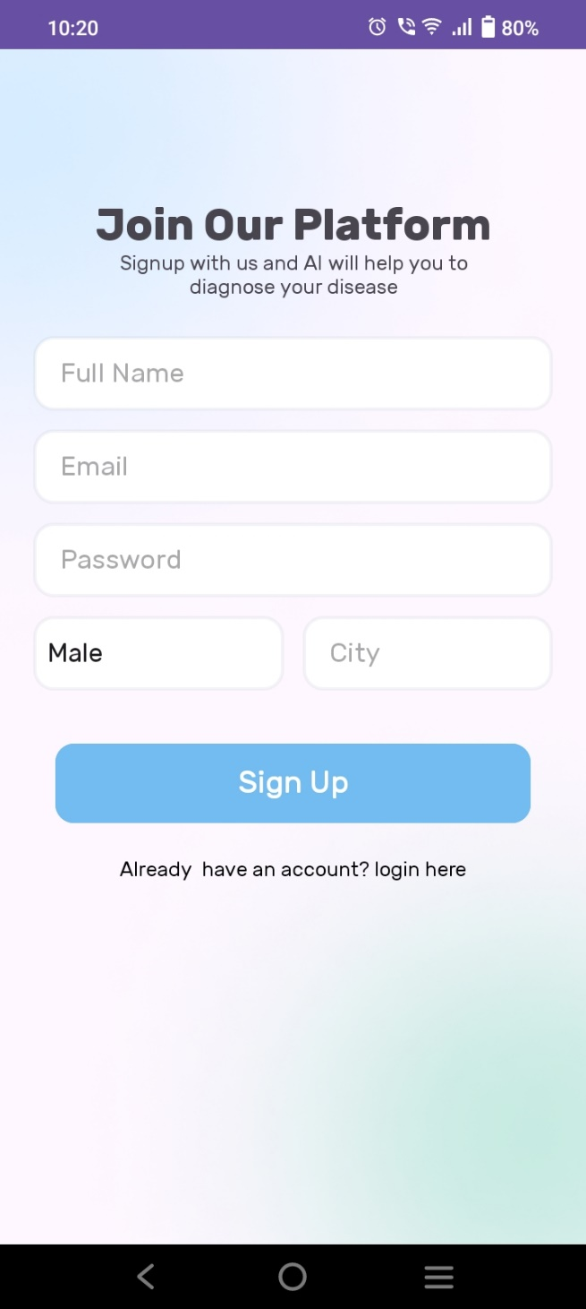
Figure 4.3.1: Signup
    - Login Screen
Users can enter their credentials here to login to the system.
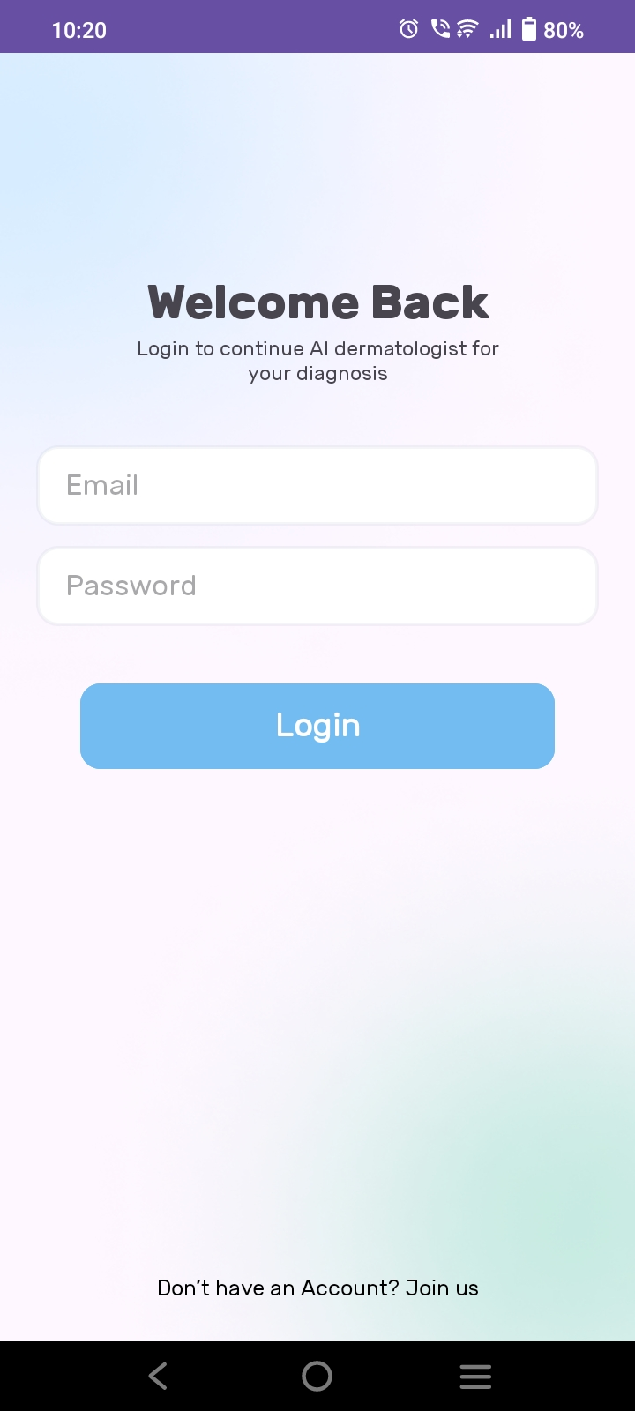
Figure 4.3.2: Login
    - Patient’s Home Screen
Patients after login will be redirected to this home screen it will contain there previous scan history and a navigation bar to edit there profile and scan there disease.
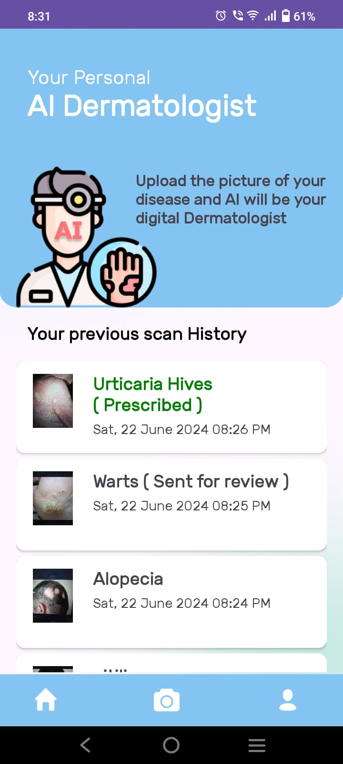
Figure 4.3.3: Patient’s Home screen
    - Camera Intent
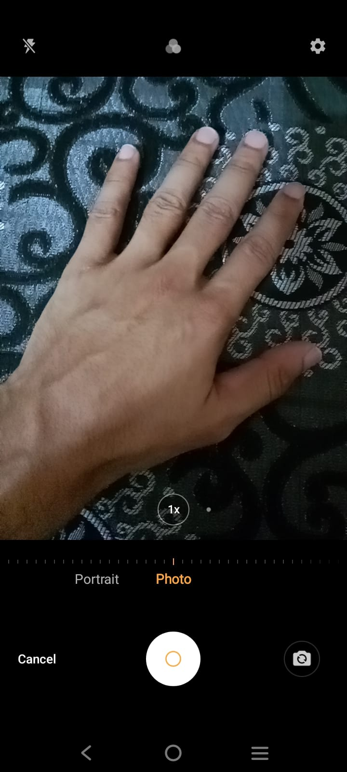
Figure 4.3.4: Camera Intent
    - Disease Detail Activity
Patients will be able to see the result of there scanned disease in this activity.
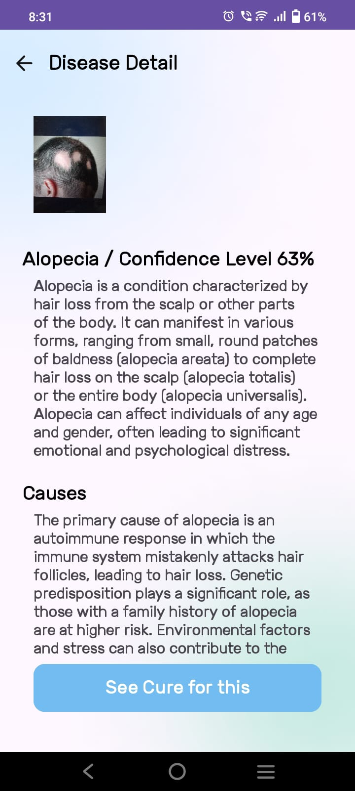
Figure 4.3.5: Disease Detail Activity
    - Disease Cure Activity
Patients will be able to see cure for the disease that was detected in the previous activity.
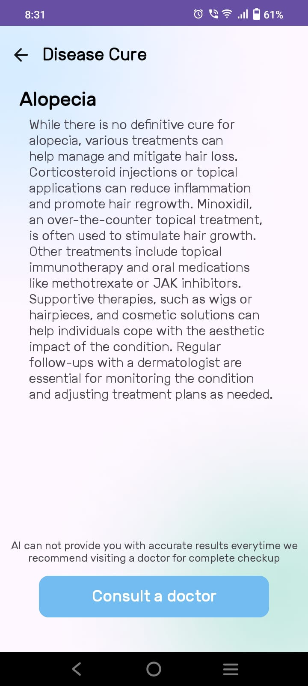
Figure 4.3.6: Disease Cure Activity
    - Prescription Provided by doctor
Patients will be able to see the prescription that the doctors will provide to the patients.
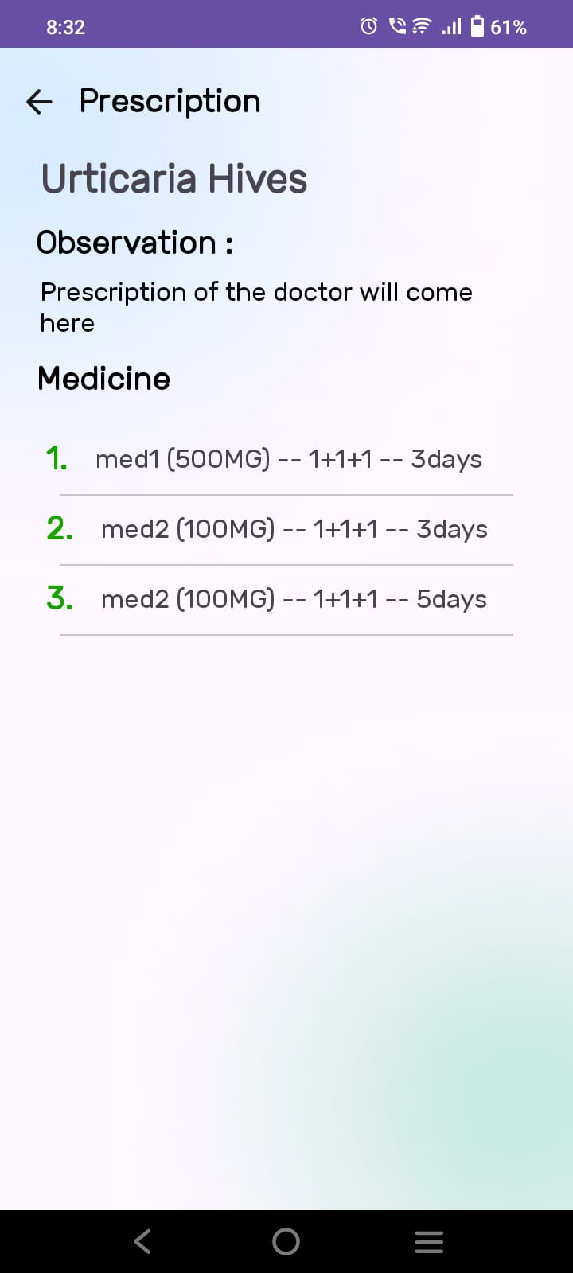
Figure 4.3.7: Doctor’s Prescription
    - Patient’s Profile
Patients can view and edit there personal information on this screen.
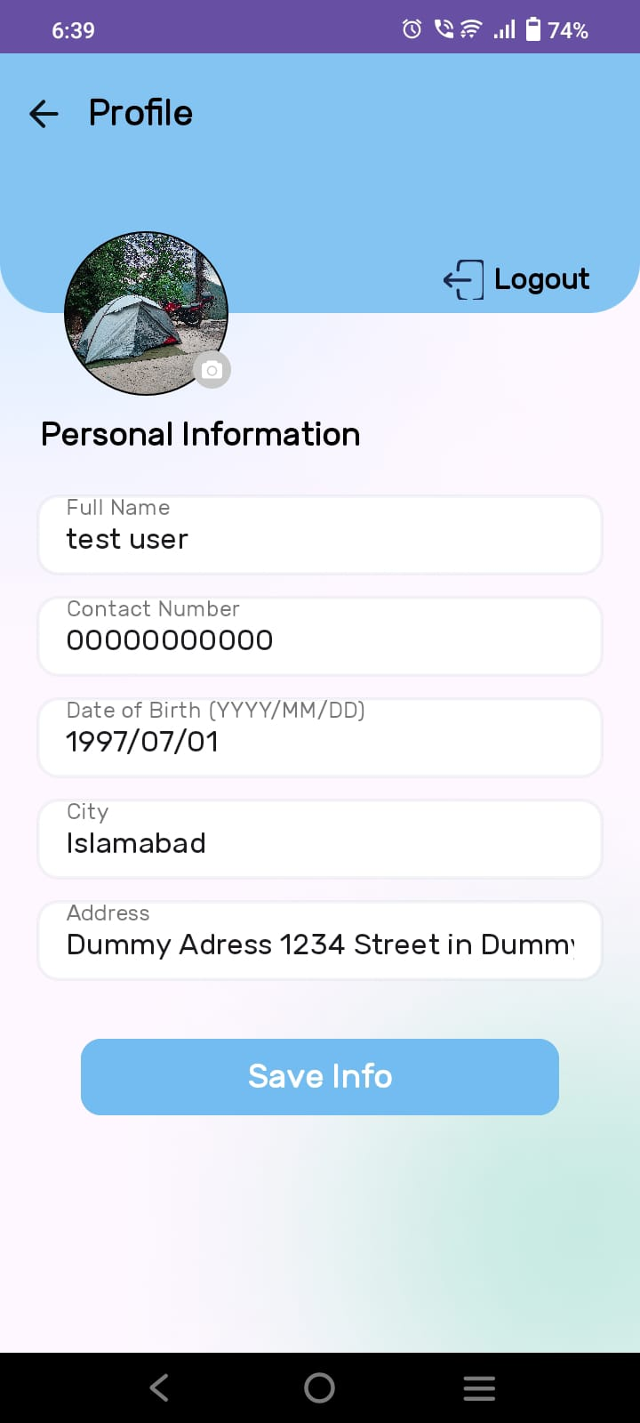
Figure 4.3.8: Patient’s profile
    - Doctor’s Home screen

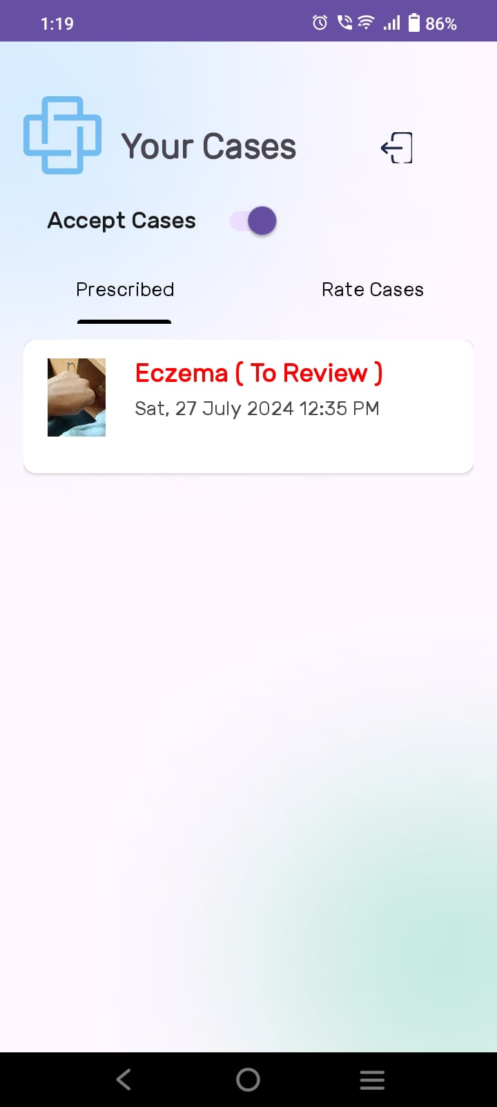
Figure 4.3.9: Doctor’s Home screen
    - Writing Prescription
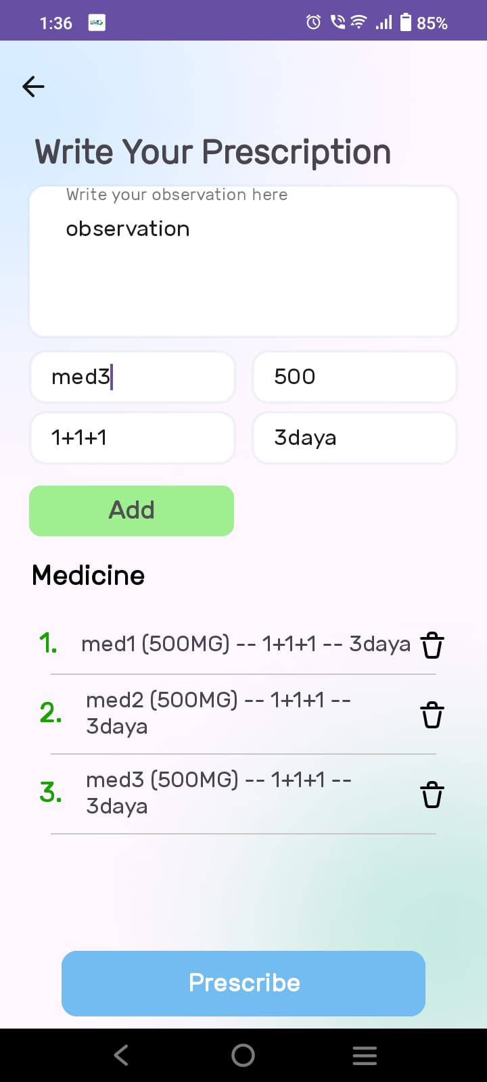
Figure 4.3.10: Doctor prescribing patient
    - Cases needs to be rated

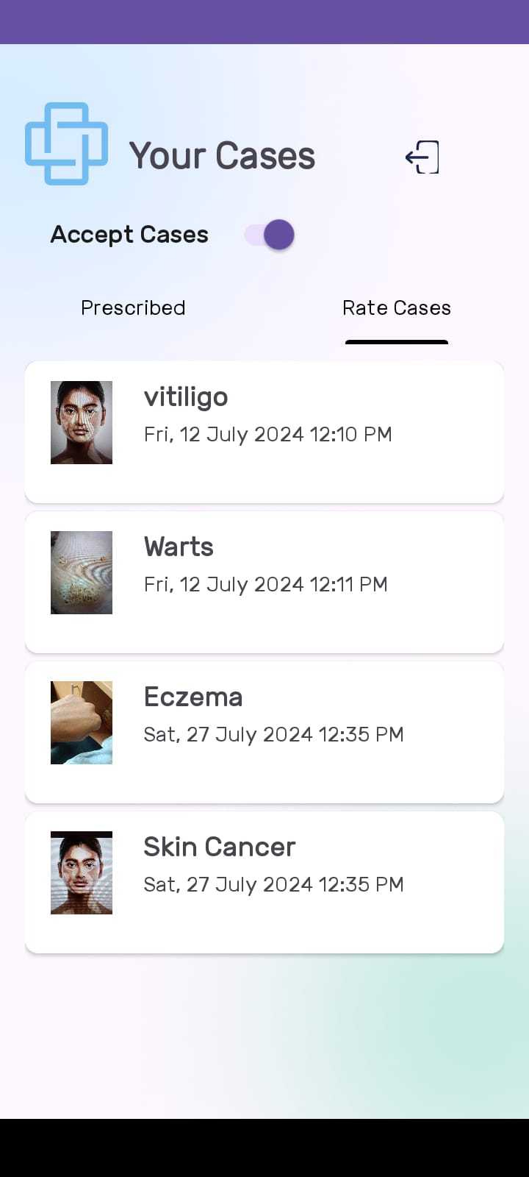
Figure 4.3.11: Cases needs to be rated
    - Rating a Case

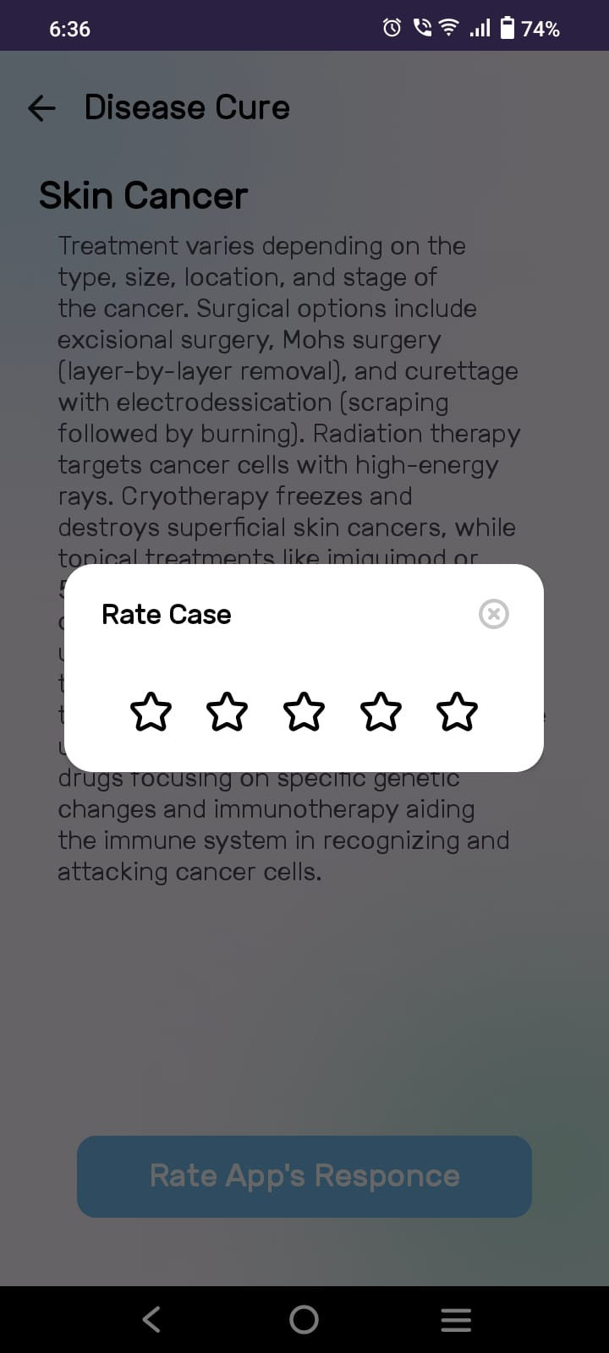
Figure 4.3.12: Rating a Case
    - Case Rating Review
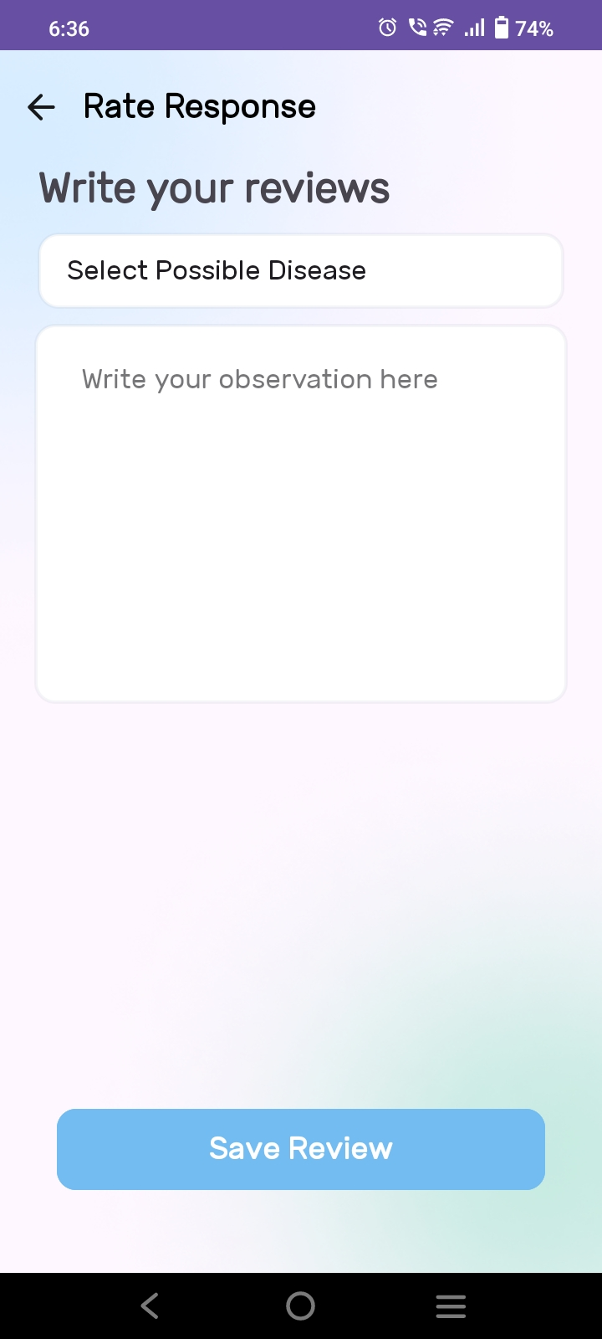
Figure 4.3.13: Writing case review
    - Admin’s Home screen
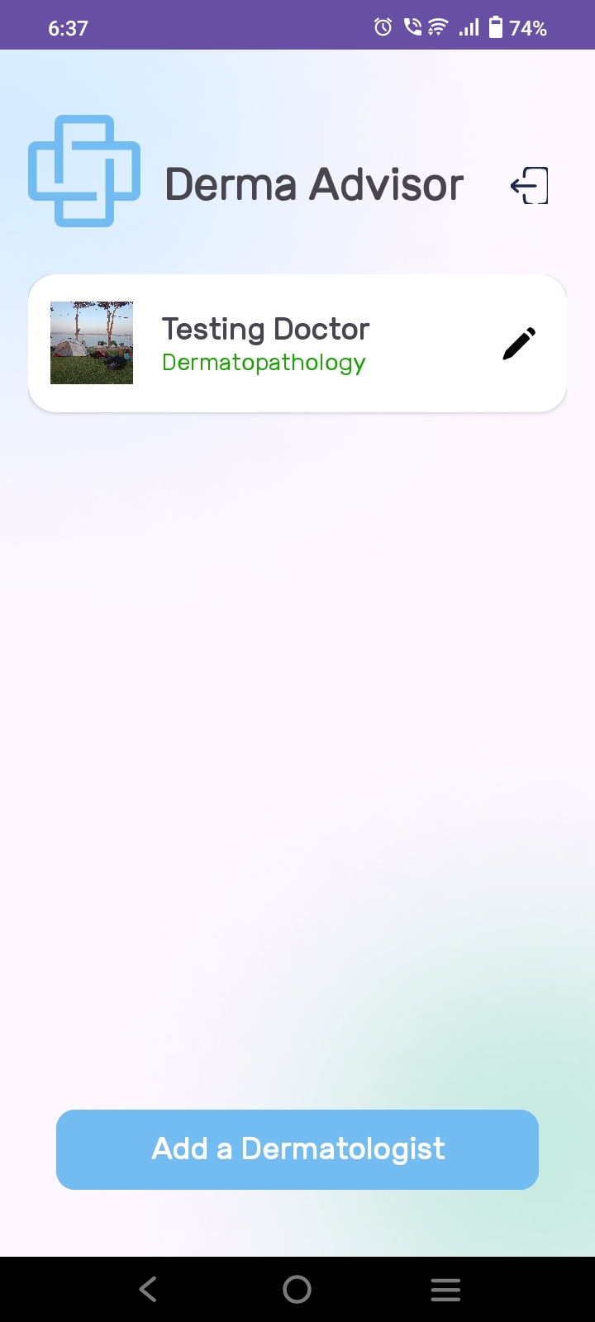
Figure 4.3.14: Admin’s home screen
    - Adding a Dermatologist
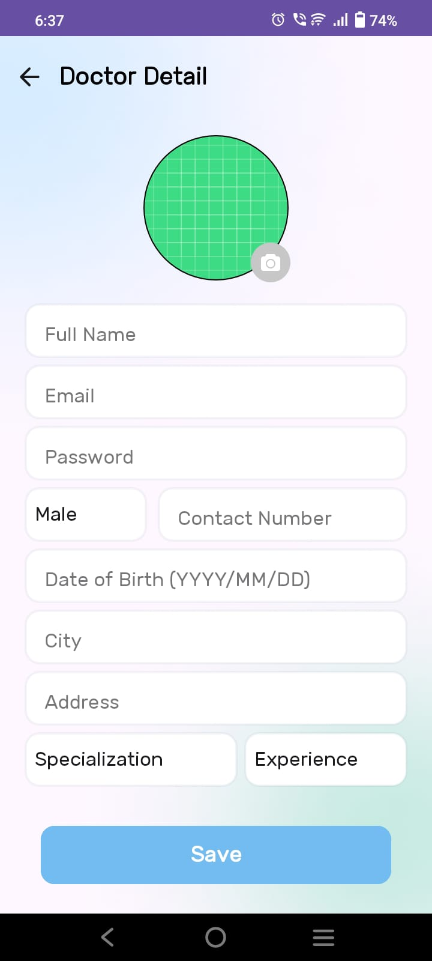
Figure 4.3.15: Adding a dermatologist

    - Updating Dermatologist
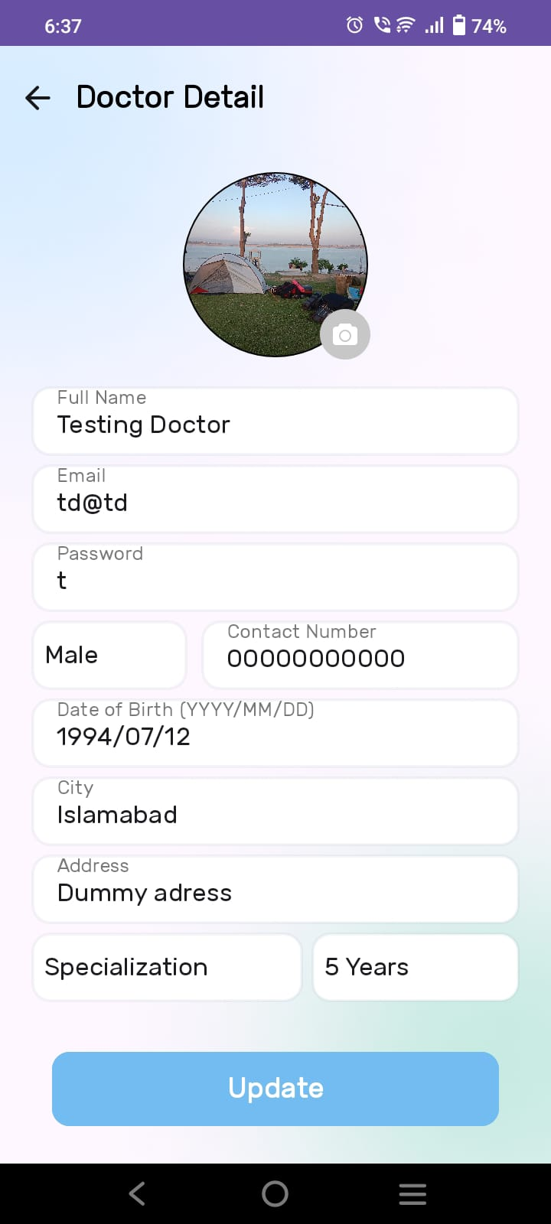
Figure 4.3.16: Updating a Dermatologist

CHAPTER 5

CONCLUSION
5.1 Conclusion Remarks
This project is successfully completed and met the requirements and objectives. The application covers all the major modules necessary to fulfill the requirements and facilities, providing an effective and efficient platform for users to diagnose and manage dermatological conditions. The "Dermatology Advisor" application is a comprehensive software solution for patients, doctors, and administrators involved in dermatological care. This app offers a seamless and accessible way to receive accurate AI-based diagnoses, detailed medical information, and personalized virtual consultations, ensuring comprehensive and reliable dermatological care for all users.

5.2 Future Directions
In the future, we can make the Dermatology Advisor even better by adding features to help everyone involved feel more comfortable and find what they need easily. This might mean integrating more advanced AI models for even more accurate diagnoses and expanding the database to cover a wider range of dermatological conditions. We could also add personalized homepages for users, offering tailored information and recommendations based on their medical history and preferences. Visual data representations, such as charts and graphs, can be included to show important information like trends in skin health and treatment progress.

5.3 Limitations
One limitation of the Dermatology Advisor is its reliance on internet connectivity, which may hinder access for users in areas with poor internet coverage. Compatibility issues with certain devices or operating systems could also pose challenges, potentially impacting the user experience. Additionally, the accuracy of AI-based diagnoses depends on the quality of the uploaded images, which can vary significantly among users. Technical glitches and downtime could further disrupt users' ability to use the app effectively, while the dependency on user cooperation for uploading clear images and providing accurate information may affect the overall functionality and reliability of the application.

REFERENCES
- Anitha, R., & Raja, K. (2022). Dermatological Diseases and AI: A Comprehensive Review. Journal of Medical Informatics, 15(2), 85-98.
- Redmon, J., & Farhadi, A. (2018). YOLOv3: An Incremental Improvement. arXiv preprint arXiv:1804.02767.
- Simonyan, K., & Zisserman, A. (2015). Very Deep Convolutional Networks for Large-Scale Image Recognition. arXiv preprint arXiv:1409.1556.
- He, K., Zhang, X., Ren, S., & Sun, J. (2016). Deep Residual Learning for Image Recognition. In Proceedings of the IEEE conference on computer vision and pattern recognition (pp. 770-778).
- Krizhevsky, A., Sutskever, I., & Hinton, G. E. (2012). ImageNet Classification with Deep Convolutional Neural Networks. Advances in Neural Information Processing Systems, 25, 1097-1105.
- Kingma, D. P., & Ba, J. (2015). Adam: A Method for Stochastic Optimization. arXiv preprint arXiv:1412.6980.
- Privacy and Security Issues in Digital Health, Journal of Healthcare Informatics, 2020.
- Dermatology Online Journal, American Academy of Dermatology. (2021). Advances in AI for Dermatological Applications.
.

ANNEXURE
Annexure A: Authentication and Login
Step 1: Enter username and password.
Step 2: Click on the Login button.
Annexure B: Patient Registration
Step 1: Enter full name, email, password, gender, and city.
Step 2: Click on the Sign Up button.
Step 3: If all fields are valid, save the data; otherwise, display an error message.
Annexure C: Home Screen
On successful login, the user will be redirected to the home screen based on their role:
(a) If the user is a Patient, display the Patient’s Home screen.
(b) If the user is a Doctor, display the Doctor’s Home screen.
(c) If the user is an Admin, display the Admin’s Home screen.
Annexure D: Patient’s Home Screen
Step 1: Display history of previous scans if available.
Step 2: If the profile button is clicked, redirect to the Patient’s profile page for editing personal information.
Step 3: If the camera icon is clicked, open camera intent to scan the affected area.
Step 4: After processing, display disease detail activity with options to see cures and consult a doctor.
Annexure E: Doctor’s Home Screen
Step 1: Display cases needing prescription and cases that have been prescribed.
Step 2: Allow toggling to accept incoming cases.
Step 3: Display a tab for prescribing and rating cases.
Step 4: If a case is clicked, show case details and provide an option to write a prescription or rate the case.

Annexure F: Admin’s Home Screen
Step 1: Admin can view and manage doctor profiles.
Step 2: Display a list of enrolled doctors.
Step 3: Allow adding new doctors and editing existing ones.
Step 4: Admin can log out from the application.
Annexure G: Disease Detail Activity
Step 1: Display disease details after processing the scanned image.
Step 2: Provide a button to see potential cures for the disease.
Step 3: Allow consulting a doctor for further advice.
Annexure H: Patient Profile Management
Step 1: Display personal information including name, contact, DOB, and address.
Step 2: Allow updating of the information.
Step 3: Provide a logout option for the user.
Annexure I: Feedback Mechanism
Step 1: Allow doctors to rate AI-generated results on a scale of one to five stars.
Step 2: If rating is less than five stars, prompt doctors for feedback and alternative diagnoses.
Step 3: Store feedback for future AI model improvements.
Annexure J: Data Security and Privacy
Step 1: Implement user authentication and authorization mechanisms.
Step 2: Ensure data security compliance with data protection regulations.
Annexure K: Scalability and Future Enhancements
Step 1: Design the platform to accommodate growing user numbers.
Step 2: Plan for future feature additions to meet evolving needs.

PROJECT SUMMARY
The Dermatology Advisor is a cross-platform mobile application designed to assist users in the early detection of dermatological conditions through an AI-powered diagnosis. Utilizing the YOLOv8 model, the application enables users to capture images of their skin concerns and receive immediate analysis, including a description of potential conditions, their causes, and suggested treatments. The app also provides a platform for virtual consultations with licensed dermatologists, allowing users to receive professional advice and prescriptions as needed.
The application is built with a focus on user experience, offering distinct interfaces for patients, doctors, and administrators. Patients can easily manage their profiles, access their scan history, and consult with doctors through a streamlined process. Doctors, on the other hand, can review cases assigned to them, prescribe treatments, and provide feedback on cases. Admins manage user registrations and oversee the overall functionality of the application.
Key Features
- AI-Powered Diagnosis: Leveraging YOLOv8 for accurate identification of dermatological conditions.
- Virtual Consultations: Connecting users with dermatologists for professional advice.
- User Management: Custom interfaces for patients, doctors, and administrators.
- Profile Management: Patients can update their information and view their medical history.
- Security: Ensuring the confidentiality of user data and compliance with healthcare regulations.
The Dermatology Advisor addresses the challenges of traditional dermatological diagnosis, providing an accessible and efficient solution for users seeking medical assistance for skin-related issues.

