Design:

**UML Class Diagram:**

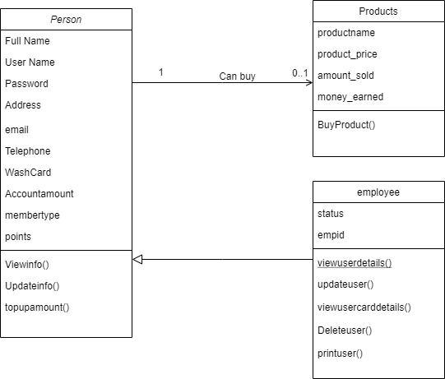

**Rules:**

* Person is a Base Class.
* Employee inherits all the attributes and functions of the person.
* Person can buy one or many products.

**Description:**

There are 3 major classes of the object:

1. **Person:**

A person has multiple attributes like Full name, username , password , address , email, telephone, washcard , accountamount , membertype and points. It is base class and can perform following functionalities:

**View info():**

User/ Person can view his/her complete information.

**Update info():**

User can update all the attributes of the person mentioned above.

**Top up Amount():**

Person can add balance to his personal account.

1. **Employee:**

An employee has attributes like status and empid. A status of an employee can be employee or a manager. An employee performs different functionalities based on his/her status. Few of them are mentioned below:

**View user Details():**

An Employee can View Details of all the users present in the system.

**Update User():**

Employee can update information of a specific user.

**View User Card Details():**

Employee can also View information regarding the balance of users registered.

**Delete User():**

Employee can delete an existing user.

**Print User():**

Employee can also print details of an existing user.

1. **Product:**

An information saved on the file regarding the product is product name, product price, amount sold and money earned.

**Buy Product():**

A person or an employee can buy a product.