Syed Ahsan Ahmed (sa02908)

Question 2

We studied L-Systems that help us create patterns, and we also studied Evolutionary Algorithms un great detail. Now, the question arises, can we use these two techniques together? In the light of the research papers mention below, we see that it indeed is possible to combine the two techniques. Now, before we jump into the how’s of the combining the two techniques, we must know, why should we be doing it?

**Why fuse the two techniques together?**

According to Jon McCormack, creating new rules for L-Systems to make them aesthetic and interactive requires a lot of hard work. It needs the experts to study which formula will result in what kind of pattern, so that we can with a really good and interactive pattern. Jon McCormack says that we can use Evolutionary Algorithms to avoid hard work, and everything is taken care of by the Evolutionary Algorithms itself. EA through mutation, and crossovers tends to bring new patterns and formulae that we humans can’t think of. Thus, we can say that one reason of using the two techniques together is to come up with more interactive patterns without putting in much hard work. The other reason that Gregory S. Hornby’s paper puts forward is that he says that if the two systems are used separately to create natural structures, they both have some limitations. When the natural structures are created using just EA, they lack symmetries and regularities, and these structures are not natural looking. On the other hand, when we try to create these structures using just the L-Systems, due to a well-defined formula and being so much well-structured with patterns emerging on every step, they tend to exhibit an unnatural look. Thus, Hornby says that these unnatural looking structures can be made to look natural by making them taking the qualities of both of these techniques and fusing them together.

**How to fuse the two techniques?**

Now, coming to how the two techniques can be combined, it depends on where these two techniques will be used, i.e. that context. But all the procedures of fusing these two techniques have similar fundamental steps. In the first step, a random population of rules for L-Systems are generated, these are the chromosomes that will be used by the EA. Now, these chromosomes can be such that “A>ABBBAABA” for the 1st chromosome, for the 2nd chromosome, its “A>BABAAAB”, and similar for all the chromosomes. It’s not necessary that these chromosomes are randomly generated. It can be the case that initially, we have some good L-Systems rules, and we convert them into chromosomes to evolve them.

After we have the initial population generated, it’s time to compute their fitness using a fitness function. Now, this fitness function depends on the context where we are using these two techniques together. For example, in Gregory S. Hornby’s paper where he tries to create the virtual creatures using L-System and tries to evolve the definition of the L-System, here for the fitness function, he using a 2d track. For every chromosome that creates the body of the virtual creature, that will eventually help it to walk, the creatures are placed on a 2d track, and made to walk. The distance travelled by them in a unit of time is the fitness of the chromosome. Similarly, for other problems the fitness function can differ, such as, when trying to evolve an L-System for aesthetic purposes, the fitness function can be a person who rates every pattern produced on a scale of 1 to 10. Now, that we have our fitness function ready and we can calculate the fitness of each chromosome, let’s move to the next step.

The next step is the selection of the parents for crossover. For the selection of the two parents, any technique can be used that we have already studied in the course. The crossover occurs by the method that we have already studied. Some part from first parent, and the rest part from the second parent. After the crossover, it’s time for mutation. According to McCormack’s paper, there are three basic areas to which mutation can be applied:

1. Mutation of rules and letters.

2. Mutation of parameters and parametric expressions.

3. Mutation of growth functions and letter ages.

After the mutation is done, their fitness is again calculated for killing the worst chromosomes. This process is repeated again and again until a finely developed L-System’s equation is not obtained.

**Effectiveness of the method**

Now, moving on to the effectiveness of combining the two techniques, to McCormack shows some results from his paper that he came out with using the above discussed technique. The pictures attached below shows some structures where the pattern seems to change gradually, thus giving a more natural look. For example, in the 2nd and the 3rd picture in figure 1, we see that the repeating patterns show some random changes as the structure expands, thus giving a more aesthetically pleasing look. Similarly, Hornby in his paper shares the result where he was able to evolve the virtual creatures. He puts forwards the interesting findings of his research that a large amount of the evolved creatures shaped themselves to enable them to roll in order to move and thus showing a better movement that the other virtual creatures. See figure 2 for reference.

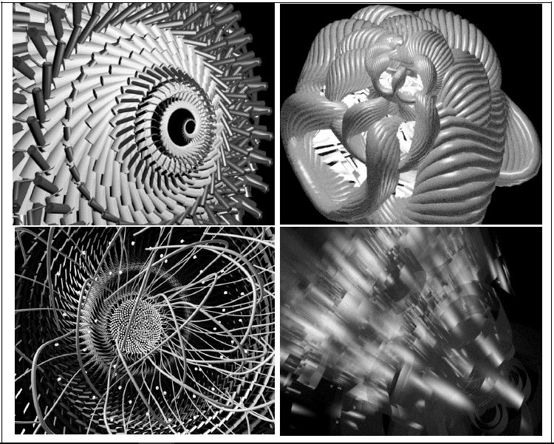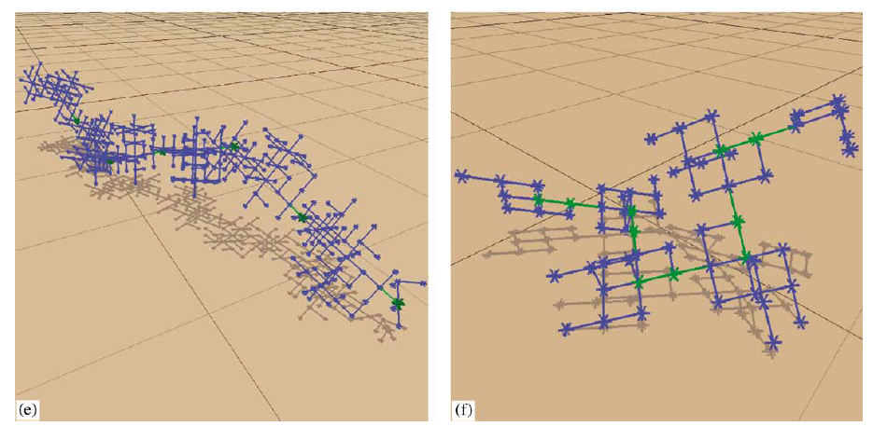

Figure 1 Figure 2

**Conclusion:**

Concluding, we say why it’s better to use L-Systems along with Evolutionary Algorithms, depending where it’s being used. We answered the all questions asked, in the light of two research papers that explored this topic in detail.

**References**:

[1] Jon McCormack (1993) “Interactive Evolution of L-System Grammars for Computer Graphics Modelling”, *Monash University*, 6, pp 118–130.

[2] Gregory S. Hornby*, Jordan B. Pollack (2001) “Evolving L-systems to generate virtual creatures*”, Computers & Graphics,* 25*,* pp 1041 - 1048