CI assignment plots:

Parameters:

nPopulation = 60

PmutationRate = 0.4

nChildren = 10

nGenerations = 200

nIterations = 10

We will analyse all our algorithms combination on 200 gen, the the best combination will then be run on more generations to get the best resuls.

Red line indicates Average total distance of the path. Blue line indicates average minimum total distance of the path.

fitnessProportionalSelection with fitnessProportionalSelection (parent, new population selection) [done-Sheet1]

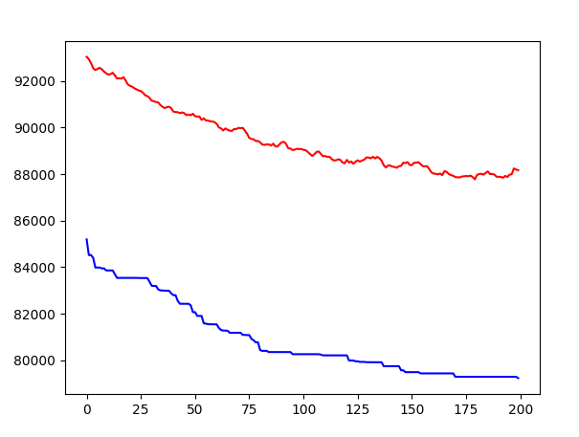

fitnessProportionalSelection with rankbasedSelection (parent, new population selection) [done-Sheet2]

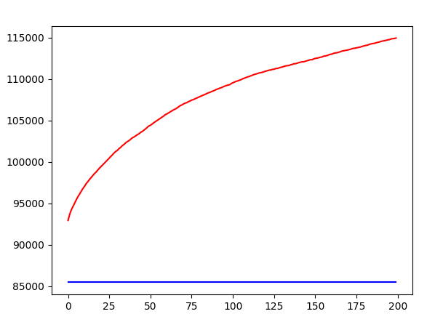

fitnessProportionalSelection with binaryTournament (parent, new population selection) [done-Sheet3]

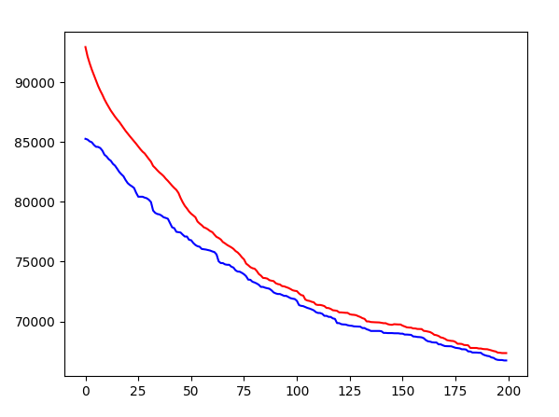

fitnessProportionalSelection with randomSelection (parent, new population selection) [done-Sheet4]

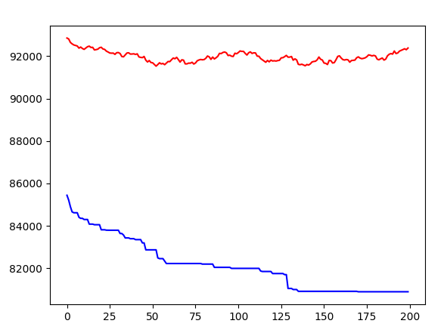

fitnessProportionalSelection with truncation (parent, new population selection) [done-Sheet5]

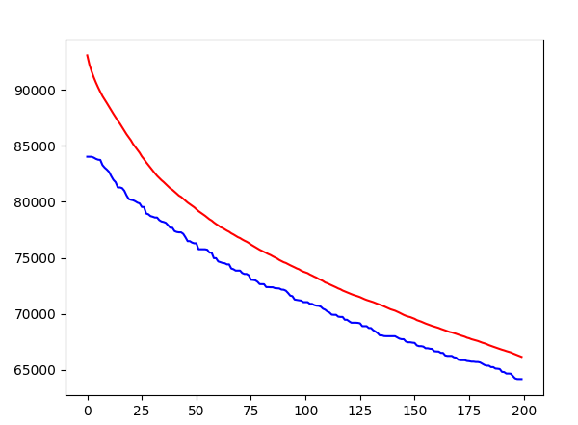

rankbasedSelection with fitnessProportionalSelection (parent, new population selection) [done-Sheet6]

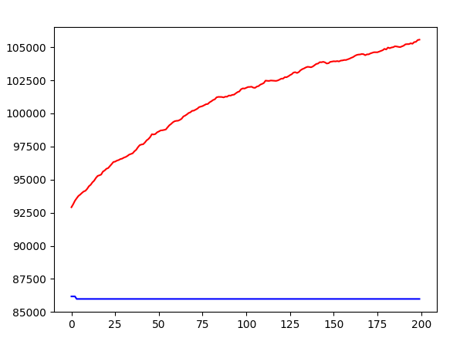

rankbasedSelection with rankbasedSelection (parent, new population selection) [Done-Sheet7]

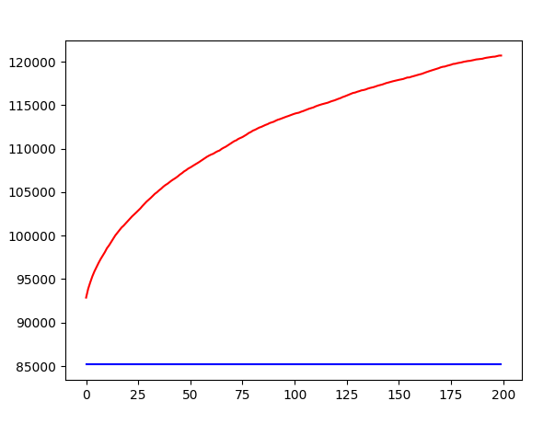

rankbasedSelection with binaryTournament (parent, new population selection)

[Sheet 8]

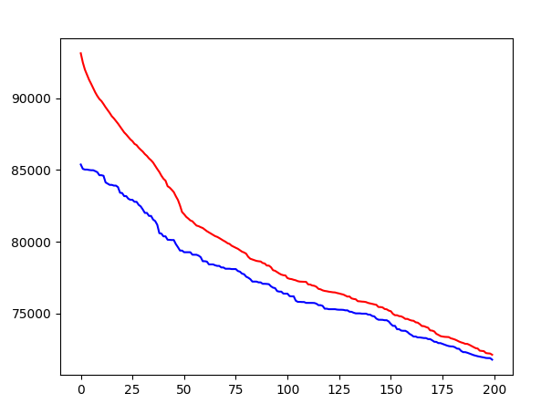

rankbasedSelection with randomSelection (parent, new population selection) [done-Sheet 9]

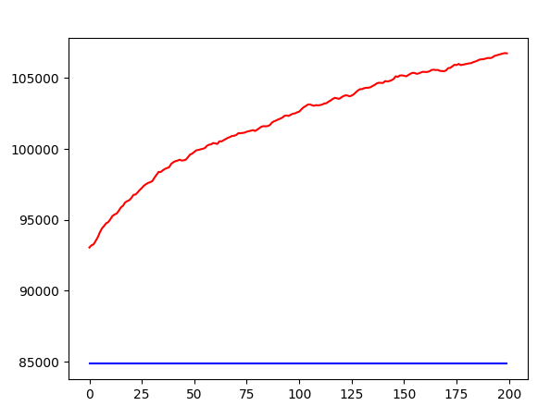

rankbasedSelection with truncation (parent, new population selection) [done-Sheet10]

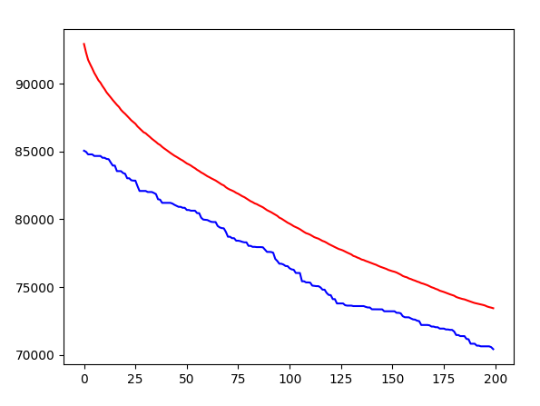

binaryTournament with fitnessProportionalSelection (parent, new population selection) [done-Sheet 11]

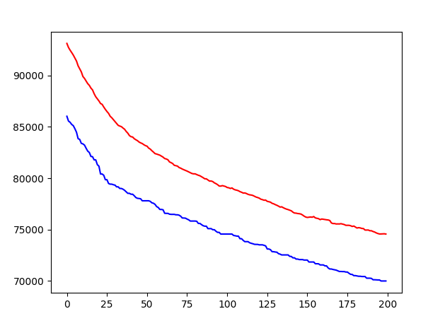

binaryTournament with rankbasedSelection (parent, new population selection) [Sheet 12]

binaryTournament with binaryTournament (parent, new population selection) [Sheet 13]

binaryTournament with randomSelection (parent, new population selection) [Sheet 14]

binaryTournament with truncation (parent, new population selection) [Sheet 15]

randomSelection with fitnessProportionalSelection (parent, new population selection) [Sheet 16]

randomSelection with rankbasedSelection (parent, new population selection) [Sheet 17]

randomSelection with binaryTournament (parent, new population selection) [Sheet 18]

randomSelection with randomSelection (parent, new population selection) [Sheet 19]

randomSelection with truncation (parent, new population selection) [Sheet 20]

truncation with fitnessProportionalSelection (parent, new population selection) [Sheet 21]

truncation with rankbasedSelection (parent, new population selection) [Sheet 22]

truncation with binaryTournament (parent, new population selection) [Sheet 23]

truncation with randomSelection (parent, new population selection) [Sheet 24]

truncation with truncation (parent, new population selection) [Sheet 25]