**Tinder Auto Swipe: Developed by Ahsan Ahmed (Fiverr/ahsanahmedsn)**

**Notes:**

1. You must have the Google Chrome browser, as selenium webdriver runs on Chrome.
2. Before running the program if you get install any import error such as, “ModuleNotFoundError: No module named ' selenium'”, simply type on CMD, ‘pip install selenium’
3. If for some reason, you start getting the following error, it happens because the websites that are most prone to bot sometimes change their xPath dynamically every once in a month or few months.

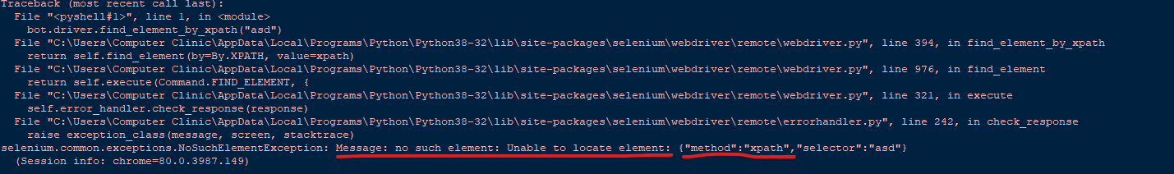

The solution to this problem is very simple, simply change the corresponding XPath variable by following these steps.

1. For example, if you see that the xpath for the LIKE variable has changed.
2. Press CTRL+SHIFT+I. Then click the cursor on the top left of the inspect panel, and hover it on top of the like button and click it. Then, follow picture instructions.
   1. 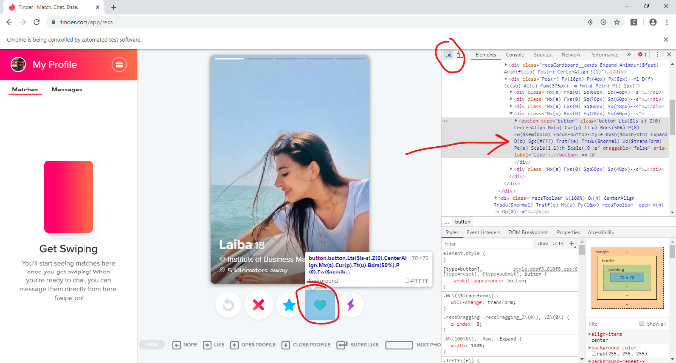
   2. 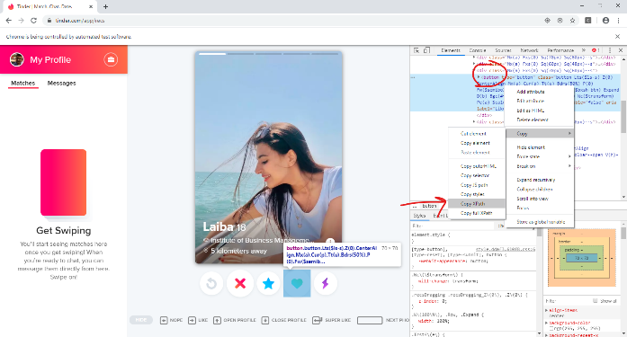
   3. 
   4. Replace, the corresponding Xpath variable with your new Xpath variable it will work. ☺

If you have any questions, feel free to reach me out on fiverr.