* **DATABASE PROJECT REPORT**

**INSTALLMENT MANAGEMENT SYSTEM**

**Group Members:**

* **Muhammad Ahsan Sajjad (368857)**
* **Muhammad Yameen (368264)**
* **Fatima Binte Tanveer (373630)**

**Abstract**

The purpose of this project is to develop software named as installment management system for a company. This system will be capable of storing information about the company employees, it’s customers, accounts of each customer, balance of each account, recovery details of each account, the details about the accounts assigned to the recovery collectors for recovering the installment on the correct date and maintain record about it, and also the details about the annual and monthly packages and products the company offers to it’s customers. The frontend of the system was implemented in using PyQT5 and QT Designer and the backend was implemented by connecting MySQL Workbench with PyQT5 using MySQL connector.

**Introduction**  
  
Currently the businesses working on installments are using registers and books to keep the record of their customers and accounts. This is such a tedious job as this approach can only be catered in the initial stage of this business. But, as the business expands it becomes such a difficult task for each business to handle accounts record manually because whenever a new account is created and the owner of that account which is the customer has to pay installments on monthly basis, so whenever he came for paying installment, it becomes a hectic job to search for the particular customer account by checking each and every page of the registers.

Rather there must be a system which stores the record of accounts and whenever a customer arrives for paying installment, the computer operator of the company feeds the data in the software and the software automatically performs the rest. This software is Installment Management System, it is also capable of printing monthly reports at the end of each month so that the company owners may capable of seeing the profit generated for that month and also checks the performance record of each employee.

**Proposed Methodology**

1. **Tools**

- MySQL workbench

-VSCode

**b) Technologies**

-PyQT5

-SQL

***Reasons for using these tools:***

The choice of tools and technologies chosen was influenced by both our prior familiarities with these technologies, and also the consideration of which backend would be simpler to integrate with the MySQLWorkbench.

**b) Hand-drawn ERD**

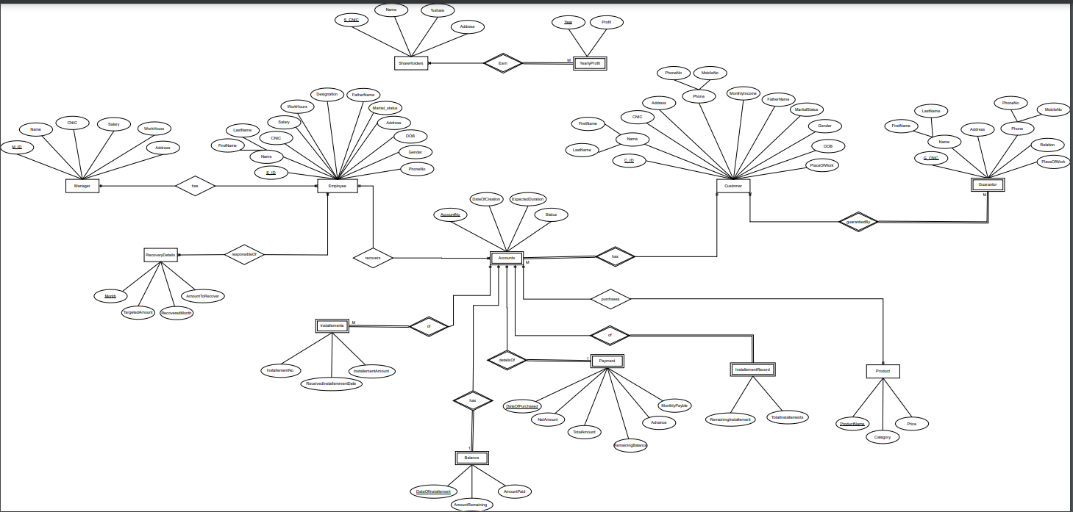

NOTE: source file of ERD is attached

**c) System-generated ERD**

NOTE: source file of ERD is attached

**Triggers, views and stored procedures**

* ***Triggers:***

We have created one triggers,

when operator fills customer form, and at the time of saving this form, a report will be generated, which will include account information (customer name, product purchased, number of installments, installment per month, etc.)

* ***Views:***

Number of views: 4

As our database, data is being displayed in multiple GUI girds, and in one gird data is retrieved from many tables using joins, so we have created views for displaying each gird in GUI.

* ***Stored procedures:***

Number of stored procedures: 4

Stored procedures are being used, where we needed to retrieve data from multiple tables with arguments, like, retrieving every information of any specific customer or employee from multiple tables, using customer/employee Id.

**Usage of database**

The database created will be used to maintain record of company shareholders, employees, customers, accounts, products, and all other entities involved in the Company. It is used to keep a track of:

* all accounts created
* employees working for the company
* recovery details of each account
* details of accounts assigned to the recovery collector for taking installments
* all products and their prices
* category of packages company offers

**Maintenance**

In order to make maintenance of the database easier, all code is saved in one file. Easily comprehendible yet descriptive names are given to all entities and all functionalities generated. In the future, regular maintenance will be carried out to ensure that any changes in the real world constraints that the company runs under are reflected in the database and functionalities are correspondingly updated.

**Conclusion**

The major purpose of undertaking this project was to develop a system for managing a complete business in a more systematic way by the use of technology. Generating reports and record details by the end of each month was a tedious job because everything was done manually. The developed system delivers all such functionalities required by the company and business automatically and makes the process very simple and just one click away.