

**BAHRIA UNIVERSITY, Karachi Campus**

*Department of Software Engineering*

REPORT

**Course Title: CCN**  **Course Code**: **CEN-223**

**Course Instructor: Dr. Hussain Class**: BSE- (A/B)

**Lab Instructor:** **Engr. Asma Shaheen**

# **Telephony System Network**

GROUP MEMBERS LIST:

|  |  |  |  |
| --- | --- | --- | --- |
| S.NO | Enrollment | Name | Email |
| 01 | **02-131212-049** | Ahsan Sajjad |  |
| 02 | **02-131212-002** | Adeeb-ul-Hassan |  |
| 03 | **02-131212-063** | Mutayyab Imran |  |

**Submission Date: __________________**

Contents

**Telephony System Network** 1

**1.** **INTRODUCTION** 3

**Introduction** 3

**Proposed Solution** 3

**Problem Statement** 4

**Technologies Used** 4

**2.** **DESIGN DESCRIPTION** 5

**Workflow Diagram** 5

**User Interfaces** 5

**Conclusions, Commands and further work:Finance Switch:** 5

**3.** **REFERENCES** 36

# **INTRODUCTION**

## **Introduction**

Turtle Consultancy Limited, a global IT infrastructure solutions provider, is expanding its operations and requires a robust and scalable network infrastructure for a newly acquired branch. The project involves designing and implementing a Voice over IP (VoIP) network, with a focus on scalability and availability. The network will comprise four servers (DHCP, EMAIL, DNS, HTTP) and will interconnect three departments, each equipped with desktops and associated telephone sets.

Our mission is to bring this vision to life using specific IP addresses for Data, Voice, and inter-router communication. The project will implement various technologies and functionalities, including VLAN creation, subnetting, IP addressing, Inter-VLAN routing, and configuring DHCP servers. The project will culminate with a thorough communication test to ensure the successful implementation of all configurations.

## **Proposed Solution**

All desktops have an associated telephone set (each PC is connecting directly to a Phone, not a switch). The network consists of four servers (DHCP, EMAIL, DNS, HTTP) located at the server side site and is fully configured for the operations, and all servers are shared between all users.  
Each group has been assigned the task of designing, and implementing a network infrastructure for Turtle Consultancy Limited by internetworking three departments which are as follows:;

The IT Manager emphasized scalability and availability, and hence you are required to provide a complete network infrastructure design and implementation. Turtle Consultancy Limited will be using the following IP address: 192.168.100.0/24 for Data, 172.16.100.0/24 for Voice, and 10.10.10.0/24 between the routers.

* Design a networked system to meet the given specifications. Use packet tracer software to design your network.
* Routers- Each department is to have VoIP enabled router with server-side LAN attached to the ICT department router. Note: use Cisco 2811 router.
* Switches- Each department has an access layer switch. Note: use Cisco 2960 switch.
* Connections- Use serial connections between a router and a router, then a straight through cable between the router to switch, switch to hosts, phones to PCs.
* Subnets- Each department will be accessing two subnetworks, for example, data and voice subnets. Note: carry out appropriate subnetting.
* Basic settings- Configure basic device settings such as hostnames, console passwords, enable passwords, banner messages, encrypt all passwords, and disable IP domain lookup.
* DHCP Server- For voice (VoIP), use the respective router as the DHCP server while for Data use the DHCP server device at the server-side site.
* VLANs- Each department will be in two VLANS. One for data and another for voice. Note: All IP phones in the network should be in VLAN 100.
* Inter-VLAN Routing- Use router-on-a-stick to enable inter-VLAN routing on the network. Note: create sub interfaces for both data and voice VLANs.
* IP Addressing- All devices in the network are expected to obtain an IP address dynamically from the respective DHCP servers while the devices in the server room are to be allocated IP addresses statically.
* Routing protocol- Use OSPF as the routing protocol to advertise routes on the routers.
* Remote Access- Configure SSH in all the routers for remote login.
* Telephony service- Configure VoIP on the routers and allocate dial numbers in this format for the departments, Finance(1..), HR (2..), Sales (3..), and ICT (4..), (where 1.. can be 101 to 199) and so on.
* Routing for VoIP- Configure dial-peering on the routers to allow IP phones from different routers to communicate.

## **Problem Statement** Problem: Design and implement a scalable and available network infrastructure for Turtle Consultancy Limited, integrating three departments, emphasizing VoIP, subnetting, VLANs, inter-VLAN routing, DHCP, OSPF routing, SSH remote access, and VoIP dial numbers. Solution: Utilize Cisco 2811 routers for VoIP, Cisco 2960 switches for access, interconnect routers with serial connections, use straight-through cables for router-to-switch and switch-to-host connections. Implement appropriate subnetting for data and voice (192.168.100.0/24 and 172.16.100.0/24). Configure VLANs (IP phones in VLAN 100), inter-VLAN routing via router-on-a-stick, OSPF routing protocol, SSH for remote access, and dial-peering for VoIP communication. Configure DHCP servers accordingly.

## **Technologies Used**

1. Creating a network topology using Cisco Packet Tracer.
2. Hierarchical Network Design.
3. Connecting Networking devices with Correct cabling.
4. Configuring Basic device settings.
5. Creating VLANs and assigning ports VLAN numbers.
6. Creating both data and voice VLANs and assigning ports VLAN numbers.
7. Subnetting and IP Addressing.
8. Configuring Inter-VLAN Routing on the Routers (router-on-a-stick).
9. Configuring Dedicated DHCP Server device for Data to provide dynamic IP allocation.
10. Configuring Routers as DHCP server for Voice to provide IP Phones dynamic IP allocation.
11. Configuring SSH for secure Remote access.
12. Configuring OSPF as the routing protocol.
13. Configuring VoIP or Telephony service configuration in all routers.
14. Configuring Routing for VoIP or Dial peering configuration in all routers.
15. Host Device Configurations.

# **DESIGN DESCRIPTION**

## **Workflow Diagram**

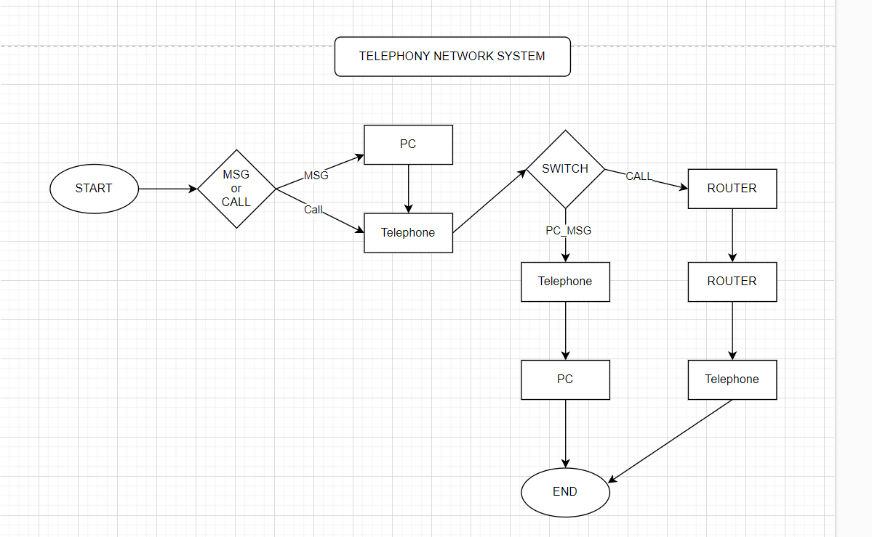

## **User Interfaces**

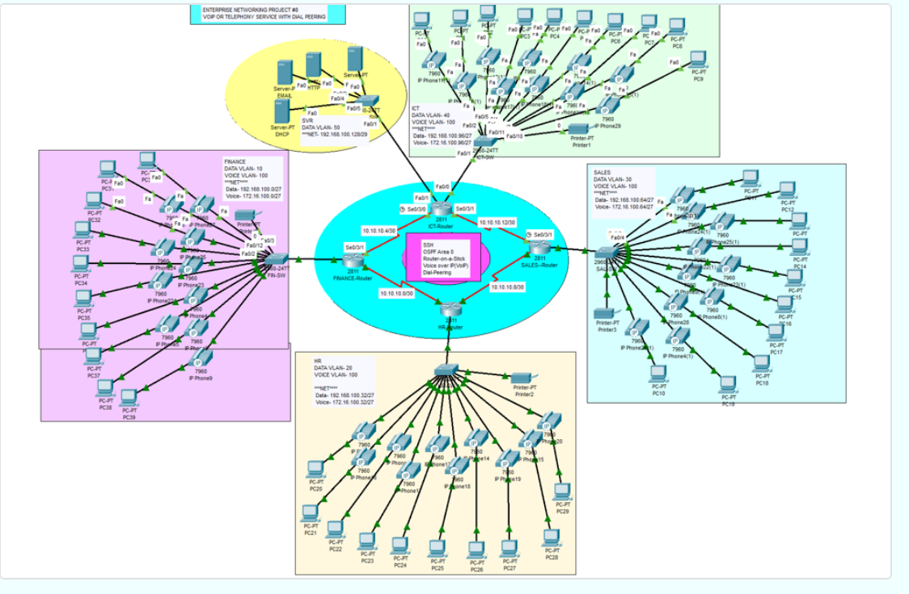

## **Conclusions, Commands and further work:Finance Switch:**

**Finance Switch:**

en

config t

hostname Finance-SW

enable password cisco

line console 0

password cisco

login

exit

banner motd #N0 UNAUTHORISED ACCESS, THIS IS PUNISHABLE BY LAW!!!#

service password-encryption

no ip domain lookup

do wr

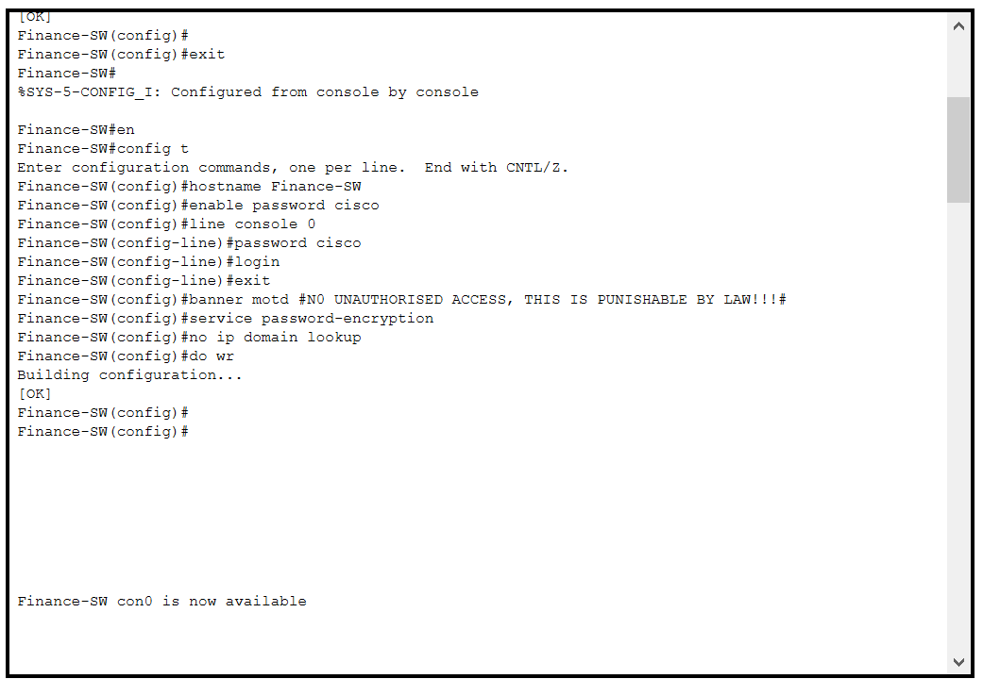

**AFTER BASIC CONFIGURATION:**

vlan 10

name DATA

vlan 100

name VOICE

int fa0/1

switchport mode trunk

exit

int range fa0/2-24

switchport mode access

switchport access vlan 10

switchport voice vlan 100

do wr

**HR Switch:**

en

config t

hostname HR-SW

enable password cisco

line console 0

password cisco

login

exit

banner motd #N0 UNAUTHORISED ACCESS, THIS IS PUNISHABLE BY LAW!!!#

service password-encryption

no ip domain lookup

do wr

**AFTER BASIC CONFIGURATION:**

vlan 20

name DATA

vlan 100

name VOICE

int fa0/1

switchport mode trunk

exit

int range fa0/2-24

switchport mode access

switchport access vlan 20

switchport voice vlan 100

do wr

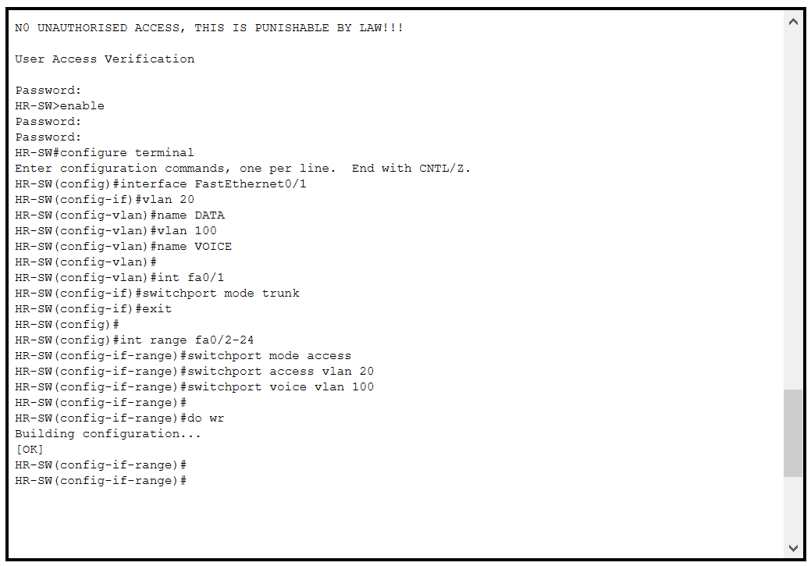

**Sale Switch:**

en

config t

hostname Sale-SW

enable password cisco

line console 0

password cisco

login

exit

banner motd #N0 UNAUTHORISED ACCESS, THIS IS PUNISHABLE BY LAW!!!#

service password-encryption

no ip domain lookup

do wr

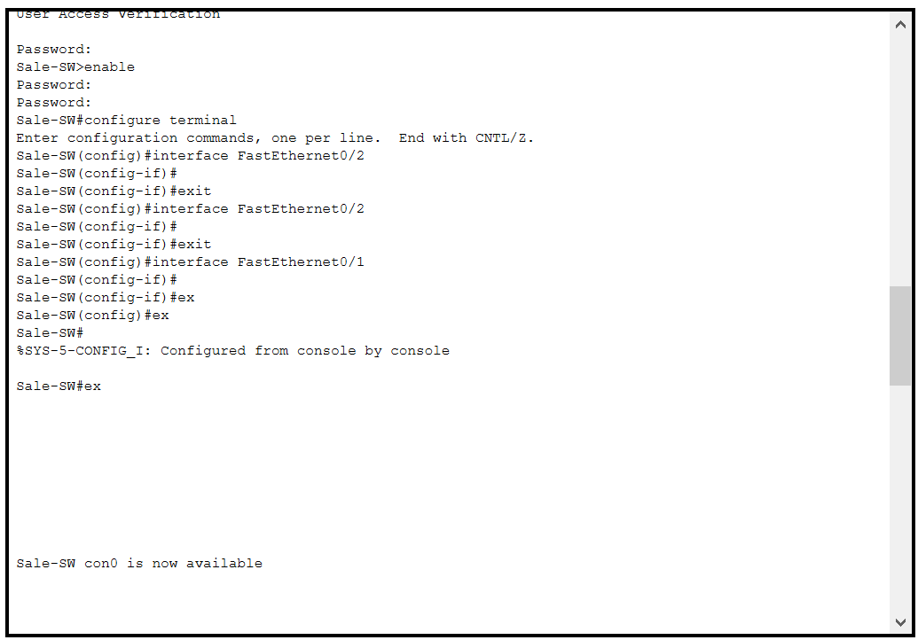

**AFTER BASIC CONFIGURATION:**

vlan 30

name DATA

vlan 100

name VOIC

int fa0/1

switchport mode trunk

exit

int range fa0/2-24

switchport mode access

switchport access vlan 30

switchport voice vlan 100

do wr

**ICT Switch:**

en

config t

hostname ICT-SW

enable password cisco

line console 0

password cisco

login

exit

banner motd #N0 UNAUTHORISED ACCESS, THIS IS PUNISHABLE BY LAW!!!#

service password-encryption

no ip domain lookup

do wr

**AFTER BASIC CONFIGURATION:**

vlan 40

name DATA

vlan 100

name VOICE

int fa0/1

switchport mode trunk

exit

int range fa0/2-24

switchport mode access

switchport access vlan 40

switchport voice vlan 100

do wr

**SERVER SWITCH:**

vlan 40

name DATA

int fa0/1

switchport mode trunk

exit

int range fa0/2-5

switchport mode access

switchport access vlan 50

do wr

**FINANCE ROUTER:**

en

config t

hostname Fin-Router

enable password cisco

line console 0

password cisco

login

exit

banner motd #N0 UNAUTHORISED ACCESS, THIS IS PUNISHABLE BY LAW!!!#

service password-encryption

no ip domain lookup

do wr

username cisco password cisco

ip domain name cisco.net

crypto key generate rsa general-keys modulus 1024

line vty 0 15

login local

transport input ssh

exit

do wr

**INTERFACES**

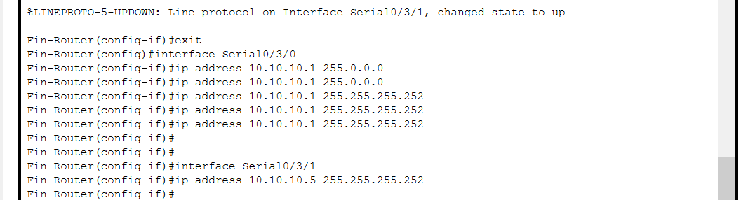

**CONFIGURE DHCP FOR VOICE:**

**Inter-VLAN routing on the Routers Plus Ip dhcp helper Address**

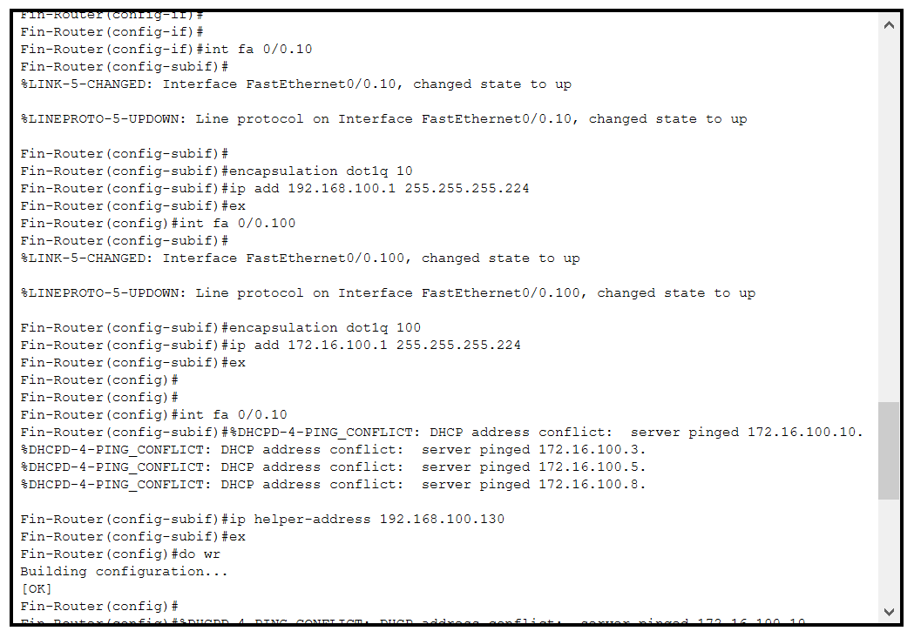

**OSPF on the Routers**

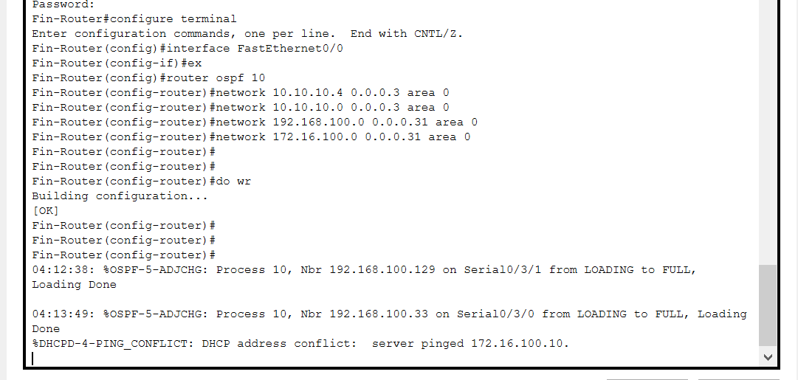

**Configure Voip Configuration:**

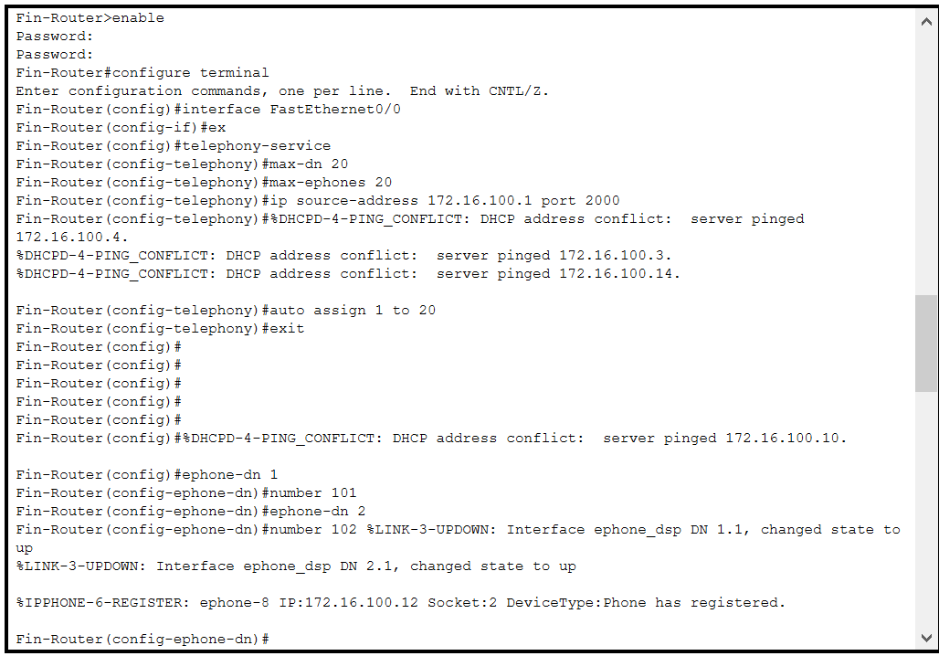 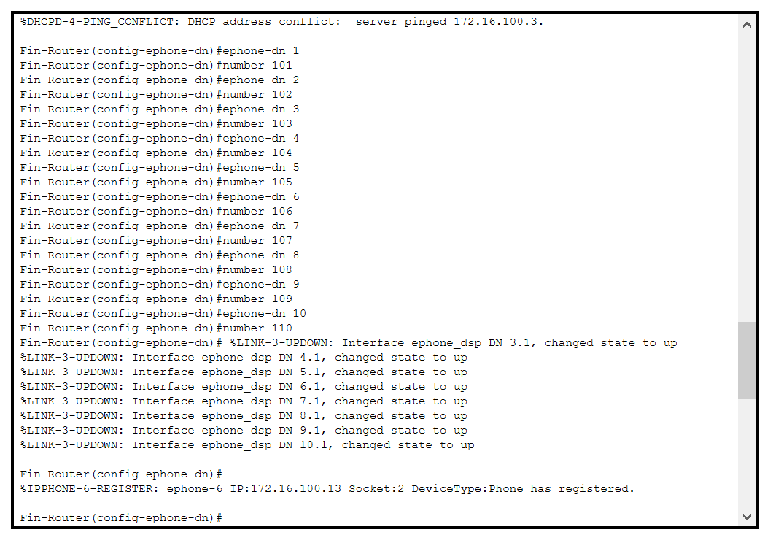

**Dial Peering Configuration:**

**HR ROUTER:**

en

config t

hostname HR-Router

enable password cisco

line console 0

password cisco

login

exit

banner motd #N0 UNAUTHORISED ACCESS, THIS IS PUNISHABLE BY LAW!!!#

service password-encryption

no ip domain lookup

do wr

username cisco password cisco

ip domain name cisco.net

crypto key generate rsa general-keys modulus 1024

line vty 0 15

login local

transport input ssh

exit

do wr

**INTERFACES**

**CONFIGURE DHCP FOR VOICE:**

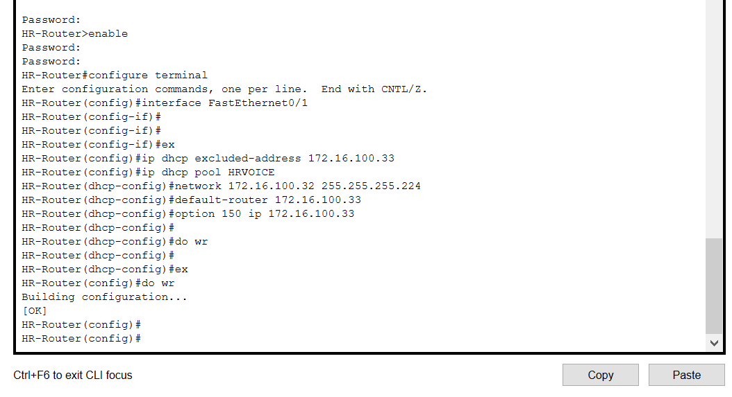

**Inter-VLAN routing on the Routers Plus ip dhcp helper Address**

**OSPF on the Routers**

**Configure Voip Configuration:**

**Dial Peering Configuration:**

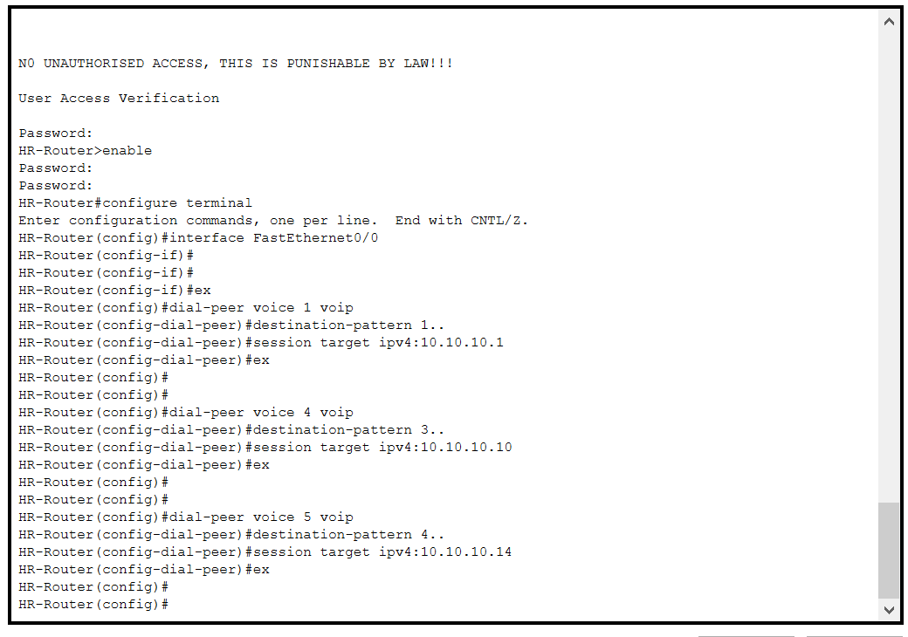

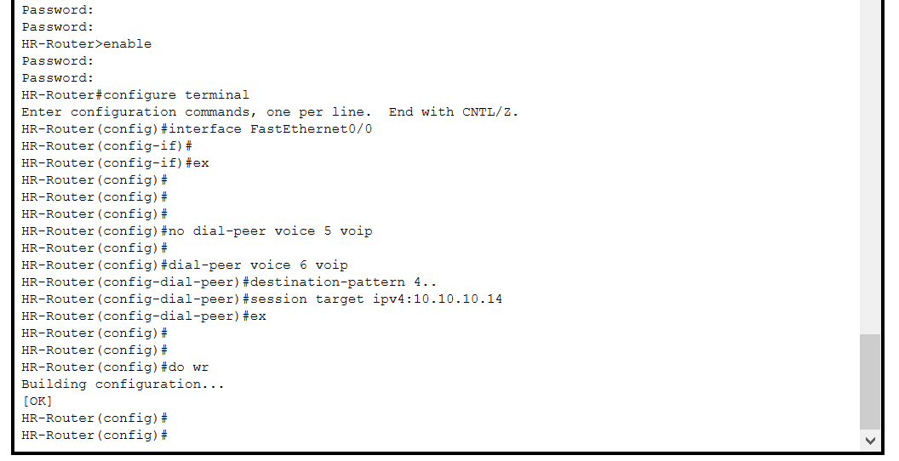

**SALE ROUTER**

en

config t

hostname SALE-Router

enable password cisco

line console 0

password cisco

login

exit

banner motd #N0 UNAUTHORISED ACCESS, THIS IS PUNISHABLE BY LAW!!!#

service password-encryption

no ip domain lookup

do wr

username cisco password cisco

ip domain name cisco.net

crypto key generate rsa general-keys modulus 1024

line vty 0 15

login local

transport input ssh

exit

do wr

**INTERFACES**

**CONFIGURE DHCP FOR VOICE:**

**Inter-VLAN routing on the Routers Plus ip dhcp helper Address**

**OSPF on the Routers**

**Configure Voip Configuration:**

**Dial Peering Configuration:**

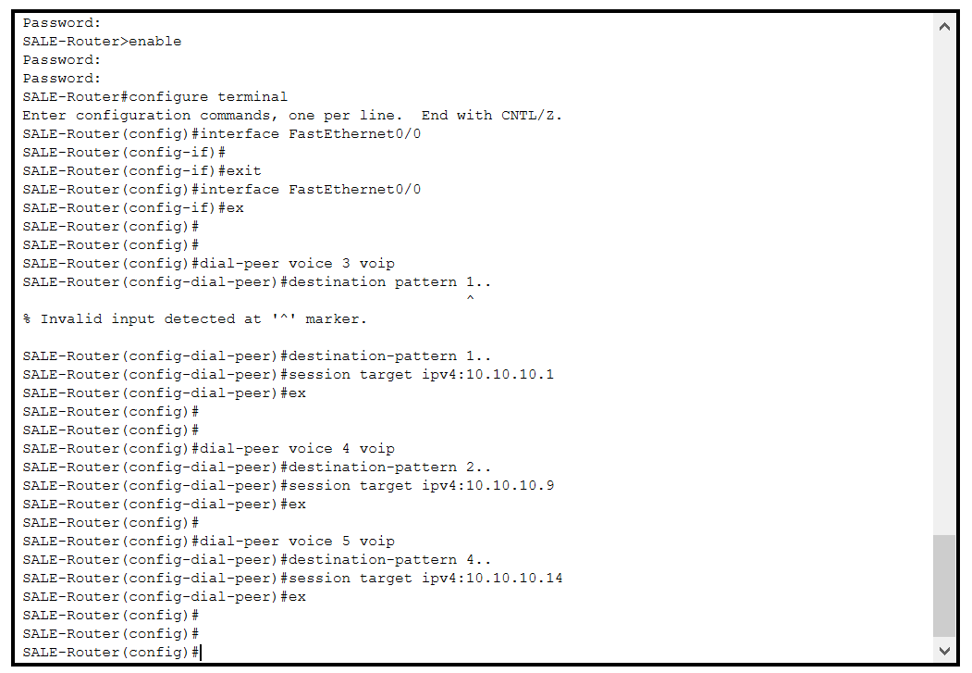

**ICT ROUTER:**

en

config t

hostname ICT-Router

enable password cisco

line console 0

password cisco

login

exit

banner motd #N0 UNAUTHORISED ACCESS, THIS IS PUNISHABLE BY LAW!!!#

service password-encryption

no ip domain lookup

do wr

username cisco password cisco

ip domain name cisco.net

crypto key generate rsa general-keys modulus 1024

line vty 0 15

login local

transport input ssh

exit

do wr

**INTERFACES**

**CONFIGURE DHCP FOR VOICE:**

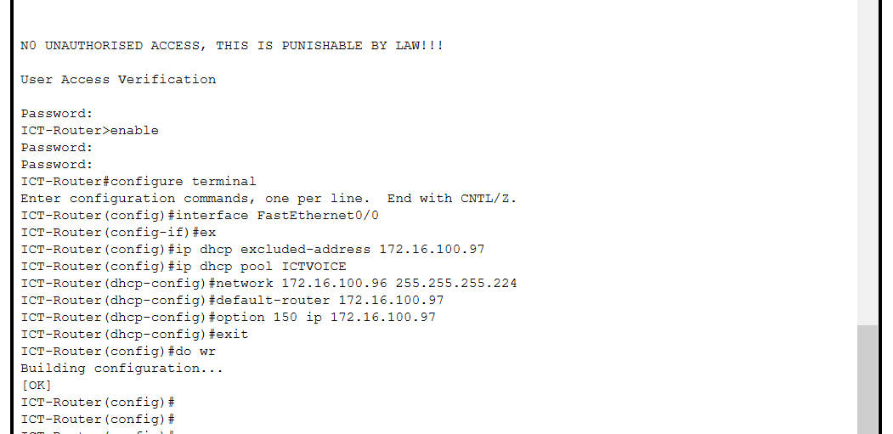

**Inter-VLAN routing on the Routers Plus ip dhcp helper Address**

**Inter-VLAN routing on the Routers Plus ip dhcp helper Address For SERVER**

**OSPF on the Routers**

**Configure Voip Configuration:**

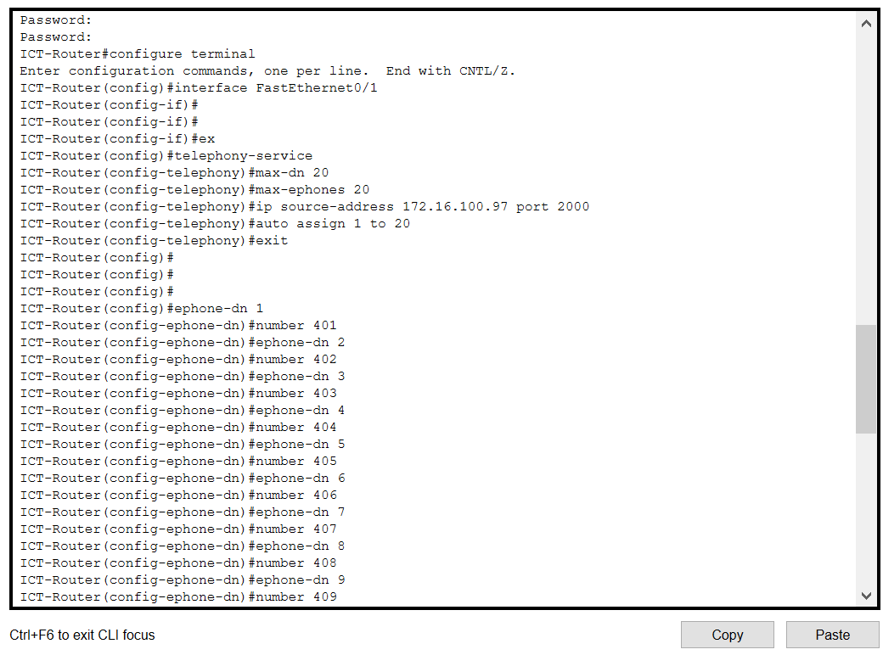

**Dial Peering Configuration:**

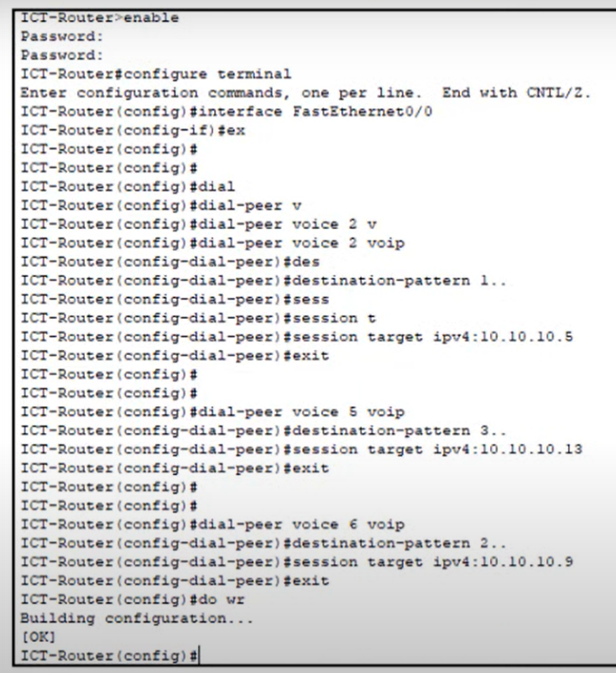

# **REFERENCES**

<https://gurutechnetworks.otombenard.com/assetsProject/project8>