**Finance Switch:**

en

config t

hostname Finance-SW

enable password cisco

line console 0

password cisco

login

exit

banner motd #N0 UNAUTHORISED ACCESS, THIS IS PUNISHABLE BY LAW!!!#

service password-encryption

no ip domain lookup

do wr

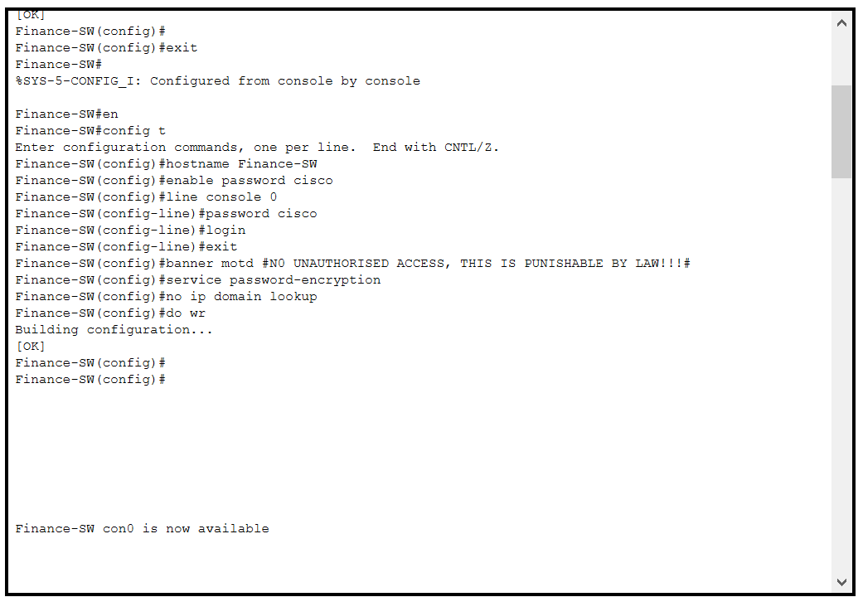

**AFTER BASIC CONFIGURATION:**

vlan 10

name DATA

vlan 100

name VOICE

int fa0/1

switchport mode trunk

exit

int range fa0/2-24

switchport mode access

switchport access vlan 10

switchport voice vlan 100

do wr

**HR Switch:**

en

config t

hostname HR-SW

enable password cisco

line console 0

password cisco

login

exit

banner motd #N0 UNAUTHORISED ACCESS, THIS IS PUNISHABLE BY LAW!!!#

service password-encryption

no ip domain lookup

do wr

**AFTER BASIC CONFIGURATION:**

vlan 20

name DATA

vlan 100

name VOICE

int fa0/1

switchport mode trunk

exit

int range fa0/2-24

switchport mode access

switchport access vlan 20

switchport voice vlan 100

do wr

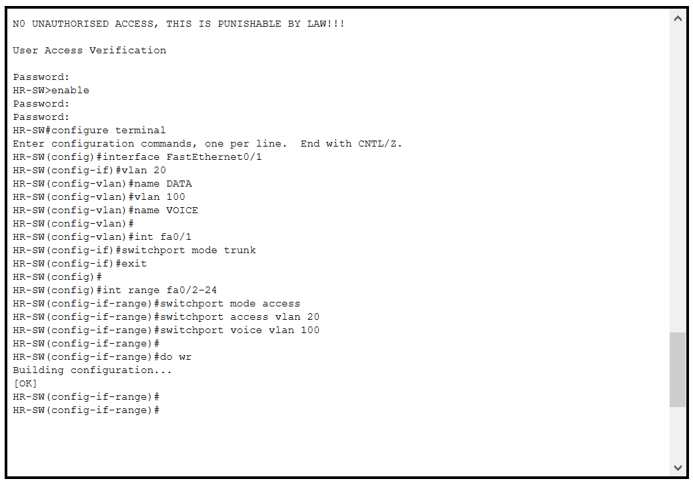

**Sale Switch:**

en

config t

hostname Sale-SW

enable password cisco

line console 0

password cisco

login

exit

banner motd #N0 UNAUTHORISED ACCESS, THIS IS PUNISHABLE BY LAW!!!#

service password-encryption

no ip domain lookup

do wr

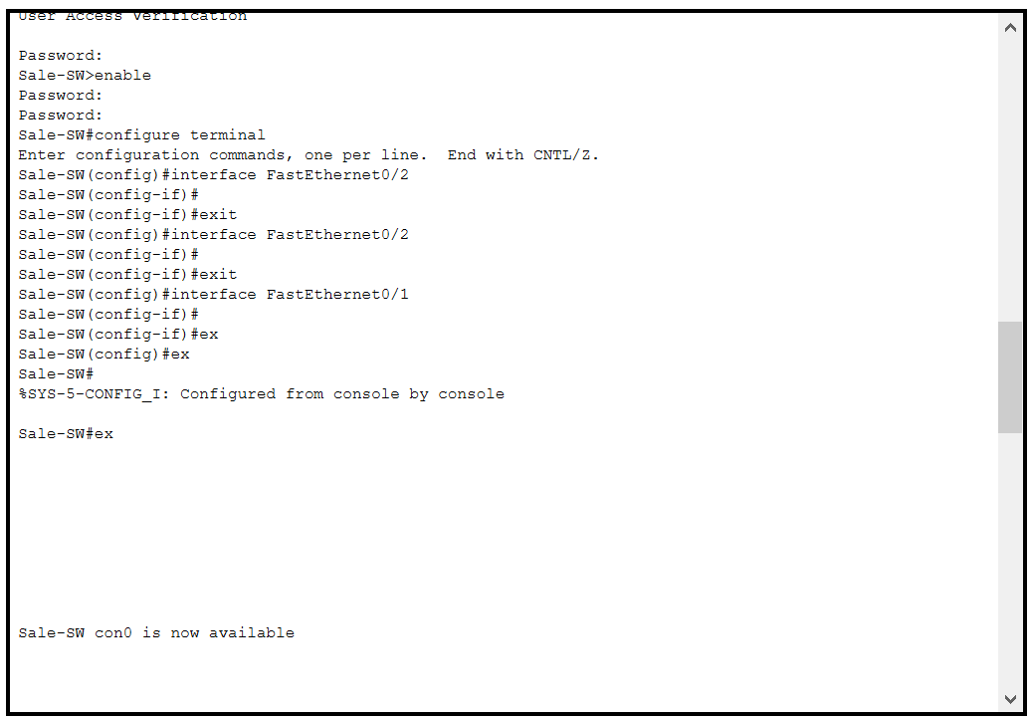

**AFTER BASIC CONFIGURATION:**

vlan 30

name DATA

vlan 100

name VOIC

int fa0/1

switchport mode trunk

exit

int range fa0/2-24

switchport mode access

switchport access vlan 30

switchport voice vlan 100

do wr

**ICT Switch:**

en

config t

hostname ICT-SW

enable password cisco

line console 0

password cisco

login

exit

banner motd #N0 UNAUTHORISED ACCESS, THIS IS PUNISHABLE BY LAW!!!#

service password-encryption

no ip domain lookup

do wr

**AFTER BASIC CONFIGURATION:**

vlan 40

name DATA

vlan 100

name VOICE

int fa0/1

switchport mode trunk

exit

int range fa0/2-24

switchport mode access

switchport access vlan 40

switchport voice vlan 100

do wr

**SERVER SWITCH:**

vlan 40

name DATA

int fa0/1

switchport mode trunk

exit

int range fa0/2-5

switchport mode access

switchport access vlan 50

do wr

**FINANCE ROUTER:**

en

config t

hostname Fin-Router

enable password cisco

line console 0

password cisco

login

exit

banner motd #N0 UNAUTHORISED ACCESS, THIS IS PUNISHABLE BY LAW!!!#

service password-encryption

no ip domain lookup

do wr

username cisco password cisco

ip domain name cisco.net

crypto key generate rsa general-keys modulus 1024

line vty 0 15

login local

transport input ssh

exit

do wr

**INTERFACES**

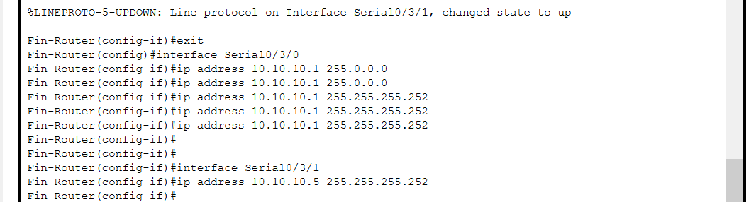

**CONFIGURE DHCP FOR VOICE:**

**Inter-VLAN routing on the Routers Plus Ip dhcp helper Address**

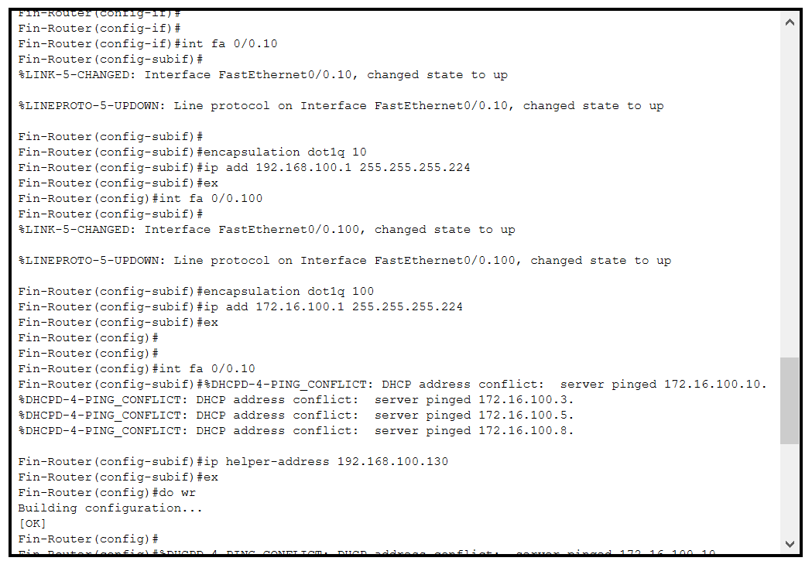

**OSPF on the Routers**

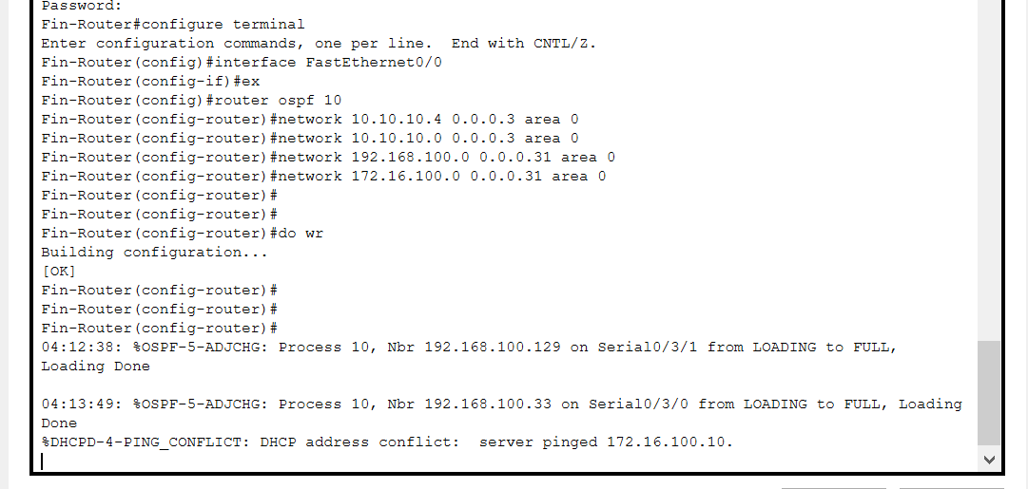

**Configure Voip Configuration:**

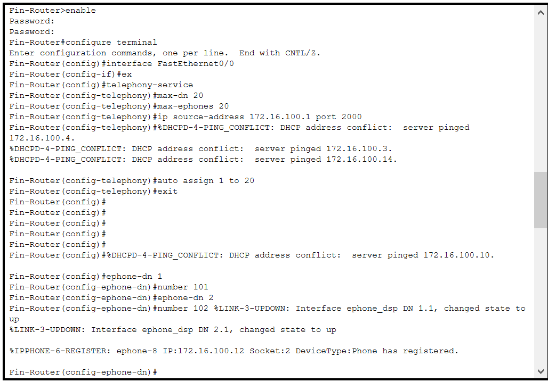 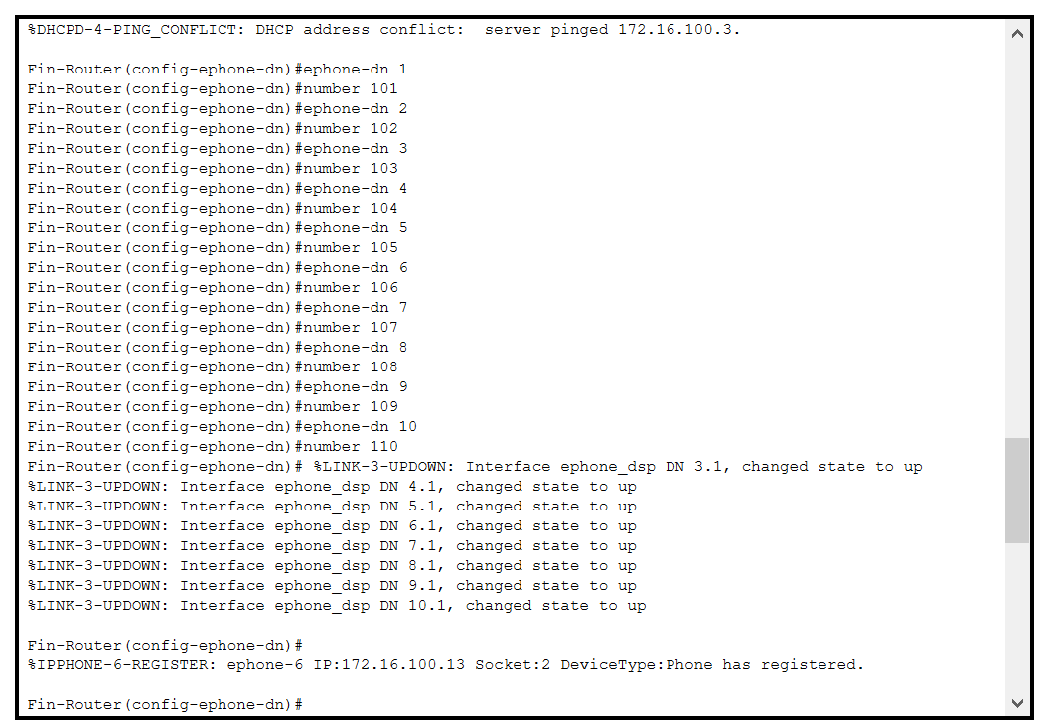

**Dial Peering Configuration:**

**HR ROUTER:**

en

config t

hostname HR-Router

enable password cisco

line console 0

password cisco

login

exit

banner motd #N0 UNAUTHORISED ACCESS, THIS IS PUNISHABLE BY LAW!!!#

service password-encryption

no ip domain lookup

do wr

username cisco password cisco

ip domain name cisco.net

crypto key generate rsa general-keys modulus 1024

line vty 0 15

login local

transport input ssh

exit

do wr

**INTERFACES**

**CONFIGURE DHCP FOR VOICE:**

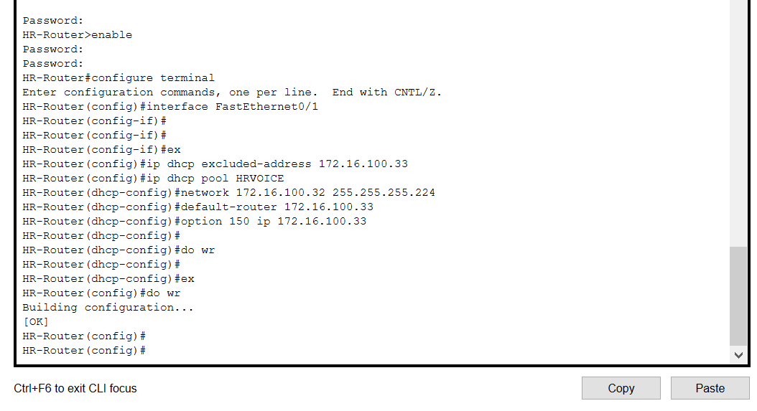

**Inter-VLAN routing on the Routers Plus ip dhcp helper Address**

**OSPF on the Routers**

**Configure Voip Configuration:**

**Dial Peering Configuration:**

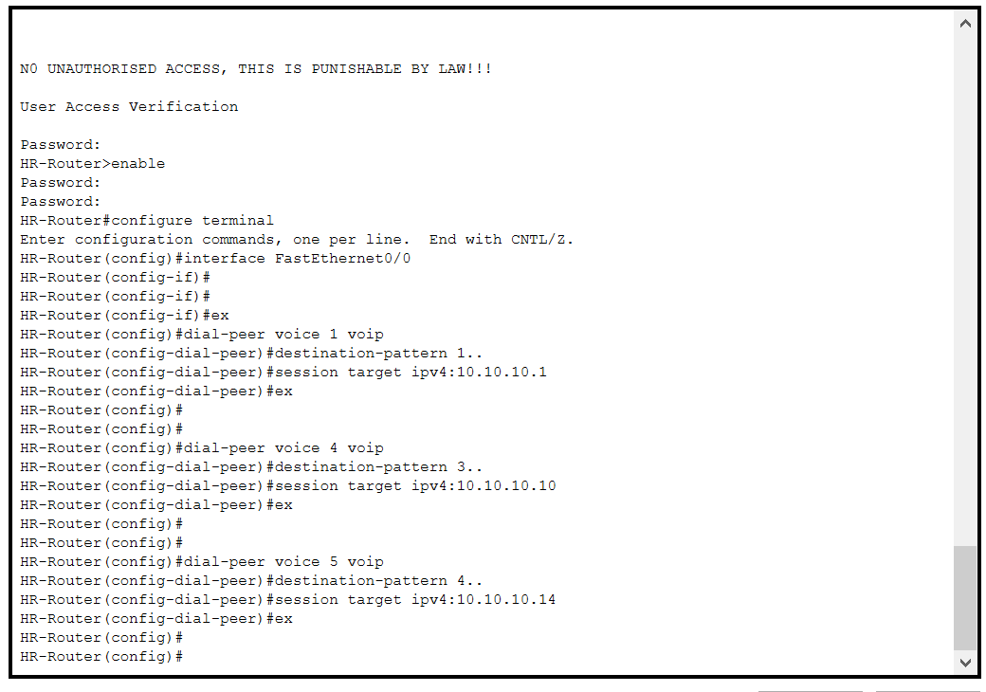

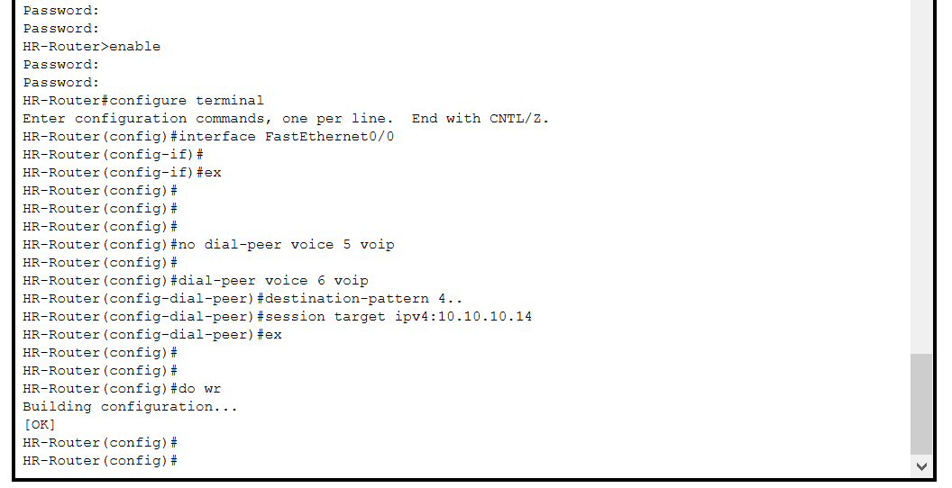

**SALE ROUTER**

en

config t

hostname SALE-Router

enable password cisco

line console 0

password cisco

login

exit

banner motd #N0 UNAUTHORISED ACCESS, THIS IS PUNISHABLE BY LAW!!!#

service password-encryption

no ip domain lookup

do wr

username cisco password cisco

ip domain name cisco.net

crypto key generate rsa general-keys modulus 1024

line vty 0 15

login local

transport input ssh

exit

do wr

**INTERFACES**

**CONFIGURE DHCP FOR VOICE:**

**Inter-VLAN routing on the Routers Plus ip dhcp helper Address**

**OSPF on the Routers**

**Configure Voip Configuration:**

**Dial Peering Configuration:**

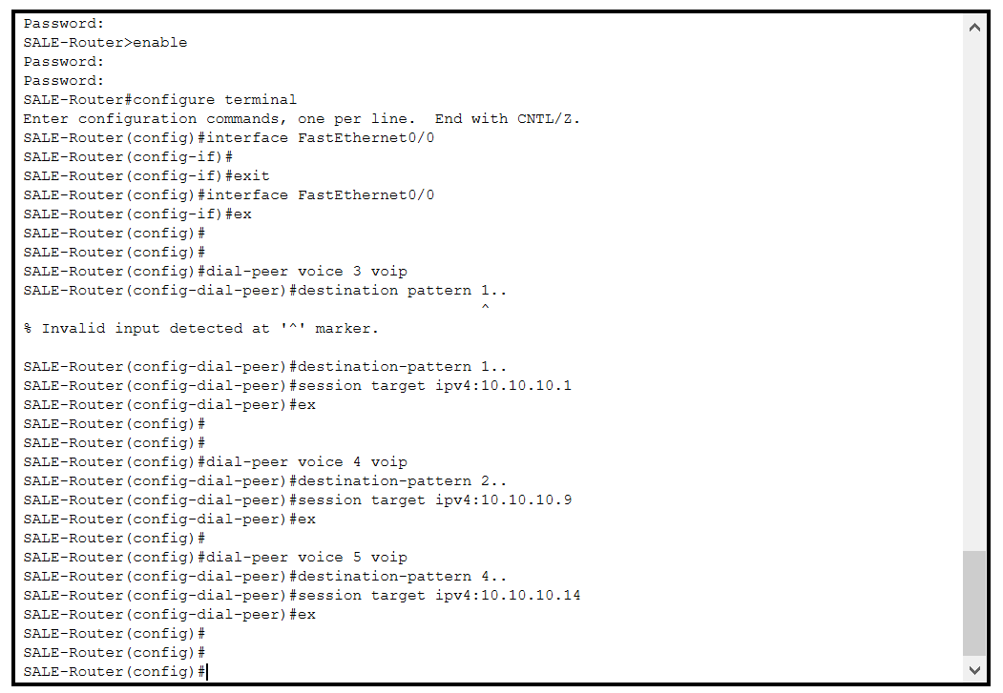

**ICT ROUTER:**

en

config t

hostname ICT-Router

enable password cisco

line console 0

password cisco

login

exit

banner motd #N0 UNAUTHORISED ACCESS, THIS IS PUNISHABLE BY LAW!!!#

service password-encryption

no ip domain lookup

do wr

username cisco password cisco

ip domain name cisco.net

crypto key generate rsa general-keys modulus 1024

line vty 0 15

login local

transport input ssh

exit

do wr

**INTERFACES**

**CONFIGURE DHCP FOR VOICE:**

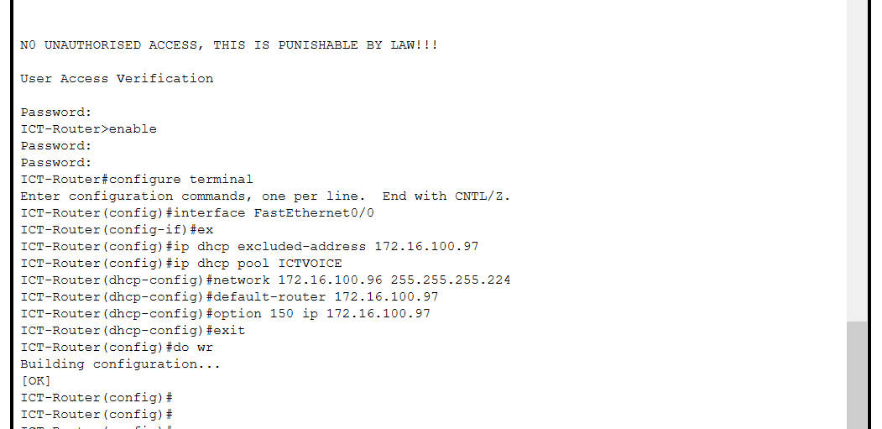

**Inter-VLAN routing on the Routers Plus ip dhcp helper Address**

**Inter-VLAN routing on the Routers Plus ip dhcp helper Address For SERVER**

**OSPF on the Routers**

**Configure Voip Configuration:**

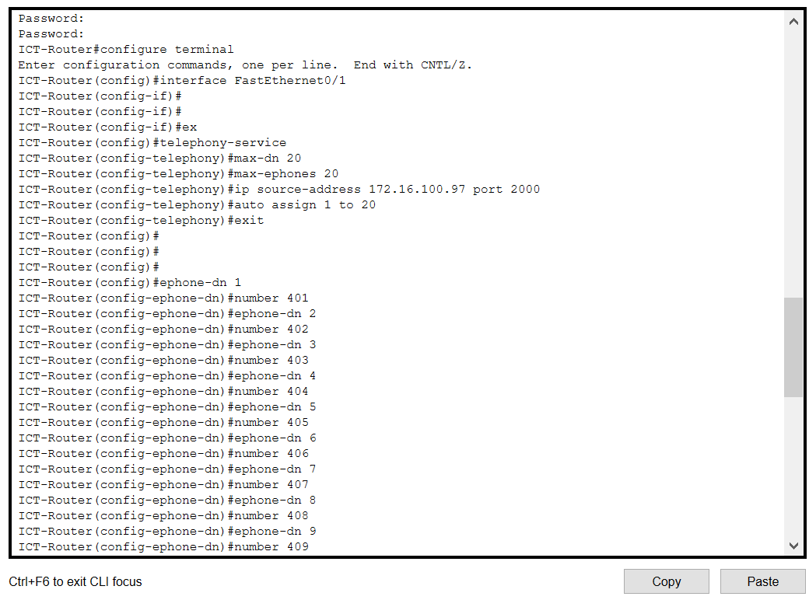

**Dial Peering Configuration:**

