Lecture 10 – SML – Training, Testing, and Classification
Tools & Techniques in Data Science
Date: | 06/10/2026
Instructor: | Mr. Omer Nazeer
Student: | Ahsan Tariq Wattoo
Roll No: | F24BDOCS1M01061

1. Lecture Overview
In this lecture we covered:
Table of Contents
1. Lecture Overview 1
2. Key Concepts 1
Dataset 1
Optimizing Metric 1
Loss Function 2
Training Error and Test Error 2
Dividing the Dataset into 3 Categories 2
What is Classification? 2
Training Steps (same as regression) 3
Evaluation Metrics 3
Accuracy 3
Precision 3
Recall 3
3. Code / Practical Examples 4
4. Summary 5

2. Key Concepts

Dataset
Our simple house dataset (same as before, a bit bigger)
Area (marla) | Rooms | Price (lakhs)
3 | 2 | 25
4 | 2 | 31
5 | 3 | 35
6 | 3 | 41
7 | 3 | 45
8 | 4 | 52
10 | 4 | 60
12 | 5 | 72

Optimizing Metric
The score we want to make as good as possible while training, like a student whose goal is to get the highest marks. For regression we want the lowest error (like RMSE), and for classification we want the highest accuracy.

Loss Function
It measures how wrong the model is while it is learning. The computer keeps changing the coefficients to make this number smaller, like a teacher who tells the student "you lost 5 marks here, fix it." For regression, MSE is a common loss function.
Simple difference: the loss function is used by the computer to learn, and the optimizing metric is used by us to judge the final model.

Training Error and Test Error
- Training error: the mistakes the model makes on the data it studied. It is like marks on practice questions.
- Test error: the mistakes it makes on new, unseen data. It is like marks in the real exam.
The test error is the one that matters most. If the training error is very low but the test error is high, the model has overfitted, which means it memorized the book but can't solve new questions.

Dividing the Dataset into 3 Categories
Say we have 100 houses. We divide them into three parts:
Dataset | Share | Purpose | Real-life example
Training | 60 houses | The model learns from it | Studying from the book
Validation | 20 houses | We check and tune the model during training | A practice test before the exam
Test | 20 houses | Final check, used only once | The final exam
The test set stays hidden until the very end, so we get an honest result. (In sklearn, we can use train_test_split() twice to make three parts.)

What is Classification?
Classification is supervised learning where the answer is a category (Yes/No), not a number. Instead of asking "What is the price?", we ask "Is this house expensive? Yes or No". It is like sorting fruits into "ripe" and "not ripe" baskets.
Our classification dataset (Expensive = Yes if the price is above 40 lakhs):
Area | Rooms | Price | Expensive? (label)
3 | 2 | 25 | No
5 | 3 | 35 | No
7 | 3 | 45 | Yes
10 | 4 | 60 | Yes

Training Steps (same as regression)
It is the same training way as before:
- Take labelled data (houses with the Yes/No answer)
- Split it with train_test_split()
- Train with model.fit()
- Predict with model.predict()
- Check the mistakes on test data using the evaluation metrics
Only the model and the metrics change.

Evaluation Metrics
First we need four terms. Say the model predicts "Is the house expensive?" for 10 houses:
Term | Meaning | Example | Count
TP (True Positive) | Predicted Yes, actually Yes | Said expensive, and it was expensive | 4
TN (True Negative) | Predicted No, actually No | Said cheap, and it was cheap | 3
FP (False Positive) | Predicted Yes, actually No | Said expensive, but it was cheap | 1
FN (False Negative) | Predicted No, actually Yes | Said cheap, but it was expensive | 2
Easy trick: the second word (Positive/Negative) is what the model predicted, and the first word (True/False) tells if the model was right or wrong.

Accuracy
Out of all houses, how many did the model get right?
Accuracy = (TP + TN) / (TP + TN + FP + FN)
= (4 + 3) / 10 = 0.70 (70%)

Precision
When the model says "Yes", how often is it really Yes? It is like a friend who says "this movie is great" and you check how often he is right.
Precision = TP / (TP + FP)
= 4 / (4 + 1) = 0.80 (80%)

Recall
Out of all the really expensive houses, how many did the model find? It is like a metal detector, and we check how much of the hidden gold it found.
Recall = TP / (TP + FN)
= 4 / (4 + 2) = 0.67 (67%)

3. Code / Practical Examples
Linear Regression Code Examples using sklearn function sir explained
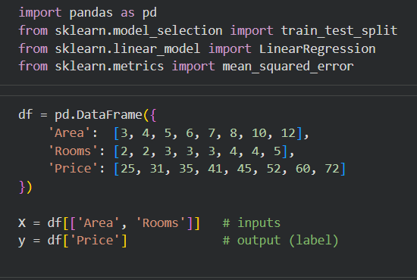

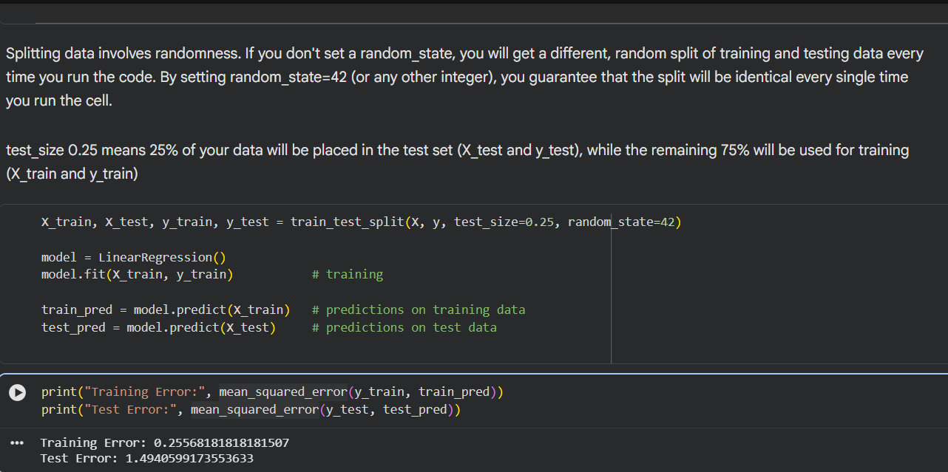

4. Summary
In short, we split our data into training, validation and test sets. Then we use model.fit() to train, and the loss function guides the model to learn better. After that, model.predict() gives the answers, and we compare the training error with the test error to check for overfitting. When the answer is a number, we use regression, and when it is a category, we use classification (Logistic Regression), which we judge using Accuracy, Precision and Recall.

