Lecture No 05 – Histogram & Centering & Scaling (Data Normalization)
Tools & Techniques in Data Science
Date: | 21/09/2026
Instructor: | Mr. Omer Nazeer
Student: | Ahsan Tariq Wattoo
Roll No: | F24BDOCS1M01061

1. Lecture Overview
In this lecture, we covered basic histogram and Data Normalization (Centering & Scaling).

2. Key Concepts

Histogram
We take a basic dataset of marks as an example to work on.
0,15,42,50,50,50,50,60,60,70,70
Here we have made a histogram in this section : 3. Code / Practical Examples

Centering & Scaling
We take a common example of regression (House price Prediction)
Area | Rooms | Price
2400 | 6 | 15000000
3600 | 5 | 12000000
4000 | 8 | 9000000
3000 | 6 | 8500000
6000 | 7 | 2000000
Goal: To prepare this dataset for our ML Model.
Method: Reduce the difference between column values like difference between price and rooms is very high. So we have to reduce it by using some techniques.
There are three main formulas for centering & Scaling:
- x/x_{max}
- (x - x_{min}) / (x_{max} - x_{min})
- Z-Score (Mostly Used) (x – mean) / (Standard Deviation)
Variance:
Average of the distance between data and the mean.
σ² = Σ(xᵢ − μ)² / N
Standard Deviation:
Square root of Variance.
σ = √[ Σ(x − μ)² / N ]
Linear Regression (multi-variant):
Linear regression is a supervised learning algorithm used to model the relationship between independent variables (inputs) and a dependent variable (output). It assumes a linear relationship, where the output changes at a constant rate with respect to the input.
Y = a_{o} + a₁x₁ + a₂x₂
Here, x1 and x2 are variables like Rooms and Area of this example dataset. A_{o,} a_{1,} a₂ are coefficients that are unknown, and we have to guess them first and then improve to train our model in linear regression. The better these coefficients are, the better our model training will be.

3. Code / Practical Examples
- Go to Google Colab
- Watch this tutorial if you don’t know how to use google colab How to Use GOOGLE COLAB | Google Colab Tutorials for Beginners | GeeksforGeeks - YouTube
- Make a new Python Notebook there
- Upload your marks.csv file from here
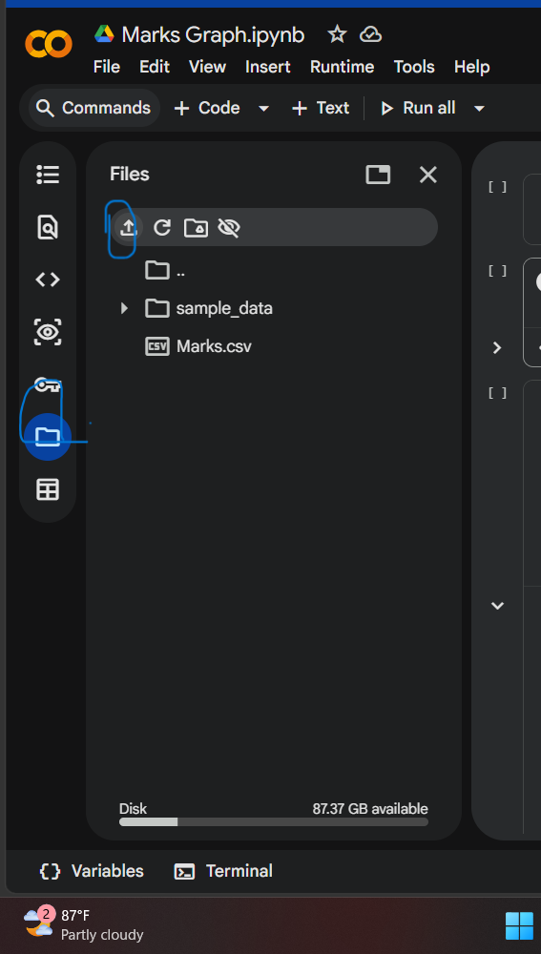
Figure 1 - Upload the file
- Write this code and run the cells one by one to make a histogram

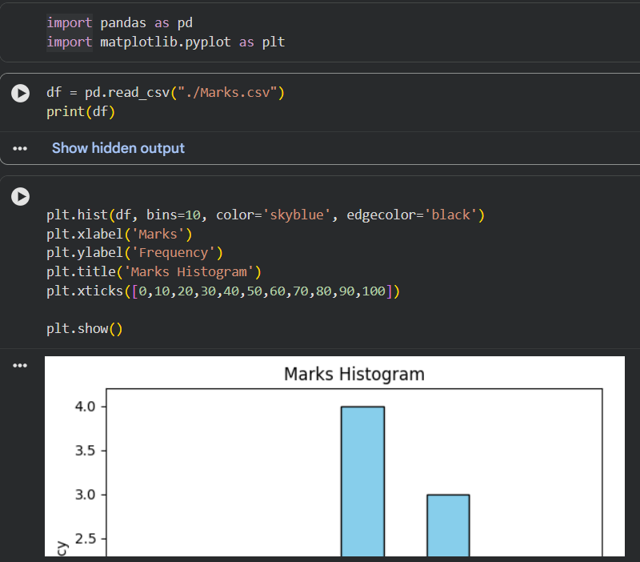
Figure 2 – The code of the histogram

4. Important Points
- If the denominator of the formula of variance or std. deviation has (n-1), it means we are working with a sample.

