Lecture 3 – Data Preprocessing Step – Categorical to Numeric Data
Tools & Techniques in Data Science
Date: | 14/09/2026
Instructor: | Mr. Omer Nazeer
Student: | Ahsan Tariq Wattoo
Roll No: | F24BDOCS1M01061

1. Lecture Overview
This lecture covers some general information about AI terms and the third step of Data Preprocessing – Categorical to Numeric Data.

2. Key Concepts
- Assignment: Research different AI platforms thoroughly, explore their features, and create an MS Word Report writing details of their features. Platforms like ChatGPT, Anthropic’s Claude, Google AI Studio, and DeepSeek.
- Learn to use MS Excel and MS Word basics.
- Categorical to Numeric Data
  - There are two types of data: categorical and Numerical. In Data Science, we are sometimes in a situation where we want some numeric presentation of the categorical data we have like if a student has grade A, we can represent it by 1 in our data.
  - One-Hot Encoding - Working of One-Hot Encoding
  - One-Hot Encoding creates a separate column for each category in the dataset. In the fruit example, when the fruit is Apple, the Fruit_Apple column gets the value 1 while the other fruit columns contain 0. Similarly, for Mango and Orange, their respective columns contain 1 and the remaining columns contain 0.
  - -Each category gets its own binary column
  - -1 indicates the presence of a category
  - -0 indicates the absence of a category
  - -Converts categorical values into numerical format for machine learning models
  - 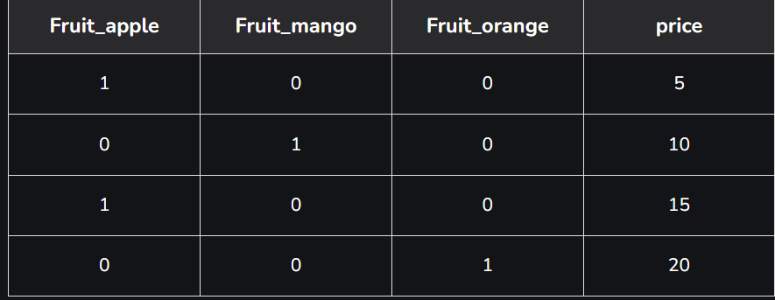

3. Important Points
- Use AI Tools and their features intelligently.
- Improve your technical vocabulary and general knowledge of Computer Science

