Lecture 6 – Data Normalization & EDA
Tools & Techniques in Data Science
Date: | 22/09/2026
Instructor: | Mr. Omer Nazeer
Student: | Ahsan Tariq Wattoo
Roll No: | F24BDOCS1M01061

1. Lecture Overview
This lecture will cover:
- Z-Score
- EDA
  - Scatter Plot
  - Box Plot

2. Key Concepts

Z-Score
A z-score tells you how far a value is from the average, measured in standard deviations.
In plain words: "Is this value normal, above average, or below average, and by how much?"
Formula:
(x – mean) / Standard Deviation
- Centering: subtract the mean (x − mean), so the mean becomes 0.
- Scaling: divide by the standard deviation, so the spread becomes 1.

Standard Deviation: Standard deviation tells us, on average, how far the values are from the mean of the column

Why Z-Score?
In many datasets on which we work in data science, Different columns have different ranges of values like rooms column have values 2,3,4,5,etc. But the price column has values in crores. So this difference can cause poor training of the ML model.

What happens after applying Z-Score?
After applying Z-score on a dataset, it centers and scales the values so that the column has a mean close to 0 and variance close to 1 while maintaining the original meaning of the data in that column. So this helps in better model training.

EDA:
EDA is the step where we explore and understand the dataset before building a model, using summary statistics and graphs.

Scatter Plot
What it is: A graph that plots two numerical variables as points, one on the X-axis and one on the Y-axis.
Used for:
- Seeing the relationship/correlation between two variables (positive, negative, or none)
- Spotting outliers
Example: Rooms vs Price. If more rooms means a higher price, the points trend upward (positive correlation).

Box Plot
What it is: A graph that summarizes a single numerical column using five numbers (the five-number summary):
- Minimum
- Q1 (25th percentile)
- Median (middle value, the line inside the box)
- Q3 (75th percentile)
- Maximum
Used for:
- Detecting outliers
- Seeing the spread and skewness of data
- Comparing distributions of different columns

3. Code / Practical Examples

Scatter Plot

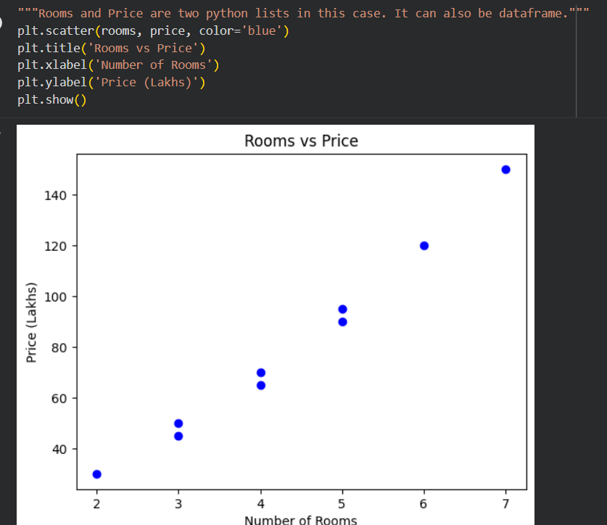
Figure 1 - Scatter Plot

Box-Plot

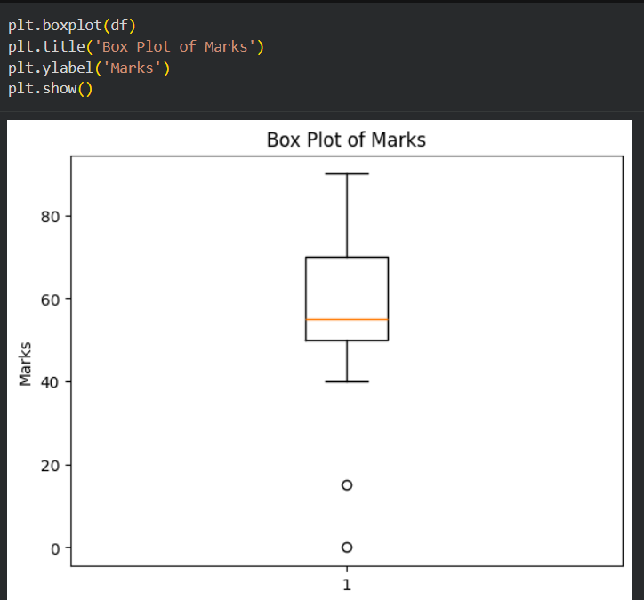
Figure 2 - Box Plot

