Lecture 7 – EDA and Its Types
Tools & Techniques in Data Science
Date: | 28/09/2026
Instructor: | Mr. Omer Nazeer
Student: | Ahsan Tariq Wattoo
Roll No: | F24BDOCS1M01061

1. Lecture Overview
In this lecture we will cover:
- EDA
  - Numeric EDA
  - Visual EDA
- 4 Pandas Functions

2. Key Concepts

EDA
EDA is the process of exploring and understanding a dataset using summary statistics and graphs before building a model. It helps us find patterns, outliers, missing values and relationships between columns. It has following two types:

Numeric EDA
Summarizes data using numbers instead of graphs.
Common measures:
- Central tendency: mean, median, mode
- Spread: range, variance, standard deviation, IQR
- Shape: skewness
- Others: count, min, max, missing values, correlation
Example: finding the average price, or the correlation between rooms and price.

Visual EDA
Summarizes data using graphs, which make patterns and outliers easy to see.
Common plots:
- Histogram: distribution of one numeric column
- Box plot: spread and outliers
- Scatter plot: relationship between two numeric columns
- Bar graph: comparing categories

Pandas Functions

Function | Purpose
df.head() | Shows the first 5 rows. Gives a quick look at the data.
df.tail() | Shows the last 5 rows.
df.info() | Shows the structure: number of rows/columns, column names, data types, and non-null counts (helps find missing values).
df.describe() | Shows summary statistics of numeric columns: count, mean, std, min, 25%, 50%, 75%, max.

3. Code / Practical Examples
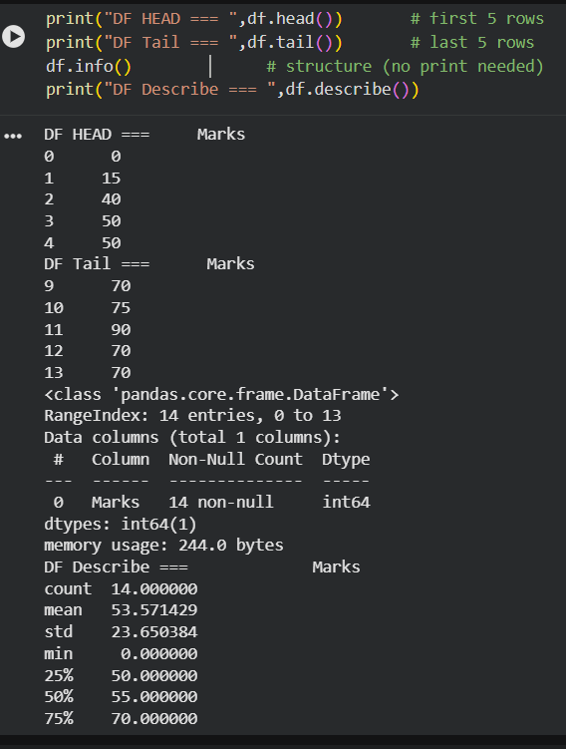
Figure 1 - Pandas Functions

