Table of Contents

Budget Execution Report
Fiscal Year 2023-24
December 2023

Foreword
This Budget Execution Report (BER) provides a comprehensive overview of the Government of Punjab’s fiscal performance for the 2023-24 fiscal year. Prepared in accordance with the Punjab Public Financial Management Act 2022, Section-41, this report fulfills a legal obligation for transparent and accountable financial reporting. The BER serves as a critical tool for analyzing the government’s financial performance by directly comparing actual revenue and expenditure against the budgeted figures. This comparative analysis enables a thorough assessment of budgetary effectiveness, identifies any deviations from planned allocations, and provides valuable insights for improved resource allocation and more informed fiscal decision-making in future budget cycles. This report underscores the government’s commitment to transparency and accountability in public financial management.

Macroeconomic Assumptions
Macroeconomic Assumptions for FY 2023-24
- Overview: The macroeconomic environment for FY 2023-24 presents a complex landscape shaped by various internal and external factors. This report’s analysis of key macroeconomic indicators provides context for understanding the fiscal planning and execution for the current fiscal year. A detailed examination of GDP and inflation, based on available data, is crucial for interpreting the economic backdrop against which the budget is being executed.
- GDP Analysis: The nominal GDP for the preceding fiscal year reached 83,995.00. This figure serves as a baseline for evaluating economic growth in FY 2023-24. A larger GDP suggests a greater overall economic output, which can positively influence government revenue streams and provide greater fiscal space for expenditure. Conversely, any slowdown in GDP growth compared to the previous fiscal year could necessitate adjustments to budgetary allocations and fiscal strategies. Further analysis correlating this GDP figure with other economic data, such as employment and investment, is necessary for a comprehensive understanding of the current economic momentum.
- Inflation Analysis: The inflation rate in the previous fiscal year stood at 29.20%. This level of inflation has significant ramifications for purchasing power, monetary policy, and government finances. A high inflation rate erodes the real value of incomes and savings, potentially impacting consumer spending and overall economic activity. It also presents challenges for monetary policy, often leading to adjustments in interest rates to control inflation. Furthermore, high inflation can affect government finances by increasing the cost of goods and services procured by the public sector. Understanding the underlying drivers of this inflation rate and forecasting its trajectory for FY 2023-24 is essential for effective fiscal management.
- Trends and Outlook: A comprehensive assessment of current macroeconomic conditions requires a comparative analysis with historical data for these indicators. Examining trends in GDP growth and inflation over previous years can reveal underlying economic patterns and inform projections for the current fiscal year. For example, a consistent upward trend in GDP growth would suggest a positive economic outlook, while a sustained high inflation rate could signal potential challenges for fiscal stability. Understanding these historical trends is crucial for making informed fiscal decisions and ensuring that the budget is aligned with the prevailing economic realities of FY 2023-24.
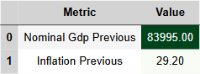
Table for Macroeconomic Assumptions

Analysis of Receipts - 3.1.1 Provincial General Revenue Receipts
Provincial General Revenue Receipts (FY 2023-24)
- General Overview of Provincial General Revenue Receipts
General Revenue Receipts (GRR) constitute a cornerstone of the provincial budget, providing the financial resources necessary to fund essential public services and investments. A robust GRR base is crucial for maintaining fiscal stability and ensuring the government’s capacity to meet its spending obligations. The three primary components of GRR are the Federal Divisible Pool (FDP), Provincial Tax Revenue, and Provincial Non-Tax Revenue. Historically, revenue trends have played a significant role in shaping fiscal policy, influencing decisions on public expenditure, debt management, and overall economic development strategy. Understanding these historical patterns is crucial for effective budget planning and execution.
- Performance vs. Budget Targets
In FY 2023-24, the province’s actual GRR collection presented a mixed picture when compared to the budget estimates. While certain revenue streams exhibited positive growth, others fell short of projected targets, necessitating a thorough analysis of the underlying factors. The FDP, a crucial component of provincial finances, recorded a year-over-year growth of 0.24% against the budgeted target, reaching Rs. 2560.63 billion. However, this figure represents only 94.61% achievement of the budgetary target. Provincial tax revenue also experienced slower-than-anticipated growth, registering a 0.10% increase compared to the previous fiscal year, achieving 86.79% of the projected target with actual collections of Rs. 341.54 billion. In contrast, provincial non-tax revenue demonstrated stronger performance, achieving a year-over-year growth of 0.32% and reaching Rs. 153.39 billion. While this growth is encouraging, it only constitutes 66.17% of the budgeted target. These variations in revenue performance highlight the complex interplay of economic conditions, policy decisions, and administrative efficiency in influencing revenue outcomes.
- Analysis of Key Indicators
The Federal Divisible Pool (FDP) reached Rs. 2560.63 billion in FY 2023-24, falling short of the target of Rs. 2706.41 billion but exceeding the previous year’s collection of Rs. 2065.15 billion. Provincial Tax Revenue stood at Rs. 341.54 billion, against a target of Rs. 393.51 billion and a previous year’s figure of Rs. 309.69 billion. Provincial Non-Tax Revenue amounted to Rs. 153.39 billion, compared to a target of Rs. 231.81 billion and a previous collection of Rs. 115.97 billion. Total GRR reached Rs. 3055.56 billion, against a target of Rs. 3331.72 billion and a previous year’s figure of Rs. 2490.82 billion. The FDP shortfall of Rs. -1088.78 billion is a significant concern that requires in-depth analysis and corrective measures. Comparing these figures with historical performance and trends reveals the extent to which current economic conditions and policy implementations have influenced revenue outcomes.
- Causes and Implications
Several factors may have contributed to the deviation of FDP revenue from expectations, including macroeconomic volatility, fluctuations in national revenue collection, and potential adjustments in the resource distribution formula. Regarding provincial tax revenue, the realism of the collection targets needs further examination, considering the actual economic growth and taxpayer compliance patterns. The impact of any recent tax reforms or enforcement initiatives on revenue collection should also be assessed. Challenges in provincial non-tax revenue collection could stem from various factors, including changes in user fees, royalty rates, or the performance of government-owned enterprises. Shifts in policy related to the delivery of public services and resource management could also have played a role. The observed revenue performance has direct implications for government spending plans, potentially necessitating adjustments in budgetary allocations across various sectors. Future fiscal planning must incorporate lessons learned from this year’s revenue performance to ensure more accurate projections and effective resource allocation.
- Future Outlook and Policy Considerations
Projecting revenue trends for the next fiscal year requires careful consideration of macroeconomic forecasts, planned policy changes, and potential external shocks. Expected policy adjustments aimed at improving revenue collection might include strengthening tax administration, streamlining non-tax revenue streams, and exploring new avenues for resource mobilization. Potential risks that could impact future revenue performance include economic downturns, tax evasion, administrative inefficiencies, and unforeseen changes in intergovernmental fiscal arrangements. These factors need to be integrated into budget planning processes to enhance resilience and ensure the sustainable delivery of public services.
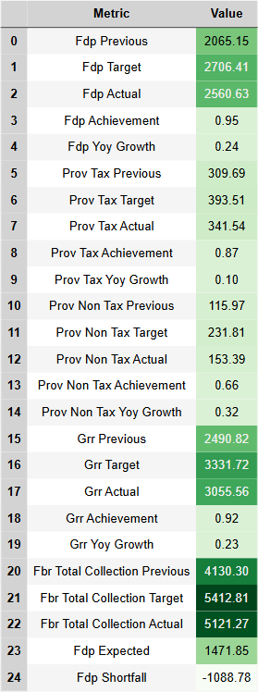
Table for Analysis of Receipts - 3.1.1 Provincial General Revenue Receipts
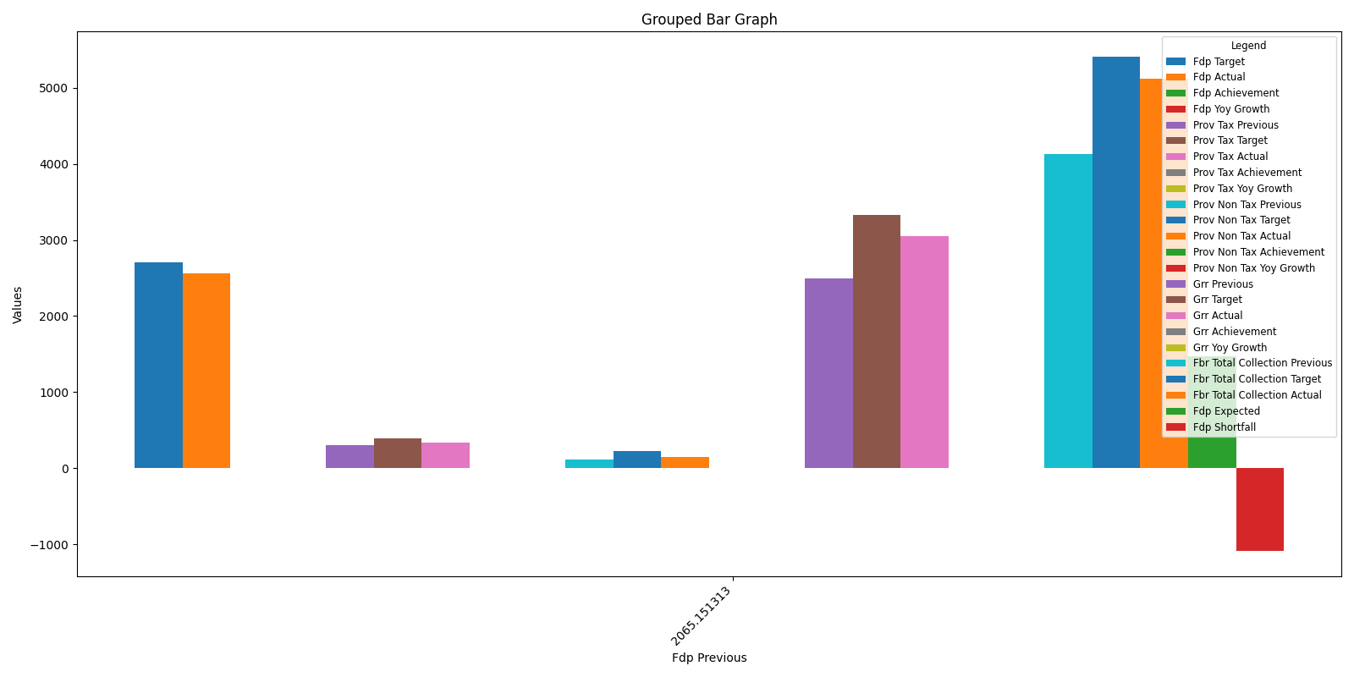
Bar Graph for Analysis of Receipts - 3.10.1 Provincial General Revenue Receipts

Analysis of Receipts - 3.1.1.A Provincial Tax Revenue

Provincial Tax Revenue: FY 2023-24
1. Overview of Provincial Tax Revenue
Provincial Tax Revenue is the cornerstone of Punjab’s fiscal capacity, providing the resources necessary for public services and infrastructure development. This revenue stream is vital for funding essential programs, supporting economic growth, and maintaining fiscal stability. Three primary contributors dominate the provincial tax landscape: the Punjab Revenue Authority (PRA), the Board of Revenue (BOR), and the Excise, Taxation & Narcotics Control Department (ET&NCD). Each entity plays a distinct role, collectively forming the backbone of provincial revenue generation. The FY 2023-24 budget execution analysis reveals critical insights into the performance of these contributors and the overall health of provincial tax revenue. While the total provincial tax revenue saw a positive year-over-year growth, achieving 86.79% of the budgeted target necessitates a deeper examination of the individual components and contributing factors.
2. Performance vs. Budget Targets
The actual tax collection for FY 2023-24 was compared against the budget estimates to assess the effectiveness of revenue mobilization efforts. A detailed analysis considering year-over-year (YoY) growth is crucial for evaluating performance and identifying areas for improvement. Further context is provided by comparing the current YoY growth with the 5-year average growth rate (data not provided). The overall provincial tax revenue achieved 86.79% of the budget target. Breaking down the performance of individual contributors, the PRA achieved 95.88% of its target, the BOR achieved 67.15%, and the ET&NCD achieved 95.92%. This variance in performance across different revenue streams underscores the need for a deeper investigation into factors influencing tax collection efficiency and the impact of any policy changes implemented during the fiscal year.
3. Analysis of Key Indicators
Total Provincial Tax Revenue reached Rs. 341.54 billion against a target of Rs. 393.51 billion. This represents a YoY growth of 10.28% compared to the previous year’s collection of Rs. 309.69 billion. The PRA contributed Rs. 230.11 billion against a target of Rs. 240 billion. The BOR contributed Rs. 66.62 billion against a target of Rs. 99.20 billion. The ET&NCD contributed Rs. 43.64 billion against a target of Rs. 45.50 billion. The Transport sector contributed Rs. 0.96 billion against a target of Rs. 1.21 billion. Comparing these figures to historical performance and trends (data not provided) will offer a comprehensive understanding of long-term revenue patterns and inform future projections.
4. Causes and Implications
Analyzing the contributing factors behind the PRA’s performance, whether it exceeded or fell short of expectations, is essential for refining revenue strategies. Regarding the Board of Revenue, it is crucial to determine whether property taxes met expectations and assess the impact of any legal or policy changes affecting revenue streams. For the Excise & Taxation Department, understanding whether tax compliance improved and whether there were enforcement issues or tax rate adjustments is key to evaluating its performance. The observed tax trends and their implications must be carefully considered for future fiscal policy planning, ensuring alignment between revenue projections and expenditure requirements.
5. Future Outlook and Policy Considerations
Projecting trends for provincial tax collection in the next fiscal year requires a thorough assessment of current economic conditions and potential policy changes. Proposed reforms aimed at enhancing tax revenue collection should be detailed and their potential impact quantified. Identifying potential risks that could impact future tax revenue, such as economic downturns, policy shifts, or enforcement challenges, is crucial for developing mitigation strategies and ensuring fiscal resilience. A proactive approach to risk management and a commitment to continuous improvement in tax administration will be critical for achieving sustainable revenue growth in the coming years.
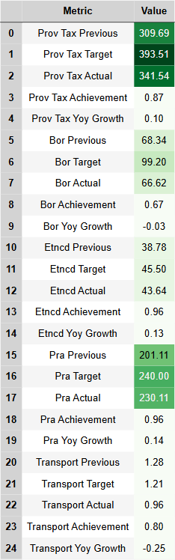
Table for Analysis of Receipts - 3.1.1.A Provincial Tax Revenue
Bar Graph for Analysis of Receipts - 3.10.1.A Provincial Tax Revenue
Bar Graph for Analysis of Receipts - 3.10.1.A Provincial Tax Revenue

Analysis of Receipts - 3.1 Total Provincial Receipts

Analysis of Receipts: Total Provincial Receipts (TPR) for FY 2023-24
1. Overview of Total Provincial Receipts (TPR)
Total Provincial Receipts (TPR) represent the aggregate revenue inflows accruing to the provincial government during a fiscal year. These receipts are crucial for funding public services and development initiatives. TPR comprises two primary components: General Revenue Receipts (GRR) and Total Capital Receipts. GRR encompasses resources derived from the Federal Divisible Pool, provincial taxes (e.g., sales tax on services, property tax), and non-tax revenue (e.g., fees, fines, and permits). Total Capital Receipts include inflows from domestic loans, recoveries of disbursed loans, and borrowings specifically allocated for State Trading enterprises. Historically, GRR has constituted the larger share of TPR, reflecting the province’s dependence on shared federal resources and its own tax base. Analysis of historical trends reveals the evolving composition of TPR, influenced by factors such as federal-provincial fiscal arrangements, economic growth, and provincial tax policy. Understanding the historical context is essential for interpreting current year performance and projecting future revenue streams. The budgeted versus actual performance of these components provides a critical assessment of the province’s revenue mobilization efforts and their alignment with fiscal targets. Expected growth, based on budgetary projections and economic forecasts, informs resource allocation decisions and policy adjustments.
2. Performance vs. Budget Targets
The actual revenue performance for FY 2023-24 is analyzed against the initial budget estimates to assess the effectiveness of revenue collection mechanisms and the accuracy of revenue projections. For GRR, the actual receipts of Rs. 3055.56 billion compare to a budgeted target of Rs. 3331.72 billion, representing an achievement of 91.71%. Capital receipts totaled Rs. 610.46 billion against a target of Rs. 1148.94 billion, reflecting a 53.13% achievement rate. Consequently, TPR reached Rs. 3666.02 billion against a budgeted target of Rs. 4480.67 billion, resulting in an overall achievement of 81.82%. Deviations from budgeted targets warrant detailed investigation. Factors contributing to revenue shortfalls or overperformance may include macroeconomic conditions, changes in tax compliance behavior, the effectiveness of tax administration reforms, and unexpected fluctuations in federal transfers. Analyzing budgeted growth versus actual growth provides further insights. GRR experienced a YoY_growth% actual growth compared to a budgeted growth of 33.76%. Similarly, capital receipts recorded a YoY_growth% growth against a budgeted 104.62% increase. TPR, consequently, witnessed a YoY_growth% growth against a projected 46.80% increase. External factors, such as global economic downturns or shifts in international commodity prices, can significantly impact provincial revenues. Internal factors, including changes in provincial tax policy, administrative reforms within revenue collection agencies, and the effectiveness of revenue mobilization strategies, also play a crucial role.
3. Analysis of Key Indicators
Key indicators provide a concise snapshot of revenue performance. General Revenue Receipts (GRR) reached Rs. 3055.56 billion against a target of Rs. 3331.72 billion, compared to Rs. 2490.82 billion in the previous fiscal year. Total Capital Receipts amounted to Rs. 610.46 billion, falling short of the Rs. 1148.94 billion target and exhibiting a modest increase from the previous year’s Rs. 561.51 billion. This resulted in Total Provincial Receipts (TPR) of Rs. 3666.02 billion against a target of Rs. 4480.67 billion and compared to Rs. 3052.32 billion in the previous year. The growth in GRR was YoY_growth% compared to the budgeted 33.76%. Capital receipts grew by YoY_growth% against the budgeted 104.62% increase. Overall TPR growth stood at YoY_growth% compared to the budgeted 46.80% growth. Analyzing these figures against historical revenue trends over the past five years provides crucial context for evaluating the current fiscal performance. This historical analysis would reveal long-term trends in revenue growth, identify periods of significant fluctuations, and highlight the impact of past policy interventions on revenue mobilization.
4. Causes and Implications
A deeper examination of the drivers behind GRR performance is essential. This analysis should consider the relative contributions of various tax and non-tax revenue streams, the impact of tax administration reforms on compliance and collection efficiency, and the influence of broader economic factors on revenue generation. In the case of Capital Receipts, challenges in securing anticipated domestic and foreign loans, as well as the effectiveness of loan recovery mechanisms, require careful scrutiny. The realism of initial revenue targets should be assessed in light of actual outcomes. If targets were unrealistic, it necessitates a review of the revenue forecasting methodology and potential adjustments to fiscal policy to ensure greater accuracy and alignment with resource availability. The implications of these revenue trends on the province’s fiscal stability are profound. Shortfalls in revenue collection can constrain the government’s ability to finance essential public services, implement development programs, and maintain fiscal sustainability.
5. Future Outlook & Policy Considerations
Projecting revenue trends for the next fiscal year requires careful consideration of anticipated economic growth, potential changes in tax policy, and evolving intergovernmental fiscal arrangements. Recommendations for improving revenue collection efficiency may include strengthening tax administration, streamlining tax laws, leveraging technology for improved compliance monitoring, and enhancing public awareness about tax obligations. Risks that could potentially impact revenue inflows in the future, such as unforeseen economic downturns, shifts in federal policy, or changes in global funding trends, must be identified and proactively addressed. Developing contingency plans to mitigate these risks is crucial for ensuring the long-term fiscal health of the province.
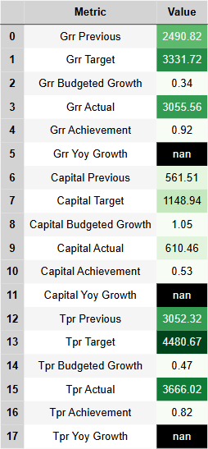
Table for Analysis of Receipts - 3.1 Total Provincial Receipts

Provincial Non-Tax Revenue
Provincial Non-Tax Revenue: FY 2023-24
- Overview of Provincial Non-Tax Revenue (NTR)
Provincial Non-Tax Revenue (NTR) constitutes a crucial element of fiscal sustainability, representing income generated by provincial governments from sources other than taxation. These revenues play a vital role in funding public services and development initiatives, reducing reliance on federal transfers, and enhancing fiscal autonomy. The composition of NTR encompasses diverse streams, including receipts from provincial departments like finance, irrigation, and mines & minerals, as well as fines, fees, and other miscellaneous sources. Understanding the performance of NTR and its underlying components is essential for evaluating the overall fiscal health of the province. A key aspect of this analysis involves comparing revenue targets established in the budget against actual collections. This comparison sheds light on the effectiveness of revenue mobilization efforts and provides insights into areas requiring policy adjustments.
The degree to which a province relies on federal transfers has significant implications for its fiscal autonomy and long-term financial stability. While transfers provide essential resources, a heavy reliance can create vulnerabilities to changes in federal policy and limit a province’s ability to prioritize its own spending needs. This report will analyze the province’s revenue targets versus actual collections for NTR, providing a comprehensive assessment of its performance in this critical area.
- Performance vs. Budget Estimates
This section analyzes the actual non-tax revenue performance against the budget targets set for FY 2023-24. Achieving budgeted revenue targets is critical for effective fiscal management and the delivery of planned programs and services. Variances between actual collections and budget estimates necessitate careful examination to understand the underlying factors driving these differences and inform corrective actions.
The achievement rates for key non-tax revenue sources are as follows: Finance achieved 59.68% of its target; Irrigation achieved 48.09% of its target; Mines & Minerals achieved 73.68% of its target; Police achieved 138.45% of its target; and Miscellaneous receipts achieved 138.84% of its target. These figures indicate a mixed performance across different revenue streams, with some exceeding expectations while others fell short.
Several factors can contribute to deviations from budget estimates, including external economic conditions, changes in government policies, and internal administrative challenges. For instance, an economic downturn can negatively impact revenue generation from sources like mines and minerals, while policy changes related to fees and fines can either enhance or diminish revenue collections. Furthermore, internal factors such as the efficiency of revenue collection mechanisms and the effectiveness of enforcement can significantly influence performance. A detailed analysis of each sector’s performance will provide a more granular understanding of the drivers behind these variances.
- Analysis of Key Indicators
Total provincial non-tax revenue for FY 2023-24 reached Rs. 153.39 billion against a target of Rs. 231.81 billion. This section provides a detailed breakdown of each revenue component. The Finance Department generated Rs. 54.72 billion against a target of Rs. 91.68 billion. Irrigation (Abiyana Receipts) amounted to Rs. 4.81 billion against a target of Rs. 10 billion. Mines & Minerals Royalties reached Rs. 14.62 billion compared to a target of Rs. 19.85 billion. The Police department collected Rs. 12.88 billion in fines and licensing fees, exceeding the target of Rs. 9.30 billion. Finally, Miscellaneous receipts totaled Rs. 35.43 billion, surpassing the target of Rs. 25.52 billion.
Year-on-year (YoY) growth rates provide a valuable perspective on revenue trends and help assess the long-term sustainability of revenue streams. While specific YoY growth rates for each sector were not provided in the data, it is crucial to analyze these trends to identify potential areas of concern and opportunities for improvement. Calculating and comparing YoY growth rates will offer a more comprehensive understanding of the province’s non-tax revenue performance.
- Causes and Implications
Understanding the causes underlying the performance of each non-tax revenue component is essential for informed policymaking. For the Finance Department, the impact of federal transfers and hydropower royalties requires in-depth analysis. Irrigation faces challenges in abiyana collection, necessitating examination of historical trends and the effectiveness of collection mechanisms. Fluctuations in royalties and lease agreements are key factors affecting Mines & Minerals revenue, highlighting the need to understand the underlying market dynamics and contractual arrangements. For Police, the effectiveness of fine collection and revenue administration plays a crucial role in determining performance. Finally, the variability in smaller revenue sources comprising Miscellaneous receipts raises concerns about sustainability and requires a closer examination of their individual contributions. Collectively, these non-tax revenue trends have significant implications for the province’s financial management and its ability to maintain fiscal stability.
- Future Outlook and Policy Recommendations
Forecasting expected trends in non-tax revenue growth is essential for proactive fiscal planning. This involves analyzing historical data, considering anticipated economic conditions, and factoring in potential policy changes. Based on this analysis, recommendations can be formulated to enhance revenue collection efficiency. These reforms may include streamlining administrative procedures, strengthening enforcement mechanisms, and exploring innovative revenue generation strategies. It’s equally crucial to identify and assess risks and external factors that may impact non-tax revenue streams. These could include changes in federal policies, economic downturns, or natural disasters. By understanding these risks, the province can develop mitigation strategies and strengthen its fiscal resilience.
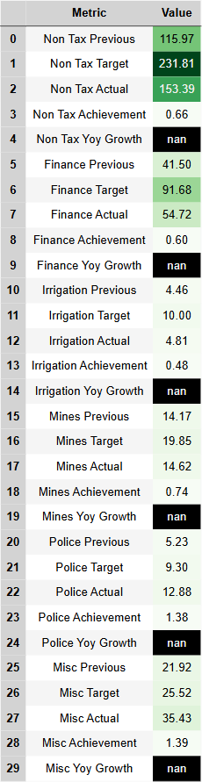
Table for Provincial Non-Tax Revenue
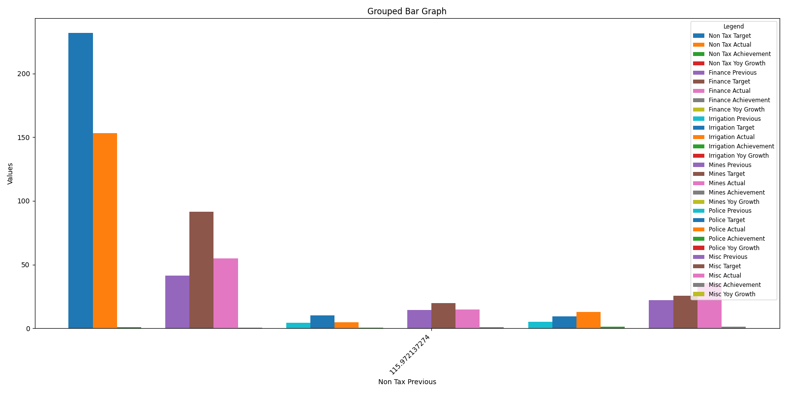
Bar Graph for Provincial Non-Tax Revenue

Analysis of Receipts - 3.1.2 Total Capital Receipts
Total Capital Receipts – FY 2023-24
1. Overview of Capital Receipts
Total Capital Receipts (TCR) represent the non-revenue inflows into the government’s coffers, primarily utilized to finance development projects and capital expenditures. Unlike revenue receipts, which are recurring in nature and stem from taxation and other non-debt sources, capital receipts are generally non-recurring and involve borrowing or the sale of assets. TCR plays a crucial role in funding public sector investments, driving economic growth, and ensuring the long-term fiscal sustainability of the province. A healthy flow of capital receipts allows the government to invest in critical infrastructure, enhance public services, and manage its debt obligations without solely relying on revenue generation.
2. Performance vs. Budget Targets
The actual total capital receipts for FY 2023-24 reached Rs. 610.46 billion, compared to the budgeted target of Rs. 1148.94 billion and the previous year’s receipts of Rs. 561.51 billion. This represents an achievement rate of 53.13% against the budget estimates. The underperformance against the projected target warrants a thorough analysis. Factors potentially contributing to this deviation could include changes in global credit market conditions impacting borrowing costs and investor appetite, adjustments to government borrowing policies, fluctuations in investment inflows, and unforeseen delays in asset sales. A detailed assessment of these external influences is critical to understanding the overall fiscal performance and refining future budget estimations.
3. Analysis of Key Indicators
Total Capital Receipts for FY 2023-24 amounted to Rs. 610.46 billion. This figure falls significantly short of the Rs. 1148.94 billion target but marks a modest increase over the previous fiscal year’s Rs. 561.51 billion. Delving into the components, Current Capital Receipts reached Rs. 517.61 billion against a target of Rs. 1039.23 billion and a previous figure of Rs. 516.91 billion. Development Capital Receipts totaled Rs. 92.85 billion compared to a target of Rs. 109.72 billion and previous receipts of Rs. 44.59 billion. Recoveries of Loans and Advances reached Rs. 1.10 billion against a target of Rs. 2.65 billion and previous recoveries of Rs. 3.58 billion. Debt Financing secured Rs. 35.17 billion compared to a target of Rs. 47.96 billion and a previous figure of Rs. 76.73 billion. Data for Account I and Account II (Commodity Financing) contributions were not provided and therefore cannot be analyzed in this report. Year-on-Year (YoY) growth figures are also unavailable for a comparative analysis. A more comprehensive historical analysis encompassing the past five years is required to contextualize these results and identify long-term trends.
4. Causes and Implications
The substantial shortfall in Debt Financing, reaching only Rs. 35.17 billion against a target of Rs. 47.96 billion, raises critical questions regarding the government’s ability to secure planned borrowing. This underperformance likely reflects challenges in the credit markets, potentially influenced by rising interest rates or a tightening of lending conditions. The significantly lower recoveries of loans and advances, totaling only Rs. 1.10 billion against a target of Rs. 2.65 billion, warrant investigation into the factors impacting repayment rates. This shortfall could be attributed to economic downturns affecting borrowers’ ability to repay, inefficiencies in loan recovery mechanisms, or a combination of both. The overall underachievement of the capital receipts budget has significant implications for provincial financial sustainability. Reduced capital inflows can constrain the government’s capacity to invest in crucial infrastructure projects and deliver essential public services. This necessitates a thorough review of expenditure priorities and potential adjustments to fiscal policies.
5. Future Outlook & Policy Considerations
Projecting future capital receipt trends requires careful consideration of the prevailing economic climate, anticipated borrowing needs, and potential changes in government policies. Enhancing debt financing efficiency could involve exploring diverse borrowing instruments, optimizing debt portfolio management strategies, and actively engaging with credit rating agencies to improve investor confidence. Improving recoveries of loans and advances necessitates strengthening loan recovery mechanisms, implementing stricter lending criteria, and providing support to borrowers facing financial difficulties. Several risks may impact capital receipts in the coming fiscal year, including interest rate fluctuations, unpredictable macroeconomic conditions, and limitations on government borrowing capacity. Mitigating these risks requires proactive fiscal management, prudent debt management strategies, and continuous monitoring of the economic landscape.
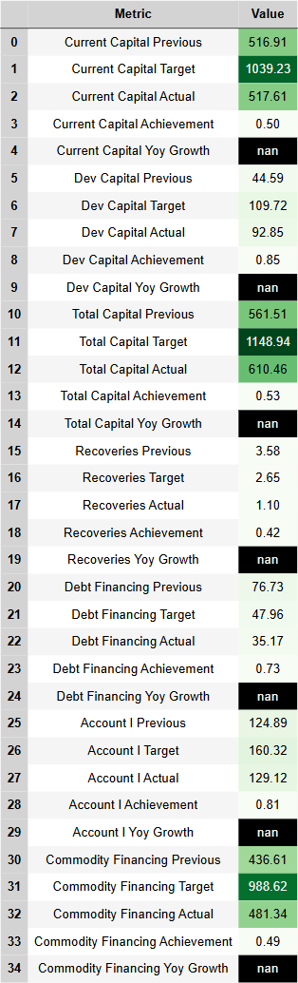
Table for Analysis of Receipts - 3.1.2 Total Capital Receipts
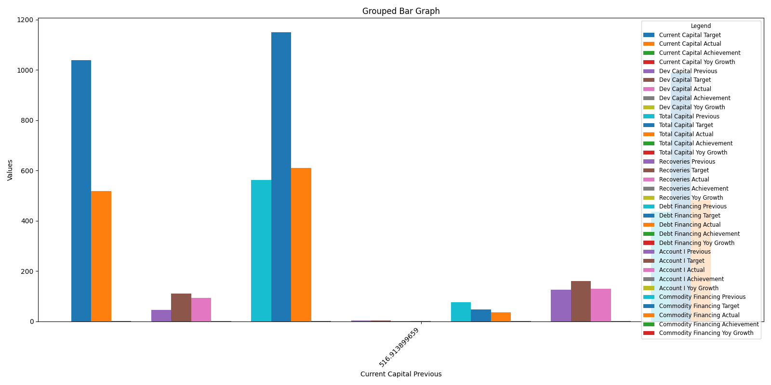
Bar Graph for Analysis of Receipts - 3.10.2 Total Capital Receipts

Analysis of Expenses - 4.1 Total Provincial Expenditure
Total Provincial Expenditure (TPE) for FY 2023-24
- Overview of Provincial Expenditure
Total Provincial Expenditure (TPE) represents the aggregate spending by the provincial government across all sectors and functions. It is a crucial indicator of fiscal health and reflects the government’s commitment to providing public services and investing in development initiatives. TPE is composed of several key components: current expenditure, which covers operational costs and service delivery; capital expenditure, which is further divided into two accounts (A/C-I and A/C-II) encompassing investments in physical assets and infrastructure; and development expenditure, which focuses on long-term capacity building and socio-economic development programs. Effective management of TPE is paramount for achieving fiscal targets, ensuring efficient public service delivery, and promoting sustainable economic growth.
- Performance vs. Budget Targets
A detailed comparison of actual expenditure against budgeted estimates for FY 2023-24 reveals both alignments and deviations across various expenditure categories. Analyzing these variances is crucial for understanding the province’s fiscal performance and identifying areas for improvement. External factors, including prevailing economic conditions, administrative constraints, and policy shifts, can significantly influence spending patterns and contribute to deviations from the original budget allocations. A deeper exploration of these influencing factors will provide a more comprehensive understanding of the province’s fiscal performance.
- Analysis of Key Expenditure Categories
- Current Expenditure: An actual expenditure of Rs. 1985.08 billion was recorded against a budgeted amount of Rs. 2074.12 billion, compared to Rs. 1667.17 billion in the previous fiscal year. This reflects the province’s commitment to maintaining and improving service delivery. The YoY growth of 19.07% suggests an expansion in operational activities, while the budget achievement of 95.71% indicates a slight underspending in this category. Further investigation is needed to ascertain the reasons for this underspending and its potential impact on service provision.
- Current Capital Expenditure A/C-I: Actual spending on capital projects under A/C-I reached Rs. 482.16 billion, compared to a budgeted amount of Rs. 637.92 billion and a previous year’s expenditure of Rs. 347.20 billion. Factors such as loans, equity investments, and pension liabilities can significantly influence this expenditure category. The YoY growth of 38.87% demonstrates an increase in capital investments, while achieving 75.58% of the budget indicates a potential for further capital project implementation.
- Current Capital Expenditure A/C-II: This category saw an actual expenditure of Rs. 482.79 billion against a budgeted amount of Rs. 988.62 billion and a previous expenditure of Rs. 445.33 billion. Issues such as delays in fund allocations and loan repayments often affect this category. The YoY growth of 8.41% is relatively modest, and the budget utilization of 48.83% suggests significant underspending that warrants detailed analysis.
- Development Expenditure: Rs. 568.31 billion was spent on development activities, compared to a budgeted amount of Rs. 655.00 billion and a previous expenditure of Rs. 585.76 billion. This category encompasses crucial investments in capacity building and infrastructure projects. The negative YoY growth of -2.98% indicates a contraction in development spending compared to the previous year, and a budget achievement of 86.76% suggests further scope for utilizing allocated funds.
- Total Provincial Expenditure: The overall provincial expenditure reached Rs. 3518.34 billion against a budgeted amount of Rs. 4355.67 billion and a previous year’s spending of Rs. 3045.46 billion. The overall YoY growth of 15.53% and budget utilization of 80.78% indicate a reasonable pace of expenditure growth, although further analysis is needed to understand the factors contributing to the underutilization of the allocated budget.
- Functional Classification of Expenditure
General Public Service: Actual: 2019.11 billion (Target: 2381.15 billion, Previous: 1730.27 billion), Utilization: 84.80%, YoY Growth: 16.69%.
Public Order & Safety Affairs: Actual: 281.11 billion (Target: 246.91 billion, Previous: 232.24 billion), Utilization: 113.85%, YoY Growth: 21.04%.
Economic Affairs: Actual: 583.07 billion (Target: 1084.03 billion, Previous: 533.10 billion), Utilization: 53.79%, YoY Growth: 9.37%.
Environment Protection: Actual: 3.71 billion (Target: 5.30 billion, Previous: 2.95 billion), Utilization: 70.05%, YoY Growth: 25.85%.
Housing and Community Amenities: Actual: 127.03 billion (Target: 126.53 billion, Previous: 117.09 billion), Utilization: 100.40%, YoY Growth: 8.49%.
Health: Actual: 324.64 billion (Target: 305.32 billion, Previous: 268.21 billion), Utilization: 106.33%, YoY Growth: 21.04%.
Recreational, Culture and Religion: Actual: 9.53 billion (Target: 11.43 billion, Previous: 9.23 billion), Utilization: 83.40%, YoY Growth: 3.27%.
Education Affairs and Services: Actual: 139.73 billion (Target: 169.30 billion, Previous: 118.34 billion), Utilization: 82.53%, YoY Growth: 18.08%.
Social Protection: Actual: 30.39 billion (Target: 25.69 billion, Previous: 34.03 billion), Utilization: 118.30%, YoY Growth: -10.69%.
Overall (Function Total): Actual: 3518.33 billion (Target: 4355.66 billion, Previous: 3045.46 billion), Utilization: 80.78%, YoY Growth: 15.53%.
These figures reveal significant variations in budget utilization and YoY growth across different functions. For instance, Public Order & Safety Affairs and Health exceeded their budget allocations, while Economic Affairs showed significant underspending. Understanding the drivers behind these variations is crucial for informed policy adjustments.
- Causes, Implications, and Policy Considerations
Several factors may have contributed to the observed expenditure variances. Administrative challenges, such as delays in project approvals and procurement processes, can lead to underspending. Economic conditions, including inflation and fluctuations in revenue collection, can also influence spending patterns. The implications of these variances can be substantial, affecting fiscal sustainability and the effective delivery of public services. To improve budget utilization and align spending with fiscal targets, several policy considerations are recommended. These include strengthening budget planning and execution processes, enhancing transparency and accountability mechanisms, and promoting greater coordination between different government agencies. A comprehensive review of current budget practices and the development of targeted interventions are essential for achieving optimal fiscal outcomes and maximizing the impact of public spending on the well-being of the province’s citizens.
Table for Analysis of Expenses - 4.1 Total Provincial Expenditure
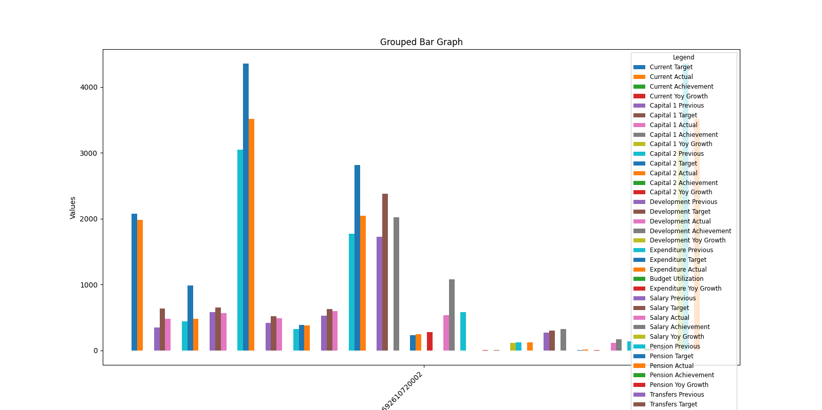
Bar Graph for Analysis of Expenses - 4.10 Total Provincial Expenditure

Analysis of Expenses - 4.1.1 Current Expenditure
Current Expenditure
Current expenditure constitutes the largest component of provincial spending, encompassing essential recurring costs necessary for the daily operation of government and the delivery of public services. It includes compensation for government employees (salaries and pensions), transfers to local governments for their operational needs, and other operational expenses crucial for service delivery. Effective management of current expenditure is paramount for ensuring the efficient functioning of government, maintaining fiscal sustainability, and providing essential services to the public.
Performance vs. Budget Targets
The actual current expenditure for FY 2023-24 reached Rs. 1985.08 billion, compared to the budgeted target of Rs. 2074.12 billion. This represents a budget utilization rate of 95.71%. The variance between actual and budgeted expenditure may be attributed to a confluence of factors, including inflationary pressures on goods and services, potentially high interest rates affecting debt servicing costs, and possible policy constraints or adjustments implemented during the fiscal year. A thorough analysis of these contributing factors is crucial for informing future budget planning and execution.
Analysis of Key Expenditure Categories
- Salary Expenditure: Actual salary expenditure totaled Rs. 488.09 billion against a budgeted amount of Rs. 513.74 billion and a previous year’s expenditure of Rs. 413.97 billion. This represents a year-over-year (YoY) growth of 17.90% and a budget achievement of 95.01%. This growth reflects potential increases in public sector employment, salary adjustments, or other employee-related costs. Further analysis is needed to understand the specific drivers of this increase.
- Pension Expenditure: Pension expenditure reached Rs. 380.98 billion, compared to a budgeted amount of Rs. 392.09 billion and a previous expenditure of Rs. 324.47 billion. This signifies a YoY growth of 17.42% and a budget achievement of 97.17%. The growth in pension expenditure is likely driven by mandatory pension payments and potentially exacerbated by inflationary adjustments. The long-term fiscal implications of pension obligations require continuous monitoring and appropriate policy responses.
- Transfers to Local Governments: Transfers to local governments amounted to Rs. 591.31 billion, compared to a budgeted amount of Rs. 627.65 billion and a previous expenditure of Rs. 517.37 billion. This indicates a YoY growth of 14.29% and a budget utilization of 94.21%. These transfers are essential for supporting local governance and service delivery at the community level. Variations in these transfers can reflect changing needs at the local level or adjustments in intergovernmental fiscal arrangements.
- Non-Salary (Service Delivery) Expenditure: Spending on non-salary, service delivery related items amounted to Rs. 524.70 billion, compared to a budgeted amount of Rs. 540.64 billion and a previous year’s spending of Rs. 411.35 billion. This signifies a YoY growth of 27.56% and a budget achievement of 97.05%. This category encompasses a wide range of operational costs directly related to providing public services. The substantial growth in this area warrants further investigation to ensure cost-effectiveness and alignment with service delivery priorities.
- Total Current Expenditure: The total current expenditure of Rs. 1985.08 billion, compared to a budgeted amount of Rs. 2074.12 billion and the previous year’s expenditure of Rs. 1667.17 billion, demonstrates a YoY growth of 19.07% and an overall budget utilization of 95.71%.
Object-Level Analysis
A detailed object-level analysis provides further insights into the composition of current expenditure. Employee-related expenses reached Rs. 488.40 billion (Target: Rs. 514.05 billion, Previous: Rs. 414.26 billion), demonstrating a YoY growth of 17.90% and a budget achievement of 95.01%. Project pre-investment analysis expenditures were Rs. 0.00 billion (Target: Rs. 0.06 billion, Previous: Rs. 0.02 billion) with a YoY decrease of -76.50% and a budget achievement of 6.30%. Operating expenses amounted to Rs. 182.47 billion (Target: Rs. 172.09 billion, Previous: Rs. 162.33 billion), marking a YoY growth of 12.40% and exceeding the budget by 106.03%. Employees’ retirement benefits reached Rs. 384.94 billion (Target: Rs. 401.23 billion, Previous: Rs. 332.80 billion), with a YoY growth of 15.67% and a budget achievement of 95.94%. Grants/Subsidies/Write-offs were Rs. 747.53 billion (Target: Rs. 824.23 billion, Previous: Rs. 636.00 billion) displaying a YoY growth of 17.54% and budget achievement of 90.70%. Transfers at the object level were Rs. 18.40 billion (Target: Rs. 18.24 billion, Previous: Rs. 16.03 billion) representing a YoY growth of 14.81% and budget achievement of 100.86%. Interest payments totaled Rs. 75.91 billion (Target: Rs. 67.95 billion, Previous: Rs. 43.15 billion) showing significant YoY growth of 75.92% and budget achievement of 111.71%. Acquisitions of physical assets reached Rs. 18.38 billion (Target: Rs. 20.22 billion, Previous: Rs. 16.68 billion) with a YoY growth of 10.21% and budget achievement of 90.91%. Civil works expenditures were Rs. 0.32 billion (Target: Rs. 0.71 billion, Previous: Rs. 0.21 billion) indicating a YoY growth of 48.53% and budget achievement of 44.36%. Repairs and maintenance expenditures totaled Rs. 68.60 billion (Target: Rs. 55.01 billion, Previous: Rs. 45.52 billion) with a YoY growth of 50.71% and budget achievement of 124.69%. Suspense and clearing expenses were Rs. 0.14 billion (Target: Rs. 0.33 billion, Previous: Rs. 0.18 billion), demonstrating a YoY decrease of -23.09% and budget achievement of 42.27%. The total object-level expenditure was Rs. 1985.08 billion, reflecting a utilization rate of 95.71% and a YoY growth of 19.07%. Detailed analysis of these object-level variances is crucial for understanding spending patterns and identifying potential areas for efficiency improvements.
Functional Classification of Current Expenditure
Analyzing current expenditure by function reveals resource allocation across different government priorities. General Public Services utilized Rs. 1129.02 billion (Target: Rs. 1207.38 billion, Previous: Rs. 951.05 billion) representing 93.51% utilization and 18.71% YoY growth. Public Order & Safety Affairs saw an expenditure of Rs. 273.83 billion (Target: Rs. 241.18 billion, Previous: Rs. 230.38 billion), representing a utilization of 113.54% and a YoY growth of 18.86%. Economic Affairs spent Rs. 162.51 billion (Target: Rs. 219.90 billion, Previous: Rs. 156.02 billion) with a utilization of 73.90% and YoY growth of 4.16%. Environment Protection spent Rs. 0.73 billion (Target: Rs. 1.55 billion, Previous: Rs. 0.63 billion) exhibiting a utilization of 47.20% and 16.60% YoY growth. Housing and Community Amenities utilized Rs. 37.76 billion (Target: Rs. 24.10 billion, Previous: Rs. 21.28 billion), showing a utilization of 156.69% and substantial YoY growth of 77.47%. Health expenditures totaled Rs. 242.04 billion (Target: Rs. 227.92 billion, Previous: Rs. 184.66 billion), indicating a utilization of 106.20% and a YoY growth of 31.07%. Recreational, Culture, and Religion utilized Rs. 6.83 billion (Target: Rs. 6.55 billion, Previous: Rs. 5.13 billion), representing a utilization of 104.29% and YoY growth of 33.09%. Education Affairs and Services reached Rs. 102.84 billion (Target: Rs. 120.30 billion, Previous: Rs. 85.45 billion), with a utilization of 85.49% and a YoY growth of 20.36%. Social Protection utilized Rs. 29.52 billion (Target: Rs. 25.24 billion, Previous: Rs. 32.57 billion) representing a utilization rate of 116.95% and a YoY decline of -9.36%. Overall, the total functional expenditure was Rs. 1985.08 billion (Target: Rs. 2074.12 billion, Previous: Rs. 1667.17 billion), reflecting a utilization of 95.71% and a YoY growth of 19.07%. Fluctuations in functional allocations may be attributed to changing policy priorities, emerging needs, or specific program performance.
Causes, Implications, and Policy Considerations
A comprehensive assessment of the factors driving current expenditure variances is essential for informed policy adjustments. Factors such as inflationary pressures, potentially high interest rates impacting debt servicing, and any policy changes or constraints implemented during the fiscal year should be thoroughly examined. The implications of these variances on fiscal sustainability and public service delivery require careful consideration. Moving forward, recommendations for enhancing budget utilization and aligning current expenditure with fiscal targets should focus on improving budget planning processes, strengthening expenditure controls, and prioritizing programs with the greatest impact on public welfare. A detailed analysis of spending patterns across categories, objects, and functions is crucial for making informed decisions and ensuring responsible fiscal management.
Table for Analysis of Expenses - 4.1.1 Current Expenditure
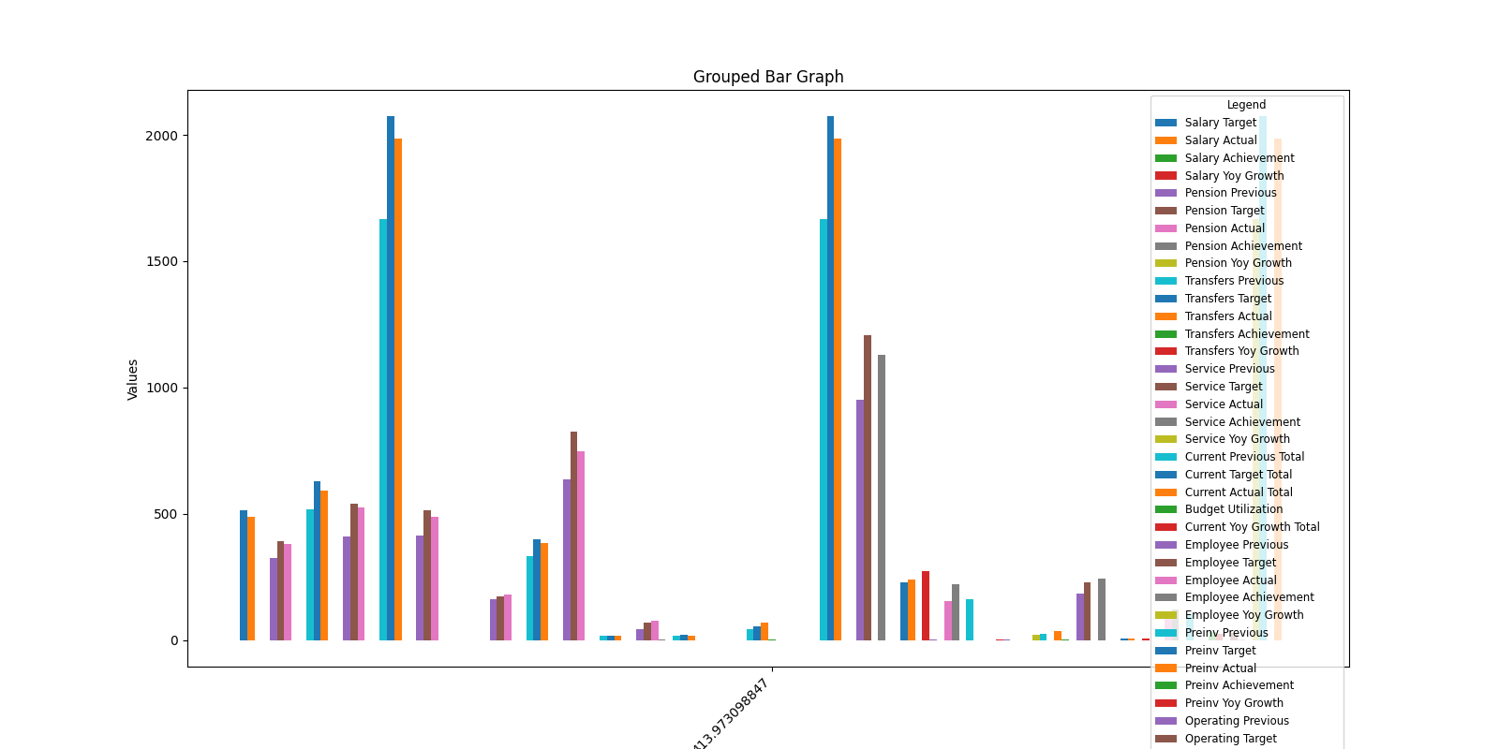
Bar Graph for Analysis of Expenses - 4.10.1 Current Expenditure

Analysis of Expenses - 4.1.2 Total Current Capital Expenditure
Total Current Capital Expenditure
Total current capital expenditure for FY 2023-24 was Rs. 964.95 billion. The budget target was Rs. 1626.54 billion with an overall budget utilization of 59.33%. Year-on-year growth was 21.76%, reflecting significant fiscal adjustments in capital spending.
Breakdown of Expenditure Categories:
- Current Capital Expenditure A/C-I: This category, which includes debt repayments, government loans, and public sector investments, saw actual expenditure of Rs. 482.16 billion versus a target of Rs. 637.92 billion. This represents an achievement of 75.58% of its budget with a year-on-year growth of 38.87%. Notably, debt repayments accounted for Rs. 0.00 billion, emphasizing efforts to reduce fiscal liabilities. The substantial year-on-year growth indicates a significant increase in spending within this category, driven primarily by increased public sector investments and government loans.
- Current Capital Expenditure A/C-II: This category pertains primarily to commodity financing operations. Actual spending was Rs. 482.79 billion against a target of Rs. 988.62 billion. Budget utilization in this category was 48.83% with a year-on-year growth of 8.41%. Commodity financing expenditure reached Rs. 0.00 billion, influenced by revised market policies. The lower-than-targeted spending and modest year-on-year growth suggest a more cautious approach to commodity financing.
Performance vs. Budget Targets:
Overall, the province’s current capital expenditure increased compared to the previous fiscal year (from Rs. 792.53 billion). The strong performance in A/C-I demonstrates an aggressive approach to public sector investment and lending, while A/C-II’s performance reflects a more cautious strategy in commodity financing. The combined results underscore a dual-track fiscal strategy focused on stimulating economic activity through investments while carefully managing commodity financing exposure in volatile market conditions.
Implications and Future Policy Considerations:
The robust growth in A/C-I, particularly with the noted increase in public investment and lending, signals a clear commitment to fostering economic growth. The underperformance in A/C-II suggests that market conditions and policy shifts have led to more conservative commodity financing. Future policies should aim to balance strategic public investment with adaptive commodity financing strategies to ensure long-term fiscal sustainability and economic stability.
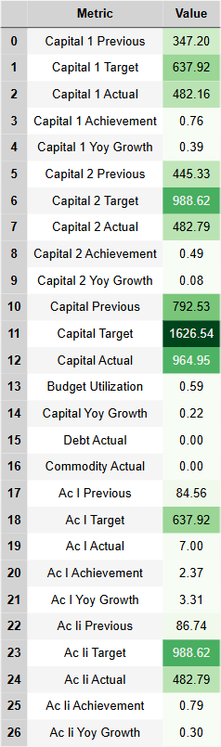
Table for Analysis of Expenses - 4.1.2 Total Current Capital Expenditure
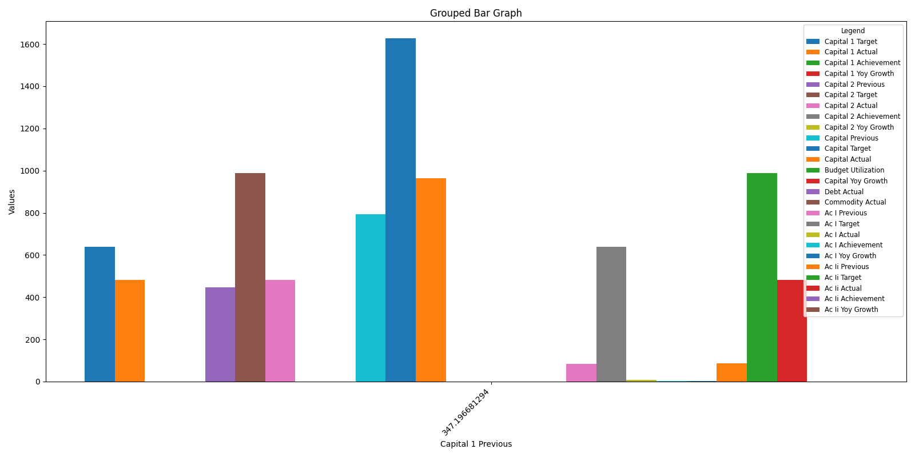
Bar Graph for Analysis of Expenses - 4.10.2 Total Current Capital Expenditure

Analysis of Expenses - 4.1.3 Development Expenditure
Development Expenditure
Development expenditure, encompassing government spending directed towards enhancing service delivery and constructing vital infrastructure, plays a crucial role in fostering long-term improvements in public services and driving economic development. In FY 2023-24, total development expenditure reached Rs. 568.31 billion against a target of Rs. 655.00 billion. This represents a budget utilization rate of 86.76% and a year-over-year (YoY) growth of -2.98%.
Analysis by Object
A detailed examination of object-level expenditure reveals the following: Employee Related Expenses saw an actual expenditure of Rs. 5.16 billion in FY 2023-24 compared to a budget of Rs. 4.03 billion and a previous year’s actual expenditure of Rs. 3.84 billion. This translates to a budget utilization rate of 128.07% and a YoY growth of 34.52%. Expenditure on Project Pre-investment Analysis reached Rs. 0.07 billion against a target of Rs. 0.08 billion, with a utilization rate of 87.60% and a YoY growth of 273.57% from a previous actual expenditure of Rs. 0.02 billion. Operating Expenses stood at Rs. 11.60 billion compared to a budget of Rs. 11.08 billion and a previous actual expenditure of Rs. 8.15 billion, resulting in a utilization rate of 104.64% and a YoY growth of 42.27%. Employees Retirement Benefits registered an actual expenditure of Rs. 0.01 billion against a budget of Rs. 0.02 billion and a previous year’s expenditure of Rs. 0.02 billion. This represents a utilization rate of 91.92% and a YoY decrease of -6.41%. Transfers amounted to Rs. 55.66 billion against a budgeted amount of Rs. 85.63 billion and a previous actual expenditure of Rs. 54.69 billion, resulting in a utilization rate of 65.01% and a YoY growth of 1.79%. Loans and Advances recorded no expenditure in both the current and previous fiscal years, aligning with the zero budget allocation. Expenditure on Acquiring of Physical Assets totalled Rs. 24.99 billion compared to a budgeted Rs. 34.69 billion and a previous actual expenditure of Rs. 23.25 billion. This represents a utilization rate of 72.03% and a YoY increase of 7.50%. No expenditure was recorded for Investments, consistent with the zero budget allocation in both the current and previous fiscal years. Civil Works expenditure reached Rs. 251.16 billion against a target of Rs. 296.18 billion and a previous actual expenditure of Rs. 305.09 billion, indicating a utilization rate of 84.80% and a YoY decline of -17.68%. Finally, Repairs and Maintenance expenditure was Rs. 1.19 billion compared to a budget of Rs. 1.48 billion and a previous year’s expenditure of Rs. 0.60 billion. This signifies a utilization rate of 80.36% and a YoY growth of 99.95%. The total object-level expenditure amounted to Rs. 568.31 billion against a budget of Rs. 655.00 billion and a previous actual expenditure of Rs. 458.76 billion, indicating a utilization rate of 86.76% and a YoY decrease of -2.98%.
Analysis by Function
Analyzing expenditure by function, General Public Services recorded an actual expenditure of Rs. 49.08 billion compared to a budget of Rs. 60.70 billion and a previous actual expenditure of Rs. 45.97 billion. This indicates a budget utilization of 80.85% and a YoY growth of 6.76%. Public Order & Safety Affairs reached an actual expenditure of Rs. 7.28 billion against a budget of Rs. 5.73 billion and a previous year’s expenditure of Rs. 1.86 billion. This signifies a utilization rate of 126.96% and a substantial YoY growth of 290.55%. Economic Affairs recorded an actual expenditure of Rs. 296.63 billion against a budget of Rs. 350.65 billion and a previous actual expenditure of Rs. 317.80 billion, demonstrating a budget utilization of 84.59% and a YoY decline of -6.66%. Expenditure on Environment Protection amounted to Rs. 2.98 billion compared to a budget of Rs. 3.75 billion and a previous year’s expenditure of Rs. 2.32 billion, representing a utilization rate of 79.53% and a YoY growth of 28.58%. Housing and Community Amenities registered an expenditure of Rs. 89.27 billion against a budget of Rs. 102.43 billion and a previous actual expenditure of Rs. 95.81 billion, exhibiting a budget utilization of 87.15% and a YoY decrease of -6.83%. Recreational, Culture and Religion recorded an actual expenditure of Rs. 2.70 billion against a budget of Rs. 4.88 billion and a previous year’s actual expenditure of Rs. 4.09 billion, indicating a utilization rate of 55.41% and a YoY decline of -34.02%. Education Affairs and Services showed an actual expenditure of Rs. 36.89 billion compared to a budget of Rs. 49.01 billion and a previous actual expenditure of Rs. 32.89 billion, representing a utilization rate of 75.27% and a YoY growth of 12.13%. Social Protection recorded an expenditure of Rs. 0.87 billion against a budget of Rs. 0.45 billion and a previous year’s expenditure of Rs. 1.46 billion, demonstrating a utilization rate of 195.87% and a YoY decline of -40.32%. Total function-level expenditure was Rs. 568.31 billion against a budget of Rs. 655.00 billion and a previous actual expenditure of Rs. 585.76 billion, indicating a budget utilization rate of 86.76% and a YoY decline of -2.98%.
Causes, Implications, and Policy Considerations
Several factors may have contributed to deviations in development expenditure. Political transitions, such as the presence of an interim government, can introduce delays in project approvals and implementation. Shifts in government policy priorities can lead to reallocations of funds, affecting the execution of previously planned projects. External factors, including market fluctuations and unforeseen economic downturns, can also impact project timelines and costs. These spending patterns directly influence the progress of infrastructure projects and the effective delivery of public services. Delays or underutilization of allocated funds can hinder the timely completion of crucial infrastructure projects, potentially impacting economic growth and public welfare. To optimize future development spending and enhance budget utilization, several recommendations warrant consideration. Strengthening project planning and implementation processes, coupled with enhanced monitoring and evaluation mechanisms, can improve project timelines and minimize delays. Building greater resilience to external shocks through robust risk assessment and mitigation strategies can safeguard projects from unforeseen disruptions. Finally, fostering greater coordination among government agencies and stakeholders can streamline decision-making processes and facilitate efficient project execution.

Analysis of Budget Management - 5.1
Budget Management
- Overview of Budget Management:
Budget management is the cornerstone of sound public finance, encompassing the processes of formulating, implementing, and monitoring government budgets. Its primary objective is to ensure fiscal discipline, optimize resource allocation towards strategic priorities, and promote long-term financial sustainability. Effective budget management involves a continuous cycle of planning, execution, and evaluation, allowing governments to align resource allocation with policy objectives and adapt to evolving economic realities. Budgetary performance is assessed by comparing actual receipts and expenditures against the budget estimates, providing insights into the government’s financial health and the efficiency of resource utilization. Key fiscal metrics, such as revenue balance, net capital receipts, development expenditure, and fiscal balance, serve as crucial indicators for evaluating the overall financial performance and sustainability.
- Performance vs. Budget Targets:
The fiscal year 2023-24 witnessed a total provincial receipt of Rs. 3055.56 billion, compared to a budgeted target of Rs. 3331.72 billion and a previous year’s collection of Rs. 2490.82 billion. This represents an underperformance against the target but a substantial increase compared to the previous fiscal year. A detailed analysis of the factors contributing to this outcome, including economic conditions, tax compliance rates, and the performance of external financing sources, is crucial for understanding the dynamics of revenue collection. On the expenditure side, total provincial expenditure reached Rs. 1985.08 billion against a budgeted amount of Rs. 2074.12 billion and previous expenditure of Rs. 1667.17 billion. This indicates lower-than-projected spending, yet a rise compared to the previous year. A comprehensive examination of spending patterns across various sectors is necessary to understand these variances. Furthermore, deviations in crucial fiscal indicators like revenue balance, net capital receipts, and fiscal balance offer valuable insights into emerging fiscal performance trends and inform future budgetary strategies.
- Analysis of Key Fiscal Indicators:
Total Provincial Receipts reached Rs. 3055.56 billion against a target of Rs. 3331.72 billion and a previous year figure of Rs. 2490.82 billion. Total Provincial Expenditure amounted to Rs. 1985.08 billion, compared to the target of Rs. 2074.12 billion and previous expenditure of Rs. 1667.17 billion. The Revenue Balance stood at Rs. 1070.48 billion, compared to a projected Rs. 1257.60 billion and the previous year’s Rs. 823.65 billion. Net Capital Receipts were recorded at Rs. -354.49 billion against a target of Rs. -477.60 billion and a previous figure of Rs. -231.02 billion. Capital Receipts amounted to Rs. 610.46 billion against a target of Rs. 1148.94 billion and a previous receipt of Rs. 561.51 billion, while Capital Expenditure reached Rs. 964.95 billion against a target of Rs. 1626.54 billion and previous expenditure of Rs. 792.53 billion. Development Resources Available reached Rs. 715.99 billion compared to a target of Rs. 780.00 billion and a previous figure of Rs. 592.63 billion. Development Expenditure stood at Rs. 568.31 billion compared to a target of Rs. 655.00 billion and previous spending of Rs. 585.76 billion. The Fiscal Balance was Rs. 147.68 billion against a projected Rs. 125.00 billion and a previous balance of Rs. 6.87 billion. Interest Expense totalled Rs. 75.91 billion compared to a projected Rs. 67.95 billion and previous expense of Rs. 43.15 billion. Finally, the Primary Balance reached Rs. 223.59 billion compared to a target of Rs. 192.96 billion and a previous balance of Rs. 50.02 billion.
- Causes, Implications, and Policy Considerations:
The observed fiscal outcomes for FY 2023-24 are a result of complex interactions between various economic and policy factors. A deeper understanding of these underlying drivers is crucial for developing effective policy interventions. The shortfall in receipts against the projected target warrants a detailed investigation into potential contributing factors, such as economic downturns, tax evasion, or underperformance in specific revenue streams. Similarly, the variances in expenditure across different sectors necessitate a thorough assessment of program efficiency and potential areas for optimization. The observed trends in fiscal indicators, including the fiscal balance, net capital receipts, and development expenditure, have significant implications for the long-term fiscal sustainability of the province. Based on these findings, targeted policy recommendations can be formulated to enhance revenue mobilization, optimize expenditure allocation, and strengthen overall fiscal management. These policy interventions might include measures to enhance tax administration, improve budget execution, and prioritize spending on growth-enhancing and socially beneficial programs.
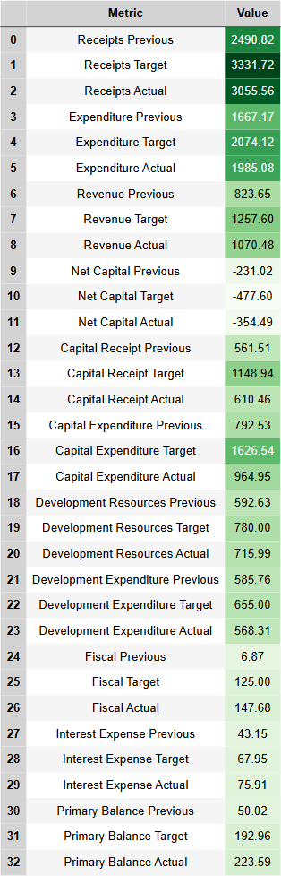
Table for Analysis of Budget Management - 5.1
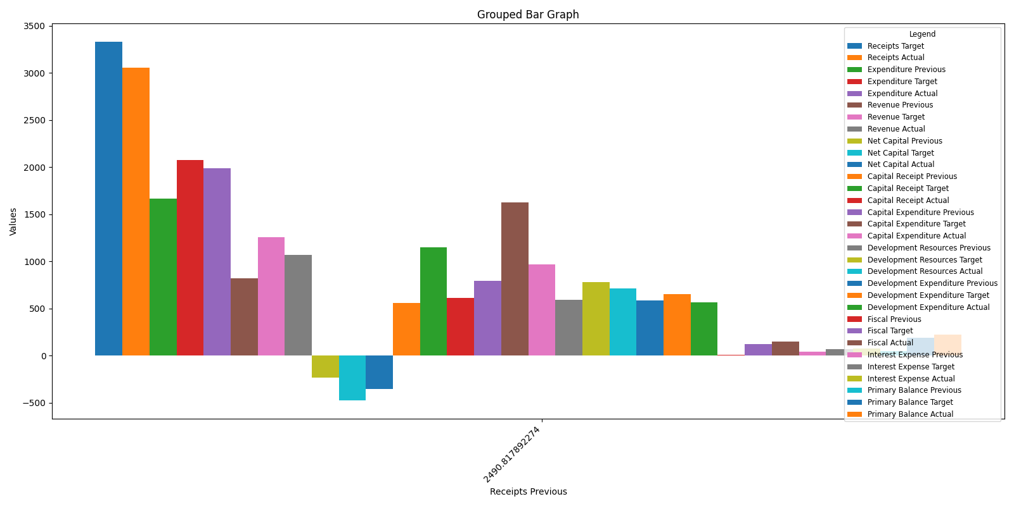
Bar Graph for Analysis of Budget Management - 5.10

