french_fragrance_db — Table Structures

Overview
The competitor price tracker keeps everything in one Postgres database on Render, french_fragrance_db, in 36 tables (checked 13 Nov 2026): 22 competitor shop lists, competitor_table, Item Master tables, settings and logs.

Tables
Table | What it holds | Created by | Rows (13 Nov)
competitor_table | Our products, every competitor's link / price / stock (22 shops), least price, suggested price, LOP / MOP, Skip automatic price | app.py (CT_CREATE) + price_limits.py + skip_auto.py | 9,619
french_fragrance_catalog | All French Fragrance products | migrate_ff_catalog.py | 15,499
branded_perfume_catalog | The same products on Branded Perfume | branded_perfume.py | 15,406
essenzi_catalog | The same products on Essenzi | essenzi.py | 15,406
samawa_catalog | Samawa full product list | samawa_catalog.py | 26,871
vperfumes_catalog | V Perfumes full product list | vperfumes.py | 8,620
alinjaz_catalog | Al Injaz full product list | alinjaz.py | 1,486
ounass_catalog | Ounass full product list | ounass.py | 3,670
amberiya_catalog | Amberiya full product list | amberiya.py | 3,234
nichegallerie_catalog | Niche Gallerie full product list | nichegallerie.py | 5,910
app_settings | Settings and run progress (discount rate, Run 1, Run 2) | discount_rate.py, competitors_page.py, daily_update.py | 9
brand_automation | Which brands are on automatic price | app.py | 65
app_users | Website logins | auth.py | 5
price_check_runs | One row per run of the old daily price check | price_check.py | 3
price_check_log | Every link that price check opened | price_check.py | 214
price_check_progress | Last check per product | price_check.py | 51
test_price_backup | Real French Fragrance price saved by test_price.py, so undo can put it back | test_price.py | 0
abdulsamad_catalog | Abdul Samad Al Qurashi full product list (new) | shop list scraper | 72
ajmal_catalog | Ajmal full product list (new) | shop list scraper | 228
alharamain_catalog | Al Haramain full product list (new) | shop list scraper | 300
aljazeera_catalog | Al Jazeera full product list (new) | shop list scraper | 151
anfasic_catalog | Anfasic full product list (new) | shop list scraper | 57
arabianoud_catalog | Arabian Oud full product list (new) | shop list scraper | 189
brandsperfume_catalog | Brands Perfume full product list (new) | shop list scraper | 11,816
emiratespride_catalog | Emirates Pride full product list (new) | shop list scraper | 30
khaltat_catalog | Khaltat full product list (new) | shop list scraper | 70
mhgboutique_catalog | MHG Boutique full product list (new) | shop list scraper | 662
oudelite_catalog | Oud Elite full product list (new) | shop list scraper | 156
perfumedubai_catalog | Perfume Dubai full product list (new) | shop list scraper | 1,524
reefperfumes_catalog | Reef Perfumes full product list (new) | shop list scraper | 60
brand_discount | Discount rate per brand (instead of the general rate) (new) | Settings | 0
item_master | Item Master page: every French Inventories field (prices per country, notes, description, images) | item_master.py | 9,619
item_master_deleted | Products deleted from the Item Master (new) | item_master.py | 1
item_options | Extra dropdown choices added on the Item Master (new) | item_master.py | 0
brand_sku | SKU prefix and next SKU number per brand | Item Master tools | 470
button_runs | One row per button run on the Item Master page (e.g. Create product description), with its steps and errors | description_gen.py | 164

competitor_table
One row per product of ours (from French Inventories in Airtable); the key is fi_record_id. Each competitor has its own group of columns with the same pattern.
Our product
Column | Type | Meaning
id | SERIAL | Row number
fi_record_id | TEXT, unique | Airtable record id (recXXX) of the product
french_inventory_code | TEXT | Code in French Inventories
sku | TEXT | Our SKU, e.g. AMF1085
product_name | TEXT | Full product name
perfume_name | TEXT | Perfume name without brand / size
brand | TEXT | Brand
barcode | TEXT | Barcode (GTIN). Admins can edit it on the card (barcode_edit.py); the change is saved to Airtable first
uae_price | NUMERIC(10,2) | Our UAE price (AED)
our_link | TEXT | Product link on fragrantsouq.com
our_title | TEXT | Product name on our site
our_stock | BOOLEAN | In stock on our site
updated_at | TIMESTAMP | Last change of the row
our_stock_qty | INTEGER | Our stock quantity (new)
Per competitor (prefix = samawa, ff, bp, es, vp, aj, on, am, ng, aq, jm, ah, jz, an, ao, br, ep, kh, mh, oe, pd, rf)
Column | Type | Meaning
<prefix>_link | TEXT | Matched product page on that shop (empty = not matched)
<prefix>_price | NUMERIC(10,2) | Their price incl. 5% VAT
<prefix>_stock | BOOLEAN | TRUE = in stock
<prefix>_title | TEXT | Product name on that shop
<prefix>_suggestion | TEXT | Possible match waiting for OK / Not OK
<prefix>_method | TEXT | How it was matched (barcode, fuzzy, confirmed)
<prefix>_score | NUMERIC(5,3) | Name-match score 0–1
<prefix>_confirmed | BOOLEAN | TRUE = a person clicked OK or set the link with Edit link (kept by later match runs)
<prefix>_rejected | TEXT | Link refused with Not OK or removed by an admin (never suggested again)
Branded Perfume (bp) and Essenzi (es) only have _link, _price, _stock, _title and _confirmed: they follow the French Fragrance match, unless an admin set their own link with Edit link (_confirmed = TRUE). All other shops have the full set of 9 columns.

Prices and limits
Column | Type | Meaning
least_price | NUMERIC(10,2) | Cheapest of our price and every in-stock competitor
least_priced_website | TEXT | Every website with that price, e.g. "V Perfumes"
suggested_price | NUMERIC(10,2) | Cheapest in-stock competitor − discount rate, kept between LOP and MOP
LOP | NUMERIC(10,2) | Lowest allowed suggested price (empty = no limit)
MOP | NUMERIC(10,2) | Highest allowed suggested price (empty = no limit)
limits_by | TEXT | Who saved LOP / MOP last
limits_at | TIMESTAMP | When
no_auto | BOOLEAN | TRUE = Skip automatic price ticked: never changed automatically in Airtable
no_auto_by | TEXT | Who ticked / unticked it
no_auto_at | TIMESTAMP | When
uae_price_website | BOOLEAN | UAE price set from the website (new)
website_edits | JSONB | Changes made on the website (new)

French Fragrance, Branded Perfume, Essenzi
These three shops sell the same products. Branded Perfume and Essenzi rows point to their French Fragrance row through ff_id. Run 1(daily run by 10brands) on the PC updates their price and stock every working day.
french_fragrance_catalog
Column | Type | Meaning
id | SERIAL | Row number (= ff_id in the two tables below)
airtable_record_id | TEXT, unique | Record id from the old Airtable FF Catalog
product_url | TEXT | Product page on frenchfragrance.com
gtin | TEXT | Barcode
name | TEXT | Product name
price_inc_tax | NUMERIC(10,2) | Price incl. 5% VAT
price | NUMERIC(10,2) | Price without VAT
stock | TEXT | In stock / Out of stock / Not on site
volume | TEXT | e.g. 100 ml
updated_at | TIMESTAMP | Last change

essenzi_catalog (Branded Perfume: same columns, bp_ instead of es_)
Column | Type | Meaning
id | SERIAL | Row number
ff_id | INTEGER, unique | The product's id in french_fragrance_catalog
ff_url | TEXT | French Fragrance link (source)
gtin | TEXT | Barcode
name | TEXT | Product name (from French Fragrance)
volume | TEXT | e.g. 100 ml
es_url | TEXT | Same page on essenzi.com
es_price | NUMERIC(10,2) | Price without VAT
es_price_inc_tax | NUMERIC(10,2) | Price incl. 5% VAT
es_stock | TEXT | In stock / Out of stock / Not on site
es_status | TEXT | ok / not_found (why)
es_title | TEXT | Product name on Essenzi
es_size | TEXT | Size read from that name
checked_at | TIMESTAMP | When the page was last opened
updated_at | TIMESTAMP | Last change
The live branded_perfume_catalog has exactly these columns with bp_ (checked 13 Nov 2026).

Whole product list shops
These shops share almost the same columns; each table holds that shop's whole product list. Samawa, V Perfumes and Amberiya are refreshed by Run 2 on Render; Ounass, Al Injaz and Niche Gallerie by the PC (Run 1) every 14 days, because they block Render. A tick means the table has that column.
Column | Type | Meaning | Samawa | V Perfumes | Al Injaz | Ounass | Amberiya | Niche Gallerie
id | SERIAL | Row number | ✓ | ✓ | ✓ | ✓ | ✓ | ✓
variant_id | BIGINT, unique | Shopify variant id (one row per size) | ✓ |  |  |  | ✓
product_id | BIGINT | Shopify product id | ✓
product_url | TEXT | Product page (unique where there is no variant_id) | ✓ | ✓ | ✓ | ✓ | ✓ | ✓
gtin | TEXT | Barcode | ✓ | ✓ | ✓ | ✓ (empty) | ✓ | ✓
sku | TEXT | Their SKU / product number |  |  | ✓ | ✓ | ✓ | ✓
brand | TEXT | Brand as written on their site | ✓ |  |  | ✓ | ✓
name | TEXT | Product name | ✓ | ✓ | ✓ | ✓ | ✓ | ✓
product_type | TEXT | Shopify product type |  |  |  |  | ✓
price_inc_tax | NUMERIC(10,2) | Price shown on the site, incl. 5% VAT |  | ✓ | ✓ | ✓ | ✓ | ✓
price | NUMERIC(10,2) | Samawa: price shown. Others: without VAT (price_inc_tax ÷ 1.05) | ✓ | ✓ | ✓ | ✓ | ✓ | ✓
stock | TEXT | In stock / Out of stock / Not on site | ✓ | ✓ | ✓ | ✓ | ✓ | ✓
volume | TEXT | e.g. 100 ml | ✓ | ✓ | ✓ | ✓ | ✓ | ✓
updated_at | TIMESTAMP | Last change | ✓ | ✓ | ✓ | ✓ | ✓ | ✓
Table names: samawa_catalog, vperfumes_catalog, alinjaz_catalog, ounass_catalog, amberiya_catalog, nichegallerie_catalog.

13 newer shops — Shopify shops, exactly the same columns as Amberiya (id, variant_id, product_url, gtin, sku, brand, name, product_type, price_inc_tax, price, stock, volume, updated_at)
Shop | Table | Prefix in competitor_table | Rows (13 Nov)
Abdul Samad Al Qurashi | abdulsamad_catalog | aq | 72
Ajmal | ajmal_catalog | jm | 228
Al Haramain | alharamain_catalog | ah | 300
Al Jazeera | aljazeera_catalog | jz | 151
Anfasic | anfasic_catalog | an | 57
Arabian Oud | arabianoud_catalog | ao | 189
Brands Perfume | brandsperfume_catalog | br | 11,816
Emirates Pride | emiratespride_catalog | ep | 30
Khaltat | khaltat_catalog | kh | 70
MHG Boutique | mhgboutique_catalog | mh | 662
Oud Elite | oudelite_catalog | oe | 156
Perfume Dubai | perfumedubai_catalog | pd | 1,524
Reef Perfumes | reefperfumes_catalog | rf | 60

Settings, automation and users
app_settings — one row per setting
Column | Type | Meaning
key | TEXT, primary key | Name of the setting
value | TEXT | Its value (a number, or JSON for run progress)
updated_by | TEXT | User or script that saved it
updated_at | TIMESTAMP | When

Key | What it stores | Saved by
discount_rate | Auto discount rate X in %, e.g. 3 | Settings → Auto discount rate
daily_update | Run 1 progress: brand position, today's brands, results, new products | daily_update.py on the PC
full_lists | Run 2 progress: today's shop, round start, done dates, results | daily_update.py inside the website
daily_brands_per_day | Brands per day for Run 1 (default 10) | Settings → Automate
daily_weekly_day | Old: day for the weekly full lists. No longer used (can be deleted) | —
brand_automation — brands whose UAE Price follows the suggested price in Airtable
Column | Type | Meaning
brand | TEXT, primary key | Brand name
auto | BOOLEAN | TRUE = automatic price
updated_by | TEXT | Who ticked / unticked it
updated_at | TIMESTAMP | When
app_users — website logins
Column | Type | Meaning
username | TEXT, primary key | Lower case, e.g. ahsana
password_hash | TEXT | Hashed password (the real password is never saved)
role | TEXT | admin or user
active | BOOLEAN | FALSE = disabled
created_by | TEXT | Admin who added the user
created_at | TIMESTAMP | When
last_login | TIMESTAMP | Last successful login
failed_logins | INT | Wrong passwords in a row
locked_until | TIMESTAMP | Locked until this time after too many wrong passwords

brand_discount — discount rate per brand (new; empty = every brand uses the general discount_rate)
Column | Type | Meaning
brand_key | TEXT, primary key | Brand name in lower case
brand | TEXT | Brand name as shown
rate | NUMERIC | Discount rate in % for this brand
updated_by | TEXT | Who saved it
updated_at | TIMESTAMP | When

Item Master
item_master — every French Inventories product with all its Airtable fields (Item Master page)
Column | Type | Meaning
fi_record_id | TEXT, primary key | Airtable record id (recXXX), same as in competitor_table
airtable_fields | JSONB | All fields of the French Inventories record, as read from Airtable
loaded_at | TIMESTAMP | When it was read from Airtable
sku | TEXT | Our SKU (search index)
brand | TEXT | Brand
product_type | TEXT | Product type
perfume_name | TEXT | Perfume name without brand / size
product_name | TEXT | Full product name
uae_price | NUMERIC | UAE price
asia_price | NUMERIC | Asia price
america_price | NUMERIC | America price
kuwait_price | NUMERIC | Kuwait price
qatar_price | NUMERIC | Qatar price
uae_comparison_price | NUMERIC | UAE comparison (compare-at) price
asia_comparison_price | NUMERIC | Asia comparison price (new)
america_comparison_price | NUMERIC | America comparison price (new)
kuwait_comparison_price | NUMERIC | Kuwait comparison price (new)
qatar_comparison_price | NUMERIC | Qatar comparison price (new)
stock_qty | NUMERIC | Stock quantity
type | TEXT | EDP / EDT / ...
category | TEXT | Men / Women / Unisex
size | TEXT | e.g. 100 ml
barcode | TEXT | Barcode (GTIN)
top_notes | TEXT | Top notes
middle_notes | TEXT | Middle notes
base_notes | TEXT | Base notes
shopify_description | TEXT | Product description (Create product description writes it, also to Airtable)
shopify_id | TEXT | Shopify product id
image_urls | TEXT | Image links
gift_items | TEXT | Items in a gift set
desc_created_at | TIMESTAMP | When the description was created
source | TEXT | Where the row came from
edited_fields | JSONB | Fields edited on the Item Master page (new)
item_master_deleted — products deleted from the Item Master (new)
Column | Type | Meaning
fi_record_id | TEXT, primary key | Airtable record id of the deleted product
sku | TEXT | Its SKU
product_name | TEXT | Its name
deleted_by | TEXT | Who deleted it
deleted_at | TIMESTAMP | When
item_options — extra dropdown choices added on the Item Master (new)
Column | Type | Meaning
field | TEXT | Which field the choice belongs to (unique together with value, case ignored)
value | TEXT | The choice
added_by | TEXT | Who added it
added_at | TIMESTAMP | When
brand_sku — SKU numbering per brand
Column | Type | Meaning
brand | TEXT, primary key | Brand name (also unique in lower case)
sku_prefix | TEXT | SKU prefix of the brand, e.g. AMF
next_sku_number | INTEGER | Next free SKU number (starts at 1001)
airtable_id | TEXT | Brand's record id in Airtable
updated_at | TIMESTAMP | Last change
created_by | TEXT | Who added the brand (new)
button_runs — one row per button run on the Item Master page
Column | Type | Meaning
id | SERIAL | Row number
action | TEXT | Which button, e.g. Create product description
fi_record_id | TEXT | Product (search index)
product | TEXT | Product name
started_by | TEXT | User who clicked
started_at | TIMESTAMP | Start
finished_at | TIMESTAMP | End
status | TEXT | running / done / error
error | TEXT | Error text when it failed
steps | JSONB | Step-by-step log of the run

Triggers and checking the live structure
Two kinds of database trigger (db_triggers.py, installed when the website starts) keep prices in step:
- copy_to_competitor on each of the 22 shop lists: a price or stock change is copied into competitor_table (<prefix>_price, <prefix>_stock) for every product matched to that link.
- recalc_suggested_price on competitor_table: a competitor price / stock / link, our UAE price, LOP or MOP change recalculates least_price, least_priced_website and suggested_price of that row.
competitor_table also has an index on each <prefix>_link so the copy is fast. Checked 13 Nov 2026: 23 triggers live (22 × copy_to_competitor + recalc_suggested_price).
To see the live structure, run from the PC folder with sql.py:
python sql.py "SELECT table_name, column_name, data_type FROM information_schema.columns WHERE table_schema = 'public' ORDER BY table_name, ordinal_position" > tables.txt
python sql.py "SELECT event_object_table, trigger_name FROM information_schema.triggers"

How the tables connect?
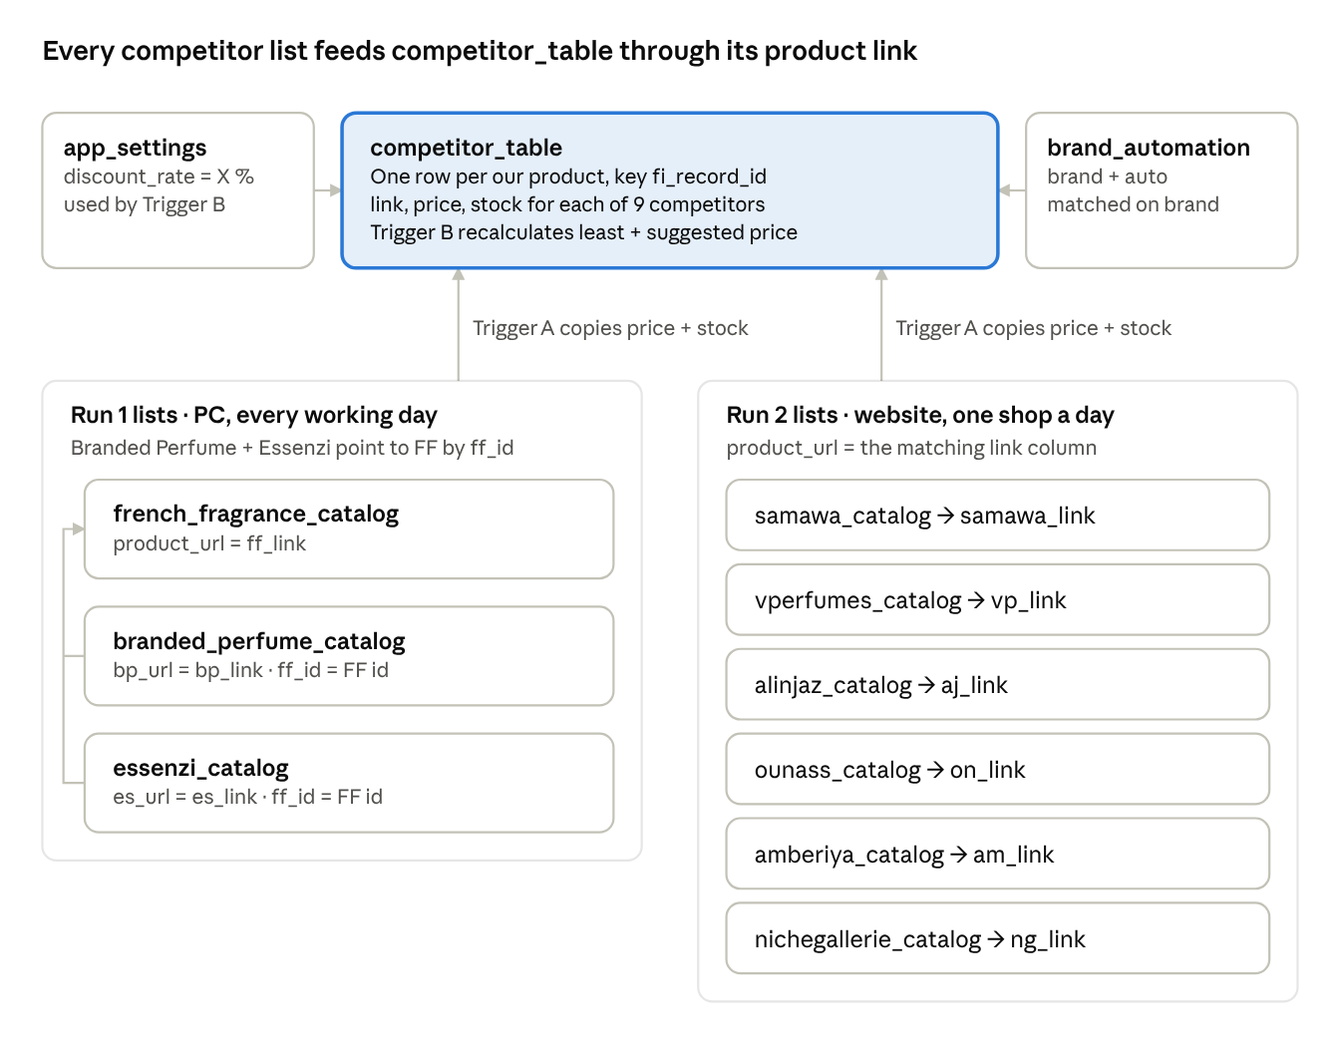

Indexes
Table | Unique (no duplicates allowed) | Search indexes
competitor_table | id, fi_record_id | sku, brand, and one per competitor link: samawa_link, ff_link, vp_link, aj_link, on_link, am_link, ng_link, aq_link, jm_link, ah_link, jz_link, an_link, ao_link, br_link, ep_link, kh_link, mh_link, oe_link, pd_link, rf_link, bp_link, es_link (used by the triggers)
french_fragrance_catalog | id, airtable_record_id | gtin
branded_perfume_catalog | id, ff_id | gtin
essenzi_catalog | id, ff_id | gtin
samawa_catalog | id, variant_id | gtin
amberiya_catalog | id, variant_id | —
vperfumes_catalog | id, product_url | —
alinjaz_catalog | id, product_url | —
ounass_catalog | id, product_url | —
nichegallerie_catalog | id, product_url | —
app_settings | key | —
brand_automation | brand | —
app_users | username | —
price_check_runs | run_id | —
price_check_log | id | run_id; fi_record_id + checked_at
price_check_progress | fi_record_id | —
test_price_backup | ff_link | —
13 newer shop lists (abdulsamad_catalog, ajmal_catalog, alharamain_catalog, aljazeera_catalog, anfasic_catalog, arabianoud_catalog, brandsperfume_catalog, emiratespride_catalog, khaltat_catalog, mhgboutique_catalog, oudelite_catalog, perfumedubai_catalog, reefperfumes_catalog) | id, variant_id | —
brand_discount | brand_key | —
item_master | fi_record_id | sku
item_master_deleted | fi_record_id | —
item_options | field + lower(value) | —
brand_sku | brand, lower(brand) | —
button_runs | id | fi_record_id

