Database Systems Lab
Deliverable 2
FAST INFINITY: Campus Life Simulator

Group Members:
- Muhammad Moosa (24L-0561)
- Sheikh Ahsan Omer (24L-3062)
- Eman Jameel (24L-0556)

Description:
FAST Infinity is a comprehensive database-driven system designed to simulate essential campus operations within a virtual university environment. The system connects multiple modules into one unified platform: Campus Simulation Interface, E-Sports Gaming Center, Cafeteria Management System, Bookshop Management System, and a Wallet & Transaction System

Question 1:

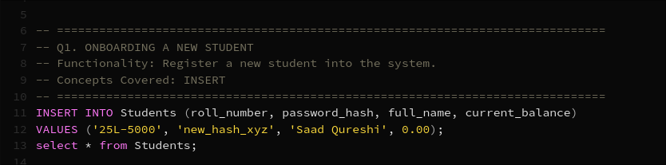

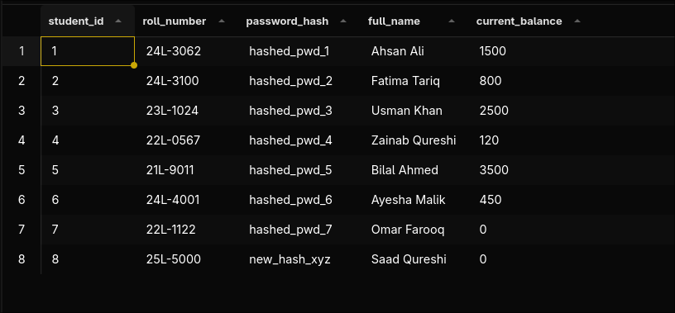

Question 2:

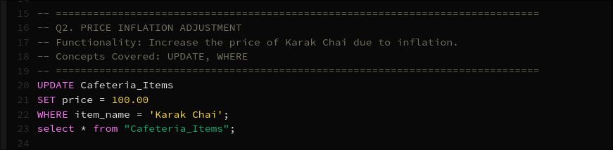

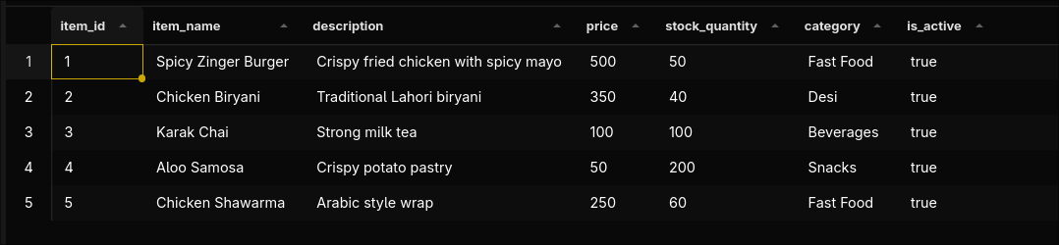

Question 3:

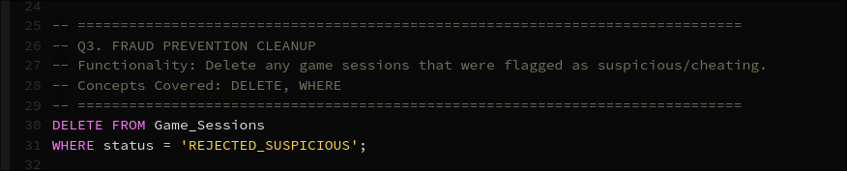

Question 4:

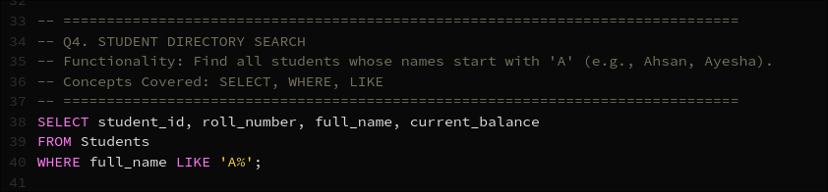

Question 5:

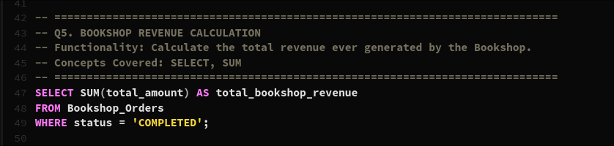



Question 6:

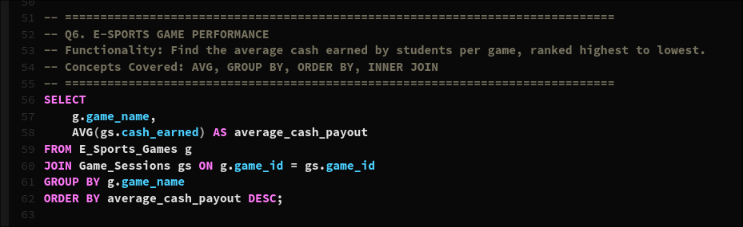

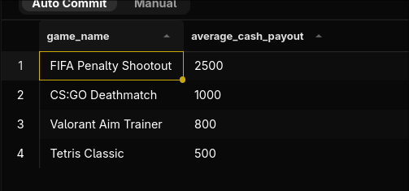

Question 7:

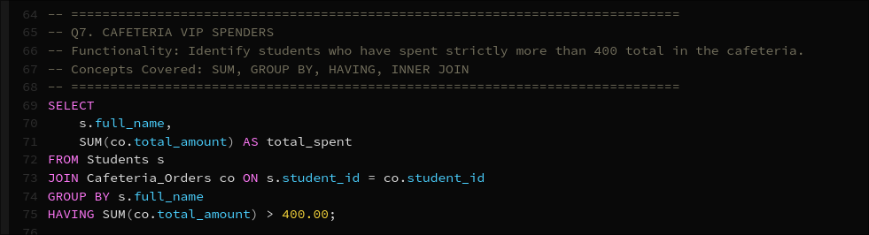

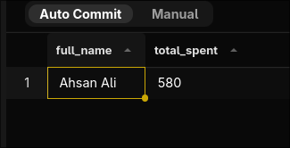

Question 8:

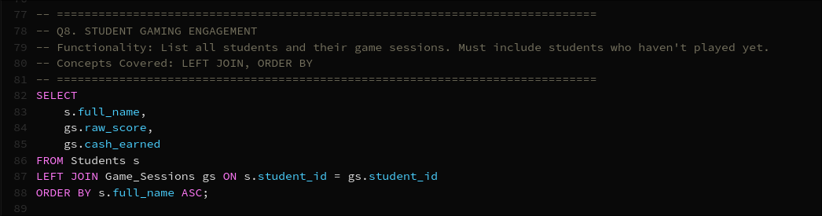



Question 9:

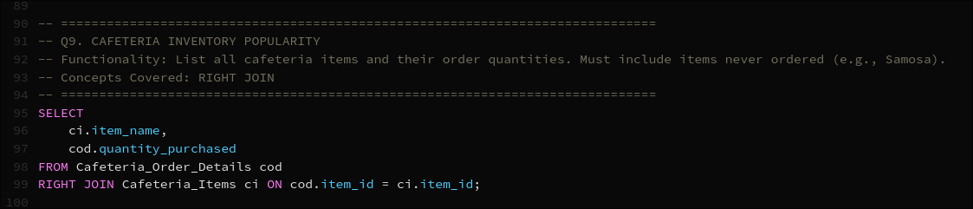

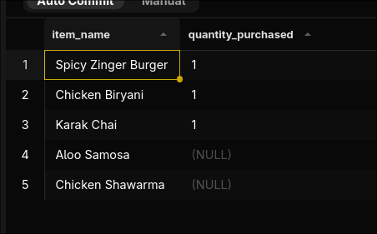

Question 10:

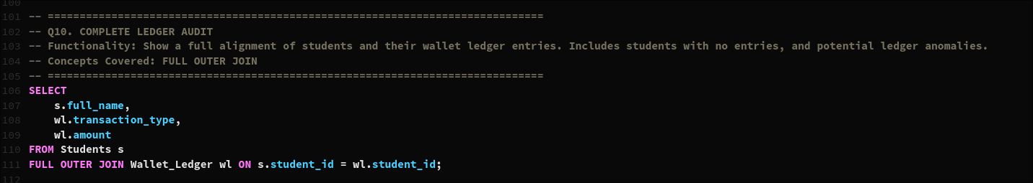

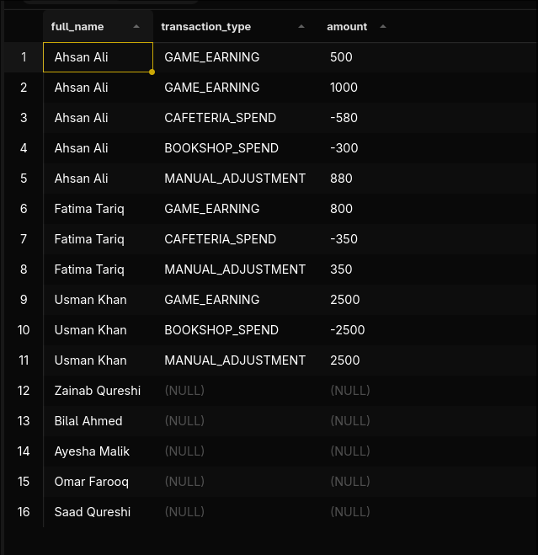

Question 11:

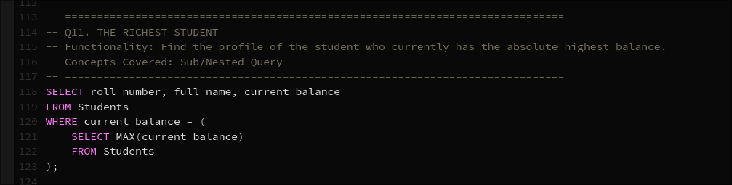



Question 12

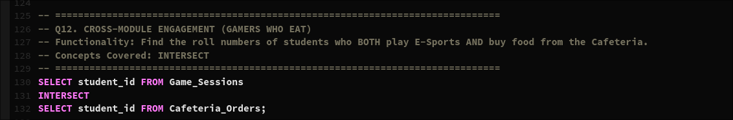

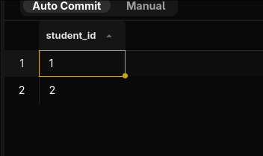

Question 13

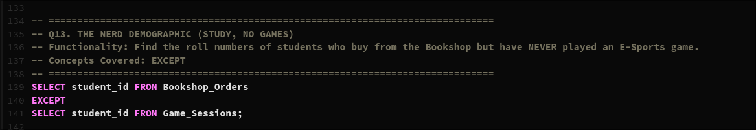



Question 14:

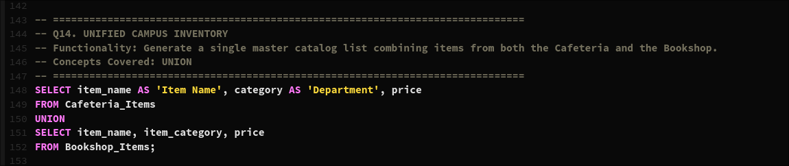

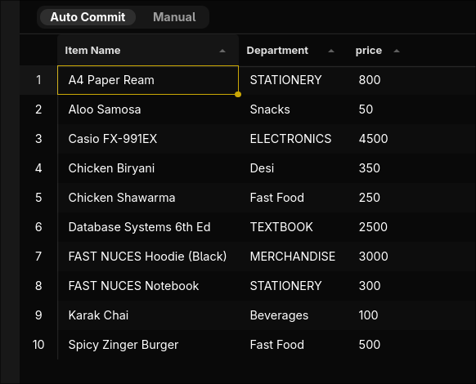

Question 15

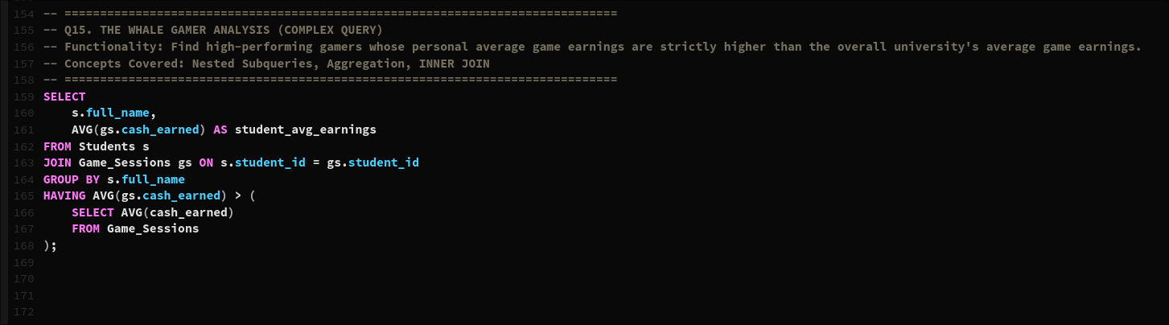



Question 16

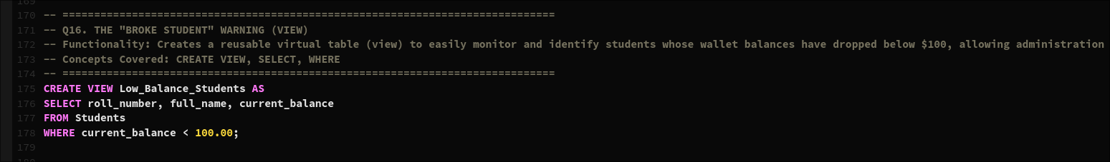

Question 17

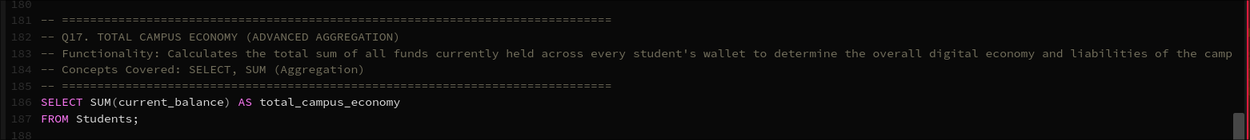

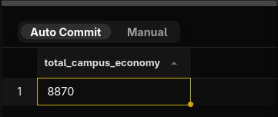

Question 18

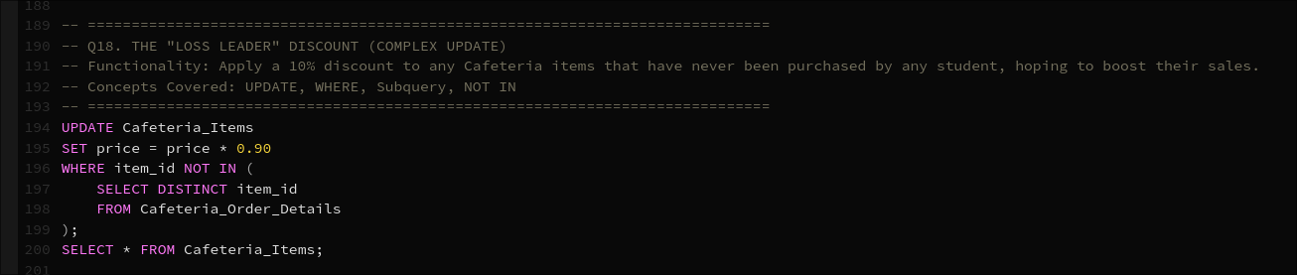

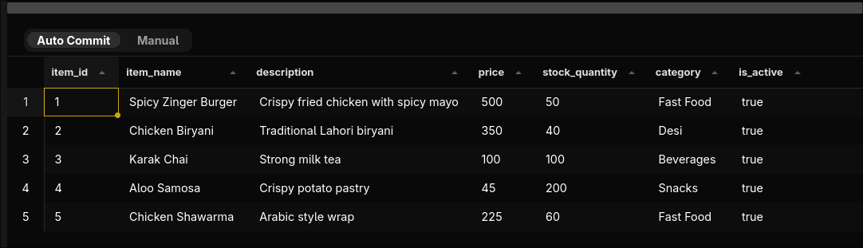

Question 19

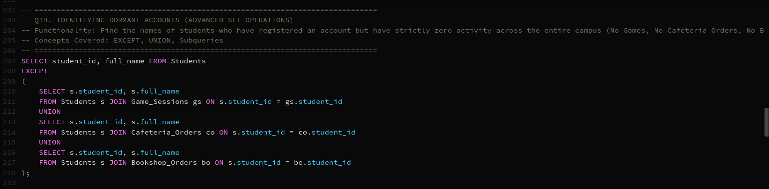

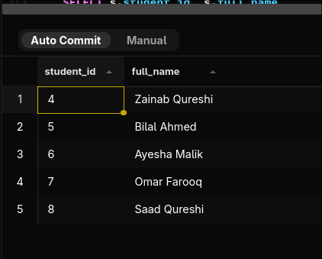

Question 20

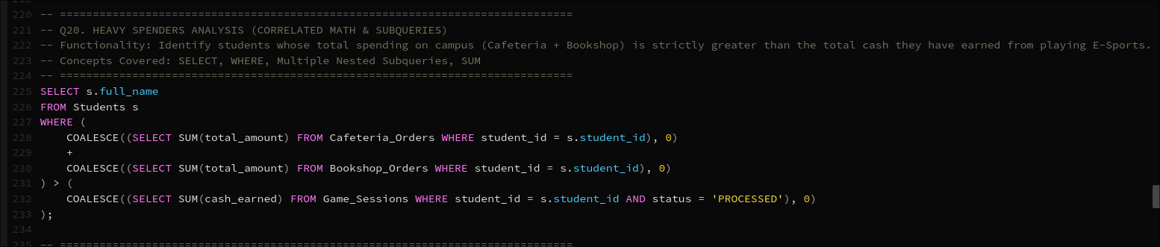



Question 21

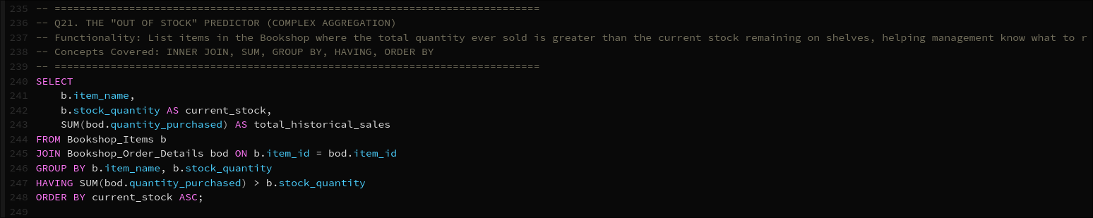

Question 22

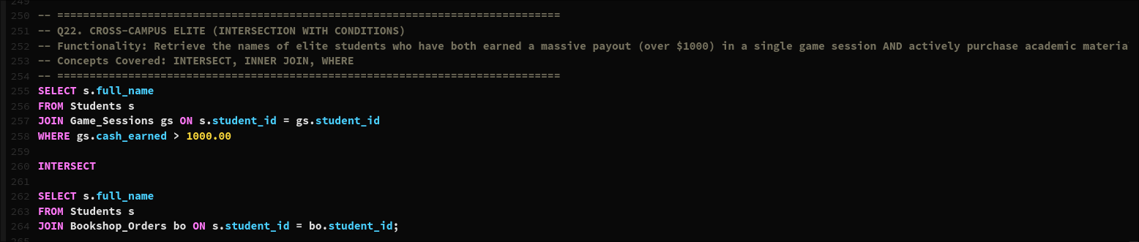

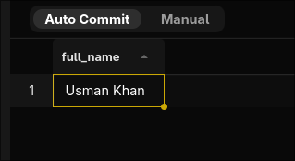

Question 23

