Introduction

I am making some simple web pages as our Eastern University.

Description

My webpages are Eu homepage(index.html),Degree Requirements(Ahsan.html),About Us(Site Designers[about_us.html]),login page(login.html) ,Student Homepage(home.html).  
for building this i am using  
1.Html   
2.Css  
3.Bootstrap 4.0 , 4.1  
4.js{ for a few case}

Code (Only your part)  
Considering Eu homepage(index.html) and login page(login.html) As default.

My Works are:

***About_us.html  
 Ahsan.html  
 home.html***what have you learnt  
While Completing the project i have learned   
i) Many properties of css,  
ii) Responsive css,  
iii)use of source img,   
iv) Bootsrap 4, etc

References  
i) <https://www.w3schools.com/css/>  
ii) <https://www.w3schools.com/bootstrap4/>  
iii) <https://getbootstrap.com/docs/4.0/getting-started/introduction/>  
iv)<https://www.google.com/search?rlz=1C1CHZL_enBD716BD716&q=css+color+picker&sa=X&ved=0ahUKEwjD85aAg_LcAhWIKo8KHd_pAvAQ1QIIqQEoAA&biw=1032&bih=365>  
v) <https://www.w3schools.com/colors/colors_picker.asp>  
vi)<https://www.google.com/search?q=eastern+university+campus+logo+bd&rlz=1C1CHZL_enBD716BD716&source=lnms&tbm=isch&sa=X&ved=0ahUKEwjG5qSOyfjcAhUDqo8KHQ-zBfUQ_AUICigB&biw=1137&bih=204>

Images  
 Degree Requirements:  


Here this page is degree requirement. This page is designed by bootstrap 4[mostly] with inline and external Css files.  
this contains header main-body and footer.

About Us  
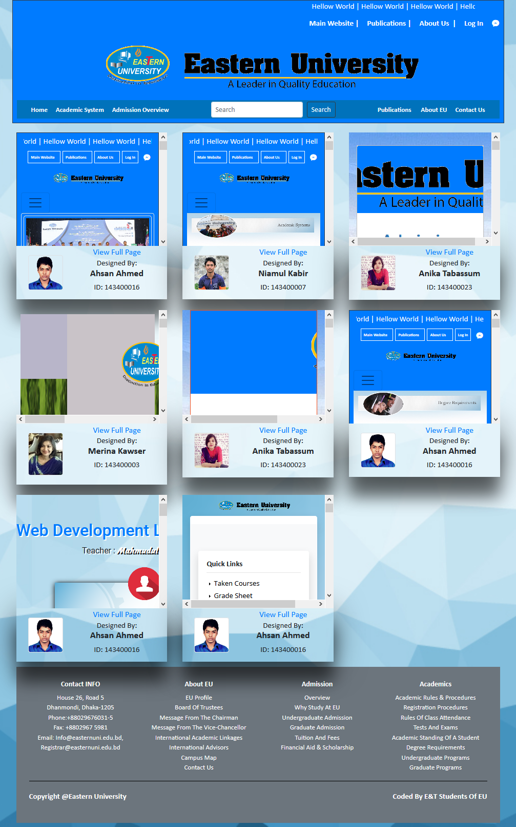  
this Page contains the Overall View of work. Who has done which work is clearly declared here.  
and this also contains a particular view[small overview] of its [each] pages.

Home page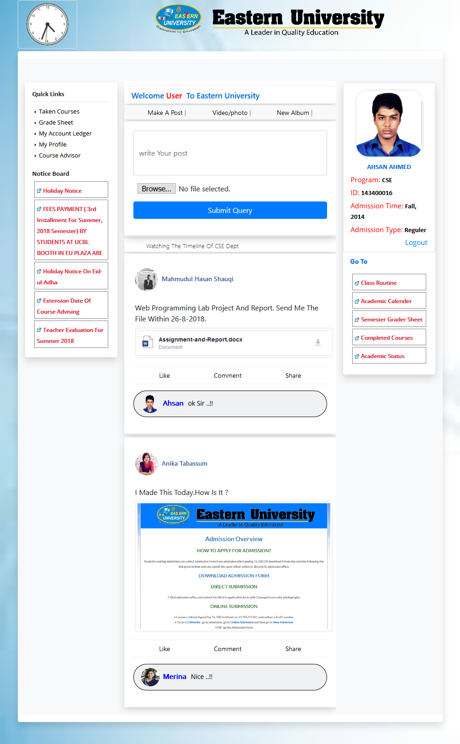  
After Successfully Login a person can access this page.  
1.this page will contain his/her profile.  
2.notice given by university.  
3.class Routine.  
4.results or marksheet  
5.Own department[ Student/teacher ] posts.  
6.s/he can share their important posts  
7.like,comment, on those posts.

conclusion.

Made this site for the reason is to show the site more attractive and useful to the viewers and also for the learning Puppose.