Introduction :

I am making a simple web page as our University (Eastern University) Navbar: About EU >EU Profile.

Description:

Here, I am using these programming languages:

**1.** HTML

**2.** CSS

**1 Description of HTML Portion with Code:**

I am dividing this whole page into two section using html tags **1.** <div id=”left”> </div> and **2.** <div id=”right”></div> .

**Left-portion ( <div id=”left”> </div> ) :** In this section ; there are two contents

1. Image “eastern university campus image ” where width and height are set like this <img

src="EU.jpg" width="600" height="2500" >

1. and “Eastern University at a Glance “which is represented this <h3> </h3> tag. And

showing this text vertically using <br> tag each & every letters.

**Right-portion (<div id=”right”></div> ) :** In this right portion there are using many html tags and image

**1.** Image “Eastern university text image with logo” is defined as <div id="heading"><img src="eu.png" width="660" height="200" ></div>

**2.** All the main text are listed with <li> </li> tags

Like ( same as EU Profile from Eastern university website ) :

<li>History, Vision and Mission</li>

<li>Governance and Administration</li> and so on…………..

**3.** Each <li> </li> tag contains <p> </p> (paragraph) tag and <b></b> ( bold ) tag and using <br> tag for new line.

Like ( same as EU Profile from Eastern university website ) :

<li>Centres and Cells</li>

<p>The University has four specialized centres and two cells: Centre for Modern Languages, Centre ………………………….. and so on……..

4. here using hraf text for back to top of the page like this <a href="#top">Back to Top</a>

**2 Description of CSS Portion with Code:**

In CSS <style> </style> :

There are two id selectors are named as

**1.** #left and

**2.** #right

And five element selectors are :

**1.** h3 (heading tag ),

**2.** a ( links ),

**3.** b ( bold tag ), and

**4.** p ( paragraph tag) .

**5.** li **(** list tag **)**

**Id selctor #left :** here using four CSS property

**<style>**

**#left {**

**float** : left ;  **/\*** the float property is used for positioning and layout on web pages and all the

elements of float left should be the left side . **\*/**

**width : 35 % ;**

**height : 470 em ;** **/\*** the height and width properties are used to set the height and width of the

element . and length are used % (relative to the parent element) and em

(relative to the font size of the element eg. 2 em means 2 times the size of the

current font) . **\*/**

**background-color: #b8b5c9;** **/\*** background color is set to be this color code (

color code reference is given at the last page ) **\*/**

**}**

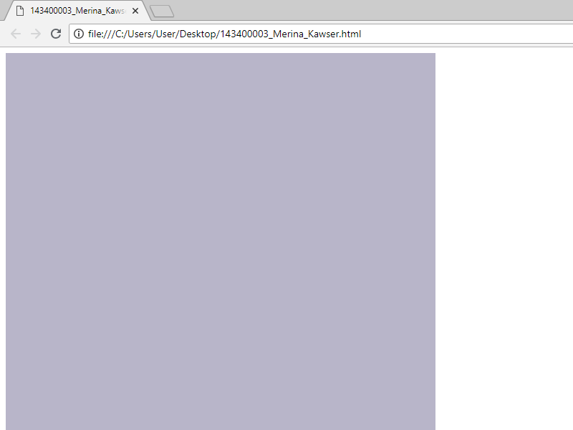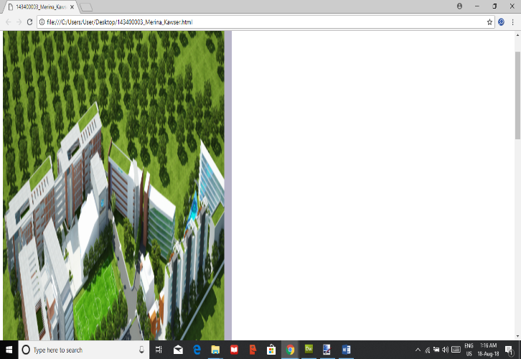

**Figure : left portion figure : left-portion (Image)**

**Id selector #right :**

**#right {**

**float : right ; /\*** the float property is used for positioning and layout on web pages and

all the elements of float right should be the right side . **\*/**

**width : 65 % ;**

**height : 470 em ; /\*** the height and width properties are used to set the height and width of

the element . and length are used % (relative to the parent element)

and em (relative to the font size of the element eg. 2 em means 2 times

size of the current font) . **\*/**

**background-color : #c9c3c8 ; /\*** background color is set to be this color code (color

code link is given at the last page ) **\*/**

**list-style:inside ; /\*** in the html segment there is listed element are defined as **<li> </li>** tag. So

the reason is all the listed element text should be the inside oh the right portion **\*/**

**}**

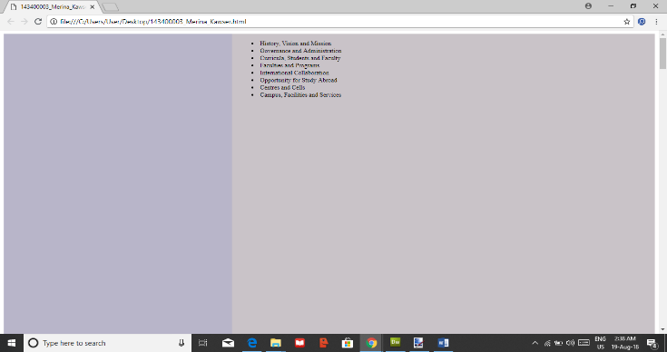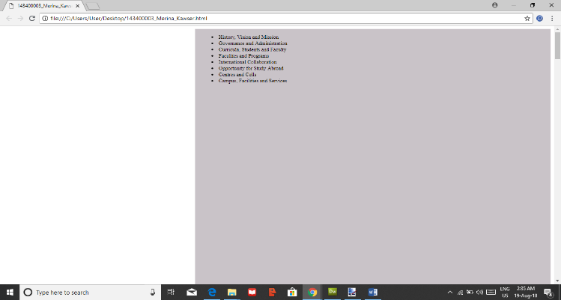

**Figure : right portion Figure : left-right portion**

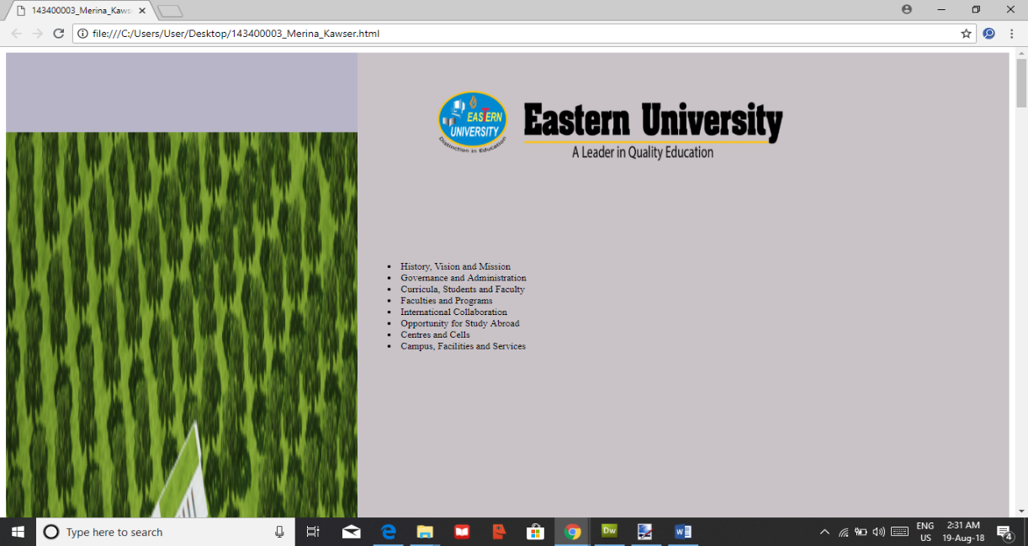

**Figure : left-right-portion (image)**

**Element selector h3 :**

**h3 {**

**text-transform:uppercase; /\*** transform properties define the text is in upper or lower case

here text is in the upper case **\*/**

**font-size: 50px; /\*** font properties define the font family, boldness, size

and the text of a style. Here setting the text size **\*/**

**text-align:center; /\*** “Eastern University at a Glance” text is in the center of left portion **\*/**

**color: #543f3f; /\*** set the text color (color code link is in the last page) **\*/**

**}**

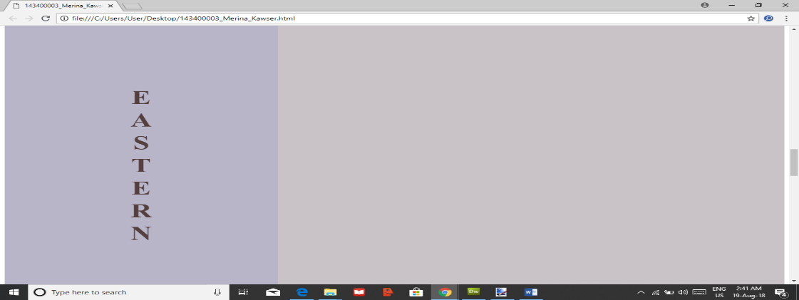

**Figure : <h3> Eastern University at a Glance </h3>**

**Element selector li :**

**li {**

**text-align:center; /\*** all the listed text is in the center of right portion **\*/**

**color: #6b2626; /\*** set the text color (color code link is in the last page) **\*/**

**font-weight: bold; /\*** here font properties define the boldness **\*/**

**font-size: 20px; /\*** font properties define the font family, boldness, size

and the text of a style. Here setting the text size **\*/**

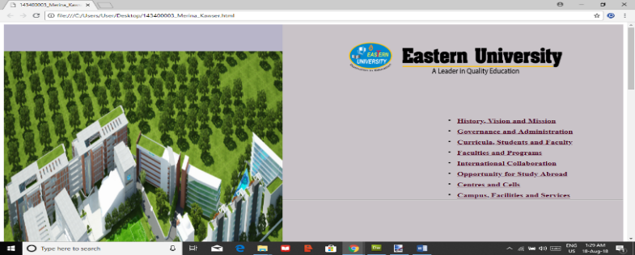 **}**

**Figure : adding (<style> li { }</style>)**

**Element selector p :**

**p {**

**color:#59424; /\*** setting the color of text paragraph **\*/**

**font-size: 18px; /\*** font properties defines the text size **\*/**

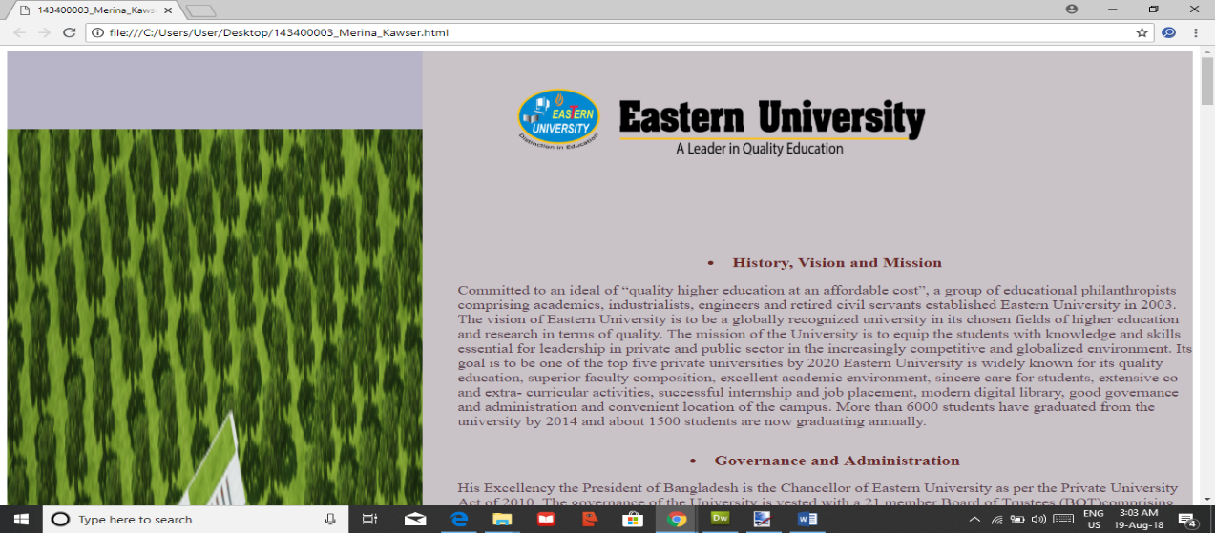 **}**

**Figure : adding (<style> p{ }</style>)**

**Element selector b :**

**b**

**{**

**color: #ad3765; /\*** set the color of bold text **\*/**

**}**

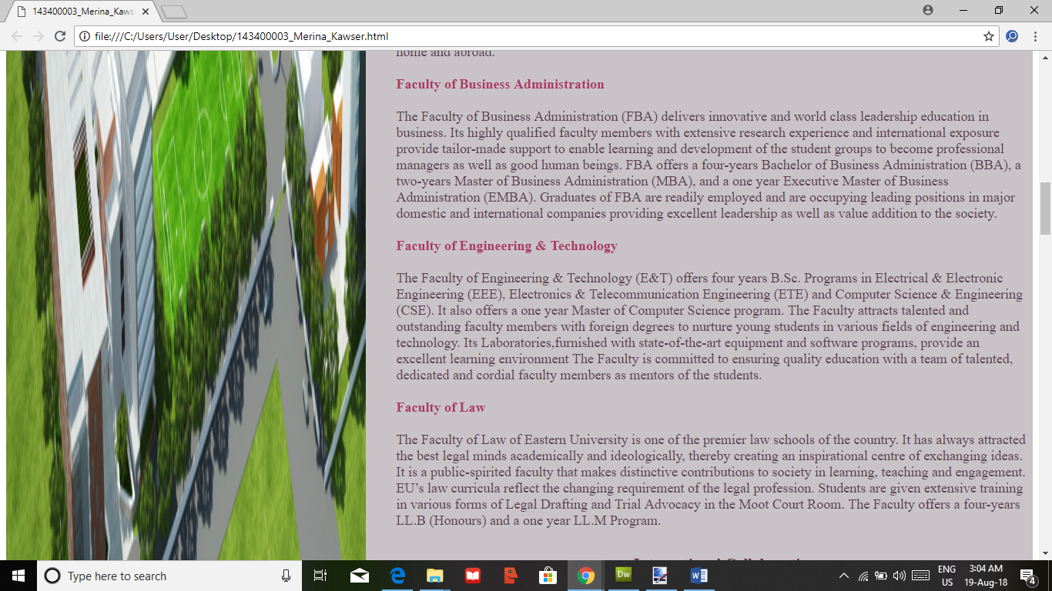

**Figure : adding (<style> b{ }</style>)**

**Element selector a :**

**a {**

**color: #070000; /\*** set the color of hyper-link text **\*/**

**font-size: 18px; /\*** font properties define the font family, boldness, size

and the text of a style. Here setting the text size **\*/**

**font-weight: bold; /\*** here font properties define the boldness **\*/**

**}**

**</style>**

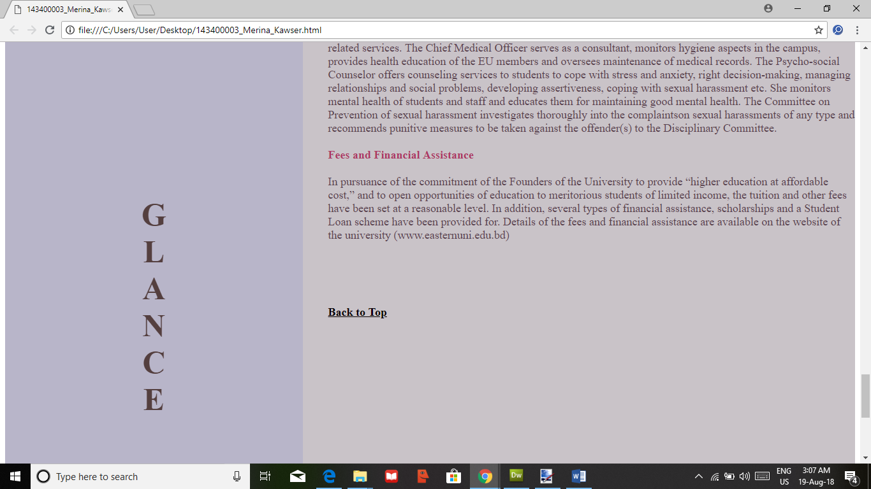

**Figure : adding (<style> a { } </style>) Back to Top**

**Conclusion :**

Making this site for the reason is to show the site attractive way to the viewers.

**References:**

**[1]https://www.google.com/search?rlz=1C1CHZL_enBD716BD716&q=css+color+picker&sa=X&ved=0ahUKEwjD85aAg_LcAhWIKo8KHd_pAvAQ1QIIqQEoAA&biw=1032&bih=365**

**[ color code]**

**[2]**[**https://www.google.com/search?q=eastern+university+campus+logo+bd&rlz=1C1CHZL_enBD716BD716&source=lnms&tbm=isch&sa=X&ved=0ahUKEwjG5qSOyfjcAhUDqo8KHQ-zBfUQ_AUICigB&biw=1137&bih=204**](https://www.google.com/search?q=eastern+university+campus+logo+bd&rlz=1C1CHZL_enBD716BD716&source=lnms&tbm=isch&sa=X&ved=0ahUKEwjG5qSOyfjcAhUDqo8KHQ-zBfUQ_AUICigB&biw=1137&bih=204) **[ versity images ]**

**[3]** [**https://www.w3schools.com/**](https://www.w3schools.com/) **[ css properties ]**