Introduction :

I am making a simple web page as our University (Eastern University) Navbar: About EU > Admission Overview and Contact Us .

Description:

*Front-end Design:*

• HTML5

• CSS3

• Bootstrap Framework (for responsiveness)

**1 Description of HTML & Bootstrap Portion with Code:**

* I am using "**Bootstrap Grid Sustem " : <div class="col-sm-12 col-xs-12">** .
* **<div class="panel panel-default text-center">** That use for making a panel and text will be shown in center.A panel in bootstrap is a bordered box with some padding around its content.
* **<div class="panel-body"> :** Panels are created with the .panel class, and content inside the panel has a .panel-body class. The .panel-default class is used to style the color of the panel.
* **<h1 class="display-4 text-center text-capitalize text-primary font-weight-bold"></h1>** : Text will be shown in center , capital letter , blod and text will be blue color for (**text-primary)** option.
* **<h2 class="text-center text-success" ></h2> :** Text color will be green and display in center.
* **<footer> :** Bootstrap footer is an additional navigation for the website. It can hold links, buttons, company info, copyrights, forms and many other elements.
* **<footer class="container-fluid text-center">** : Choose from a responsive, fixed-width container (meaning its max-width changes at each breakpoint) or fluid-width (meaning it's 100% wide all the time).
* **"glyphicon glyphicon-chevron-up"** : Glyphicons Bootstrap provides 260 glyphicons from the Glyphicons Halflings set. Glyphicons can be used in text, buttons, toolbars, navigation, forms, etc.Glyphicons Halflings are normally not available for free, but their creator has made them available for Bootstrap free of cost. And here use for up symbol.
* **<p>Copyright <a href="http://www.easternuni.edu.bd/" title="Visit Eastern University"></a></p>** : that will shown copyright from here and orginal site page .
* **background-image:url(eu.jpg) :** using in background .
* Each <p> </p> (paragraph) tag and <strong></strong>( bold ) tag and using <br> tag for new line.

Like ( same as EU Profile from Eastern university website ) :

**<p class="text-center text-dark"><strong>**

**Candidates having total GPA 7.0 in SSC & HSC or equivalent will be exempted from admission test.** **</strong></p>** ………………………….. and so on……..

* Here using hraf text for back to top of the page like **this <a href="#myPage" title="To Top"></a>**

**2 Description of CSS Portion with Code:**

In CSS <style> </style> :

And five element selectors are :

**1.** **h1,h2,h3,h4** (heading tag ),

**2.** **a** ( links ),

**3.** **strong** ( bold tag ), and

**4.** **p** ( paragraph tag) .

**3. Bootstrap Panels , Footer :**

**<style>**

**.panel-heading {**

**color: #FFCC33 !important;/\*** set the text color (color code link is in the last page) **\*/**

**padding: 25px;**

**border-bottom: 1px solid transparent;**

**border-top-left-radius: 0px;**

**border-top-right-radius: 0px;**

**border-bottom-left-radius: 0px;**

**border-bottom-right-radius: 0px;**

**background-image:url(eu.png)!important;**

**background-size:cover;**

**}**

**.panel-footer {**

**background-color: #0033FF !important;/\*** background color is set to be this color code (

color code reference is given at the last page ) **\*/**

**}**

**.panel-footer h3 {**

**font-size: 32px; /\*** font properties define the font family, boldness, size

and the text of a style. Here setting the text size **\*/**

**}**

**.panel-footer h4 {**

**color: #aaa;/\*** set the text color (color code link is in the last page) **\*/**

**font-size: 14px;/\*** font properties define the font family, boldness, size

and the text of a style. Here setting the text size **\*/**

**}**

**footer .glyphicon {**

**font-size: 20px;/\*** font properties define the font family, boldness, size

and the text of a style. Here setting the text size **\*/**

**margin-bottom: 20px;**

**color: #f4511e;**

**} .container-fluid {**

**padding: 60px 50px;**

**}**

**</style>**

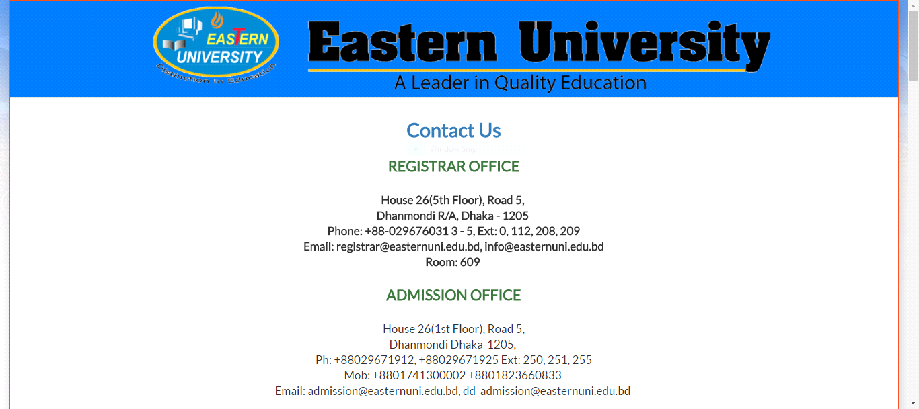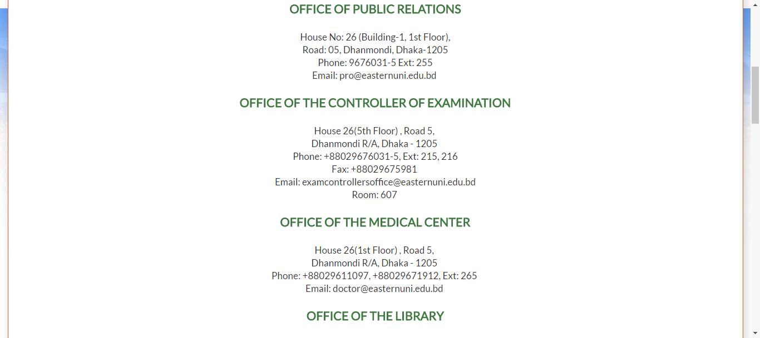￼￼

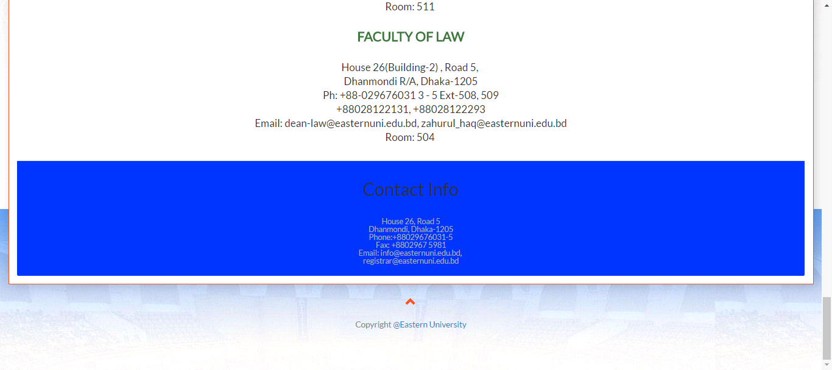

**Figure : Top portion - middle portion - bottom portion of "Contact us" page .**

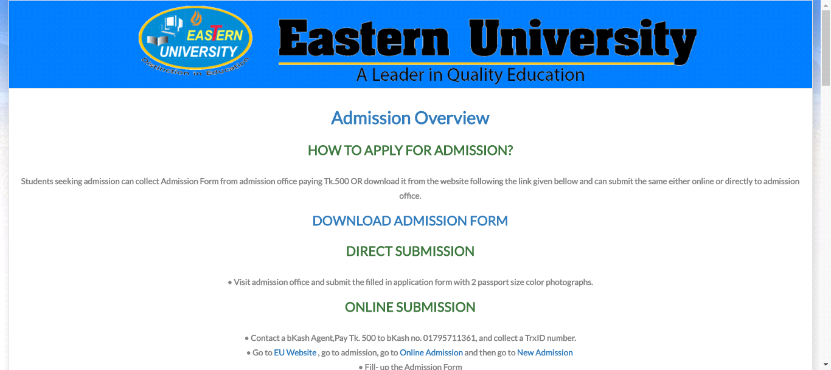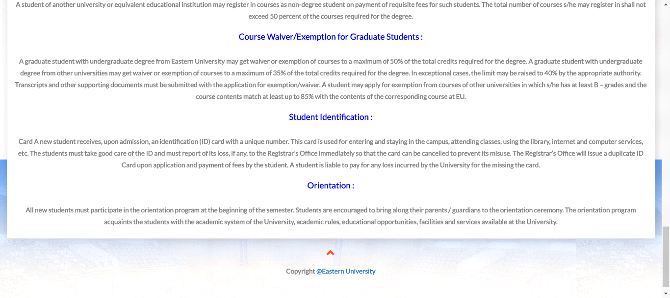

**Figure : Top portion - bottom portion of "Addmission Overview" page .**

**Conclusion :**

Making this site for the reason is to show the site attractive way to the viewers.

**References:**

**[1]http://www.easternuni.edu.bd/**

**[ For Collecting Information ]**

**[2]**[**https://www.google.com/search?q=eastern+university+campus+logo+bdHYPERLINK "https://www.google.com/search?q=eastern+university+campus+logo+bd&rlz=1C1CHZL_enBD716BD716&source=lnms&tbm=isch&sa=X&ved=0ahUKEwjG5qSOyfjcAhUDqo8KHQ-zBfUQ_AUICigB&biw=1137&bih=204"&HYPERLINK "https://www.google.com/search?q=eastern+university+campus+logo+bd&rlz=1C1CHZL_enBD716BD716&source=lnms&tbm=isch&sa=X&ved=0ahUKEwjG5qSOyfjcAhUDqo8KHQ-zBfUQ_AUICigB&biw=1137&bih=204"rlz=1C1CHZL_enBD716BD716HYPERLINK "https://www.google.com/search?q=eastern+university+campus+logo+bd&rlz=1C1CHZL_enBD716BD716&source=lnms&tbm=isch&sa=X&ved=0ahUKEwjG5qSOyfjcAhUDqo8KHQ-zBfUQ_AUICigB&biw=1137&bih=204"&HYPERLINK "https://www.google.com/search?q=eastern+university+campus+logo+bd&rlz=1C1CHZL_enBD716BD716&source=lnms&tbm=isch&sa=X&ved=0ahUKEwjG5qSOyfjcAhUDqo8KHQ-zBfUQ_AUICigB&biw=1137&bih=204"source=lnmsHYPERLINK "https://www.google.com/search?q=eastern+university+campus+logo+bd&rlz=1C1CHZL_enBD716BD716&source=lnms&tbm=isch&sa=X&ved=0ahUKEwjG5qSOyfjcAhUDqo8KHQ-zBfUQ_AUICigB&biw=1137&bih=204"&HYPERLINK "https://www.google.com/search?q=eastern+university+campus+logo+bd&rlz=1C1CHZL_enBD716BD716&source=lnms&tbm=isch&sa=X&ved=0ahUKEwjG5qSOyfjcAhUDqo8KHQ-zBfUQ_AUICigB&biw=1137&bih=204"tbm=ischHYPERLINK "https://www.google.com/search?q=eastern+university+campus+logo+bd&rlz=1C1CHZL_enBD716BD716&source=lnms&tbm=isch&sa=X&ved=0ahUKEwjG5qSOyfjcAhUDqo8KHQ-zBfUQ_AUICigB&biw=1137&bih=204"&HYPERLINK "https://www.google.com/search?q=eastern+university+campus+logo+bd&rlz=1C1CHZL_enBD716BD716&source=lnms&tbm=isch&sa=X&ved=0ahUKEwjG5qSOyfjcAhUDqo8KHQ-zBfUQ_AUICigB&biw=1137&bih=204"sa=XHYPERLINK "https://www.google.com/search?q=eastern+university+campus+logo+bd&rlz=1C1CHZL_enBD716BD716&source=lnms&tbm=isch&sa=X&ved=0ahUKEwjG5qSOyfjcAhUDqo8KHQ-zBfUQ_AUICigB&biw=1137&bih=204"&HYPERLINK "https://www.google.com/search?q=eastern+university+campus+logo+bd&rlz=1C1CHZL_enBD716BD716&source=lnms&tbm=isch&sa=X&ved=0ahUKEwjG5qSOyfjcAhUDqo8KHQ-zBfUQ_AUICigB&biw=1137&bih=204"ved=0ahUKEwjG5qSOyfjcAhUDqo8KHQ-zBfUQ_AUICigBHYPERLINK "https://www.google.com/search?q=eastern+university+campus+logo+bd&rlz=1C1CHZL_enBD716BD716&source=lnms&tbm=isch&sa=X&ved=0ahUKEwjG5qSOyfjcAhUDqo8KHQ-zBfUQ_AUICigB&biw=1137&bih=204"&HYPERLINK "https://www.google.com/search?q=eastern+university+campus+logo+bd&rlz=1C1CHZL_enBD716BD716&source=lnms&tbm=isch&sa=X&ved=0ahUKEwjG5qSOyfjcAhUDqo8KHQ-zBfUQ_AUICigB&biw=1137&bih=204"biw=1137HYPERLINK "https://www.google.com/search?q=eastern+university+campus+logo+bd&rlz=1C1CHZL_enBD716BD716&source=lnms&tbm=isch&sa=X&ved=0ahUKEwjG5qSOyfjcAhUDqo8KHQ-zBfUQ_AUICigB&biw=1137&bih=204"&HYPERLINK "https://www.google.com/search?q=eastern+university+campus+logo+bd&rlz=1C1CHZL_enBD716BD716&source=lnms&tbm=isch&sa=X&ved=0ahUKEwjG5qSOyfjcAhUDqo8KHQ-zBfUQ_AUICigB&biw=1137&bih=204"bih=204**](https://www.google.com/search?q=eastern+university+campus+logo+bd&rlz=1C1CHZL_enBD716BD716&source=lnms&tbm=isch&sa=X&ved=0ahUKEwjG5qSOyfjcAhUDqo8KHQ-zBfUQ_AUICigB&biw=1137&bih=204)

**[ versity images ]**

**[3]** [**https://www.w3schools.com/**](https://www.w3schools.com/) **[ Bootstrap properties ]**