Fundamentals of Programming

Lab Manual-3

Home Tasks

Ahsan Kamran (481898)

1. Write a C++ program to print the total number of populations in Punjab, Sindh, KPK, and Balochistan using a switch case.

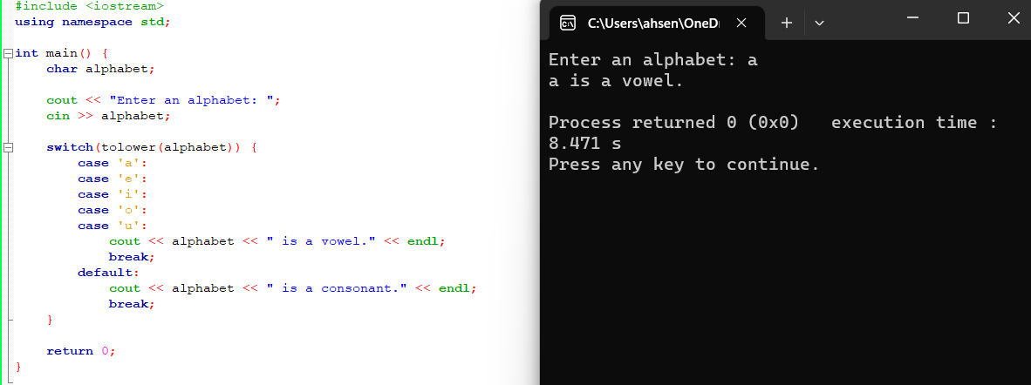2. Write a C++ program to check whether an alphabet is a vowel or consonant using a switch case.

3. Write a C++ program to check whether a number is positive, negative, or zero using a switch case.

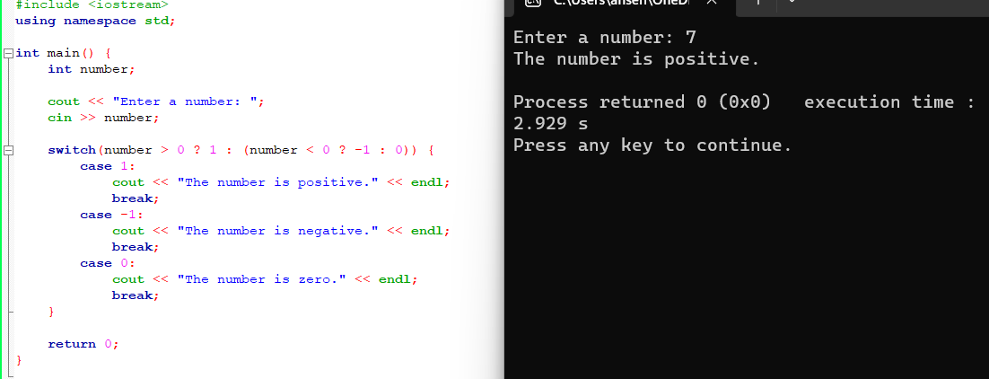

4. Write a C++ to find out whether a person is an adult, teenager, or child using nested if-else.

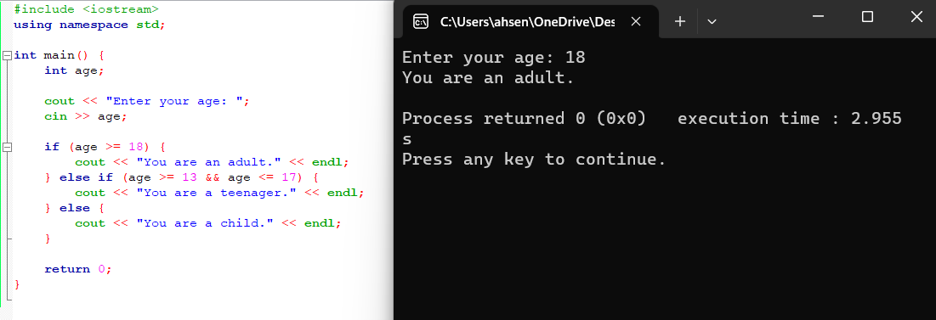

5. Write a C++ program that takes three number from the user and find the greatest number out of the three numbers using nested if-else statements.

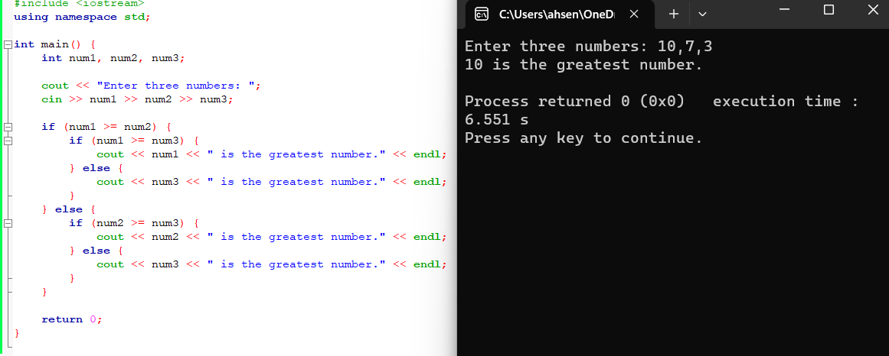

6. Write a C++ program to check whether the alphabet entered by the user is Vowel or Consonant using nested if-else.

