Muhammad Tayyab

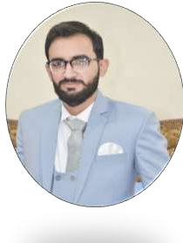

# Contact

 **Address:**

Al Hamad Hostel Wahdat Road Lahore

 **Phone:**

03041517931

 **Email:**

[tayyabarine@gmail.com](mailto:tayyabarine@gmail.com)

**Gender:** Male

**Date of birth:** 21 November 1997

**Nationality:** Pakistani

# Languages

Urdu Punjabi English

# Summary

Web Developer specializing in front end development. All stages of the development cycle for web projects. Well-versed in numerous programming languages including HTML5, PHP, CSS, MySQL. Strong background in project management and customer relations.

# Skill Highlights

* MS Office (Word, Excel, power Point )
* Basic Web development(HTML,CSS, Bootstrap)
* Ability to motivate staff and maintain good relations
* Good manners

# Education

**Master of Computer Science(M.Sc(CS**) 2018–2020

Department of Computer Science, **University of Agriculture, Faisalabad**, Pakistan

Major subjects: Operating system, Database Management system, C++, JAVA, Assembly language, compiler theory

**Bachelor of Science(ADP(IT))** 2015–2017

**University of central Punjab**, Okara, Pakistan

Major subjects: Computer Science, Mathematics, Economics,

**Intermediate(ICS)** 2013–2015

Board of Intermediate and Secondary Education, Sahiwal. Major subjects: Computer Science, Mathematics, Physics

**Matriculation** 2011-2013

Board of Intermediate and Secondary Education, Sahiwal. Major subjects: Physics, Chemistry, Biology

# Experience

**Supervisor:** 2017–2018

Image Garments (Pvt.) Ltd. 11 KM Satyana Road. Faisalabad Pakistan.

# References

**Dr.Salman Asfar**

Head of Department of Computer Science,University of Agriculture, Faisalabad,Pakistan