**CSE-102(A1)**

**How To Submit:**

* Create a folder 1605xxx (for example, 1605001)
* Put all the source codes inside the folder.
* Zip the folder. The name of the zip file should be 1605xxx.zip
* Upload in moodle.

*If you are still facing difficulty using moodle, bring your source codes in the sessional class and submit to any of the teachers within 11:10 AM. Anyway, uploading in moodle is preferred.

**Offline 1**

1. Write a function **factorial** which takes a number(nonnegative integer) as input and prints the factorial of that number. The prototype of the function should be:

**int *factorial* (int *n*);**

2. Now use the **factorial** function to compute ***ⁿ $C_{r}$*** , number of possible selections of ***r*** items from ***n*** different items. The prototype of this function should be:

**long int *nCr* (int *n* ,int *r*);**

3. The rows of Pascal's triangle are conventionally enumerated starting with row *n* = 0 at the top (the 0th row). The entries in each row are numbered from the left beginning with *k* = 0 and are usually staggered relative to the numbers in the adjacent rows. The triangle may be constructed in the following manner: In row 0 (the topmost row), there is a unique nonzero entry 1. Each entry of each subsequent row is constructed by adding the number above and to the left with the number above and to the right, treating blank entries as 0. For example, the initial number in the first (or any other) row is 1 (the sum of 0 and 1), whereas the numbers 1 and 3 in the third row are added to produce the number 4 in the fourth row.

The entry in the $n^{th}$  row and $k^{th}$  column of Pascal's triangle is denoted {\displaystyle {\tbinom {n}{k}}}by ***ⁿ***.

­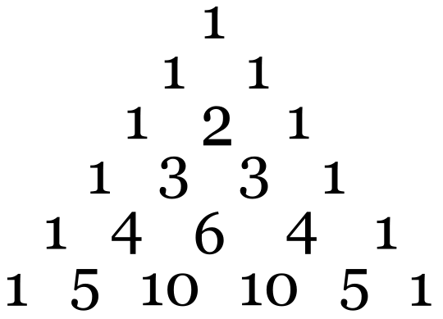

Figure

Write a C code to display Pascal’s triangle as in Figure 1.

4. In mathematics, the **Fibonacci numbers** are the numbers in the following [integer sequence](https://en.wikipedia.org/wiki/Integer_sequence), called the **Fibonacci sequence**, and characterized by the fact that every number after the first two is the sum of the two preceding ones. First few terms of this series is given below:

1, 1, 2, 3, 5, 8 …

{\displaystyle 1,\;1,\;2,\;3,\;5,\;8,\;13,\;21,\;34,\;55,\;89,\;144,\;\ldots \;}

If the rows of Pascal's triangle are left-justified, the diagonal bands (colour-coded in the figure) sum to the **Fibonacci Numbers**.

|  |
| --- |
| 1 |
| 1 | 1 |
| 1 | 2 | 1 |
| 1 | 3 | 3 | 1 |
| 1 | 4 | 6 | 4 | 1 |
| 1 | 5 | 10 | 10 | 5 | 1 |
| 1 | 6 | 15 | 20 | 15 | 6 | 1 |
| 1 | 7 | 21 | 35 | 35 | 21 | 7 | 1 |

Your task is to print first 10 **Fibonacci Numbers** using only loops and the defined functions above. You should not use **arrays.**