For Laravel Environment

Download composer 1st

<https://getcomposer.org/>

then inside a folder run cmd

and type

composer create-project Laravel/Laravel foldername

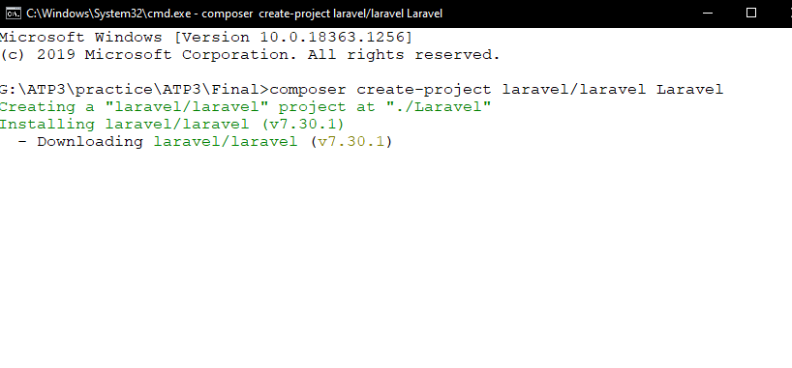

Start server –

$php artisan serve

Change default server port

$php artisan serve –port 3000

**Knowledge**

**App folder work as – Model**

**Router folder : app.js**

**Resources/views – EJS view for node.js but here blade.php**

**In confic folder database configuration**

**User request first drop in public folder then send to Router folder wep.php**