Ahsanul Qalbi – Employee Database Documentation

* How to run the apps locally
  + Install Nodejs : <https://nodejs.org/en/download/>
  + Install Postgresql : <https://www.postgresql.org/>
  + Get Nodemon : (in command prompt) npm install nodemon
  + Run the apps : (in command prompt) nodemon server.js
  + Go to browser : <http://127.0.0.1:3000/> to access webpage
* Website Pages
  + 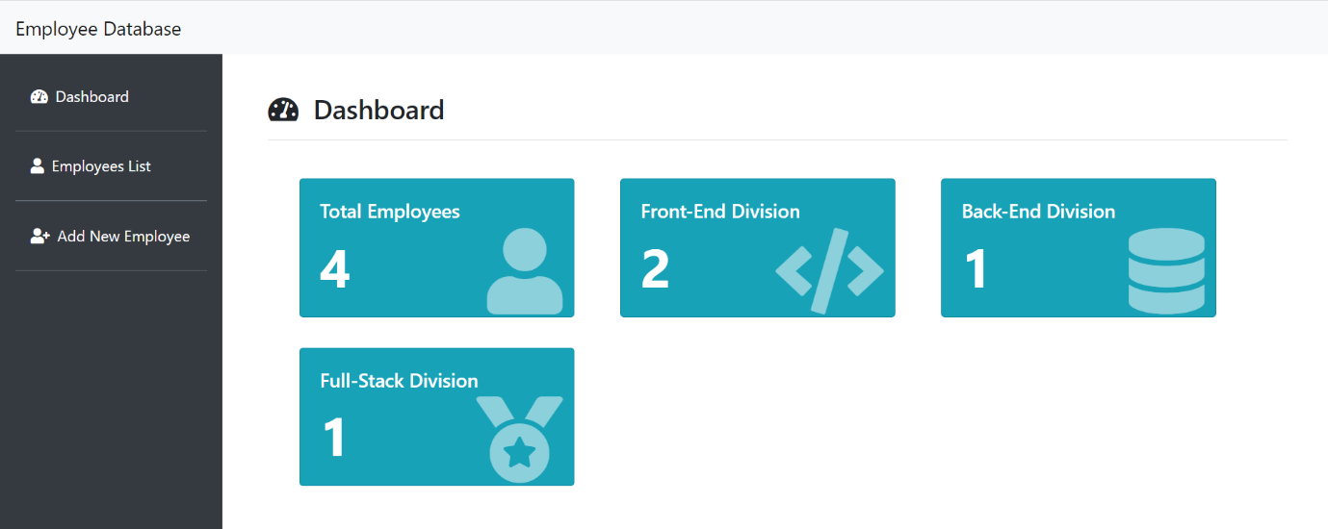Main page , go to browser : <http://127.0.0.1:3000/>

This page is the summary of employee database, showing total employee from each divisions.

* 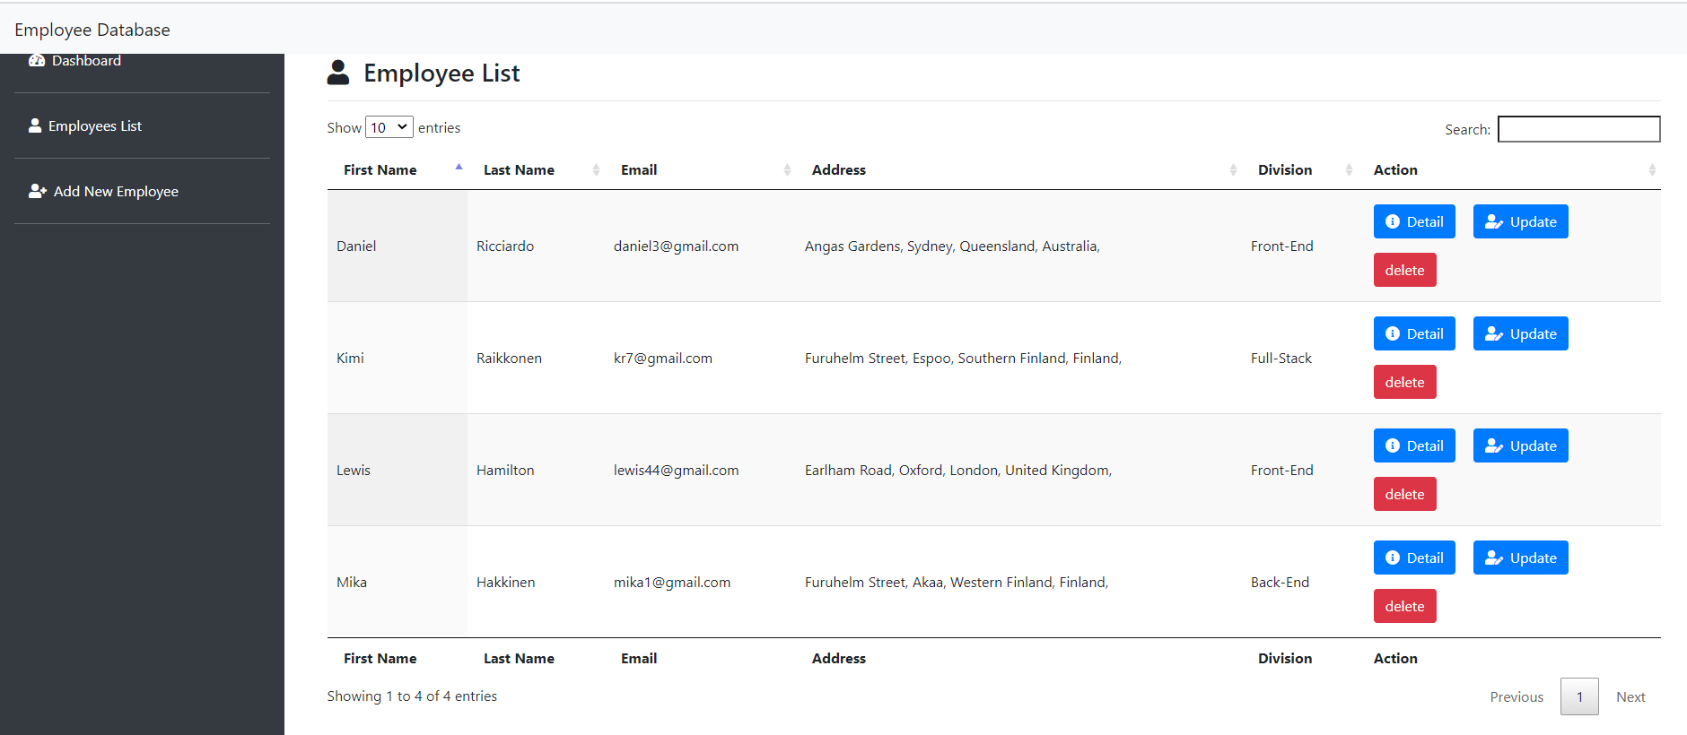Employee List Page, go to browser : <http://127.0.0.1:3000/employee_list>

This page is used to view, change, and delete employee data. “detail” button is used to display detailed employee data. “update” button is used to update an employee data, and “delete” button is used to delete an employee data.

* Add New Employee Page , go to browser : <http://127.0.0.1:3000/add_employee>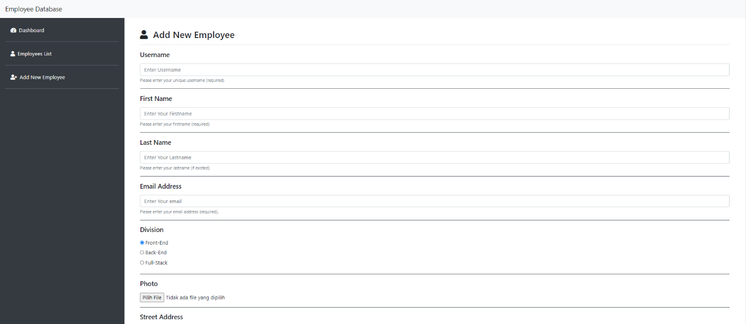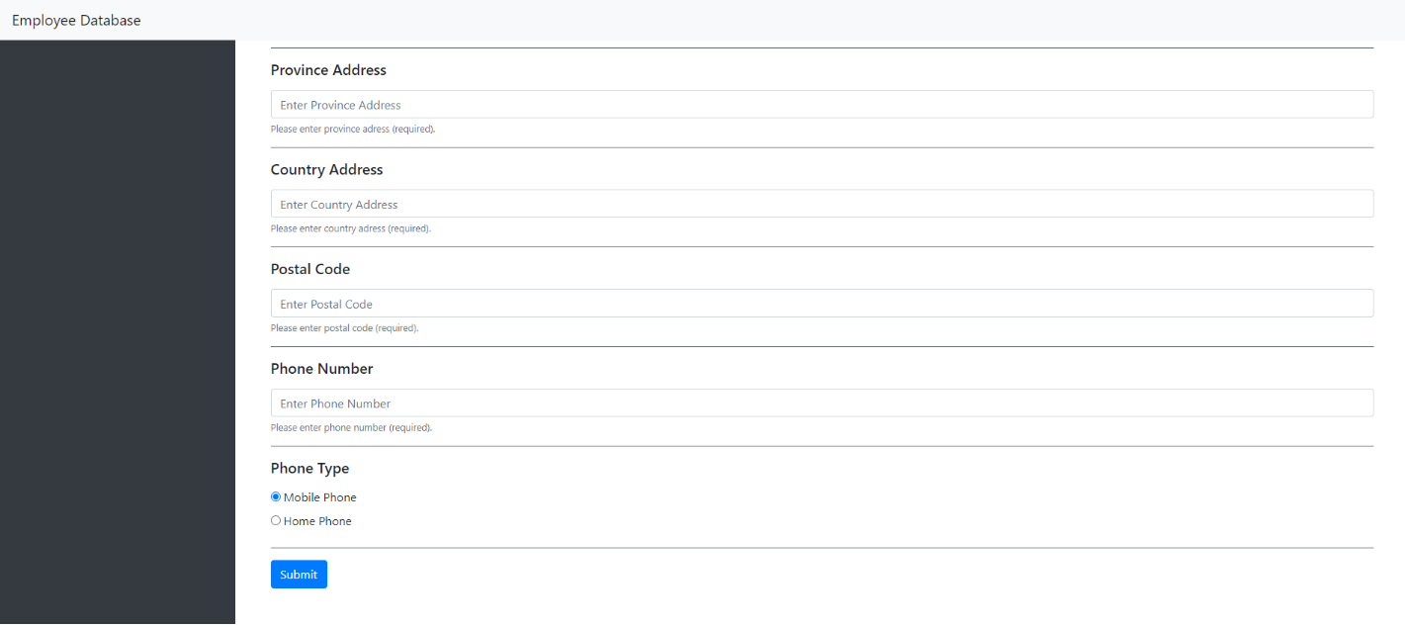

This page is used add new employee data. When submit button is clicked and user have input all required data, the new employee data will be stored in database.