TECHNICAL RESEARCH AND PROJECT ANALYSIS
DailyCart
Architecture, Feasibility, Readiness, and Improvement Roadmap
A repository-based evaluation of a Sri Lankan multi-vendor grocery delivery platform
Prepared from the project snapshot and authoritative technical, market, payment, security, and regulatory sources
18 July 2026

Abstract
This study evaluates DailyCart as a multi-vendor grocery delivery system for Sri Lanka. The analysis combines repository inspection, route and schema inventory, source-level tracing of critical business rules, automated verification, web/mobile contract comparison, and comparison against authoritative guidance for Laravel, Flutter, MySQL, API security, PayHere, Google Maps, and Sri Lankan digital-commerce obligations. The web platform demonstrates unusually broad functional coverage: marketplace governance, stock-safe multi-vendor checkout, four payment modes, rider delivery, loyalty, subscriptions, refunds, support, reports, notifications, integrations, and encrypted backups. All 54 available automated tests passed with 241 assertions, and the web asset production build completed successfully.
The central finding is that the Laravel web application is a credible feature-complete baseline, but the end-to-end product is not yet release-complete. The Flutter client contains 227 Dart files and rich customer/vendor/rider screens, yet many client service paths do not exist in the current 27-route API surface, and the default mobile base URL omits the /v1 prefix. The recommended strategy is to preserve the modular monolith, establish an explicit OpenAPI contract, close the mobile/API gap, harden payment and top-up placeholders, complete privacy and consumer-transparency controls, define operational service levels, and add production-like load, recovery, and mobile verification.
Research conclusion: DailyCart is technically viable and architecturally appropriate for a controlled pilot. Production launch should be gated on API contract completion, payment hardening, privacy/compliance implementation, and operational validation.

1. Research Context

1.1 Problem Setting
Grocery delivery platforms coordinate short-lived stock, vendor ownership, geographic coverage, time-slot promises, last-mile handoff, payment uncertainty, refunds, consumer disclosures, and frequent status communication. A Sri Lankan platform also benefits from LKR-native pricing, local payment integration, district delivery logic, mobile-first access, and resilience to variable connectivity.
Sri Lanka's Department of Census and Statistics reported that 54.6 percent of the population aged 5-69 used the internet in 2024, and smartphones accounted for 80.3 percent of devices used to connect to internet or email [1]. A U.S. International Trade Administration guide reported significant local e-commerce growth and estimated that 43 percent of roughly 11 million internet users had made online purchases, while the Western Province accounted for around half of orders [2]. Central Bank reporting for 2025 recorded continued retail digital payment growth, with CEFTS representing 55 percent of retail payment value [3]. These indicators support demand but also make rollout geography, affordability, trust, and assisted recovery critical.

1.2 Research Objectives
- Determine whether the selected architecture fits current scale and complexity.
- Assess feature breadth, transaction integrity, security, testing, and operations.
- Compare the Laravel web/API contract with Flutter expectations.
- Identify technical, operational, economic, legal, privacy, and delivery risks.
- Provide a prioritized roadmap and measurable pilot/production criteria.

1.3 Research Questions
- RQ1. Does the modular monolith support marketplace, payment, delivery, and administration?
- RQ2. Are commerce invariants protected against concurrency, ownership, and partial failure?
- RQ3. Is the mobile contract aligned with the backend API?
- RQ4. Which gaps block pilot or production launch?
- RQ5. What evidence would credibly demonstrate readiness?

2. Methodology
The study used a structured, evidence-led technical review. It did not infer completion from screen names or project guides alone. Where documentation and source disagreed, executable routes, migrations, services, policies, and tests were authoritative.
Method | Evidence | Purpose
Repository inventory | 51 models, 91 controllers, 35 services, 18 policies, 35 requests, 26 notifications, 189 Blade views, 227 Dart files | Estimate scope and architecture
Contract inventory | 298 Laravel routes, 27 API routes; Flutter service paths | Compare server and client
Rule tracing | Cart, order, payment, wallet, refund, delivery, promotion, loyalty, subscription, notification, backup services | Validate state invariants
Data review | Migrations, relationships, indexes, statuses, money, queues, logs, backups | Assess integrity/operations
Verification | PHPUnit suite and Vite build | Measure executable evidence
External comparison | Official technical, market, payment, mapping, security, and regulatory sources | Benchmark decisions

Limitations: no production traffic, live PayHere merchant, live Maps credentials, signed mobile pipeline, penetration test, assistive-technology test, or legal opinion was available. The Flutter CLI could not be verified locally. Readiness scores are analytical, not certification.

3. System Under Study
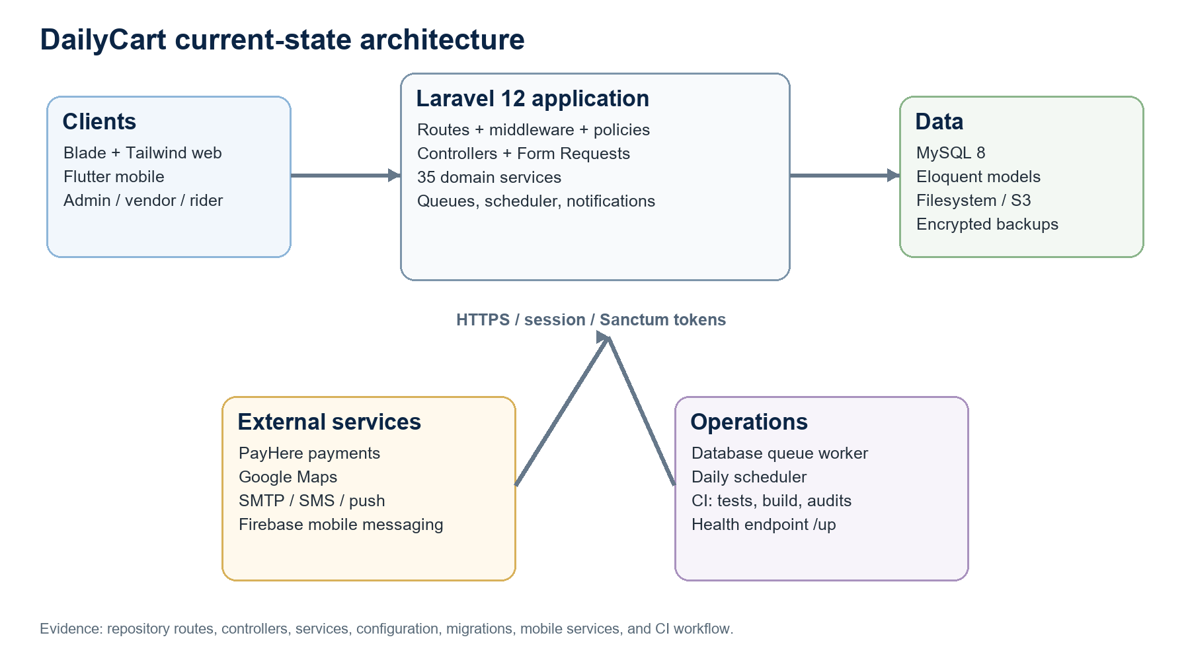
Figure 1. Current-state DailyCart architecture derived from the repository.

3.1 Technology Profile
Layer | Technology | Observed role
Backend | PHP 8.2+, Laravel 12.64.0 | Routing, validation, policies, services, ORM, queues, scheduler, notifications
Web | Blade, Tailwind, Alpine, Axios, Vite | Responsive public and role dashboards
Data | MySQL 8 | Transactional marketplace and operational persistence
API auth | Laravel Sanctum 4 | Expiring bearer tokens and abilities
RBAC | Spatie Permission 6 | Roles/permissions with middleware and policies
Mobile | Flutter/Dart, Riverpod, Dio, GoRouter | Customer/vendor/rider screens and services
Integrations | PayHere, Google Maps, email, SMS, push/Firebase, S3 | Payment, location, communication, backup

3.2 Functional Breadth
The codebase covers the commerce loop rather than a catalog prototype. Five role areas connect to catalog governance, multi-vendor order splitting, payment, delivery, finance, refund, loyalty, subscriptions, reviews, support, content, analytics, backups, and mobile. This breadth is valuable but raises the cost of state consistency, documentation, contract testing, and release coordination.

4. Findings
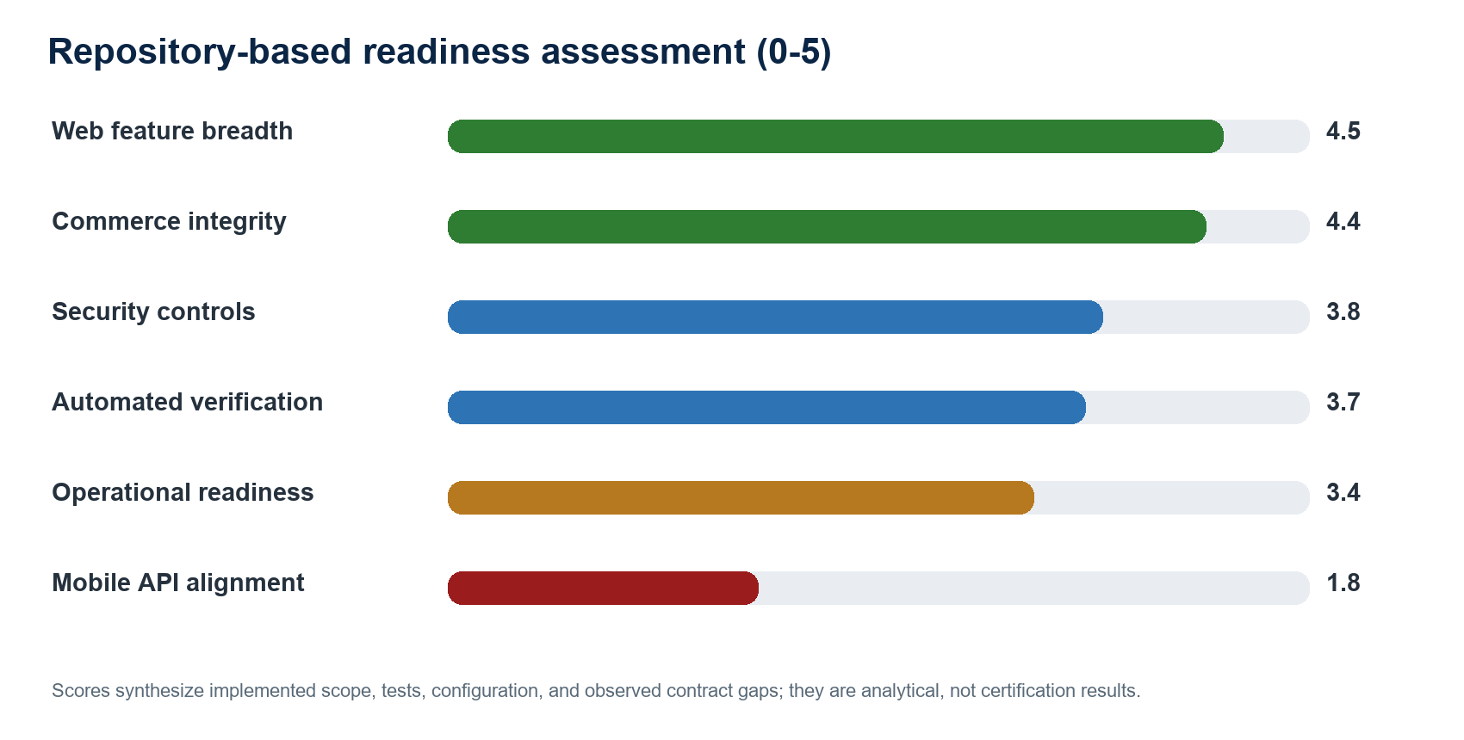
Figure 2. Repository-based readiness assessment; 5 represents strong evidence for reviewed scope.

4.1 Architecture Fitness
The modular monolith is a sound current choice. Core workflows share transactions across stock, orders, payments, deliveries, wallets, loyalty, refunds, and notifications. One Laravel deployment simplifies ACID behavior, authorization, development, and ownership. Premature microservices would add distributed transaction, ordering, observability, deployment, and data-ownership complexity without measured need.
The service layer is the strongest pattern. Laravel documents Sanctum as a preferred fit for first-party web plus mobile/token APIs [4], matching DailyCart's scoped abilities. Laravel also warns that queued work inside transactions should run after commit [5]; DailyCart uses after-commit queuing for several communications.

4.2 Commerce Integrity
Checkout and wallet behavior show mature consistency. Eligibility is rechecked, product rows are locked, order creation is transactional, and the cart converts only after all vendor orders exist. Wallet debit locks the customer, rejects overdraft, records balance-after, and marks payment paid. Refund approval coordinates wallet, payment, order, and loyalty in one transaction.
These choices match MySQL InnoDB locking reads [6]. Tests exercise competing checkout, quote/order parity, coupon limits, wallet single debit, and delivery fees. Remaining assurance should cover callback idempotency, recurring jobs, refund races, and repeated rider updates.

4.3 Security Posture
Positive controls include verification gates, token abilities, role middleware, ownership policies, rate limits, CSRF with a callback exception, upload validation, encrypted backups, dependency audits, and separate integration secrets. These address central OWASP API risks including object authorization, authentication, resource consumption, and sensitive flows [7].
Priority work includes threat modeling, negative authorization tests, callback replay protection, mobile authorization, disabling simulations/placeholders, secret scanning, security headers, cookie review, log redaction, upload malware strategy, access review, and incident response. Trusting all proxies should be constrained to known production proxies.

4.4 Payment and Mapping Integrations
PayHere states that notify_url is the authoritative server callback, localhost cannot receive it, and md5sig must be recomputed before state changes [8]. DailyCart's signature validation is directionally correct; production still needs idempotency, exact amount/currency/order matching, chargeback mapping, reconciliation, and sandbox/live separation.
Google recommends application/API key restrictions, separate keys per app/platform where practical, and server proxying for sensitive mobile web-service calls [9]. DailyCart separates browser, server, and mobile keys. Release should enforce restrictions, quotas, monitoring, HTTPS, and a plan to replace legacy Distance Matrix usage.

4.5 Mobile/API Contract Gap
This is the clearest blocker. Laravel exposes 27 API routes under /api/v1. Flutter defaults end at /api and services call /login or /products, so implemented endpoints resolve incorrectly without central v1 insertion. Flutter also expects addresses, wishlist, coupons, checkout, payment, notifications, loyalty, reviews, support, search, vendor products/profile/dashboard/earnings, and richer rider endpoints absent from routes/api.php.
Area | Backend | Flutter | Assessment
Base URL | /api/v1 | /api plus /login etc. | Immediate mismatch
Customer | Cart, quote, create/list/show orders | Also address, wishlist, coupon, checkout, cancel, payment, loyalty, review, support | Partial
Vendor | Overview, orders, wallet | Dashboard/profile/products/inventory/orders/earnings/reviews | Large gap
Rider | Deliveries/detail/status/location | Dashboard/profile/earnings/proof upload | Partial gap
Products | List/detail/categories | Featured/best/new/flash/recommended/search | Gap or query consolidation
Notifications | No API routes | List/read/read-all/delete/device token | Missing

Flutter recommends clear UI/data layers with repositories/services and testable boundaries [10]. DailyCart has screens, providers, services, models, and routing, but an explicit repository interface would improve mocking, caching, offline behavior, contract migration, and error normalization.

4.6 Verification and Operations
The baseline is meaningful: 54 tests and 241 assertions passed, including registration, API security, cart isolation, variant ownership, pricing parity, configurable delivery fees, oversell prevention, coupon use, wallet debit, encrypted backup retention, offers, and location. Vite also built successfully, and CI covers PHPUnit, formatting, build, and audits.
Evidence is thinner for delivery states, callback permutations, refunds, subscriptions, support/review, reports, retries, mobile, accessibility, performance, and restores. Worker, scheduler, deployment, and backup instructions exist, but SLOs, RPO/RTO, alerts, capacity, and a restore record do not.

4.7 Regulatory and Consumer Considerations
Sri Lanka's Personal Data Protection Act applies to local processing and providers offering goods/services to people in Sri Lanka [11]. The Data Protection Authority announced operational dates beginning in March 2025 for major parts [12]. DailyCart therefore needs a data inventory, purpose analysis, notices, rights procedures, retention, safeguards, incident governance, and processor controls.
Consumer Affairs Authority Direction 91 covers e-commerce privacy, transparent data use, safeguards, prominent privacy policies, and appropriate cancellation opportunities [13]. DailyCart's policy, receipt, cancellation, support, and review functions are a base; legal review should reconcile disclosures, actual behavior, vendor duties, fees, refunds, safety, and complaints.

5. Comparative Design Evaluation
Decision | Selected | Alternative | Evaluation
Architecture | Laravel modular monolith | Microservices | Prefer selected approach while core workflows share transactions and one team operates the system.
Web | Blade/Tailwind/Alpine | React/Vue SPA | Selected approach reduces API/deployment overhead; SPA only if interaction or team independence demands it.
Mobile | Flutter | Native / React Native | Flutter fits reuse; backend contract is the constraint.
Database | MySQL 8/InnoDB | PostgreSQL / NoSQL | MySQL supports relational commerce and locks; migration lacks a business case.
API auth | Sanctum abilities | OAuth2/Passport | Sanctum is appropriate for first-party mobile; OAuth2 only for delegated third parties.
Queue | Database queue | Redis/SQS | Suitable for pilot; migrate when throughput/isolation evidence justifies it.

6. Feasibility Analysis
Dimension | Assessment | Rationale
Technical | High with conditions | Core web architecture, rules, tests, and build are viable; mobile/API and assurance remain.
Operational | Moderate | Roles are clear; staffing, onboarding, exceptions, monitoring, and restores need procedures.
Economic | Moderate to high | Open-source stack limits licenses; costs are hosting, Maps, payments, messaging, storage, support, riders, stores.
Schedule | Moderate | Pilot follows focused hardening; full mobile breadth needs scope control.
Legal/privacy | Moderate risk | Obligations are identifiable; processes and formal review are needed.
Scalability | Good for pilot/early growth | Laravel/MySQL/queues scale; optimize from metrics before decomposition.

7. SWOT Analysis
Strengths | Weaknesses
Broad scope; transactional rules; five-role RBAC; LKR/PayHere/location fit; tests; CI; encrypted backups. | Mobile/API mismatch; limited mobile tests; documentation drift; placeholders; no SLO/RPO/RTO; incomplete privacy operations.

Opportunities | Threats
Mobile adoption; vendor digitization; district expansion; subscriptions; loyalty; local payments; analytics; localization. | Fraud; overselling; delivery failure; privacy breach; external API cost; store rejection; vendor quality; competition; regulation.

8. Prioritized Gap Analysis
Priority | Gap | Impact | Action
P0 | Mobile URL/contract | Core screens fail | Publish OpenAPI; fix /api/v1; implement/gate paths; contract tests.
P0 | Payment/top-up boundaries | Financial loss/state error | Disable placeholders; idempotent PayHere reconciliation; authorized top-up.
P0 | Privacy/consumer operations | Legal and trust risk | Data map, notices, rights, retention, processors, legal review.
P1 | Critical workflow tests | Regressions | Delivery/refund/subscription/concurrency/callback tests.
P1 | Targets/observability | Slow detection/recovery | SLO/RPO/RTO, metrics, alerts, restore/failover runbooks.
P1 | Mobile CI/release | Platform/store risk | Analyze/test/build, signing, Firebase, staged rollout.
P2 | Documentation drift | Developer confusion | Generate route/OpenAPI/data documentation.
P2 | Accessibility/localization | Reduced reach | WCAG audit, localization, Sinhala/Tamil, low-bandwidth UX.

9. Recommended Delivery Roadmap
Phase | Deliverable
Weeks 1-2: Contract | Inventory enabled screens/calls; OpenAPI; fix /api/v1; define pilot modules and schemas.
Weeks 3-5: API | Implement/gate customer essentials, vendor/rider minimum, notifications, profiles, addresses, cancellation, proof.
Weeks 4-6: Finance | Idempotent callback, amount/currency validation, reconciliation, chargebacks, production flags, top-up.
Weeks 5-7: Assurance | Threat model, authorization matrix, workflow/concurrency tests, secret/upload audits.
Weeks 6-8: Compliance | Notices, data map, retention, rights, vendor terms, fee/refund disclosures, legal review.
Weeks 8-10: Operations | SLO/RPO/RTO, dashboards, alerts, load test, restore drill, incident/rollback runbooks.
Weeks 9-11: Mobile | Flutter CI, device matrix, offline/error states, Firebase, signed staging builds, store declarations.
Week 12: Pilot | Limited districts/vendors/riders, live support, reconciliation, metrics, flags, rollback criteria.

10. Evaluation Framework
Outcome | Measure | Pilot target
API | Enabled mobile calls with passing contract tests | 100 percent
Checkout | Successful orders / valid attempts | >=99 percent excluding abandonment
Stock | Negative or oversold stock | 0
Payment | Unreconciled callbacks or duplicate ledger effects | 0; daily reconciliation
Delivery | On-time and proof completeness | District target; proof 100 percent
Performance | Server p95 catalog/checkout | <=1.5 s / <=3 s under agreed load
Reliability | Availability and queue age | Approved SLO; no unalerted backlog
Recovery | Restore drill | Pass before pilot and quarterly
Security | Open critical/high findings | 0 critical; highs remediated/accepted
Experience | Completion, support, refund reason, crash-free users | Baseline then sprint improvement

11. Conclusion
DailyCart has crossed from prototype to serious application platform. The repository demonstrates coherent Laravel architecture, broad role functionality, local market fit, and deliberate protection of high-risk commerce invariants. Passing tests and the production web build strengthen confidence in the web baseline.
The next phase should emphasize completion and evidence rather than features. Contract-first API work, financial hardening, mobile verification, privacy/consumer implementation, and operational measurement can convert the existing breadth into a controlled pilot. The modular monolith remains the best balance of safety, velocity, and simplicity until measured scaling or organizational boundaries justify decomposition.

References
Ref. | Source | URL
[1] | Sri Lanka Department of Census and Statistics. Labour Force Survey Annual Report 2024. | https://www.statistics.gov.lk/Resource/en/LabourForce/Annual_Reports/LFS2024.pdf
[2] | U.S. International Trade Administration. Sri Lanka - eCommerce. | https://www.trade.gov/country-commercial-guides/sri-lanka-ecommerce
[3] | Central Bank of Sri Lanka. Annual Economic Review 2025. | https://www.cbsl.gov.lk/sites/default/files/cbslweb_documents/publications/aer/2025/en/Full_Text.pdf
[4] | Laravel. Authentication, version 12.x. | https://laravel.com/docs/12.x/authentication
[5] | Laravel. Queues, version 12.x. | https://laravel.com/docs/12.x/queues
[6] | Oracle MySQL. InnoDB transaction isolation and locking reads. | https://dev.mysql.com/doc/refman/8.0/en/innodb-transaction-isolation-levels.html
[7] | OWASP. API Security Top 10 - 2023. | https://owasp.org/API-Security/editions/2023/en/0x00-header/
[8] | PayHere. Checkout API and callback signature verification. | https://support.payhere.lk/api-%26-mobile-sdk/checkout-api
[9] | Google. Maps Platform API security best practices. | https://developers.google.com/maps/api-security-best-practices
[10] | Flutter. Guide to app architecture. | https://docs.flutter.dev/app-architecture/guide
[11] | Government of Sri Lanka. Personal Data Protection Act, No. 9 of 2022. | https://www.documents.gov.lk/view/act/2022/3/09-2022_E.pdf
[12] | Data Protection Authority of Sri Lanka. PDPA operational dates. | https://www.dpa.gov.lk/est.php
[13] | Consumer Affairs Authority. Direction 91 for e-commerce. | https://caa.gov.lk/web/images/Direction/English/sec10/91_E.pdf

Appendix A. Repository Evidence Summary
Evidence | Observed result
Routes | 298 total: 94 admin, 53 customer, 53 public/auth/shared, 37 vendor, 27 API, 19 super-admin, 15 rider
Backend | 51 models, 91 controllers, 35 services, 18 policies, 35 requests, 26 notifications
Presentation | 189 Blade views; Vite production build succeeded with 56 modules
Mobile | 227 Dart files; role screens/providers/services/models/widgets; release verification unavailable
Tests | 54 passed, 241 assertions, about 166 seconds
Operations | Database queues, subscription scheduler, token pruning, /up, encrypted backups, CI audits

