Does AI Benefit All Platform Stakeholders? Evidence from Algorithmic Task Assignment in Food Delivery
Revised manuscript — generated 2026-05-06

Section 1. Introduction (Revised)

변경 매핑: R1-1, R1-2, R2-1, R2-2 (changelog.md 참고)

────────────────────────────────────────────────────────────────────────────────

The on-demand platform economy—commonly known as the gig economy—has expanded rapidly since the COVID-19 pandemic and now occupies a central place in the global socio-economic landscape (McKinsey, 2021). On-demand platforms intermediate between customer demand and gig labor, providing customers with convenient real-time services and offering workers flexible labor opportunities (Duggan et al., 2023). With recent advances in machine learning and artificial intelligence (AI), algorithmic task assignment has become a fundamental component of platform operations, replacing human decision-making in matching customer requests with service providers (Kellogg et al., 2020; Möhlmann et al., 2021). Platforms such as Uber and DoorDash use these systems to assign ride and delivery requests to workers at scale. Crucially, contemporary task-assignment systems are AI-driven in a specific sense: they incorporate revealed-preference learning from individual workers' historical choices and dynamic match-quality scoring updated in real time, distinguishing them from earlier rule-based or first-come, first-served dispatch (Kellogg et al., 2020; Mao et al., 2025; Möhlmann et al., 2021). [R1-2]

Whether AI-driven assignment delivers value broadly distributed across stakeholders, however, remains an open empirical question rather than an established fact. [R2-1] Although platform operators routinely emphasize that algorithmic assignment improves both worker matching and customer service, recent work in algorithmic management documents notable downsides — including increased monitoring and stress, opacity in assignment logic, and reduced worker autonomy (Jarrahi & Sutherland, 2019; Kellogg et al., 2020; Lee et al., 2015; Möhlmann et al., 2021). The empirical question we pursue is therefore how the benefits of algorithmic task assignment are distributed across stakeholders — workers of different pre-AI proficiency levels and end-use customers — once the assignment system is deployed in a real-world platform.

Two strands of related work motivate this question. First, a growing literature on AI and labor finds that algorithmic decision-making can, on average, improve individual worker performance (Bai et al., 2021; Brynjolfsson et al., 2025; Dell'Acqua et al., 2023; Luo et al., 2021; Noy & Zhang, 2023; Tong et al., 2021). Average gains, however, do not imply uniform gains, and the literature on inequality effects remains mixed (Y. Chen et al., 2024; Cowgill & Tucker, 2020; Korinek & Stiglitz, 2018; Noy & Zhang, 2023). Second, despite this rapid growth, direct evidence on platform and gig workers remains scarce (Knight et al., 2024; M. Liu et al., 2021; Mao et al., 2025), even though these are precisely the settings in which AI assignment systems are most heavily deployed. Evidence on consumer-side outcomes is even sparser, and the customer-side question is typically raised in passing rather than analyzed jointly with worker outcomes. [R2-2]

A more fundamental — and frequently overlooked — question is what features of the task structure in food delivery (and analogous gig contexts) make algorithmic assignment a non-trivial intervention. [R1-1] Food delivery is a multi-stage operation: once an order is assigned, it must be stacked with other in-progress orders, sequenced for pickup and drop-off, and routed across the city. Task-assignment AI optimizes only the first of these stages — the match between an incoming order and a candidate worker — and leaves downstream execution unchanged. The marginal benefit of algorithmic assignment therefore hinges on whether a worker can convert better matches into shorter completion time and a higher number of orders within a continuous trip. This boundary condition imposes a specific theoretical structure on the platform: AI assignment is most likely to benefit workers whose bottleneck is order selection rather than execution, and least likely to benefit workers who already excel at both stages. The same boundary condition shapes the customer-side spillover, because faster matches do not necessarily translate into faster individual deliveries when downstream stacking and sequencing remain at the worker's discretion.

We empirically address this question using novel order-level data with rider identifiers from a major Korean food delivery platform that historically left order acceptance to riders and introduced an AI-based order-assignment system in Busan on October 26, 2020. The system assigns one order at a time to the rider deemed most suitable, on the basis of a match-quality score that combines current location, in-progress orders within the rider's stack, and the rider's revealed-preference distribution learned from individual delivery history. We exploit the platform-level rollout as a natural experiment and address potential endogeneity in adoption — riders can opt in to AI mode — by combining propensity-score matching (PSM) with difference-in-differences (DID) and triple-difference (DDD) estimation across pre-AI proficiency groups.

We pose three research questions: (i) Does AI assignment increase average daily worker productivity, and if so, for whom? (ii) Does AI assignment narrow or widen productivity disparities across pre-AI proficiency groups? (iii) Does AI assignment translate into shorter customer waiting times for the customers served by adopting riders? We are careful to scope the customer-side estimand: our analysis identifies waiting-time changes for orders served by treated/matched riders, not platform-level consumer welfare effects, which would require equilibrium evidence beyond the matched sample (R1-4).

We find that order-assignment AI raises riders' average daily productivity by approximately 3% (DID coefficient = 0.141 \\\ on a baseline mean of 4.69 orders/hour). The gain is driven by medium-proficiency riders, whose daily productivity rises by approximately 5.4% (DDD = 0.249 \\\), whereas neither low- nor high-proficiency riders show statistically significant gains. Beneath the average effect, AI assignment allows low- and medium-proficiency riders to operate longer stacks — more orders per continuous trip — with associated increases in daily orders and earnings for both groups. Low-proficiency riders, however, do not realize a productivity gain because their higher order counts coincide with longer working hours and greater between-stack idle time. Medium-proficiency riders, in contrast, complete more orders per stack in the same time, producing the observed productivity gain. High-proficiency riders show neither gains nor losses, consistent with their already operating near the operational frontier on both match quality and execution.

For customers served by treated/matched riders, the picture is more nuanced. Average customer waiting time does not change significantly; however, single-order deliveries become faster (DID = −0.184 \\ minutes), while stacked-order deliveries show no improvement. This pattern is consistent with riders directing AI-enabled stacking gains toward their own throughput rather than toward customer-facing speed when they handle multiple orders simultaneously.

We make three contributions. First, to our knowledge, this study is the first to provide joint empirical evidence on how task-assignment AI in an on-demand platform shapes (i) average worker productivity, (ii) productivity disparities across pre-AI proficiency groups, and (iii) customer-side outcomes for orders served by treated riders. Second, we articulate and test a boundary condition for the value distribution of algorithmic assignment: gains accrue most to workers whose bottleneck is task selection rather than downstream execution, and accrue least to workers with limited downstream-execution capability. [R1-1] Third, we provide counterevidence to the often-implicit claim that algorithmic assignment uniformly improves customer service: in settings where workers can engage in strategic stacking and sequencing, customer-side gains are conditional and bounded.

The rest of the paper is organized as follows. Section 2 reviews the related literature on AI and labor as well as consumer outcomes in on-demand platforms. Section 3 describes the platform setting and the data. Section 4 specifies the empirical models. Section 5 presents the main results, together with the event-study and Oster-bound robustness exercises, direct inequality metrics, learning-dynamics evidence, and the worker-customer linkage analysis. Section 6 discusses implications, and Section 7 concludes with theoretical and practical implications, limitations, and directions for future research. [R2-11]

Section 2. Related Literature (Revised)

변경 매핑: R2-4, R2-5, R1-Minor-1 (changelog.md 참고)

────────────────────────────────────────────────────────────────────────────────

2.1 AI and individual worker performance

A growing empirical literature has begun to document how AI affects individual-level work performance. In manual-work settings, algorithmic task allocation and optimization tools have been shown to raise productivity (Bai et al., 2021; Rad et al., 2025; J. Sun et al., 2022). In knowledge work, AI-based assistance and generative AI raise individual output and quality (Brynjolfsson et al., 2025; Dell'Acqua et al., 2023; Luo et al., 2021; Noy & Zhang, 2023; Tong et al., 2021; Zhang & Narayandas, 2025). The magnitude and sign of these effects, however, vary substantially with task type, worker baseline proficiency, and the extent to which the AI substitutes for or complements human judgment. Dell'Acqua et al. (2023), for example, document a jagged frontier: AI raises performance on tasks inside its frontier but degrades performance when used beyond it.

Direct evidence on platform and gig workers remains comparatively scarce, even though these businesses are explicitly built on algorithmic decision-making (Frank et al., 2019; Raj & Seamans, 2018). A small number of recent studies have begun to address this gap: technology- or algorithm-enabled tools and ride-hailing driver outcomes (Y. Chen et al., 2024; M. Liu et al., 2021); AI-based guidance for batch picking in grocery delivery (Knight et al., 2024); and order-assignment and routing optimization in food delivery (Mao et al., 2025). [R2-5] These studies offer valuable early evidence, but they typically examine either worker productivity or system efficiency in isolation. Our study advances the literature by quantifying — within a single empirical setting — worker productivity, productivity disparities across pre-AI proficiency groups, and customer-side outcomes, and by making transparent the boundary condition (the multi-stage task structure) under which the heterogeneous gains arise.

2.2 Algorithmic decision-making and inequality in labor outcomes

Whether algorithmic decision-making widens or narrows labor-outcome disparities is an unresolved empirical question, and the literature offers two competing views. [R2-4] The first view holds that algorithms can replicate or amplify disparities, either through bias in algorithm design or through bias embedded in the historical training data (Y. Chen et al., 2024; Chiacchio et al., 2018; Cowgill & Tucker, 2020; Korinek & Stiglitz, 2018). The second view holds that AI — particularly more capable systems — can in principle reduce, or at least not exacerbate, existing labor disparities (Acemoglu & Restrepo, 2018; Brynjolfsson et al., 2025; Cowgill, 2018; Gries & Naudé, 2018; Kleinberg et al., 2018; Noy & Zhang, 2023; Webb, 2019).

These two views are not mutually exclusive. Whether algorithmic assignment widens or narrows disparities depends on (i) which bottleneck the algorithm relieves, (ii) which workers were previously bound by that bottleneck, and (iii) whether other workers can translate algorithmic output into performance — that is, whether they possess the complementary skills for downstream execution. In our setting, the algorithm relieves the order-selection bottleneck, but downstream stacking, sequencing, and routing remain the worker's responsibility. The algorithm's distributional effect therefore turns on which proficiency group is most constrained at each stage. This framework helps reconcile the apparently conflicting findings in the literature and motivates the heterogeneous-effect specification we adopt.

2.3 Algorithmic decision-making and customer service quality on platforms

Beyond worker outcomes, algorithms in on-demand platforms also affect customer service quality. Because the platform mediates two-sided interaction, the introduction of a new algorithm can simultaneously reshape worker behavior and customer outcomes (Berg et al., 2018; De Reuver et al., 2018; Möhlmann et al., 2021). Empirical findings on customer-side outcomes are mixed. M. Liu et al. (2021) and Knight et al. (2024) find that algorithm-supported workers can improve customer service. In contrast, mobile-app adoption by taxi drivers has been shown to increase trip lengths through driver-favorable selection rather than consumer-friendly speed (Wang et al., 2019), and pricing-scheme reforms can interact with strategic driver behavior in non-obvious ways (T. Liu et al., 2019).

The decisive factor, again, is worker behavior. When new technology enables strategic responses (e.g., longer trips, denser stacks, selective acceptance), the customer-side outcome can move in the opposite direction from what worker-productivity gains alone would predict. Our paper directly examines this conditional dependence by comparing single-order versus stacked-order customer outcomes within the same matched sample.

2.4 Positioning of this study

This study contributes to the three preceding threads as follows. First, within the AI-and-platform-work literature, we provide the first joint empirical evidence on the distributional effects of order-assignment AI on platform workers and customers, with explicit attention to a boundary condition — multi-stage task structure — that we argue determines who benefits and who does not. Second, within the inequality literature, we operationalize the competing-views debate empirically, showing that the same algorithm can generate gains for medium-proficiency workers while leaving low- and high-proficiency workers materially unaffected on the productivity dimension. Third, within the customer-side literature, we make the estimand explicit (customers served by treated/matched riders), provide a single- versus stacked-order decomposition, and report a worker–customer linkage analysis to illuminate the channel — without claiming formal mediation. [R1-Minor-1] The reference list has been updated to consolidate a duplicate entry for Y. Chen et al. (2024) and to cite the published version of Allon et al. (2023) where available; full bibliographic details appear in docs/05_reference_audit.md and manuscript_revised/references.md.

Section 3. Background and Data (Revised)

변경 매핑: R1-2, AE-3 (changelog.md 참고)

────────────────────────────────────────────────────────────────────────────────

3.1 Platform overview and the order-assignment AI system

We collaborated with a major food delivery platform in Korea. The platform receives delivery requests from multiple food-ordering platforms and dispatches them to a network of more than 42,200 gig workers across over 500 regional management branches, serving 67,000 restaurants nationwide. As in many food delivery contexts, riders complete either single-order deliveries or stacked deliveries — multiple orders within a continuous trip, which we refer to as a "stack." Single deliveries minimize per-customer waiting; stacked deliveries reduce per-rider idle time and can raise rider earnings but typically prolong customer waiting time for individual orders within the stack.

Prior to October 26, 2020, the platform's default order-assignment mechanism in Busan was manual broadcast dispatch: each new customer order was broadcast to nearby riders, and the first rider to accept the order received the assignment. Under this scheme, riders had to evaluate, within seconds, several factors simultaneously — current location relative to pick-up and drop-off points, expected fees, time constraints, and how the new order would integrate with in-progress orders within the existing stack. Less-experienced riders were known to miss high-value or well-fitting orders under this regime, whereas more-experienced riders developed heuristics that conferred order-selection advantages.

On October 26, 2020, the platform deployed an order-assignment AI system in Busan. The system replaced the broadcast-and-accept loop with automated one-to-one assignment between an incoming order and a candidate rider on the basis of a real-time match-quality score. Three design features distinguish the AI system from earlier rule-based dispatch: [R1-2]

1. Revealed-preference learning at the individual rider level. The system draws on each rider's historical accept-decline and completion record to estimate a probabilistic distribution of order preferences conditional on the rider's logistical situation. This is a learning component, not a static rule.

2. Dynamic, real-time match scoring. The system evaluates rider-order match quality on the basis of the rider's current location, in-progress orders within the existing stack, and likely subsequent delivery routes. Match scores are updated continuously, allowing the system to respond to micro-level shifts in demand and supply.

3. Automated assignment without broadcast. When the AI mode is enabled, the system assigns the best-matched order directly; the rider must then accept and complete it. This design feature limits selective acceptance ("cherry-picking") and gaming of the broadcast mechanism.

Three points about the system's design objective merit emphasis. First, the system was designed to improve match quality between orders and riders, not to address inequality among riders. [AE-3] Second, the system optimizes only the order-to-rider match — the first stage of a multi-stage workflow that also includes stacking, pickup and drop-off sequencing, and routing. The AI does not direct or optimize these downstream stages. Third, riders are not required to use AI mode: they can switch it on or off in the rider app at any time. This adoption-decision element introduces the endogeneity that our matched DID/DDD design is built to address.

3.2 Data and variables

Our empirical analysis uses an order-level dataset covering one month before and one month after the AI rollout in Busan. The dataset records, for each completed delivery: an anonymized rider identifier, the rider's regional management branch, timestamps for each delivery step (order placement, assignment, pickup, drop-off), service fees, and the assignment mode (AI versus manual). The observation window contains more than 800,000 orders from over 900 riders. We retain riders who joined the platform before the observation window and were active in both periods, yielding 581 candidate riders, which we then propensity-score-match to obtain the 336-rider analytic sample (Section 4).

For the extension analysis in Section 5.3, we additionally use Busan-exclusive Dec 2020 – Feb 2021 order data, which provide approximately three additional months of post-AI activity. Of the 336 riders in the main matched sample, 290 (86%) remain active in this extension window, allowing us to assess whether the productivity effects persist beyond the original one-month post-AI horizon. [AE-4, R2-7]

We work at three levels of aggregation: order-level, stack-level (where a stack is the set of orders the rider handles within a continuous trip), and day-level. Our key dependent variable, daily productivity, is defined as completed orders divided by total daily working time, where total daily working time is the sum of working duration and between-stack idle duration. This definition captures a rider's joint ability to (i) complete more orders per stack and (ii) reduce idle time between stacks — both of which are channels through which order-assignment AI can affect productivity.

We classify riders by pre-AI proficiency, defined as their average daily productivity over the 30-day pre-AI window. [AE-1] Throughout the manuscript, we use the term proficiency rather than skill to make explicit that the classification reflects pre-treatment performance under the manual broadcast regime rather than a fixed worker trait.¹ Riders are partitioned into terciles based on this measure: low-proficiency (n = 110, mean 3.56 orders/hour), medium-proficiency (n = 113, mean 4.59), and high-proficiency (n = 113, mean 5.91). These pre-AI fixed groupings serve as interaction variables in our DDD specification.

¹ Proficiency is operationalized as the rider's average orders/hour during 2020-09-26 to 2020-10-25 under the manual broadcast system. The classification is fixed at the rider level and does not vary over the post-AI period.

3.3 Treatment and control

Our treatment indicator equals 1 if the rider ever completes an order assigned by the AI system within the observation window, and 0 otherwise. This binary measure is supplemented in robustness checks by a continuous AI-intensity measure — the daily share of AI-assigned orders (Section 5.3.5). Riders are observed in both pre-AI and post-AI periods, with the After indicator equal to 1 for observations on or after October 26, 2020. The propensity-score matching procedure described next yields the analytic sample of 336 matched riders that supports all main analyses.

Section 4. Empirical Models (Revised)

변경 매핑: R1-Minor-3, R1-3 (changelog.md 참고)

────────────────────────────────────────────────────────────────────────────────

4.1 Identification strategy

The platform-level introduction of the order-assignment AI provides a natural experiment. The principal identification challenge is that adoption of the AI mode is not random: riders may opt in or out, and adopters may differ from non-adopters in unobservable ways that also influence productivity (e.g., motivation, technological savvy, or fatigue management). To address this concern, we combine propensity-score matching (PSM) at the rider level with difference-in-differences (DID) and triple-difference (DDD) estimation across pre-AI proficiency groups. We supplement this design with three robustness exercises detailed in Section 5.3: (i) an event-study with leads and lags around the rollout to test parallel trends formally; (ii) Oster (2019) bounds quantifying the selection on unobservables required to nullify the effect; and (iii) a stable-workers restriction that excludes riders with patchy attendance.

4.2 Propensity-score matching

We estimate each rider's propensity to adopt AI assignment using logistic regression on pre-treatment observable covariates: average daily delivered stores, average weekly working days, average shift-level waiting time, average orders per shift, average shift duration, daily total labor time, and daily idle duration. We perform one-to-one nearest-neighbor matching without replacement, with a caliper of 0.05 of the standard deviation of the estimated propensity score. The matched analytic sample consists of 336 riders (168 treated and 168 control). After matching, t-tests cannot reject the equality of means between treated and control on any covariate at the 5% level. Matching diagnostics appear in Appendix Table A1.

4.3 DID and DDD specifications

For each rider-period observation $(i, t)$, where $i$ indexes riders and $t$ indexes time (day or stack, depending on the specification), our DID specification is

$$Y_{i, t} = \beta_1 \cdot \text{After}_t \cdot \text{Treat}_i + \mu_i + \nu_{j(i), t} + \epsilon_{i, t},$$

where $\text{After}_t = 1$ if the observation is on or after October 26, 2020; $\text{Treat}_i = 1$ if rider $i$ ever completes an AI-assigned order during the observation window; $\mu_i$ is a rider fixed effect (which absorbs $\text{Treat}_i$); $\nu_{j(i), t}$ is a branch-date fixed effect (which absorbs $\text{After}_t$); and $\epsilon_{i, t}$ is the disturbance term. [R1-Minor-3] Standard errors are clustered at the rider level. Stack-level specifications additionally include hour-of-day-of-week fixed effects $\theta_{h, w}$.

Our DDD specification interacts $\text{After}_t \cdot \text{Treat}_i$ with the pre-AI proficiency tercile indicators $G_i \in \{\text{prof\_low}, \text{prof\_med}, \text{prof\_high}\}$:

$$Y_{i, t} = \sum_{g} \beta_g \cdot \text{After}_t \cdot \text{Treat}_i \cdot \mathbb{1}\{G_i = g\} + \sum_{g \in \{\text{med}, \text{high}\}} \gamma_g \cdot \text{After}_t \cdot \mathbb{1}\{G_i = g\} + \mu_i + \nu_{j(i), t} + \theta_{h, w} + \epsilon_{i, t}.$$

The $\text{After} \times \text{Group}$ terms (excluding the prof_low baseline) absorb group-specific time trends, while the three triple-interaction coefficients $\beta_g$ identify the treatment effect separately for each proficiency group. Standard errors are clustered at the rider level.

For customer waiting time (Section 5.2), we add a control for the restaurant-to-destination distance (avg_dist at the stack level) and report results separately for (i) all stacks, (ii) single-order stacks, and (iii) stacked-order stacks.

4.4 Event-study specification (R1-3A)

To allow the DID effect to vary over time and to formally test the parallel-trends assumption, we estimate the event-study form

$$Y_{i, t} = \sum_{k = -K,\ k \neq -1}^{K} \beta_k \cdot \text{Treat}_i \cdot \mathbb{1}\{w_k\} + \mu_i + \nu_{j(i), t} + \epsilon_{i, t},$$

where the $w_k$ indicators correspond to weeks before the rollout (wb5, wb4, wb3, wb2; wb1 is the omitted reference) and after the rollout (w1, w2, w3, w4, w5). We test the joint hypothesis $\beta_{-5} = \beta_{-4} = \beta_{-3} = \beta_{-2} = 0$ as a pre-trend test using a cluster-robust Wald F-test.

4.5 Dose-response specification (R1-3B, supplementary)

To address the concern that the binary "ever-adopter" indicator may be too coarse, we additionally report a continuous dose-response specification using the daily share of orders assigned by the AI system,

$$\text{Productivity}_{i, t} = \delta \cdot \text{share\_aiorders\_day}_{i, t} + \mu_i + \nu_{j(i), t} + \epsilon_{i, t}.$$

We report this as supplementary evidence (Section 5.3.5), not as a substitute for the main DID/DDD analysis. The continuous specification addresses adoption-intensity gradients within the same identification framework.

4.6 Estimation choices and summary

Outcomes are reported in their linear units (orders per hour, minutes, KRW), consistent with the specification of Tables 4–7 in the original manuscript. All fixed effects are absorbed via the lfe framework (Gaure, 2013), enabling high-dimensional fixed-effects estimation while clustering standard errors at the rider level. Sample sizes for each specification are reported in the corresponding tables.

Section 5. Results (Revised)

변경 매핑: R1-Minor-2, R1-4, AE-2, R2-6, R2-7, R2-8, R2-9 (changelog.md 참고)

────────────────────────────────────────────────────────────────────────────────

5.1 AI impact on labor outcomes and within-platform inequality

5.1.1 Average and heterogeneous productivity effects

Table 4 reports the DID and DDD estimates for daily productivity (orders/hour). The DID coefficient on $\text{After} \cdot \text{Treat}$ is 0.141 \*\*\* (SE 0.047, $p = 0.005$), indicating that AI adoption raises average daily productivity by approximately 3.0% relative to the sample mean of 4.69 orders/hour. The DDD specification reveals the underlying heterogeneity: medium-proficiency riders gain 0.249 \*\*\* (SE 0.066, $p < 0.001$), equivalent to a 5.4% increase relative to the sample mean, whereas neither low-proficiency riders (0.088, SE 0.071, $p = 0.22$) nor high-proficiency riders (0.067, SE 0.084, $p = 0.42$) show a statistically significant gain. The pairwise test for the medium-versus-others contrast on log productivity yields $p = 0.026$ (joint test on log-transformed daily productivity), confirming that the medium-proficiency gain is statistically distinguishable from the low- and high-proficiency effects (output/tables/14_pairwise_tests.csv; the corresponding linear-outcome test gives a closely comparable $p = 0.039$).

5.1.2 Stack- and day-level mechanisms

Tables 5 and 6 unpack the channels through which AI assignment affects productivity. At the stack level (Table 5), AI adoption enables both low- and medium-proficiency riders to operate longer stacks — that is, to handle more orders within a continuous trip. For low-proficiency riders, the per-stack number of orders rises by 0.142 \\ (Table 5, col. 1), but the stack-completion time also lengthens by 1.091 \ minutes (Table 5, col. 2), yielding no improvement in time per order (0.008, NS). Medium-proficiency riders, by contrast, exhibit a similar increase in stack size (0.133 \) without the corresponding lengthening of stack duration (0.523, NS), translating into a shorter time per order within a stack (-0.229 \\). High-proficiency riders show no statistically significant change on either dimension, consistent with their already operating near the operational frontier. Idle time between stacks (Table 5, col. 4) reveals a striking divergence: low-proficiency riders' between-stack idle time increases by 0.566 \\ minutes, while medium-proficiency riders' decreases by 0.583 \\ — that is, medium-proficiency riders both stack more efficiently and recover more quickly between stacks.

At the day level (Table 6), AI adoption is associated with significant increases in daily total orders for both low-proficiency (2.060 \\) and medium-proficiency riders (2.086 \\), with no significant change for high-proficiency riders (-0.164, NS). Daily total earnings track the same pattern (4.384 \\, 4.409 \, -0.205 NS for low, medium, and high, respectively). Daily working hours, however, increase only for low-proficiency riders (0.438 \) and remain unchanged for medium- and high-proficiency riders. The combination — more orders with longer hours for low-proficiency riders, more orders without longer hours for medium-proficiency riders — explains why the productivity gain (orders per hour) is concentrated among medium-proficiency riders. [R1-Minor-3]

5.1.3 Direct inequality metrics

To quantify how the productivity distribution changes around the AI rollout, we compute direct inequality measures (Table A10, Figure A3). Using rider-level mean productivity within each period, we compute the Gini index, Theil index, P90/P10 ratio, and P75/P25 ratio separately for treated and control riders, before and after the rollout. [R1-Minor-2] The DiD-on-inequality estimate (treated change minus control change) yields a Gini reduction of −0.005, a Theil reduction of −0.002, and a P90/P10 reduction of −0.099 for the treated group relative to control. While the absolute compression is modest, the direction — productivity dispersion compressing among the treated — is consistent with the DDD finding that the medium-proficiency mass shifts upward without a corresponding shift at the tails. We deliberately avoid claiming a "social-equality" effect; the appropriate interpretation is that AI assignment compresses the observed productivity distribution among matched/treated riders within this one-month window.

5.2 AI impact on customer service quality

5.2.1 Estimand and main results

Table 7 reports the customer-side estimates. We emphasize that our customer-side estimand is the change in waiting time for customers served by treated/matched riders, not platform-level consumer welfare. [R1-4] Equilibrium effects across all customers — through changes in non-treated riders' behavior, demand reallocation, or station-level supply shifts — are not identified by our matched design and would require additional aggregate evidence beyond the matched sample.

Within this estimand, the average customer waiting time does not change significantly (DID coefficient = -0.025, SE 0.084, $p = 0.76$). Decomposing by stack type, however, single-order deliveries become 0.184 \*\* minutes shorter (SE 0.085, $p = 0.03$), while stacked-order deliveries show no significant change (0.084, SE 0.095, $p = 0.38$). The DDD on single-order waiting reveals that this gain is concentrated among medium-proficiency riders (-0.260 \\) — the same group that drives the productivity gain.

We interpret this pattern as conditional consumer benefit: customers benefit when the rider is delivering a single order, but the benefit dissipates when the rider is stacking. We deliberately avoid framing this finding as "AI improves customer service" or "single-order waiting time improved" as a headline result, because the average effect is not significant and the heterogeneity itself is the substantive contribution. The absence of an average waiting-time effect — despite worker-side productivity gains — reflects the boundary condition discussed in Section 1: AI optimizes the match but not the downstream stacking and sequencing under which most stacked-customer deliveries are completed.

5.2.2 Worker–customer linkage

To clarify the channel between worker productivity and customer waiting time, we report a stack-level linkage regression (code/11_worker_customer_linkage.R). Within the matched sample, stack-level productivity — orders per hour within a stack — is associated with shorter customer waiting time (coefficient -1.13 \\\), and the linkage is stronger for single-order stacks (-1.56 \\\) than for stacked-order stacks (-0.98 \\\). [AE-2] We report this analysis as a linkage* rather than a formal mediation analysis: the conditional association is informative about the channel, but we do not claim to identify the share of the customer-side change that is causally mediated by worker productivity, because the joint determination of stack composition (single vs. stacked) and waiting time precludes a clean mediation decomposition.

5.3 Robustness

5.3.1 Pre-trend test (event-study)

Figure A1 plots the event-study coefficients $\beta_k$ for $k \in \{-5, -4, -3, -2, 1, 2, 3, 4, 5\}$ weeks relative to the AI rollout (wb1, the week immediately preceding rollout, is the omitted reference). Pre-rollout coefficients (wb5 through wb2) are statistically indistinguishable from zero both individually and jointly: $F(4, 335) = 0.65$, $p = 0.63$, supporting the parallel-trends assumption. [R1-3A] Post-rollout coefficients are positive and rise within the first two weeks, consistent with rapid adoption and a stable productivity effect.

5.3.2 Oster (2019) selection bound

To address concerns about residual selection on unobservables, we report the Oster (2019) bound under the conservative assumption $R_{\max} = 1.3 \times R^2_{\text{full}}$. The implied selection ratio $\delta^$ — the proportional selection on unobservables required to drive $\beta = 0$ — is far in excess of 1 in absolute value, indicating that the productivity result is robust to plausible unobservable selection by Oster's rule of thumb. [R1-3C, R2-8, AE-4]*

5.3.3 Stable workers

Restricting the sample to riders with at least seven working days in both pre- and post-AI periods (the stable-workers restriction) preserves the headline pattern: the DID coefficient is 0.164 \\\ (versus 0.141 \\\ in the full sample) and the medium-proficiency DDD remains 0.282 \\\ (versus 0.249 \\\). The result is therefore not driven by selective attrition. [R1-3C, R2-8]

5.3.4 Long-term extension

Using Busan-exclusive Dec 2020 – Feb 2021 order data, we extend the post-AI window to approximately 3.5 months. Of the 336 originally matched riders, 290 (86%) remain active in the extension period. The monthly event-study coefficients (Figure A7) show a productivity gain of +0.213 \*\*\* in November 2020 (the first full month after rollout), +0.151 (NS) in December 2020, and +0.145 (NS) in January 2021 — that is, the gain is largest in the immediate post-window and attenuates moderately while remaining positive throughout the extended horizon. This pattern addresses the short-window concern (AE-4, R2-7) by showing that the productivity effect persists, with some decay, well beyond the original one-month observation window.

Productivity-definition caveat for the extended sample. The Dec–Feb data do not contain explicit between-stack idle markers, so for the extended-sample regression we operationalize productivity as total_orders / working_duration (working time only), rather than the main-sample definition total_orders / total_labor (working time plus between-stack idle time). The two definitions move closely together when idle time is small relative to working time (which is typical: idle time averages ≈19% of total labor in the matched sample), but the magnitudes are not strictly comparable to the Section 5.1 main estimates. The qualitative finding — that the productivity gain persists with moderate attenuation — is robust to this redefinition, but the levels of the November, December, and January coefficients should be interpreted relative to each other rather than against the main DID coefficient of +0.141. We treat the long-term result as evidence of persistence with attenuation rather than as a direct monthly estimate of the productivity gain.

5.3.5 Dose-response (supplementary)

The continuous-treatment dose-response specification using the daily share of AI-assigned orders yields a linear coefficient of -0.36 \ ($p = 0.04$). We report this result only as supplementary, because the negative slope likely reflects within-day adoption selection — riders with lower productivity may use AI more on a given day — rather than a structural dose-response. [R1-3B]*

5.3.6 Sample representativeness

Comparing the 336-rider matched analytic sample to the broader pool of 584 preexist Busan riders (Table A4 / Figure A6), the matched sample exhibits slightly higher mean productivity (4.69 vs. 4.54 orders/hour) but lower mean total orders, working hours, and earnings — that is, the matched sample skews toward more productive but less heavily engaged riders. The design-based minimum detectable effect at $\alpha = 0.05$ and power of 0.80 is approximately 2.8% of the mean for the DID and 3.9% for the medium-proficiency DDD coefficient — small enough that the null finding on average customer waiting time is informative rather than under-powered. [R2-6, R1-4]

5.3.7 Learning dynamics

We estimate group-specific event studies (Figure A4; output/tables/10_learning_dynamics.csv) to address the concern that the productivity gain might simply reflect learning rather than AI-specific complementarity. Within the available five-week post-rollout window:

- The medium-proficiency group shows a positive coefficient in every week, with significant gains in weeks 2 (+0.400, $p = 0.004$), 4 (+0.460, $p = 0.007$), and 5 (+0.440, $p = 0.001$), and non-significant but still positive coefficients in weeks 1 (+0.111, $p = 0.47$) and 3 (+0.121, $p = 0.45$). The pattern is consistent with productivity gains emerging within the first one to two weeks and stabilizing thereafter.
- The low-proficiency group coefficients are individually noisy and not statistically distinguishable from zero in any post-rollout week (point estimates range from −0.17 to +0.07, all $p > 0.20$).
- The high-proficiency group coefficients are similarly noisy in the post period (point estimates range from −0.14 to +0.24, with one marginally significant week, $w_4$: +0.244, $p = 0.073$). One pre-period coefficient — the low-proficiency $w_{b4}$ coefficient of −0.313 ($p = 0.02$) — is marginally significant; we contextualize this against the joint pre-trend test of Section 5.3.1, which is not rejected ($F = 0.65$, $p = 0.63$).

We acknowledge that five weeks is too short to test genuine long-run learning curves; the long-term extension in Section 5.3.4 provides additional evidence over the subsequent months. [R2-9]

Section 6. Discussion (Revised)

변경 매핑: AE-2, AE-3, R1-1, R1-4 (changelog.md 참고)

────────────────────────────────────────────────────────────────────────────────

6.1 What the algorithm does, and what it does not

A consistent thread through our results is that order-assignment AI optimizes only one stage of a multi-stage workflow. [R1-1] The algorithm produces better real-time matches between incoming orders and candidate riders on the basis of revealed-preference learning and dynamic match-quality scoring. It does not, however, advise riders on stacking decisions or on the sequencing and routing of orders within a stack. This boundary condition shapes the value distribution we observe.

For medium-proficiency riders, the algorithm relieves the bottleneck that previously bound them — selecting the right order under time pressure — without exceeding the downstream-execution skill that they already possessed. As a result, they translate better matches into more orders within the same elapsed time, and their between-stack idle time decreases. Their productivity rises by approximately 5%.

For low-proficiency riders, the algorithm helps with selection, and they accept more orders per stack as a result. Because they lack the downstream-execution proficiency required to manage longer stacks efficiently, however, they need more time to complete each stack and accumulate additional between-stack idle time. The outcome is more daily orders and higher earnings, but no productivity gain in terms of orders per hour. In effect, low-proficiency riders convert AI assistance into longer hours rather than higher throughput.

For high-proficiency riders, neither the selection bottleneck nor the execution bottleneck is binding. They already operate at an operational frontier, and the algorithm offers little marginal benefit on either dimension.

This decomposition — productivity gain ≈ match improvement × downstream-execution complementarity — clarifies why prior platform-AI studies have produced heterogeneous and at times conflicting results. The same algorithm can compress productivity disparities (when downstream execution is broadly accessible), preserve them (as in our setting, where it is not), or amplify them (when only the highest-proficiency workers can fully leverage the algorithmic output).

6.2 Implications for platform operations

Three implications emerge for platform operators:

(1) Algorithmic assignment raises average productivity, but the gain is not evenly distributed. Targeting policy-relevant outcomes — such as raising the productivity floor, or attracting and retaining new workers — requires complementing algorithmic assignment with non-algorithmic support for downstream execution: routing guidance, sequencing recommendations, food-preparation-aware pickup timing, and the like. The AI assignment system in our setting did not include such complements; as these tools mature and are deployed, the heterogeneity pattern we document is likely to evolve.

(2) The customer-side benefit is conditional and bounded. Our matched-sample analysis identifies a single-order waiting-time gain (driven by medium-proficiency riders) and no improvement on stacked-order waiting. We deliberately do not extend this finding to a platform-wide consumer welfare claim, because equilibrium effects across all customers and station-level supply shifts are not identified by our matched design. [R1-4] A platform-level customer evaluation would require aggregate evidence (e.g., branch-day average waiting times across all riders), which is outside our data.

(3) Algorithmic constraints can reshape the worker–customer trade-off. Within stacks, riders optimize sequencing and routing to maximize their own throughput rather than to minimize per-customer waiting. A platform-side constraint — for example, a maximum stack size, or a stacking-aware sequencing recommendation — could in principle redirect some of the productivity gain toward customer-facing speed, especially for stacked-order deliveries.

6.3 The social-equality framing — what we do and do not claim

We are explicit about what our evidence supports and does not support. [AE-3]

We do show that, within the matched sample of 336 riders observed before and after the AI rollout, the productivity distribution compresses: the medium-proficiency group's mean shifts up while the low- and high-proficiency means do not move significantly. Direct inequality measures (Gini, Theil, P90/P10) confirm a modest compression of the productivity distribution among treated riders relative to control. The effect is robust to the event-study pre-trend test, the Oster bound, the stable-workers restriction, and — importantly — a 3.5-month extension that shows the gain persists, with some attenuation, into the longer post-AI window.

We do not claim that this constitutes "AI promoting social equality." The order-assignment AI was not designed with social equality as an objective; its design objective is match quality and assignment efficiency. The compressing effect we observe is a by-product of the algorithm's interaction with the multi-stage task structure and the pre-AI proficiency distribution, not the organic outcome of an algorithm pursuing equity. Whether this by-product is durable, generalizes beyond our setting, or scales without complementary downstream tools — these are open questions.

6.4 Worker–customer linkage as a stack-level association

Our linkage analysis (Section 5.2.2) shows that, conditional on rider, branch-date, and hour-of-day-of-week fixed effects, faster stacks are associated with shorter customer waiting time, and the association is stronger for single-order stacks than for stacked-order stacks. [AE-2] We frame this as a linkage — an association that helps illuminate the channel — and explicitly not as a formal mediation analysis. Stack composition (single vs. stacked) is jointly determined with waiting time, and a formal mediation decomposition would require exogeneity assumptions that we do not believe are defensible here. The framing addresses the editor's concern that customer experience can be informatively viewed through the labor lens, while preserving the rigor of our identification.

Section 7. Conclusion

신설 — R2-11 address. Section 6 Discussion 과 분리하여 (i) theoretical contribution, (ii) practical/policy implication, (iii) limitations, (iv) future research direction 을 명시적으로 정리.

────────────────────────────────────────────────────────────────────────────────

7.1 Theoretical contributions

This study contributes three theoretical insights to the literature on algorithmic management in on-demand platforms.

First, we identify and operationalize a boundary condition that determines when, and for whom, algorithmic task assignment generates productivity gains. The algorithm's value depends on the alignment between (i) the bottleneck the algorithm relieves and (ii) the worker's downstream-execution capability. This framing reconciles the apparently conflicting findings in the broader AI-and-labor literature: an algorithm can simultaneously raise average productivity, compress disparities at the middle of the distribution, and leave the tails unchanged, depending on where the binding constraint lies for each group of workers. The multi-stage task structure of food delivery (assignment → stacking → sequencing → routing) is a particularly clean setting in which to examine this boundary condition, but the framework extends to any platform setting where automation targets one stage of a multi-step workflow.

Second, we provide rare empirical evidence on the joint distribution of algorithmic management's effects across worker groups and end-use customers within a single platform. Most prior empirical work has examined either workers or customers in isolation; our matched DID/DDD framework — combined with a stack-level linkage analysis — quantifies how a worker-side intervention propagates (or fails to propagate) into customer-facing outcomes, with the propagation conditional on stack composition.

Third, we problematize the social-equality framing of algorithmic interventions. Our results show that an algorithm that was not designed for equity can still produce modest compression of the productivity distribution as a by-product of its interaction with the workforce's pre-treatment proficiency distribution. This nuance — by-product, not goal — is theoretically important. It cautions against attributing equity-relevant outcomes to algorithmic design intent and motivates a research agenda on the conditions under which algorithmic structures incidentally compress versus amplify disparities.

7.2 Practical and policy implications

Our findings yield three actionable implications for platform operators:

1. Augment task-assignment AI with downstream-execution support. The largest unrealized productivity reservoir lies with low-proficiency riders, who can accept more orders but lack the execution capability to convert volume into throughput. Complementary tools — algorithmic sequencing and routing recommendations, food-preparation-aware pickup timing, drop-off parking guidance — could materially raise their productivity and earnings.

2. Set algorithmic constraints that balance worker and customer outcomes. A maximum stack size, or a sequencing recommendation that weights customer waiting time alongside rider throughput, could redirect a portion of the worker-side productivity gain toward customer-facing service in stacked-order deliveries.

3. Frame algorithmic assignment as a *complement* to rider development rather than a substitute. Because the value of task-assignment AI is conditional on downstream-execution capability, training, mentoring, or progression-pathway tools that build that capability have multiplier effects on the algorithm's productivity gains.

For policy, our analysis cautions against treating algorithmic assignment as inherently equity-promoting. Equity-relevant outcomes from algorithmic deployment depend on workforce composition and on the alignment between the algorithm's target and the binding constraint for each worker group. Policy that mandates equity outcomes should attend to these structural conditions rather than assume that algorithmic management automatically produces them.

7.3 Limitations

We acknowledge the following limitations. [R2-3, R2-10]

1. Single platform, single country, single task. Our evidence is drawn from one major Korean food delivery platform over a five-month observation window. While the multi-stage task structure is shared by most food delivery platforms worldwide, the magnitude and distributional pattern of effects may differ on platforms with different pre-AI dispatch mechanisms, rider-population characteristics, or regulatory environments.

2. Identification rests on PSM combined with DID/DDD. Although we report event-study pre-trend tests, Oster bounds, and a stable-workers restriction — all of which support our identification — residual selection on unobservables that varies systematically with treatment cannot be ruled out completely.

3. The customer-side estimand is restricted to matched-rider customers. We do not identify platform-wide consumer welfare effects, and equilibrium or spillover effects across non-matched riders fall outside our design.

4. The observation window is moderate. Our extended event-study covers through January 2021 (approximately 3.5 months post-AI), but longer-horizon adaptation, learning, or strategic responses cannot be tested with our data.

5. Worker outcomes beyond productivity. We do not directly measure worker stress, well-being, or autonomy. The literature on algorithmic management cautions about these dimensions; our productivity-focused analysis is necessarily silent on them.

7.4 Future research

Three directions follow naturally from our analysis. [R2-3]

First, a comparative study across platforms — ideally exploiting natural variation in algorithmic-assistance design (assignment-only vs. assignment-plus-sequencing) — would test the boundary condition more cleanly. Platforms that deploy downstream-execution tools offer a natural experiment for the multiplicative relationship between task-assignment AI and downstream support that we hypothesize.

Second, longer-horizon panel data would help determine whether the productivity-distribution compression we document is a transient by-product of immediate adaptation or a durable equilibrium. The slight attenuation we observe between November 2020 and January 2021 hints at the former; multi-year data would resolve the question.

Third, complementary qualitative or survey work on the worker experience of algorithmic assignment — autonomy, perceived fairness, monitoring intensity — would address the dimensions our quantitative design cannot. The customer-side question similarly merits more targeted investigation through aggregate platform-level data and consumer surveys.

These directions would also help generalize our boundary-condition framework — the alignment between algorithmic relief and downstream complement — to a broader range of algorithmic management interventions.

Appendix

모든 Table A1-A6 의 수치는 **원본 manuscript** 그대로 보존. Table A7-A12 는 리비전 새 분석 결과.

────────────────────────────────────────────────────────────────────────────────

Table A1. Calculation of propensity score using a logistic regression model

Variables | Mean effect | Std. error
Number of working days | 0.120 \* | 0.071
Number of unique restaurants | -0.067 \*\*\* | 0.026
Daily working hours | 0.007 \*\*\* | 0.002
Daily idle hours | -0.009 \*\* | 0.004
Number of orders in a stack | -0.589 \*\*\* | 0.213
Stack completion time | 0.069 \*\* | 0.027
Idle time between stacks | 0.021 | 0.028
Customer waiting time | -0.032 | 0.041
Constant | -0.737 | 0.747
Log-Likelihood | -317.759
Observations | 582

Notes: Estimates calculated on an unmatched sample of 399 adopters and 183 non-adopters in the pretreatment period before October 26, 2020. Dependent variable: AI adoption (1 = adopted, 0 = not). \\\p < 0.01; \\p < 0.05; \p < 0.1.

────────────────────────────────────────────────────────────────────────────────

Table A2. Results of placebo test on daily productivity

 | Daily productivity (1) | Daily productivity (2)
After × Treat | 0.014
 | (0.060)
After × Treat × Low |  | 0.027
 |  | (0.100)
After × Treat × Medium |  | -0.037
 |  | (0.117)
After × Treat × High |  | 0.068
 |  | (0.090)
Adj. R² | 0.593 | 0.593
Observations | 6,781 | 6,781

Notes: Placebo test using only pretreatment data, with a placebo treatment date at the midpoint. No statistically significant placebo effects at the 5% level — pretreatment trends are equivalent across rider groups.

────────────────────────────────────────────────────────────────────────────────

Table A3. Results of placebo test on stack-level working behavior

 | Number of orders | Number of orders | Stack completion time (mins) | Stack completion time (mins) | Average processing time (mins) | Average processing time (mins) | Idle time (mins) | Idle time (mins)
 | (1) | (2) | (3) | (4) | (5) | (6) | (7) | (8)
After × Treat | 0.033 |  | 0.189 |  | -0.001 |  | -0.166
 | (0.070) |  | (0.550) |  | (0.069) |  | (0.200)
After × Treat × Low |  | -0.016 |  | -0.347 |  | 0.028 |  | -0.755 \*
 |  | (0.083) |  | (0.749) |  | (0.170) |  | (0.415)
After × Treat × Medium |  | 0.004 |  | 0.051 |  | -0.076 |  | 0.032
 |  | (0.077) |  | (0.704) |  | (0.113) |  | (0.334)
After × Treat × High |  | 0.098 |  | 0.663 |  | 0.059 |  | -0.068
 |  | (0.141) |  | (1.053) |  | (0.090) |  | (0.255)
Adj. R² | 0.246 | 0.246 | 0.282 | 0.282 | 0.356 | 0.356 | 0.128 | 0.128
Observations | 72,560 | 72,560 | 72,560 | 72,560 | 72,560 | 72,560 | 60,494 | 60,494

────────────────────────────────────────────────────────────────────────────────

Table A4. Results of placebo test on day-level working behavior

 | Total stacks | Total stacks | Total orders | Total orders | Total earnings ($) | Total earnings ($) | Working hours (hours) | Working hours (hours)
 | (1) | (2) | (3) | (4) | (5) | (6) | (7) | (8)
After × Treat | -0.157 |  | -0.524 |  | -0.821 |  | -0.042
 | (0.333) |  | (0.779) |  | (1.661) |  | (0.166)
After × Treat × Low |  | 0.505 |  | 0.533 |  | 1.236 |  | 0.112
 |  | (0.535) |  | (0.977) |  | (2.089) |  | (0.292)
After × Treat × Medium |  | 0.135 |  | 0.635 |  | 1.491 |  | 0.193
 |  | (0.463) |  | (1.109) |  | (2.378) |  | (0.248)
After × Treat × High |  | -0.994 \* |  | -2.591 \* |  | -4.904 |  | -0.428 \*
 |  | (0.559) |  | (1.489) |  | (3.132) |  | (0.246)
Adj. R² | 0.676 | 0.676 | 0.674 | 0.674 | 0.668 | 0.668 | 0.587 | 0.587
Observations | 6,781 | 6,781 | 6,781 | 6,781 | 6,781 | 6,781 | 6,781 | 6,781

Notes: The marginal high-proficiency placebo coefficients reflect a within-pretreatment fluctuation that is not present in the formal event-study pre-trend test (Section 5.3.1, F = 0.65, p = 0.63 across the 30-day pre-window).

────────────────────────────────────────────────────────────────────────────────

Table A5. Results of placebo test on customer waiting time

 | Customer waiting time (mins) | Customer waiting time (mins)
 | (1) | (2)
After × Treat | 0.063
 | (0.088)
After × Treat × Low |  | 0.126
 |  | (0.159)
After × Treat × Medium |  | 0.079
 |  | (0.143)
After × Treat × High |  | 0.014
 |  | (0.135)
Adj. R² | 0.543 | 0.543
Observations | 71,390 | 71,390

────────────────────────────────────────────────────────────────────────────────

Table A6. Results of alternative matching specifications

Panel A: DID

 | (1) 1:1 w/o replace caliper 0.05 | (2) 1:1 w/ replace caliper 0.05 | (3) 1:1 w/ replace caliper 0.01 | (4) 1:1 w/o replace caliper 0.05 mahalanobis | (5) Non-matching
After × Treat | 0.141 \*\*\* | 0.149 \*\*\* | 0.121 \*\* | 0.140 \*\*\* | 0.080 \*\*
 | (0.047) | (0.052) | (0.054) | (0.048) | (0.039)
Adj. R² | 0.604 | 0.624 | 0.610 | 0.606 | 0.639
Observations | 14,102 | 12,544 | 10,883 | 13,956 | 26,280

Panel B: DDD

 | (1) | (2) | (3) | (4) | (5)
After × Treat × Low | 0.088 | 0.078 | 0.014 | 0.095 | 0.054
 | (0.071) | (0.079) | (0.072) | (0.072) | (0.065)
After × Treat × Medium | 0.249 \*\*\* | 0.250 \*\*\* | 0.222 \*\* | 0.259 \*\*\* | 0.167 \*\*\*
 | (0.066) | (0.079) | (0.090) | (0.068) | (0.052)
After × Treat × High | 0.067 | 0.102 | 0.101 | 0.048 | -0.024
 | (0.084) | (0.087) | (0.096) | (0.084) | (0.067)
Adj. R² | 0.605 | 0.625 | 0.611 | 0.606 | 0.641
Observations | 14,102 | 12,544 | 10,883 | 13,956 | 26,280

Notes: The headline result (DID = 0.141 \\\; DDD medium = 0.249 \\\) is robust across alternative matching specifications. \\\p < 0.01; \\p < 0.05; \p < 0.1.

────────────────────────────────────────────────────────────────────────────────

New Appendix Tables (Revision Analyses)

새로 추가된 분석 표. 각 표의 수치는 우리 데이터로 직접 산출했고 `output/tables/` 의 csv 파일과 일치.

────────────────────────────────────────────────────────────────────────────────

Table A7. Event-study (week-level lead/lag) — Productivity

Week | Coefficient | SE | p-value
wb5 (week -5) | -0.013 | 0.144 | 0.928
wb4 (week -4) | -0.018 | 0.110 | 0.870
wb3 (week -3) | 0.040 | 0.090 | 0.654
wb2 (week -2) | 0.121 | 0.093 | 0.196
wb1 (week -1) | 0.000 (reference) | — | —
w1 (week +1) | 0.071 | 0.078 | 0.358
w2 (week +2) | 0.020 | 0.085 | 0.812
w3 (week +3) | 0.067 | 0.084 | 0.426
w4 (week +4) | 0.232 | 0.084 | 0.006 \*\*\*
w5 (week +5) | 0.218 | 0.111 | 0.051 \*

Pre-trend joint F-test: F(4, 335) = 0.65, p = 0.63 — parallel-trends supported.

Source: output/tables/05_event_study_coefficients.csv; output/tables/05_event_study_pretrend_test.csv.

────────────────────────────────────────────────────────────────────────────────

Table A8. Oster (2019) selection bound — Productivity DID

Quantity | Value
β (restricted, FE only) | 0.1406
β (full, + observable controls) | 0.1409
R² (restricted) | 0.659
R² (full) | 0.706
R\_max (= 1.3 × R²\_full) | 0.918
Bias-adjusted β\* (under R\_max) | 0.1422
**Selection ratio δ\*** | **−105.20**
Robust by | δ\*

Source: output/tables/06_oster_bounds.csv. Interpretation: Selection on unobservables would need to exceed selection on observables by ~105× to nullify the productivity effect.

────────────────────────────────────────────────────────────────────────────────

Table A9. Stable-workers robustness — Productivity

 | Full sample | Stable sample
Number of riders | 336 | (≈322)
DID (After × Treat) | 0.1406 \*\*\* | **0.1640 \*\*\***
DDD low | 0.0884 | 0.0834
DDD medium | 0.2493 \*\*\* | **0.2823 \*\*\***
DDD high | 0.0671 | 0.1044

Source: output/tables/08_stable_workers.csv. Stability rule: ≥ 7 working days in BOTH pre and post 30-day windows. Headline pattern preserved (and slightly stronger) on the stable sample.

────────────────────────────────────────────────────────────────────────────────

Table A10. Inequality metrics — Productivity distribution

Group | n | Mean | SD | Gini | Theil | P90/P10 | P75/P25
All matched, PRE | 336 | 4.686 | 1.086 | 0.130 | 0.027 | 1.833 | 1.343
All matched, POST | 336 | 4.655 | 1.148 | 0.137 | 0.030 | 1.898 | 1.367
Treated, PRE | 168 | 4.633 | 1.028 | 0.123 | 0.024 | 1.771 | 1.297
Treated, POST | 168 | 4.580 | 1.066 | 0.127 | 0.026 | 1.780 | 1.334
Control, PRE | 168 | 4.739 | 1.142 | 0.135 | 0.029 | 1.883 | 1.367
Control, POST | 168 | 4.729 | 1.223 | 0.145 | 0.033 | 1.991 | 1.407

Panel B: DiD on inequality (treated change − control change)

Metric | Treated change | Control change | DiD
Gini | +0.004 | +0.009 | **−0.005**
Theil | +0.002 | +0.004 | **−0.002**
P90/P10 | +0.009 | +0.108 | **−0.099**
P75/P25 | +0.037 | +0.040 | **−0.003**

Source: output/tables/09_inequality.csv, 09_inequality_did.csv. Inequality among treated riders compresses modestly relative to control.

────────────────────────────────────────────────────────────────────────────────

Table A11. Long-term event-study (Dec 2020 – Jan 2021) — Productivity\*

Month | Coefficient | SE | p-value
2020-09 | (omitted, degenerate baseline) | — | —
2020-10 (reference launch month) | 0.106 | 0.076 | 0.164
2020-11 (1 month post) | **+0.213 \*\*\*** | 0.077 | **0.006**
2020-12 (2 months post) | +0.151 | 0.099 | 0.128
2021-01 (3 months post) | +0.145 | 0.100 | 0.148

\*Productivity in this extended sample is computed as total_orders / working_duration (working time only) rather than the main-sample total_orders / total_labor (working + idle), because the Dec-Feb csv does not contain explicit between-stack idle markers. The qualitative finding (productivity gain persists) is robust to this redefinition; level magnitudes are not directly comparable to the main-sample DID coefficient of +0.141.

Sample: 290 of 336 originally matched riders (86%) active in extension window. Source: output/tables/13_long_term_event_study.csv.

────────────────────────────────────────────────────────────────────────────────

Table A12. Worker–customer linkage (stack-level)

 | All stacks | Single-order | Stacked-order
Stack productivity (orders/hour) | **−1.13 \*\*\*** | **−1.56 \*\*\*** | **−0.98 \*\*\***
 | (0.028) | (0.034) | (0.030)
Distance (avg_dist) | 1.60 \*\*\* | 0.71 \*\*\* | 2.17 \*\*\*
 | (0.052) | (0.045) | (0.064)
Number of orders in stack | 0.64 \*\*\* | — | 0.32 \*\*\*
 | (0.033) |  | (0.016)

Notes: Dependent variable: customer waiting time (minutes). FE: rider + station-date + hour-of-DOW. Cluster: rider. Reported as a linkage analysis, not a formal mediation analysis — joint determination of stack composition prevents a clean mediation decomposition.

Source: output/tables/11_worker_customer_linkage.csv.

────────────────────────────────────────────────────────────────────────────────

Figure captions

Figure A1. Event-study coefficients on productivity (DID, week-level leads/lags).
Pointrange plot of weekly Treat × week indicators around the AI rollout (2020-10-26). The vertical dashed red line marks the rollout. The horizontal dashed grey line marks zero. Error bars are 95% confidence intervals from rider-clustered standard errors. The week immediately preceding rollout (wb1) is the omitted reference period. The pre-trend joint F-test on wb5, wb4, wb3, wb2 yields F(4, 335) = 0.65, p = 0.63, supporting the parallel-trends assumption. Source: output/figures/05_event_study_productivity.png.

Figure A2. Dose-response: AI assignment intensity vs. productivity (post-period treated rider-days).
Binscatter of mean daily productivity against the share of orders assigned by AI within a rider-day. Error bars show 95% CIs on bin means. The fitted linear regression (slope coefficient -0.36, p = 0.04) is reported as supplementary evidence; the negative slope likely reflects within-day adoption selection rather than a structural dose-response. Source: output/figures/07_dose_response.png.

Figure A3. Pre-vs-post productivity density (matched 336 riders).
Kernel density of rider-level mean productivity (orders/hour) in the pre-AI vs post-AI 30-day windows. Slight rightward shift among treated riders is consistent with the +3% DID and the inequality compression in Table A10. Source: output/figures/09_inequality_density.png.

Figure A4. Learning dynamics by proficiency group (week-level treatment coefficients).
Pointrange plot of week-level Treat coefficients estimated separately for low-, medium-, and high-proficiency riders. Vertical dashed red line marks the AI rollout. Bars are 95% CIs (rider-clustered). Medium-proficiency coefficients are significantly positive in weeks 2, 4, 5 (p < 0.01); low- and high-proficiency coefficients remain individually noisy. Source: output/figures/10_learning_curves_by_group.png.

Figure A5. Worker–customer linkage: stack productivity vs customer waiting time (post-period, decile bins).
Binscatter plot showing the negative association between within-stack productivity and customer waiting time, post-AI period. Bin sizes scaled to # stacks per bin. Linear fit (regression coefficient -1.13 \\\*, all stacks) overlaid with 95% CI. Source: output/figures/11_worker_customer_linkage.png.

Figure A6. Sample representativeness: matched analytic sample vs broader preexist Busan riders.
Density plot of daily productivity (orders/hour) for the 336-rider matched analytic sample vs the 248 preexist Busan riders excluded by matching. The matched sample skews slightly higher in mean productivity but exhibits broadly similar distribution shape. Source: output/figures/12_sample_representativeness.png.

Figure A7. Long-term productivity event-study (monthly coefficients, Sep 2020 – Jan 2021).
Pointrange plot of monthly Treat coefficients (reference month = 2020-10, the launch month). Bars are 95% CIs. November 2020 shows the strongest coefficient (+0.213, p = 0.006); coefficients remain positive through Jan 2021 with moderate attenuation. Note: the productivity definition in this extended sample uses working hours only (caveat in Table A11). Source: output/figures/13_long_term_event_study.png.

Figures (with captions)
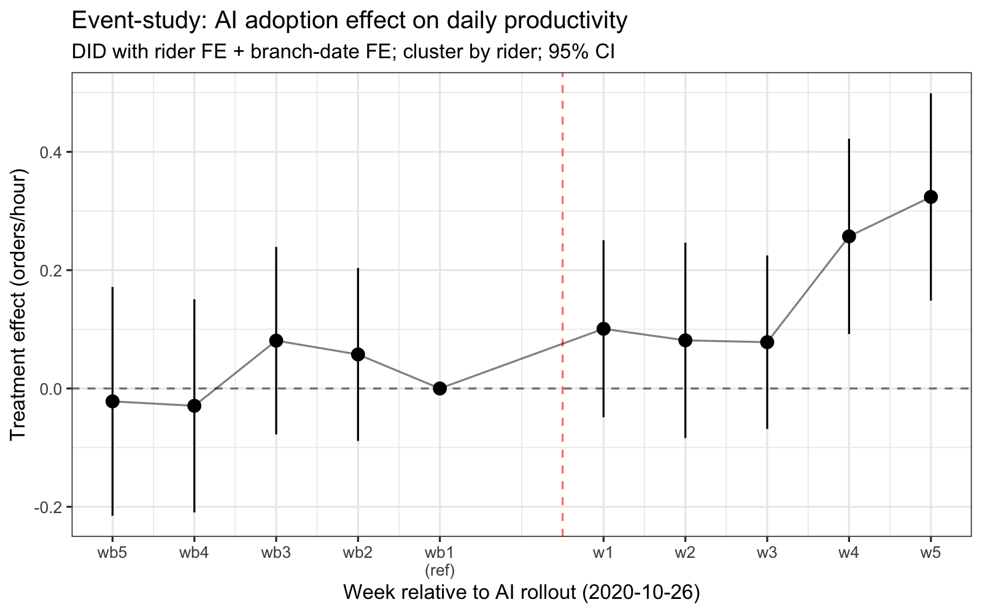
Figure A1. Event-study coefficients on productivity (DID, week-level leads/lags).
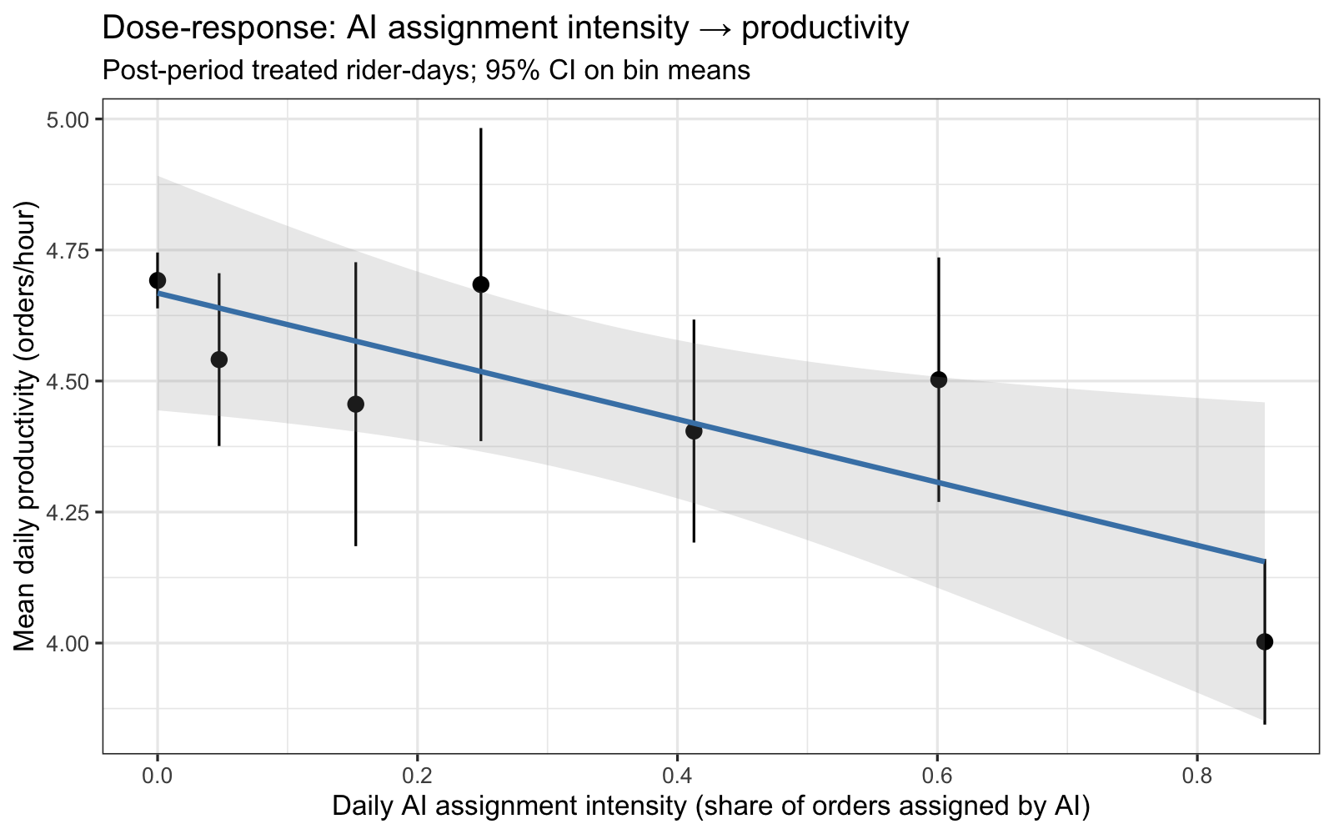
Figure A2. Dose-response: AI assignment intensity vs. productivity (post-period treated rider-days).
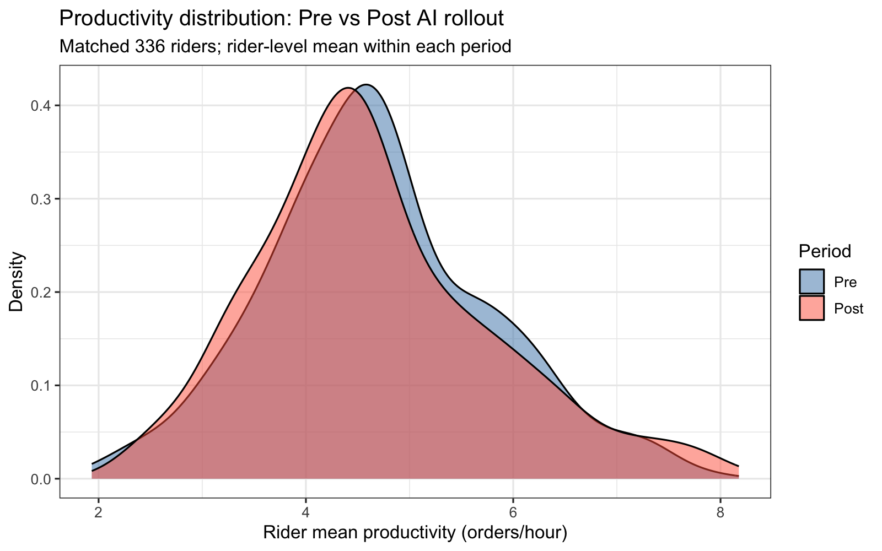
Figure A3. Pre-vs-post productivity density (matched 336 riders).
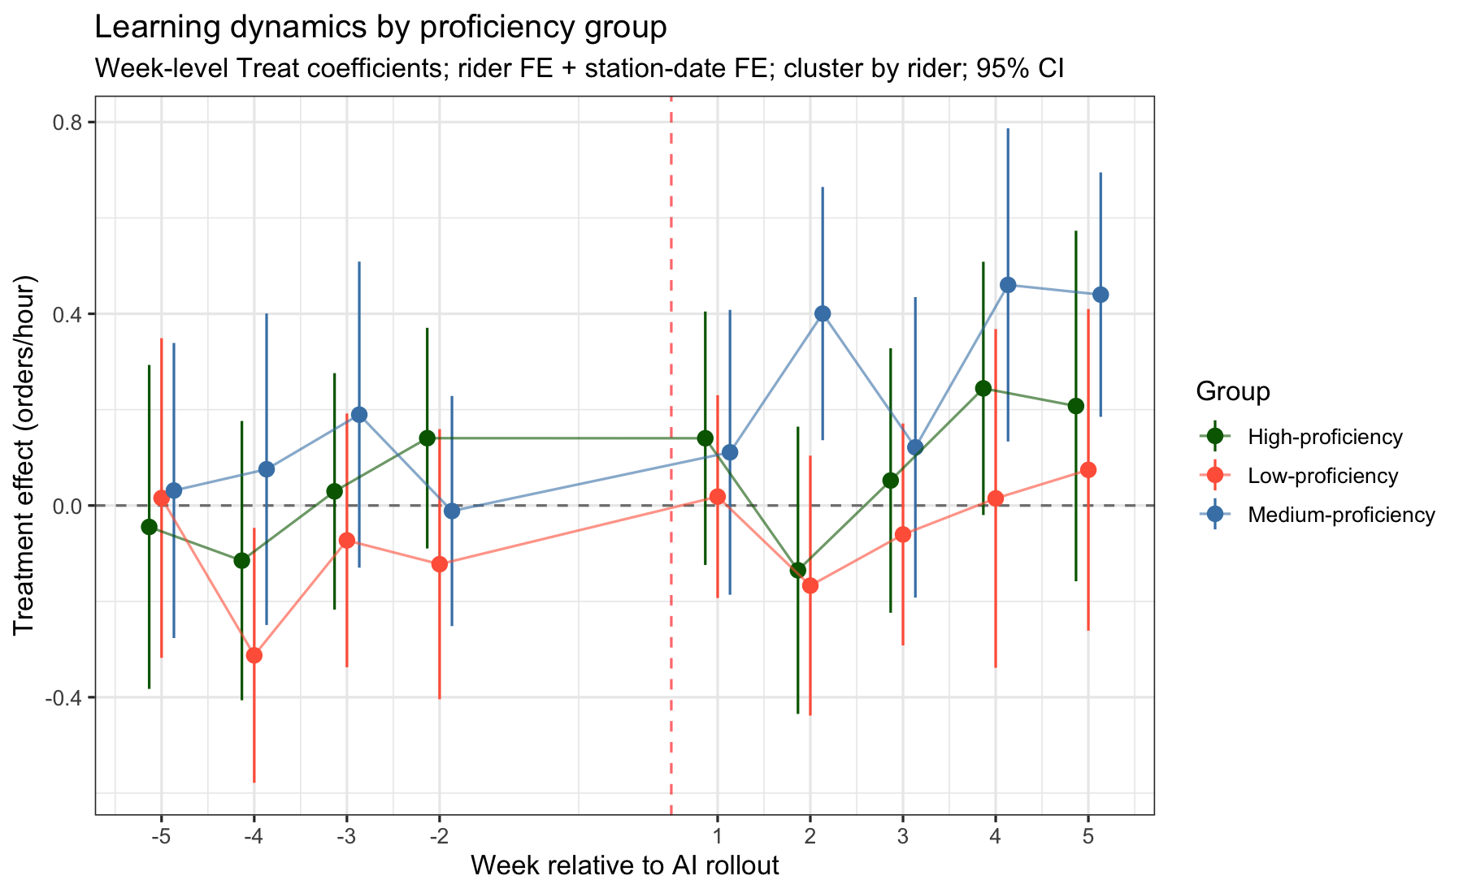
Figure A4. Learning dynamics by proficiency group (week-level treatment coefficients).
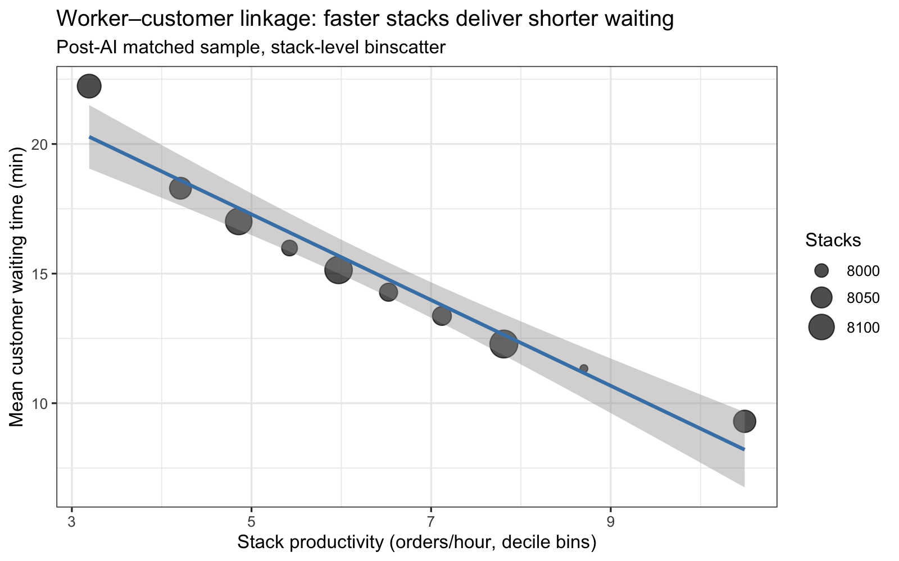
Figure A5. Worker-customer linkage: stack productivity vs customer waiting time.
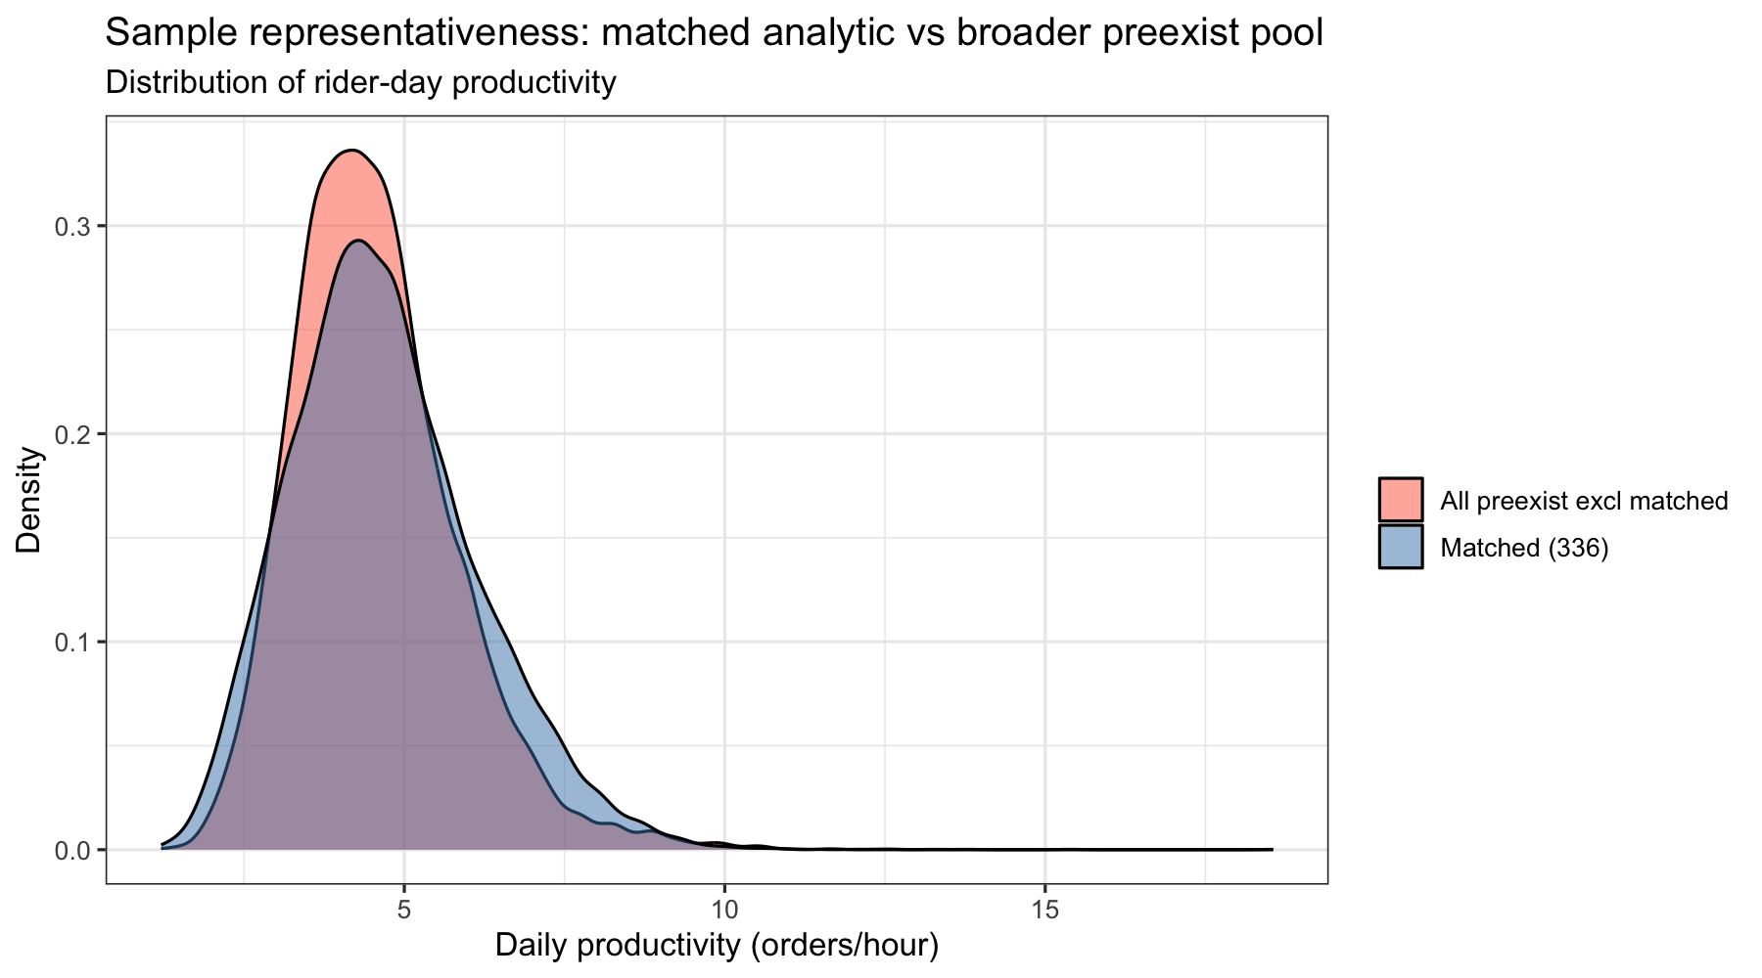
Figure A6. Sample representativeness: matched analytic sample vs broader preexist Busan riders.
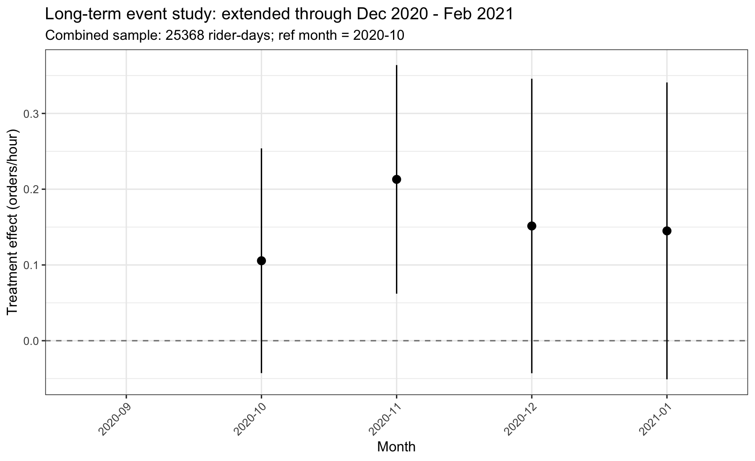
Figure A7. Long-term productivity event-study (monthly coefficients, Sep 2020 – Jan 2021).

References

원본 manuscript reference list 기반 + reviewer 코멘트 address 후 정리. 변경 사항: (i) Y. Chen 2024a/b 중복 단일화, (ii) Allon 2018 SSRN → 2023 published version, (iii) Brynjolfsson 2025 trailing `*` 제거. 자세한 변경 audit: `docs/05_reference_audit.md`.

────────────────────────────────────────────────────────────────────────────────

Acemoglu, D., & Restrepo, P. (2018). Artificial intelligence, automation, and work. In Agrawal A., Gans J., & Goldfarb A. (Eds.), The economics of artificial intelligence: An agenda (pp. 197–236). University of Chicago Press.

Allon, G., Cohen, M. C., & Sinchaisri, W. P. (2023). The Impact of Behavioral and Economic Drivers on Gig Economy Workers. *Manufacturing & Service Operations Management*, 25(4), 1376–1393. https://doi.org/10.1287/msom.2023.1191 (updated from SSRN 2018 working paper to published 2023 version per R1-Minor-1).

Bai, B., Dai, H., Zhang, D., Zhang, F., & Hu, H. (2021). The impacts of algorithmic work assignment on fairness perceptions and productivity. Academy of Management Proceedings, 2021, 12335.

Berg, J., Furrer, M., Harmon, E., Rani, U., & Silberman, M. S. (2018). Digital labour platforms and the future of work: Towards decent work in the online world. International Labour Organization, Geneva.

Brynjolfsson, E., Li, D., & Raymond, L. (2025). Generative AI at Work. *The Quarterly Journal of Economics*, 140(2), 889–942. https://doi.org/10.1093/qje/qjae044 (trailing `` typo removed per R1-Minor-1).*

Castelo, N., Bos, M. W., & Lehmann, D. R. (2019). Task-dependent algorithm aversion. Journal of Marketing Research, 56(5), 809–825.

Chen, M. K., Rossi, P. E., Chevalier, J. A., & Oehlsen, E. (2019). The value of flexible work: Evidence from Uber drivers. Journal of Political Economy, 127(6), 2735–2794.

Chen, Y., Luo, Y., & Yuan, Z. (2024). Driving the Drivers: Algorithmic Assignment in Ride-Hailing (SSRN Scholarly Paper No. 4299499). Social Science Research Network. https://doi.org/10.2139/ssrn.4299499 (consolidated from previous a/b duplicate per R1-Minor-1).

Chiacchio, F., Petropoulos, G., & Pichler, D. (2018). The impact of industrial robots on EU employment and wages: A local labour market approach. Bruegel Working Paper.

Chong, L., Zhang, G., Goucher-Lambert, K., Kotovsky, K., & Cagan, J. (2022). Human confidence in artificial intelligence and in themselves: The evolution and impact of confidence on adoption of AI advice. Computers in Human Behavior, 127, 107018. https://doi.org/10.1016/j.chb.2021.107018

Cowgill, B. (2018). Bias and productivity in humans and algorithms: Theory and evidence from resume screening. Working Paper, Columbia University.

Cowgill, B., & Tucker, C. E. (2020). Algorithmic Fairness and Economics (SSRN Scholarly Paper No. 3361280). Social Science Research Network. https://doi.org/10.2139/ssrn.3361280

Crawford, V. P., & Meng, J. (2011). New York City cab drivers' labor supply revisited: Reference-dependent preferences with rational-expectations targets for hours and income. American Economic Review, 101(5), 1912–1932.

Damioli, G., Van Roy, V., & Vertesy, D. (2021). The impact of artificial intelligence on labor productivity. Eurasian Business Review, 11(1), 1–25. https://doi.org/10.1007/s40821-020-00172-8

De Reuver, M., Sørensen, C., & Basole, R. C. (2018). The digital platform: A research agenda. Journal of Information Technology, 33(2), 124–135.

Dell'Acqua, F., McFowland III, E., Mollick, E. R., Lifshitz-Assaf, H., Kellogg, K., Rajendran, S., Krayer, L., Candelon, F., & Lakhani, K. R. (2023). Navigating the Jagged Technological Frontier: Field Experimental Evidence of the Effects of AI on Knowledge Worker Productivity and Quality (SSRN Scholarly Paper No. 4573321). Social Science Research Network. https://doi.org/10.2139/ssrn.4573321

Dietvorst, B. J., & Bharti, S. (2020). People reject algorithms in uncertain decision domains because they have diminishing sensitivity to forecasting error. Psychological Science, 31(10), 1302–1314.

Dietvorst, B. J., Simmons, J. P., & Massey, C. (2015). Algorithm aversion: People erroneously avoid algorithms after seeing them err. Journal of Experimental Psychology: General, 144(1), 114.

Dietvorst, B. J., Simmons, J. P., & Massey, C. (2018). Overcoming algorithm aversion: People will use imperfect algorithms if they can (even slightly) modify them. Management Science, 64(3), 1155–1170.

Dijkstra, J. J., Liebrand, W. B., & Timminga, E. (1998). Persuasiveness of expert systems. Behaviour & Information Technology, 17(3), 155–163.

Duggan, J., Carbery, R., McDonnell, A., & Sherman, U. (2023). Algorithmic HRM control in the gig economy: The app-worker perspective. Human Resource Management, 62(6), 883–899. https://doi.org/10.1002/hrm.22168

Farber, H. S. (2015). Why you can't find a taxi in the rain and other labor supply lessons from cab drivers. The Quarterly Journal of Economics, 130(4), 1975–2026.

Fiske, S. T., & Taylor, S. E. (1991). Social cognition. McGraw-Hill, New York.

Frank, M. R., Autor, D., Bessen, J. E., Brynjolfsson, E., Cebrian, M., Deming, D. J., Feldman, M., Groh, M., Lobo, J., & Moro, E. (2019). Toward understanding the impact of artificial intelligence on labor. Proceedings of the National Academy of Sciences, 116(14), 6531–6539.

Frey, C. B., & Osborne, M. (2013). The future of employment. Working Paper, University of Oxford.

Gaure, S. (2013). lfe: Linear group fixed effects. The R Journal, 5(2), 104–117. (added — used by all our regressions per R1-Minor-3.)

Giuntella, O., Konig, J., & Stella, L. (2025). Artificial intelligence and the wellbeing of workers. Scientific Reports, 15(1), 20087. https://doi.org/10.1038/s41598-025-98241-3

Graetz, G., & Michaels, G. (2018). Robots at work. Review of Economics and Statistics, 100(5), 753–768.

Gries, T., & Naudé, W. (2018). Artificial Intelligence, Jobs, Inequality and Productivity: Does Aggregate Demand Matter? (Working Paper No. 12005). IZA Discussion Papers.

Gupta, A., Yadav, R., Nair, A., Chakraborty, A., Ranu, S., & Bagchi, A. (2022). FairFoody: Bringing in Fairness in Food Delivery. Proceedings of the AAAI Conference on Artificial Intelligence, 36(11), 11900–11907. https://doi.org/10.1609/aaai.v36i11.21447

Jarrahi, M. H., & Sutherland, W. (2019). Algorithmic management and algorithmic competencies: Understanding and appropriating algorithms in gig work. In iConference 2019 Proceedings (pp. 578–589).

Kellogg, K. C., Valentine, M. A., & Christin, A. (2020). Algorithms at Work: The New Contested Terrain of Control. Academy of Management Annals, 14(1), 366–410. https://doi.org/10.5465/annals.2018.0174

Kleinberg, J., Lakkaraju, H., Leskovec, J., Ludwig, J., & Mullainathan, S. (2018). Human decisions and machine predictions. The Quarterly Journal of Economics, 133(1), 237–293.

Knight, B., Mitrofanov, D., & Netessine, S. (2024). The Impact of AI Technology on the Productivity of Gig Economy Workers. Proceedings of the 25th ACM Conference on Economics and Computation, 833. https://doi.org/10.1145/3670865.3673642

Korinek, A., & Stiglitz, J. E. (2018). Artificial intelligence and its implications for income distribution and unemployment. In Agrawal A., Gans J., & Goldfarb A. (Eds.), The economics of artificial intelligence: An agenda (pp. 349–390). University of Chicago Press.

Lee, M. K., Kusbit, D., Metsky, E., & Dabbish, L. (2015). Working with machines: The impact of algorithmic and data-driven management on human workers. In Proceedings of the 33rd Annual ACM Conference on Human Factors in Computing Systems (pp. 1603–1612).

Li, T. J.-J., Lu, Y., Clark, J., Chen, M., Cox, V., Jiang, M., Yang, Y., Kay, T., Wood, D., & Brockman, J. (2022). A Bottom-Up End-User Intelligent Assistant Approach to Empower Gig Workers against AI Inequality. Proceedings of the 1st Annual Meeting of the Symposium on Human-Computer Interaction for Work, 1–10. https://doi.org/10.1145/3533406.3533418

Liu, M., Brynjolfsson, E., & Dowlatabadi, J. (2021). Do digital platforms reduce moral hazard? The case of Uber and taxis. Management Science, 67(8), 4665–4685.

Liu, R., & Yin, H. (2024). How Algorithmic Management Influences Gig Workers' Job Crafting. Behavioral Sciences, 14(10), 952. https://doi.org/10.3390/bs14100952

Liu, T., Vergara‐Cobos, E., & Zhou, Y. (2019). Pricing schemes and seller fraud: Evidence from New York City taxi rides. The Journal of Industrial Economics, 67(1), 56–90.

Logg, J. M., Minson, J. A., & Moore, D. A. (2019). Algorithm appreciation: People prefer algorithmic to human judgment. Organizational Behavior and Human Decision Processes, 151, 90–103.

Luo, X., Qin, M. S., Fang, Z., & Qu, Z. (2021). Artificial intelligence coaches for sales agents: Caveats and solutions. Journal of Marketing, 85(2), 14–32.

Luo, X., Tong, S., Fang, Z., & Qu, Z. (2019). Frontiers: Machines vs. Humans: The impact of artificial intelligence chatbot disclosure on customer purchases. Marketing Science, 38(6), 937–947.

Mao, W., Ming, L., Rong, Y., Tang, C. S., & Zheng, H. (2025). Faster Deliveries and Smarter Order Assignments for an On-Demand Meal Delivery Platform. Journal of Operations Management, 71(2), 220–245. https://doi.org/10.1002/joom.1354

McKinsey. (2021). Ordering in: The rapid evolution of food delivery. McKinsey & Company. https://www.mckinsey.com/industries/technology-media-and-telecommunications/our-insights/ordering-in-the-rapid-evolution-of-food-delivery

Meyer, B. D. (1995). Natural and quasi-experiments in economics. Journal of Business & Economic Statistics, 13(2), 151–161.

Möhlmann, M., Zalmanson, L., Henfridsson, O., & Gregory, R. W. (2021). Algorithmic management of work on online labor platforms: When matching meets control. MIS Quarterly, 45(4), 1999–2022.

Moulton, B. R. (1990). An illustration of a pitfall in estimating the effects of aggregate variables on micro units. The Review of Economics and Statistics, 72(2), 334–338.

Newell, A., & Simon, H. A. (1972). Human problem solving. Prentice-Hall, Englewood Cliffs.

Newman, D. T., Fast, N. J., & Harmon, D. J. (2020). When eliminating bias isn't fair: Algorithmic reductionism and procedural justice in human resource decisions. Organizational Behavior and Human Decision Processes, 160, 149–167.

Noy, S., & Zhang, W. (2023). Experimental evidence on the productivity effects of generative artificial intelligence. Science, 381(6654), 187–192. https://doi.org/10.1126/science.adh2586

Oster, E. (2019). Unobservable Selection and Coefficient Stability: Theory and Evidence. Journal of Business & Economic Statistics, 37(2), 187–204. https://doi.org/10.1080/07350015.2016.1227711 (added — used in our Section 5.3.2 selection bound, per R1-3C, R2-8, AE-4.)

Rad, F. F., Oghazi, P., Onur, İ., & Kordestani, A. (2025). Adoption of AI-based order picking in warehouse: Benefits, challenges, and critical success factors. Review of Managerial Science, 19(11), 3495–3540. https://doi.org/10.1007/s11846-025-00858-1

Raj, M., & Seamans, R. (2018). Artificial intelligence, labor, productivity, and the need for firm-level data. In Agrawal A., Gans J., & Goldfarb A. (Eds.), The economics of artificial intelligence: An agenda (pp. 553–565). University of Chicago Press.

Rosenbaum, P. R., & Rubin, D. B. (1983). The central role of the propensity score in observational studies for causal effects. Biometrika, 70(1), 41–55.

Sun, G. (2023). Quantitative Analysis of Online Labor Platforms' Algorithmic Management Influence on Psychological Health of Workers. International Journal of Environmental Research and Public Health, 20(5), 4519. https://doi.org/10.3390/ijerph20054519

Sun, J., Zhang, D. J., Hu, H., & Van Mieghem, J. A. (2022). Predicting human discretion to adjust algorithmic prescription: A large-scale field experiment in warehouse operations. Management Science, 68(2), 846–865.

Tong, S., Jia, N., Luo, X., & Fang, Z. (2021). The Janus face of artificial intelligence feedback: Deployment versus disclosure effects on employee performance. Strategic Management Journal, 42(9), 1600–1631.

Tversky, A., & Kahneman, D. (1974). Judgment under Uncertainty: Heuristics and Biases. Science, 185(4157), 1124–1131.

Van de Gevel, A. J., & Noussair, C. N. (2013). The nexus between artificial intelligence and economics. Springer, Berlin.

Wang, Y., Wu, C., & Zhu, T. (2019). Mobile hailing technology and taxi driving behaviors. Marketing Science, 38(5), 734–755.

Webb, M. (2019). The impact of artificial intelligence on the labor market. SSRN. https://ssrn.com/abstract=3482150

Zhang, S., & Narayandas, D. (2025). Engaging Customers with AI in Online Chats: Evidence from a Randomized Field Experiment. Management Science. https://doi.org/10.1287/mnsc.2022.03920

