National Textile University, Faisalabad



Department of Computer Science
Name | M. Ahsan Siddiqi
Class | BSSE 5th
Section | B
Registration No | 24-NTU-CS-1179
Course Name | Web Application Development
Submitted To | Sir Basit

ACTIVITY – 2
LAB PLAN 1
Question 1:
Create your own web page in HTML to display an ordered list of 5 specific things.
<!DOCTYPE html>
<html lang="en">
<head>
<meta charset="UTF-8">
<meta name="viewport" content="width=device-width, initial-scale=1.0">
<title>Question1</title>
</head>
<body>
<h4>5 Senses</h4>
<ol>
<li>Taste</li>
<li>Sight</li>
<li>Smell</li>
<li>Touch</li>
<li>Hear</li>
</ol>
</body>
</html>
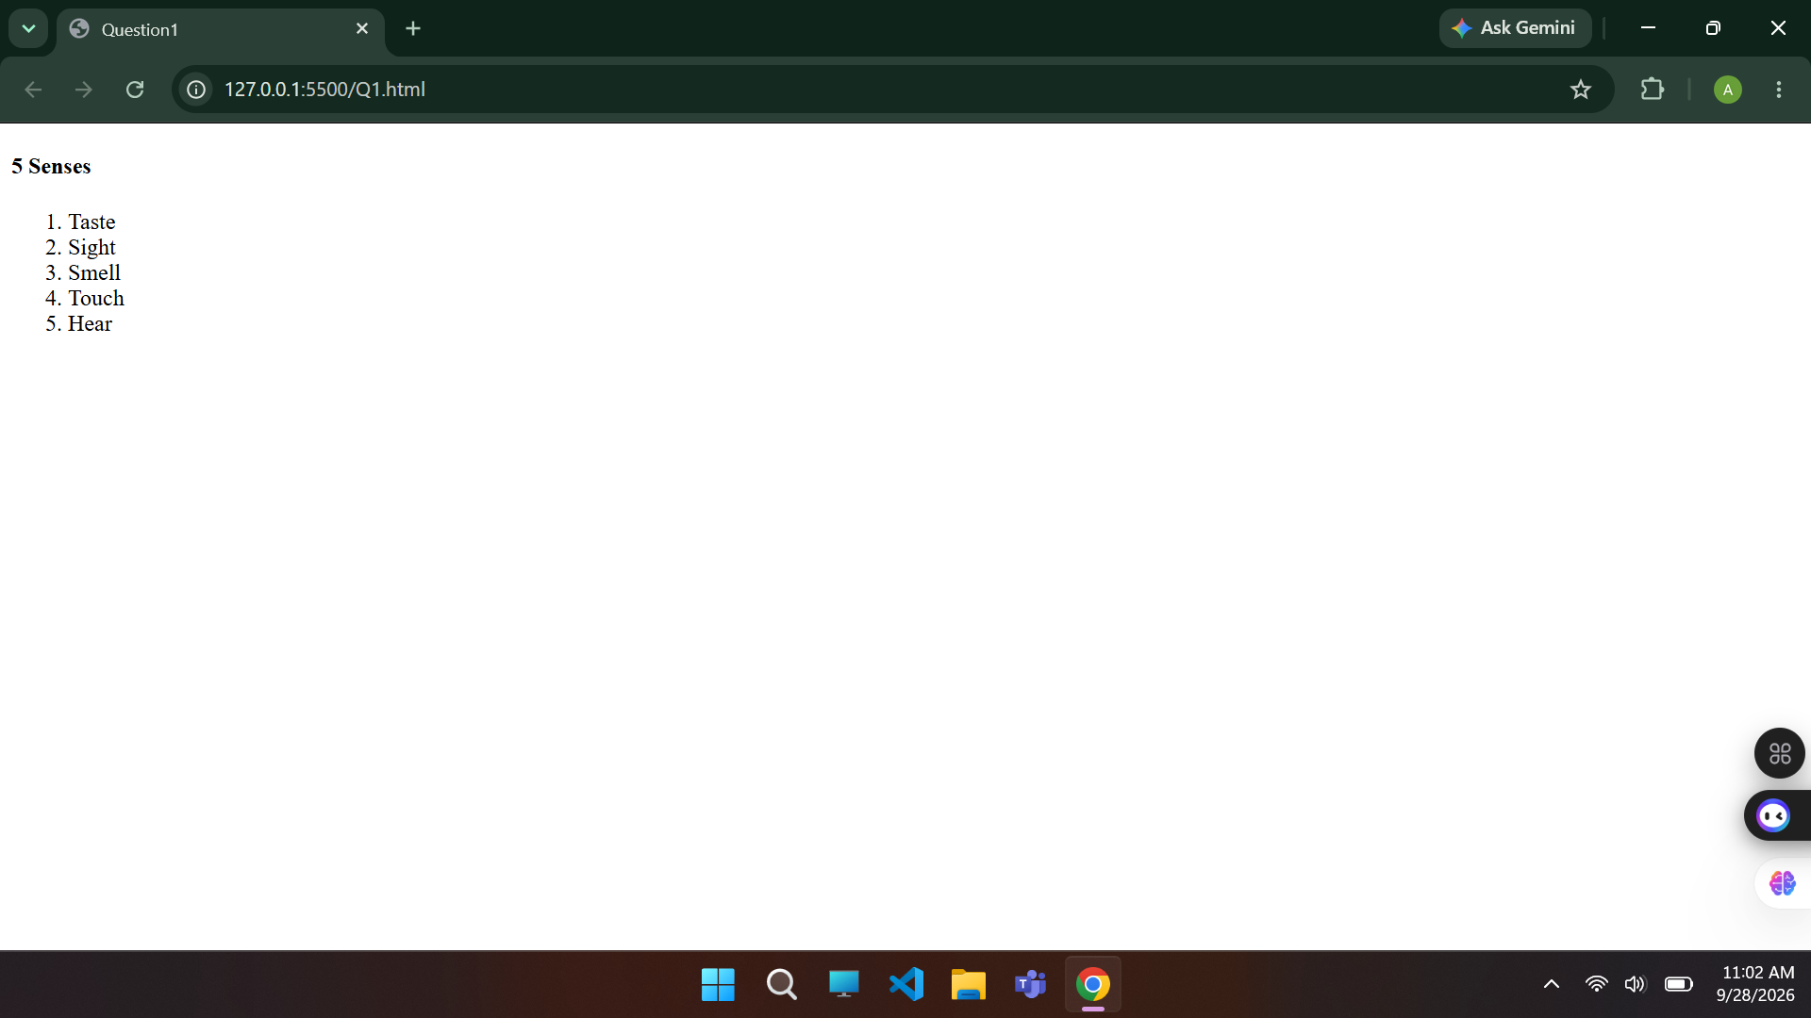

Question 2:
Create your own web page in HTML to display an unordered list of 7 name of fruits.

<!DOCTYPE html>
<html lang="en">
<head>
<meta charset="UTF-8">
<meta name="viewport" content="width=device-width, initial-scale=1.0">
<title>Question2</title>
</head>
<body>
<h3>Name of fruits</h3>
<ul>
<li>Apple</li>
<li>Banana</li>
<li>Strawberry</li>
<li>Orange</li>
<li>Peach</li>
<li>Mango</li>
<li>Avocado</li>
</ul>
</body>
</html>
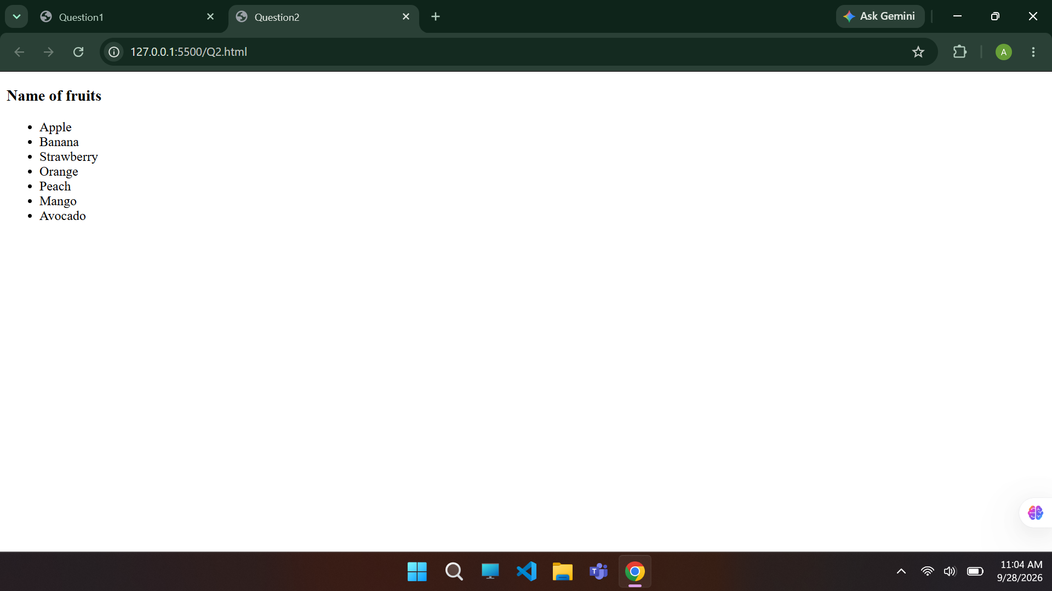

Question 3:
Create a web page in a file named Yourpage.html and display order list to start the list from specific value 10.

<!DOCTYPE html>
<html lang="en">
<head>
<meta charset="UTF-8">
<meta name="viewport" content="width=device-width, initial-scale=1.0">
<title>Question3</title>
</head>
<body>
<p><b>Starting from 10:</b></p>
<ol>
<li value="10">Bottle</li>
<li>Can</li>
<li>Bag</li>
<li>Watch</li>
</ol>
</body>
</html>
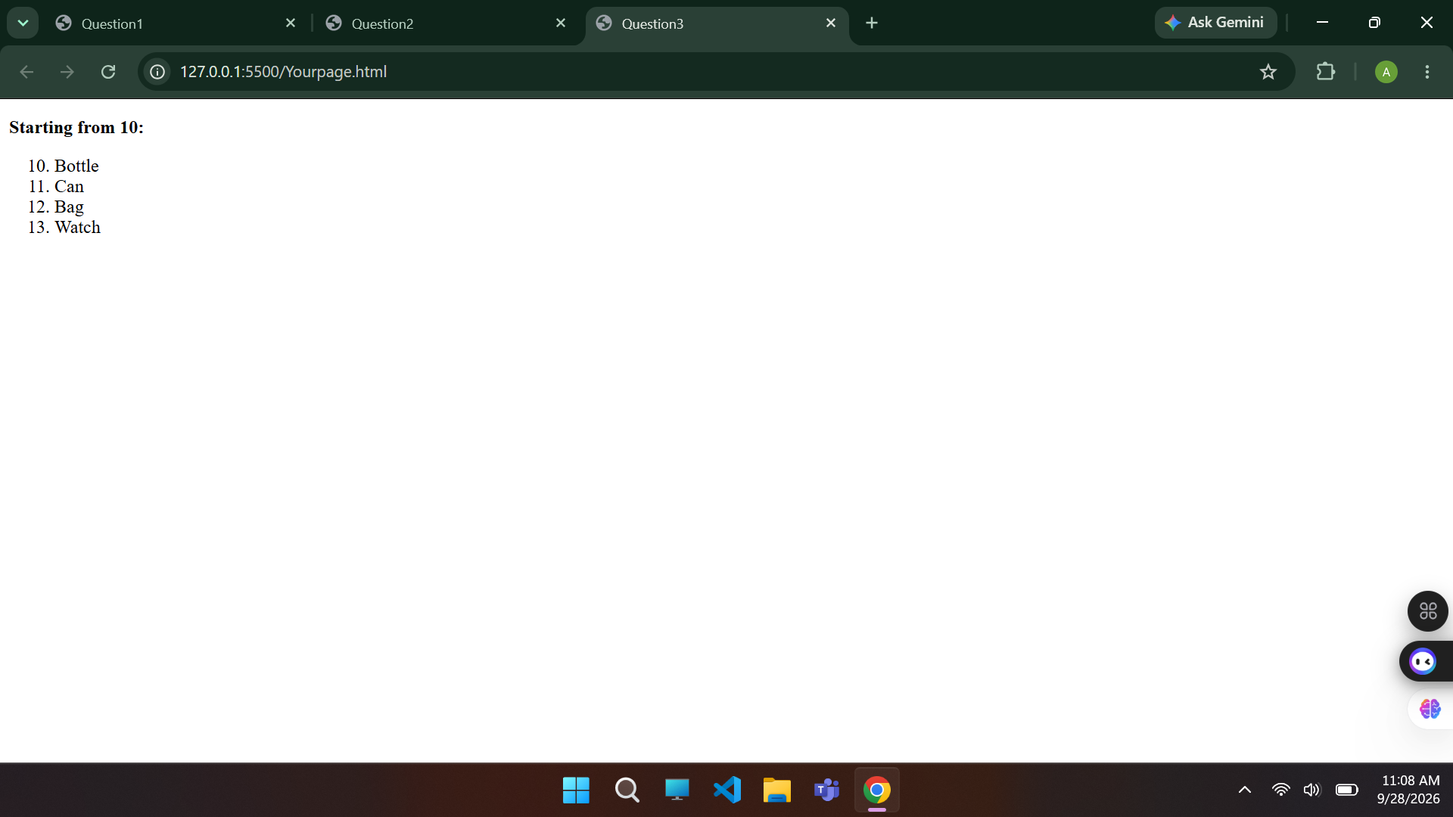

Question 4:
Create a web page in a file named Mypage.html and display order list to start list from specific value 5. A list type is roman type and list color is red.

<!DOCTYPE html>
<html lang="en">
<head>
<meta charset="UTF-8">
<meta name="viewport" content="width=device-width, initial-scale=1.0">
<title>Question4</title>
</head>
<body>
<p><b>List in roman, red and starting from 5</b></p>
<ol type="i" style="color: red;">
<li value="5">HEllo</li>
<li>Heyy</li>
<li>Byeee</li>
<li>Yeahh</li>
</ol>
</body>
</html>
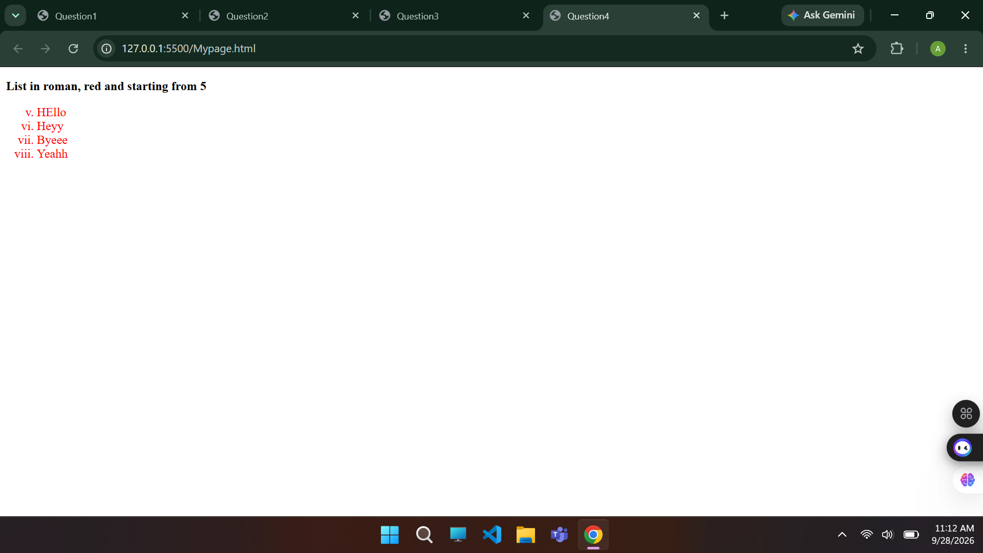

Question 5:
Create a web page in a file named Firstpage.html and display order list of OSI layer name like with different colors.

<!DOCTYPE html>
<html lang="en">
<head>
<meta charset="UTF-8">
<meta name="viewport" content="width=device-width, initial-scale=1.0">
<title>Document</title>
</head>
<body>
<header style="margin-left: 160px;"><b>OSI LAYERS</b></header>
<ol start="7" reversed>
<li style="width: 300px; background-color:teal; margin-bottom: 6px; padding: 15px; text-align: center; border-radius: 8px; list-style: none;">7 Application</li>
<li style="width: 300px; background-color:skyblue; margin-bottom: 6px; padding: 15px; text-align: center; border-radius: 8px; list-style: none;">6 Presentation</li>
<li style="width: 300px; background-color:lightseagreen; margin-bottom: 6px; padding: 15px; text-align: center; border-radius: 8px; list-style: none;">5 Session</li>
<li style="width: 300px; background-color:steelblue; margin-bottom: 6px; padding: 15px; text-align: center; border-radius: 8px; list-style: none;">4 Transport</li>
<li style="width: 300px; background-color:dodgerblue; margin-bottom: 6px; padding: 15px; text-align: center; border-radius: 8px; list-style: none;">3 Network</li>
<li style="width: 300px; background-color:royalblue; margin-bottom: 6px; padding: 15px; text-align: center; border-radius: 8px; list-style: none;">2 Data Link</li>
<li style="width: 300px; background-color:darkcyan; margin-bottom: 6px; padding: 15px; text-align: center; border-radius: 8px; list-style: none;">1 Physical</li>
</ol>
</body>
</html>
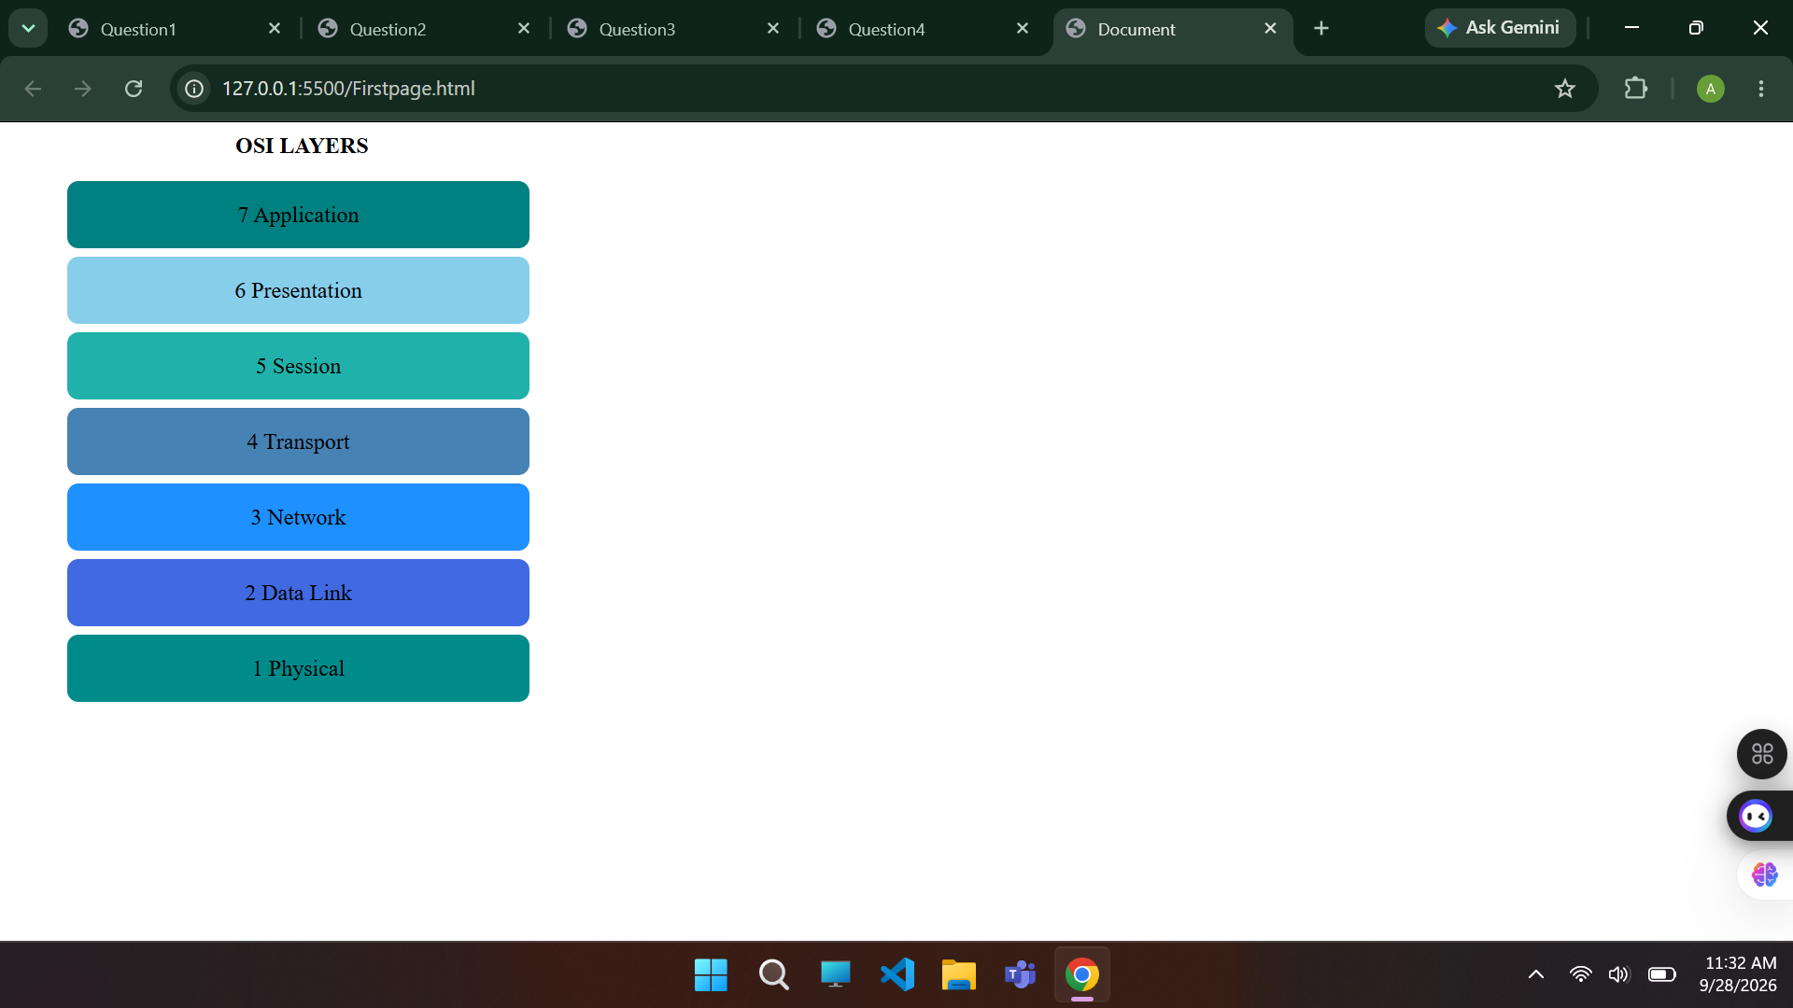

Question 6:
Create your own web page in HTML to display the unordered list like

<!DOCTYPE html>
<html lang="en">
<head>
<meta charset="UTF-8">
<meta name="viewport" content="width=device-width, initial-scale=1.0">
<title>Question6</title>
</head>
<body>
<h2>Nested Unordered List</h2>
<p>Geeks for Geeks course List:</p>
<ul>
<li>DSA
<ul type="circle">
<li>Array</li>
<li>Linked List</li>
<li>Stack</li>
<li>Queue</li>
</ul>
</li>
<li>Web Technologies
<ul>
<li>HTML</li>
<li>CSS</li>
<li>JavaScript</li>
</ul>
</li>
<li>Aptitude</li>
<li>Gate</li>
<li>Placement</li>
</ul>
</body>
</html>
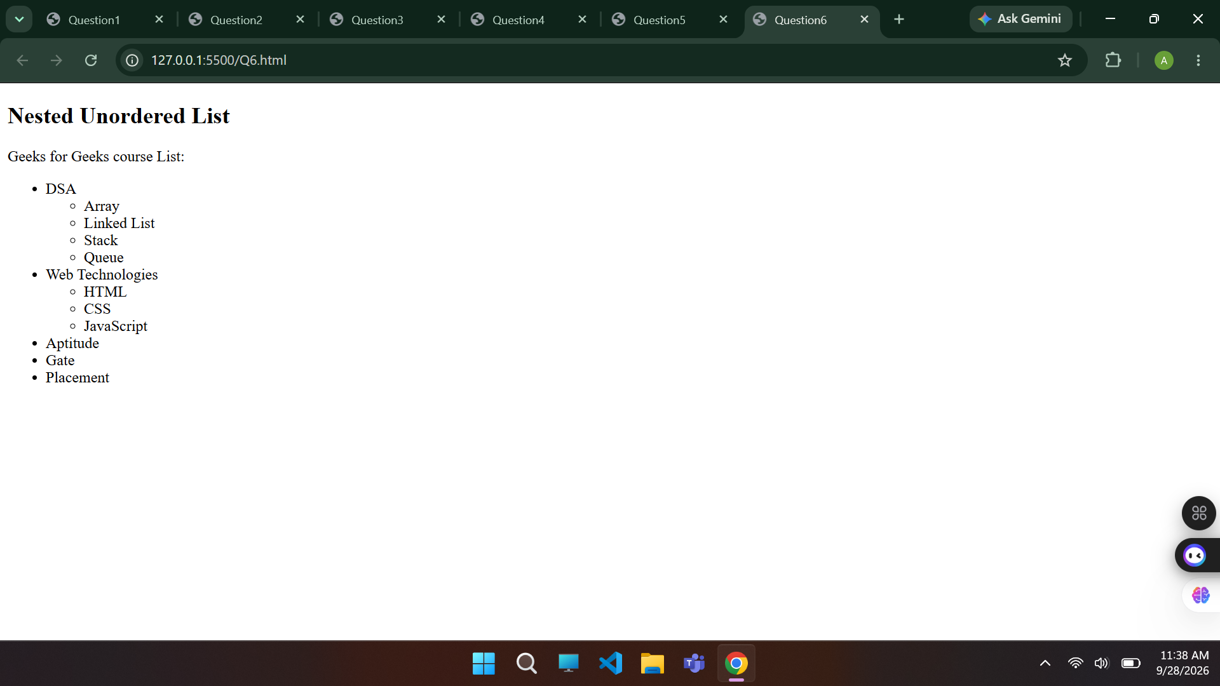

Question 7:
Create an HTML document to display the following nested list style

<!DOCTYPE html>
<html lang="en">
<head>
<meta charset="UTF-8">
<meta name="viewport" content="width=device-width, initial-scale=1.0">
<title>Question7</title>
</head>
<body>
<p>Preceding Text</p>
<ol type="I">
<li>List Item 1
<ol type="a">
<li>Nested Item 1.1</li>
<li>Nested Item 1.2</li>
</ol>
</li>
<li>List Item 2
<ol type="1">
<li>Nested Item 2.1</li>
<li>Nested Item 2.2
<ul type="circle">
<li>Nested Item 2.2.1</li>
<li>Nested Item 2.2.2
<ul type="square">
<li>Nested Item 2.2.2.1</li>
<li>Nested Item 2.2.2.2</li>
</ul>
</li>
<li>Nested Item 2.2.3</li>
</ul>
</li>
<li>Nested Item 2.3</li>
</ol>
</li>
<li>List Item 3
<ul type="disc">
<li>Nested Item 3.1</li>
<li>Nested Item 3.2</li>
<li>Nested Item 3.3</li>
</ul>
</li>
</ol>
</body>
</html>
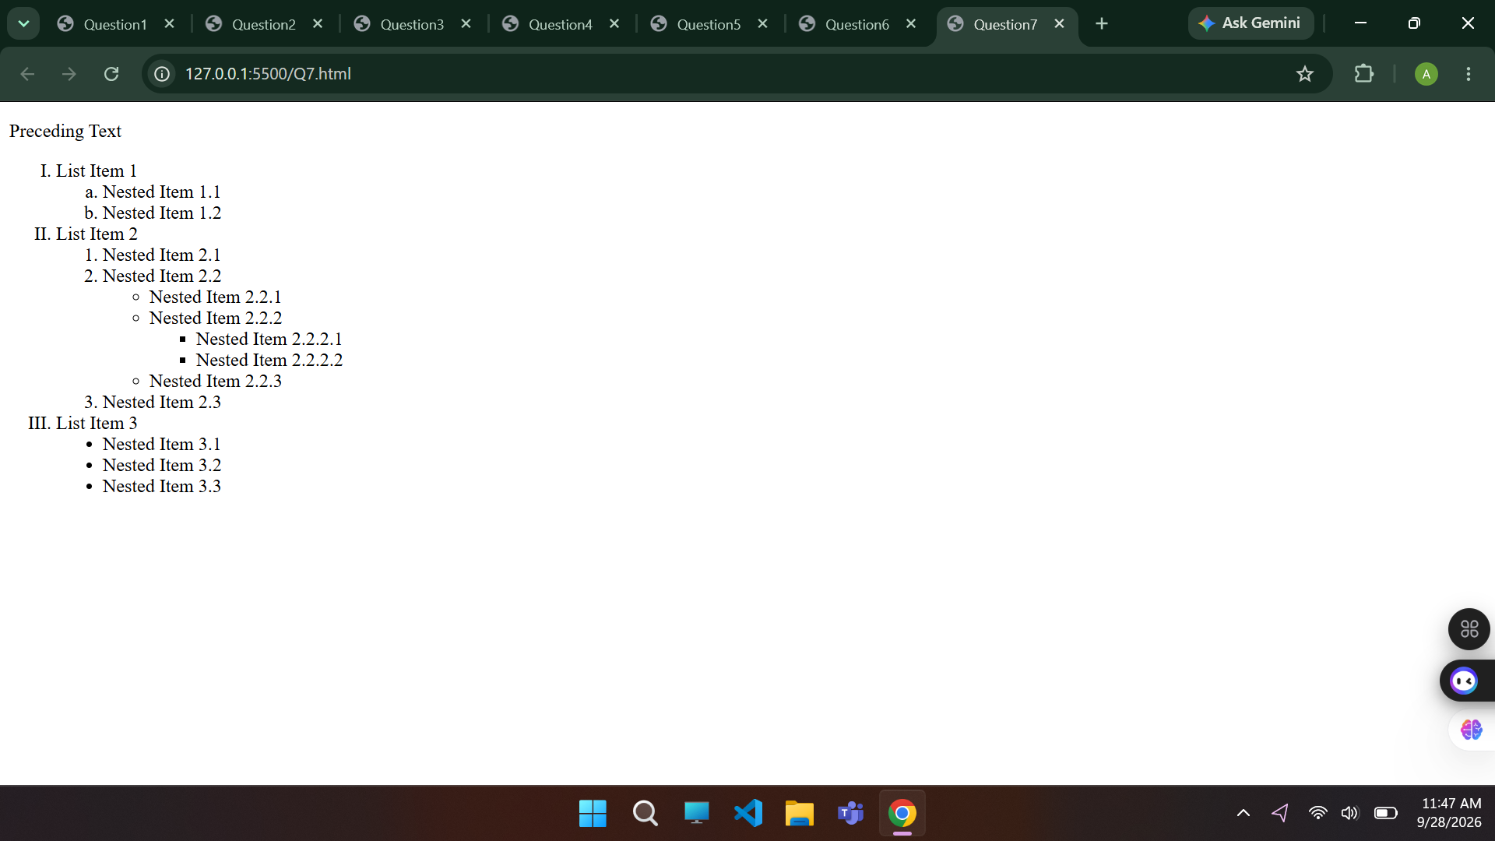

Question 8:
Create an HTML document to display the following nested list style

<!DOCTYPE html>
<html lang="en">
<head>
<meta charset="UTF-8">
<meta name="viewport" content="width=device-width, initial-scale=1.0">
<title>Question8</title>
</head>
<body>
<h2>Welcome!</h2>
<img src="bear.png" alt="bear" width="300px" height="300px">
<p style="width: 600px;">Lorem ipsum, dolor sit amet consectetur adipisicing elit. Nostrum fugit quibusdam voluptas voluptatem culpa blanditiis nemo, non reprehenderit quas? Asperiores a, quidem ex doloremque fugiat exercitationem voluptas inventore atque ipsum!</p>
</body>
</html>
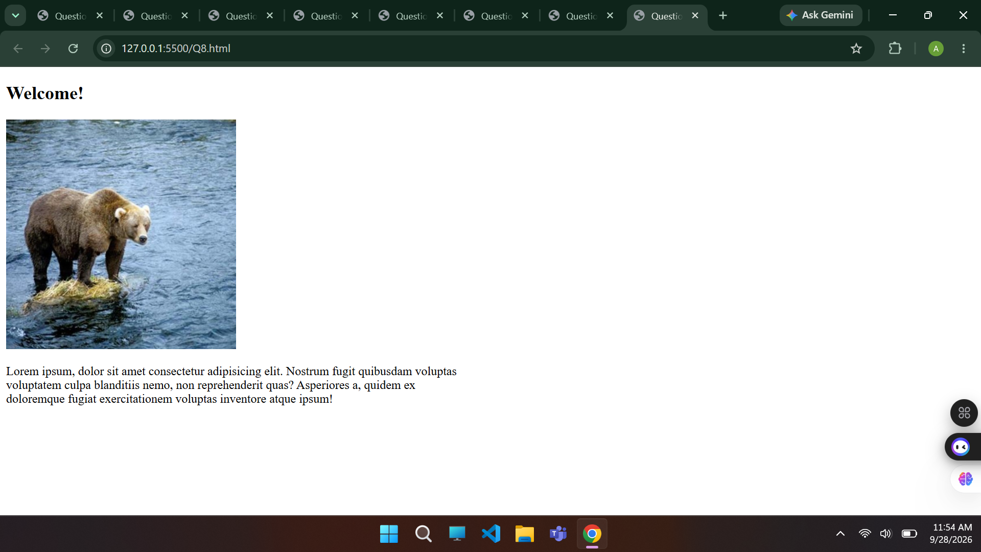

Question 9:
Create your own static web page in HTML to display image and one paragraph from left side is look like below.
<!DOCTYPE html>
<html lang="en">
<head>
<meta charset="UTF-8">
<meta name="viewport" content="width=device-width, initial-scale=1.0">
<title>Question9</title>
</head>
<body>
<div style="display: flex;">
<img src="cat.png" alt="cat" width="200px" height="200px">
<p style="width: 400px; margin-left: 10px;"><b>Lorem ipsum, dolor sit amet consectetur adipisicing elit. Molestias corporis mollitia perspiciatis ducimus, hic rerum at aliquid iure quo, aut quis aperiam delectus in repudiandae. Quia, ex saepe. Cum, exercitationem. Lorem, ipsum dolor sit amet consectetur adipisicing elit. Distinctio asperiores deleniti voluptate odio magnam molestias! Culpa et at rem! Exercitationem itaque nisi est, obcaecati ab dolorum assumenda error totam in.</b></p>
</div>
</body>
</html>
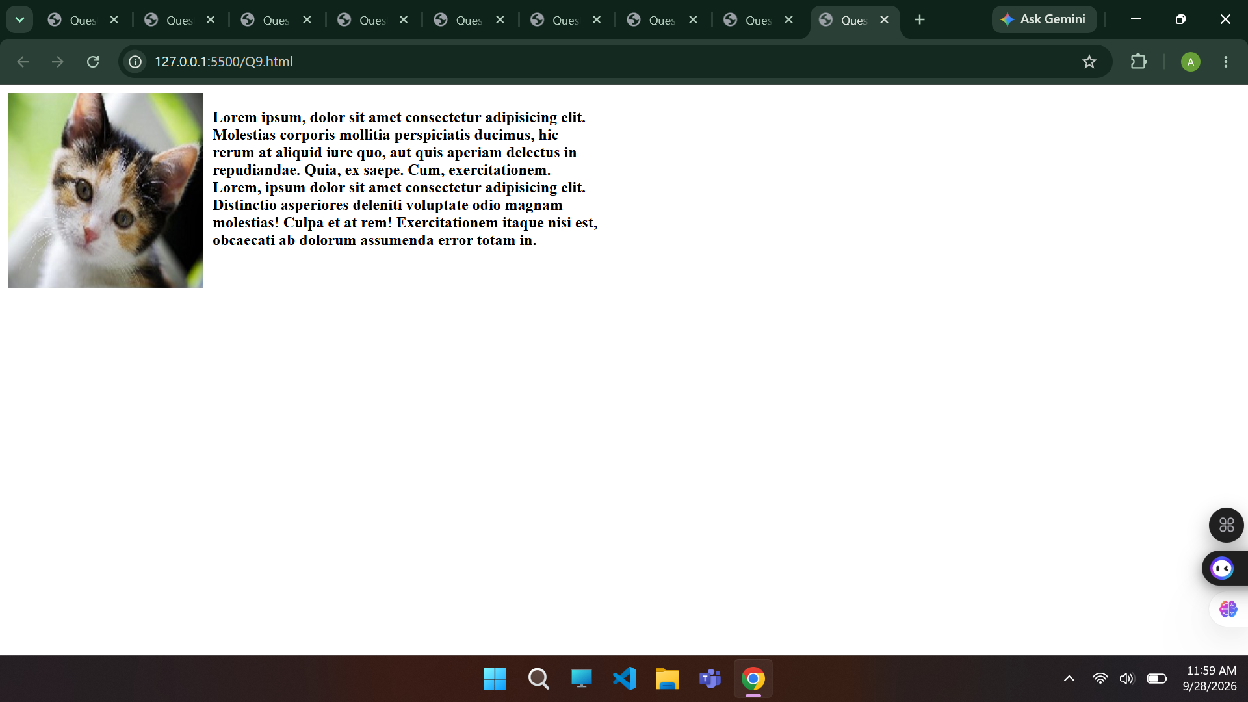

Question 10:
Create your own static web page in HTML to display image and one heading H1 and order list is look like below.

<!DOCTYPE html>
<html lang="en">
<head>
<meta charset="UTF-8">
<meta name="viewport" content="width=device-width, initial-scale=1.0">
<title>Question10</title>
</head>
<body>
<h1>Compare- Write about things that are similar or the same</h1>
<div style="display: flex;">
<img src="boy.png" alt="boy" width="200px" height="200px">
<Ol><b>Paragraph structure</b>
<li>Topic Sentence</li>
<li>3-4 Sentences about things they do, like or have that are the same</li>
<li>Concluding Sentence</li>
</Ol>
</div>
</body>
</html>
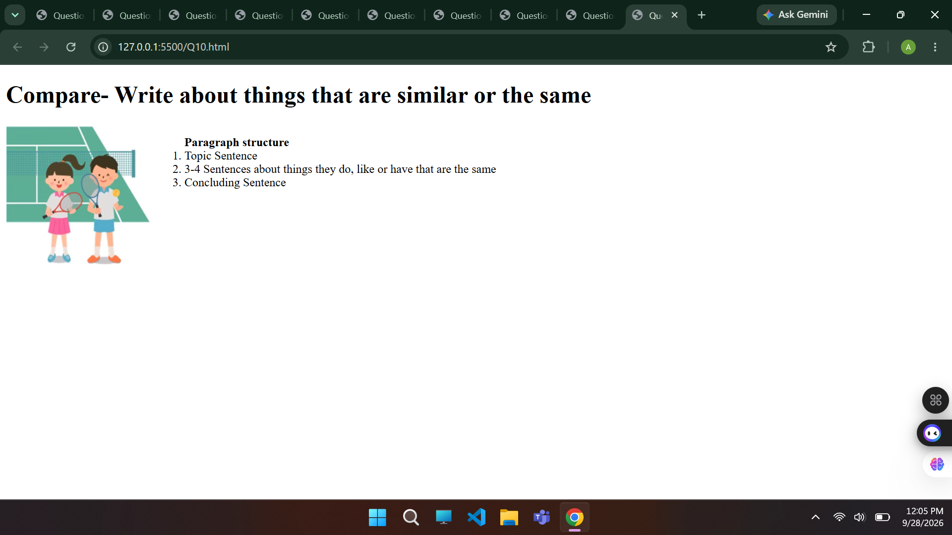

LAB PLAN 2
Question 1:
Create your own web page in HTML to display an Unordered list of 5 specific fruit name.

<!DOCTYPE html>
<html lang="en">
<head>
<meta charset="UTF-8">
<meta name="viewport" content="width=device-width, initial-scale=1.0">
<title>Question1</title>
</head>
<body>
<h3>unordered list:</h3>
<ul>
<li>Apple</li>
<li>Banana</li>
<li>Mango</li>
<li>Grapes</li>
<li>Orange</li>
</ul>
</body>
</html>
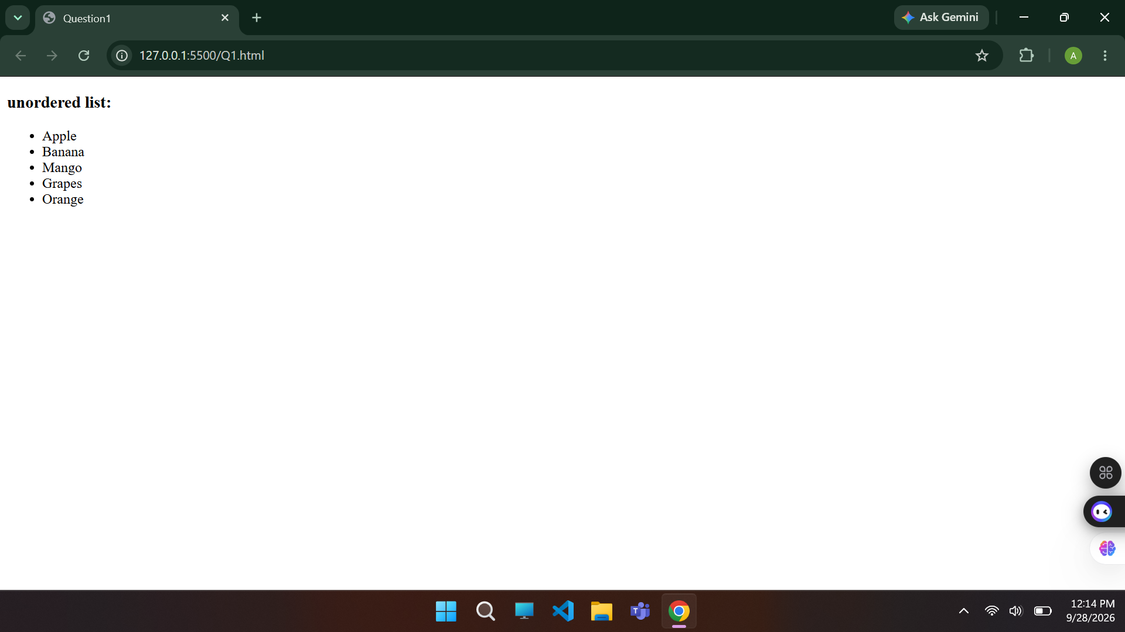

Question 2:
Create your own web page in HTML to display an unordered list of 4 Students name with type of is Circle Marker and 3 City name with type of Disc Marker.

<!DOCTYPE html>
<html lang="en">
<head>
<meta charset="UTF-8">
<meta name="viewport" content="width=device-width, initial-scale=1.0">
<title>Question2</title>
</head>
<body>
<h4>Students name:</h4>
<ul type="circle">
<li>Ahsan</li>
<li>Ali</li>
<li>Ahmad</li>
<li>Asad</li>
</ul>
<h4>Cities name:</h4>
<ul type="disc">
<li>Faisalabad</li>
<li>Lahore</li>
<li>Islamabad</li>
</ul>
</body>
</html>
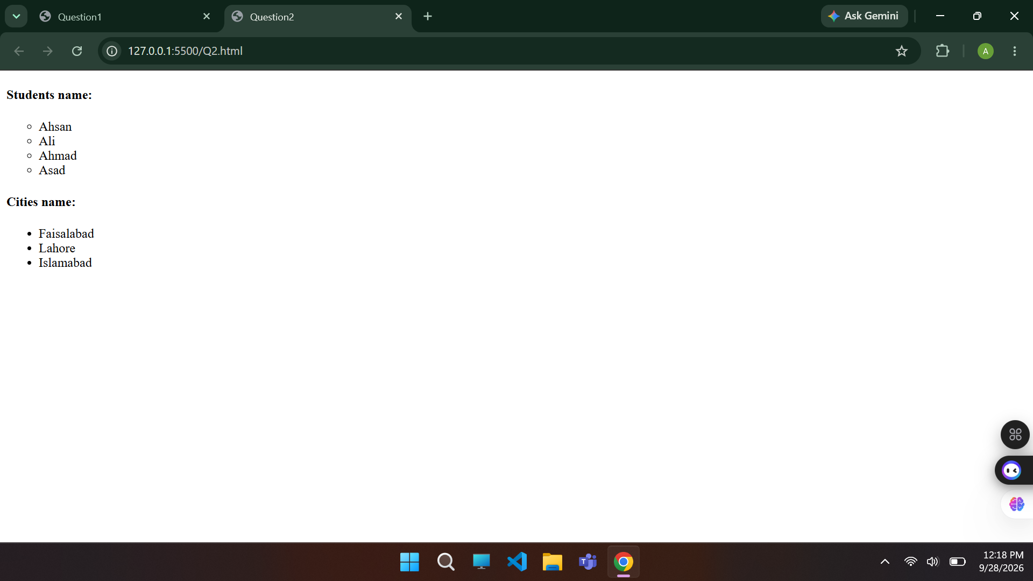

Question 3:
Create a web page in a file named Mypage.html and display order list to start the specific numbers as given below: Student Name 1 Zahid 3 Ali 6 Usman 7 Khalid 9 Zeeshan
<!DOCTYPE html>
<html lang="en">
<head>
<meta charset="UTF-8">
<meta name="viewport" content="width=device-width, initial-scale=1.0">
<title>Question3</title>
</head>
<body>
<h2>Students Name</h2>
<ol>
<li value="1">Zahid</li>
<li value="3">Ali</li>
<li value="6">Usman</li>
<li value="7">Khalid</li>
<li value="9">Zeeshan</li>
</ol>
</body>
</html>
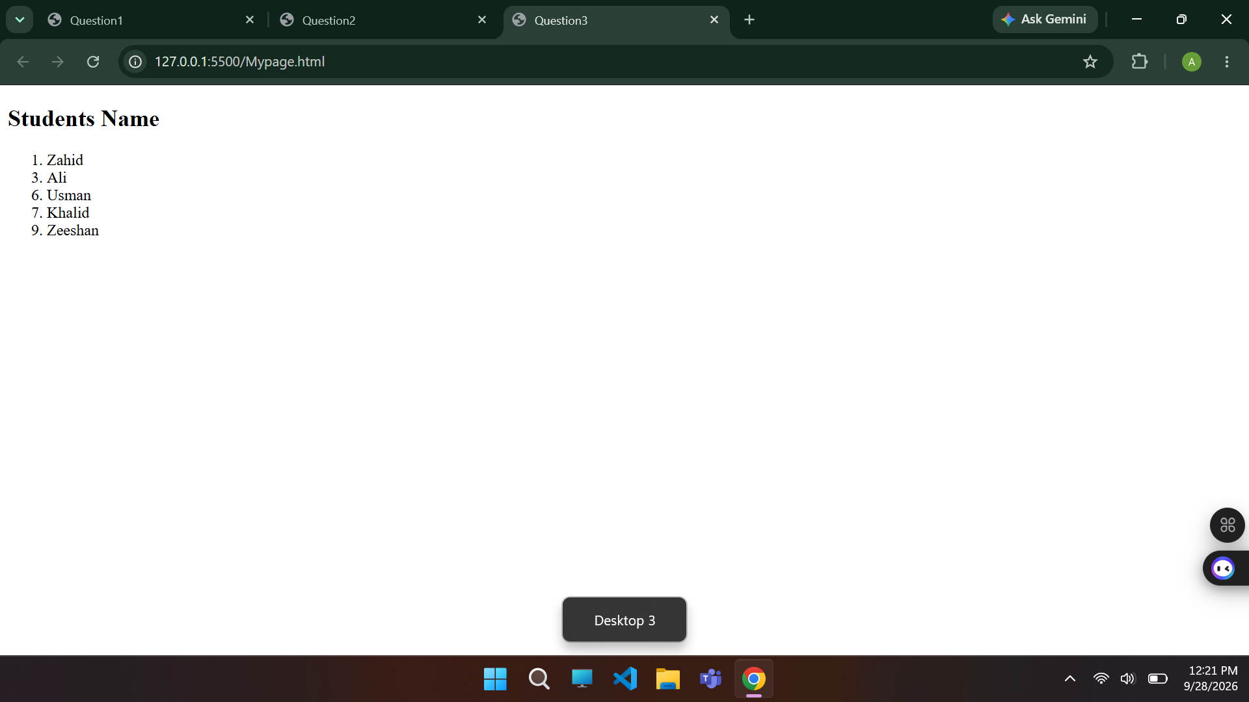

Question 4:
Create a web page in a file named MyList.html and display order list to start list from specific value 7 using Start attribute. The list items must be numbered with lowercase letters and text color is green, font is “Algerian” and size is +3

<!DOCTYPE html>
<html lang="en">
<head>
<meta charset="UTF-8">
<meta name="viewport" content="width=device-width, initial-scale=1.0">
<title>Question4</title>
</head>
<body>
<Font Face="Algerian" Size=+3>
<ol start="7" type="a" style="color: green;">
<li>Hello</li>
<li>Heyy</li>
<li>Hiii</li>
</ol>
</Font>
</body>
</html>
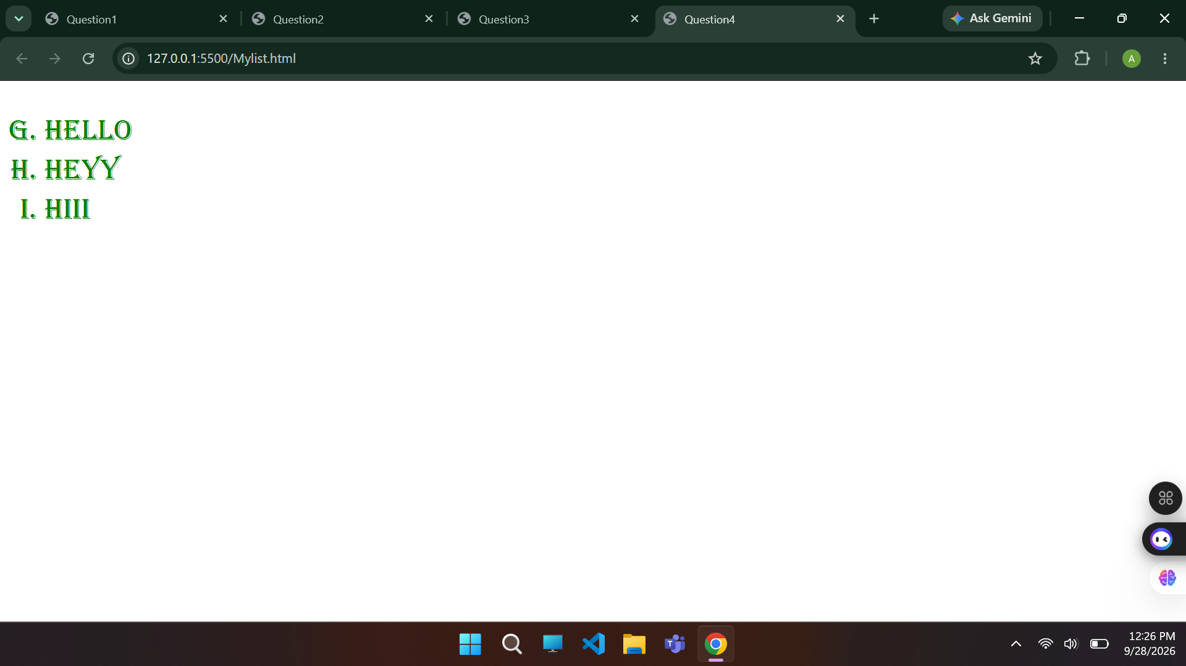

Question 5:
Create a web page in a file named FirstWebPage.html and display list as like given below: - colors.

<!DOCTYPE html>
<html lang="en">
<head>
<meta charset="UTF-8">
<meta name="viewport" content="width=device-width, initial-scale=1.0">
<title>Question5</title>
</head>
<body>
<div style="display: flex;">
<ul type="none">
<li>Disc
<ul type="disc">
<li>First item</li>
<li>Second item</li>
<li>Third item</li>
</ul>
</li>
<li>Square
<ul type="square">
<li>First item</li>
<li>Second item</li>
<li>Third item</li>
</ul>
</li>
<li>Circle
<ul type="circle">
<li>First item</li>
<li>Second item</li>
<li>Third item</li>
</ul>
</li>
<li>No Bullets
<ul type="none">
<li>First item</li>
<li>Second item</li>
<li>Third item</li>
</ul>
</li>
</ul>
<ol style="list-style-type: none;">
<li>Decimal
<ol type="1">
<li>First item</li>
<li>Second item</li>
<li>Third item</li>
</ol>
</li>
<li>Decimal with leading zeros
<ol style="list-style-type:decimal-leading-zero;">
<li>First item</li>
<li>Second item</li>
<li>Third item</li>
</ol>
</li>
<li>lowercase ascii letters
<ol type="a">
<li>First item</li>
<li>Second item</li>
<li>Third item</li>
</ol>
</li>
<li>lowercase roman numerals
<ol type="i">
<li>First item</li>
<li>Second item</li>
<li>Third item</li>
</ol>
</li>
</ol>
</div>
</body>
</html>
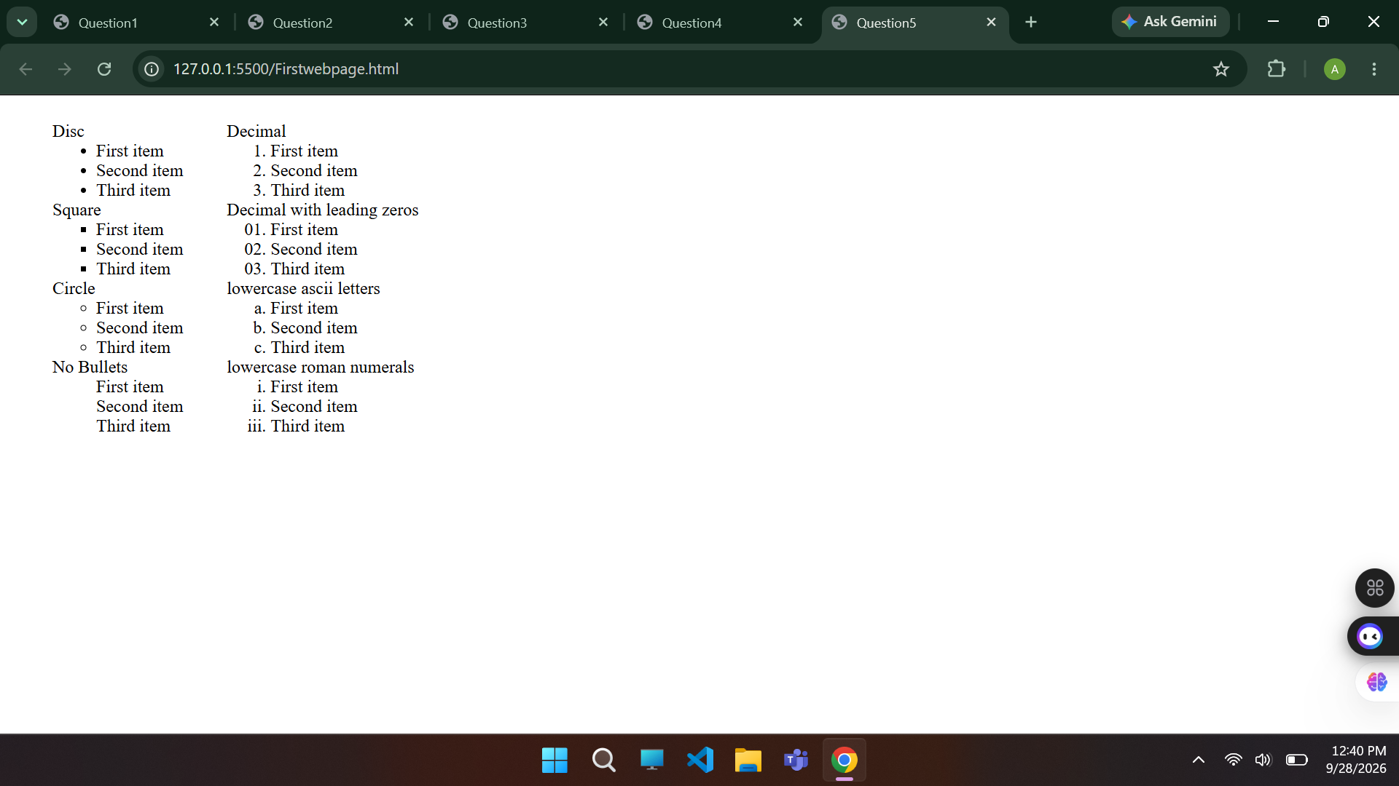

Question 6:
Create your own web page in HTML to display the nested list like

<!DOCTYPE html>
<html lang="en">
<head>
<meta charset="UTF-8">
<meta name="viewport" content="width=device-width, initial-scale=1.0">
<title>Question6</title>
</head>
<body>
<ol start="107">
<li>English First Paper
<ul style="list-style-type: square;">
<li>True/False</li>
<li>Fill in the gap</li>
</ul>
</li>
<li>English Second Paper<ul style="list-style-type: circle;">
<li>
Grammar Section
<ol type="a">
<li>Article</li>
<li>Narration</li>
<li>Preposition</li>
</ol>
</li>
<li>Writing Section</li>
</ul>
</li>
</ol>
</body>
</html>
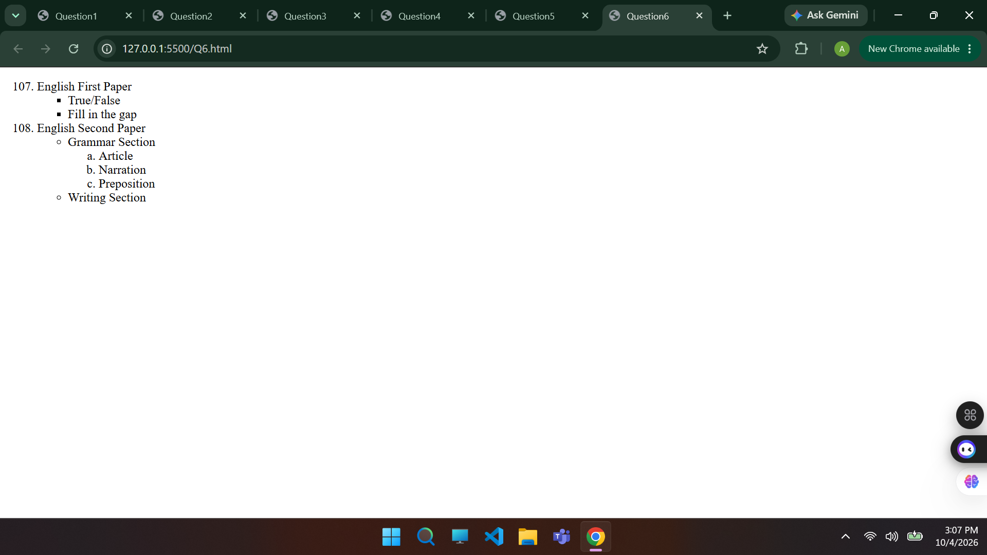

Question 7:
Create an HTML document to display the following nested list style.

<!DOCTYPE html>
<html lang="en">
<head>
<meta charset="UTF-8">
<meta name="viewport" content="width=device-width, initial-scale=1.0">
<title>Document</title>
</head>
<body>
<h1>List Example</h1>
<ol type="1">
<li>List Item 1
<ol type="A">
<li>Nested item 1.1</li>
<li>Nested item 1.2</li>
</ol>
</li>
<li>List Item 2
<ol type="i">
<li>Nested item 2.1</li>
<li>Nested item 2.2
<ul style="list-style-type: square;">
<li>Nested item 2.2.1</li>
<li>Nested item 2.2.2
<ul style="list-style-type: circle;">
<li>Nested item 2.2.2.1</li>
<li>Nested item 2.2.2.2</li>
</ul>
</li>
<li>Nested item 2.2.3</li>
</ul>
</li>
<li>Nested item 2.3</li>
</ol>
</li>
<li>List Item 3
<ul style="list-style-type: disc;">
<li>Item 1</li>
<li>Item 2</li>
<li>Item 3</li>
</ul>
</li>
</ol>
</body>
</html>
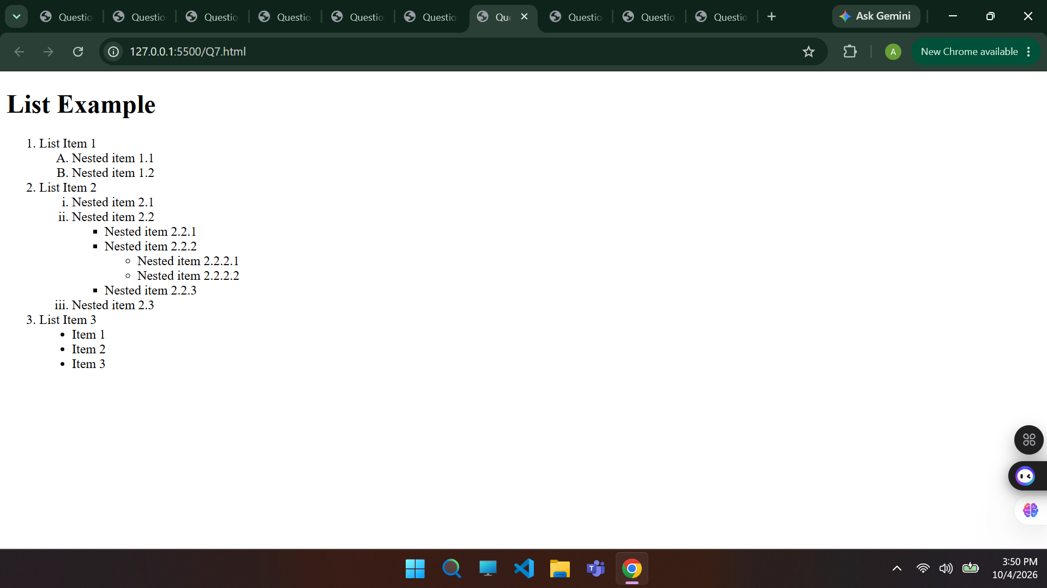

Question 8:
Create your own static web page in HTML to display two images and one left side of the heading and second right side the paragraph as look like below. One Unordered list with hyperlink
<!DOCTYPE html>
<html lang="en">
<head>
<meta charset="UTF-8">
<meta name="viewport" content="width=device-width, initial-scale=1.0">
<title>Document</title>
</head>
<body>
<div style="max-width: 800px; padding: 20px;">
<div style="display: flex; align-items: center; gap: 15px;">
<img src="leaf.png" alt="Leaf Logo" style="height: 50px;" />
<div>
<h1>The Garden Company</h1>
<p style="font-style: italic; color: #555;">Helping you help your gardens grow since 1975</p>
</div>
</div>

<hr style="margin: 20px 0;" />

<div style="overflow: auto;">
<img src="tech.png" alt="Logos" style="float: right; margin-left: 20px; width: 180px;" />

<p>
<strong>Fruit trees are now in stock!</strong> We have just received a large shipment of peach, pear, apple, and plum trees with sturdy root systems and healthy foliage, with prices as low as $29.99. Visit the <a href="#">Products</a> page for details.
</p>

<p><strong>New articles!</strong> Check out these recently posted articles:</p>
<ul>
<li><a href="#">Diagnosing Foliage Problems</a></li>
<li><a href="#">Spraying Techniques for Fruit Trees</a></li>
</ul>

<p>
<strong>What does that mean?</strong> Run into an unfamiliar gardening term? Look it up in our <a href="#">Glossary</a>.
</p>
</div>
</div>
</body>
</html>
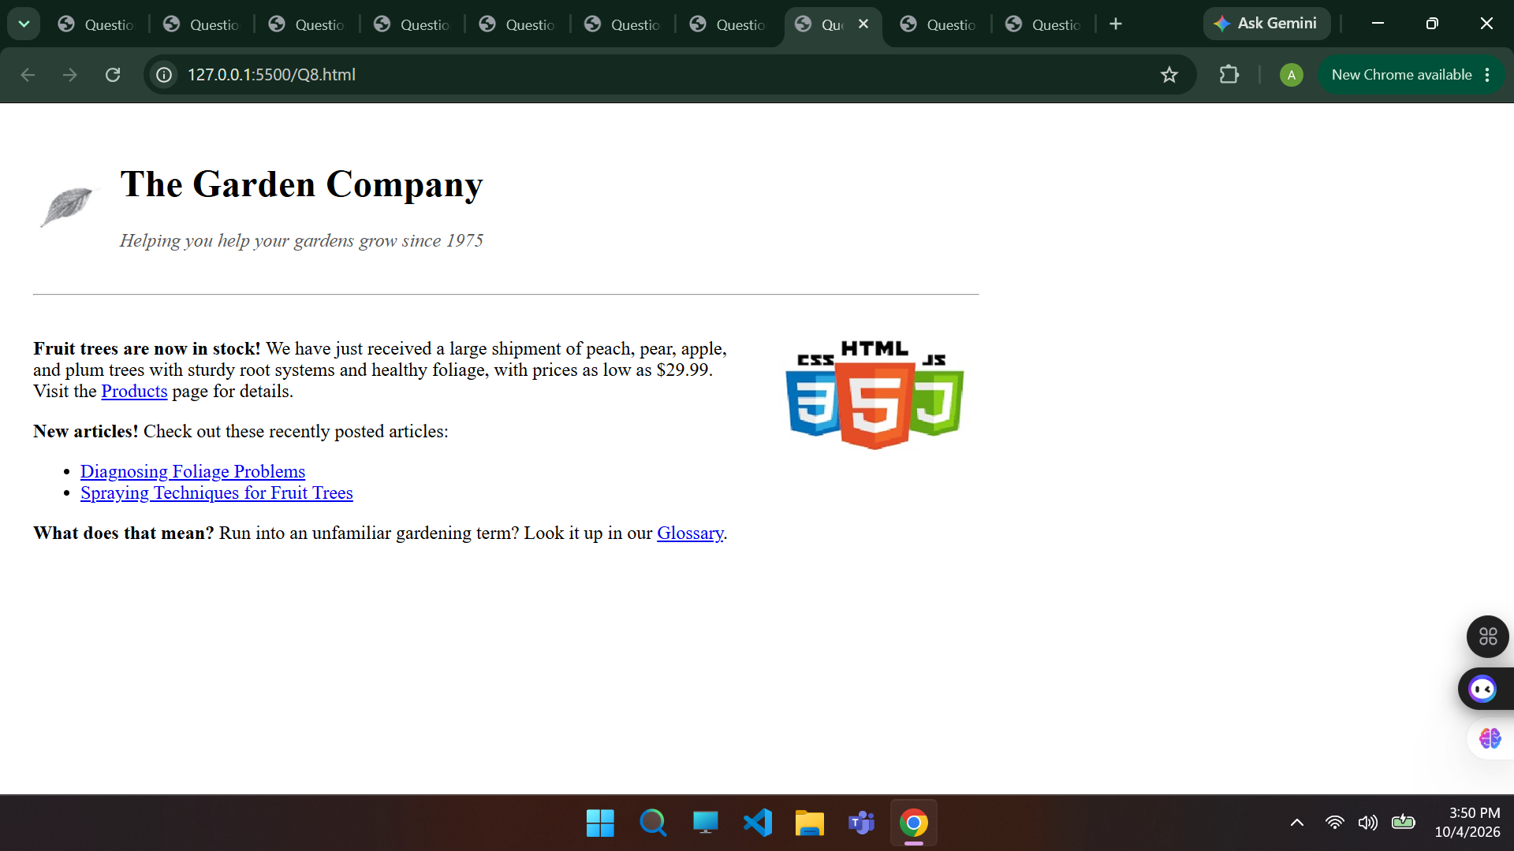

Question 9:
Create your own static web page in HTML to display image and one paragraph from left side is look like below.
<!DOCTYPE html>
<html lang="en">
<head>
<meta charset="UTF-8">
<meta name="viewport" content="width=device-width, initial-scale=1.0">
<title>Document</title>
</head>
<body>
<h3 style="margin-left: 60px;">Advanced HTML tag for Table using thead,tbody and tfoot</h3>

<table style="width: 50%; border: 3px solid blue;">

<tr style="background-color: #e6f2ff;">
<th colspan="3" style="border: 2px solid blue; padding: 8px; text-align: left;">
Purchase order:987654321
</th>
<th colspan="2" style="border: 2px solid blue; padding: 8px; text-align: right;">
Tutorialbrain - 10th Oct 2020
</th>
</tr>
<tr>
<td colspan="2" style="border: 2px solid blue; padding: 8px; vertical-align: top;">
<strong>Vendor:</strong><br>
ABC XYZ ltd. <br>
DUMMY STREET<br>
BUILDING 123<br>
HAZARIBAGH, JHARKHAND, 825301
</td>
<td colspan="2" style="border: 2px solid blue; padding: 8px; vertical-align: top;">
<strong>SHIP TO:</strong><br>
MS DHONI<br>
WILSON GARDEN<br>
SOUTHEAST BLOCK, RANCHI - 834001
</td>
</tr>
<tr style="font-weight: bold; text-align: center;">
<th style="border: 2px solid blue; padding: 6px;">Qty.</th>
<th style="border: 2px solid blue; padding: 6px;">Item Code.</th>
<th style="border: 2px solid blue; padding: 6px;">Description</th>
<th style="border: 2px solid blue; padding: 6px;">Unit Price</th>
</tr>

<tr>
<td style="border: 2px solid blue; padding: 6px;">100</td>
<td style="border: 2px solid blue; padding: 6px;">IABCDE</td>
<td style="border: 2px solid blue; padding: 6px;">Pencils</td>
<td style="border: 2px solid blue; padding: 6px;">20.00</td>
</tr>
<tr>
<td style="border: 2px solid blue; padding: 6px;">1000</td>
<td style="border: 2px solid blue; padding: 6px;">IN877</td>
<td style="border: 2px solid blue; padding: 6px;">Notebooks</td>
<td style="border: 2px solid blue; padding: 6px;">100.00</td>
</tr>
<tr>
<td style="border: 2px solid blue; padding: 6px;">500</td>
<td style="border: 2px solid blue; padding: 6px;">IP8675</td>
<td style="border: 2px solid blue; padding: 6px;">Pens</td>
<td style="border: 2px solid blue; padding: 6px;">70.00</td>
</tr>

<tr>
<th colspan="3" style="border: 2px solid blue; padding: 6px; text-align: center;">Subtotal</th>
<td style="border: 2px solid blue; padding: 6px;">190.00</td>
</tr>
<tr>
<th colspan="2" style="border: 2px solid blue; padding: 6px; text-align: center;">GST</th>
<td style="border: 2px solid blue; padding: 6px;">5%</td>
<td style="border: 2px solid blue; padding: 6px;">9.50</td>
</tr>
<tr style="font-weight: bold;">
<th colspan="3" style="border: 2px solid blue; padding: 6px; text-align: center;">Grand Total</th>
<td style="border: 2px solid blue; padding: 6px;">$ 199.50</td>
</tr>
</table>
</body>
</html>
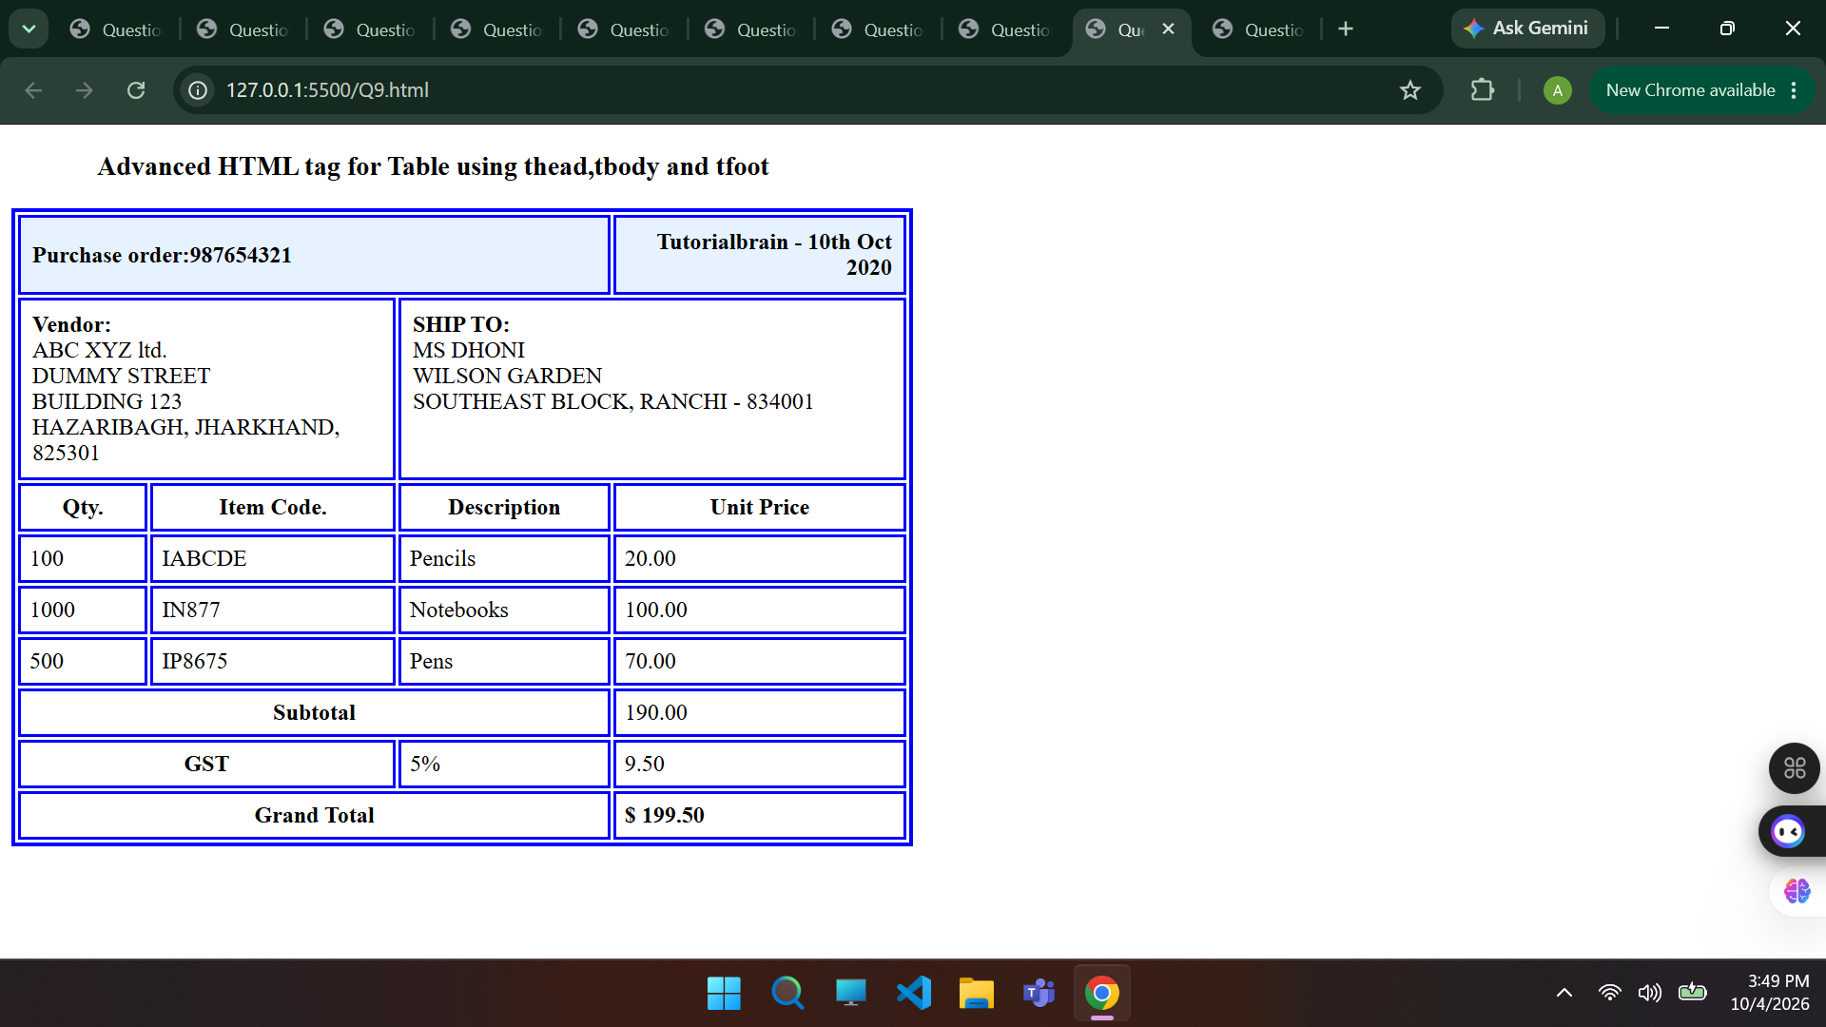
Question 10:
Create an HTML document to display the following table and fill data as given below.
<!DOCTYPE html>
<html lang="en">
<head>
<meta charset="UTF-8">
<meta name="viewport" content="width=device-width, initial-scale=1.0">
<title>Question10</title>
</head>
<body>
<table style="width: 50%; border: 2px solid #333;">
<tr style="background-color: #f2f2f2;">
<th style="border: 1px solid #333; padding: 8px;">Question No.</th>
<th style="border: 1px solid #333; padding: 8px;">Question</th>
<th style="border: 1px solid #333; padding: 8px;">Answer</th>
<th style="border: 1px solid #333; padding: 8px;">Marks per Answer</th>
<th style="border: 1px solid #333; padding: 8px;">Total Marks</th>
</tr>
<tr>
<td rowspan="3" style="border: 1px solid #333; padding: 8px; text-align: center;">1</td>
<td rowspan="3" style="border: 1px solid #333; padding: 8px;">Name three features in a ROM</td>
<td style="border: 1px solid #333; padding: 8px;">A</td>
<td style="border: 1px solid #333; padding: 8px;"></td>
<td rowspan="3" style="border: 1px solid #333; padding: 8px; text-align: center;">5</td>
</tr>
<tr>
<td style="border: 1px solid #333; padding: 8px;">B</td>
<td style="border: 1px solid #333; padding: 8px;"></td>
</tr>
<tr>
<td style="border: 1px solid #333; padding: 8px;">D</td>
<td style="border: 1px solid #333; padding: 8px;"></td>
</tr>
<tr>
<td style="border: 1px solid #333; padding: 8px; text-align: center;">2</td>
<td style="border: 1px solid #333; padding: 8px;">Here is a single answer</td>
<td style="border: 1px solid #333; padding: 8px;">True</td>
<td style="border: 1px solid #333; padding: 8px;"></td>
<td style="border: 1px solid #333; padding: 8px; text-align: center;">5</td>
</tr>
</table>
</body>
</html>
