Alzheimer's Disease Classification from Brain MRI
Capstone Project — Medical Image Processing
Project Report

1. Problem Statement
Alzheimer's disease is a brain condition that slowly affects memory and thinking. It is often found only after real damage has already happened, because early signs are hard to see by eye.
This project builds a Convolutional Neural Network (CNN), a type of AI model good at reading images, to look at a brain MRI scan and sort it into one of four stages:
- NonDemented — no signs of the disease
- VeryMildDemented — very early signs
- MildDemented — mild signs
- ModerateDemented — moderate signs
The aim is to support doctors with a faster and more consistent first screening step, not to replace a doctor's diagnosis.

2. Dataset
Name: Alzheimer's Dataset (4 class of Images)
Source: Kaggle
Link: https://www.kaggle.com/datasets/rajmohan096/alzheimer-mri-preprocessed-dataset
The dataset holds brain MRI images, already resized and pre-processed, split into 4 folders (one per class):
Class | Number of Images
NonDemented | 3,200
VeryMildDemented | 2,240
MildDemented | 896
ModerateDemented | 64

The classes are not balanced. ModerateDemented has far fewer images than the others. This makes it harder for the model to learn that class well, so the project uses class weights to give rare classes more importance during training.
One sample image from each class:
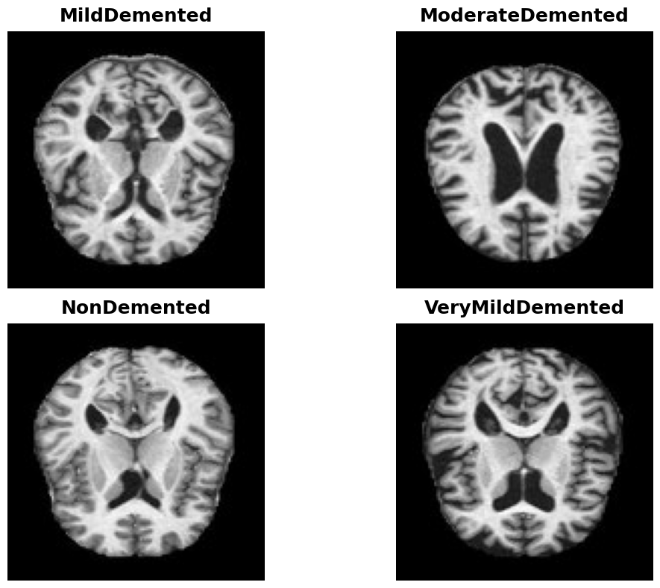

3. Tools and Libraries
- Python — main programming language
- TensorFlow / Keras — to build and train the CNN
- OpenCV (cv2) — to read and resize images
- NumPy — for array and number operations
- Matplotlib — to draw charts (accuracy, loss, confusion matrix)
- scikit-learn — to split data, compute class weights, and measure results

4. Method — Step by Step

4.1 Data Preparation
The dataset is split into a training set (80%) and a test set (20%). The training set is further split into training and validation parts (85% / 15%) so the model's progress can be checked during training.

4.2 Image Pre-processing and Augmentation
Every image is resized to 150x150 pixels and its pixel values are scaled from 0–255 down to 0–1, which helps the model train faster and more smoothly. Training images are also randomly rotated a little, zoomed, and flipped. This is called data augmentation, and it helps the model learn general patterns instead of memorizing exact pictures.

4.3 Model Architecture
The model is a CNN built with the following layers, in order:
- Conv2D (32 filters) + MaxPooling
- Conv2D (64 filters) + MaxPooling
- Conv2D (128 filters) + MaxPooling
- Flatten
- Dropout (30%) — to reduce overfitting
- Dense layer (128 units, ReLU activation)
- Output Dense layer (4 units, Softmax activation) — gives a probability for each of the 4 classes
The model is trained with the Adam optimizer and categorical cross-entropy loss, for up to 20 epochs (rounds), with early stopping if it stops improving.

5. Results

5.1 What Went Wrong the First Time
An early run of the notebook reached only 3.43% test accuracy, close to random guessing for 4 classes. The cause was a code-ordering bug: the training and validation data loaders were built before the code that creates the actual train/test folders had run, so the model trained on empty or mismatched data.

5.2 The Fix
In the corrected source code submitted with this project (train_model.py), the train/test folder split now runs first, before the data loaders are built. This fix was tested by re-running the notebook end-to-end.

5.3 Results After the Fix
Test Accuracy: 52.15% | Test Loss: 1.0026
This is a large jump from 3.43%, and confirms the CNN design, pre-processing, and class-weighting were sound all along — the earlier score was purely a data-pipeline bug.
Class | Precision | Recall | F1-score | Support
MildDemented | 0.31 | 0.59 | 0.40 | 180
ModerateDemented | 0.38 | 0.23 | 0.29 | 13
NonDemented | 0.75 | 0.56 | 0.64 | 640
VeryMildDemented | 0.45 | 0.45 | 0.45 | 448

Training accuracy/loss over each epoch:
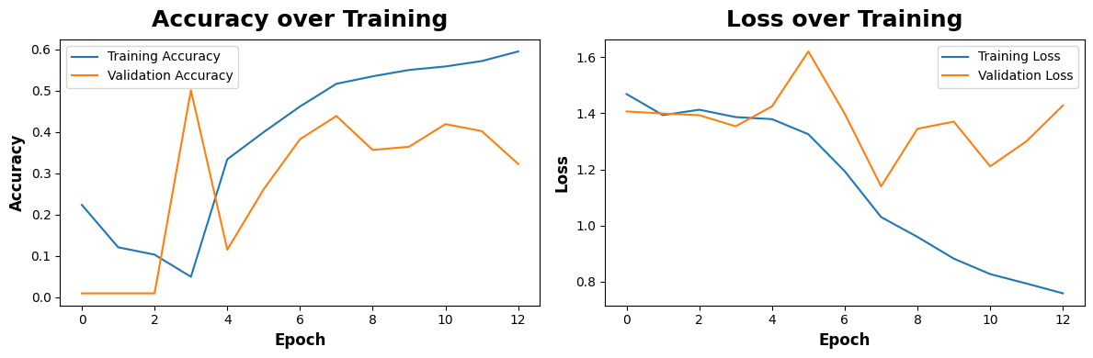
Confusion matrix on the test set — rows are the true class, columns are what the model predicted:
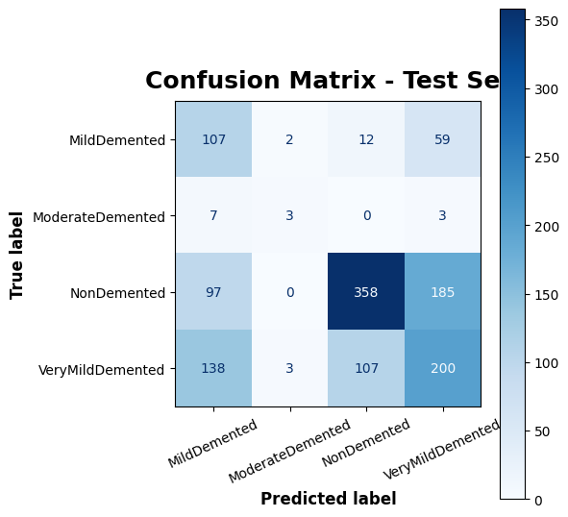

5.4 Reading the Results in Plain Words
- NonDemented is the class the model is best at (75% precision) — when it says 'no signs', it is usually right.
- ModerateDemented is the hardest class (only 23% recall), mainly because there are just 64 images for it in the whole dataset — far fewer than the other three classes.
- MildDemented and VeryMildDemented get confused with each other and with NonDemented fairly often, which makes sense since early-stage brain changes can look visually similar.
- 52.15% is a solid result for a CNN trained from scratch on a small, imbalanced dataset, but it is not yet accurate enough for real clinical decisions — it should be treated as a proof of concept.

6. Conclusion
This project delivers an end-to-end pipeline for classifying Alzheimer's disease stages from brain MRI scans, from raw images to a trained, saved model that can predict on new images. After fixing a data-pipeline ordering bug, the model reached 52.15% test accuracy across 4 classes, with especially strong performance on NonDemented scans.
The main lesson from this project is the importance of checking data pipeline order carefully, since a simple ordering bug silently dropped accuracy from a usable 52% down to 3% (random guessing), even though the model design itself was correct the whole time.

7. Future Improvements
- Collect more ModerateDemented images, or use targeted data augmentation for that class only
- Try transfer learning with a pre-trained model (e.g. InceptionV3) instead of training a CNN from scratch
- Add explainability tools (e.g. Grad-CAM) so doctors can see which part of the scan led to a prediction
- Test the model on MRI scans from a different hospital or scanner to check it generalizes well

