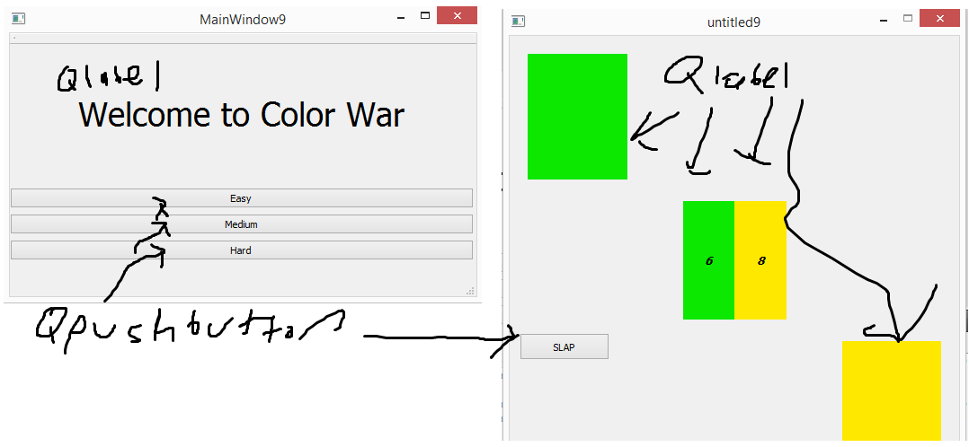

For this game called color war, I will create a game where you play versus the computer in a game where you slap if there are two color cards with the same level. The winner gets to keep the current color cards in the center. When a deck contains all of the levels from one color, those colors are removed from play and the rest of the colors are used. There are 5 colors and points are awarded for slapping correctly. Eventually the computer will be able to slap before the player for points also. There will be a timer and the goal is to beat the computer while also going as fast as possible. The Current game is below.

Gameplay left and right to draw cards for the different players, space to SLAP for points

