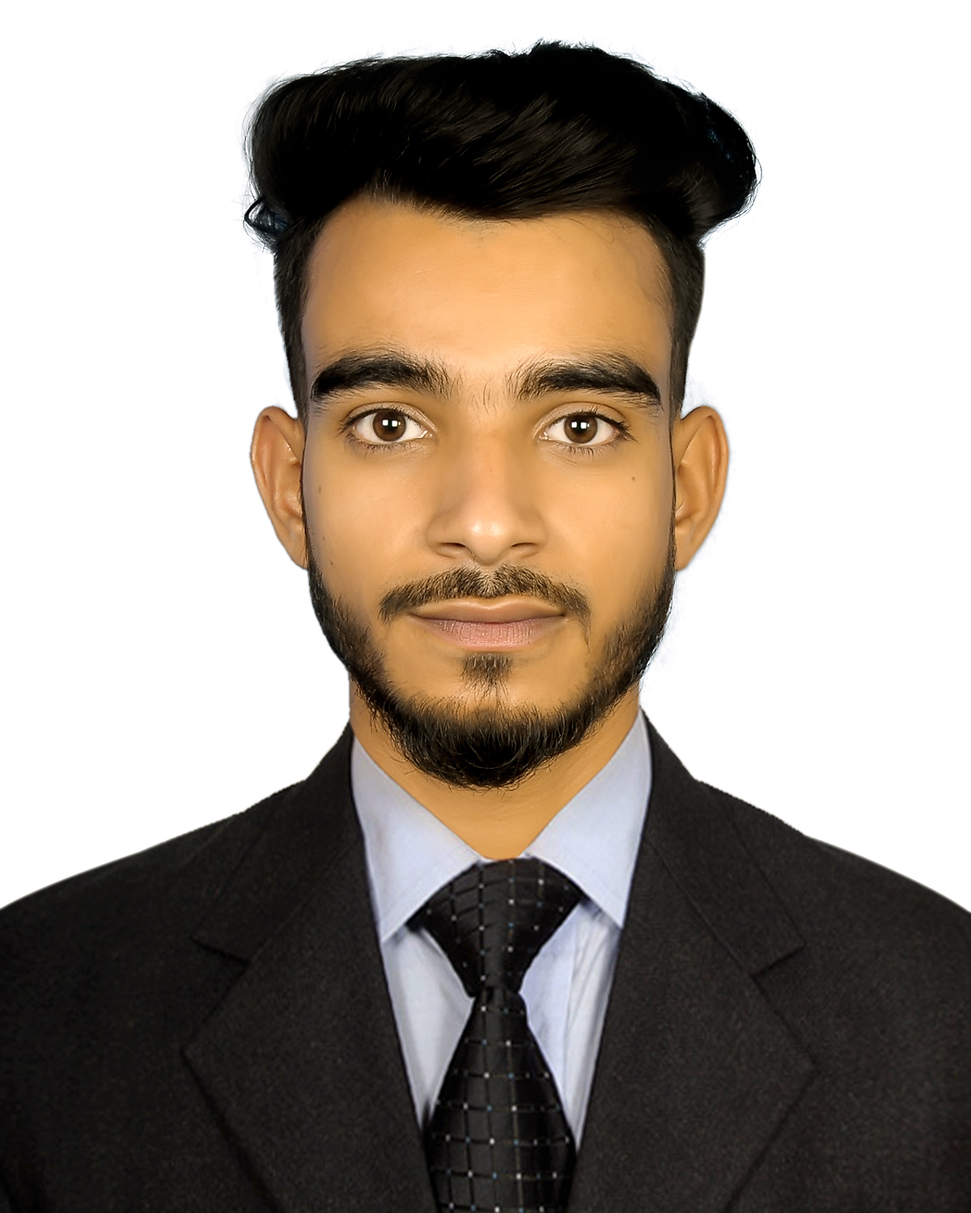
RESUME
OF
Md. Ahteshamul Hasan

Mailing Address:
228, West Shewrapara, Mirpur,
Dhaka-1216.
Contact# +88 01879938602
E-mail: hm2657675@gmail.com

Career Objective:
I would always like to have an opportunity to work in such a position where I will be able to apply my educational and technical skill gathered from my academic background. I want one utilize my potentiality, adaptability and skills to do something innovative and to enhance my knowledge.

Academic Qualification:

Secondary School Certificate (S.S.C)

Institute : Hiron Moyee High School & College, Sherpur.
Group : Science.
Year of Passing : 2019
Board : Dhaka.
Result : GPA- 4.06 (out of 5)

Diploma In Engineering .
Institute : Sherpur Polytechnic Institute.
Group : Computer.
Year of Passing : 2023.
Board : BTEB.
Result : GPA- 3.20 (out of 4)

Self Analysis:

- Strong Motivation & Commitment.
- Ability to work independently as well as in team.
- Endurance to work for long hours & under pressure.
- Pleasant personally and good inter personal skills.

Hobbies & Interest:

- Reading Literature
- Traveling.
- Playing Games.
- Making Friends.

Language Proficiency:

- Working knowledge of written and spoken English and Bengali.

Computer Skill:

- HTML
- CSS
- JAVA SCRIPT
- JQUERY
- BOOTSTRAP
- MY SQL
- PHP
- WORD PRESS

Personal Information:

Name : Md. Ahteshamul Hasan
Father`s Name : Md. Tufajjal Hossen
Mother’s Names : Sajeda Khatun
Permanent Address : Vill: Guzaqura, P.O: Fakirpara
P.S: Nalitabari, Dist: Sherpur.
Date of Birth : 13th August, 2004.
Sex : Male.
Marital Status : Unmarried.
Religion : Islam.
Blood Group : O+ ^{(ve)}
Nationality : Bangladeshi (by birth)

Declaration:

I, undersigned, certify that to the best of my knowledge and belief this CV correctly describes my qualifications and me. Any willful miss statement described herein may lead to my disqualification or dismissal, if employed.

Date: ......................... (Signature)

