Requirement Analysis:
- The program should be able to encrypt/decrypt.
- It should properly deal with unsupported files.
- It should only decrypt the encrypted files.
- Once the file is encrypted it should not encrypt the file again and vice versa.
- There should be a log to track history.
Design
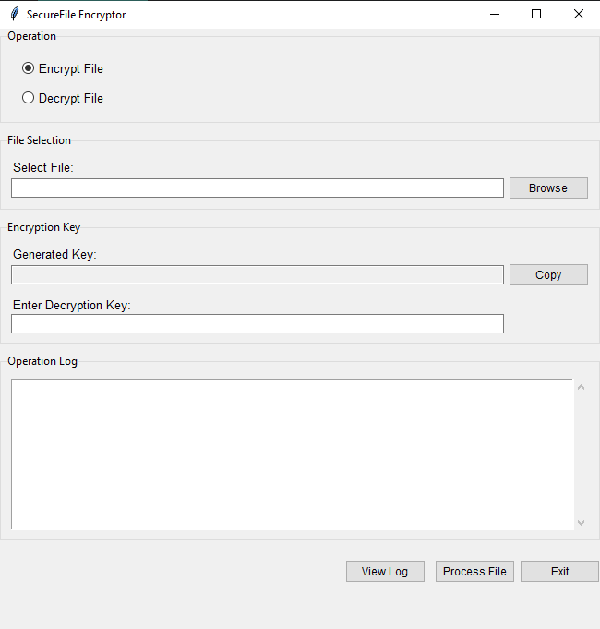
The interface is user friendly build using Python Tkinter.
The application contains three files to make the application functional (GUI.py, backend.py, log_file.txt) rest of the files for testing.
The application supports python(.py), Hyper Text Markup Language(.html/.htm),
Comma separated values (.csv), Tex (.txt) JavaScript Object Notation (.json).
For code modularization, the backend and fronted are created separately to handle business logic and user interface.
We have a GUI.py file for fronted handling through which the application runs. backend.py for handling encryption and decryption and log_file.txt for history.
For encryption/decryption a file should be selected first.
After the encryption a key will be generated which is read only which secures it from interpretation, and after copying the key using copy button the key will vanish from the screen.
Before decryption a key is required and if the key is incorrect, it won’t decrypt the file.
The exit button will ask the user before closing the application if a file is selected.
The view log button will show the history of the files with location, time and status(encrypted/decrypted).
The log area will show the file status like we have selected the file, encrypted it and decrypted it during the run time.

Implementation
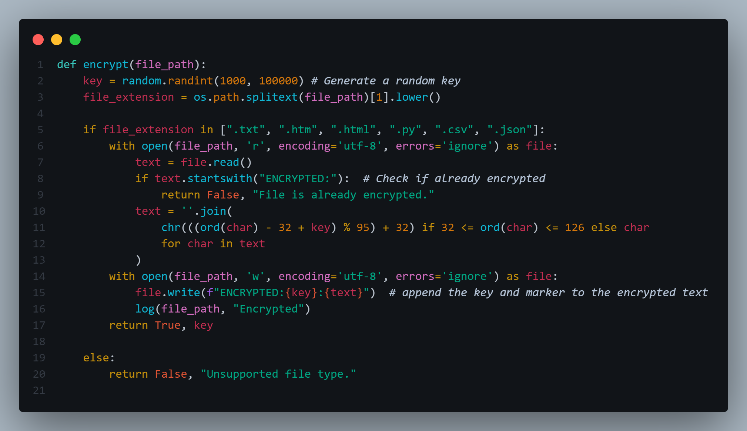
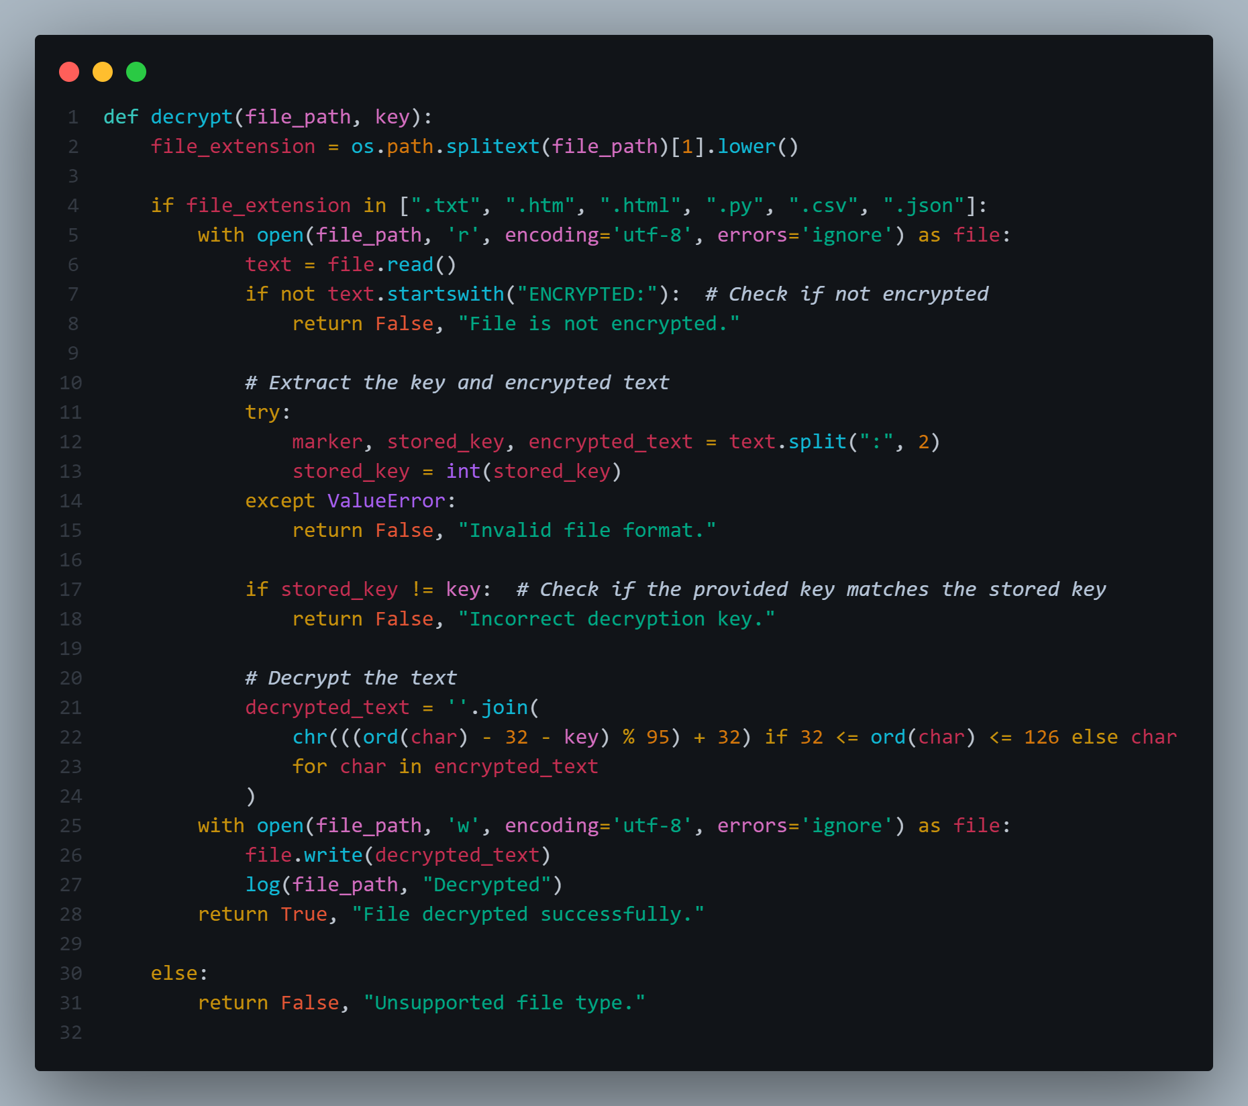
The logic for encryption and decryption is the same and simple. During encryption a random key will be generated which will work for encryption and decryption as well. The algorithm will only shift the text forward and backward within the range of 32 to 126 because after and before the character and invisible and irrelevant. But before algorithms proceed it checks for file support, already encrypted/decrypted and a log function will always be called to store the status.
Before the decryption it will always check if the file is encrypted or not and the provided key is valid.

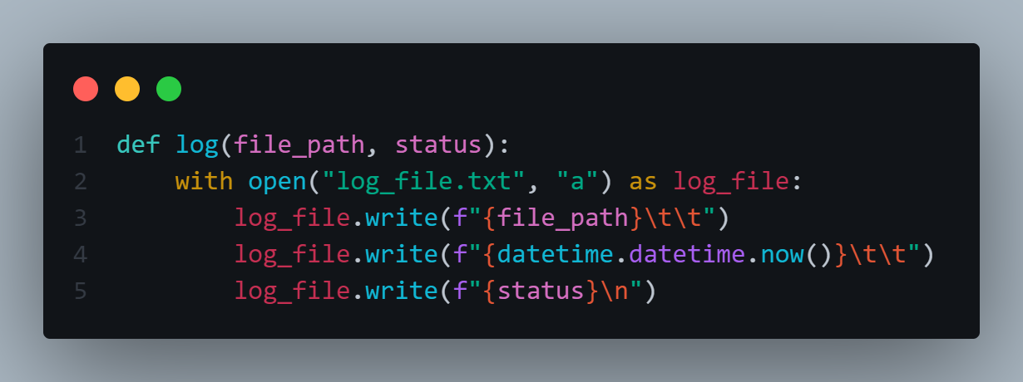
The log function will take a file path and a status(encrypted/decrypted) as a parameter and by default add date and time in the log_file.txt
Testing
We have created five file names (test) with different extensions to test the application.
The first problem we faced was encrypting/decrypting the file multiple times which can change the file content if we do multiple times for that we add the restriction during the encryption to add ENCRYTED as file start to avoid this.
The second problem was the application was able to decrypt the file whether it is encrypted or not which was handled using the solution of first problem (ENCRYPTED).
The third problem was we are generating a random Key and meaning if Key value is greater than 126 then the application will definitely generate the error till then we already have opened the file which will erase the file content (data loss) to prevent this we come with the solution to always check that it is in range of 126 and always dividing with 95 to make the it in the range because of ASCII.
The fourth problem was that the application will always decrypt the file if the provided key is invalid. For that we are also storing the key in the file and during decryption we extract the key from the file and check if it is a valid one or not.
Now whether we change the file location and name, the encryption/decryption can be easily performed which makes this application standout.
We have applied testing in different ways hence we have made this application 90% flawless. There is one problem that if we open a file, we can take key from that and can interpret the file easily, for that we have two solutions.
- One is to store the key in encrypted form too and apply the same code for always decrypting the key first which makes it secure.
- Second is to store the key in database which we thought to apply first but changing the file name and location would make it useless.
Hence, we haven’t applied any of these methods looking for guidance and a good approach to tackling this.
Summary
The development of the encryption/decryption application followed a structured and thoughtful approach:
1. Requirement Analysis:
The project identified clear objectives: encrypting/decrypting files securely, handling unsupported file types, preventing redundant operations, and maintaining a log for tracking history. These requirements were pivotal in guiding the design and implementation phases.
2. Design:
The application was designed with a modular architecture to separate user interface (GUI.py), business logic (backend.py), and log tracking (log_file.txt). Tkinter was chosen for a user-friendly interface, and the application supported multiple file formats (e.g., .py, .html/.htm, .csv, .txt, .json).
3. Implementation:
The encryption and decryption algorithms employed ASCII-based character shifting to ensure security within a defined range (32-126). A random key was generated for encryption, which also served for decryption. Safeguards were implemented to handle errors (e.g., unsupported files, invalid keys) and avoid repeated processing of the same file. Logging functionality ensured that file history was systematically recorded.
4. Testing:
Comprehensive testing was conducted using multiple files and scenarios. Key issues were identified and addressed, such as:
- Preventing redundant encryption/decryption.
- Ensuring valid key verification.
- Restricting key values within ASCII range.
- Avoiding decryption with incorrect keys.
5. Remaining Challenges:
One notable vulnerability was the exposure of keys in plain text, which poses a security risk. Suggested solutions included encrypting keys or storing them in a database, though file relocation issues made database storage impractical.
The application does not work with files which contain images because dealing with those types of files will be difficult as they require working with binary values and sometimes the pdf file are not the valid pdf type means images used in them are hard to encrypt. For simplicity we have only worked with those files which only contain text.
Does the Implementation Meet the Requirements?
Yes, the implementation successfully fulfills most requirements:
- Secure encryption and decryption for supported file types.
- Prevention of redundant operations through a flag system (ENCRYPTED).
- Proper handling of unsupported files and invalid keys.
- Comprehensive logging to track file history.
Lessons Learned:
- Modular architecture simplifies development, testing, and maintenance.
- Error handling and validation are crucial to avoid unintended file corruption or data loss.
- Security measures, such as key encryption, should be considered early in the design phase to address vulnerabilities.
- Thorough testing reveals hidden issues and ensures robust functionality.
- Balancing simplicity and security require thoughtful decision-making, especially when trade-offs (e.g., database vs. file-based storage) arise.
Overall, the process demonstrated the importance of meticulous planning, problem-solving, and iterative testing to create a reliable application.

