“Application of Ensemble Learning Model for Disease Prediction”
A Project Report
submitted in partial fulfilment of the requirements for the award of the degree
of
Bachelor of Technology
in

COMPUTER SCIENCE & ENGINEERING
By
Ahtreya
Roll No. 22115006

Under the guidance of Dr Aakanksha Sharaff Associate Professor


DEPARTMENT OF COMPUTER SCIENCE & ENGINEERING NATIONAL INSTITUTE OF TECHNOLOGY RAIPUR, C.G (INDIA)

Date:17th April 2026

DECLARATION

I hereby declare that the work described in this report, entitled “Application of Ensemble Learning Model for Disease Prediction” which is being submitted by me in partial fulfilment of the award of the degree of Bachelor of Technology in Computer Science & Engineering to the Department of CSE, National Institute of Technology Raipur, is the result of investigations carried out by me under the guidance of Dr. Aakanksha Sharaff.
The work is original and has not been submitted for any Degree/Diploma of this or any other Institute/university.

Signature
Name of the Candidate:
Ahtreya
22115006

Place: RAIPUR, C.G

DEPARTMENT OF COMPUTER SCIENCE & ENGINEERING NATIONAL INSTITUTE OF TECHNOLOGY RAIPUR



CERTIFICATE

This is to certify that the project entitled “Application of Ensemble Learning Model for Disease Prediction”, that is being submitted by Ahtreya (Roll No. 22115006) in partial fulfilment of the requirements for the award of the degree of Bachelor of Technology in Computer Science & Engineering at National Institute of Technology Raipur, is a record of bonafide work carried out by them under my guidance and supervision.
The matter presented in this project document has not been submitted by them for the award of any other degree/diploma elsewhere.

Dr. Aakanksha Sharaff Signature of Supervisor
Associate Professor
Department of Computer Science and Engineering
National Institute of Technology, Raipur (C.G)

Project Coordinator, H.O.D
Dr. Dilip Singh Sisodia
Department of C.S.E
National Institute of Technology, Raipur (C.G)

ACKNOWLEDGEMENT

I want to acknowledge our college, the National Institute of Technology, Raipur, for providing a holistic environment that nurtures creativity and research-based activities.
I express my sincere thanks to Dr. Aakanksha Sharaff, Associate Professor, HOD CSE Department, NIT Raipur, the supervisor of the project, for guiding and correcting throughout the process with attention and care. She has frequently suggested creative ideas to me and guided me through the major hurdles that occurred during the duration of the project.

Thank You!!

Ahtreya
Roll No.22115006

ABSTRACT

“Application of Ensemble Learning Model for Disease Prediction”

Disease Prediction plays a very important role in modern healthcare by enabling medical professionals and patients to make informed decisions regarding early diagnosis and treatment planning.
The traditional diagnostic approach often struggles to capture nonlinear relationships present in multi-symptom medical datasets. To address this challenge, this study evaluates 9 state-of-the-art machine learning models:- Logistic Regression, Decision Tree Classifier, Random Forest Classifier, Gradient Boosting Classifier, XGBoost Classifier, K-Nearest Neighbors, Support Vector Classifier, MLP Classifier and Gaussian Naïve Bayes Classifier—using multiple performance metrics including Accuracy, Precision, Recall and F1-Score.

Furthermore, a Hybrid Stacking Ensemble Model is proposed by combining the predictions of all 9 base models using a meta-learner. This hybrid approach enhances learning by integrating the strengths of individual models, reducing error variance, and improving overall robustness.
Experimental results demonstrate that the Hybrid Stacking model significantly outperforms all standalone models, achieving a higher accuracy and considerably lower error values, making it suitable for real-time medical applications. The proposed method proves to be faster, more accurate, and more reliable for large medical datasets, contributing to improved decision-making, enabling early-stage diagnosis and more efficient patient healthcare management.

CONTENT
DESCRIPTION | PAGE NO.
DECLARATION | 2
CERTIFICATE | 3
ACKNOWLEDGEMENT | 4
ABSTRACT | 5
CONTENT  INTRODUCTION  Overview  Objectives  LITERATURE SURVEY  2.1 Recent Works Table  2.2 Problems in Existing Methodologies  PROPOSED METHODOLOGY  Overview of Proposed Methodology  Datasets Used & Pre-Process Datasets  FLOWCHARTS  RESULT ANALYSIS  OUTCOME  CONCLUSION AND FUTURE SCOPE  REFERENCES | 6  7  7  7  8  8  9  9  9  10  11  12  12  15  15

INTRODUCTION

1.1 Overview
Disease diagnosis refers to the process of determining which disease best reflects a person’s symptoms. The most challenging issue is diagnosis because certain symptoms and indications are vague, and precise disease identification is vital in treating any sickness. In the modern era, major chronic diseases, including heart disease, kidney disease, diabetes, etc; is responsible for nearly 89% of deaths in certain developed nations.
Traditional single-model approaches such as Logistic Regression or Decision Trees often fail to capture all nonlinear patterns in medical data. To overcome these limitations, ensemble learning methods combine multiple models to produce more reliable and accurate predictions. Techniques like Random Forest, Gradient Boosting, and XGBoost have shown excellent performance on real-world datasets.
In recent years, hybrid and meta-learning-based ensemble models have gained popularity due to their ability to handle large, high-dimensional, and noisy datasets. These models intelligently combine the strengths of several base learners to produce a final, highly accurate prediction.
Therefore, this study focuses on developing an Application of Ensemble Learning for Disease Prediction and comparing its performance with nine widely used machine learning models. The goal is to achieve higher accuracy values and lower error metrics, enabling more dependable predictions for clinical decision-making and improved patient healthcare management.

OBJECTIVES
The primary objective of this study is to develop an optimised hybrid ensemble model that outperforms individual classifiers by leveraging stacking-based meta-learning. To achieve this, the study focuses on the following specific objectives:
- Data Preparation by handling missing values and implementing categorical encoding techniques for symptom features to ensure the model compatibility.
- To implement and evaluate nine baseline machine learning models—Logistic Regression, Decision Tree Classifier, Random Forest Classifier, Gradient Boosting Classifier, XGBoost, Gaussian Naïve Bayes Classifier, Support Vector Classifier, K-Nearest Neighbors and MLP Classifier—based on their predictive accuracy and error metrics.
- To construct a hybrid ensemble model using meta-learning (stacking) that integrates the predictions of base learners to achieve diagnostic precision superior to any other individual models.
- To compare the performance of the hybrid model with all baseline models using standard evaluation metrics such as Accuracy, Precision, Recall and F1-Score, ensuring measurable and significant improvement in diagnostic reliability.

Literature Survey

Recent Works Table

S.No. | Title/Author(s) | Publication/Year | Description | Limitation
1. | Disease Prediction Using Machine Learning: A Comparative Study of Classification Algorithms,  Priya Mishra, Uday Singh Kushwaha, and Shraddha Singh | International Journal of Creative Research Thoughts (IJCRT), 2025/26 | A comprehensive comparison of Decision Tree (DT), Random Forest (RF), and Naive Bayes (NB). It highlights that RF and DT achieved high accuracy (~95.12%) on 132 binary-encoded symptoms. | The findings are constrained by dataset coverage and the simplicity of binary symptom representation (present vs. absent).
2. | AI-Based Disease Prediction and Guidance Using Symptoms and Language Models, Hardik Sondhi | International Journal of Research Trends and Innovations (IJRTI), 2025 | It introduces a hybrid model using an ensemble of ML algorithms (NB, DT, RF) paired with the DeepSeek Large Language Model (LLM) to provide both a diagnosis and medical guidance. | Accuracy is sensitive to the number of input symptoms; the system is optimised for a limited set (often three) for initial screening.
3. | Identifying Diseases, Symptoms, and General Rules Using Supervised and Unsupervised Machine Learning, Almansour, A. M., et al. | Scientific Reports, 2024 | This study integrates rule-based machine learning (Apriori algorithm) with classification models (SVM, Bootstrap Forest, and Boosted Trees) to identify frequent symptom patterns and predict diseases. | Difficult to predict communicable diseases due to highly overlapping symptoms across different conditions.
4. | Early Life Style Disease Detection Using ML, Cheeryal V., et al. | ResearchGate, 2024 | It explores the prediction of lifestyle-related diseases using machine learning integrated into a single web application using the Flask framework. | An imbalanced class (where some diseases have many more data samples than others) is a major hurdle to training unbiased models.
5. | Symptom-Based Disease Prediction Using Machine Learning: A Web Application, Mohamed Sadiq B. and Nahush R. Jain | International Journal of Sustainable Research in Engineering and Management (IJSREM),2023 | It evaluates Naive Bayes, Decision Trees, and Random Forests to classify 41 diseases from 132 symptoms, focusing on creating an accessible web interface | Model performance can be limited by feature dependencies that traditional algorithms like Naive Bayes may fail to capture accurately.

  - Gaps / Problems in Existing Methodologies
- A limited number of samples restricts the model’s generalisation to new unseen data.
- Rare disease classes can lead to models that perform poorly on these specific conditions.
- High accuracy on a small dataset with many features suggests potential overfitting.
- Complex Ensemble Learning Models made it difficult to understand and predict the diseases.

3 PROPOSED METHODOLOGY

3.1 Overview of Proposed Methodology
The proposed methodology introduces a structured and data-driven framework for improving disease prediction using ensemble and meta-learning techniques. The approach begins with rigorous cleaning to address missing values and inconsistent entries. Categorical symptom data is transformed into a machine-readable format using one-hot encoding, resulting in a high-dimensional binary feature set that represents the presence or absence of specific clinical indicators.
After preprocessing, nine diverse machine learning models—Logistic Regression, Decision Tree, Random Forest, Gradient Boosting, XGBoost, Support Vector Classifier (SVC), K-Nearest Neighbors (KNN), Multi-Layer Perceptron (MLP), and Gaussian Naïve Bayes—are individually trained. By utilising models with different mathematical foundations (e.g., probabilistic, tree-based, and distance-based), the framework captures a wide variety of patterns and dependencies within the medical data.
To synthesise these diverse insights, the outputs (probability predictions) of the nine base learners serve as input features for a secondary Meta-Learner. Utilising XGBoost as the meta-classifier, this layer intelligently weights the predictions of the base models, emphasising the most reliable learners while minimizing individual biases and variances.
The stacked ensemble generates the final diagnosis. This multi-layered architecture is specifically designed to achieve higher accuracy and lower error metrics than standalone models, ensuring robustness and improved generalisation across diverse clinical profiles and overlapping symptom patterns.
3.2 Datasets Used & Pre-Process Datasets

A. Datasets Used
- Disease and Symptom Dataset containing historical records of patient symptoms, clinical indicators, and confirmed medical diagnoses. It contains 4920 entries and 18 columns.
- Attributes typically include 132 clinical symptoms.
- The dataset is collected from established resources like Kaggle’s Disease Symptom Prediction
- The target variable representing the specific disease diagnosis
- The primary purpose of this dataset is to predict the Disease based on the reported symptoms.
- The dataset contains missing values in columns.

B. Pre-Processing Steps
- Handling Missing Values:
a. Since clinical cases vary in complexity, missing symptom entries were filled with a "None" placeholder. This ensures that the absence of a symptom is treated as a meaningful feature rather than missing information during the encoding phase.
- Feature Transformation and Encoding:
  - The categorical disease labels were converted into integer labels using Label Encoder to allow the multi-class classifiers to process the target variable.
  - Categorical symptoms were transformed into a binary format (0 or 1) using one-hot encoding to represent the presence or absence of each clinical indicator.
- Train–Test Split:
  - The processed data was divided into 80% training and 20% testing dataset to evaluate model generalisation on unseen data and ensure the reliability of the diagnostic output.
- Model Training and Evaluation:
  - 9 distinct baseline classification models are trained: Logistic Regression, Decision Tree, Random Forest, Support Vector Classifier (SVC), K-Nearest Neighbors (KNN), Multi Layer Perceptron Classifier, Gaussian Naïve Bayes, XGBoost and Gradient Boosting.
  - Each model was evaluated using standard performance metrics, including Accuracy, Precision, Recall, and F1-Score, to establish a performance benchmark.
- Hybrid Meta-Model:
  - A Stacking architecture was implemented to improve the predictive performance beyond that of any single model.
  - XGBoost was selected as a meta-learner to aggregate the diverse strengths of the nine base models and resolve conflict predictions.
- Performance Evaluation:
  - The hybrid ensemble model is evaluated using a comprehensive suite of metrics to ensure its reliability and diagnostic precision.
- Final Prediction:
  - The system utilises the optimised hybrid model to generate a final disease prediction.

3.3. FLOWCHART

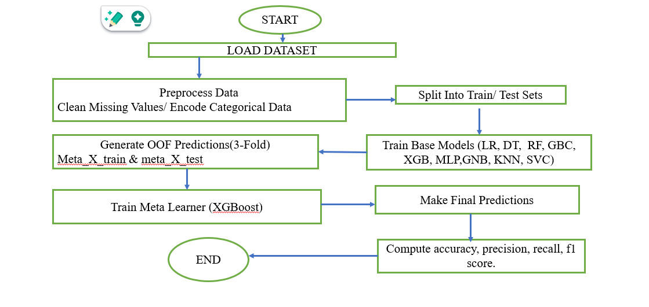

4. RESULT ANALYSIS

Model | Accuracy
Logistic Regression | 100%
Support Vector Machine | 88.5%
Decision Tree | 72.1%
Random Forest | 96.7%
K-Nearest Neighbor | 95.08%
Gaussian Naïve Bayes | 100%
MLP Classifier | 100%
Gradient Boosting | 86.8%
XGBoost | 78.7%

- OUTCOME

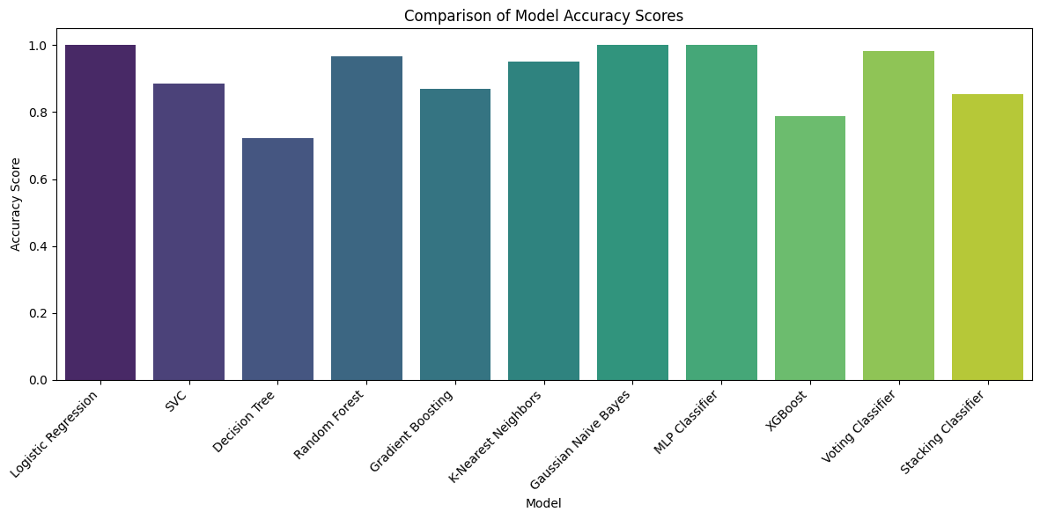
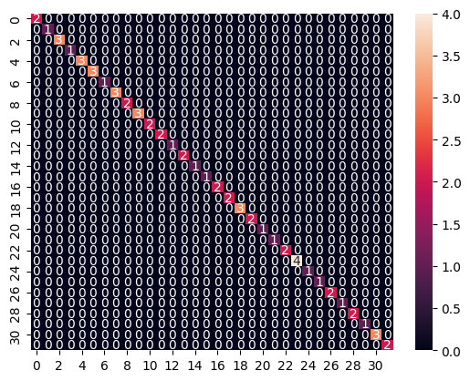

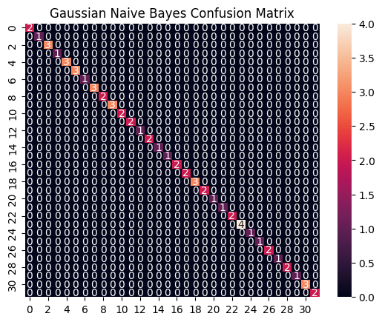
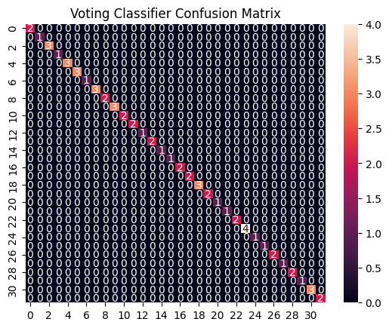

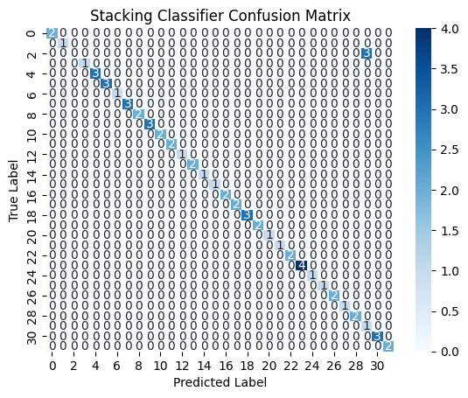
- CONCLUSION AND FUTURE SCOPE

6.1 Conclusion

- The study shows that ensemble learning algorithms improve disease prediction accuracy compared to individual models.
- Combining multiple base models using stacking and meta-learning results in a more stable and reliable hybrid model.
- Proper data preprocessing, feature engineering, and model evaluation are essential for achieving high performance.
- Synthesise the results from the accuracy comparison and confusion matrices to draw a comprehensive conclusion about the performance of the various models, highlighting the best
- REFERENCES
- Mishra, P., U. S. Kushwaha, and S. Singh. "Disease Prediction Using Machine Learning..." IJRASET 13, no. 12 December 2025
- H. Sondhi, "AI-based disease prediction and guidance using symptoms and language models," Int. J. Res. Trends Innov. (IJRTI), vol. 10, no. 11, Nov. 2025
- P. Vikas, L. Keerthan, and K. Mohit, "Early life style disease detection using ML,", Apr. 2024
- A. M. Almansour et al., "Identifying diseases symptoms and general rules using supervised and unsupervised machine learning," Sci. Rep., vol. 14, no. 1, Art. no. 17956, Aug. 2024
- M. Sadiq B. and N. R. Jain, "Symptoms based disease prediction using machine learning," Int. J. Sustain. Res. Eng. Manag. (IJSREM), vol. 7, no. 7, Jul. 2023

