**PROJECT CASE**

**COMP7084 – MULTIMEDIA SYSTEM – BG01**

14 May 2019 **EVEN SEMESTER 2018/2019**

**GROUP MEMBERS:**

AGUSTINUS THEODORUS 2101668036

ALBERTUS HERONIUS 2101690042

DANIEL PRAWIRA 2101628064

MICHAEL JONG 2101626651

On this project case, we choose the first theme, which is Bluejack Score (provide soccer information). For some reasons, we don’t want our application name is Bluejack Score, so we name it **BolaTube Indonesia**. On our application, we divide it into 3 pages; the **main page** (*project.html*), **video** (*video.html*), and **fixtures** (*fixtures.html*). Video and fixtures page will be hyperlinked from the main page, so you can access video and fixtures pages from the main page. The detailed descriptions from each page can be seen below, and for viewing pleasure, the available animations (.gif) can be accessed from the **documentations** folder, because .doc extension doesn’t support showing animated images. On first opening those pages, they will show these displays:

1. Main Page

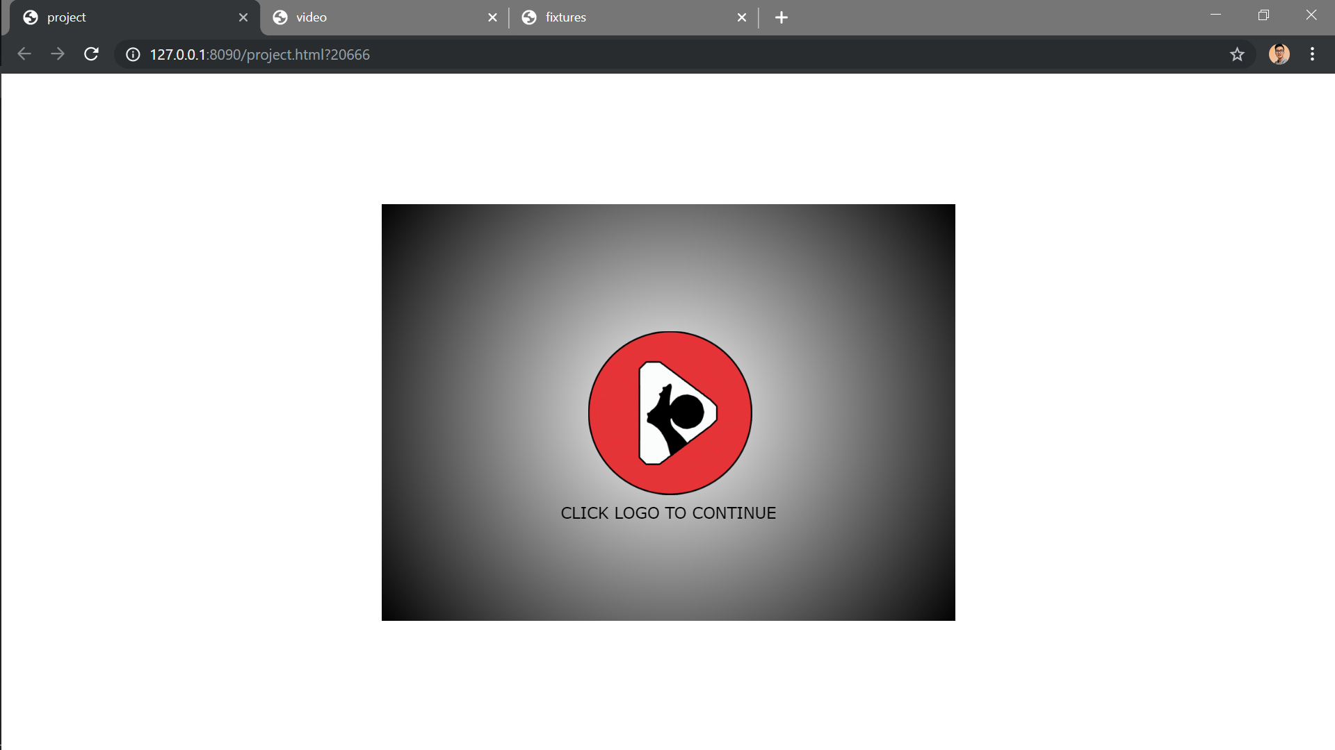

1. Fixtures

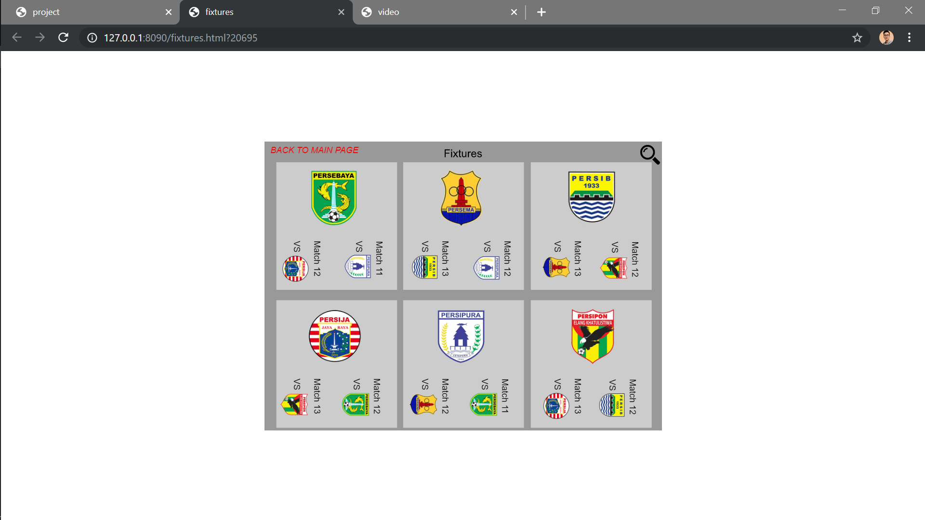

1. Video

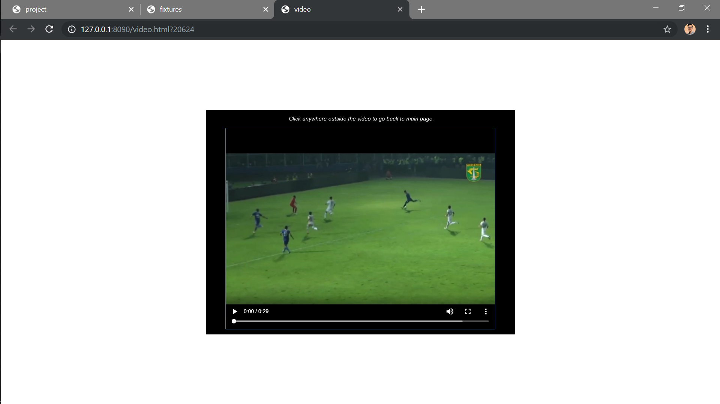

The application has 2 sections with 4 main features. First section is the **opening**, and then the application will show the second section, the **main menu**. The 4 main features are; **view** **standings**, **fixtures**, **match** **highlight**, and **today’s matches**. To make this project easier to understand, I will divide it by the sections and the main features as stated above.

**Opening**

The opening of the application is a movie clip that show us the logo animation of BolaTube. The logo is originally made by combining an image of people kicking ball with basic shapes on Adobe Photoshop. The animations in this frame are made with mostly motion tween (the bouncing logo effect), masking (for the “CLICK THE LOGO TO CONTINUE” text), and classic tweens (to move the mask). By clicking the logo, it will redirect you to the main menu (move the opening frame out) and you will also hear a sound effect of people shouting (*goal.mp3*), I embed the sound on the opening logo button down state. Some action events that I put out in this page would be the click events to remove opening frame and “this.stop()” to make the movie clip stay.

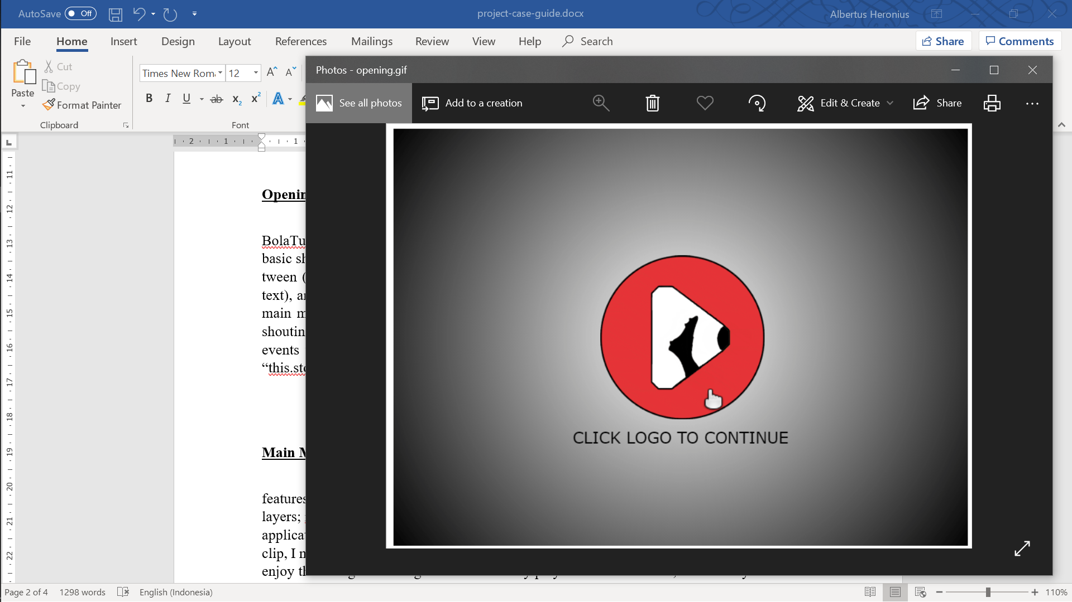

**Main Menu**

The main menu is the next frame after the opening. On this part, you can see the 4 main features button with their own up, hover, down, and hit box button. The main menu has several layers; mainBg is a movie clip that show the section elements colour, the application logo, the application name, the moving text footer, and the ball animation. For the ball animation movie clip, I made it with masking from the ball sprite. When you first arrive on this display, you will enjoy the background song that automatically played. Because of that, the next layer I have is the background music movie clip layer that is used for obviously controlling the background music using the button (play & pause).

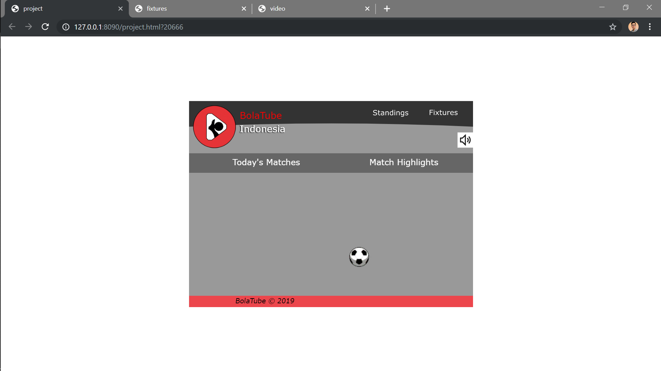

The mainButtons layer will hold our 4 main features buttons. MainContent is the layer with several movie clips that will show the contents. BackBt layer is a button for returning after seeing standings, I made this because I applied virtual camera on seeing the standings and we can’t go back to main menu if the button is not created because other buttons are out of the display. Last layer is the camera, I think this layer is self-explanatory, this layer is needed for the viewing the standings. Most of the frames on the main page is movie clip, because I don’t want to scatter the main page with unnecessary animations. So, I create most animation inside the movie clips on each frame. This page contains the most action events, like gotoAndStop, gotoAndPlay, this.stop, and open new tab (hyperlink).

**Standings**

The first main feature would be view standings, on clicking the standings button on the main menu, you will jump into frame 4 with custom virtual camera view (zoomed in). On this frame of movie clip, you will see the team’s standings; points, win, loss, and draw count. To go back to main menu, you only need to click the Return button. On standings movie clip contains 2 shape tweens, motion guide, 2 motion tweens, and 4 classic tweens.



**Fixtures**

Unlike standings that remains on the same page as main page, clicking the fixtures button will make you to open new page (hyperlink), *fixtures.html*. On this page, you will see upcoming matches for the 6 teams. There are 3 buttons to interact with, the zoom/magnifier button, and button to go back to main page (open the main page, *project.html*), and the close button (X) to go back to original display (appear after clicking the zoom button). The zoom button will rotate the display for easier viewing. On rotating, there are several animations; shape tween & motion guide (Fixtures title), and classic tween for the virtual camera. I think the event actions is noticeable; zoom button to go to next frame, back button to go back to previous frame, and “BACK TO MAIN PAGE” button for the main page hyperlink.

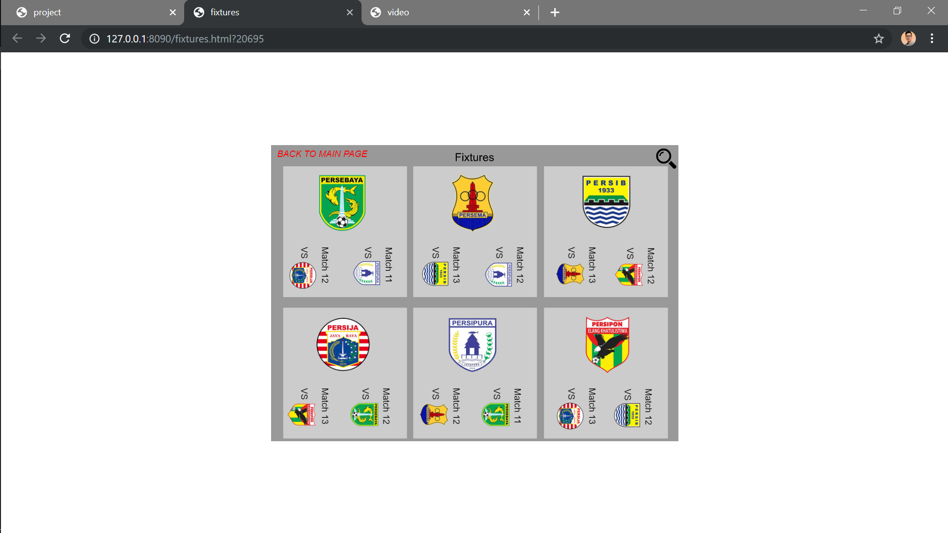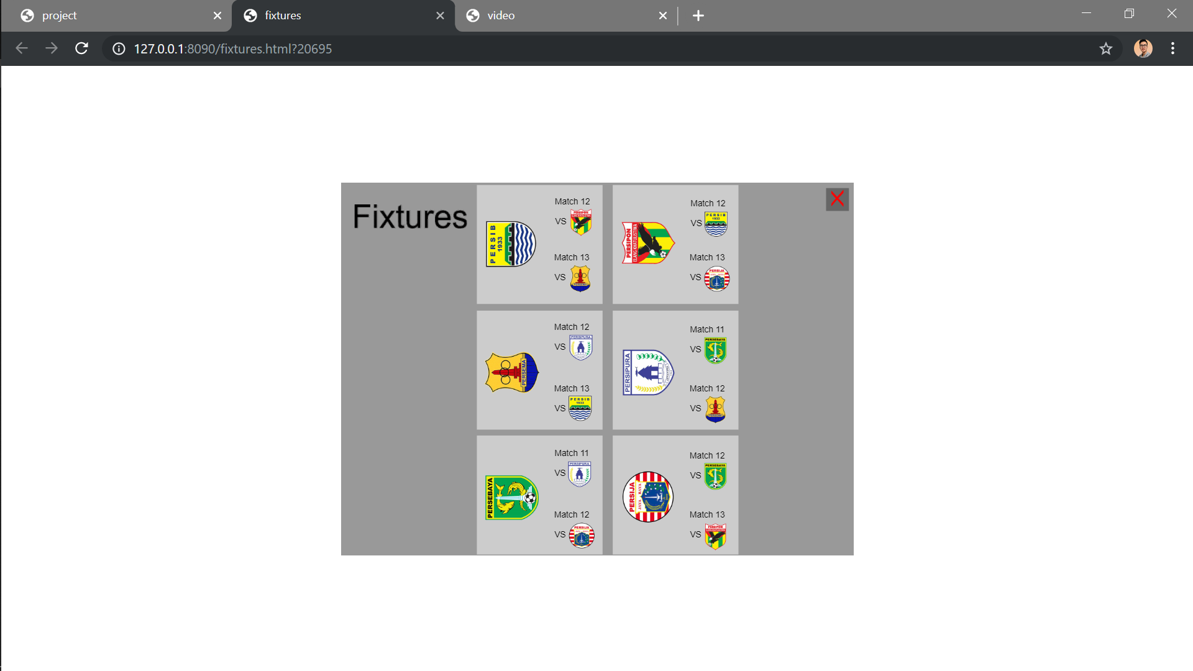

**Today’s Matches**

On this movie clip frame, you can view the matches that will be played today. You can navigate between matches by clicking the arrow button on the right side. To view the match full description, you can click the “Match descriptions” button. It will darken the background and go to next movie clip frame that contains; the match winner probability, match time, and the stadium. After the match descriptions pop up, you can close it by clicking the X close button. The matches I provide are 3 matches, and by clicking the next arrow on last match will return you to the first match again. The matches transition is simply a classic tween. Most of the event here is to navigate around the today’s matches movie clip timeline. There is no button to go back to main page, you can navigate around directly by clicking the other main features button (match highlights, fixtures, standings).

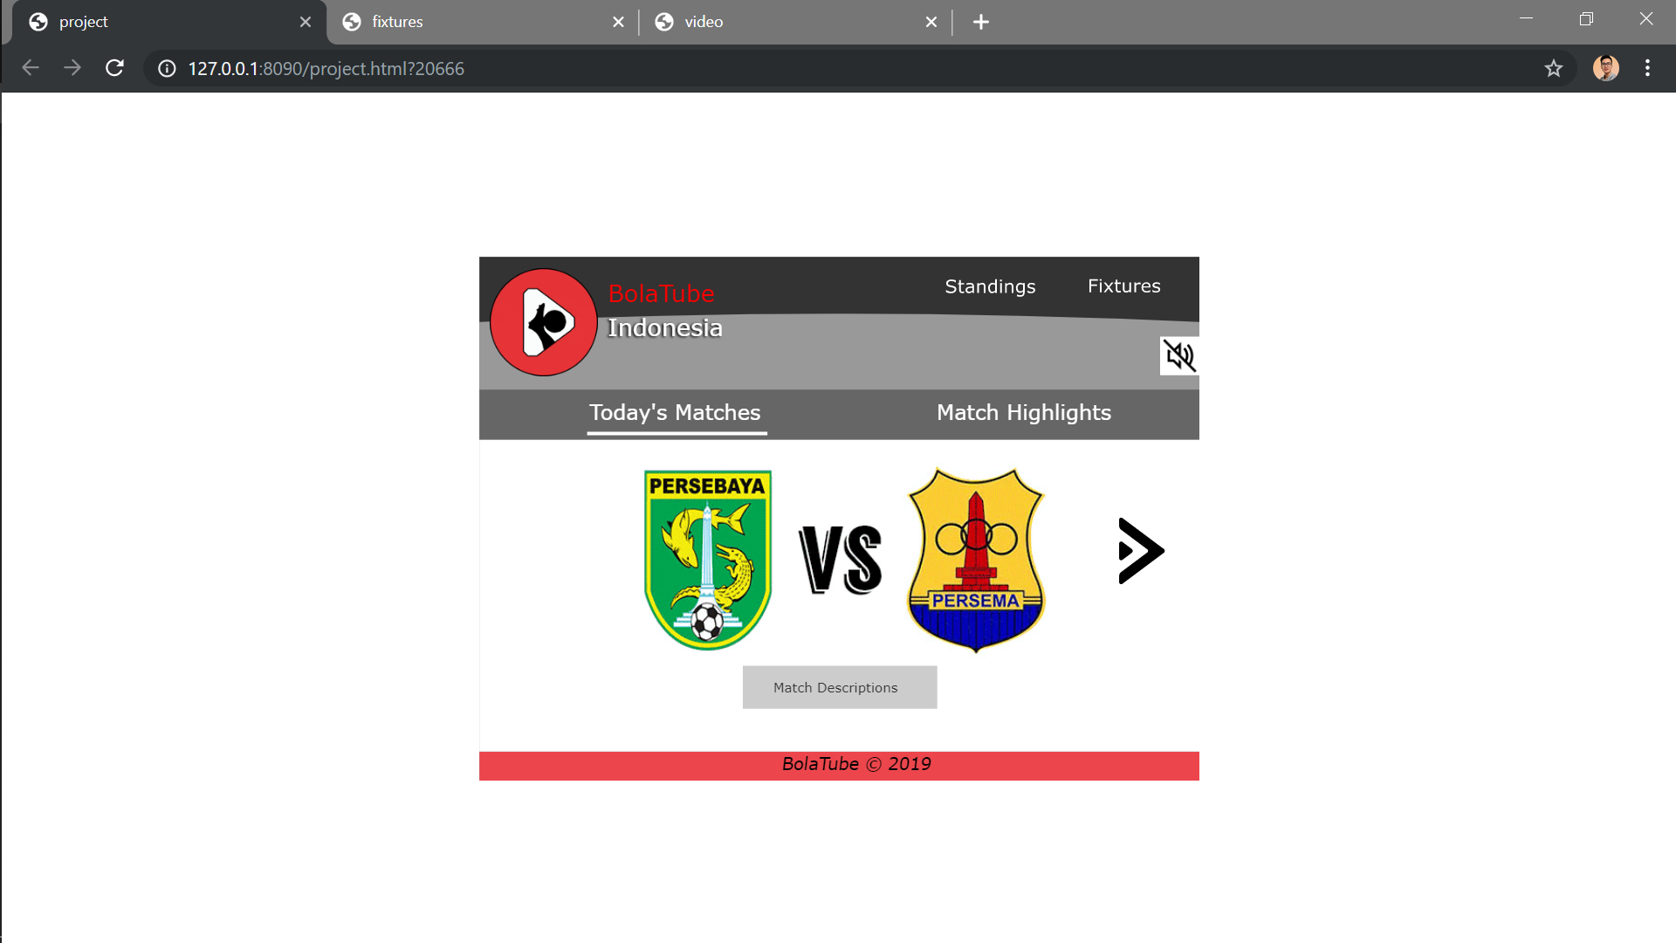 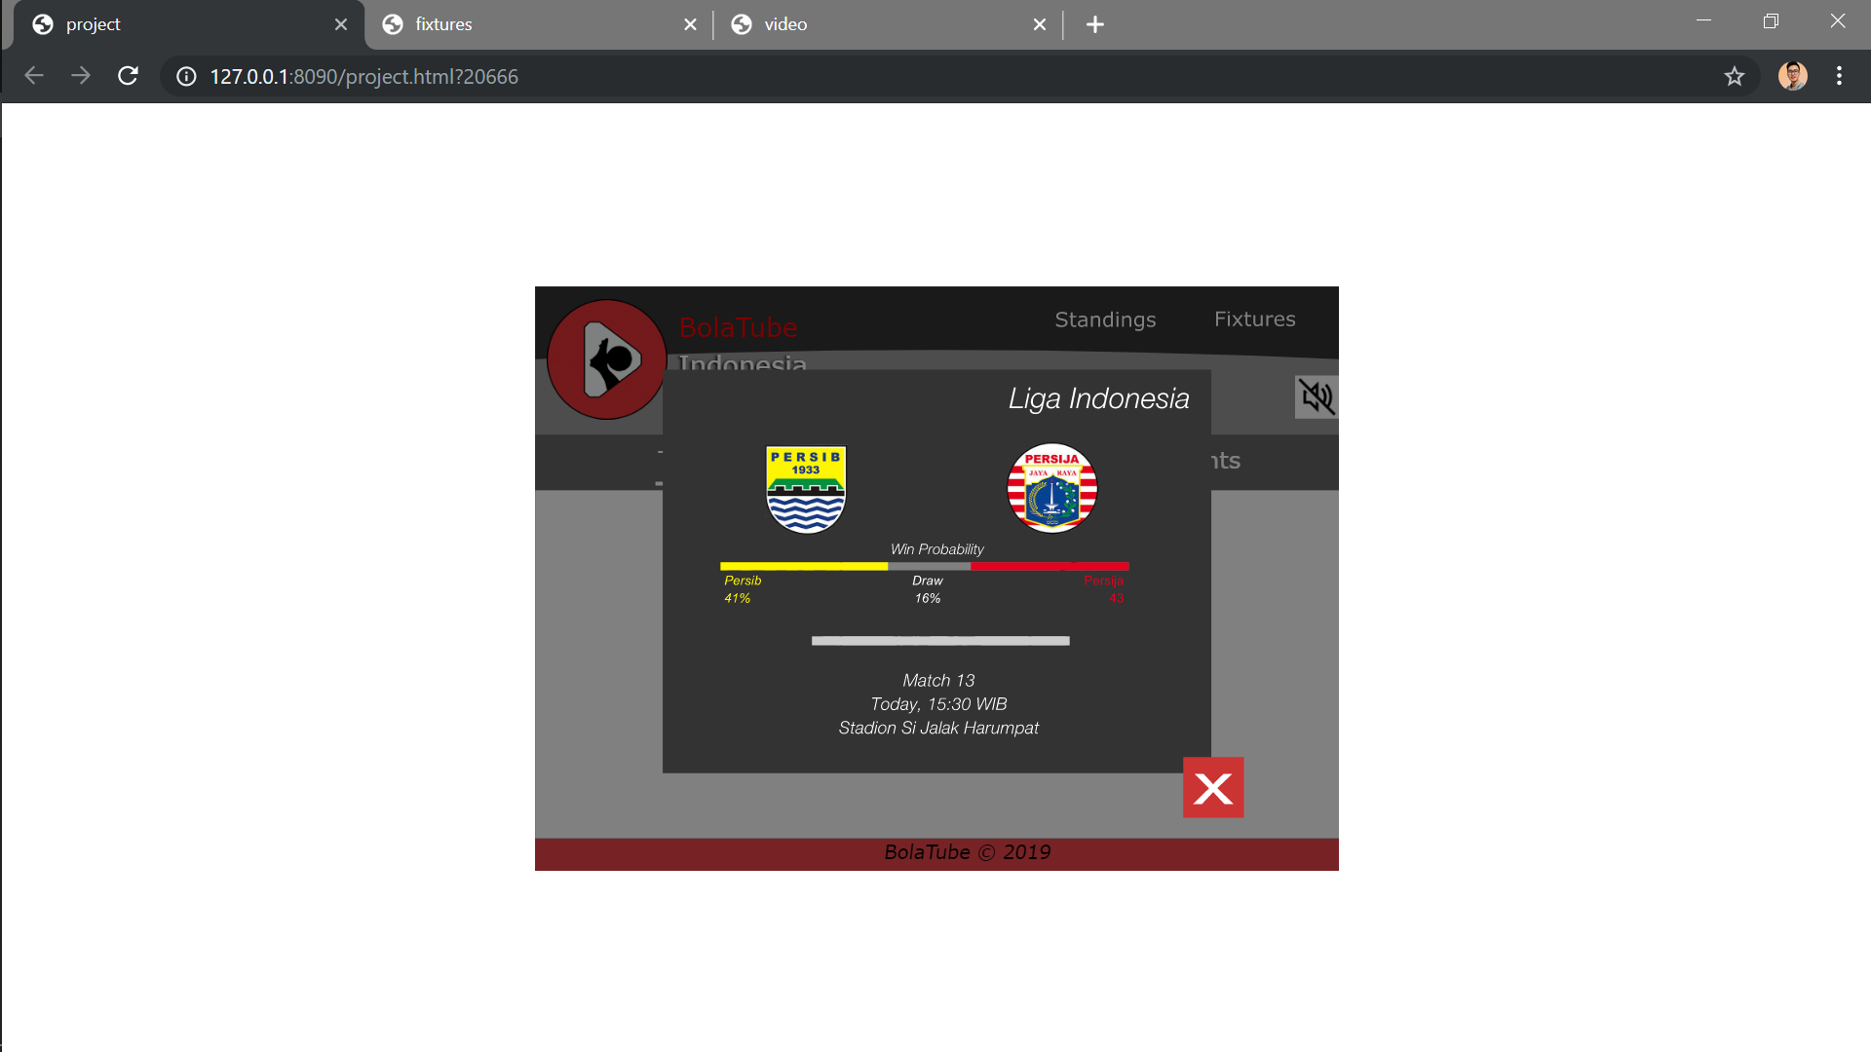

**Match Highlights**

Almost the same with Today’s Matches, you will see a display that contains the latest matches. Match highlights will contain the post-match descriptions, the scores, match details, and you can also view the match highlight video by clicking the “Watch Match Highlight” button. The match highlights transition animation is a classic tween from the right side. There is only a button on match highlights, which is to view the video. The event handler here is only hyperlink button (open new tab, *video.html*), and this.stop() to make the movie clip stay. Just like today’s matches, there is no button to go back to main page, you can navigate around directly by clicking the other main features button (today’s matches, fixtures, standings).

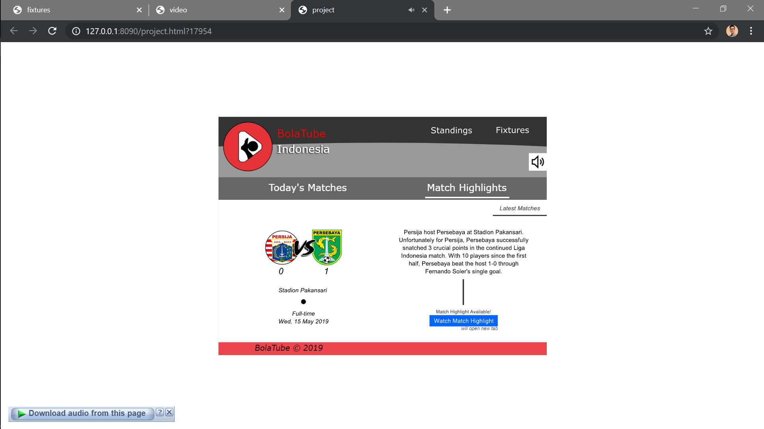

**Match Highlight Video**

The match highlight video is on “*video.html”* page. On that simple page, there is only a button to open main page again (whole area outside of the video), and the video component to show the video highlight obviously. As a closing animation, you will see a virtual camera animation that zoom in into the video as the page is closing. There is an event handler to stop the frame, so it won’t loop. Because I insert the video using video component, you can control the video with the buttons provided by the video component.

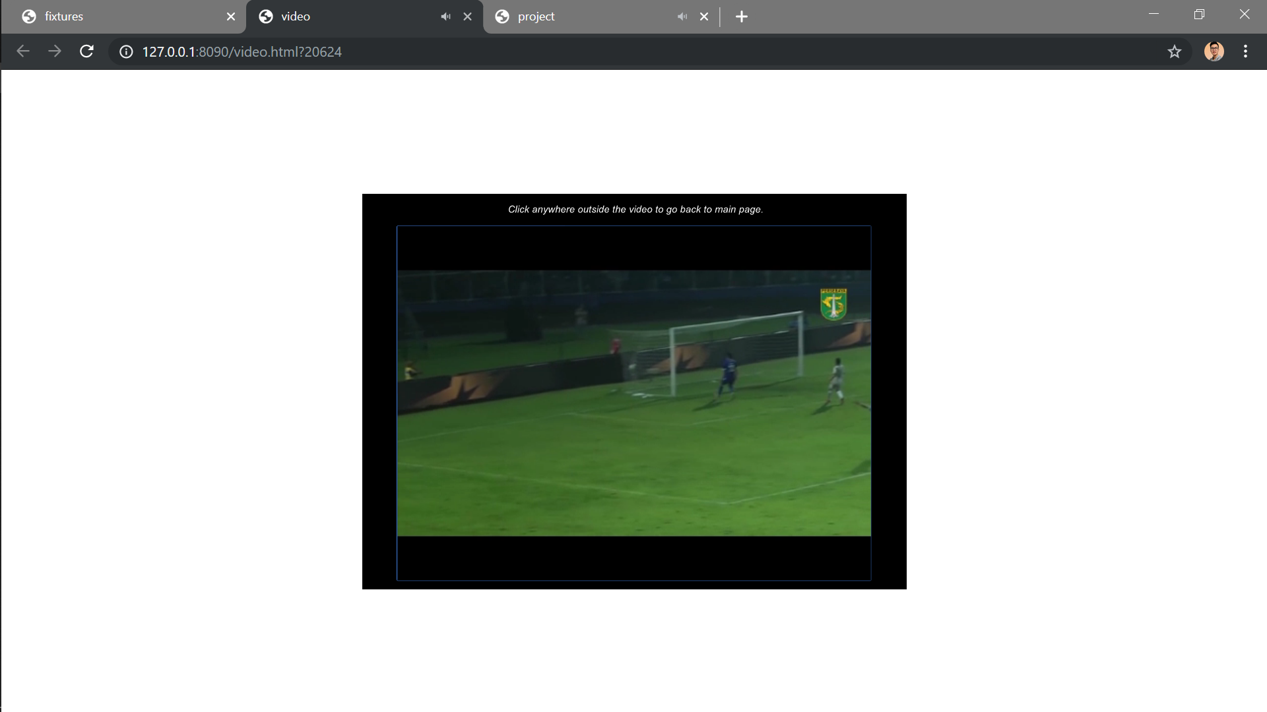

**Background Music**

As I stated on above, you will hear a background song (*idealism-phosphenes.mp3*) on entering the main page, and to control that, you can directly click the sound button to pause, and if you click it again, you will resume the background music. The button has their own hover and down graphic based on the song state (paused / is playing). You can also control the background music directly when navigating on today’s matches and match highlights button.

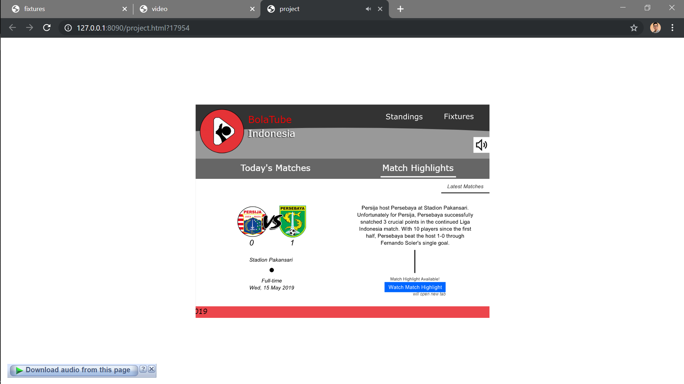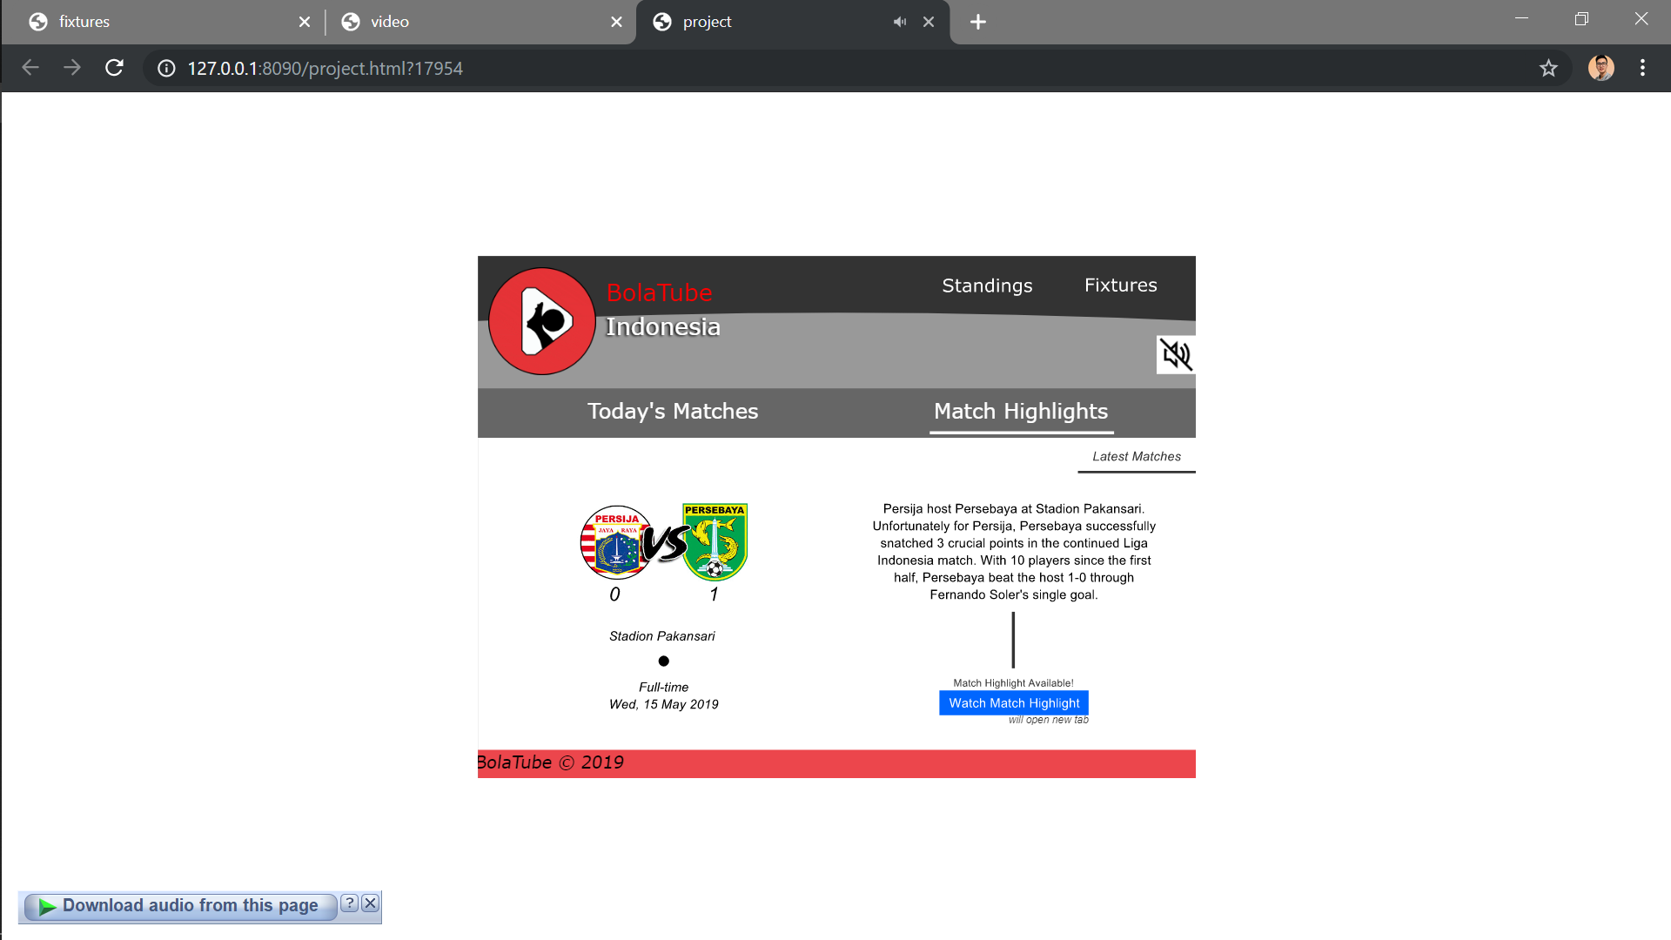

**ASSET SOURCES:**

Football team logos:

<https://www.bitebrands.co/2016/11/logo-klub-sepakbola-indonesia-terbaik.html>

Highlight Persebaya video: (trimmed)

<https://www.youtube.com/watch?v=e4Ax49kukzY>

Base logo image:

<https://storage.needpix.com/rsynced_images/football-2755481_1280.png>

Animation soccer ball sprite: (edited)

<https://www.spriters-resource.com/resources/sheets/18/19830.png>

Opening sound effect (*goal.mp3*) by paulw2k:

<https://freesound.org/people/paulw2k/sounds/196461/>

Background song (*idealism-phosphenes.mp3*) by idealism: (free download by inputting 0$)

<https://idealismus.bandcamp.com/track/phosphenes>

Magnifier icon:

<https://www.freepik.com/free-icon/magnifier_737588.htm>

Sound icon:

<https://www.visualpharm.com/free-icons/medium%20volume-595b40b65ba036ed117d1f9f>

No audio icon:

<https://www.visualpharm.com/free-icons/no%20audio-595b40b65ba036ed117d20bb>

Arrow icon:

<https://i0.wp.com/png.pngtree.com/element_our/md/20180304/md_5a9bfc5fb0fc0.png>

Base image for standings display:

<https://www.premierleague.com/tables>

Used fonts:

* Arial, Verdana,
* HelveticaNeue: <https://freefontsdownload.net/free-helveticaneue-font-74318.htm>,
* Langdon: <https://www.fontsquirrel.com/fonts/langdon>,
* Buvard: <https://www.dafont.com/buvard.font>

GIF recording software – ScreenToGif by Nicke Manarin:

<https://www.screentogif.com/>