# Prerequisites

# Oracle Architecture - Parallel execution

## Task 01: CREATE Example of Select Parallel execution

CREATE TABLE parallel_example AS SELECT time_id, day_name FROM times WHERE ROWNUM < 1001;

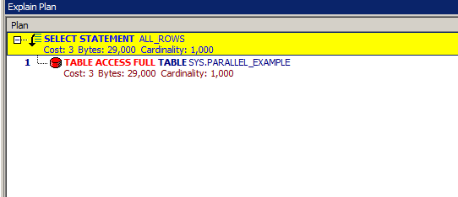

ALTER TABLE parallel_example PARALLEL 2;

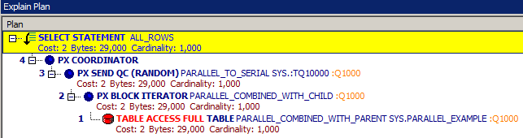

|  |  |  |
| --- | --- | --- |
| **Execution** | **Cost** | **Bytes** |
| nonParallel | 3 | 29,000 |
| Parallel | 2 | 29,000 |
|  |  |  |

Parallel Query allows one to separate a given statement so that its parts can run simultaneously on different processors. Typical operations that can run in parallel are: full table scans, sorts, sub-queries, data loading.

Parallel Query can improve performance of certain types of operations greatly.

## Task 02: CREATE Example of Parallel DML

*--------------------NOPARALLEL------------------------------*

CREATE TABLE parallel_example AS SELECT * FROM times WHERE ROWNUM < 0;

INSERT */*+ NOPARALLEL*/* INTO parallel_example SELECT * FROM times WHERE ROWNUM < 3000;

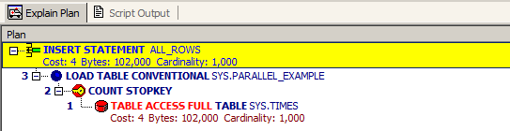

UPDATE */*+ NOPARALLEL*/* parallel_example SET day_name = 'Weekend';

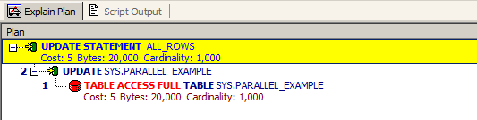

DELETE */*+ NOPARALLEL*/* FROM parallel_example;

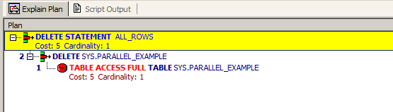

*-------------------PARALLEL DML----------------------------------*

ALTER SESSION FORCE PARALLEL DML;

INSERT INTO parallel_example SELECT * FROM times WHERE ROWNUM < 3000;

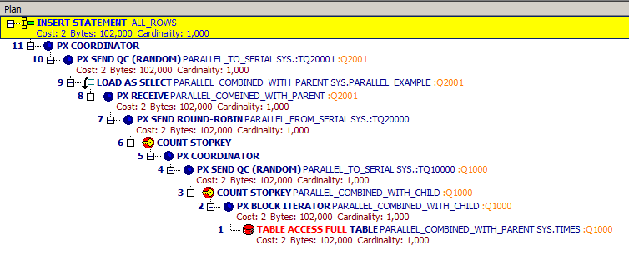

UPDATE parallel_example SET day_name = 'Weekend';

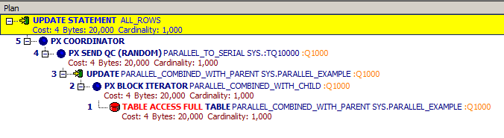

DELETE from parallel_example;

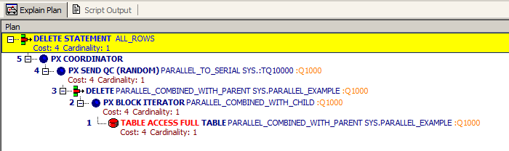

|  |  |  |  |
| --- | --- | --- | --- |
| **DML** | INSERT | UPDATE | DELETE |
| NONPARALLEL | 4 | 5 | 5 |
| PARALLEL | 2 | 4 | 4 |

## Task 03: CREATE Example of Parallel DDL

CREATE */*+ NOPARALLEL*/* TABLE parallel_example PARALLEL(DEGREE 4)

AS SELECT * FROM times WHERE ROWNUM < 3000;

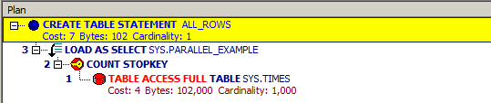

ALTER SESSION FORCE PARALLEL DDL;

CREATE TABLE parallel_example PARALLEL(DEGREE 4)

AS SELECT * FROM times WHERE ROWNUM < 3000;

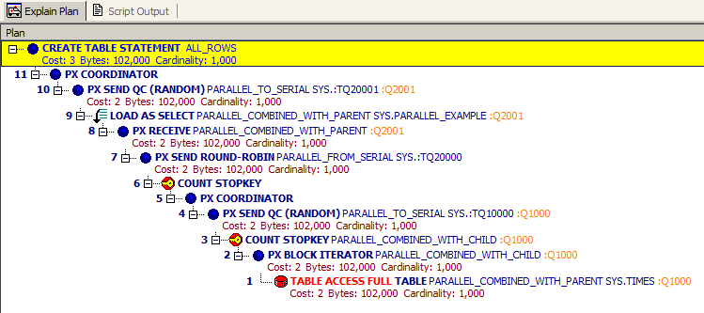

|  |  |
| --- | --- |
| **DDL** | CREATE |
| NONPARALLEL | 7 |
| PARALLEL | 3 |