# Auto Trace & Explain Plan

## Task 1: Auto Trace configuration training

**set** **autotrace off**

## C:\Users\Aliaksandr_Ahushevic\Desktop\Dropbox\Oracle database. Introduction to Data Warehousing\Lab5\Autotrace_Off.png

**set autotrace on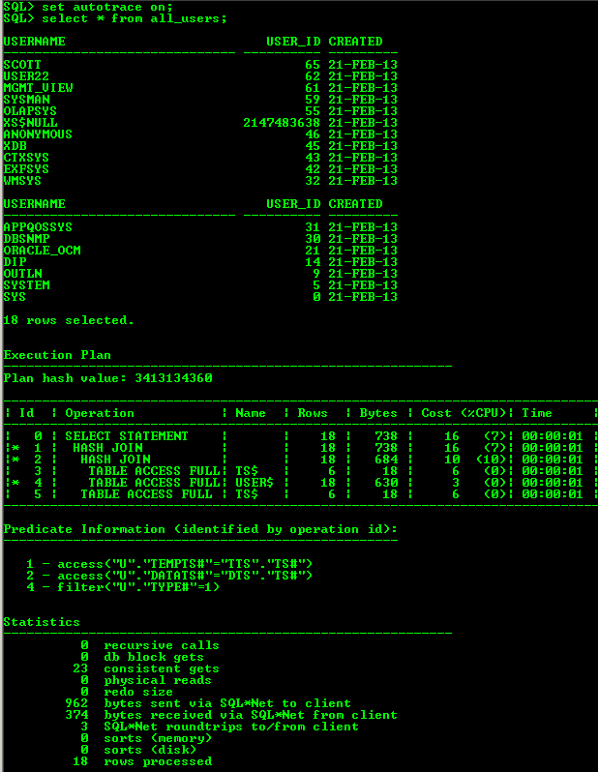**

**set autotrace traceonly**

**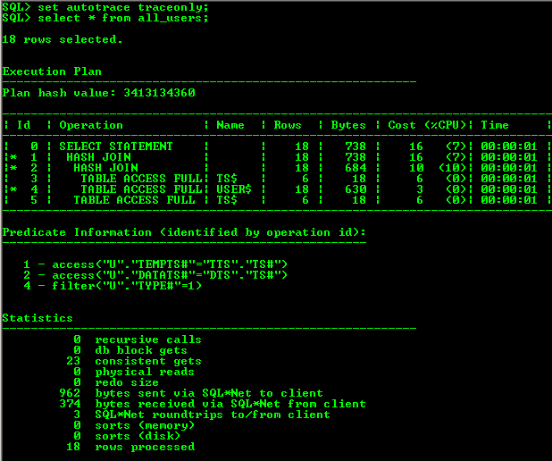**

**set autotrace on explain;**

**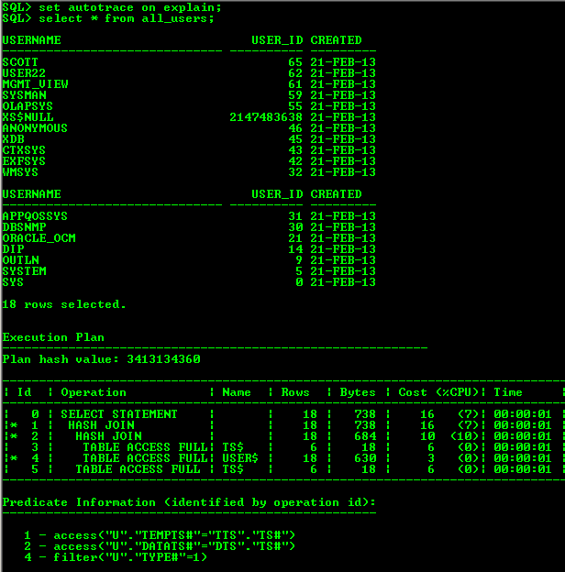**

**set autotrace on statistics; 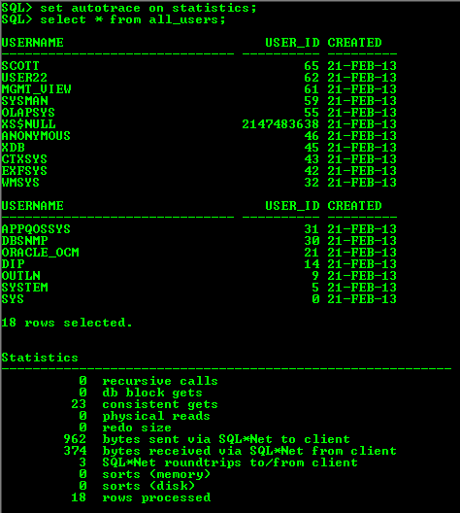**

**set autotrace on explain statistics;**

**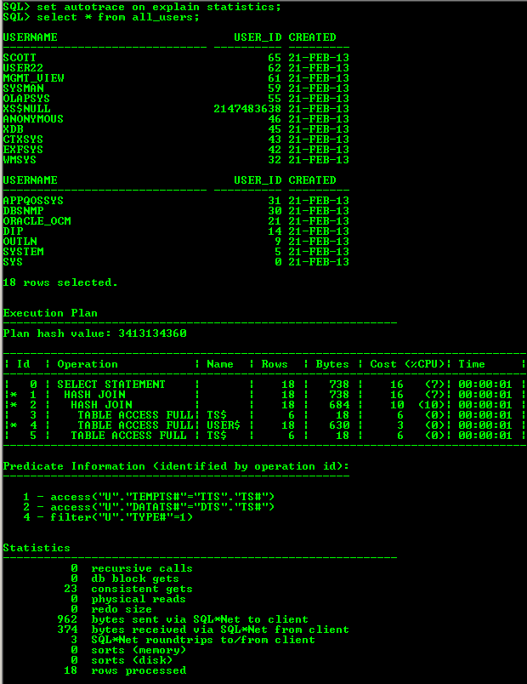**

**set autotrace traceonly explain;**

**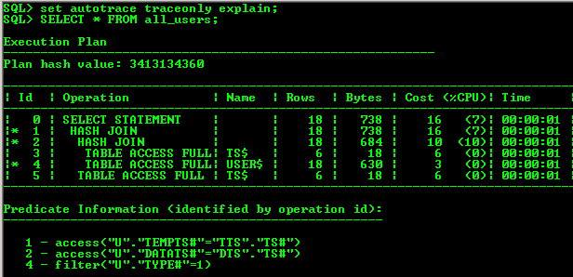**

**set autotrace traceonly statistics; 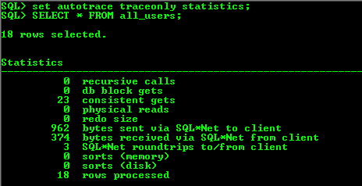**

**set autotrace traceonly explain statistics; 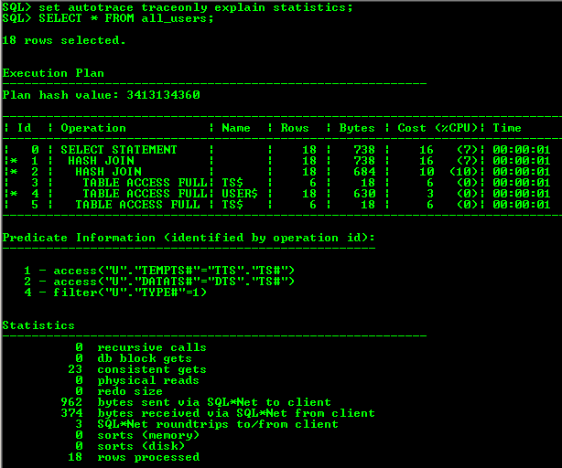**

**set autotrace off explain;**

**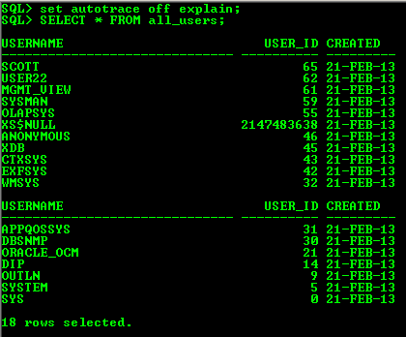**

**set autotrace off statistics;**

**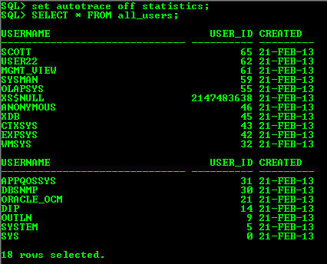**

**set autotrace off explain statistics;**

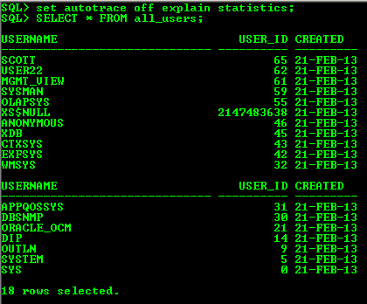

|  |  |  |  |
| --- | --- | --- | --- |
| № | Auto Trace Configuration Options | Expected Results | Description |
| 1 | set autotrace off | Display query only | autotrace not displayed |
| 2 | set autotrace on | Display query, execution plan and statistics |  |
| 3 | set autotrace traceonly | Display execution plan and statistics |  |
| 4 | set autotrace on explain; | Display query and execution plan |  |
| 5 | set autotrace on statistics; | Display query and statistics |  |
| 6 | set autotrace on explain statistics; | Display query, execution plan and statistics |  |
| 7 | set autotrace traceonly explain; | Display execution plan only |  |
| 8 | set autotrace traceonly statistics; | Display statistics only |  |
| 9 | set autotrace traceonly explain statistics; | Display execution plan and statistics |  |
| 10 | set autotrace off explain; | Display query only | autotrace not displayed |
| 11 | set autotrace off statistics; | Display query only | autotrace not displayed |
| 12 | set autotrace off explain statistics; | Display query only | autotrace not displayed |

Join Methods

## Task 2: Nested Loops JoinsC:\Users\Aliaksandr_Ahushevic\Desktop\Dropbox\Oracle database. Introduction to Data Warehousing\Lab5\nested_loops.png

## Task 3: Sort-Merge JoinsC:\Users\Aliaksandr_Ahushevic\Desktop\Dropbox\Oracle database. Introduction to Data Warehousing\Lab5\merge_join.png

## Task 4: Hash JoinsC:\Users\Aliaksandr_Ahushevic\Desktop\Dropbox\Oracle database. Introduction to Data Warehousing\Lab5\hash_join.png

## Task 5: Cartesian Joins

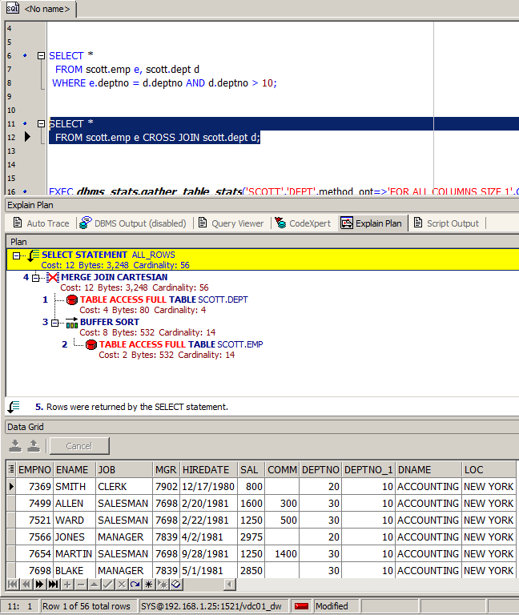

## Task 6: Left/Right Outer Joins

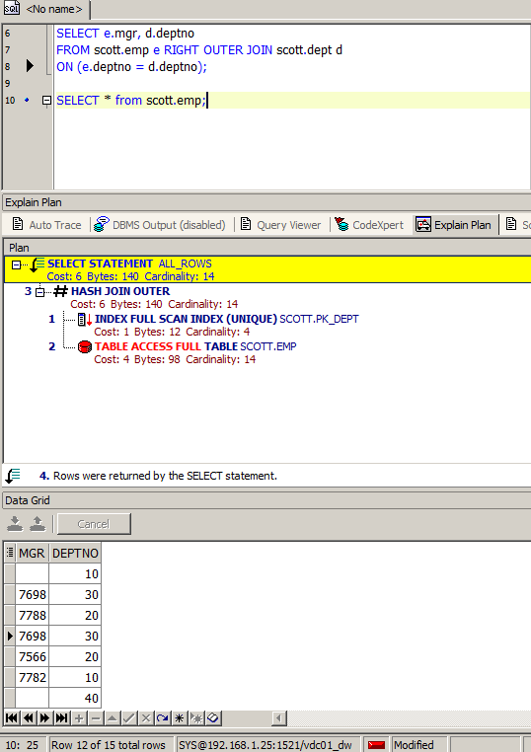

## Task 7: Full Outer Join

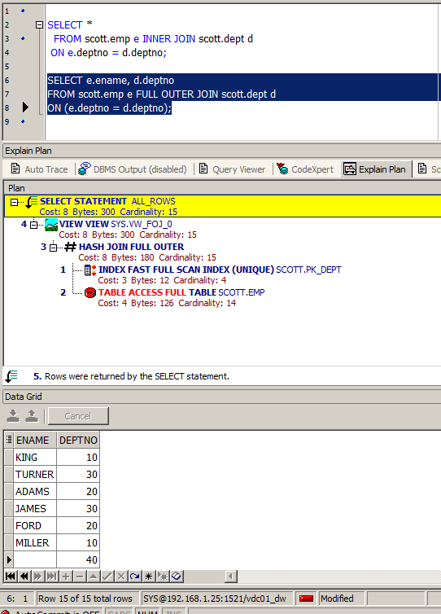

## Task 8: Semi Joins

Merge Semi Join

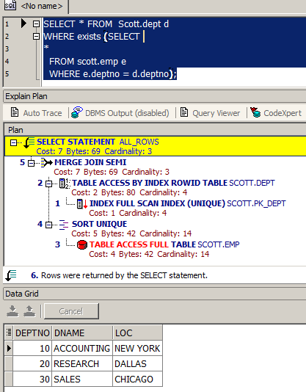

NOSEMIJOIN

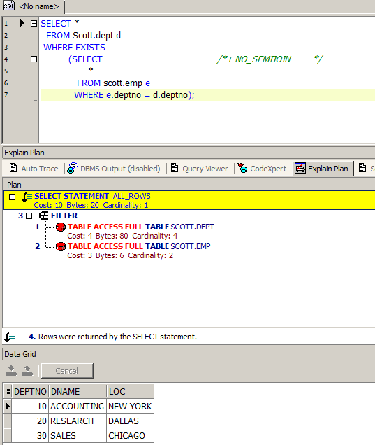

Hash SJ

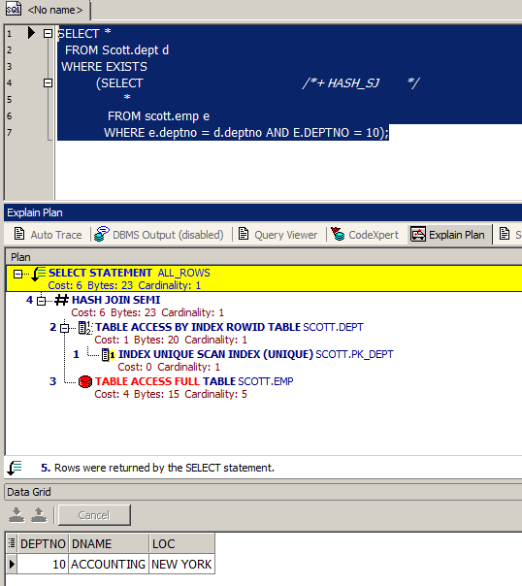

NL\_SJ

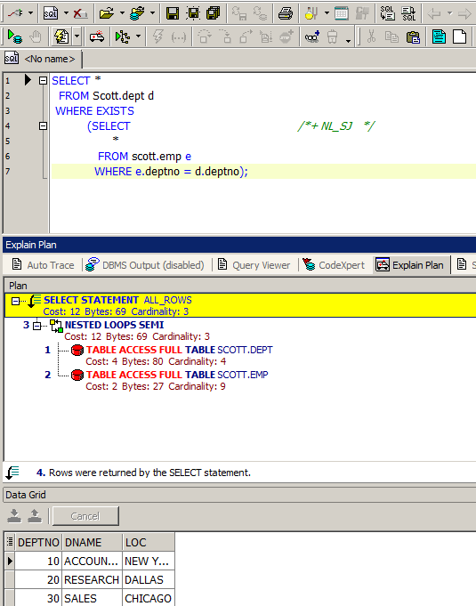

## Task 9: Anti Joins

Merge AJ

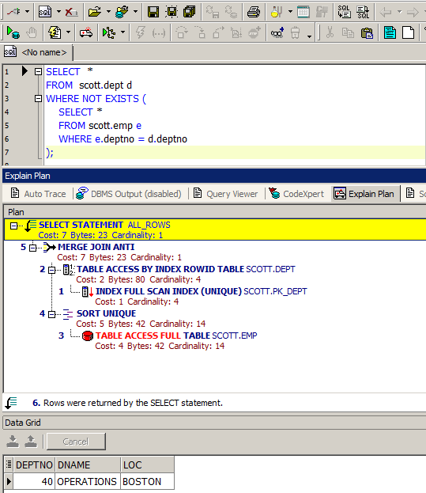

NL\_AJ

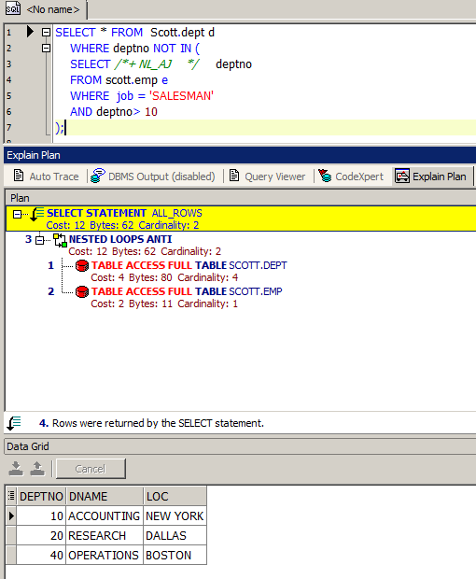

Hash AJ

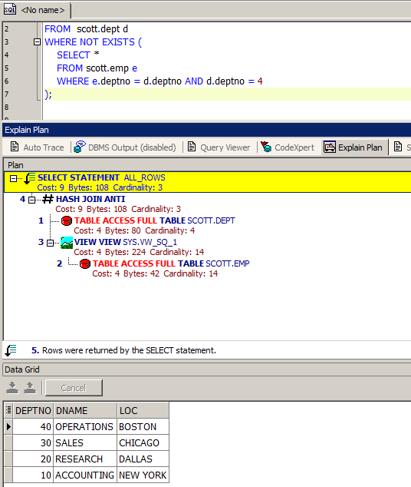

## Task 10: Prepare summary table

|  |  |  |  |  |  |  |
| --- | --- | --- | --- | --- | --- | --- |
| Join Access “A” | Join Access “B” | Nested Loop | Hash Join | Sort-Merge Join | Anti-Join | Semi-Join |
| Small Table | Small Table | + | + | +- | + | + |
| Small Table | IO Small Table | + | + | + | + | + |
| Small Table | Large Table | - | + | - | +- | +- |
| Small Table | IO Table | -+ | + | +- | +- | +- |