# Prerequisites

# OLTP – Load External References – Normalization of Data

## Task 01 – Install and expand load of external references T\_LanguagesD:\Рабочий стол\task\all_tables.png

## D:\Рабочий стол\task\all_views (deleted b61a964d03d8c7b1171efe46824a118e).png

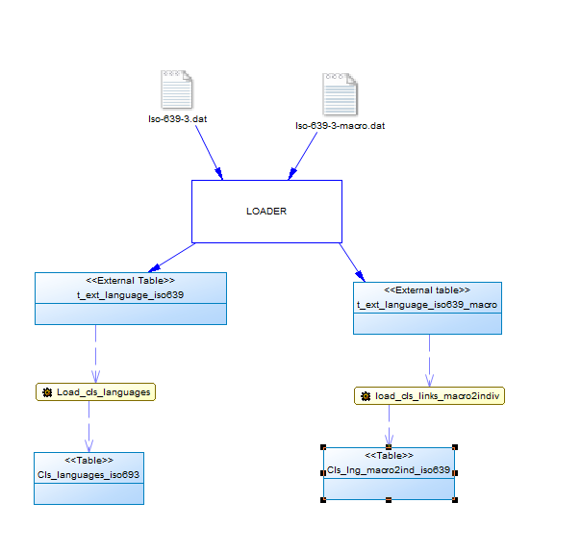

**T\_LOCALIZATION**

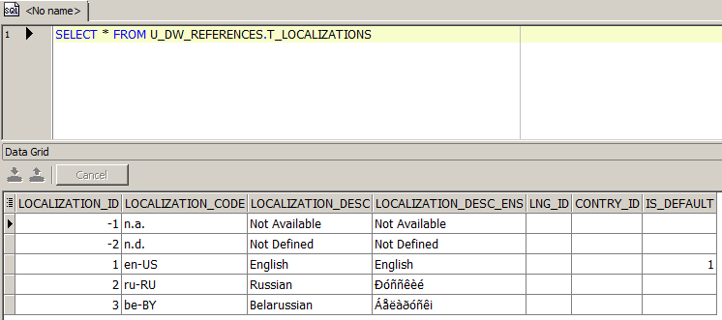

**CU\_KANGUAGES**

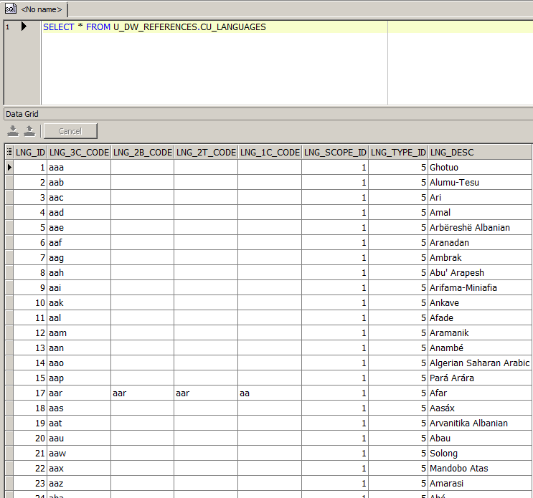

**CU\_LNG\_SCOPES**

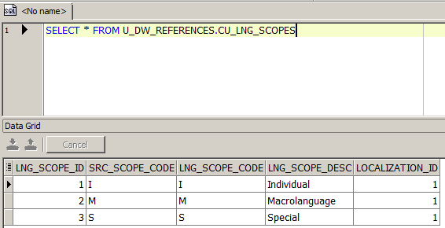

**W\_LNG\_LINKS**

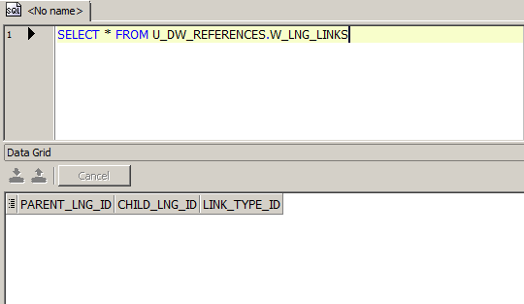

**CU\_LNG\_TYPES**

**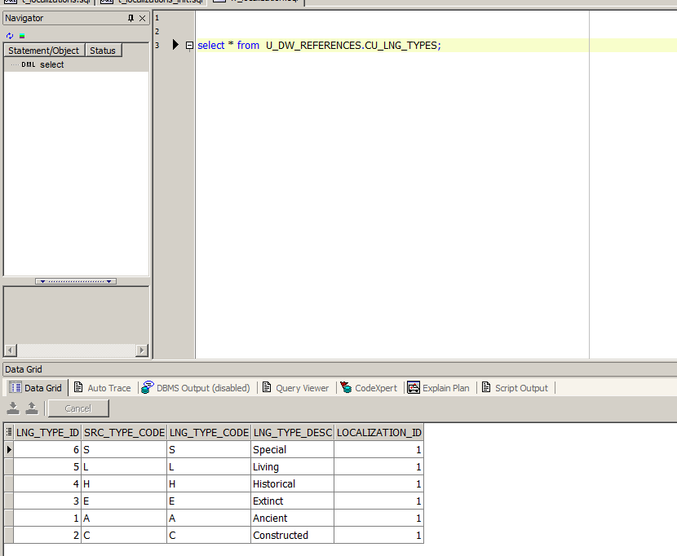**

**Phisical\_Diagram\_of\_T\_Languages**

## D:\Рабочий стол\task\Phisical_Diagram_of_T_Languages (deleted f43243330e1c84c32c548f3236cf382b).png

## Task 02 – Create load process for External references T\_Countries

**SQL scripts to show All created Tables and Views**

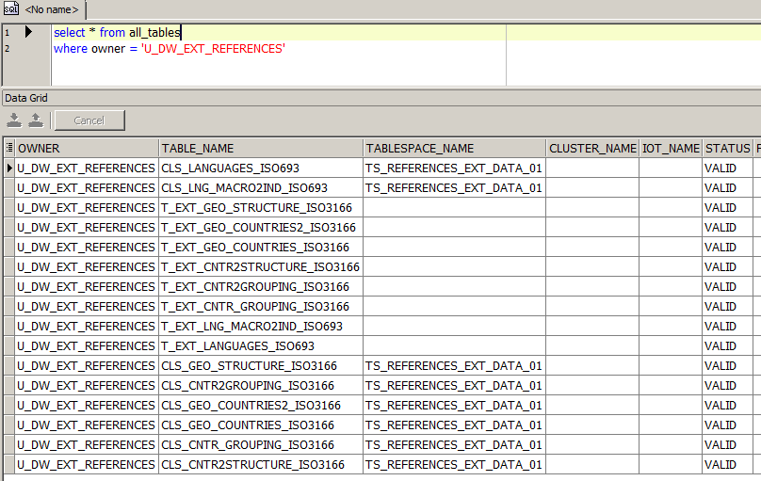

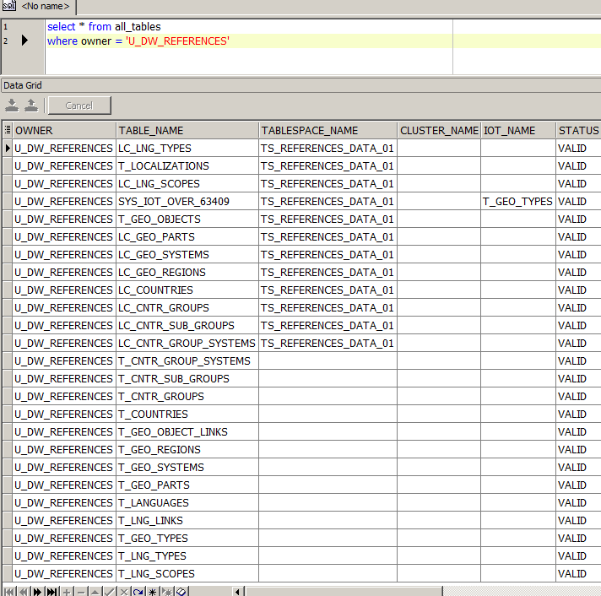

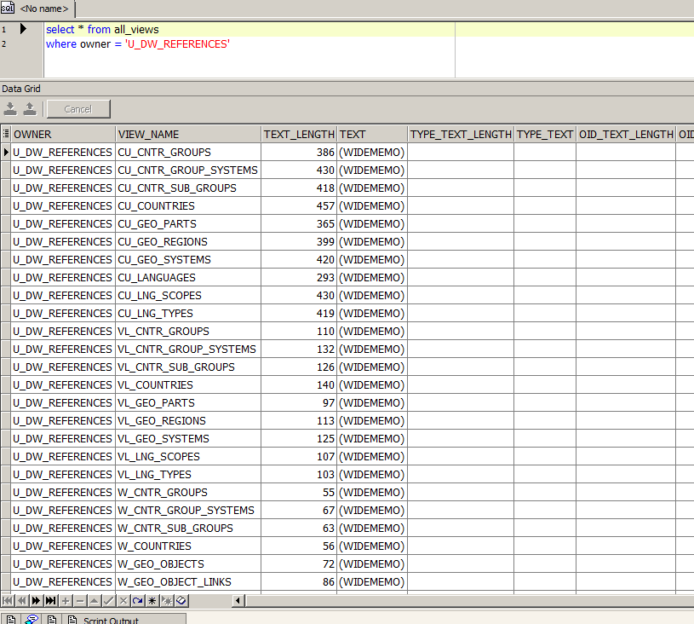

**Showing result of data on main objects: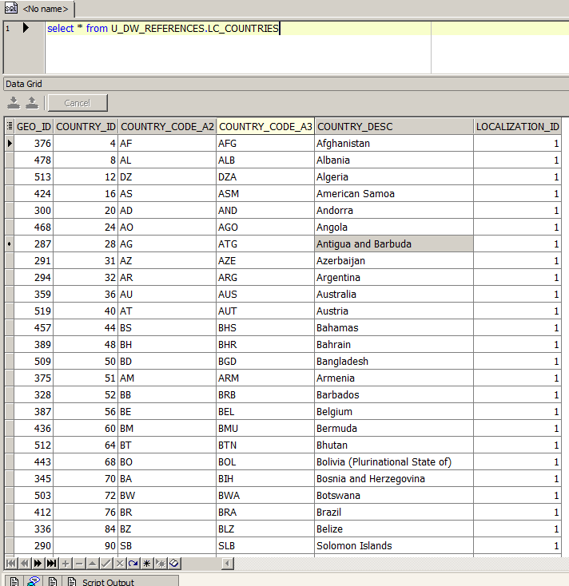**

**The Physical Diagram of T\_Countries**

