# Prerequisites

# Create and populate Dimension of TIME DW – LayerC:\Users\Aliaksandr_Ahushevic\Desktop\task\lab7\Calendar_Physical_Diagram.png

## Task 01: CREATE DW.T\_DAYS

DROP TABLE T\_DAYS;

CREATE TABLE T\_DAYS AS

SELECT CurrDate AS DAY\_ID

,TO\_CHAR (CurrDate, 'Day') AS DAY\_NAME

,TO\_NUMBER (TRIM (LEADING '0' FROM TO\_CHAR (CurrDate, 'D'))) AS DAY\_NUMBER\_IN\_WEEK

,TO\_NUMBER (TRIM (LEADING '0' FROM TO\_CHAR (CurrDate, 'DD'))) AS DAY\_NUMBER\_IN\_MONTH

,TO\_NUMBER (TRIM (LEADING '0' FROM TO\_CHAR (CurrDate, 'DDD'))) AS DAY\_NUMBER\_IN\_YEAR

,UPPER (TO\_CHAR (CurrDate, 'YYYY')|| '-' ||TO\_CHAR (CurrDate, 'MM')) AS CALENDAR\_MONTH\_DESC

FROM ( SELECT LEVEL n,

*-- Календарь формируется начиная со следующей после указанной даты.*

TO\_DATE ('31/12/2010', 'DD/MM/YYYY')

+ NUMTODSINTERVAL (LEVEL, 'day')

CurrDate

FROM DUAL

*-- Количество дней в календаре.*

CONNECT BY LEVEL <= 365)

ORDER BY CurrDate;

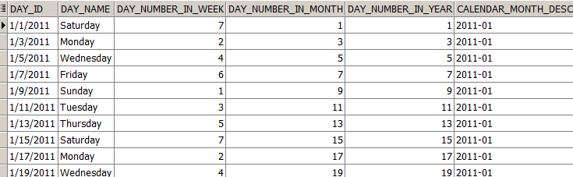

## Task 02: CREATE DW.T\_WEEKS

## Task 03: CREATE DW.T\_MONTHS

DROP TABLE T\_MONTH;

CREATE TABLE T\_MONTH AS SELECT

UPPER (TO\_CHAR (CurrDate, 'YYYY') || '-' || TO\_CHAR (CurrDate, 'MM')) AS CALENDAR\_MONTH\_DESC

,TO\_NUMBER (TO\_CHAR (CurrDate, 'MM')) AS CALENDAR\_MONTH\_NUMBER

,TO\_CHAR (CurrDate, 'Month') AS CALENDAR\_MONTH\_NAME

,COUNT (\*) OVER (PARTITION BY TO\_CHAR (CurrDate, 'MM')) AS DAYS\_IN\_CAL\_MONTH

,MAX (CurrDate) OVER (PARTITION BY TO\_CHAR (CurrDate, 'MM')) AS END\_OF\_CAL\_MONTH

,UPPER (TO\_CHAR (CurrDate, 'YYYY') || '-' ||'Q'|| TO\_CHAR (CurrDate, 'Q')) AS CALENDAR\_QUARTER\_DESC

FROM ( SELECT LEVEL n,

*-- Календарь формируется начиная со следующей после указанной даты.*

TO\_DATE ('31/12/2010', 'DD/MM/YYYY')

+ NUMTODSINTERVAL (LEVEL, 'day')

CurrDate

FROM DUAL

*-- Количество дней в календаре.*

CONNECT BY LEVEL <= 365)

ORDER BY CurrDate;

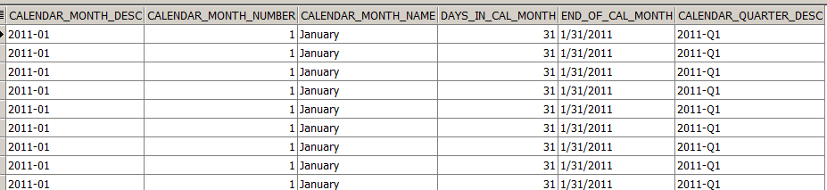

## Task 04: CREATE DW.T\_QUARTERS

DROP TABLE T\_QUARTERS;

CREATE TABLE T\_QUARTERS AS

SELECT UPPER (TO\_CHAR (CurrDate, 'YYYY') || '-' ||'Q'|| TO\_CHAR (CurrDate, 'Q')) AS CALENDAR\_QUARTER\_DESC

,COUNT (\*) OVER (PARTITION BY TO\_CHAR (CurrDate, 'Q')) AS CALENDAR\_DAYS\_IN\_QUARTER

,MIN (CurrDate) OVER (PARTITION BY TO\_CHAR (CurrDate, 'Q')) AS BEG\_OF\_CAL\_QUARTER

,MAX (CurrDate) OVER (PARTITION BY TO\_CHAR (CurrDate, 'Q')) AS END\_OF\_CAL\_QUARTER

,TO\_NUMBER (TO\_CHAR (CurrDate, 'Q')) AS QUARTER\_NUMBER

,TO\_CHAR (CurrDate, 'YYYY') AS CALENDAR\_YEAR

FROM ( SELECT LEVEL n,

*-- Календарь формируется начиная со следующей после указанной даты.*

TO\_DATE ('31/12/2010', 'DD/MM/YYYY')

+ NUMTODSINTERVAL (LEVEL, 'day')

CurrDate

FROM DUAL

*-- Количество дней в календаре.*

CONNECT BY LEVEL <= 365)

ORDER BY CurrDate;

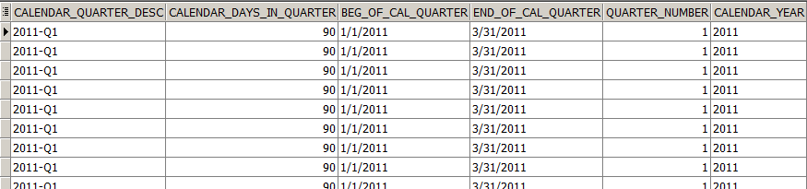

## Task 05: CREATE DW.T\_YEARS

DROP TABLE T\_YEARS;

CREATE TABLE T\_YEARS AS

SELECT TO\_CHAR (CurrDate, 'YYYY') AS CALENDAR\_YEAR

,COUNT (\*) OVER (PARTITION BY TO\_CHAR (CurrDate, 'YYYY')) AS DAYS\_IN\_CAL\_YEAR

,MAX (CurrDate) OVER (PARTITION BY TO\_CHAR (CurrDate, 'YYYY')) AS END\_OF\_CAL\_YEAR

FROM ( SELECT LEVEL n,

*-- Календарь формируется начиная со следующей после указанной даты.*

TO\_DATE ('31/12/2010', 'DD/MM/YYYY')

+ NUMTODSINTERVAL (LEVEL, 'day')

CurrDate

FROM DUAL

*-- Количество дней в календаре.*

CONNECT BY LEVEL <= 365)

ORDER BY CurrDate;

