# Prerequisites

# Oracle Architecture - Partitioning

## Task 01: CREATE Example of Range partitioning

*-----------Range Composite Range-\**

*----------------------Adding Partitions*

DROP TABLE range_example;

CREATE TABLE range_example

(

DAY_ID DATE NOT NULL,

DAY_NAME VARCHAR2(36)

)

PARTITION BY RANGE (DAY_ID)

(PARTITION part_1

VALUES LESS THAN (TO_DATE ('01/01/2012', 'dd/mm/yyyy')),

PARTITION part_2

VALUES LESS THAN (TO_DATE ('01/01/2013', 'dd/mm/yyyy')),

PARTITION part_3

VALUES LESS THAN (TO_DATE ('01/01/2014', 'dd/mm/yyyy')));

INSERT INTO range_example SELECT DAY_ID, DAY_NAME

FROM TIMES WHERE rownum < 1000;

SELECT * FROM range_example;

SELECT * FROM user_segments WHERE segment_name = UPPER ('range_example')

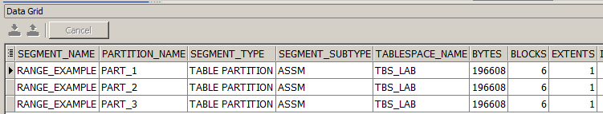

*----------------------Dropping Partitions*

ALTER TABLE range_example DROP PARTITION PART_3

SELECT * FROM user_segments WHERE segment_name = UPPER ('range_example');

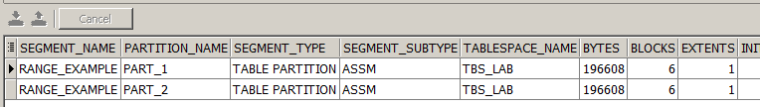

*----------------------Moving Partitions*

ALTER TABLE range_example MOVE PARTITION PART_2

TABLESPACE P1_LAB NOLOGGING;

SELECT * FROM user_segments WHERE segment_name = UPPER ('range_example');

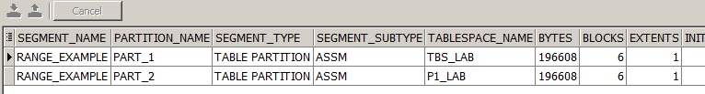

*----------------------Splitting Partitions*

ALTER TABLE range_example SPLIT PARTITION

part_1 at (TO_DATE ('01/07/2011', 'dd/mm/yyyy')) INTO

( PARTITION part_1_0,

PARTITION part_1_1

);

SELECT * FROM user_segments WHERE segment_name = UPPER ('range_example')

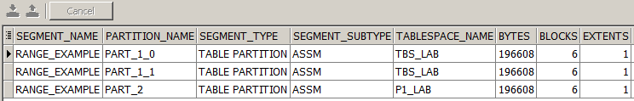

*----------------------Merging Partitions*

ALTER TABLE range_example MERGE PARTITIONS

part_1_0, part_1_1

INTO PARTITION split_part_1

UPDATE INDEXES;

SELECT * FROM user_segments WHERE segment_name = UPPER ('range_example');

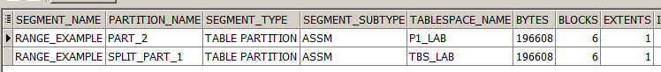

*----------------------Truncating Partitions*

alter table range_example truncate partition split_part_1

SELECT * FROM user_segments WHERE segment_name = UPPER ('range_example')

*All data contained in split_part_1 have been truncated*

*-----------Interval Composite Interval-\**

*----------------------Adding Partitions*

*----------------------Dropping Partitions*

SELECT * FROM user_segments WHERE segment_name = UPPER ('range_example')

*----------------------Merging Partitions*

*----------------------Moving Partitions*

*----------------------Splitting Partitions*

*----------------------Truncating Partitions*

*-----------Hash*

*----------------------Adding Partitions*

CREATE TABLE hash_example

(Date_hash_key date,

day_name varchar2(36)

)

PARTITION BY HASH (Date_hash_key)

(

partition part_1 tablespace p1_lab,

partition part_2 tablespace p2_lab

);

INSERT INTO hash_example

SELECT

TO_DATE(day_id) hash_key_column, day_name

FROM times

WHERE rownum < 1000;

select * from hash_example;

SELECT * FROM user_segments WHERE segment_name = UPPER ('hash_example')

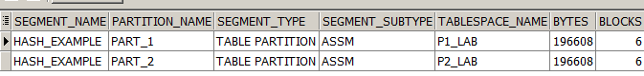

*----------------------Coalescing Partitions*

ALTER TABLE hash_example COALESCE PARTITION;

SELECT * FROM user_segments WHERE segment_name = UPPER ('hash_example')



*----------------------Moving Partitions*

*----------------------Truncating Partitions*

*-----------List Composite List-\**

*----------------------Adding Partitions*

CREATE TABLE list_example (day_id DATE, day_name VARCHAR2 (36))

PARTITION BY LIST (day_name)

(PARTITION part_1

VALUES ('Monday', 'Tuesday', 'Wednesday', 'Thursday', 'Friday'),

PARTITION part_2

VALUES ('Saturday', 'Sunday'),

PARTITION part_3

VALUES (DEFAULT));

INSERT INTO list_example SELECT day_id, day_name FROM times;

SELECT * FROM user_segments WHERE segment_name = UPPER ('list_example')

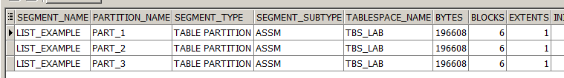

*----------------------Dropping Partitions*

*----------------------Moving Partitions*

*----------------------Splitting Partitions*

ALTER TABLE list_example SPLIT PARTITION part_1 VALUES ( 'Friday', 'Thursday') INTO ( PARTITION part_1_0

TABLESPACE p1_lab,

PARTITION part_1_1

STORAGE (NEXT 5M PCTINCREASE 25))

PARALLEL 5;

SELECT * FROM user_segments WHERE segment_name = UPPER ('list_example')

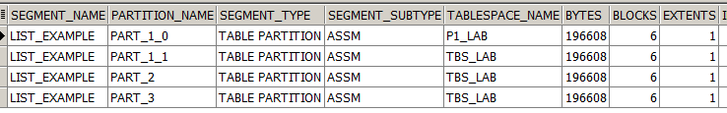

*----------------------Merging Partitions*

ALTER TABLE list_example MERGE PARTITIONS

part_1_0, part_1_1

INTO PARTITION part_1

STORAGE(MAXEXTENTS 20);

SELECT * FROM user_segments WHERE segment_name = UPPER ('list_example')

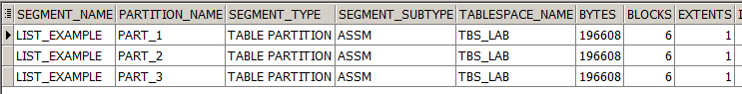

*----------------------Truncating Partitions*

*-----------Reference*

CREATE TABLE reference_example

(

day_id date,

day_name VARCHAR2(26),

PRIMARY KEY (day_id)

)

enable row movement

PARTITION BY RANGE (day_id)

(

PARTITION part_1 VALUES LESS THAN (TO_DATE ('01/01/2009', 'dd/mm/yyyy')),

PARTITION part_2 VALUES LESS THAN (TO_DATE ('01/01/2012', 'dd/mm/yyyy')),

PARTITION part_3 VALUES LESS THAN (TO_DATE ('01/01/2015', 'dd/mm/yyyy'))

);

INSERT INTO reference_example select day_id, day_name from times;

select * from reference_example;

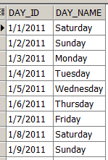

CREATE TABLE reference_example2

(

DAY_NUMBER_IN_YEAR number,

day_id date NOT NULL,

constraint c1_pkey primary key(DAY_NUMBER_IN_YEAR),

constraint c1_fkey_p foreign key(day_id) references reference_example (day_id)

)

enable row movement

partition by reference(c1_fkey_p)

;

INSERT INTO reference_example2

SELECT

DAY_NUMBER_IN_YEAR,

day_id

FROM times

WHERE rownum < 1000;

select * from reference_example2;

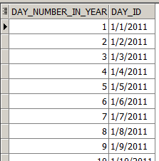

DROP TABLE reference_example;

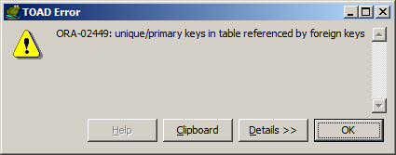

SELECT * FROM user_segments WHERE segment_name in (UPPER ('reference_example'), UPPER('reference_example2'))

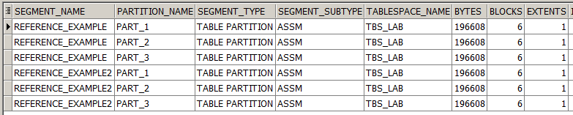

*----------------------Moving Partitions*

*----------------------Truncating Partitions*