**Institute of Technology University of Moratuwa**

**SEYONI**

**COMPREHENSIVE SMART WORKERS**

**MANAGEMENT SYSTEM**

**Project I Final Report**

M F M Ahzem 21IT0455

A A M Amjad 21IT0457

P A P Dewindi 21IT0462

I M D W Dissanayake 21IT0467

U D S S Kumara 21IT0490

Division of Information Technology

Institute of Technology University of Moratuwa

May 2024

**SEYONI**

**COMPREHENSIVE SMART WORKERS**

**MANAGEMENT SYSTEM**

M F M Ahzem 21IT0455

A A M Amjad 21IT0457

P A P Dewindi 21IT0462

I M D W Dissanayake 21IT0467

U D S S Kumara 21IT0490

Project I report submitted to the Division of Information Technology, Institute of

Technology, University of Moratuwa, Sri Lanka for the partial fulfillment of the

requirements of the National Diploma in Information Technology.

June 2024

### 

### Declaration

We declare that this thesis is our own work and has not been submitted in any form for another degree or diploma at any university or other institution of tertiary education. Information derived from the published or unpublished work of others has been acknowledged in the text and a list of references is given.



|  |  |
| --- | --- |
| M F M Ahzem |  |
| A A M Amjad |  |
| P A P Dewindi |  |
| I M D W Dissanayake |  |
| U D S S Kumara |  |

Date: 30/06/2024

Supervised by

|  |  |
| --- | --- |
| Ms.Sithara Madhubashini |  |

Date: 30/06/2024

### Acknowledgement

We extend our heartfelt gratitude to the individuals who have provided unwavering support throughout our project journey. First and foremost, we express our sincere appreciation to our project coordinator/supervisor, Ms.Sithara Madhubashini, and our instructor, Mr.Nipuna Yasas. Their enthusiasm, patience, invaluable insights, helpful information, practical advice, and constant flow of ideas have been instrumental in the success of our project. Without their unwavering support and guidance, this project would not have been possible.

Additionally, we are thankful to all the lecturers of the Information Technology division at the Institute of Technology, University of Moratuwa, for their continuous support and assistance.

Finally, we would like to extend our thanks to everyone who has provided encouragement and motivation during this project. Your support has played a significant role in our progress and achievements.

### Abstract

Our project proposes a transformative solution in the realm of home service provision by harnessing innovative digitization and advanced IT enablement. We strive to establish a comprehensive platform that connects service seekers with verified providers and will address the prevalent challenges inherent in traditional recruitment methods such as security, reliability issues, and inefficiencies. Our solution is to strive to create trust, transparency, and accountability in the field of service delivery. Here we hope to use mobile technology, real-time tracking functionality, secure payment integration, and a strong authentication mechanism.

Our platform is designed for the convenience of users and provides a seamless experience for people looking for various housing services. Users can easily browse through verified service providers, request services, and select the most suitable ones based on their preferences and needs. We integrate a real-time location tracking system which can be seen as a major step towards improving security and reliability for both users of the system. This feature allows users to track the location and progress of service providers. Also, we use an emergency assistance feature to maintain a high level of security for both parties, such as an accident or inappropriate behavior. Our platform also includes a rating and review system to encourage users to provide feedback on their service experience and help others make informed decisions when choosing service providers.

We hope to bridge the gap between service seekers and providers, thereby revolutionizing the way people access and engage with housing services is our project aim. We strive to improve the overall service experience and create greater trust between service providers and customers through improved convenience, reliability, and security measures. Our project represents an important step towards creating a more efficient as well as transparent and accountable ecosystem for in-house service interactions, ultimately benefiting users and service providers alike.

**Table of Contents**

Declaration ii

Acknowledgement iii

Abstract iv

1. Introduction 1

1.1 Introduction 1

1.2 Background and Motivation 2

1.2.1 Background 2

1.2.2 Motivation 2

1.3 Aim and Objectives 3

1.3.1 Aim 3

1.3.2 Objectives 3

1.4 Proposed solution 4

1.4.1 Users 4

1.4.2 Inputs 1

1.4.3 Outputs 1

1.4.4 Process 1

1.5 Summary 1

2. Literature Review 2

2.1 Introduction 2

2.2 Available approaches 3

2.2.1 TaskRabbit 3

2.2.2 Thumbtack 4

2.2.3 Handy 5

2.2.4 TIDY 6

2.2.5 Zaarly 7

2.2.6 Angi 8

2.2.7 HomeAdvisor 9

2.2.8 ServisHero 10

2.3 Summary 11

3. Approach 13

3.1 Introduction 13

3.2 Approach 14

3.2.1 Module 01: User Management 14

3.2.2 Module 02: Service Listing and Search 16

3.2.3 Module 03: Booking and Appointment Management 18

3.2.4 Module 04: Service Provider Management 20

3.2.5 Module 05: Service Request Management 22

3.2.6 Module 06: Real-time Location Tracking 24

3.2.7 Module 07: Messaging and Communication 26

3.2.8 Module 08: Payment Processing 29

3.2.9 Module 09: Rating and Review System 32

3.2.10 Module 10: Emergency Assistance Feature 35

3.2.11 Module 11: Admin Dashboard 38

3.2.12 Module 12: Reporting and Analytics 41

3.3 Summary 44

4. Technology 45

4.1 Introduction 45

4.2 Technology Adapted 45

4.2.1 Programming Languages: 45

4.2.2 Libraries and Frameworks: 45

4.2.3 IDE - Visual Studio Code 46

4.2.4 Databases/Data Storages - MongoDB 46

4.2.5 Versioning Control/Continuous Integration Tools: GitHub 46

4.2.6 Application and Web Servers: Express.js 46

4.2.7 Cloud Computing: Microsoft Azure 46

4.2.8 UX, UI, and Graphic Tools: 47

4.3 Summary 47

5. Analysis 48

5.1 Introduction 48

5.2 Requirement gathering and analysis 49

5.3 Requirements of the suggested solution 50

5.4 Summary 53

6. Design 54

6.1 Introduction 54

6.2 Design 55

6.2.1 Use Case Diagram 55

6.2.2 Sequence Diagram for User Account Creation 56

6.2.3 Sequence Diagram for Admin Verification 57

6.2.4 Sequence Diagram for Service Request Proccess 58

6.2.5 Activity Diagram for Service Request Process 59

6.2.6 Class Diagram for System Entities and Relationships 60

6.2.7 State Chart Diagram for User Authentication Process 61

6.2.7.1 Service Seeker Behavior 61

6.2.7.2 Service Provider Behavior 62

6.2.8 Components Diagram for System 63

6.2.9 Deployment Diagram 64

6.3 Summery 65

7. Conclusion 67

7.1 Summary of Findings 67

7.2 Achievements 68

7.3 Future Work 69

7.4 Conclusion 69

References 70

**List of Figures**

Figure 1 Use Case Diagram 55

Figure 2 Sequence Diagram 1 56

Figure 3 Sequence Diagram 2 57

Figure 4 Sequence Diagram 3 59

Figure 5 Activity Diagram 59

Figure 6 Class Diagram 60

Figure 7 State Chart Diagram 1 61

Figure 8 State Chart Diagram 2 62

Figure 9 Component Diagram 63

Figure 10 Deployment Diagram 64

**List of** **Tables**

Table 1- Comparison Table 12

**Chapter 1**

# Introduction

# Introduction

This section is initiated with the introduction of our final project, beginning with an explanation of why this project was chosen and what inspired us. Then, our main goal is stated and broken down into smaller objectives.

Our plan to achieve these goals is discussed; including who will use our system, what information will be taken in, and what results will be produced. Additionally, how the system works internally is explained.

By organizing this information, a straightforward overview of our project is hoped to be given, setting the stage for the rest of our report.

## Background and Motivation

#### Background

The genesis of our project stems from the evolving landscape of home services and the inherent challenges associated with traditional hiring methods. In recent years, there has been a surge in the demand for various home services, ranging from plumbing and electrical work to cleaning and maintenance tasks. However, the existing system often falls short in ensuring safety, reliability, and transparency during service appointments. Instances of inappropriate behavior, thefts, and safety concerns have underscored the need for a more secure and efficient platform to connect service seekers with verified providers.

#### Motivation

The motivation behind our project is multifaceted, driven by the desire to address the shortcomings of the current system and improve the overall experience for both service seekers and providers. Factors such as safety concerns, lack of trust, and inefficiencies in traditional hiring methods have fueled our determination to develop a comprehensive solution. By leveraging innovative digitization and advanced IT enablement, we aim to create a platform that not only streamlines the process of finding and hiring service providers but also fosters trust, reliability, and accountability in service delivery.

## Aim and Objectives

#### Aim

At the heart of our project lies the aim to develop a synergistic platform for multifaceted service provision. Our overarching goal is to create a solution that revolutionizes the way users connect with service providers, offering unparalleled convenience, reliability, and transparency.

#### Objectives

To achieve our aim, we have delineated several objectives:

* Implement a user-friendly mobile application that serves as a seamless interface between service seekers and providers.
* Establish a robust verification system to ensure the credibility and reliability of service providers, thereby enhancing trust and safety.
* Enable real-time tracking of service providers to provide users with up-to-date information on the status and location of their service appointments.
* Implement a rating and review system that empowers users to provide feedback and evaluate service providers based on their experiences.
* Integrate secure payment gateways to facilitate seamless transactions between users and service providers directly through the platform.

## Proposed solution

In our proposed solution, we envision a comprehensive platform that seamlessly connects service seekers with verified service providers, addressing the surge in inappropriate behavior and security concerns prevalent in traditional service hiring methods. Through innovative digitization and advanced IT enablement, our platform will offer a user-friendly interface catering to the diverse needs of three distinct user groups: administrators, service seekers, and service providers.

#### Users

Our proposed solution caters to two main user groups: service seekers and service providers.

* Service Seekers will utilize the platform to post their service requirements, browse through provider profiles, and select suitable candidates based on reviews and ratings.
* Service Providers (Individuals or businesses offering services) will benefit from a dedicated profile space where they can showcase their skills, qualifications, and availability, allowing them to connect with potential clients efficiently.

Administrators will have elevated privileges to oversee the platform's operations, including verifying the registration of service providers to ensure trustworthiness and reliability.

By catering to the needs of these distinct user groups, our solution aims to provide a seamless and secure environment for facilitating home service transactions while fostering trust and accountability among all stakeholders.

#### 

#### Inputs

Inputs to the system encompass a diverse range of data, including service requests from users, location information, user credentials for authentication, and payment details for transactions.

#### Outputs

The primary output of our system is the successful connection between service seekers and providers, leading to the fulfillment of service requests.

Additionally, the system generates outputs such as real-time tracking information, service provider ratings and reviews, and transaction confirmations.

#### Process

The system orchestrates a complex array of processes; including,

* User request processing
* Service provider verification
* Request-provider matching
* Communication facilitation
* Location tracking
* Payment management
* Feedback collection

## Summary

In summary, this chapter has provided a comprehensive overview of our project, outlining its background, motivation, aim, objectives, and proposed solution. By addressing the challenges inherent in the current system and leveraging innovative technologies, we aim to redefine the landscape of service provision, offering a platform that is safe, reliable, and user-centric.

**Chapter 2**

# Literature Review

## Introduction

The literature review is an important part of the thesis where we summarize and analyze previous research related to our main topic. In this chapter, we embark on a comprehensive examination of existing platforms within the home service provision domain. The primary focus is to assess and analyze the features and functionalities of eight prominent platforms: TaskRabbit, Thumbtack, Handy, TIDY, Zaarly, Angi, HomeAdvisor, and ServisHero. Through this review, we aim to discern the strengths, weaknesses, and potential gaps that our proposed solution can address.

### 

### Available approaches

### TaskRabbit

TaskRabbit is an online and mobile marketplace that connects users with skilled Taskers to handle everyday tasks and chores ranging from furniture assembly to home cleaning and handyman services.

Its key features include:

* Diverse service categories
* Task Posting including the type of service needed, location, and budget
* User-friendly interface for browsing and selecting providers
* Secure payment processing
* Messaging feature to facilitate communication
* User reviews and ratings for transparency and reliability

TaskRabbit prioritizes the safety and security of both users and Taskers. Some special features aimed at enhancing security and safety includes:

* Background checks to verify Taskers identities and ensure they meet certain eligibility criteria
* Insurance coverage for certain types of tasks to protect users and Taskers in case of accidents or damages
* Customer Support to address any concerns, issues, or disputes that may arise during or after a task

Overall, TaskRabbit offers a convenient and reliable platform for outsourcing various tasks and errands, with features designed to promote security, safety, and peace of mind for users and Taskers alike.

### Thumbtack

Thumbtack operates similarly to TaskRabbit, facilitating connections between users and local professionals for home improvement projects, events, and various services.

Its notable features include:

* Wide range of service categories catering to diverse needs
* Submit service requests
* Customized quoting system allowing users to specify requirements and receive quotes
* Secure payment processing
* Emphasis on user reviews and ratings for evaluating service providers
* Messaging feature to facilitate communication

Thumbtack implements several features to enhance security and safety for users and professionals, including:

* Background checks to verify Taskers identities and ensure they meet certain eligibility criteria
* Provides a satisfaction guarantee for certain services, offering reimbursement or rebooking options in case of unsatisfactory outcomes
* Thumbtack verifies customer reviews to ensure authenticity and credibility

Overall, Thumbtack offers a convenient and reliable platform for finding and hiring local professionals, with features designed to promote security, safety, and trust between users and service providers.

### 

### Handy

Specializing in home cleaning, furniture assembly, and other household tasks, Handy offers on-demand services through its website and mobile app.

Key features of Handy include:

* Streamlined booking process for scheduling appointments
* Handy Happiness Guarantee for customer satisfaction
* Secure payment processing
* Messaging feature to facilitate communication
* Rating and review system that helps to maintain quality and transparency

Handy takes security and safety seriously and has implemented several features to enhance user trust and confidence, including:

* Background checks on service professionals to verify their identities and screen for criminal records
* Insurance coverage for certain types of tasks to protect users and service professionals in case of accidents or damages

Overall, Handy offers a convenient and reliable platform for accessing a variety of home services, with features designed to promote security, safety, and peace of mind for both users and service professionals.

### TIDY

TIDY is an on-demand home cleaning service that connects users with professional cleaners to handle cleaning tasks in their homes.

Its notable features include:

* Streamlined customizable booking process for scheduling appointments through the TIDY website or mobile app
* Messaging feature to facilitate communication
* Rating and review system that helps to maintain service quality and accountability
* Handling payments securely

While TIDY primarily focuses on providing high-quality cleaning services, it also incorporates features to enhance security and safety, including:

* Background checks on its cleaners to ensure they meet certain eligibility criteria and maintain a high standard of professionalism and reliability
* Insurance coverage for certain types of cleaning services to protect users and service professionals in case of accidents or damages
* Offers customer support to address any concerns, questions, or issues

Overall, TIDY aims to provide a convenient and reliable platform for users to book home cleaning services while prioritizing security, safety, and service quality.

### Zaarly

Zaarly is an online marketplace that connects homeowners with local service providers for various home-related tasks and projects.

Some key features of Zaarly include:

* Task Posting including the type of service needed, location, and budget
* Matches users with local service providers who are best suited to their specific needs and preferences
* Messaging feature to facilitate communication
* Secure payment processing
* Rating and review system that helps to maintain quality and transparency

Zaarly prioritizes the security and safety of its users by implementing various measures, including:

* Approves service providers on its platform to ensure they meet certain quality and reliability standards
* May carry liability insurance or bonding to protect users in case of accidents or damages during the project
* Offers dispute resolution assistance to help users resolve any issues or disagreements that may arise during or after a project
* Provides customer support to address any concerns, questions, or issues

Overall, Zaarly aims to provide a reliable and transparent platform for homeowners to find trusted service providers for their home-related projects, with features and safeguards in place to enhance security, safety, and peace of mind.

### Angi

Angi, formerly known as Angie's List, is an online marketplace that connects homeowners with service professionals for various home-related projects and services to help with home improvement, maintenance, and repair needs.

Some key features of Angi include:

* Maintains a directory of service professionals, categorized by service type and location
* Facilitate with reviews and ratings
* Submit requests for quotes for specific projects or services
* Matches requests with relevant service providers
* Payment processing ensuring a secure and seamless transaction

Angi encourages service providers to undergo background checks and screenings, it means that Angi recommends or advises service providers to undergo these checks voluntarily. However, it doesn't necessarily mean that Angi conducts background checks on behalf of the service providers listed on its platform.

Overall, Angi serves as a valuable resource for homeowners seeking trusted service professionals for their home improvement and maintenance needs, with features designed to promote quality, reliability, and customer satisfaction

### HomeAdvisor

HomeAdvisor is an online marketplace that connects users with prescreened and customer-reviewed service professionals to handle everyday tasks ranging from home improvements and repairs to handyman services.

Some key features used:

* Users can use ProFinder to submit details about their project and receive quotes
* Pro Reviews facilitate with ratings and reviews
* Some service professionals on HomeAdvisor offer instant booking
* Provides cost guides and estimates for various home improvement projects
* Project planning tools on HomeAdvisor's website can be used to get ideas, inspiration, and advice for home improvement projects

HomeAdvisor prioritizes the safety and security of homeowners and service professionals. Some special features aimed at enhancing security and safety includes:

* Conducts background checks on service professionals to verify their identities, licenses, and insurance coverage
* Offers service guarantee that covers homeowners up to a certain amount in case of property damage
* Provides insurance coverage for certain types of projects in case of accidents or damages
* Offers customer support to address any concerns, issues or disputes

Overall, HomeAdvisor offers a comprehensive platform for homeowners to find and hire trusted service professionals for their home-related projects, with features and security measures designed to ensure a positive and safe experience for all parties involved.

### ServisHero

ServisHero is an online platform that connects users with trusted service providers for various home services, including cleaning, maintenance, repairs, and renovations.

Some key features of ServisHero include:

* Users can browse services, compare prices, and book service providers
* Provides detailed profiles of service providers, including qualifications, certifications, reviews, and ratings
* Instant messaging feature to facilitate communication
* Facilitates secure payments
* Rating and review system that helps to maintain quality and reliability

ServisHero prioritizes the safety and security of both users and service providers. Some special features aimed at enhancing security and safety includes:

* Conducts background checks on service providers to verify their identities, qualifications, and credentials
* May provide insurance coverage for certain types of services in case of accidents, damages, or liabilities.
* Offers customer support to address any concerns, issues, or disputes

Overall, ServisHero offers a convenient and reliable platform for accessing a variety of home services, with features designed to promote security, safety, and satisfaction for users and service providers alike.

### 

### Summary

These platforms, TaskRabbit, Thumbtack, Handy, TIDY, Zaarly, Angi, HomeAdvisor, and ServisHero, all serve as intermediaries connecting users with service providers for various home-related tasks and projects. They offer a diverse range of services, streamlined booking processes, secure payment processing, messaging features for communication, and rating/review systems to maintain quality and transparency. In terms of safety and security, they implement measures such as background checks on service providers, insurance coverage for certain tasks, and customer support to address concerns.

TaskRabbit and Handy specialize in a wide array of home services, while Thumbtack emphasizes customization and satisfaction guarantees. TIDY focuses primarily on home cleaning, while Zaarly aims for transparency and reliability in service provision. Angi and HomeAdvisor provide comprehensive directories and project planning tools. ServisHero offers a similar range of services with a focus on Southeast Asia.

Overall, these platforms provide convenient and reliable solutions for homeowners seeking assistance with their home-related needs, each with its unique features and strengths tailored to meet the demands of modern households. However, limitations may exist in terms of user experience, service availability, pricing transparency and safety measures across these platforms.

Our proposed system, SEYONI, builds upon the existing features and functionalities of platforms like TaskRabbit, Thumbtack, Handy, TIDY, Zaarly, Angi, HomeAdvisor, and ServisHero by incorporating real-time location tracking and emergency assistance options for enhanced safety and security. While those platforms offer convenience and reliability in connecting users with service providers for home-related tasks, SEYONI distinguishes itself by prioritizing user safety through location tracking, ensuring transparency and accountability in service provision. The addition of emergency assistance options further underscores SEYONI’s commitment to ensuring the well-being of both users and service providers, setting it apart as a comprehensive solution for home services with robust safety features.

1. TaskRabbit
2. Thumbtack
3. Handy
4. TIDY
5. Zaarly
6. Angi
7. HomeAdvisor
8. ServisHero

SEYONI (Smart Workers Management System)

|  |  |  |  |  |  |  |  |  |  |
| --- | --- | --- | --- | --- | --- | --- | --- | --- | --- |
| **SYSTEM**  **FEATURES** | **A** | **B** | **C** | **D** | **E** | **F** | **G** | **H** | **SEYONI** |
| User Registration & Profile Creation | √ | √ | √ | √ | √ | √ | √ | √ | **√** |
| Portfolio For Service Provider | √ | √ | √ | X | √ | √ | √ | √ | **√** |
| Verified Badges for Service Provider | √ | √ | √ | X | X | X | √ | X | √ |
| Post a Service Need | √ | √ | √ | √ | √ | √ | √ | √ | **√** |
| Service Requests | √ | √ | √ | √ | √ | √ | √ | √ | **√** |
| Rating & Review | √ | √ | √ | √ | √ | √ | √ | √ | **√** |
| Real-Time Tracking | X | X | X | X | X | X | X | X | **√** |
| Secure Payment | √ | √ | √ | √ | √ | √ | √ | √ | **√** |
| In-App Calling | X | X | X | X | X | X | X | X | **√** |
| In-App Messaging | √ | √ | √ | √ | √ | √ | √ | √ | **√** |
| Emergency Assistance | X | X | X | X | X | X | X | X | **√** |

Table 1-Comparison Table

In this comparison, **SEYONI** stands out as it incorporates all the listed features, including real-time tracking, in-app calling, and emergency assistance, which are not present in the other platforms. However, some platforms lack certain features such as real-time tracking, verified badges for service providers, and in-app calling.

**Chapter 3**

# Approach

# Introduction

Here, we will outline the methodology and strategies employed to develop and implement our proposed solution, SEYONI, for enhancing safety and security in the home service provision domain. This chapter will detail the step-by-step process followed, including requirements gathering, system design, development methodologies, and testing procedures. Additionally, it will discuss any challenges encountered during the development process and how they were addressed. Overall, this chapter aims to provide insights into the approach taken to bring SEYONI from concept to reality.

# Approach

### Module 01: User Management

Function:

The User Management module is responsible for handling all aspects related to user accounts within the SEYONI platform. It facilitates the registration, authentication, profile management, and authorization processes for both service seekers and service providers.

**Features:**

1. Registration: Users can create a new account by providing necessary details like username, email, and password.
2. Login: Registered users can securely access their accounts using their credentials.
3. Password Management: Users can reset or change their passwords if forgotten or if they want to update them.
4. Role-Based Access Control: Different roles (such as admin, service seeker, or service provider) are assigned to users to control their access.
5. Session Management: User sessions are securely handled to ensure authentication throughout their app usage.
6. Two-Factor Authentication (2FA): An extra layer of security is provided through methods like SMS codes or authenticator apps.
7. Account Verification: User accounts are verified through email confirmation or mobile phone verification to ensure authenticity.
8. Access Permissions: Access permissions are defined for each user role, specifying their allowed features and functionalities within the app.

**Overall Process:**

1. User Registration: Users start by giving their details in a registration form.
2. Account Verification: After registering, users get an email or text with a link or code to confirm their accounts.
3. Login: Registered users sign in using their username/email and password.
4. Authentication: The app checks if the user's details are correct to verify them.
5. Authorization: Once verified, the app looks at the user's role and permissions to see what they can access.
6. Session Management: The app keeps users logged in safely so they don't have to sign in repeatedly.
7. Access Control: Users can use certain features based on what they're allowed to do.
8. Password Management: Users can change their passwords as needed through the app.
9. This part makes sure only the right users can use the app's features, which keeps things safe and protects user info.

### Module 02: Service Listing and Search

Function:

This part lets users look for different services in the app. It's a place where service providers can show what they offer, and users can find and check out those services.

**Features:**

1. Service Listing: Service providers can create and show their services with details like description, price, when they're available, and where they are.
2. Search: Users can look for specific services by typing keywords, picking categories, choosing a location, or other things that matter.
3. Filters: Users can narrow down their search results by picking things like price range, type of service, ratings, and how close it is.
4. Service Info: Users can see lots of info about each service, like what it's about, pictures, reviews, and ratings.
5. Booking: Users can book services right from the app if it's set up for that.
6. Finding Nearby: The app can show services and providers close by using location services.
7. Updates: The app shows the latest info about services and search results as it changes, like if something's available or the price changes.
8. Favorites and Saved Searches: Users can save services they like or searches they've done, so they can find them easily later.
9. Suggestions: The app gives users tips on what services they might like based on what they've looked at before and what they do in the app.
10. User Profiles: It works together with user profiles, so users can manage their services or see what they've booked before.

**Overall Process:**

1. Service Listing Creation: Service providers make detailed listings for their services, adding info and pictures.
2. Searching: Users look through services using search and filters to find what they need.
3. Choosing Services: Users check out individual listings to see details, reviews, and ratings before deciding.
4. Booking Integration: Users book services right from the app by picking dates, times, and any extras.
5. Geolocation Services: The app uses location to show nearby services and suggestions.
6. Real time Updates: Listings and search results change in real-time to show what's available.
7. User Engagement: Users can leave reviews, ratings, or save listings for later.
8. Seamless Integration: This part works smoothly with other app features, like user profiles and booking, for a better experience.

This part makes it easier for users to find and book services in the app, making things more convenient and helping users and providers make deals smoothly.

### Module 03: Booking and Appointment Management

Function:

The Booking and Appointment Management module helps schedule and handle appointments between service providers and users. It makes sure everything runs smoothly from booking to finishing the service.

**Features:**

1. Appointment Booking: Users can schedule appointments with service providers based on availability and preferred times.
2. Calendar Connection: Links with users' calendars to show existing plans and free times, avoiding double bookings.
3. Confirmation and Reminders: Sends messages to confirm and remind both users and providers about appointments.
4. Flexible Booking: Users can pick specific services, preferred providers, and times that suit them best.
5. Real-Time Updates: Shows availability changes right away, like if a provider's schedule shifts or a user cancels.
6. Messaging in the App: Lets users and providers talk about appointments, requests, or changes.
7. Cancellation and Changes: Users can cancel or change appointments within a set time, with everyone notified.
8. Paying for Bookings: Handles payments for booking fees or deposits securely, confirming reservations.
9. Booking More Than One Service: Lets users book several services or appointments at once, making it easier.
10. Giving Feedback: Users can share thoughts and reviews after appointments, making things clearer and fairer.

**Overall Process:**

1. Appointment Selection: Users browse available appointment slots based on their preferences, including service type, date, time, and service provider.
2. Booking Confirmation: Users select desired appointments and proceed to confirm the booking by providing necessary details and making any required payments.
3. Appointment Management: Users can view and manage their upcoming appointments, including options to reschedule, cancel, or leave feedback.
4. Communication: In-app messaging facilitates communication between users and service providers, allowing for the exchange of relevant information or special requests.
5. Payment Processing: Payment integration enables users to securely complete transactions for booking fees or deposits, confirming their reservations.
6. Calendar Integration: Users' calendars are updated with confirmed appointments, preventing conflicts, and ensuring that all commitments are accounted for.

This module plays a crucial role in ensuring smooth and efficient appointment scheduling and management, enhancing the overall user experience, and facilitating seamless interactions between users and service providers.

### Module 04: Service Provider Management

Function:

The Service Provider Management module oversees the registration, organization, and upkeep of profiles for service providers on the platform. It ensures that only verified and qualified individuals or businesses are enlisted as service providers, and it facilitates the efficient management of their profiles and availability.

Features:

1. Registration and Profile Setup: Allows individuals or businesses to register as service providers and create detailed profiles showcasing their expertise, qualifications, certifications, and service offerings.
2. Verification and Approval: Conducts thorough background checks and verification processes to ensure the authenticity and reliability of service providers before approving their profiles for listing on the platform.
3. Availability Management: Enables service providers to set their availability preferences, including working hours, service areas, and appointment slots, to streamline the booking process and prevent overbooking.
4. Service Portfolio Management: Allows service providers to manage their service portfolios, including adding, editing, or removing services, updating pricing, and specifying service descriptions and requirements.
5. Booking Management: Provides service providers with tools to manage incoming booking requests, review appointment details, confirm or decline bookings, and communicate with users regarding appointment specifics.
6. Calendar Integration: Syncs service providers' calendars with the platform to display their availability in real-time, facilitating efficient scheduling and minimizing conflicts.
7. Ratings and Reviews: Allows users to rate and review service providers based on their experiences, providing valuable feedback for improving service quality and fostering trust and transparency.
8. Performance Analytics: Provides service providers with insights into their performance metrics, including booking frequency, customer satisfaction ratings, and earnings, to help them optimize their service delivery and business operations.
9. Communication Tools: Facilitates communication between service providers and users through in-app messaging, enabling quick and seamless exchange of information, updates, and clarifications.
10. Support and Assistance: Offers dedicated support channels and resources to assist service providers with any issues, questions, or concerns they may encounter while using the platform.

**Overall Process:**

1. Registration: Service providers create accounts and complete profile setup by providing relevant information, such as personal details, qualifications, and service offerings.
2. Verification: The platform conducts background checks and verification procedures to ensure that service providers meet eligibility criteria and adhere to platform standards before approving their profiles.
3. Profile Management: Service providers manage their profiles by updating information, adding or modifying services, adjusting availability settings, and responding to booking requests and inquiries.
4. Appointment Handling: Service providers review and manage incoming booking requests, confirm appointments based on availability, communicate with users to finalize appointment details, and provide timely updates as needed.
5. Performance Monitoring: Service providers track their performance metrics, such as booking frequency, ratings, and earnings, to evaluate their business success and identify areas for improvement.
6. User Interaction: Service providers engage with users through in-app messaging to address questions, provide updates, and ensure a positive booking experience.
7. Support Access: Service providers utilize platform resources and support channels to seek assistance with any technical issues, operational queries, or customer concerns they encounter.

This module plays a pivotal role in maintaining a high-quality and reliable pool of service providers on the platform, ensuring that users have access to trusted professionals for their home service needs.

### Module 05: Service Request Management

Function:

The Service Request Management module facilitates the process of users requesting and booking services offered by registered service providers on the platform. It ensures a seamless and efficient experience for users by providing tools for browsing, selecting, and booking services based on their specific requirements and preferences.

**Features:**

1. Service Discovery: Enables users to browse and search for available services based on categories, keywords, location, and other relevant filters to find the most suitable service providers.
2. Service Details and Pricing: Provides comprehensive information about each service, including descriptions, pricing, duration, and any additional terms or requirements specified by the service provider.
3. Booking Process: Guides users through the booking process, allowing them to select desired services, specify appointment preferences (e.g., date, time, location), and confirm bookings with preferred service providers.
4. Real-Time Availability: Displays service providers' real-time availability based on their schedules and booking calendars, helping users choose convenient appointment slots without conflicts.
5. Booking Confirmation: Sends automated confirmation notifications to users upon successful booking, including booking details, service provider information, and appointment reminders.
6. Payment Processing: Facilitates secure and seamless payment transactions for booked services, offering multiple payment methods and ensuring compliance with industry-standard security protocols.
7. Service Tracking: Allows users to track the status of their booked services, including appointment confirmation, service delivery progress, and completion notifications, providing transparency and peace of mind.
8. Rating and Reviews: Encourages users to rate and review service providers after service completion, enabling them to share feedback and experiences with others and contribute to the platform's reputation and credibility.
9. Communication Tools: Provides communication channels for users to interact with service providers, ask questions, provide additional instructions, and receive updates or clarifications regarding their bookings.
10. Support and Assistance: Offers customer support resources and assistance channels to help users with any issues, concerns, or inquiries related to their service bookings or platform usage.

**Overall Process:**

1. Service Exploration: Users browse available services, view detailed service listings, and compare options to find the most suitable service providers for their needs.
2. Service Selection: Users select desired services, review service details and pricing, and specify booking preferences (e.g., date, time, location) before proceeding to booking confirmation.
3. Booking Confirmation: Users confirm their bookings with preferred service providers, receive automated confirmation notifications, and proceed to payment processing to secure their appointments.
4. Service Delivery: Users track the progress of their booked services, communicate with service providers as needed, and await service completion within the scheduled appointment window.
5. Service Completion: Upon service completion, users provide ratings and reviews for service providers, share feedback on their experiences, and potentially book future services based on their satisfaction levels.
6. Support Access: Users access platform support resources and assistance channels to address any issues, concerns, or inquiries they encounter during the booking and service delivery process.

This module serves as the backbone of the user experience on the platform, empowering users to easily discover, book, and manage home services according to their preferences and requirements.

### Module 06: Real-time Location Tracking

Function:

The Real-time Location Tracking module enables the platform to track the live location of users and service providers during service engagements. It provides real-time updates on the geographical positions of both parties, facilitating efficient navigation, coordination, and communication throughout the service delivery process.

**Features:**

1. User and Provider Location Sharing: Allows users to share their current locations when requesting services and service providers to share their whereabouts when accepting and fulfilling service requests.
2. Live Location Updates: Provides continuous updates on the real-time locations of users and service providers on interactive maps within the platform interface.
3. Geofencing and Boundary Detection: Defines virtual perimeters or boundaries (geofences) around specified locations or service areas, triggering alerts or notifications when users or providers enter, exit, or approach these boundaries.
4. ETA Estimation: Estimates the expected time of arrival (ETA) for service providers based on their current locations, travel speed, and route conditions, allowing users to anticipate and plan for service arrivals accordingly.
5. Location Privacy Controls: Empowers users and service providers to control the sharing and visibility of their location information, enabling them to adjust privacy settings, limit location access, or opt out of location tracking if desired.
6. Emergency Assistance Integration: Integrates with emergency assistance features or functionalities, allowing users or service providers to trigger distress signals, alerts, or calls for help in urgent or emergency situations.
7. Location-Based Notifications: Sends targeted notifications, reminders, or promotions to users or service providers based on their proximity to specific locations, events, or service opportunities.
8. Historical Location Tracking: Records and stores historical location data for users and service providers, enabling retrospective analysis, reporting, and auditing for administrative, analytical, or security purposes.
9. Multi-platform Compatibility: Ensures compatibility and interoperability with various devices, operating systems, and platforms to support seamless location tracking and communication across different user environments.

**Overall Process:**

1. Location Sharing Setup: Users and service providers enable location sharing permissions and preferences within their account settings, granting access to their device's GPS or location services.
2. Real-time Location Tracking: The platform continuously monitors and updates the live locations of users and service providers, displaying their positions on interactive maps in the platform's interface.
3. Geofencing and Boundary Detection: Geofences are established around specified locations or service areas, triggering notifications or alerts when users or providers enter, exit, or approach these boundaries.
4. Route Optimization and ETA Estimation: The platform calculates optimal routes and estimated arrival times for service providers based on their current locations and service destination addresses provided by users.
5. Privacy Controls and Consent Management: Users and providers maintain control over their location privacy settings, adjusting visibility and access permissions as needed to protect personal information and ensure compliance with privacy regulations.
6. Emergency Assistance Integration: Emergency assistance features are integrated into the platform, enabling users or providers to activate emergency alerts or requests for assistance in critical or hazardous situations.
7. Location-Based Notifications: Targeted notifications or promotions are sent to users or providers based on their proximity to relevant locations, events, or service opportunities, enhancing engagement and user experience.
8. Historical Location Tracking and Analysis: Historical location data is logged and stored for users and providers, allowing for retrospective analysis, reporting, and auditing to support administrative, analytical, or security initiatives.

The Real-time Location Tracking module enhances the platform's functionality by providing real-time visibility and tracking capabilities, facilitating efficient and secure service engagements, and promoting user safety, satisfaction, and trust.

### Module 07: Messaging and Communication

Function:

The Messaging and Communication module facilitates seamless and secure communication between users and service providers within the platform. It enables real-time messaging, file sharing, and multimedia communication, enhancing collaboration and coordination throughout the service engagement process.

**Features:**

1. Real-time Messaging: Enables users and service providers to exchange text-based messages instantly and asynchronously, fostering timely communication and responsiveness.
2. Multimedia Messaging: Supports the transmission of multimedia content, including images, videos, audio recordings, and documents, allowing users and providers to share detailed information, instructions, or visual references.
3. Threaded Conversations: Organizes messages into threaded conversations or chat threads, providing a structured and chronological view of communication history for easy reference and context retention.
4. Push Notifications: Sends push notifications to users and providers to alert them of new messages, updates, or important notifications, ensuring prompt attention and response to incoming communications.
5. Message Delivery Status: Provides indicators or read receipts to confirm message delivery, receipt, and read status, enhancing transparency and accountability in communication interactions.
6. Message Translation: Offers built-in or third-party translation services to facilitate communication between users and providers who speak different languages, overcoming language barriers and promoting inclusivity.
7. Secure Communication: Implements end-to-end encryption and other security measures to protect sensitive information and ensure the confidentiality, integrity, and authenticity of messages and attachments exchanged within the platform.
8. Message Archiving and Search: Archives and indexes message content for easy retrieval and searchability, enabling users and providers to locate and review past conversations, attachments, or relevant information as needed.
9. Integration with External Platforms: Integrates with external communication platforms or APIs, such as SMS, email, or social media messaging services, to extend communication capabilities and reach users or providers across multiple channels.

**Overall Process:**

1. Message Composition: Users and providers compose and send messages within the platform's messaging interface, selecting recipients, attaching files or multimedia content, and entering text-based messages.
2. Message Transmission: The platform transmits messages securely over encrypted channels, delivering them to the intended recipients' devices or accounts in real-time or near real-time.
3. Message Receipt and Notification: Recipients receive push notifications or in-app alerts to notify them of new messages, prompting them to open and read the message content within the platform.
4. Message Interaction: Users and providers interact with messages by reading, responding, forwarding, archiving, or deleting them as needed, maintaining communication continuity and coherence.
5. Attachment Handling: Multimedia attachments are processed and displayed within the messaging interface, allowing users and providers to view, play, or download attached files directly from the platform.
6. Translation Assistance: Messages written in different languages are automatically translated or transcribed using built-in or third-party translation services, enabling users and providers to understand and respond to messages in their preferred languages.
7. Collaboration and Coordination: Users and providers use group chats, threaded conversations, and multimedia messaging features to collaborate, coordinate, and share information effectively, optimizing service delivery and customer satisfaction.
8. Security and Compliance: Message content and attachments are encrypted and protected to safeguard sensitive information and ensure compliance with data protection regulations, industry standards, and platform policies.
9. Archiving and Searchability: Message content is archived and indexed for future reference, enabling users and providers to search, retrieve, and review past communication history, attachments, or relevant details as needed.
10. Integration and Extensibility: The messaging module integrates with external communication platforms or APIs to extend communication capabilities, enabling seamless communication across diverse channels and environments.

The Messaging and Communication module serves as a vital component of the platform, facilitating efficient, secure, and collaborative communication between users and service providers. It enhances user experience, service delivery, and customer satisfaction by enabling real-time interaction, information sharing, and coordination throughout the service engagement lifecycle.

### Module 08: Payment Processing

Function:

The Payment Processing module facilitates secure and efficient financial transactions between users and service providers within the platform. It enables seamless payment collection, processing, and distribution, ensuring smooth and reliable monetary exchanges for services rendered.

**Features:**

1. Payment Gateway Integration: Integrates with third-party payment gateways, such as PayPal, Stripe, or Square, to enable credit/debit card payments, digital wallet transactions, and other electronic payment methods.
2. Secure Payment Handling: Implements industry-standard encryption protocols and security measures to protect sensitive financial information and ensure the confidentiality, integrity, and authenticity of payment transactions.
3. Multiple Payment Methods: Supports a variety of payment methods, including credit/debit cards, bank transfers, digital wallets (e.g., Frimi), and cryptocurrency payments, catering to diverse user preferences and needs.
4. One-Time and Recurring Payments: Facilitates both one-time payments for ad-hoc services and recurring payments for subscription-based services, providing flexibility and convenience for users and service providers.
5. Transparent Pricing and Billing: Displays clear and transparent pricing information, including service fees, taxes, and surcharges, to ensure users and providers understand the total cost of services and associated charges before making payment.
6. Invoice Generation: Automatically generates and issues invoices or receipts for completed transactions, providing users and providers with documentation of payment details for record-keeping and accounting purposes.
7. Payment Tracking and Status Updates: Enables users and providers to track the status of their payments in real-time, providing updates on payment processing, verification, and completion to ensure transparency and accountability.
8. Refund and Dispute Resolution: Facilitates refund processing and dispute resolution mechanisms to address payment discrepancies, billing errors, or service disputes, ensuring fair and timely resolution of financial issues.
9. Compliance and Regulation: Ensures compliance with financial regulations, data protection laws, and industry standards governing payment processing, safeguarding user financial data and mitigating risks associated with fraud, money laundering, and other financial crimes.

**Overall Process:**

1. Payment Initiation: Users initiate payment transactions by selecting their preferred payment method, entering payment details, and authorizing the transaction within the platform's payment interface.
2. Payment Verification: The platform verifies the authenticity and validity of payment information provided by users, conducting fraud checks, address verification, and card authentication to prevent unauthorized transactions and ensure payment security.
3. Payment Processing: Once payment details are verified, the platform processes the transaction through the integrated payment gateway, securely transmitting payment data to the respective financial institutions for authorization, settlement, and processing.
4. Transaction Confirmation: Users receive confirmation of successful payment processing, either through in-app notifications, email notifications, or SMS alerts, providing reassurance and acknowledgment of completed transactions.
5. Invoice Generation: For services rendered, the platform automatically generates and issues invoices or receipts to users and providers, documenting payment details, service descriptions, and transaction timestamps for record-keeping and audit purposes.
6. Payment Tracking: Users and providers can track the status of their payments in real-time within the platform's payment dashboard, monitoring payment processing, pending transactions, and completed payments to stay informed and updated.
7. Refund and Dispute Resolution: In cases of billing errors, service disputes, or unsatisfactory outcomes, the platform facilitates refund processing and dispute resolution mechanisms, allowing users and providers to request refunds, initiate chargebacks, or escalate disputes for resolution.
8. Compliance and Security: The payment module adheres to stringent security protocols and compliance standards to protect user financial data, prevent fraud, and ensure regulatory compliance with applicable financial regulations and industry guidelines.
9. Integration and Extensibility: The payment module integrates seamlessly with third-party payment gateways, financial institutions, and accounting software systems, providing scalability, flexibility, and interoperability to meet evolving business needs and user requirements.

The Payment Processing module plays a crucial role in facilitating financial transactions within the platform, providing users and service providers with a secure, convenient, and transparent payment experience. It enhances user trust, satisfaction, and retention by ensuring seamless payment processing, robust security measures, and compliance with regulatory standards.

### Module 09: Rating and Review System

Function:

The Rating and Review System module enables users to provide feedback and evaluate service providers based on their experiences. It facilitates transparent communication, fosters accountability, and helps users make informed decisions when selecting service providers.

**Features:**

1. User Ratings: Allows users to rate service providers based on their satisfaction levels, typically using a star rating system ranging from one to five stars, with higher ratings indicating better service quality.
2. Written Reviews: Enables users to submit written reviews detailing their experiences with service providers, including feedback on service quality, professionalism, punctuality, and overall satisfaction.
3. Provider Profiles: Displays comprehensive profiles for service providers, showcasing their ratings, reviews, qualifications, certifications, service offerings, and other relevant information to help users assess their suitability.
4. Rating Aggregation: Aggregates and calculates average ratings for each service provider based on the collective feedback and ratings submitted by multiple users, providing an overall assessment of provider performance.
5. Review Moderation: Implements moderation mechanisms to ensure the authenticity, relevance, and appropriateness of user reviews, including content moderation, spam detection, and fraud prevention measures.
6. Review Response: Allows service providers to respond to user reviews publicly, addressing feedback, acknowledging compliments, and resolving complaints or issues in a transparent and professional manner.
7. Review Filtering and Sorting: Enables users to filter and sort reviews based on various criteria, such as date, rating, relevance, and helpfulness, to find the most relevant and informative reviews for their decision-making process.
8. Review Notifications: Sends notifications to users and service providers when new reviews for their decision-making process.
9. Review Notifications: Sends notifications to users and service providers when new reviews are submitted or when responses are posted, facilitating timely engagement and communication between parties.
10. Review Analytics: Provides analytical insights and metrics on user ratings and reviews, including trends, patterns, sentiment analysis, and user feedback sentiment, to help platform administrators and service providers understand user preferences and identify areas for improvement.
11. Review Guidelines: Establishes clear guidelines and policies for writing reviews, outlining acceptable behavior, language, and content standards to maintain professionalism, civility, and fairness in the review process.

**Overall Process:**

1. Review Submission: Users submit reviews and ratings for service providers through the platform's interface, providing feedback on their service experiences, satisfaction levels, and any issues encountered during the service delivery process.
2. Review Display: The platform displays user reviews and ratings on service provider profiles, showcasing both numerical ratings and written feedback to help users evaluate provider performance and reputation.
3. Review Aggregation: The platform aggregates and calculates average ratings for each service provider based on the cumulative feedback received from multiple users, providing an overall assessment of provider quality and reliability.
4. Review Moderation: The platform moderates user reviews to ensure compliance with review guidelines and policies, filtering out spam, offensive content, and fraudulent reviews to maintain the integrity and credibility of the review system.
5. Review Response: Service providers have the option to respond to user reviews publicly, addressing feedback, expressing appreciation for positive reviews, and resolving issues or concerns raised by users in a transparent and constructive manner.
6. Review Engagement: Users and service providers engage with reviews by reading, rating, commenting, and reacting to reviews, fostering community engagement, dialogue, and accountability within the platform.
7. Review Analysis: Platform administrators and service providers analyze review data and metrics to gain insights into user feedback, sentiment, and satisfaction levels, identifying areas for improvement and implementing strategies to enhance service quality and user experience.
8. Continuous Improvement: Based on review analytics and user feedback, the platform continuously iterates and improves its services, policies, and features to address user needs, preferences, and expectations, ensuring ongoing customer satisfaction and retention.

The Rating and Review System module serves as a cornerstone of user engagement and trust within the platform, empowering users to share feedback, make informed decisions, and hold service providers accountable for their performance. It promotes transparency, communication, and continuous improvement, driving service quality and customer satisfaction across the platform.

### Module 10: Emergency Assistance Feature

Function:

The Emergency Assistance Feature module provides users with access to immediate help and support in emergency situations during service delivery. It enables users to request assistance, report emergencies, and receive prompt assistance from designated responders or emergency services.

**Features:**

1. Emergency Button: Integrates a prominent emergency button within the mobile application interface, allowing users to initiate emergency requests quickly and easily with a single tap.
2. GPS Location Tracking: Utilizes GPS technology to track the user's real-time location when an emergency request is triggered, providing accurate location data to responders for swift assistance.
3. Emergency Contacts: Allows users to predefine and customize a list of emergency contacts, including friends, family members, and designated responders, who can be notified automatically in case of emergencies.
4. In-App Notification: Sends immediate notifications to designated emergency contacts and service providers when an emergency request is initiated, informing them of the user's situation and location.
5. Two-Way Communication: Facilitates two-way communication between users and designated responders or emergency services through text messaging, voice calls, or video calls within the mobile application interface.
6. Emergency Response Team: Establishes a dedicated emergency response team comprising trained professionals or volunteers who are equipped to handle various emergency situations, including medical emergencies, accidents, security threats, and personal safety concerns.
7. Emergency Protocol Integration: Integrates predefined emergency protocols and procedures into the mobile application, guiding users, and responders through step-by-step instructions on how to respond effectively to different types of emergencies.
8. Real-Time Monitoring: Enables platform administrators or designated authorities to monitor and track emergency requests in real-time, ensuring timely response and intervention in critical situations.
9. Emergency Assistance History: Maintains a log of all emergency assistance requests, including timestamps, locations, actions taken, and outcomes, for post-incident analysis, reporting, and quality assurance purposes.

**Overall Process**:

1. Emergency Activation: When faced with an emergency situation, the user activates the emergency assistance feature by tapping the designated emergency button within the mobile application interface.
2. Location Tracking: The mobile application utilizes GPS technology to track the user's real-time location and transmits this information to designated responders or emergency services.
3. Notification Dispatch: Immediate notifications are dispatched to predefined emergency contacts and service providers, alerting them to the user's emergency request and providing details of the situation and location.
4. Response Coordination: Designated responders or emergency services acknowledge the emergency request and initiate appropriate response actions, such as dispatching emergency personnel, providing medical advice, or coordinating rescue efforts.
5. Two-Way Communication: Users and designated responders communicate in real-time through text, voice, or video calls within the mobile application interface, exchanging information, assessing the situation, and coordinating response efforts.
6. Emergency Resolution: Responders or emergency services provide timely assistance and support to the user, addressing the emergency situation effectively and ensuring the user's safety and well-being.
7. Post-Incident Analysis: Platform administrators or designated authorities review and analyze the emergency assistance history, identifying trends, patterns, and areas for improvement in emergency response protocols, procedures, and system performance.
8. Continuous Improvement: Based on post-incident analysis and user feedback, the emergency assistance feature undergoes continuous iteration and improvement to enhance effectiveness, reliability, and user satisfaction.

The Emergency Assistance Feature module serves as a critical component of the platform, offering users peace of mind and assurance that help is readily available in times of crisis or distress. By integrating advanced technology, real-time communication, and coordinated response mechanisms, the module enhances user safety, fosters trust, and reinforces the platform's commitment to prioritizing user well-being and security.

### Module 11: Admin Dashboard

Function:

The Admin Dashboard module serves as a centralized interface for platform administrators to manage, monitor, and oversee various aspects of the system. It provides comprehensive tools and functionalities to facilitate efficient administration, user management, content moderation, analytics, and system configuration.

**Features:**

1. User Management: Allows administrators to view, edit, and manage user accounts, including registration, authentication, profile updates, and permissions assignment.
2. Content Moderation: Enables administrators to review, moderate, and manage user-generated content, such as service listings, reviews, ratings, and comments, to ensure compliance with platform guidelines and policies.
3. Service Provider Verification: Facilitates the verification and approval process for service provider accounts, including background checks, documentation verification, and identity validation, to uphold quality standards and user trust.
4. Service Category Management: Allows administrators to create, edit, and manage service categories, subcategories, and listings, facilitating organization and navigation for users and service providers.
5. Reporting and Analytics: Provides access to comprehensive reporting and analytics tools, allowing administrators to track key performance indicators, user engagement metrics, service usage trends, and platform activity for informed decision-making and strategic planning.
6. System Configuration: Enables administrators to configure various system settings, preferences, and parameters, such as language options, currency settings, notification preferences, and privacy settings, to customize the platform according to specific requirements and preferences.
7. Communication Tools: Integrates communication tools and features, such as messaging systems, email notifications, and announcements, to facilitate communication between administrators, users, and service providers, and disseminate important updates, announcements, and notifications.
8. Security and Access Control: Implements robust security measures and access controls to protect sensitive data, prevent unauthorized access, and ensure compliance with data protection regulations and standards.
9. Performance Monitoring: Monitors system performance, uptime, and responsiveness, providing real-time alerts and notifications to administrators in case of performance issues, errors, or anomalies, and facilitating timely resolution and optimization.
10. Customization and Flexibility: Offers customization options and flexibility to tailor the Admin Dashboard interface, layout, and features according to administrator preferences, roles, and responsibilities, ensuring ease of use and efficiency in performing administrative tasks.

**Overall Process:**

1. Access and Authentication: Administrators access the Admin Dashboard using secure authentication credentials, such as usernames and passwords or multi-factor authentication methods, to ensure authorized access.
2. Dashboard Overview: Upon logging in, administrators are presented with an overview dashboard displaying key metrics, summaries, and alerts related to user activity, system performance, and moderation tasks.
3. User Management: Administrators navigate to the User Management section to view, search, filter, and manage user accounts, perform actions such as account approvals, suspensions, or bans, and update user profiles and permissions as needed.
4. Content Moderation: Administrators access the Content Moderation interface to review, moderate, and manage user-generated content, applying actions such as approval, rejection, editing, or removal based on platform guidelines and policies.
5. Service Provider Verification: Administrators verify and approve service provider accounts by reviewing documentation, conducting background checks, and validating identity information, ensuring compliance with quality standards and regulatory requirements.
6. Reporting and Analytics: Administrators utilize reporting and analytics tools to generate and analyze reports, charts, and graphs depicting user demographics, service usage patterns, engagement metrics, and platform performance indicators.
7. System Configuration: Administrators access the System Configuration settings to customize platform settings, preferences, and parameters, adjusting features such as language options, currency settings, notification preferences, and privacy settings to meet specific requirements.
8. Communication and Notifications: Administrators utilize communication tools to send messages, notifications, and announcements to users, service providers, and other administrators, facilitating effective communication and dissemination of important updates and information.
9. Security and Access Control: Administrators enforce security measures and access controls to protect sensitive data, prevent unauthorized access, and ensure compliance with data protection regulations and standards, implementing measures such as encryption, access permissions, and audit trails.
10. Performance Monitoring and Optimization: Administrators monitor system performance, uptime, and responsiveness using performance monitoring tools, responding to alerts and notifications to address performance issues, errors, or anomalies, and implementing optimizations to enhance system reliability and efficiency.

The Admin Dashboard module serves as a powerful tool for administrators to effectively manage and administer the platform, ensuring smooth operation, user satisfaction, and compliance with quality standards and regulatory requirements. With comprehensive features, intuitive interfaces, and robust security measures, the Admin Dashboard facilitates streamlined administration, data-driven decision-making, and continuous improvement of the platform.

### Module 12: Reporting and Analytics

Function:

The Reporting and Analytics module provides comprehensive tools and functionalities for collecting, analyzing, and presenting data related to platform usage, user behavior, service performance, and system metrics. It enables stakeholders to gain insights, make informed decisions, and optimize the platform's performance based on data-driven insights.

**Features:**

1. Data Collection: Collects data from various sources within the platform, including user interactions, service usage, transactions, user demographics, and system performance metrics, ensuring comprehensive coverage of relevant data points.
2. Data Storage and Management: Stores collected data securely in a centralized database or data warehouse, ensuring data integrity, reliability, and accessibility for analysis and reporting purposes.
3. Data Analysis: Performs advanced data analysis techniques, including descriptive, diagnostic, predictive, and prescriptive analytics, to uncover patterns, trends, correlations, and insights within the data, providing valuable insights into user behavior, service performance, and platform usage.
4. Custom Reports and Dashboards: Allows users to create customized reports, dashboards, and visualizations tailored to specific requirements and preferences, enabling stakeholders to monitor key performance indicators (KPIs), track progress, and identify areas for improvement.
5. Real-time Monitoring: Provides real-time monitoring and alerting capabilities to track critical metrics, detect anomalies, and respond to issues or events as they occur, ensuring timely intervention and resolution.
6. Data Visualization: Utilizes interactive data visualization techniques, such as charts, graphs, heatmaps, and geospatial maps, to present complex data in a visually appealing and easy-to-understand format, facilitating data exploration and interpretation.
7. Predictive Analytics: Leverages predictive modeling and machine learning algorithms to forecast future trends, behaviors, and outcomes, enabling proactive decision-making and resource allocation to optimize performance and mitigate risks.
8. Performance Metrics Tracking: Tracks and monitors key performance metrics, such as user engagement, service utilization, conversion rates, customer satisfaction scores, and system uptime, providing insights into the overall health and effectiveness of the platform.
9. Ad Hoc Querying: Supports ad hoc querying and data exploration capabilities, allowing users to query and analyze data on-the-fly, explore relationships, and uncover insights not captured by predefined reports or dashboards.
10. Export and Sharing: Enables users to export reports, dashboards, and raw data in various formats, such as PDF, Excel, CSV, and JSON, for sharing with stakeholders, collaborators, and decision-makers, facilitating collaboration and knowledge sharing.

**Overall Process:**

1. Data Collection: The Reporting and Analytics module continuously collects data from various sources within the platform, including user interactions, service usage, transactions, system logs, and external integrations, ensuring comprehensive data coverage.
2. Data Storage and Management: Collected data is securely stored and managed in a centralized database or data warehouse, with mechanisms in place to ensure data integrity, availability, and compliance with data privacy regulations.
3. Data Analysis: Data analysis techniques, including descriptive, diagnostic, predictive, and prescriptive analytics, are applied to the collected data to uncover insights, patterns, trends, and correlations, providing valuable insights into user behavior, service performance, and platform usage.
4. Report Generation: Custom reports, dashboards, and visualizations are created based on the analyzed data, tailored to specific user roles, requirements, and preferences, enabling stakeholders to monitor KPIs, track progress, and make data-driven decisions.
5. Real-time Monitoring: Real-time monitoring and alerting capabilities are utilized to track critical metrics, detect anomalies, and trigger alerts or notifications in case of performance issues, security breaches, or other events requiring attention.
6. Data Visualization: Interactive data visualizations, such as charts, graphs, heatmaps, and geospatial maps, are used to present complex data in a visually intuitive and easy-to-understand format, facilitating data exploration and interpretation.
7. Predictive Analytics: Predictive modeling and machine learning algorithms are applied to historical data to forecast future trends, behaviors, and outcomes, enabling proactive decision-making and resource allocation to optimize performance and mitigate risks.
8. Performance Metrics Tracking: Key performance metrics, such as user engagement, service utilization, conversion rates, customer satisfaction scores, and system uptime, are tracked and monitored to assess the overall health and effectiveness of the platform and identify areas for improvement.
9. Ad Hoc Querying: Ad hoc querying and data exploration capabilities allow users to query and analyze data on-the-fly, explore relationships, and uncover insights not captured by predefined reports or dashboards, enabling flexible and interactive data analysis.
10. Export and Sharing: Reports, dashboards, and raw data can be exported in various formats for sharing with stakeholders, collaborators, and decision-makers, facilitating collaboration, knowledge sharing, and informed decision-making.

The Reporting and Analytics module plays a crucial role in providing stakeholders with actionable insights, facilitating data-driven decision-making, and optimizing the platform's performance to meet user needs and business objectives. With robust data collection, analysis, visualization, and sharing capabilities, the module empowers stakeholders to monitor, evaluate, and improve the platform's effectiveness, efficiency, and user satisfaction.

# Summary

In this chapter, we delved into the approach adopted for the development of the SEYONI platform. We began by providing an overview of the chapter's contents, highlighting its significance in understanding the architectural design and operational framework of the proposed solution.

The chapter extensively discussed the architecture and functionalities of various modules within the SEYONI platform. Each module, including User Management, Service Provider Management, Booking Management, Payment Processing, and Communication, was meticulously analyzed to elucidate its role, features, and overall process.

The User Management module emerged as a pivotal component, facilitating user interactions, authentication, profile management, and account maintenance. It encompasses a range of features, including user registration, authentication, profile creation, preference management, booking history tracking, notification settings, feedback submission, and account management.

Furthermore, the chapter provided detailed insights into the functionalities and operational workflows of the User Management module, elucidating the registration process, authentication mechanisms, profile customization options, preference configuration, booking management procedures, feedback submission protocols, and account maintenance functionalities.

Overall, Chapter 3 elucidated the approach adopted for the development of the SEYONI platform, offering a comprehensive overview of its architectural design, module functionalities, and operational workflows. The insights provided in this chapter serve as a foundational understanding for subsequent chapters, laying the groundwork for the detailed exploration of implementation strategies, system testing methodologies, and performance evaluations in the ensuing chapters.

**Chapter 04**

# Technology

# Introduction

Here we are presenting the technologies applied for our proposed solution. We decided to overview the programming languages, frameworks, and databases, the tools and services that were chosen to develop and deploy our mobile application. It is one of the vital parts of the technological environment of our project. Therefore, it is necessary to clarify these choices, and how exactly they contribute to the achievement of our goals. But, first, let’s overview the technologies applied for our proposed solution.

# Technology Adapted

For the development of our proposed solution, we have carefully selected a range of technologies to ensure efficiency, security, and a user-friendly experience. Below is a comprehensive list of the technologies we intend to use:

### Programming Languages:

* + - 1. Frontend: Dart
* Dart is a client-optimized language for building fast and efficient user interfaces. It offers a modern syntax, strong typing, and support for asynchronous programming, making it suitable for developing responsive mobile applications.

* + - 1. Backend: JavaScript (Node.js)
* Node.js allows you to use JavaScript for server-side development, enabling you to build scalable and high-performance backend services. It provides a non-blocking, event-driven architecture, which is well-suited for handling concurrent requests in a mobile app backend.

### Libraries and Frameworks:

* + - 1. Frontend Framework: Flutter
* Flutter is a popular open-source UI toolkit for building natively compiled applications for mobile, web, and desktop from a single codebase. It offers a rich set of customizable widgets, hot reload functionality, and excellent performance, making it ideal for creating the front-end of your mobile app.
  + - 1. Backend Framework: Express.js
* Express.js is a minimalist web framework for Node.js, providing a robust set of features for building web and mobile backends. It offers middleware support, routing capabilities, and a modular structure, allowing you to create RESTful APIs efficiently.

### IDE - Visual Studio Code

* VS Code is a lightweight yet powerful code editor with built-in support for Dart, JavaScript, and various other programming languages. It offers features like IntelliSense, debugging, and Git integration, enhancing developer productivity during app development.

### Databases/Data Storages - MongoDB

* MongoDB is a NoSQL database that offers flexibility, scalability, and high performance for storing and managing data in JSON-like documents. It's well-suited for mobile app development, providing features like replication, sharding, and full-text search.

### Versioning Control/Continuous Integration Tools: GitHub

* GitHub is a widely used platform for hosting Git repositories and collaborating on software projects. It provides features like version control, issue tracking, pull requests, facilitating team collaboration and code management.

### Application and Web Servers: Express.js

* Express.js can serve as both an application and web server for hosting backend services and APIs. It's lightweight, fast, and highly customizable, making it suitable for deploying Node.js applications in production environments.

### Cloud Computing: Microsoft Azure

* Microsoft Azure provides a comprehensive cloud computing platform with services for hosting, managing, and scaling applications. It offers features like virtual machines, databases, storage, and serverless computing, enabling you to build and deploy your mobile app with ease.

### UX, UI, and Graphic Tools:

* UI/UX Design: Figma

Figma is a collaborative interface design tool that allows designers and developers to create, prototype, and collaborate on user interfaces and interactive designs in real-time. It offers features like vector editing, prototyping, and version history, streamlining the design process.

* Graphic Design: Adobe Illustrator

Adobe Illustrator is a versatile vector graphics editor used for creating logos, icons, illustrations, and other graphical assets for mobile apps. It provides a wide range of drawing tools, effects, and typography features, enabling designers to create visually appealing graphics.

These technologies have been chosen based on their suitability for mobile application development, compatibility with each other, and alignment with the project's objectives and requirements. They form the technological backbone of our solution, ensuring a robust, user-friendly, and scalable mobile application experience.

# Summary

Here we discussed the various technologies adapted for our proposed solution. From programming languages and frameworks to databases, version control systems, and cloud services, each technology was carefully chosen to meet the requirements of our mobile app project. By leveraging tools like Flutter, Express.js, MongoDB, we aim to build a secure, scalable, and user-friendly mobile app that delivers an exceptional user experience. These technologies provide the foundation for implementing key features, managing data effectively, ensuring code quality, and deploying the app to production environments. Overall, our selection of technologies reflects our commitment to delivering a high-quality mobile app solution that meets the needs and expectations of our users.

**Chapter 5**

# Analysis

# Introduction

Here, we delve into the analysis phase of our project, focusing on the requirements gathering process and the identification of key requirements for our suggested solution. Requirement analysis is a crucial step in the software development lifecycle, as it lays the foundation for designing and implementing a solution that meets the needs of stakeholders and users. By understanding the goals, objectives, and constraints of the project, we can effectively define the scope and functionality of the proposed solution. In this chapter, we will explore how we collected and analyzed requirements, as well as the specific requirements identified for our mobile app solution.

# Requirement gathering and analysis

During the initial phase of our project, we conducted extensive research into real-world incidents and news articles related to service providers and home service crimes. This included analyzing various crime reports, news articles, and incident records to understand the common challenges and risks faced by users when hiring service providers for home-related tasks. By studying these incidents, we gained valuable insights into the shortcomings of existing solutions and the specific requirements for our proposed solution.

Additionally, we reviewed existing platforms and applications in the home service industry to identify their strengths and weaknesses. This involved exploring user reviews, feedback forums, and app store ratings to understand user experiences and pain points with current solutions. By analyzing user feedback and complaints, we were able to identify areas where existing platforms fell short in addressing user concerns, such as safety, security, and transparency.

Furthermore, we consulted with industry experts and professionals in the home service sector to gain a deeper understanding of the challenges and requirements involved in providing and hiring home services. While we did not conduct formal interviews, we engaged in discussions with professionals from various backgrounds, including home service providers, safety experts, and law enforcement officials. These conversations provided valuable insights into the specific needs and expectations of both service providers and users.

Overall, our requirement gathering process involved a comprehensive analysis of real-world incidents, existing platforms, and expert insights to identify the key requirements for our proposed solution. By understanding the challenges and risks faced by users in the home service industry, we aimed to design a solution that prioritizes safety, security, and trust for all stakeholders involved.

# Requirements of the suggested solution

* + 1. **User Verification and Background Checks**
  + Implement a multi-step user verification process requiring users to provide valid identification documents and undergo identity verification checks.
  + Conduct comprehensive background checks on service providers, including verification of professional licenses, certifications, and employment history.
  + Integrate third-party verification services or APIs to ensure the authenticity of user-provided information.
    1. **Safety Measures and Emergency Assistance**
  + Develop a panic button feature within the app, allowing users to quickly notify emergency services and share their location in case of safety concerns.
  + Enable real-time tracking of service providers' locations during appointments, providing users with visibility and reassurance of their whereabouts.
  + Implement geofencing technology to establish safe zones for service appointments, ensuring that services are provided in designated areas with adequate security measures.
    1. **Transparent Communication and Feedback**
  + Enable in-app messaging and calling between users and service providers, allowing for transparent communication regarding service details, scheduling, and any concerns or questions.
  + Introduce a feedback mechanism where users can rate and review service providers based on their experience, service quality, and professionalism.
  + Display service provider ratings and reviews prominently within the app to help users make informed decisions when selecting service providers.
    1. **Secure Payment Processing**
  + Integrate secure payment gateways and encryption protocols to protect users' financial information and ensure safe and reliable transactions.
  + Offer multiple payment options within the app, including credit/debit card payments, digital wallets, and other popular payment methods.
  + Implement fraud detection measures and real-time transaction monitoring to identify and prevent fraudulent activities.
    1. **Service Guarantee and Dispute Resolution**
  + Establish clear service guarantees outlining users' rights to satisfactory service outcomes and recourse in case of service failures or disputes.
  + Develop a structured dispute resolution process within the app, providing mediation and arbitration services to help resolve conflicts between users and service providers.
  + Enable users to file complaints or report incidents directly within the app, with prompt and transparent handling of grievances by customer support teams.
    1. **User Education and Awareness**
  + Provide comprehensive safety guidelines and best practices within the app, educating users on how to identify trustworthy service providers and mitigate potential risks.
  + Offer tutorials and interactive modules covering topics such as personal safety, property protection, and emergency response procedures.
  + Collaborate with local authorities and safety organizations to disseminate relevant safety information and resources to app users.
    1. **Regulatory Compliance**
  + Ensure full compliance with industry regulations and legal requirements governing the home service sector, including licensing, insurance, and data protection laws.
  + Regularly audit and update app policies and procedures to align with evolving regulatory standards and industry best practices.
  + Maintain transparent records of user data handling practices and consent mechanisms to demonstrate compliance with data privacy regulations.
    1. **Scalability and Reliability**
  + Design a scalable and cloud-native architecture capable of handling fluctuations in user traffic and service demand.
  + Implement load balancing and auto-scaling mechanisms to optimize resource utilization and maintain performance under varying workloads.
  + Conduct regular stress testing and performance monitoring to identify and address any bottlenecks or scalability challenges proactively.
    1. **User-Friendly Interface**
  + Conduct user research and usability testing to design an intuitive and aesthetically pleasing app interface that caters to the needs and preferences of diverse user demographics.
  + Prioritize simplicity and clarity in app navigation and layout, minimizing cognitive load and friction in user interactions.
  + Offer customizable preferences and settings, allowing users to personalize their app experience and streamline their workflow.
    1. **Continuous Improvement and Adaptation**
  + Establish mechanisms for soliciting user feedback and feature requests within the app, encouraging active participation from the user community in shaping the app's evolution.
  + Adopt agile development methodologies and iterative release cycles to facilitate rapid prototyping, testing, and deployment of new features and enhancements.
  + Monitor app performance metrics, user engagement data, and market trends to identify opportunities for innovation and optimization, ensuring the app remains competitive and relevant in a dynamic landscape.

# Summary

Here, we delved into the comprehensive analysis of the requirements for our suggested solution in the realm of home service provision. We recognized the essential need for a robust and secure platform that prioritizes user safety, transparency, and satisfaction. By inspecting past incidents and considering real-world scenarios, we identified key areas where our solution must excel to address existing challenges and meet user expectations.

Our analysis emphasized the paramount importance of user verification and background checks to ensure the authenticity and credibility of service providers. Additionally, we reinforced the significance of implementing safety measures such as real-time tracking, emergency assistance features, and transparent communication channels to enhance user trust and confidence in the platform.

Furthermore, we outlined the necessity for secure payment processing, service guarantees, and effective dispute resolution mechanisms to safeguard user interests and facilitate fair and equitable transactions. Compliance with regulatory standards, scalability, reliability, and continuous improvement were also highlighted as critical factors in the success and sustainability of our solution.

By precisely defining these requirements and clarifying their significance, we have laid a solid foundation for the subsequent phases of our project, guiding the development and implementation of our solution with clarity and purpose. Through adherence to these requirements and unwavering commitment to user-centric principles, we endeavor to create a transformative platform that not only meets but exceeds the expectations of our users, fostering trust, safety, and convenience in the realm of home service provision.

**Chapter 6**

# Design

# Introduction

A good systems design determines the functionalities of the components in the system. The design part of this project report focuses on effectively structuring and visualizing the system's functionalities and interactions. Utilizing Object-Oriented (O-O) modeling and the Unified Modeling Language (UML), we aim to create a comprehensive representation of the system's behavior.

The following are the diagrams included in this chapter.

1. **Use Case Diagram**
2. **Sequence Diagram for Seeker Interaction**
3. **Sequence Diagram for Provider Interaction**
4. **Sequence Diagram for Admin Interaction**
5. **Activity Diagram for Service Request Process**
6. **Class Diagram for System Entities and Relationships**
7. **State Chart Diagram**
8. **Components Diagram for System**
9. **Deployment Diagram for System Architecture**

# Design

# Use Case Diagram

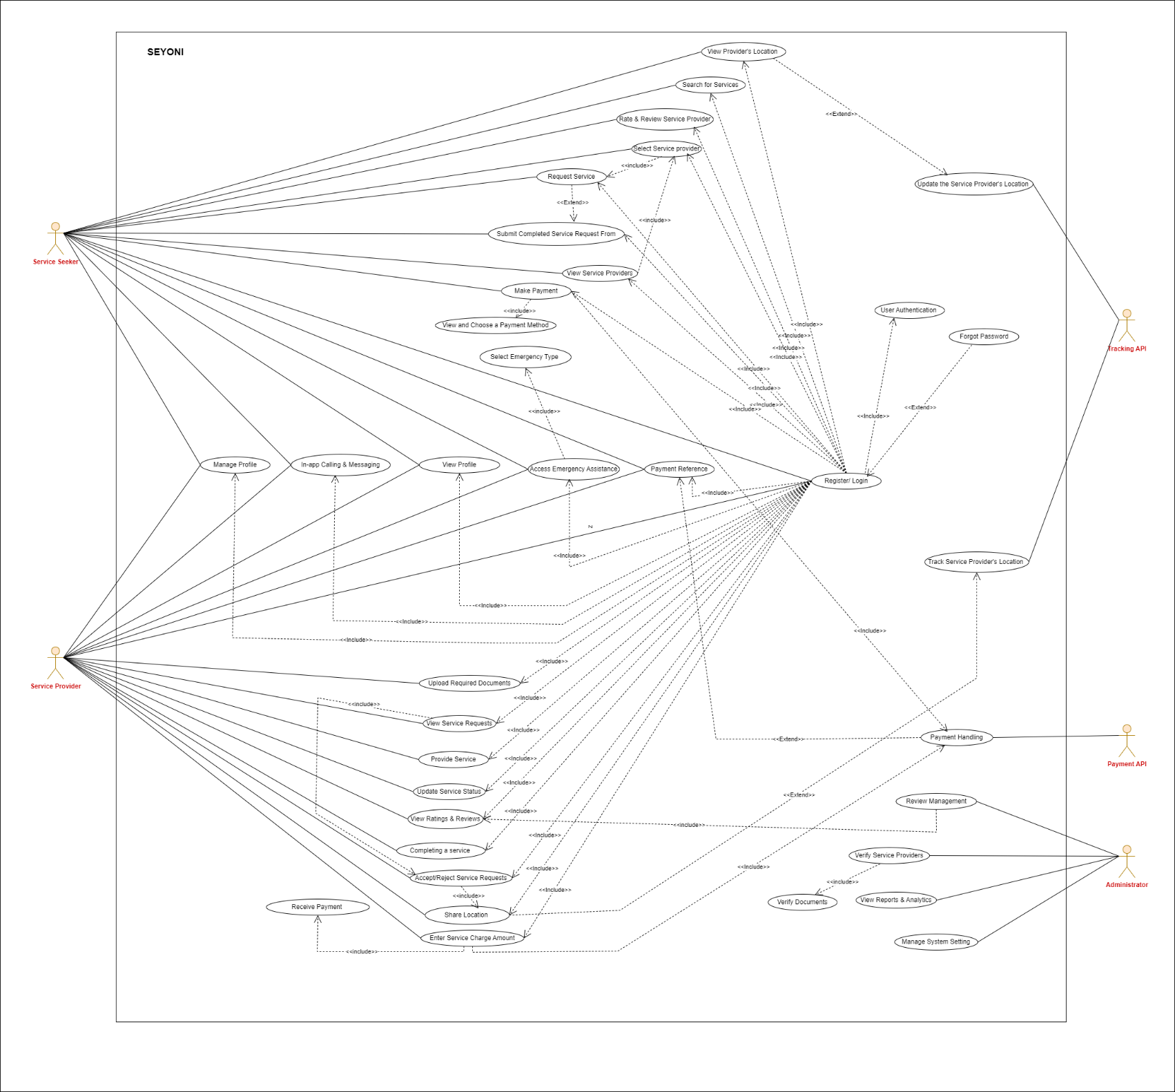Use cases are used during requirements elicitation and analysis to represent the functionality of the system. Use cases focus on the behavior of the system from an external point of view. A use case describes a function provided by the system that yields a visible result for an actor. An actor describes any entity that interacts with the system.

## 

Figure 1 Use Case Diagram

* + 1. **Sequence Diagram for User Account Creation**

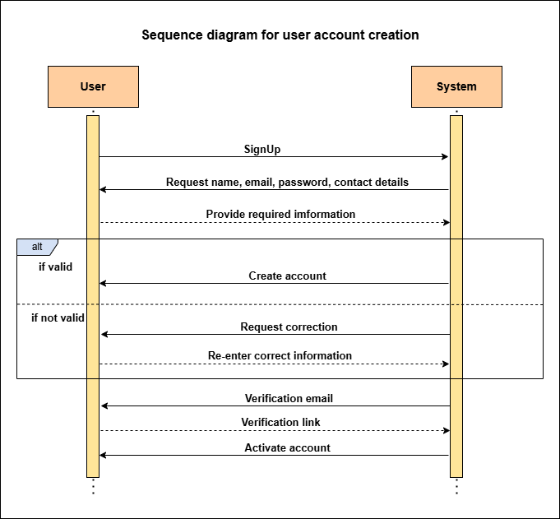

Figure 2 Sequence Diagram 1

## Sequence Diagram for Admin Verification

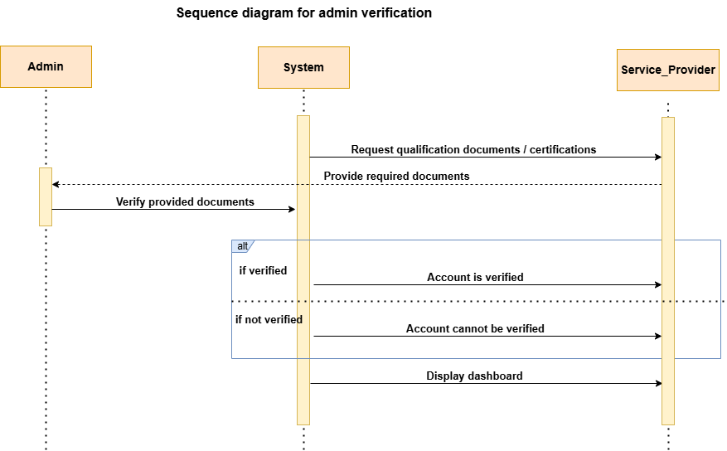

Figure 3 Sequence Diagram 2

## Sequence Diagram for Service Request Process

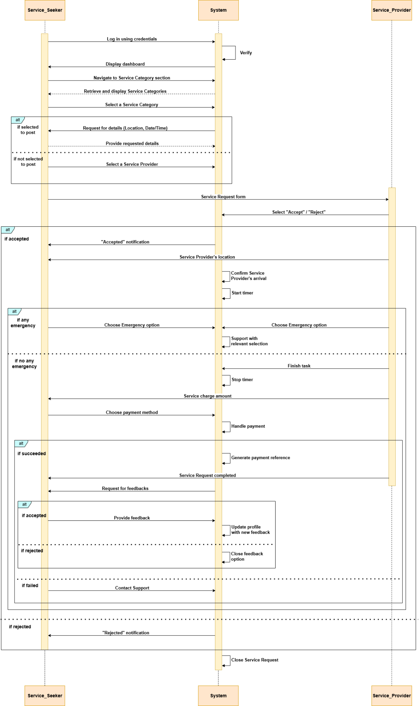

Figure 4 Sequence Diagram 3

## Activity Diagram

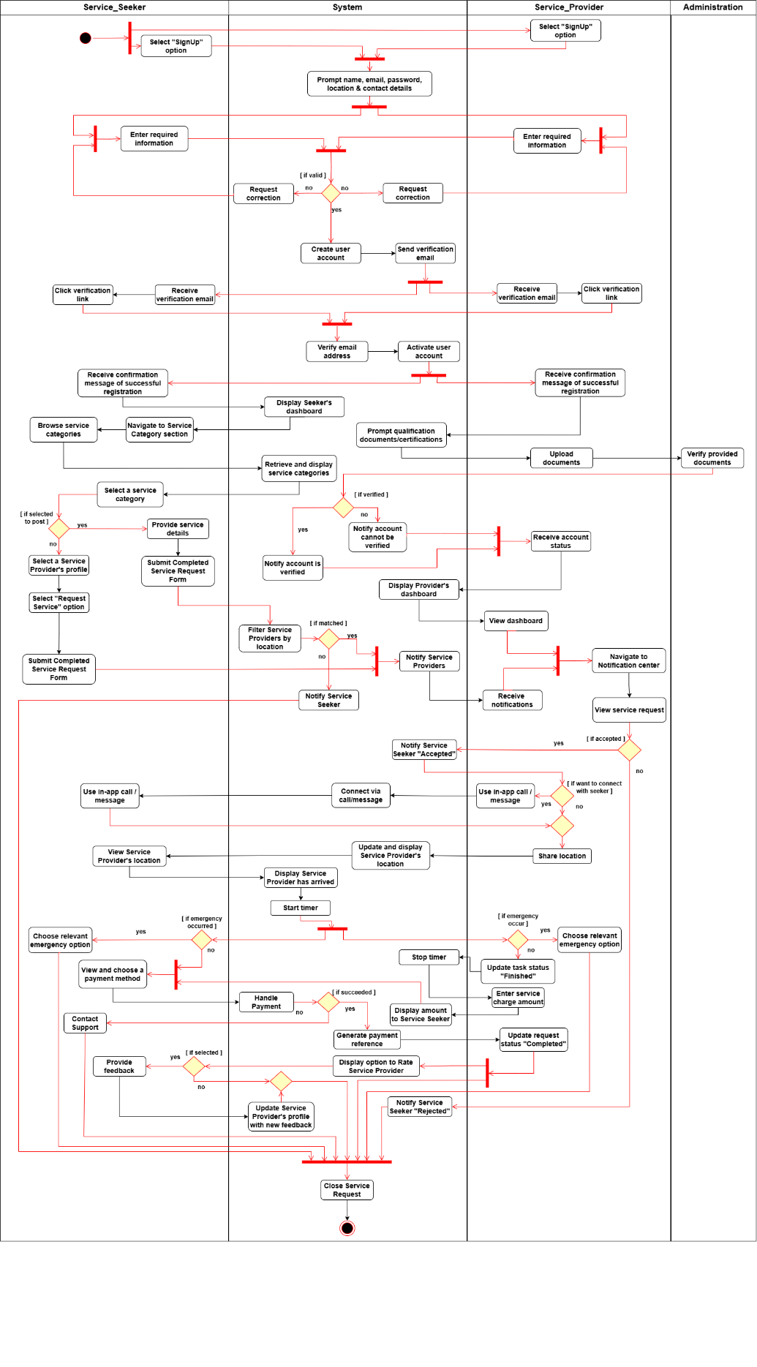Activity diagrams represent the sequencing and coordination of lower-level behaviors. An activity diagram denotes how a behavior is realized in terms of several sequences of activities and the object flows needed for coordinating the activities. Activity diagrams provide a task-centric view of the behavior of a set of objects. In the activity diagrams describes the activities of our project and the sequencing constraints among use cases.

Figure 5 Activity Diagram

## Class Diagram for System Entities and Relationships

Class diagrams offer a comprehensive view of the system's structure, presenting abstractions known as classes, which define both the common structure and behavior shared by a group of objects. Objects, in turn, are instances of these classes, created, modified, and removed during system execution. Each object possesses a state, encompassing attribute values and connections with other objects. Through Class Diagrams, we articulate the system's composition, emphasizing objects, classes, attributes, operations, and their associations. This visual representation aids us in effectively understanding and organizing the system's architecture, leading to a more coherent and robust design.

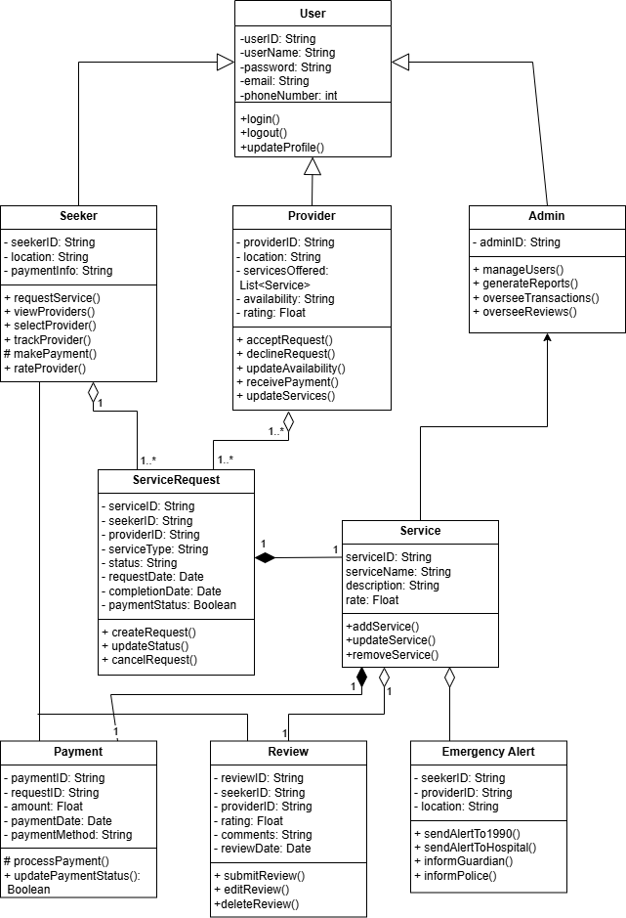

Figure 6 Class Diagram

## State Chart Diagram for User Authentication Process

State chart diagrams describe the dynamic behavior of an individual object as several states and transitions between these states. A state represents a particular set of values for an object. Given a state, a transition represents a future state the object can move to, and the conditions associated with the change of state. This diagram focuses on the transitions between states, because of external events for an individual object.

### Service Seeker Behavior

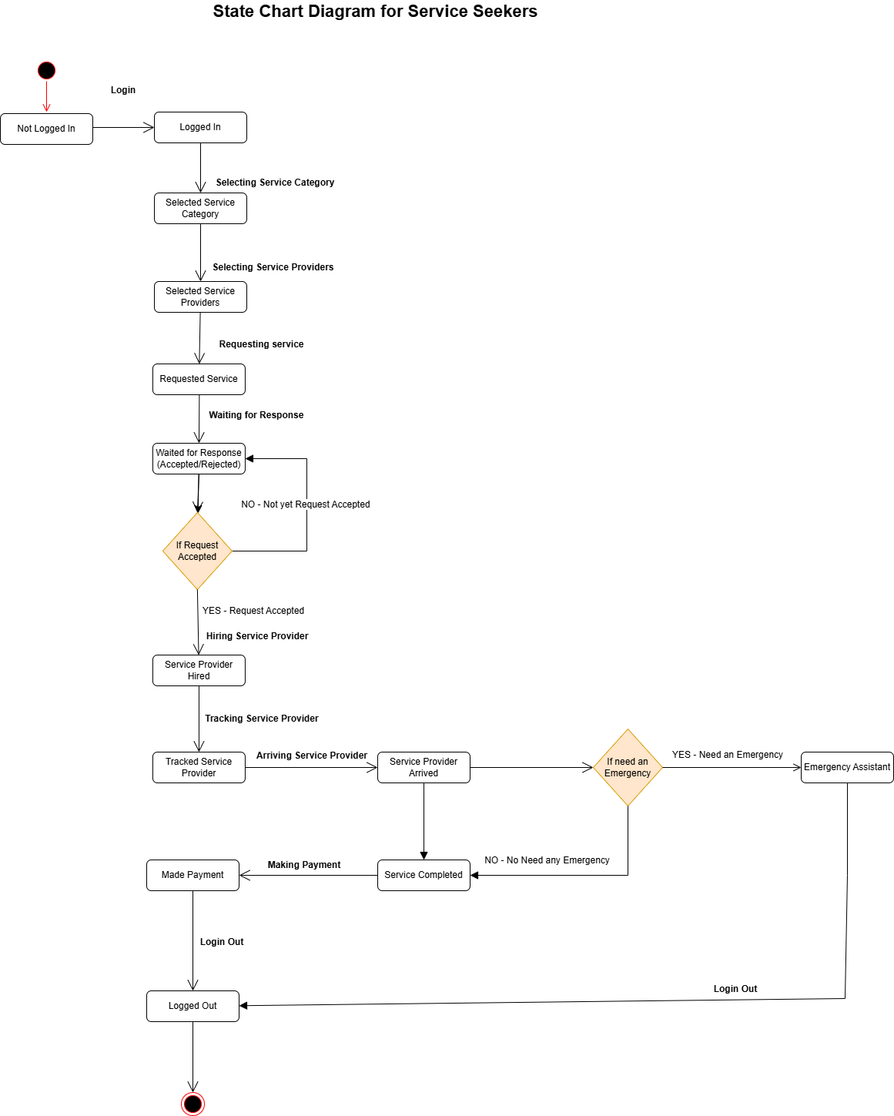

Figure 7 State Chart Diagram 1

### Service Provider Behavior

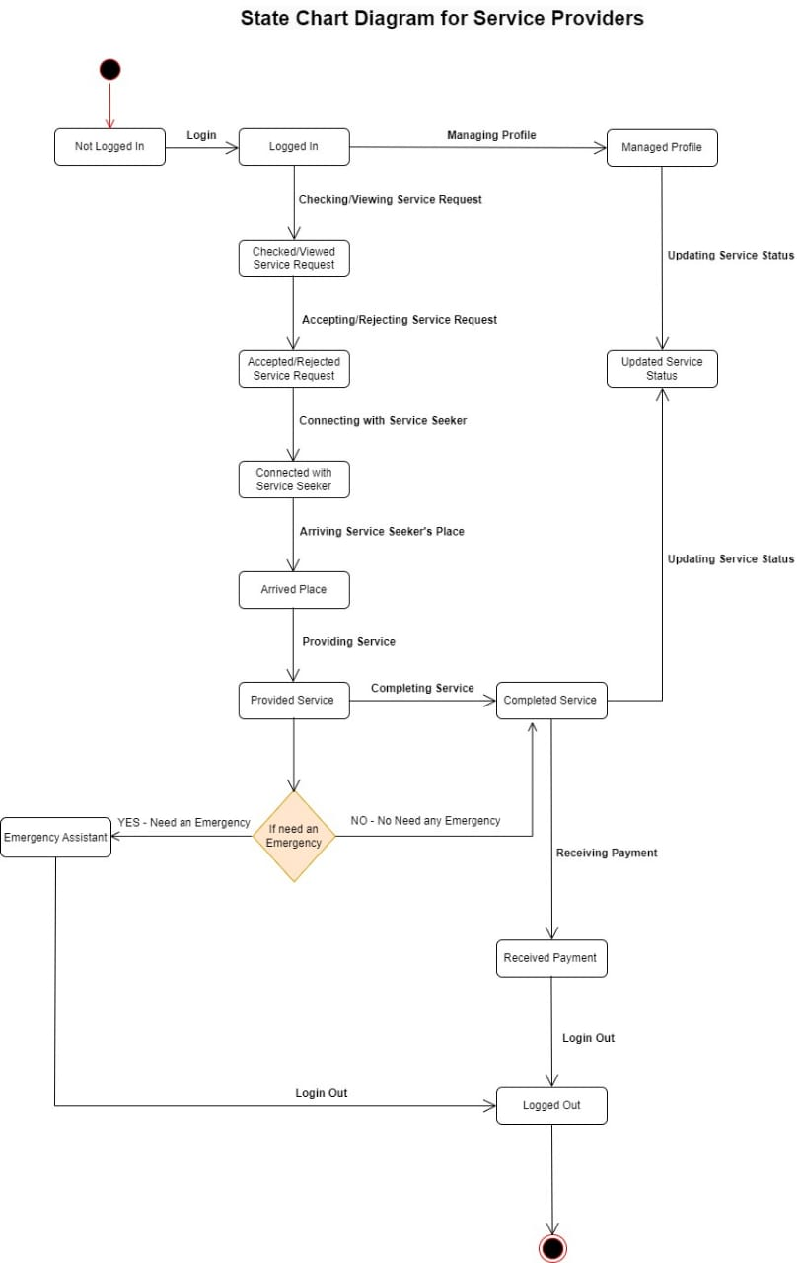

Figure 8 State Chart Diagram 2

## Components Diagram for System

Component diagrams are essentially class diagrams that focus on a system's components that often used to model the static implementation view of a system.

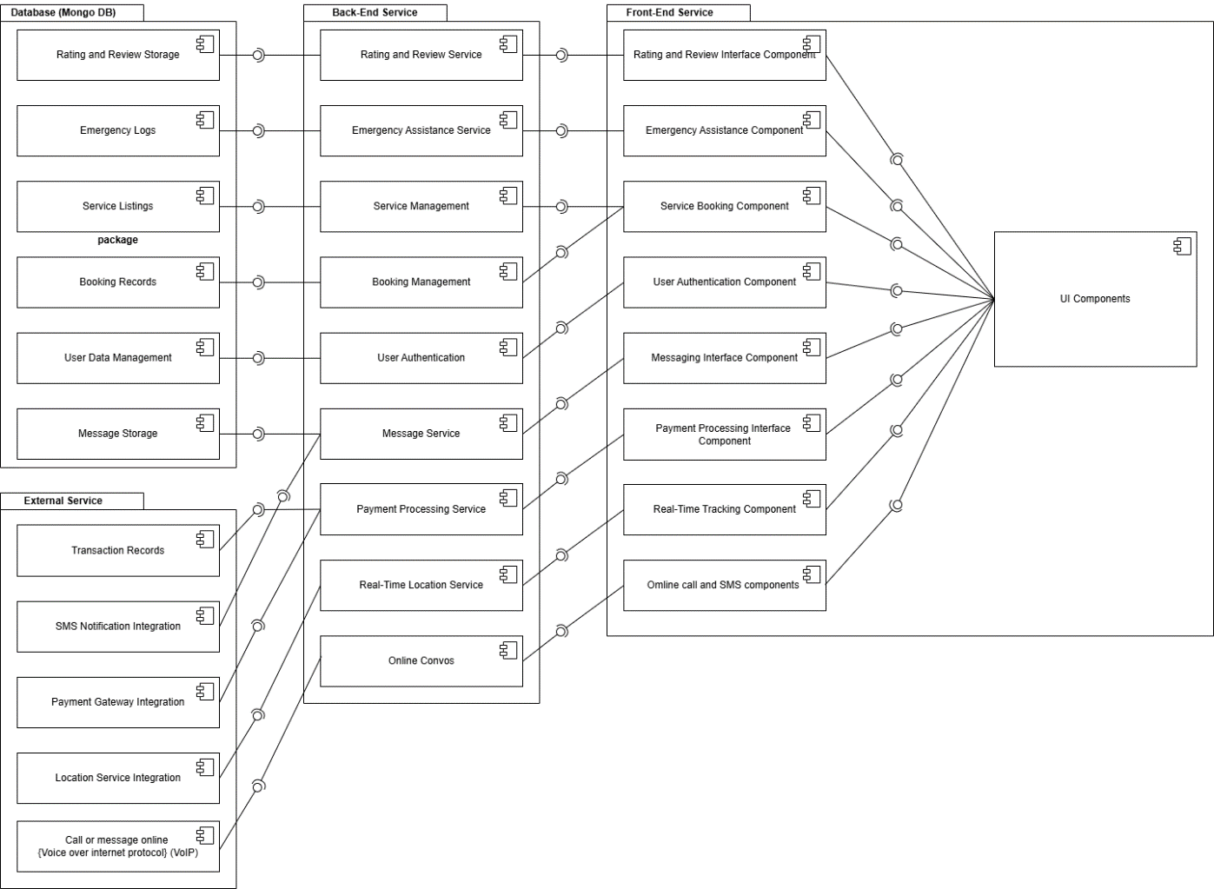

Figure 9 Component Diagram

## Deployment Diagram

A Deployment diagram showing how software components are deployed on hardware nodes in a networked environment, providing an overview of the system's physical infrastructure.

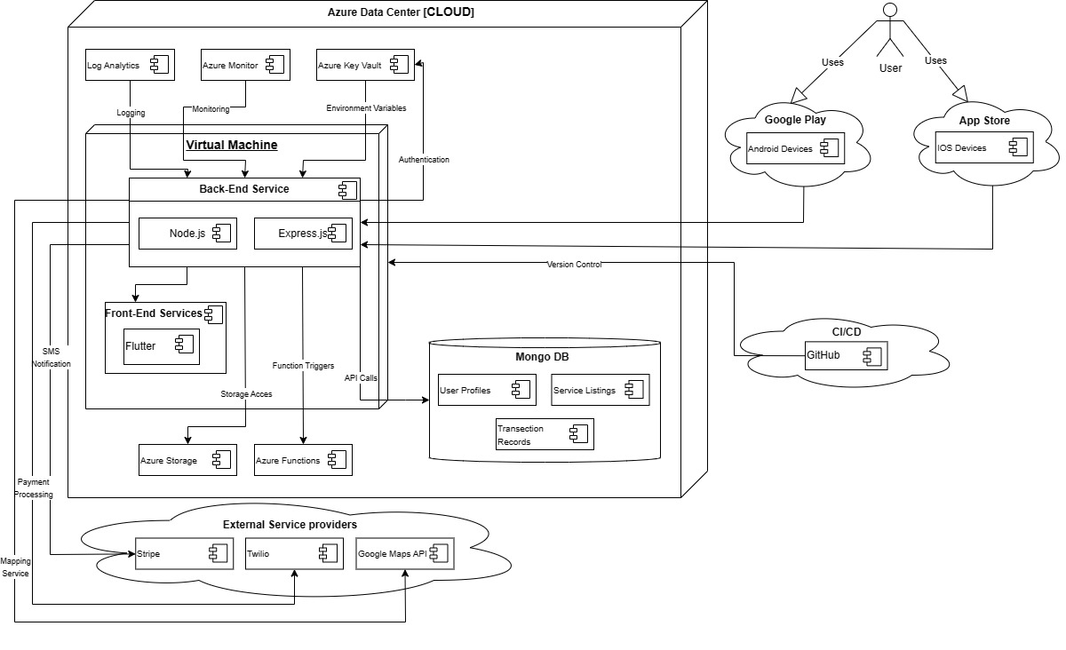

Figure 10 Deployment Diagram

# Summery

In this chapter, we delved into the design aspect of our mobile service provider application, illustrating the various structural and behavioral elements through detailed diagrams. The primary goal was to provide a comprehensive visual representation of how the different components and interactions within our system are organized and function.

We began by outlining the **Use Case Diagram**, which identifies and encapsulates the primary actors (seeker, provider, and admin) and their interactions with the system. This diagram serves as a foundational blueprint for understanding the main functionalities and user roles within our application.

Next, we provided **Sequence Diagrams** for each key interaction:

* **Seeker Interaction**: Demonstrates the step-by-step process a service seeker follows when using the application.
* **Provider Interaction**: Outlines the sequence of events for service providers when they interact with the system.
* **Admin Interaction**: Details the administrative functions and their sequential execution within the application.

We also included an **Activity Diagram** that illustrates the **Service Request Process**. This diagram captures the flow of activities from initiating a service request to its completion, highlighting decision points and concurrent activities.

The **Class Diagram** was then presented to define the system's entities and their relationships. This diagram provides a clear overview of the data structure and the interconnections between various classes within our system.

For behavioral analysis, we included **State Chart Diagrams** for both the seeker and provider. These diagrams depict the different states these entities can be in and the transitions between these states based on events or conditions.

The **Component Diagram** breaks down the system into its various software components, demonstrating the organization and dependencies of these components. This diagram is crucial for understanding the modularity and scalability of our application.

The **Deployment Diagram** provides a detailed view of the system's deployment architecture. It shows how software components are distributed across hardware nodes, specifying the configurations for both the mobile and server-side elements of our application.

In summary, this chapter has provided an in-depth look at the design of our mobile service provider application through a series of well-defined diagrams. These diagrams collectively offer a comprehensive visualization of the system's architecture, components, interactions, and behaviors, laying a solid foundation for the implementation phase.

**Chapter 7**

# Conclusion

## Summary of Findings

In this project, we set out to develop a mobile application aimed at connecting service seekers with service providers in a secure, efficient, and user-friendly manner. Throughout the course of this project, we have meticulously documented the process, from the initial problem definition to the detailed design of the system.

In **Chapter 1**, we introduced the problem, stating the need for an effective mobile application to facilitate service transactions. We defined our objectives, scope, and the potential impact of the proposed solution.

**Chapter 2** focused on the literature review, where we analyzed existing solutions and identified gaps that our application aims to fill. This review helped us understand the current landscape and guided our design decisions.

In **Chapter 3**, we outlined the approach, detailing the architecture of our proposed solution and breaking down the system into various modules. Each module, from user authentication to reporting and analytics, was described in terms of its functions, features, and overall process.

**Chapter 4** discussed the technologies adapted for the project. We chose Dart and Flutter for the front end, JavaScript (Node.js) and Express.js for the back end, MongoDB for the database, and Azure for cloud services. These choices were made to ensure that our application is robust, scalable, and efficient.

In **Chapter 5**, we conducted a thorough analysis of requirements. We described our requirement gathering process and listed the specific requirements for the proposed solution, ensuring that the application would meet user needs and expectations.

**Chapter 6** provided an in-depth design of the system. We presented various diagrams, including use case diagrams, sequence diagrams, activity diagrams, class diagrams, state chart diagrams, component diagrams, and deployment diagrams. These diagrams illustrated the structural and behavioral aspects of our system, offering a clear blueprint for implementation.

## Achievements

This project has successfully accomplished several key milestones:

* **Identification and Analysis of Needs**: We identified a significant gap in the market for a reliable service provider mobile application and analyzed user requirements comprehensively.
* **Technological Choices**: We made informed decisions on the technologies to be used, ensuring that our application leverages the latest and most suitable tools for mobile and backend development.
* **Detailed Design**: Through rigorous design documentation, we have created a solid foundation for the development phase, ensuring that every aspect of the system is well-thought-out and planned.
* **Comprehensive Documentation**: Each chapter of this report has meticulously detailed different stages of the project, providing a clear roadmap from conceptualization to design.

## Future Work

While this project has laid down a strong foundation, there are several areas that can be explored further:

* **Implementation and Testing**: The next phase involves the actual development of the application, followed by rigorous testing to ensure all functionalities work as expected and the system is secure.
* **User Feedback Integration**: Post-launch, collecting feedback from users will be crucial. This feedback will guide further enhancements and iterations of the application.
* **Feature Expansion**: Additional features, such as AI-driven recommendations, advanced analytics, and expanded service categories, could be incorporated to enhance user experience and application utility.
* **Scalability and Performance Optimization**: Continuous monitoring and optimization will be necessary to handle increasing user loads and ensure the application performs efficiently.

## Conclusion

In conclusion, this project has taken significant strides toward developing a mobile application that bridges the gap between service seekers and providers. Through careful planning, analysis, and design, we have created a comprehensive blueprint for a secure, user-friendly, and efficient application. The successful implementation of this project has the potential to significantly impact how services are requested and provided, offering a reliable platform for both users and providers. The journey does not end here; it marks the beginning of a series of future enhancements and iterations aimed at perfecting the application and continually meeting user need

# References

(n.d.). Retrieved from Thumbtack: https://www.thumbtack.com/

Biglan, M. (2023, Aug 22). *How to choose the right technology stack for your project*. Retrieved from twenty ideas: https://twentyideas.com/blog/choosing-a-technology-stack/

Blancarte, O. (2016, October 18). *Oscar Blancarte - Software Architecture*. Retrieved from oscarblancarteblog: https://www.oscarblancarteblog.com/

*House Cleaning & Handyman Services*. (n.d.). Retrieved from Handy: https://www.handy.com/

Krutiak, Y. (2024, March 5). *How to Choose the Right Tech Stack for Your Project: A Step-by-Step Guide*. Retrieved from SpdLoad: https://spdload.com/

Nishadha. ( 2022, September 28 ). *Blogs/Diagrams*. Retrieved from Creately: https://creately.com/blog/diagrams/uml-diagram-types-examples/

*Taskrabbit*. (n.d.). Retrieved from Same Day Handyman, Moving & Mounting Services: https://www.taskrabbit.com/

*TaskRabbit*. (n.d.). Retrieved from https://www.taskrabbit.com/

*Taskrabbit: Same Day Handyman, Moving & Mounting Services*. (n.d.). Retrieved from https://www.taskrabbit.com/

*Thumbtack*. (n.d.). Retrieved from Care for Your Home | Find Local Pros & Reviews: https://www.thumbtack.com/

*Unified Modeling Language (UML) Diagrams*. (2024, March 07 ). Retrieved from Geeksforgeeks: https://www.geeksforgeeks.org/