
JAVASCRIPT PROGRAMMING LAB (BCS354)
B.Tech CSE 3rd SEMESTER

SUBMITTED TO: | SUBMITTED BY:
Mr. Aman | Dhruv Saxena  Section: C  ID: BCS2025626

INDEX
Name: Dhruv Saxena Roll No.: BCS2025626 Section: C
SN. | PROGRAM NAME | PAGE | DATE | SIGNATURE
1 | Your First JavaScript Script | 3
2 | Operators, Type Conversion and a Calculator | 8
3 | Conditions and Loops | 14
4 | Writing Functions | 19
5 | Arrays, Array Methods and Nested Arrays | 24
6 | JSON Text | 31
7 | Constructor Functions and Classes | 37
8 | Inheritance, Methods and Composition | 43
9 | DOM, Validation, Storage and Quiz | 49
10 | Objects and Destructuring | 58
11 | Scope and Closures | 64
12 | Callbacks and Higher-Order Functions | 70
13 | Reduce, Some, Every and Map | 76
14 | Timers and Intervals | 82
15 | Promises and async/await with Local Data | 87

EXPERIMENT NO. 1
Course: BCS354

1. EXPERIMENT TITLE
Your First JavaScript Script

2. AIM
To run a script in the browser and with Node, and to declare values with const and let.

3. SOFTWARE / TOOLS REQUIRED
Web browser (Google Chrome / Microsoft Edge / Firefox) with the developer console (F12); Node.js; a code editor such as VS Code.

4. THEORY
JavaScript is the programming language of the web. A script can be added to an HTML page with the script tag, or run directly with Node.js. console.log() prints a value to the browser console (F12) or to the terminal. const declares a variable whose value cannot be reassigned, and let declares a variable whose value can change. The typeof operator returns the data type of a value, such as string, number or boolean.

5. ALGORITHM / PROCEDURE
Task 1
- Start.
- Create an HTML page with a heading "My First JavaScript Script".
- Add a script tag at the end of the body that loads task1.js.
- In task1.js, print "Hello from the script" using console.log.
- Open the page in a browser and check the console (F12).
- Stop.
Task 2
- Start.
- Declare the constant schoolName with the text "Sample College".
- Declare the variable year with let and the value 2026.
- Print schoolName and year, one on each line.
- Run the file with node.
- Stop.
Task 3
- Start.
- Print typeof "hello".
- Print typeof 7.
- Print typeof true.
- Run the file with node.
- Stop.

6. PROGRAM / QUERIES / COMMANDS
Task 1
– task1.html
<!DOCTYPE html>
<html lang="en">
<head>
<meta charset="UTF-8">
<meta name="viewport" content="width=device-width, initial-scale=1.0">
<title>Assignment 1 - Task 1</title>
</head>
<body>

<h1>My First JavaScript Script</h1>

<script src="task1.js"></script>
</body>
</html>

– task1.js
// Name: Dhruv Saxena
// Roll No: BCS2025626
// Assignment: 1 - Task 1

console.log("Hello from the script");

Task 2
– task2.html
<!DOCTYPE html>
<html lang="en">
<head>
<meta charset="UTF-8">
<meta name="viewport" content="width=device-width, initial-scale=1.0">
<title>Assignment 1 - Task 2</title>
</head>
<body>

<h1>Const and Let Variables</h1>

<script src="task2.js"></script>
</body>
</html>

– task2.js
// Name: Dhruv Saxena
// Roll No: BCS2025626
// Assignment: 1 - Task 2

const schoolName = "Sample College";
let year = 2026;
console.log(schoolName);
console.log(year);

Task 3
– task3.html
<!DOCTYPE html>
<html lang="en">
<head>
<meta charset="UTF-8">
<meta name="viewport" content="width=device-width, initial-scale=1.0">
<title>Assignment 1 - Task 3</title>
</head>
<body>

<h1>JavaScript Data Types</h1>

<script src="task3.js"></script>
</body>
</html>

– task3.js
// Name: Dhruv Saxena
// Roll No: BCS2025626
// Assignment: 1 - Task 3

console.log(typeof "hello");
console.log(typeof 7);
console.log(typeof true);

7. INPUT
No user input is taken. All values are fixed inside the programs: the text "Hello from the script"; schoolName = "Sample College" and year = 2026; the values "hello", 7 and true.

8. OUTPUT
Task 1
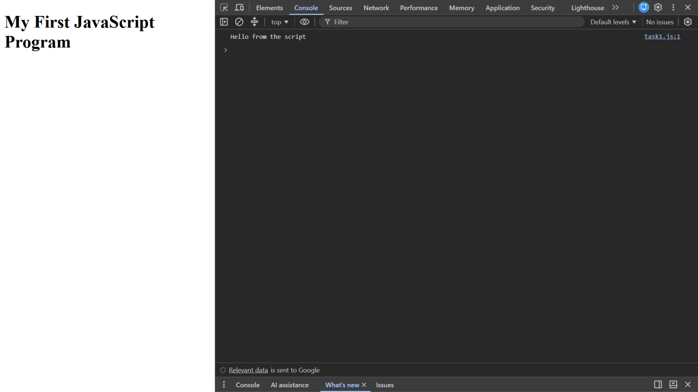

Task 2
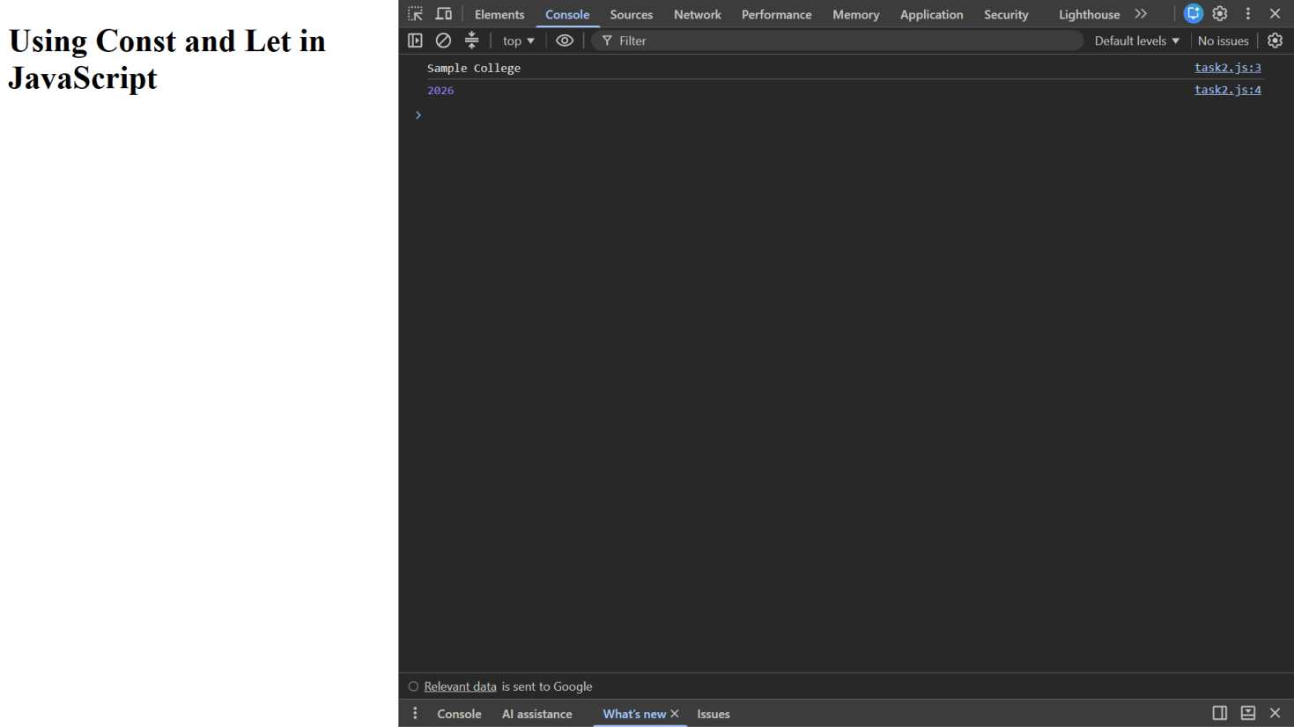

Task 3
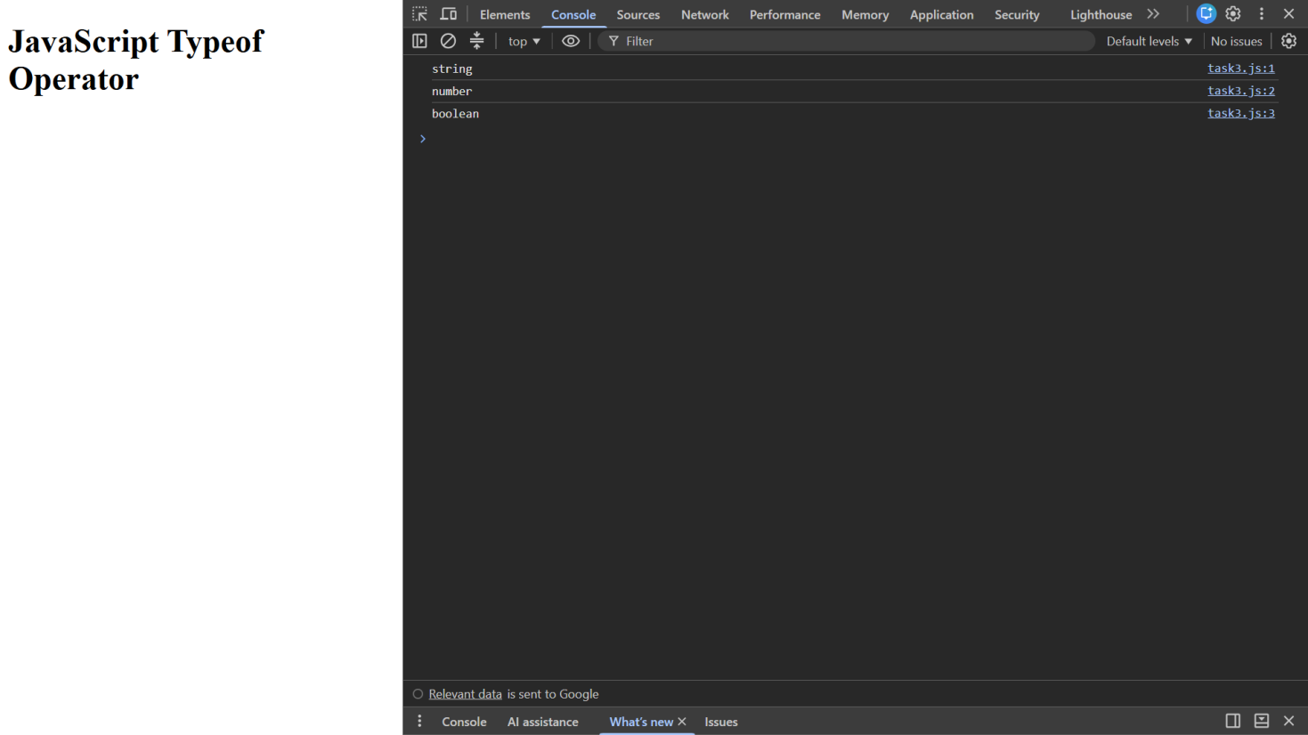

9. RESULT
JavaScript programs were written to print text with console.log, to declare values with const and let, and to find the type of values using typeof.

10. VIVA-VOCE QUESTIONS
- What is the use of the script tag in an HTML page?
- What is the difference between const and let?
- What does console.log() do?
- What does the typeof operator return?
- How do you run a JavaScript file with Node.js?

EXPERIMENT NO. 2
Course: BCS354

1. EXPERIMENT TITLE
Operators, Type Conversion and a Calculator

2. AIM
To use arithmetic operators, to convert between text and numbers, and to use if and else if to choose an operation.

3. SOFTWARE / TOOLS REQUIRED
Web browser (Google Chrome / Microsoft Edge / Firefox) with the developer console (F12); Node.js; a code editor such as VS Code.

4. THEORY
The arithmetic operators are +, -, *, / and %. JavaScript converts values between types: Number() converts text to a number and String() converts a value to text. When + is used with a number and a string, the values are joined (concatenation) instead of being added. The if and else if statements choose which block of code runs, and the strict equality operator === compares both value and type.

5. ALGORITHM / PROCEDURE
Task 1
- Start.
- Declare a = 17 and b = 5.
- Print the sum, difference, product and quotient with their labels, one on each line.
- Stop.
Task 2
- Start.
- Convert the text "12" to a number using Number() and store it in num1.
- Print num1 + 5.
- Convert the number 7 to text using String() and store it in num2.
- Print num2 joined with the text "3".
- Stop.
Task 3
- Start.
- Declare a = 8, b = 4 and operator = "+".
- If operator === "+", print a + b; else if operator === "-", print a - b.
- Change operator to "-".
- Repeat the same if and else if check.
- Stop.

6. PROGRAM / QUERIES / COMMANDS
Task 1
– task1.html
<!DOCTYPE html>
<html lang="en">
<head>
<meta charset="UTF-8">
<meta name="viewport" content="width=device-width, initial-scale=1.0">
<title>Assignment 2 - Task 1</title>
</head>
<body>

<h1>Arithmetic Operations</h1>

<script src="task1.js"></script>
</body>
</html>

– task1.js
// Name: Dhruv Saxena
// Roll No: BCS2025626
// Assignment: 2 - Task 1

let a = 17;
let b = 5;

console.log("Sum:", a + b);
console.log("Difference:", a - b);
console.log("Product:", a * b);
console.log("Quotient:", a / b);

Task 2
– task2.html
<!DOCTYPE html>
<html lang="en">
<head>
<meta charset="UTF-8">
<meta name="viewport" content="width=device-width, initial-scale=1.0">
<title>Assignment 2 - Task 2</title>
</head>
<body>

<h1>Type Conversion</h1>

<script src="task2.js"></script>
</body>
</html>

– task2.js
// Name: Dhruv Saxena
// Roll No: BCS2025626
// Assignment: 2 - Task 2

let num1 = Number("12");

console.log(num1 + 5);

let num2 = String(7);

console.log(num2 + "3");

Task 3
– task3.html
<!DOCTYPE html>
<html lang="en">
<head>
<meta charset="UTF-8">
<meta name="viewport" content="width=device-width, initial-scale=1.0">
<title>Assignment 2 - Task 3</title>
</head>
<body>

<h1>Simple Calculator</h1>

<script src="task3.js"></script>
</body>
</html>

– task3.js
// Name: Dhruv Saxena
// Roll No: BCS2025626
// Assignment: 2 - Task 3

let a = 8;
let b = 4;
let operator = "+";

if (operator === "+") {
console.log("Result:", a + b);
}
else if (operator === "-") {
console.log("Result:", a - b);
}

operator = "-";

if (operator === "+") {
console.log("Result:", a + b);
}
else if (operator === "-") {
console.log("Result:", a - b);
}

7. INPUT
No user input is taken. All values are fixed inside the programs: a = 17 and b = 5 in Task 1; the text "12" and the number 7 in Task 2; a = 8, b = 4 and operator "+" then "-" in Task 3.

8. OUTPUT
Task 1
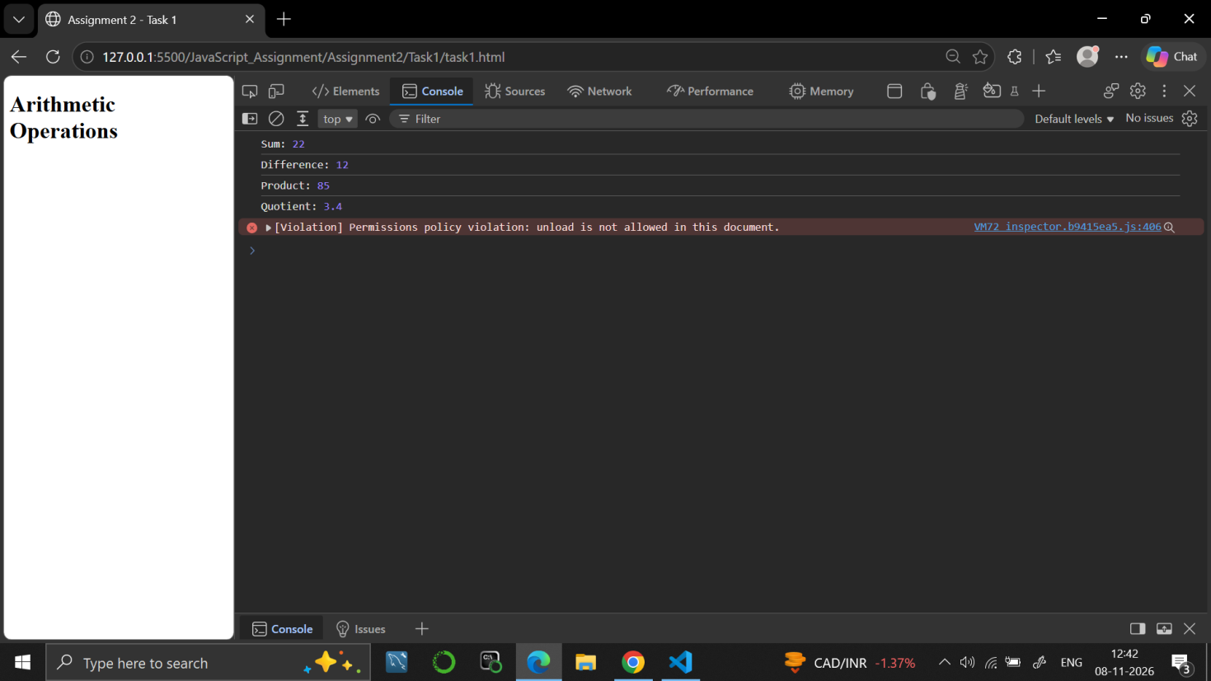

Task 2
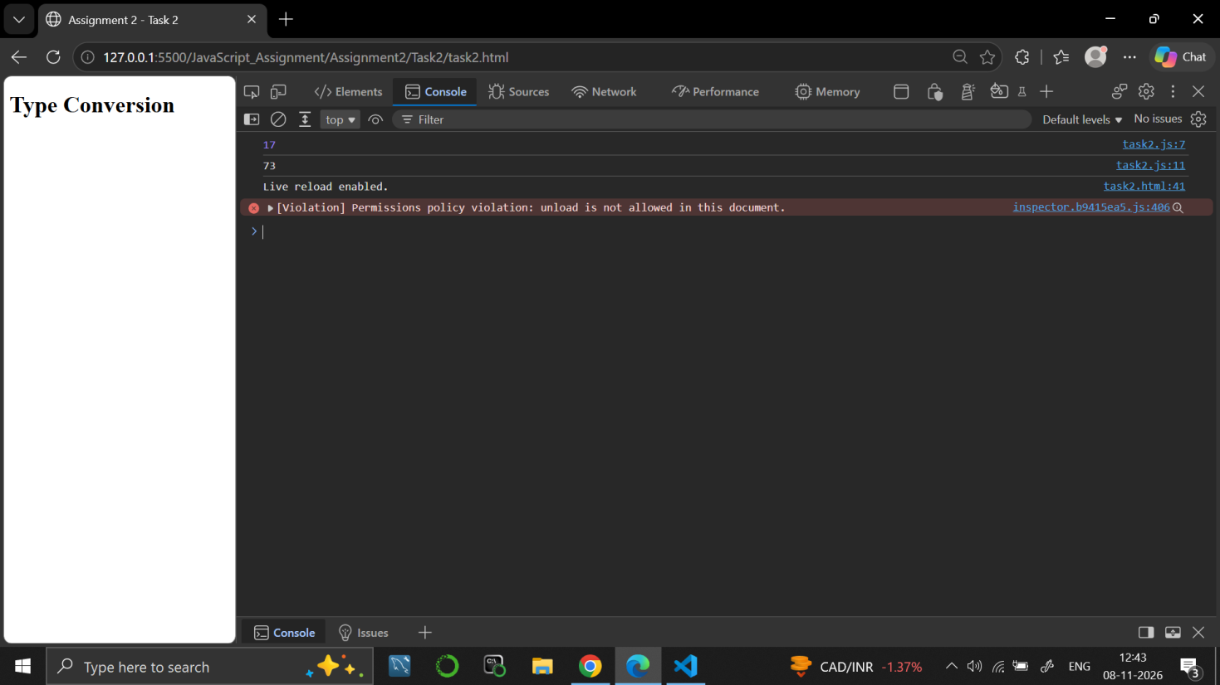

Task 3
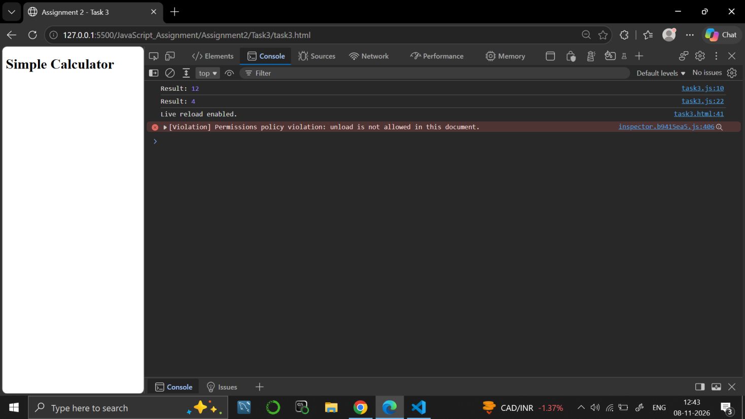

9. RESULT
JavaScript programs were written to use arithmetic operators, to convert between text and numbers, and to choose an operation using if and else if.

10. VIVA-VOCE QUESTIONS
- What is the difference between == and ===?
- How do you convert text to a number in JavaScript?
- What happens when a number is added to a string using +?
- Name the arithmetic operators in JavaScript.
- What is the use of else if?

EXPERIMENT NO. 3
Course: BCS354

1. EXPERIMENT TITLE
Conditions and Loops

2. AIM
To choose between cases with if, else if and else, and to repeat work with a for loop and a while loop.

3. SOFTWARE / TOOLS REQUIRED
Web browser (Google Chrome / Microsoft Edge / Firefox) with the developer console (F12); Node.js; a code editor such as VS Code.

4. THEORY
Conditions run a block of code only when a test is true: if checks the first test, else if checks further tests and else runs when no test is true. A for loop repeats code a fixed number of times using an initialisation, a condition and an update. A while loop repeats code as long as its condition is true, so the variables used in the condition must change inside the loop.

5. ALGORITHM / PROCEDURE
Task 1
- Start.
- Store 72 in marks.
- If marks >= 75, print "Grade A".
- Else if marks >= 60, print "Grade B".
- Otherwise, print "Grade C".
- Stop.
Task 2
- Start.
- Repeat for i = 1 to 5.
- Print i in each round.
- Stop.
Task 3
- Start.
- Set total = 0 and i = 1.
- While total <= 20: set total = total + i and increase i by 1.
- Print total.
- Stop.

6. PROGRAM / QUERIES / COMMANDS
Task 1
– task1.html
<!DOCTYPE html>
<html lang="en">
<head>
<meta charset="UTF-8">
<meta name="viewport" content="width=device-width, initial-scale=1.0">
<title>Assignment 3 - Task 1</title>
</head>
<body>

<h1>Grade Checking</h1>

<script src="task1.js"></script>
</body>
</html>

– task1.js
// Name: Dhruv Saxena
// Roll No: BCS2025626
// Assignment: 3 - Task 1

let marks = 72;

if (marks >= 75) {
console.log("Grade A");
}
else if (marks >= 60) {
console.log("Grade B");
}
else {
console.log("Grade C");
}

Task 2
– task2.html
<!DOCTYPE html>
<html lang="en">
<head>
<meta charset="UTF-8">
<meta name="viewport" content="width=device-width, initial-scale=1.0">
<title>Assignment 3 - Task 2</title>
</head>
<body>

<h1>For Loop</h1>

<script src="task2.js"></script>
</body>
</html>

– task2.js
// Name: Dhruv Saxena
// Roll No: BCS2025626
// Assignment: 3 - Task 2

for (let i = 1; i <= 5; i++) {
console.log(i);
}

Task 3
– task3.html
<!DOCTYPE html>
<html lang="en">
<head>
<meta charset="UTF-8">
<meta name="viewport" content="width=device-width, initial-scale=1.0">
<title>Assignment 3 - Task 3</title>
</head>
<body>

<h1>While Loop</h1>

<script src="task3.js"></script>
</body>
</html>

– task3.js
// Name: Dhruv Saxena
// Roll No: BCS2025626
// Assignment: 3 - Task 3

let total = 0;
let i = 1;

while (total <= 20) {
total = total + i;
i++;
}

console.log(total);

7. INPUT
No user input is taken. All values are fixed inside the programs: marks = 72 in Task 1; the numbers 1 to 5 in Task 2; the limit 20 for total in Task 3.

8. OUTPUT
Task 1
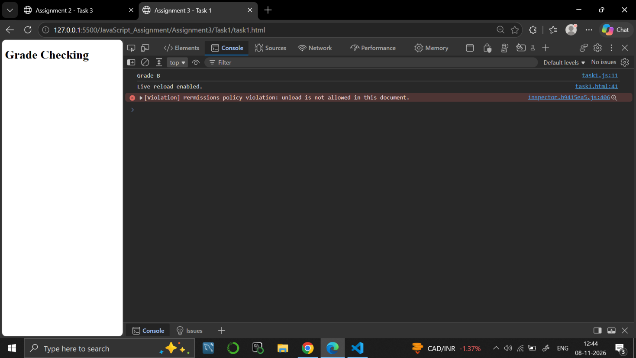

Task 2
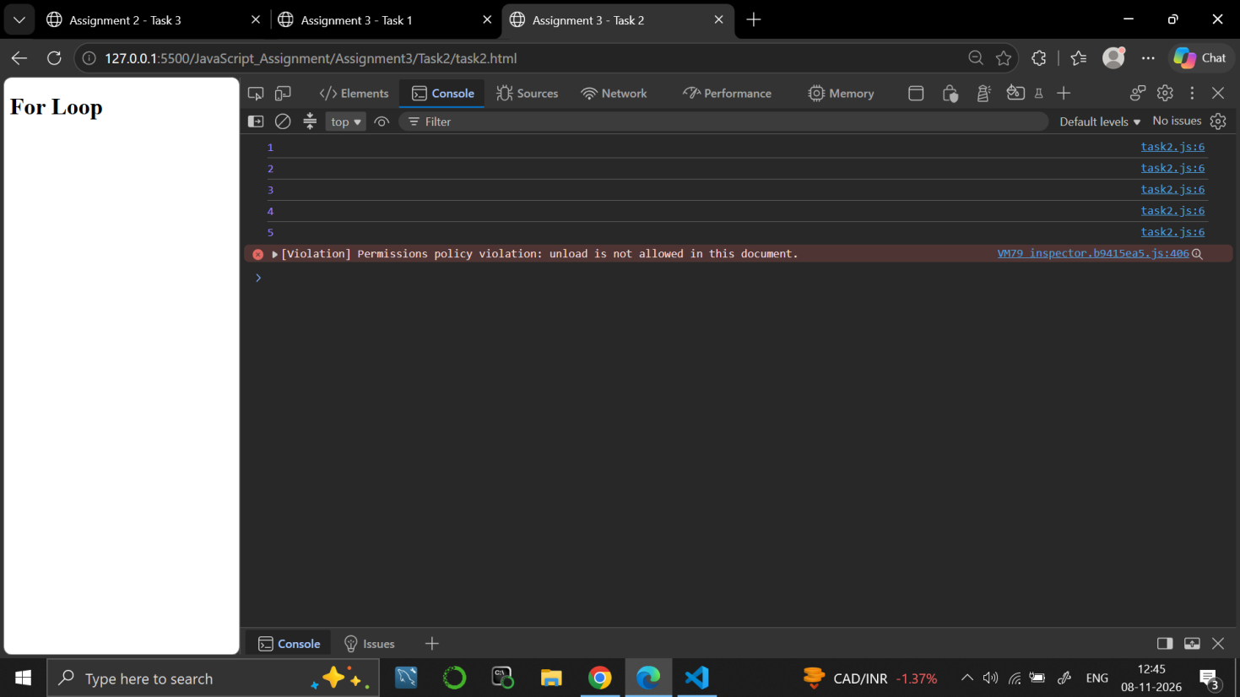

Task 3
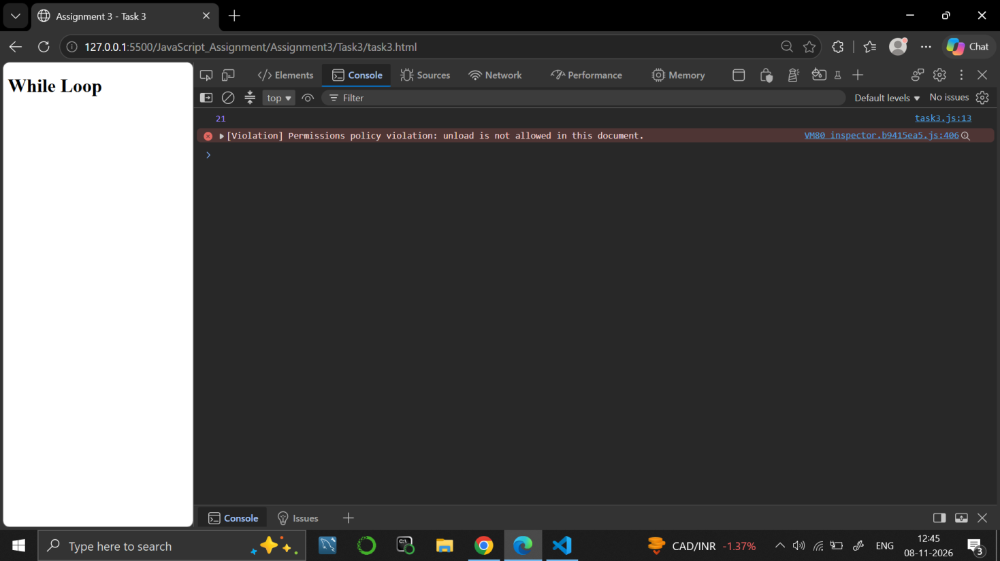

9. RESULT
JavaScript programs were written to decide a grade using an else-if ladder, to print numbers with a for loop and to add numbers with a while loop.

10. VIVA-VOCE QUESTIONS
- What is the difference between a for loop and a while loop?
- What are the three parts of a for loop?
- How does an else-if ladder work?
- What happens if the condition of a while loop never becomes false?
- Why is the variable i increased inside the while loop?

EXPERIMENT NO. 4
Course: BCS354

1. EXPERIMENT TITLE
Writing Functions

2. AIM
To write a function with a return value, an arrow function, and a default parameter.

3. SOFTWARE / TOOLS REQUIRED
Web browser (Google Chrome / Microsoft Edge / Firefox) with the developer console (F12); Node.js; a code editor such as VS Code.

4. THEORY
A function is a reusable block of code that can take parameters and return a value with the return statement. An arrow function is a shorter way to write a function using =>. A default parameter gives a parameter a value that is used when no argument is passed for it. A function runs only when it is called.

5. ALGORITHM / PROCEDURE
Task 1
- Start.
- Define the function greet(name) that returns "Hello, " joined with name.
- Call greet with the name "Asha".
- Print the returned text.
- Stop.
Task 2
- Start.
- Define the arrow function square(num) that returns num * num.
- Call square(6).
- Print the result.
- Stop.
Task 3
- Start.
- Define billWithTax(amount, taxRate = 0.18) that returns amount + (amount * taxRate).
- Call billWithTax(100) without a tax rate, so the default 0.18 is used.
- Print the result.
- Stop.

6. PROGRAM / QUERIES / COMMANDS
Task 1
– task1.html
<!DOCTYPE html>
<html lang="en">
<head>
<meta charset="UTF-8">
<meta name="viewport" content="width=device-width, initial-scale=1.0">
<title>Assignment 4 - Task 1</title>
</head>
<body>

<h1>Greet Function</h1>

<script src="task1.js"></script>
</body>
</html>

– task1.js
// Name: Dhruv Saxena
// Roll No: BCS2025626
// Assignment: 4 - Task 1

function greet(name) {
return "Hello, " + name;
}

console.log(greet("Asha"));

Task 2
– task2.html
<!DOCTYPE html>
<html lang="en">
<head>
<meta charset="UTF-8">
<meta name="viewport" content="width=device-width, initial-scale=1.0">
<title>Assignment 4 - Task 2</title>
</head>
<body>

<h1>Arrow Function</h1>

<script src="task2.js"></script>
</body>
</html>

– task2.js
// Name: Dhruv Saxena
// Roll No: BCS2025626
// Assignment: 4 - Task 2

const square = (num) => {
return num * num;
};

console.log(square(6));

Task 3
– task3.html
<!DOCTYPE html>
<html lang="en">
<head>
<meta charset="UTF-8">
<meta name="viewport" content="width=device-width, initial-scale=1.0">
<title>Assignment 4 - Task 3</title>
</head>
<body>

<h1>Default Parameter</h1>

<script src="task3.js"></script>
</body>
</html>

– task3.js
// Name: Dhruv Saxena
// Roll No: BCS2025626
// Assignment: 4 - Task 3

function billWithTax(amount, taxRate = 0.18) {
return amount + (amount * taxRate);
}

console.log(billWithTax(100));

7. INPUT
No user input is taken. All values are fixed inside the programs: the name "Asha" in Task 1; the number 6 in Task 2; the amount 100 with the default tax rate 0.18 in Task 3.

8. OUTPUT
Task 1
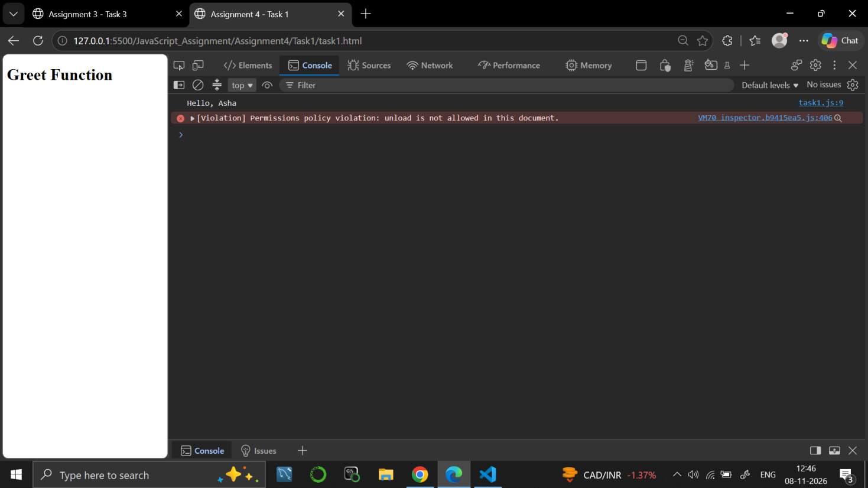

Task 2
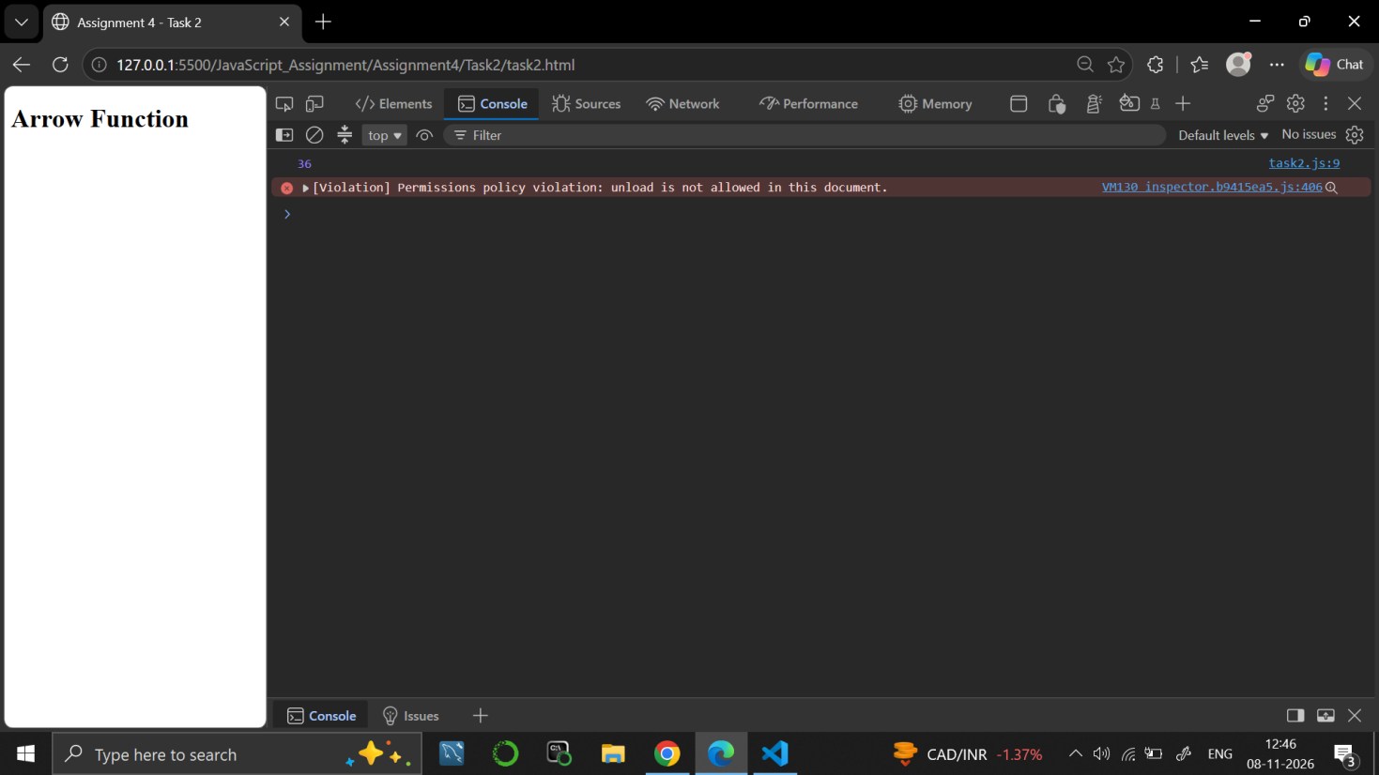

Task 3
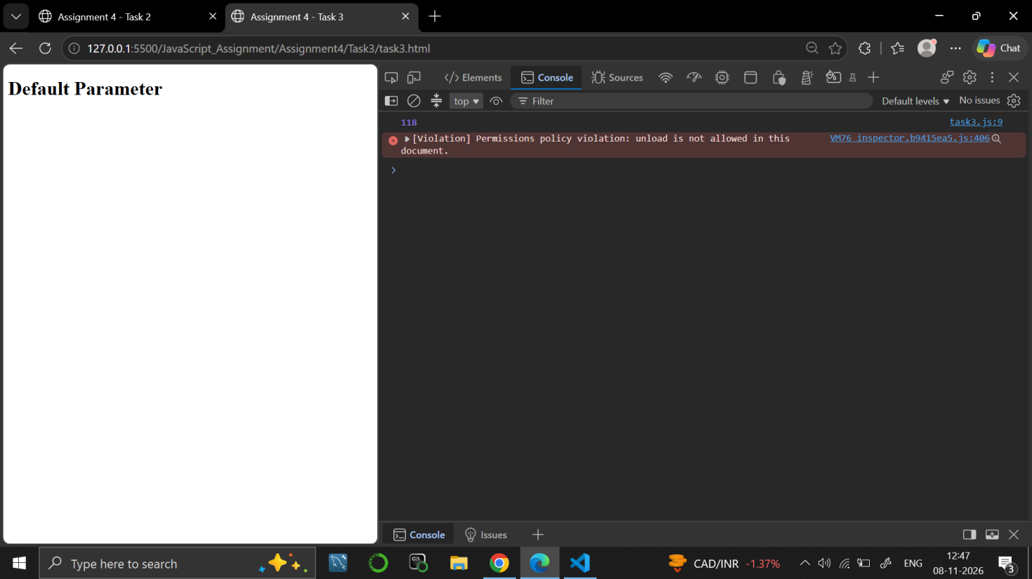

9. RESULT
JavaScript programs were written using a function with a return value, an arrow function and a function with a default parameter.

10. VIVA-VOCE QUESTIONS
- What is a function and why is it used?
- What does the return statement do?
- What is an arrow function?
- What is a default parameter?
- What is the difference between defining and calling a function?

EXPERIMENT NO. 5
Course: BCS354

1. EXPERIMENT TITLE
Arrays, Array Methods and Nested Arrays

2. AIM
To create an array, read its items, use forEach and filter, and read a value from an array inside an array.

3. SOFTWARE / TOOLS REQUIRED
Web browser (Google Chrome / Microsoft Edge / Firefox) with the developer console (F12); Node.js; a code editor such as VS Code.

4. THEORY
An array stores many values in one variable, and its items are read by an index that starts from 0. The length property gives the number of items. forEach() runs a function once for every item. filter() creates a new array with only the items that pass a test, and the original array stays unchanged. A nested array is an array inside another array, so a value is read with two indexes, such as grid[1][2].

5. ALGORITHM / PROCEDURE
Task 1
- Start.
- Create the array marks with 72, 85, 64 and 90.
- Print "Number of items:" followed by marks.length.
- Print "First mark:" followed by marks[0].
- Stop.
Task 2
- Start.
- Create the array subjects with "Maths", "Science" and "English".
- Use forEach to call a function for every subject.
- Print each subject inside the function.
- Stop.
Task 3
- Start.
- Create the array marks with 72, 85, 45 and 90.
- Use filter with a function that returns true when mark >= 60, and store the result in newMarks.
- Print newMarks.
- Stop.
Task 4
- Start.
- Create the array grid that contains the arrays [1, 2, 3] and [4, 5, 6].
- Read the value in row 2 and column 3 using grid[1][2].
- Print the value.
- Stop.

6. PROGRAM / QUERIES / COMMANDS
Task 1
– task1.html
<!DOCTYPE html>
<html lang="en">
<head>
<meta charset="UTF-8">
<meta name="viewport" content="width=device-width, initial-scale=1.0">
<title>Assignment 5 - Task 1</title>
</head>
<body>

<h1>Array Basics</h1>

<script src="task1.js"></script>
</body>
</html>

– task1.js
// Name: Dhruv Saxena
// Roll No: BCS2025626
// Assignment: 5 - Task 1

let marks = [72, 85, 64, 90];

console.log("Number of items:", marks.length);
console.log("First mark:", marks[0]);

Task 2
– task2.html
<!DOCTYPE html>
<html lang="en">
<head>
<meta charset="UTF-8">
<meta name="viewport" content="width=device-width, initial-scale=1.0">
<title>Assignment 5 - Task 2</title>
</head>
<body>

<h1>forEach Method</h1>

<script src="task2.js"></script>
</body>
</html>

– task2.js
// Name: Dhruv Saxena
// Roll No: BCS2025626
// Assignment: 5 - Task 2

let subjects = ["Maths", "Science", "English"];

subjects.forEach(function(subject) {
console.log(subject);
});

Task 3
– task3.html
<!DOCTYPE html>
<html lang="en">
<head>
<meta charset="UTF-8">
<meta name="viewport" content="width=device-width, initial-scale=1.0">
<title>Assignment 5 - Task 3</title>
</head>
<body>

<h1>filter Method</h1>

<script src="task3.js"></script>
</body>
</html>

– task3.js
// Name: Dhruv Saxena
// Roll No: BCS2025626
// Assignment: 5 - Task 3

let marks = [72, 85, 45, 90];

let newMarks = marks.filter(function(mark) {
return mark >= 60;
});

console.log(newMarks);

Task 4
– task4.html
<!DOCTYPE html>
<html lang="en">
<head>
<meta charset="UTF-8">
<meta name="viewport" content="width=device-width, initial-scale=1.0">
<title>Assignment 5 - Task 4</title>
</head>
<body>

<h1>Nested Arrays</h1>

<script src="task4.js"></script>
</body>
</html>

– task4.js
// Name: Dhruv Saxena
// Roll No: BCS2025626
// Assignment: 5 - Task 4

let grid = [
[1, 2, 3],
[4, 5, 6]
];

console.log(grid[1][2]);

7. INPUT
No user input is taken. All values are fixed inside the programs: marks 72, 85, 64 and 90 in Task 1; subjects "Maths", "Science" and "English" in Task 2; marks 72, 85, 45 and 90 in Task 3; the arrays [1, 2, 3] and [4, 5, 6] in Task 4.

8. OUTPUT
Task 1
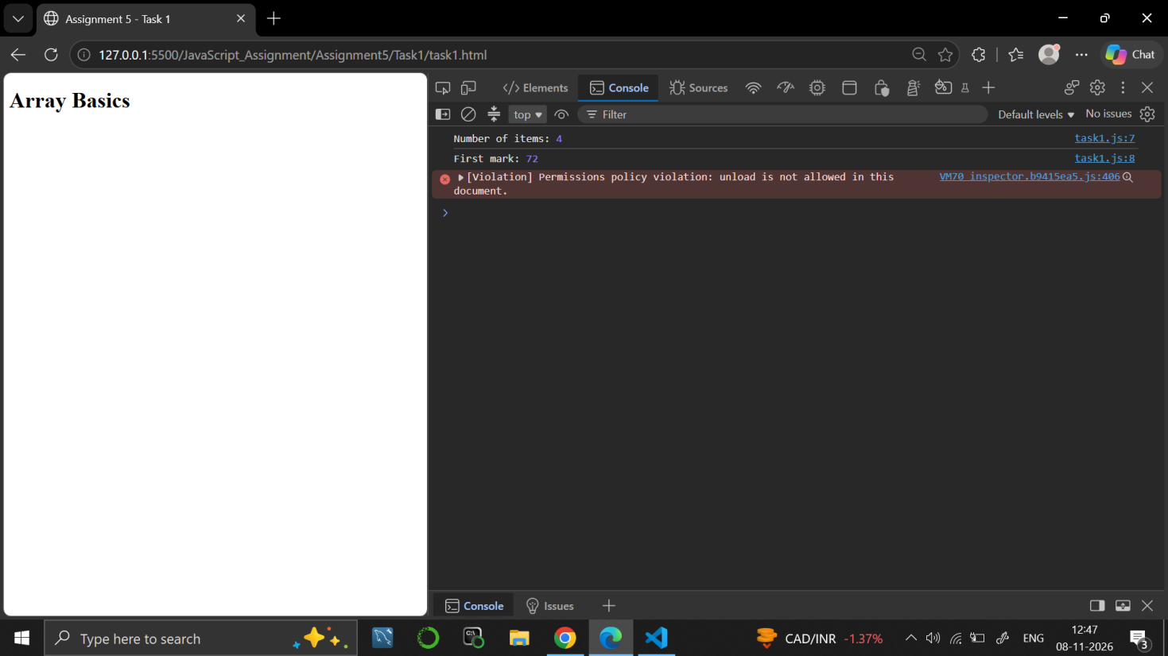

Task 2
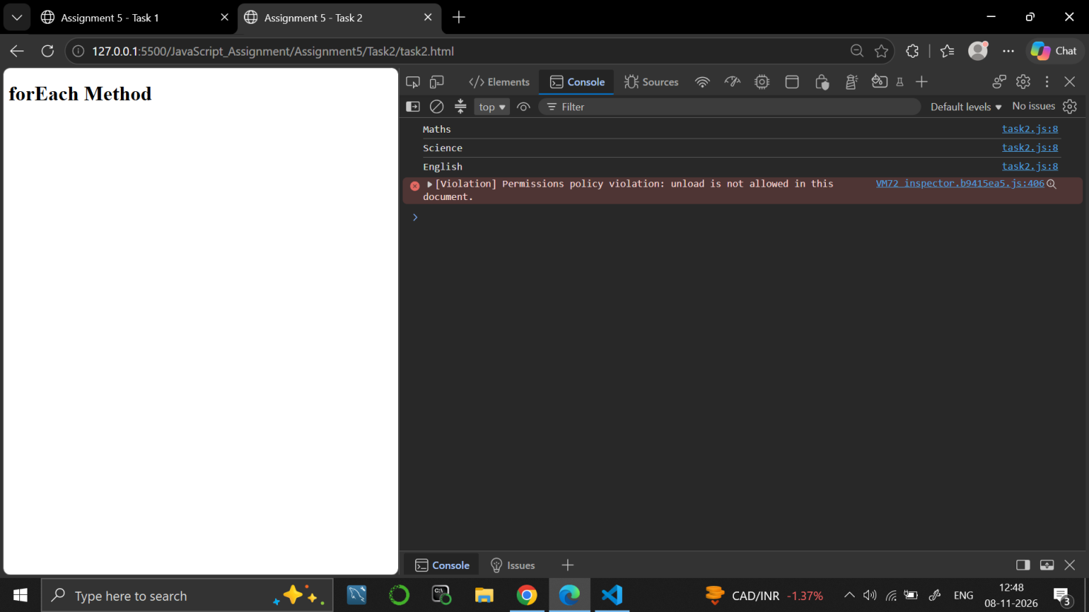

Task 3
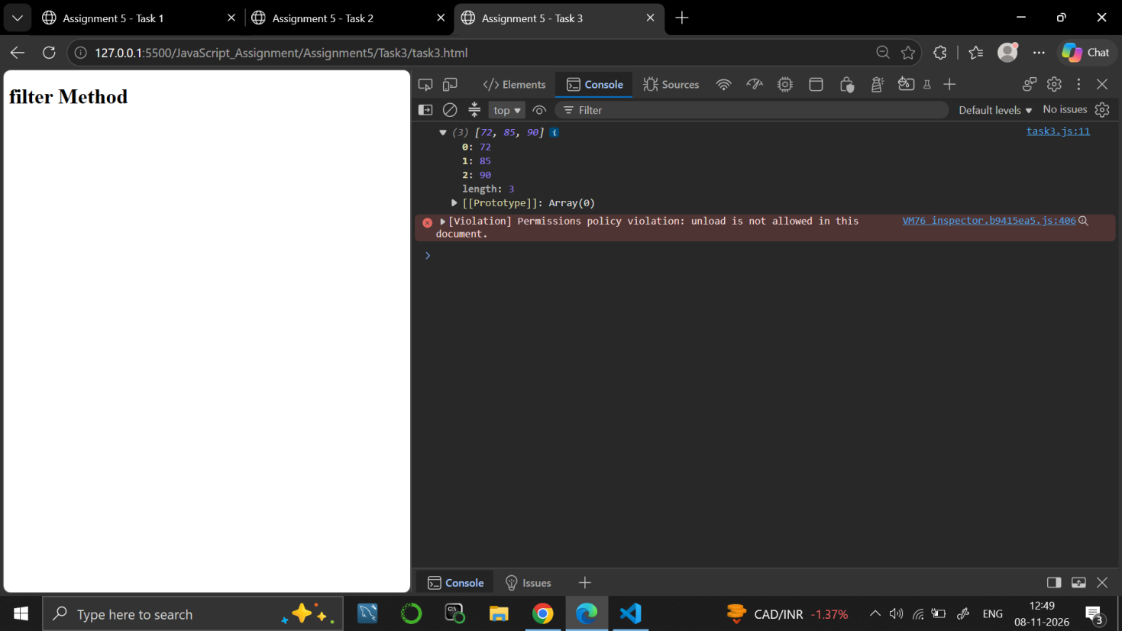

Task 4
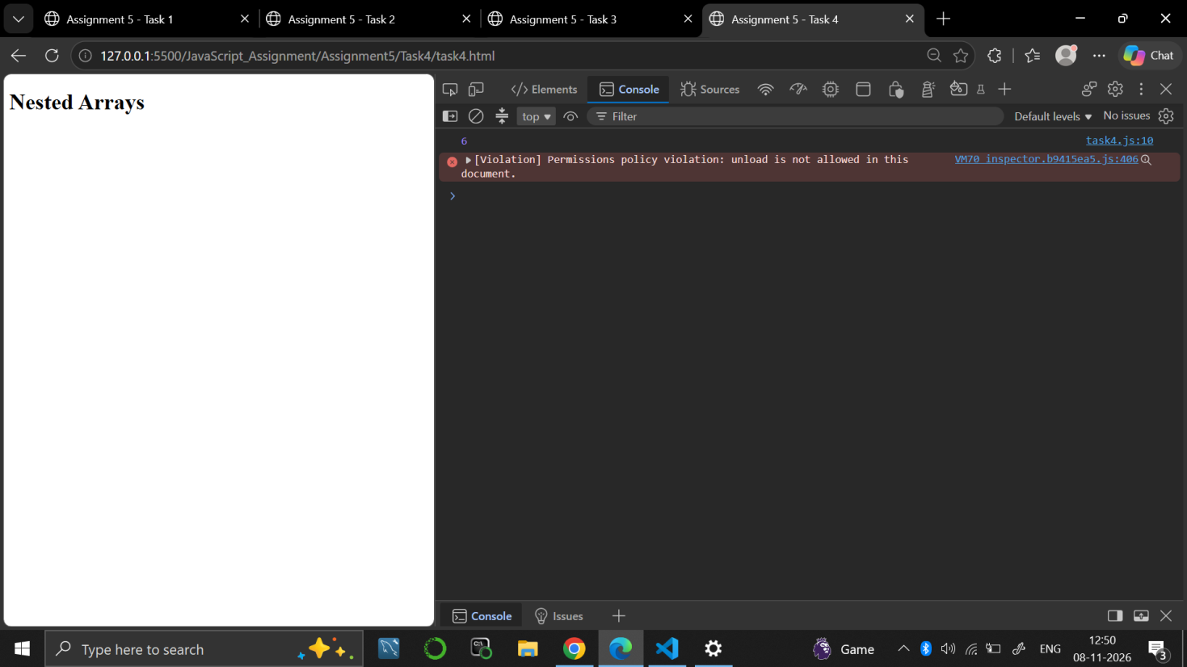

9. RESULT
JavaScript programs were written to create arrays, to read their items, to use forEach and filter, and to read a value from a nested array.

10. VIVA-VOCE QUESTIONS
- How do you find the number of items in an array?
- What is the index of the first item of an array?
- What does the forEach() method do?
- What does the filter() method return?
- How do you read a value from an array inside another array?

EXPERIMENT NO. 6
Course: BCS354

1. EXPERIMENT TITLE
JSON Text

2. AIM
To convert an object to JSON text, to convert JSON text back to an object, and to catch invalid JSON.

3. SOFTWARE / TOOLS REQUIRED
Web browser (Google Chrome / Microsoft Edge / Firefox) with the developer console (F12); Node.js; a code editor such as VS Code.

4. THEORY
JSON (JavaScript Object Notation) is a text format used to store and exchange data. JSON.stringify() converts a JavaScript object into JSON text, and JSON.parse() converts JSON text back into an object. In valid JSON, the keys and text values must be written in double quotes. When JSON.parse() gets invalid text it throws an error, which can be handled with try and catch.

5. ALGORITHM / PROCEDURE
Task 1
- Start.
- Create the object student with name "Rohan" and marks [70, 80].
- Convert it to JSON text using JSON.stringify and store it in jsonText.
- Print jsonText.
- Stop.
Task 2
- Start.
- Store the text {"city":"Pune","pin":411001} in jsonText.
- Convert it to an object using JSON.parse.
- Print "City:" followed by student.city.
- Stop.
Task 3
- Start.
- Store the text {name: Rohan} in jsonText.
- Inside a try block, call JSON.parse on jsonText and print the result.
- If parsing fails, the catch block runs and prints "Invalid JSON".
- Stop.

6. PROGRAM / QUERIES / COMMANDS
Task 1
– task1.html
<!DOCTYPE html>
<html lang="en">

<head>
<meta charset="UTF-8">
<meta name="viewport" content="width=device-width, initial-scale=1.0">
<title>Assignment 6 - Task 1</title>
</head>

<body>

<h1>Assignment 6</h1>
<h2>Task 1: JSON Stringify</h2>

<script src="task1.js"></script>

</body>

</html>

– task1.js
// Name: Dhruv Saxena
// Roll No: BCS2025626
// Assignment: 6 - Task 1

let student = {
name: "Rohan",
marks: [70, 80]
};

let jsonText = JSON.stringify(student);

console.log(jsonText);

Task 2
– task2.html
<!DOCTYPE html>
<html lang="en">

<head>
<meta charset="UTF-8">
<meta name="viewport" content="width=device-width, initial-scale=1.0">
<title>Assignment 6 - Task 2</title>
</head>

<body>

<h1>Assignment 6</h1>
<h2>Task 2: JSON Parse</h2>

<script src="task2.js"></script>

</body>

</html>

– task2.js
// Name: Dhruv Saxena
// Roll No: BCS2025626
// Assignment: 6 - Task 2

let jsonText = '{"city":"Pune","pin":411001}';

let student = JSON.parse(jsonText);

console.log("City:", student.city);

Task 3
– task3.html
<!DOCTYPE html>
<html lang="en">

<head>
<meta charset="UTF-8">
<meta name="viewport" content="width=device-width, initial-scale=1.0">
<title>Assignment 6 - Task 3</title>
</head>

<body>

<h1>Assignment 6</h1>
<h2>Task 3: Try and Catch</h2>

<script src="task3.js"></script>

</body>

</html>

– task3.js
// Name: Dhruv Saxena
// Roll No: BCS2025626
// Assignment: 6 - Task 3

let jsonText = '{name: Rohan}';

try {
let student = JSON.parse(jsonText);

console.log(student);
}
catch (error) {
console.log("Invalid JSON");
}

7. INPUT
No user input is taken. All values are fixed inside the programs: the object with name "Rohan" and marks [70, 80] in Task 1; the text {"city":"Pune","pin":411001} in Task 2; the invalid text {name: Rohan} in Task 3.

8. OUTPUT
Task 1
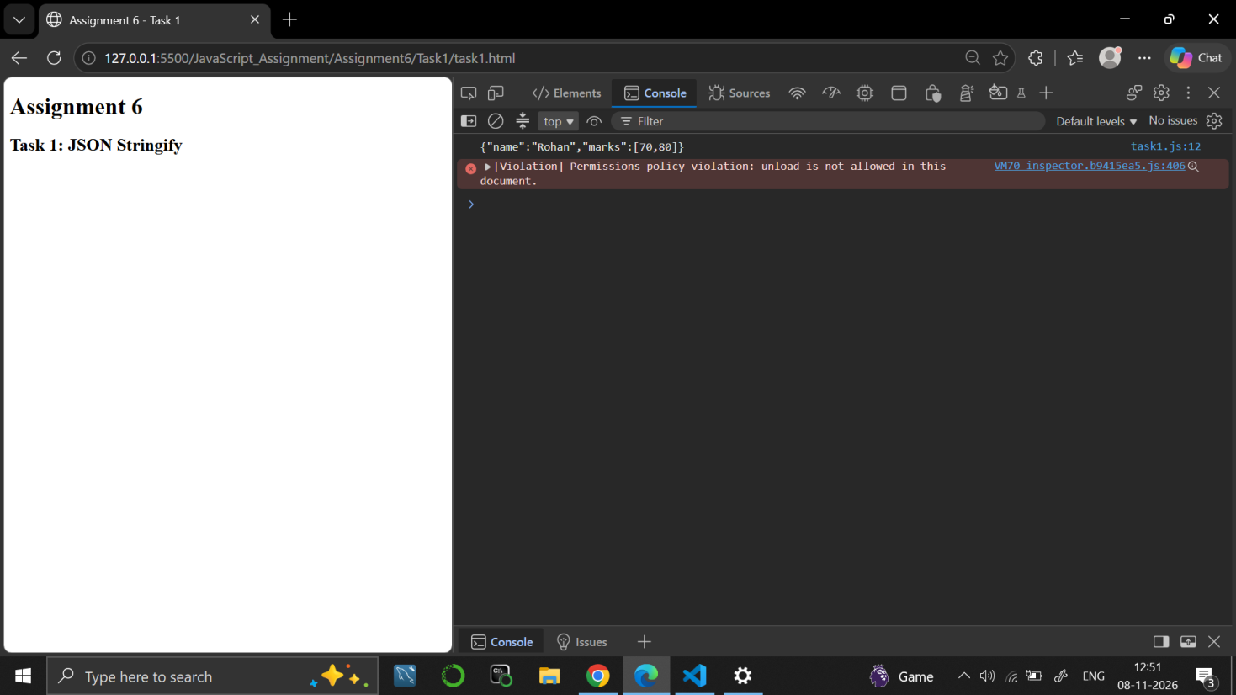

Task 2
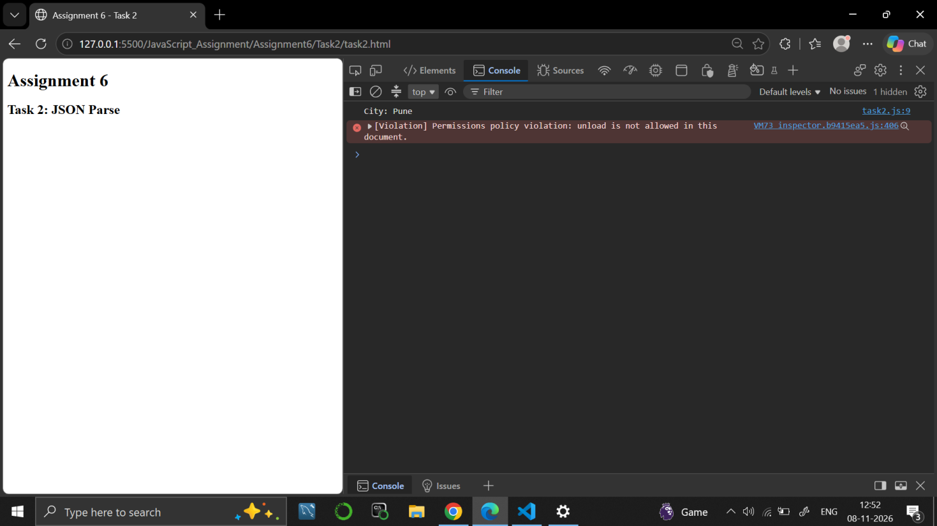

Task 3
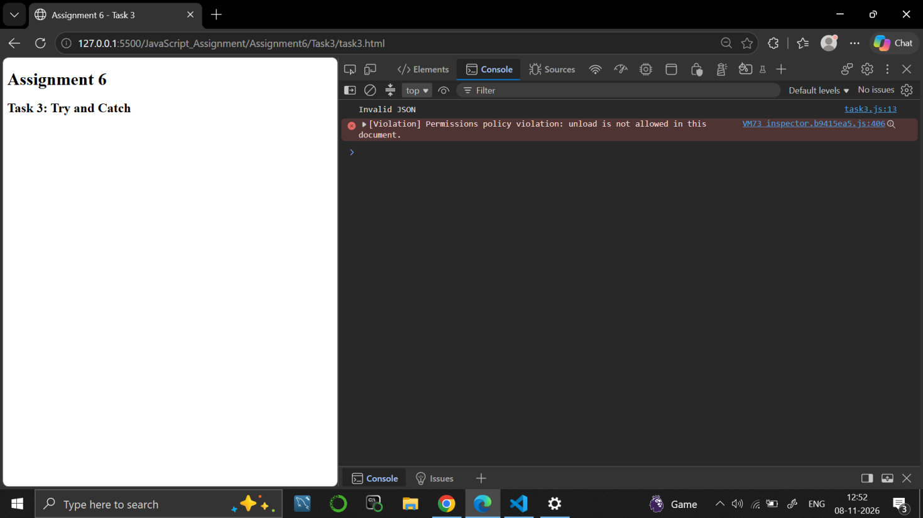

9. RESULT
JavaScript programs were written to convert an object to JSON text, to convert JSON text to an object and to catch invalid JSON using try and catch.

10. VIVA-VOCE QUESTIONS
- What is JSON?
- What is the difference between JSON.stringify() and JSON.parse()?
- Why is {name: Rohan} not valid JSON?
- What is the use of try and catch?
- How is JSON different from a JavaScript object?

EXPERIMENT NO. 7
Course: BCS354

1. EXPERIMENT TITLE
Constructor Functions and Classes

2. AIM
To create objects with a constructor function and with an ES6 class, and to add a method through the prototype.

3. SOFTWARE / TOOLS REQUIRED
Web browser (Google Chrome / Microsoft Edge / Firefox) with the developer console (F12); Node.js; a code editor such as VS Code.

4. THEORY
A constructor function is a normal function used with the new keyword to create objects; this refers to the new object. An ES6 class is a modern way to write the same idea, with a constructor method and other methods inside the class. Every constructor function has a prototype object, and a method added to it is shared by all the objects created from that constructor.

5. ALGORITHM / PROCEDURE
Task 1
- Start.
- Define the constructor function Student(name, marks) that saves name and marks on this.
- Create the object student using new Student("Asha", 88).
- Print the name and the marks with their labels, one on each line.
- Stop.
Task 2
- Start.
- Define the class Book with a constructor that saves title and pages.
- Add the method summary() that returns the title, " has ", the pages and " pages".
- Create the object book using new Book("Algorithms", 320).
- Print book.summary().
- Stop.
Task 3
- Start.
- Define the constructor function Student(name, marks).
- Add the method Student.prototype.result that returns "Pass" if marks >= 40, otherwise "Fail".
- Create the object student using new Student("Asha", 88).
- Print student.result().
- Stop.

6. PROGRAM / QUERIES / COMMANDS
Task 1
– task1.html
<!DOCTYPE html>
<html lang="en">

<head>
<meta charset="UTF-8">
<meta name="viewport" content="width=device-width, initial-scale=1.0">
<title>Assignment 7 - Task 1</title>
</head>

<body>

<h1>Assignment 7</h1>
<h2>Task 1: Constructor Function</h2>

<script src="task1.js"></script>

</body>

</html>

– task1.js
// Name: Dhruv Saxena
// Roll No: BCS2025626
// Assignment: 7 - Task 1

function Student(name, marks) {
this.name = name;
this.marks = marks;
}

let student = new Student("Asha", 88);

console.log("Student Name:", student.name);
console.log("Student Marks:", student.marks);

Task 2
– task2.html
<!DOCTYPE html>
<html lang="en">

<head>
<meta charset="UTF-8">
<meta name="viewport" content="width=device-width, initial-scale=1.0">
<title>Assignment 7 - Task 2</title>
</head>

<body>

<h1>Assignment 7</h1>
<h2>Task 2: ES6 Class</h2>

<script src="task2.js"></script>

</body>

</html>

– task2.js
// Name: Dhruv Saxena
// Roll No: BCS2025626
// Assignment: 7 - Task 2

class Book {
constructor(title, pages) {
this.title = title;
this.pages = pages;
}

summary() {
return this.title + " has " + this.pages + " pages";
}
}

let book = new Book("Algorithms", 320);

console.log(book.summary());

Task 3
– task3.html
<!DOCTYPE html>
<html lang="en">

<head>
<meta charset="UTF-8">
<meta name="viewport" content="width=device-width, initial-scale=1.0">
<title>Assignment 7 - Task 3</title>
</head>

<body>

<h1>Assignment 7</h1>
<h2>Task 3: Prototype Method</h2>

<script src="task3.js"></script>

</body>

</html>

– task3.js
// Name: Dhruv Saxena
// Roll No: BCS2025626
// Assignment: 7 - Task 3

function Student(name, marks) {
this.name = name;
this.marks = marks;
}

Student.prototype.result = function() {
if (this.marks >= 40) {
return "Pass";
}
else {
return "Fail";
}
};

let student = new Student("Asha", 88);

console.log(student.result());

7. INPUT
No user input is taken. All values are fixed inside the programs: name "Asha" and marks 88 in Task 1 and Task 3; title "Algorithms" and 320 pages in Task 2.

8. OUTPUT
Task 1
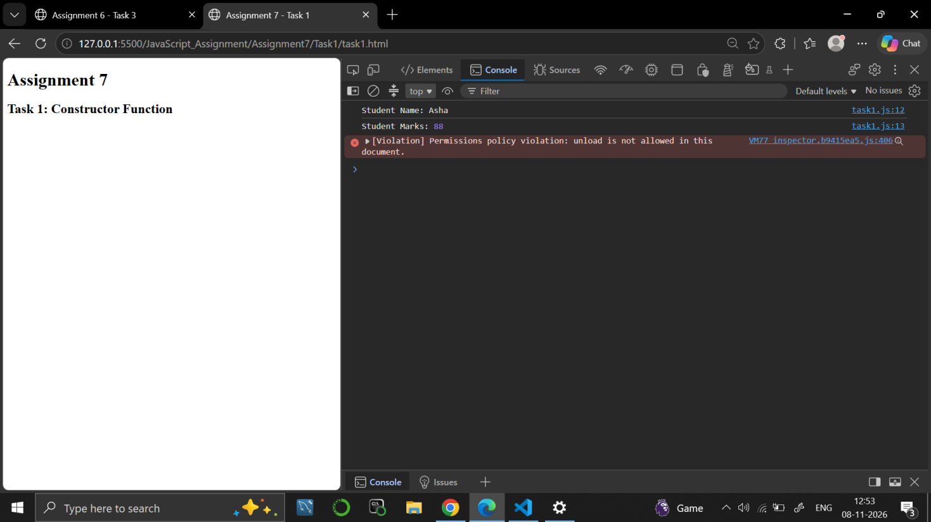

Task 2
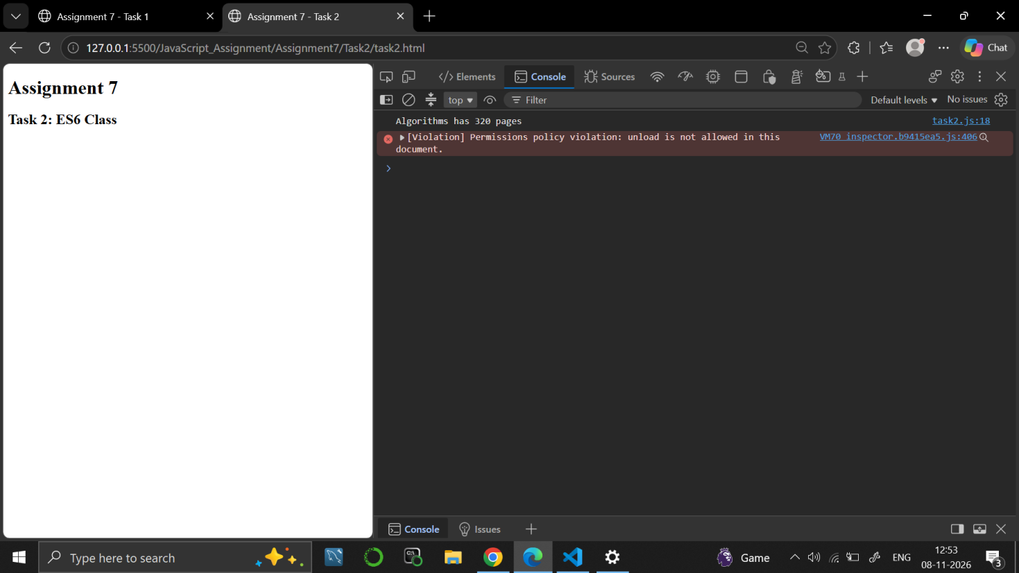

Task 3
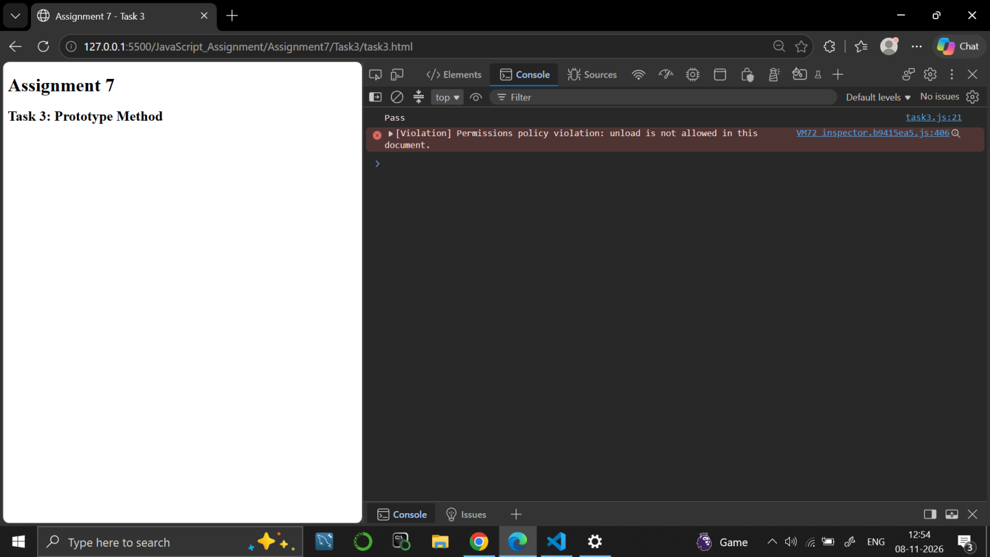

9. RESULT
JavaScript programs were written to create objects using a constructor function and an ES6 class, and to add a method using the prototype.

10. VIVA-VOCE QUESTIONS
- What is a constructor function?
- What does the new keyword do?
- What is an ES6 class?
- What is a prototype in JavaScript?
- What does the keyword this refer to inside a constructor?

EXPERIMENT NO. 8
Course: BCS354

1. EXPERIMENT TITLE
Inheritance, Methods and Composition

2. AIM
To use extends to make a child class, to write a method that checks a value, and to place one object inside another.

3. SOFTWARE / TOOLS REQUIRED
Web browser (Google Chrome / Microsoft Edge / Firefox) with the developer console (F12); Node.js; a code editor such as VS Code.

4. THEORY
Inheritance lets a child class reuse the properties and methods of a parent class using the extends keyword. The super() call inside the child constructor runs the parent constructor. A method can check a value and return true or false. In composition, an object is stored inside another object, which gives a has-a relationship, such as a Car that has an Engine.

5. ALGORITHM / PROCEDURE
Task 1
- Start.
- Define the class Person with a constructor that saves name and a method greet() that returns "Hi, I am " joined with the name.
- Define the class Teacher that extends Person; its constructor calls super(name) and saves the subject.
- Create the object teacher using new Teacher("Anita", "Maths").
- Print teacher.greet().
- Stop.
Task 2
- Start.
- Define the class Locker whose constructor sets pin = 1234.
- Add the method checkPin(number) that returns true if number === this.pin, otherwise false.
- Create the object locker.
- Print locker.checkPin(1111) and locker.checkPin(1234), one on each line.
- Stop.
Task 3
- Start.
- Define the class Engine whose constructor saves the power.
- Define the class Car whose constructor creates an Engine from the power and stores it in this.engine.
- Add the method start() that returns "Car starts with ", the engine power and " HP".
- Create the object car using new Car(150).
- Print car.start().
- Stop.

6. PROGRAM / QUERIES / COMMANDS
Task 1
– task1.html
<!DOCTYPE html>
<html lang="en">

<head>
<meta charset="UTF-8">
<meta name="viewport" content="width=device-width, initial-scale=1.0">
<title>Assignment 8 - Task 1</title>
</head>

<body>

<h1>Assignment 8</h1>
<h2>Task 1: Inheritance</h2>

<script src="task1.js"></script>

</body>

</html>

– task1.js
// Name: Dhruv Saxena
// Roll No: BCS2025626
// Assignment: 8 - Task 1

class Person {
constructor(name) {
this.name = name;
}

greet() {
return "Hi, I am " + this.name;
}
}

class Teacher extends Person {
constructor(name, subject) {
super(name);
this.subject = subject;
}
}

let teacher = new Teacher("Anita", "Maths");

console.log(teacher.greet());

Task 2
– task2.html
<!DOCTYPE html>
<html lang="en">

<head>
<meta charset="UTF-8">
<meta name="viewport" content="width=device-width, initial-scale=1.0">
<title>Assignment 8 - Task 2</title>
</head>

<body>

<h1>Assignment 8</h1>
<h2>Task 2: Locker Class</h2>

<script src="task2.js"></script>

</body>

</html>

– task2.js
// Name: Dhruv Saxena
// Roll No: BCS2025626
// Assignment: 8 - Task 2

class Locker {
constructor() {
this.pin = 1234;
}

checkPin(number) {
if (number === this.pin) {
return true;
}
else {
return false;
}
}
}

let locker = new Locker();

console.log(locker.checkPin(1111));
console.log(locker.checkPin(1234));

Task 3
– task3.html
<!DOCTYPE html>
<html lang="en">

<head>
<meta charset="UTF-8">
<meta name="viewport" content="width=device-width, initial-scale=1.0">
<title>Assignment 8 - Task 3</title>
</head>

<body>

<h1>Assignment 8</h1>
<h2>Task 3: Composition</h2>

<script src="task3.js"></script>

</body>

</html>

– task3.js
// Name: Dhruv Saxena
// Roll No: BCS2025626
// Assignment: 8 - Task 3

class Engine {
constructor(power) {
this.power = power;
}
}

class Car {
constructor(power) {
this.engine = new Engine(power);
}

start() {
return "Car starts with " + this.engine.power + " HP";
}
}

let car = new Car(150);

console.log(car.start());

7. INPUT
No user input is taken. All values are fixed inside the programs: name "Anita" and subject "Maths" in Task 1; pin 1234 with the numbers 1111 and 1234 in Task 2; power 150 in Task 3.

8. OUTPUT
Task 1
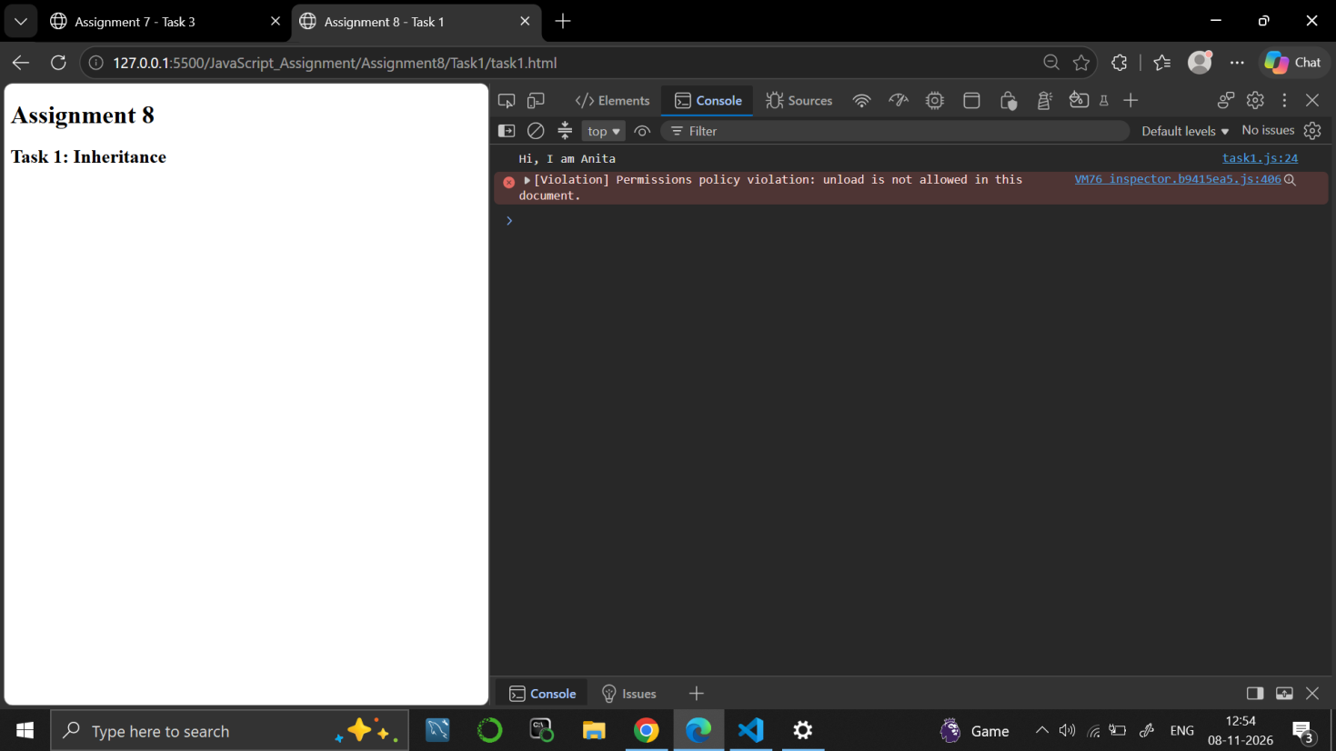

Task 2
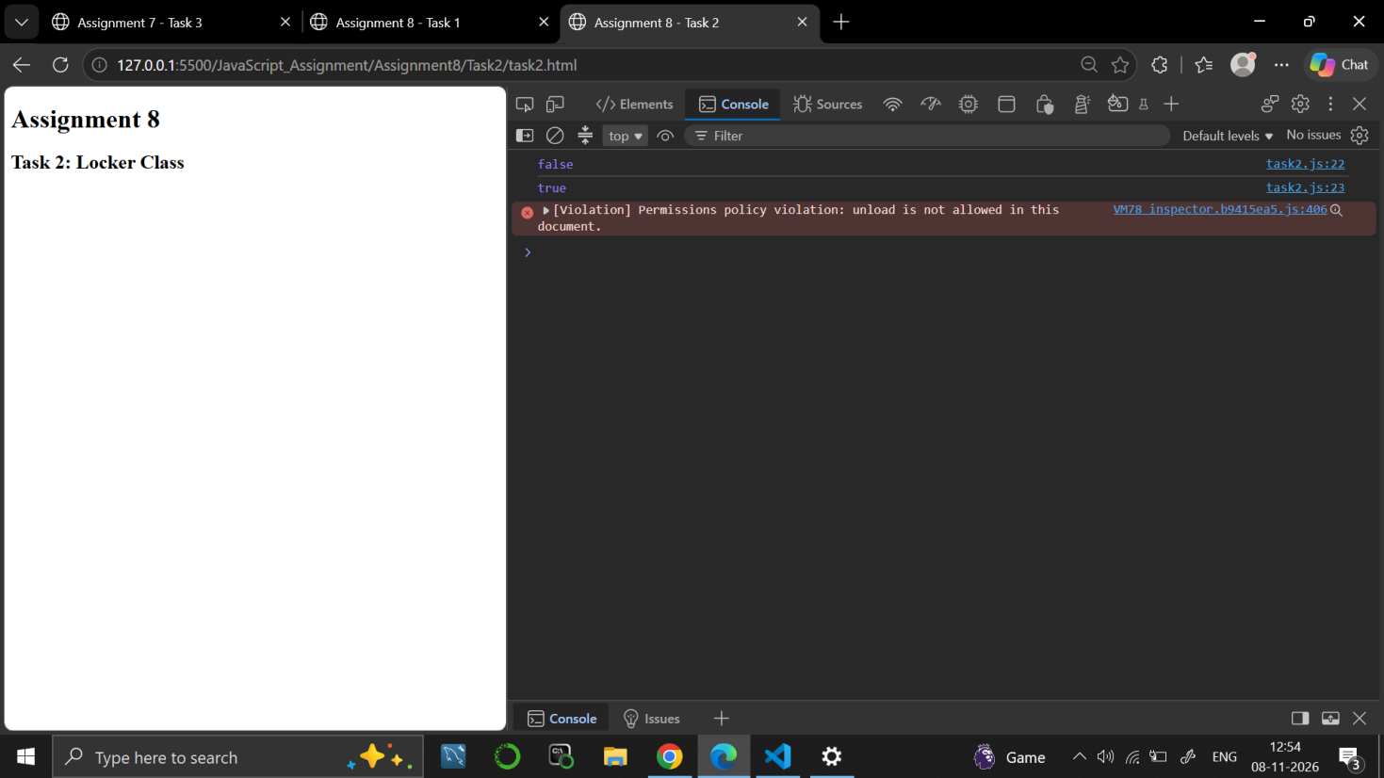

Task 3
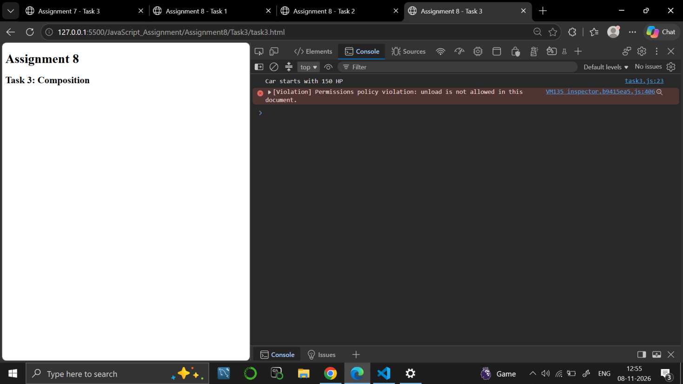

9. RESULT
JavaScript programs were written to use inheritance with extends, to check a value with a method and to place one object inside another.

10. VIVA-VOCE QUESTIONS
- What is inheritance?
- What is the use of the extends keyword?
- What does super() do?
- What is composition and how is it different from inheritance?
- Why does checkPin() return true or false?

EXPERIMENT NO. 9
Course: BCS354

1. EXPERIMENT TITLE
DOM, Validation, Storage and Quiz

2. AIM
To change a page with a click, to check form values in code, to save text in local storage, and to build a small quiz.

3. SOFTWARE / TOOLS REQUIRED
Web browser (Google Chrome / Microsoft Edge / Firefox) with the developer console (F12); Node.js; a code editor such as VS Code.

4. THEORY
The DOM (Document Object Model) represents an HTML page as objects that JavaScript can read and change. document.getElementById() finds an element, textContent changes its text, and addEventListener() runs a function when an event such as a click happens. Validation checks that a value is acceptable before it is used. localStorage saves text in the browser using setItem() and reads it back with getItem(), and the text stays after the page is closed.

5. ALGORITHM / PROCEDURE
Task 1
- Start.
- Create a page with the heading "Welcome" (id heading) and the button "Change text" (id changeBtn).
- Get both elements using getElementById.
- Add a click event listener to the button.
- When the button is clicked, set the heading text to "Button clicked".
- Stop.
Task 2
- Start.
- Define validateForm(name) and create an empty array errors.
- If name is an empty string, add "Name is required" to errors.
- Return errors.
- Print validateForm("Asha") and then validateForm("").
- Stop.
Task 3
- Start.
- Create a page with a text box (id note) and a Save button (id saveBtn).
- When the page opens, read localStorage.getItem("note") and show it in the text box (or an empty text if nothing is saved).
- When Save is clicked, store the text of the box in localStorage under the key "note".
- Show an alert "Note Saved Successfully".
- Stop.
Task 4
- Start.
- Create a page with the question "What is 2 + 3?", three radio buttons (4, 5, 6), the button "Check answer" (id checkBtn) and an empty paragraph (id result).
- When the button is clicked, find the selected radio button using querySelector.
- If a button is selected and its value is "5", show "Correct" in the result paragraph.
- Otherwise, show "Try again".
- Stop.

6. PROGRAM / QUERIES / COMMANDS
Task 1
– task1.html
<!DOCTYPE html>
<html lang="en">

<head>
<meta charset="UTF-8">
<meta name="viewport" content="width=device-width, initial-scale=1.0">
<title>Assignment 9 - Task 1</title>
</head>

<body>

<h1 id="heading">Welcome</h1>

<button id="changeBtn">Change text</button>

<script src="task1.js"></script>

</body>

</html>

– task1.js
// Name: Dhruv Saxena
// Roll No: BCS2025626
// Assignment: 9 - Task 1

let heading = document.getElementById("heading");

let button = document.getElementById("changeBtn");

button.addEventListener("click", function() {
heading.textContent = "Button clicked";
});

Task 2
– task2.html
<!DOCTYPE html>
<html lang="en">

<head>
<meta charset="UTF-8">
<meta name="viewport" content="width=device-width, initial-scale=1.0">
<title>Assignment 9 - Task 2</title>
</head>

<body>

<h1>Assignment 9</h1>
<h2>Task 2: Form Validation</h2>

<script src="task2.js"></script>

</body>

</html>

– task2.js
// Name: Dhruv Saxena
// Roll No: BCS2025626
// Assignment: 9 - Task 2

function validateForm(name) {
let errors = [];

if (name === "") {
errors.push("Name is required");
}

return errors;
}

console.log(validateForm("Asha"));

console.log(validateForm(""));

Task 3
– task3.html
<!DOCTYPE html>
<html lang="en">

<head>
<meta charset="UTF-8">
<meta name="viewport" content="width=device-width, initial-scale=1.0">
<title>Assignment 9 - Task 3</title>
</head>

<body>

<h1>Assignment 9</h1>
<h2>Task 3: Local Storage</h2>

<input type="text" id="note" placeholder="Enter your note">

<button id="saveBtn">Save</button>

<script src="task3.js"></script>

</body>

</html>

– task3.js
// Name: Dhruv Saxena
// Roll No: BCS2025626
// Assignment: 9 - Task 3

let note = document.getElementById("note");

let button = document.getElementById("saveBtn");

// Show saved text when page opens
note.value = localStorage.getItem("note") || "";

button.addEventListener("click", function() {
localStorage.setItem("note", note.value);

alert("Note Saved Successfully");
});

Task 4
– task4.html
<!DOCTYPE html>
<html lang="en">

<head>
<meta charset="UTF-8">
<meta name="viewport" content="width=device-width, initial-scale=1.0">
<title>Assignment 9 - Task 4</title>
</head>

<body>

<h1>Assignment 9</h1>
<h2>Simple Quiz</h2>

<p>What is 2 + 3?</p>

<input type="radio" name="answer" value="4"> 4
<br>

<input type="radio" name="answer" value="5"> 5
<br>

<input type="radio" name="answer" value="6"> 6
<br><br>

<button id="checkBtn">Check answer</button>

<p id="result"></p>

<script src="task4.js"></script>

</body>

</html>

– task4.js
// Name: Dhruv Saxena
// Roll No: BCS2025626
// Assignment: 9 - Task 4

let button = document.getElementById("checkBtn");

let result = document.getElementById("result");

button.addEventListener("click", function() {

let selected = document.querySelector(
'input[name="answer"]:checked'
);

if (selected && selected.value === "5") {
result.textContent = "Correct";
}
else {
result.textContent = "Try again";
}

});

7. INPUT
Task 1: click the "Change text" button. Task 2: the names "Asha" and an empty name are fixed in the program. Task 3: type a note in the text box and click Save. Task 4: select one of the radio buttons 4, 5 or 6 and click "Check answer".

8. OUTPUT
Task 1
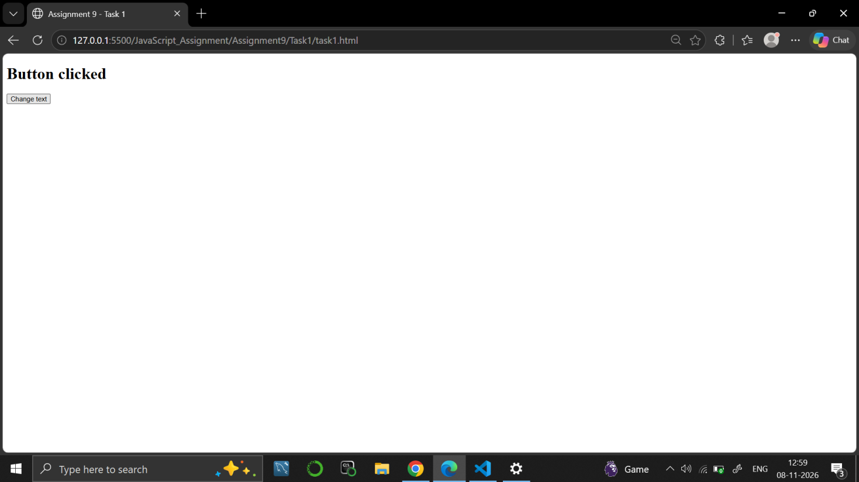

Task 2
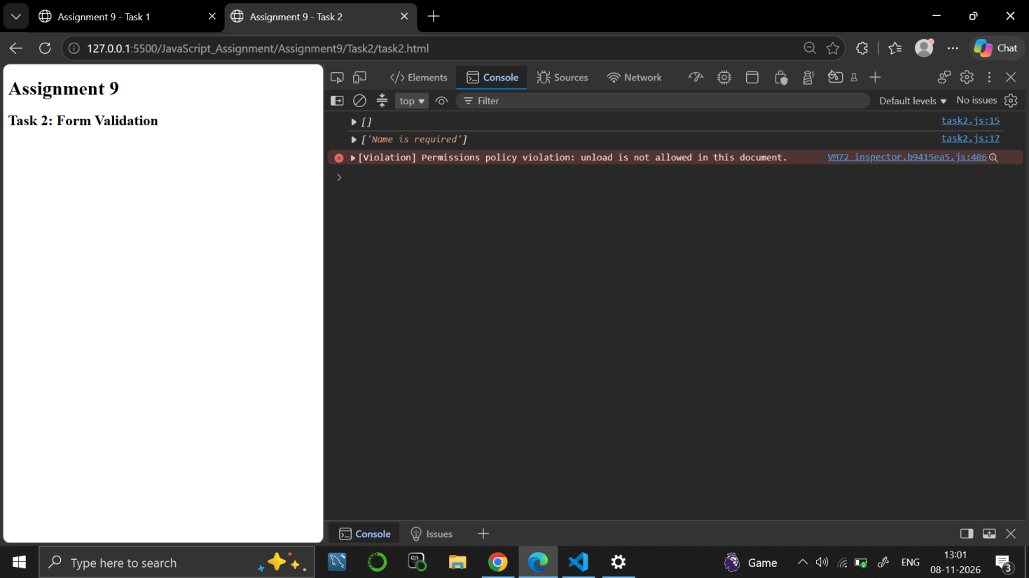

Task 3
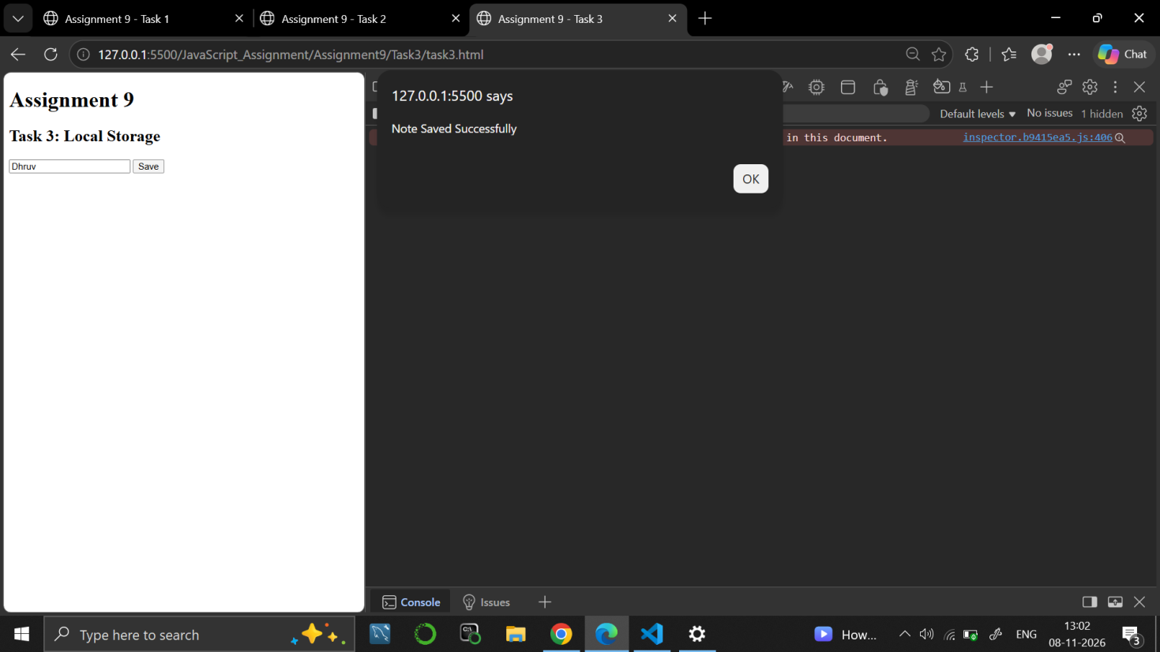

Task 4
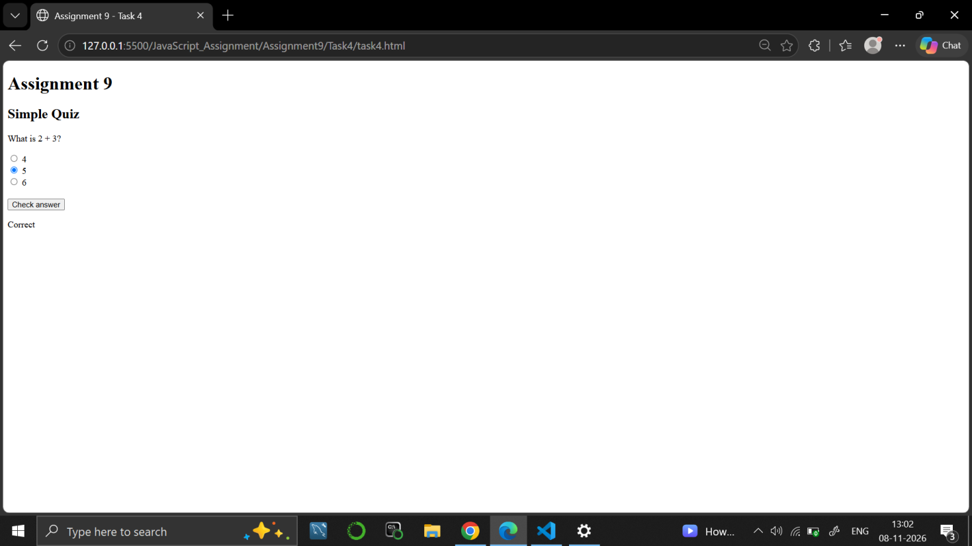

9. RESULT
JavaScript programs and pages were written to change text on a click, to validate a form value, to save and show text using localStorage and to check a quiz answer.

10. VIVA-VOCE QUESTIONS
- What is the DOM?
- What is the use of addEventListener()?
- What is the difference between setItem() and getItem() in localStorage?
- Why is form validation needed?
- How does querySelector find the selected radio button?

EXPERIMENT NO. 10
Course: BCS354

1. EXPERIMENT TITLE
Objects and Destructuring

2. AIM
To create an object, to read and change its properties, and to take values out of an array and an object with destructuring.

3. SOFTWARE / TOOLS REQUIRED
Web browser (Google Chrome / Microsoft Edge / Firefox) with the developer console (F12); Node.js; a code editor such as VS Code.

4. THEORY
An object stores data as property-value pairs and its properties are read or changed with the dot notation, such as student.name. Destructuring takes values out of an array or an object into separate variables. Array destructuring uses square brackets and follows the order of the items, and object destructuring uses curly brackets and matches the property names.

5. ALGORITHM / PROCEDURE
Task 1
- Start.
- Create the object student with name "Rohan", roll 12 and marks 78.
- Print student.name.
- Change student.marks to 81.
- Print student.marks.
- Stop.
Task 2
- Start.
- Create the array subjects with "Maths", "Science" and "English".
- Use array destructuring to store the first two items in first and second.
- Print first and second, one on each line.
- Stop.
Task 3
- Start.
- Create the object student with name "Rohan", roll 12 and marks 81.
- Use object destructuring to take out name and roll.
- Print name and roll, one on each line.
- Stop.

6. PROGRAM / QUERIES / COMMANDS
Task 1
– task1.html
<!DOCTYPE html>
<html lang="en">

<head>
<meta charset="UTF-8">
<meta name="viewport" content="width=device-width, initial-scale=1.0">
<title>Assignment 10 - Task 1</title>
</head>

<body>

<h1>Assignment 10</h1>
<h2>Task 1: Objects</h2>

<script src="task1.js"></script>

</body>

</html>

– task1.js
// Name: Dhruv Saxena
// Roll No: BCS2025626
// Assignment: 10 - Task 1

let student = {
name: "Rohan",
roll: 12,
marks: 78
};

console.log("Student Name:", student.name);

student.marks = 81;

console.log("Updated Marks:", student.marks);

Task 2
– task2.html
<!DOCTYPE html>
<html lang="en">

<head>
<meta charset="UTF-8">
<meta name="viewport" content="width=device-width, initial-scale=1.0">
<title>Assignment 10 - Task 2</title>
</head>

<body>

<h1>Assignment 10</h1>
<h2>Task 2: Array Destructuring</h2>

<script src="task2.js"></script>

</body>

</html>

– task2.js
// Name: Dhruv Saxena
// Roll No: BCS2025626
// Assignment: 10 - Task 2

let subjects = ["Maths", "Science", "English"];

let [first, second] = subjects;

console.log("First Subject:", first);
console.log("Second Subject:", second);

Task 3
– task3.html
<!DOCTYPE html>
<html lang="en">

<head>
<meta charset="UTF-8">
<meta name="viewport" content="width=device-width, initial-scale=1.0">
<title>Assignment 10 - Task 3</title>
</head>

<body>

<h1>Assignment 10</h1>
<h2>Task 3: Object Destructuring</h2>

<script src="task3.js"></script>

</body>

</html>

– task3.js
// Name: Dhruv Saxena
// Roll No: BCS2025626
// Assignment: 10 - Task 3

let student = {
name: "Rohan",
roll: 12,
marks: 81
};

let { name, roll } = student;

console.log("Student Name:", name);
console.log("Roll Number:", roll);

7. INPUT
No user input is taken. All values are fixed inside the programs: name "Rohan", roll 12 and marks 78 (changed to 81) in Task 1; subjects "Maths", "Science" and "English" in Task 2; name "Rohan", roll 12 and marks 81 in Task 3.

8. OUTPUT
Task 1
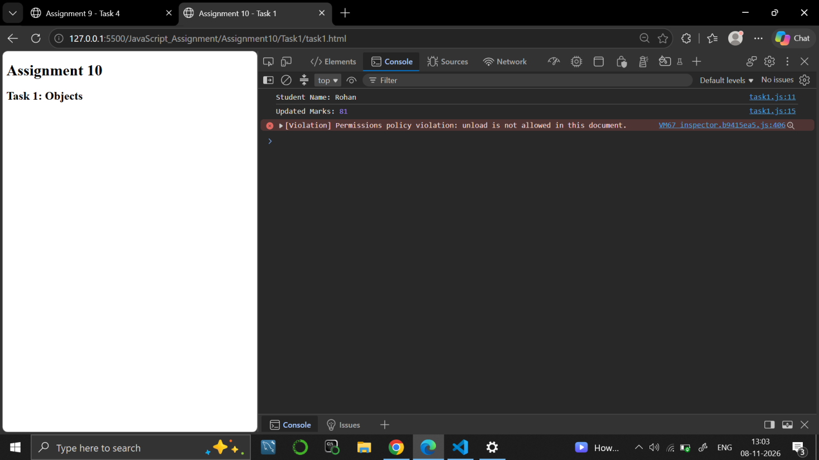

Task 2
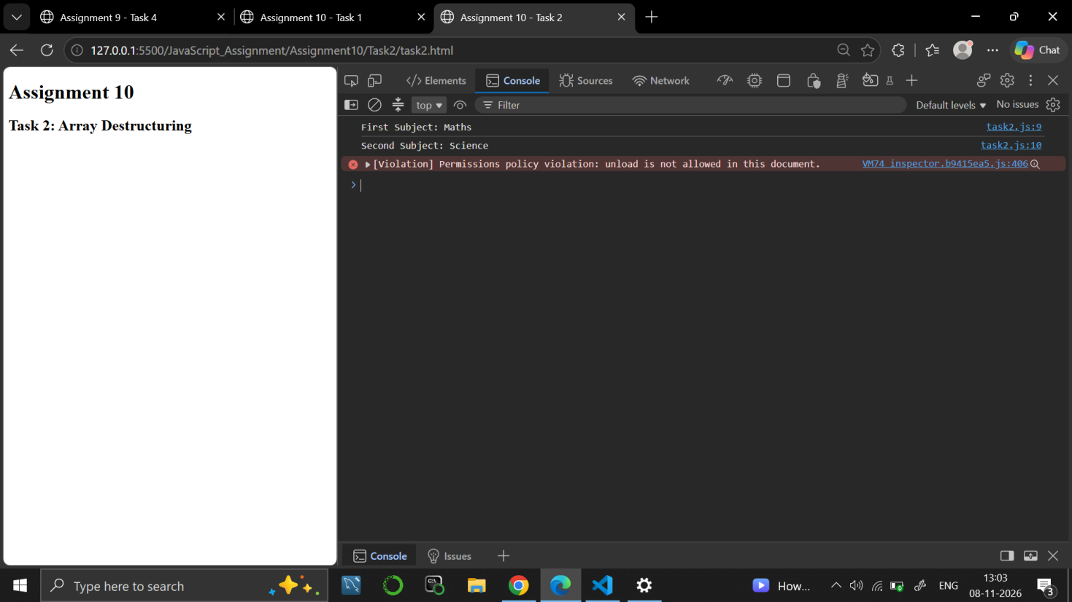

Task 3
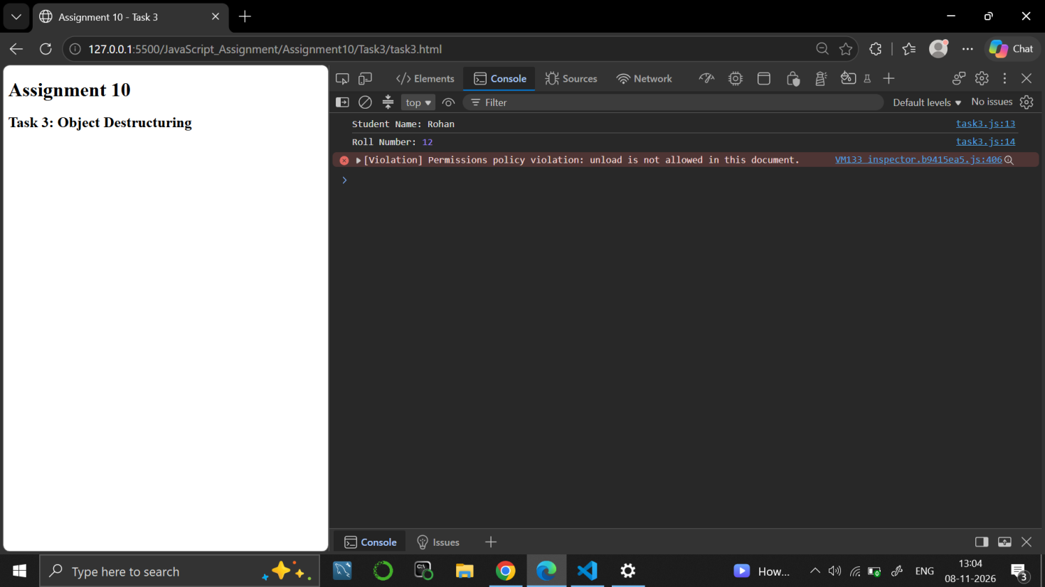

9. RESULT
JavaScript programs were written to create and change an object, and to use array and object destructuring.

10. VIVA-VOCE QUESTIONS
- What is an object in JavaScript?
- How do you read and change a property of an object?
- What is destructuring?
- What is the difference between array and object destructuring?
- What happens to the other items that are not destructured?

EXPERIMENT NO. 11
Course: BCS354

1. EXPERIMENT TITLE
Scope and Closures

2. AIM
To explain block scope and global scope, and to use a function that returns a function that keeps a value between calls.

3. SOFTWARE / TOOLS REQUIRED
Web browser (Google Chrome / Microsoft Edge / Firefox) with the developer console (F12); Node.js; a code editor such as VS Code.

4. THEORY
Scope decides where a variable can be used. A variable declared with let inside a block { } exists only in that block, and a variable declared outside all functions is global and can be used inside functions. A closure is an inner function that remembers the variables of the outer function even after the outer function has finished, so it can keep a value (such as a counter) between calls.

5. ALGORITHM / PROCEDURE
Task 1
- Start.
- Declare level = "outer".
- Open a block, declare level = "inner" inside it and print level.
- Close the block and print level again.
- Stop.
Task 2
- Start.
- Define makeCounter(): set count = 0 and return a function that increases count by 1 and returns it.
- Store the returned function in counter.
- Call counter() twice and print each result.
- Stop.
Task 3
- Start.
- Declare the global variable school = "Sample College".
- Define showSchool() that prints "Welcome to " joined with school.
- Call showSchool().
- Stop.

6. PROGRAM / QUERIES / COMMANDS
Task 1
– task1.html
<!DOCTYPE html>
<html lang="en">

<head>
<meta charset="UTF-8">
<meta name="viewport" content="width=device-width, initial-scale=1.0">
<title>Assignment 11 - Task 1</title>
</head>

<body>

<h1>Assignment 11</h1>
<h2>Task 1: Block Scope</h2>

<script src="task1.js"></script>

</body>

</html>

– task1.js
// Name: Dhruv Saxena
// Roll No: BCS2025626
// Assignment: 11 - Task 1

let level = "outer";

{
let level = "inner";

console.log(level);
}

console.log(level);

Task 2
– task2.html
<!DOCTYPE html>
<html lang="en">

<head>
<meta charset="UTF-8">
<meta name="viewport" content="width=device-width, initial-scale=1.0">
<title>Assignment 11 - Task 2</title>
</head>

<body>

<h1>Assignment 11</h1>
<h2>Task 2: Closures</h2>

<script src="task2.js"></script>

</body>

</html>

– task2.js
// Name: Dhruv Saxena
// Roll No: BCS2025626
// Assignment: 11 - Task 2

function makeCounter() {
let count = 0;

return function() {
count++;
return count;
};
}

let counter = makeCounter();

console.log(counter());
console.log(counter());

Task 3
– task3.html
<!DOCTYPE html>
<html lang="en">

<head>
<meta charset="UTF-8">
<meta name="viewport" content="width=device-width, initial-scale=1.0">
<title>Assignment 11 - Task 3</title>
</head>

<body>

<h1>Assignment 11</h1>
<h2>Task 3: Global Scope</h2>

<script src="task3.js"></script>

</body>

</html>

– task3.js
// Name: Dhruv Saxena
// Roll No: BCS2025626
// Assignment: 11 - Task 3

let school = "Sample College";

function showSchool() {
console.log("Welcome to " + school);
}

showSchool();

7. INPUT
No user input is taken. All values are fixed inside the programs: level = "outer" and "inner" in Task 1; the counter starts at 0 in Task 2; school = "Sample College" in Task 3.

8. OUTPUT
Task 1
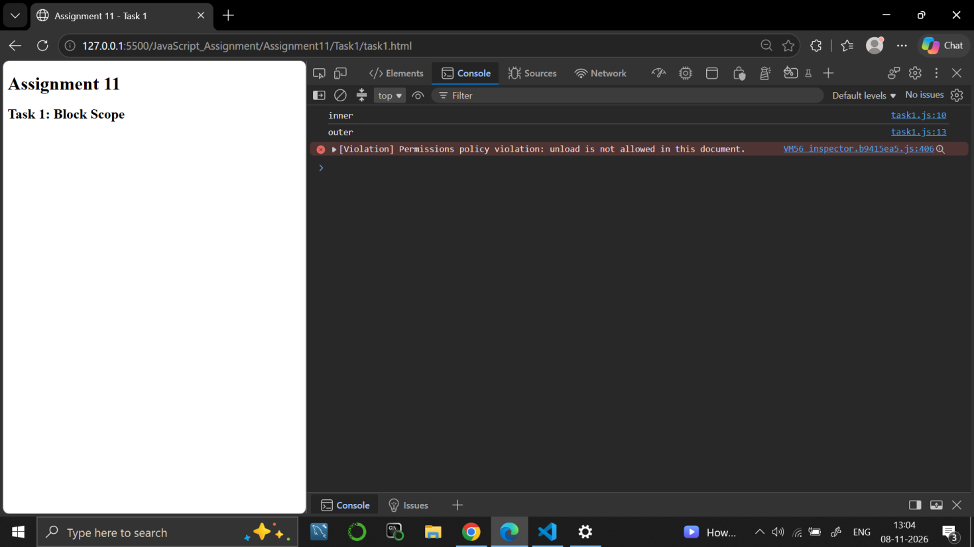

Task 2
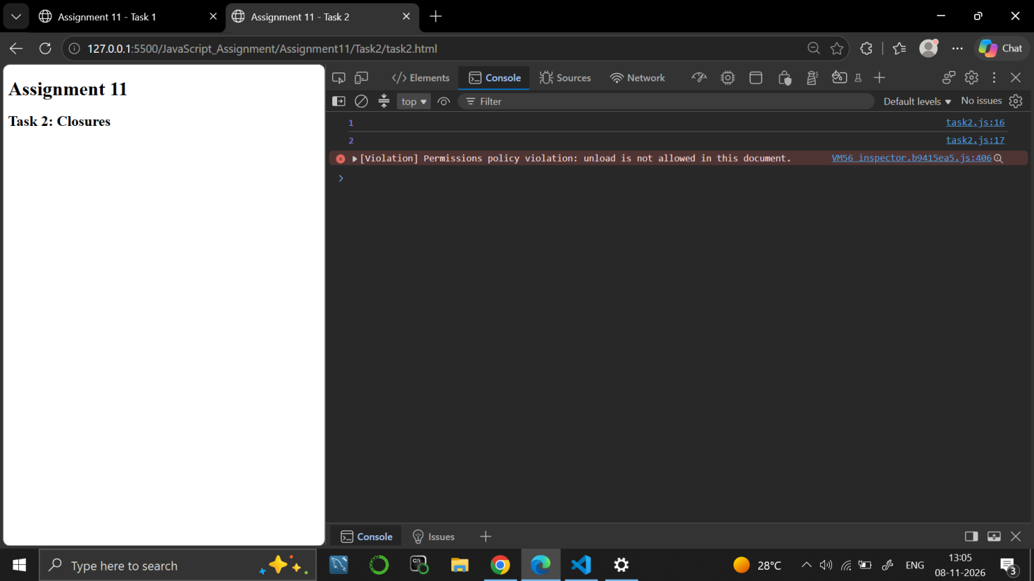

Task 3
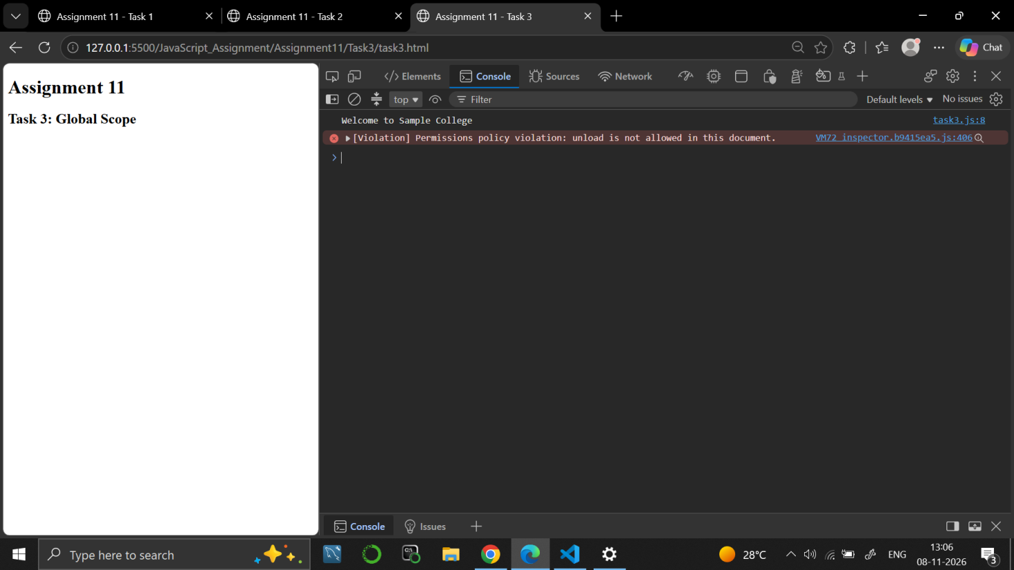

9. RESULT
JavaScript programs were written to show block scope and global scope, and to keep a value between calls using a closure.

10. VIVA-VOCE QUESTIONS
- What is scope in JavaScript?
- What is the difference between block scope and global scope?
- What is a closure?
- Why does the counter keep its value between calls?
- Can a function use a global variable? Give an example.

EXPERIMENT NO. 12
Course: BCS354

1. EXPERIMENT TITLE
Callbacks and Higher-Order Functions

2. AIM
To pass a function as an argument to another function and call it.

3. SOFTWARE / TOOLS REQUIRED
Web browser (Google Chrome / Microsoft Edge / Firefox) with the developer console (F12); Node.js; a code editor such as VS Code.

4. THEORY
In JavaScript, functions are values, so a function can be passed to another function as an argument. The function that is passed is called a callback, and a function that takes or returns another function is called a higher-order function. Callbacks make a function flexible, because the work done inside it can be changed by passing a different function.

5. ALGORITHM / PROCEDURE
Task 1
- Start.
- Define applyTwice(func, value): call func on value, then call func on the result, and return it.
- Define addTen(num) that returns num + 10.
- Call applyTwice(addTen, 5).
- Print the result.
- Stop.
Task 2
- Start.
- Define formatMarks(marks, callback) that returns callback(marks).
- Call formatMarks with 76 and an arrow function that returns "Marks: ", the marks and "/100".
- Print the result.
- Stop.
Task 3
- Start.
- Define repeatAction(times, action): repeat for i = 1 to times and call action(i).
- Call repeatAction with 3 and an arrow function that prints "Round " followed by the round number.
- Stop.

6. PROGRAM / QUERIES / COMMANDS
Task 1
– task1.html
<!DOCTYPE html>
<html lang="en">

<head>
<meta charset="UTF-8">
<meta name="viewport" content="width=device-width, initial-scale=1.0">
<title>Assignment 12 - Task 1</title>
</head>

<body>

<h1>Assignment 12</h1>
<h2>Task 1: Callbacks and Higher-Order Functions</h2>

<script src="task1.js"></script>

</body>

</html>

– task1.js
// Name: Dhruv Saxena
// Roll No: BCS2025626
// Assignment: 12 - Task 1

function applyTwice(func, value) {
let result = func(value);
result = func(result);

return result;
}

function addTen(num) {
return num + 10;
}

console.log(applyTwice(addTen, 5));

Task 2
– task2.html
<!DOCTYPE html>
<html lang="en">

<head>
<meta charset="UTF-8">
<meta name="viewport" content="width=device-width, initial-scale=1.0">
<title>Assignment 12 - Task 2</title>
</head>

<body>

<h1>Assignment 12</h1>
<h2>Task 2: Callback Function</h2>

<script src="task2.js"></script>

</body>

</html>

– task2.js
// Name: Dhruv Saxena
// Roll No: BCS2025626
// Assignment: 12 - Task 2

function formatMarks(marks, callback) {
return callback(marks);
}

let result = formatMarks(76, (marks) => {
return "Marks: " + marks + "/100";
});

console.log(result);

Task 3
– task3.html
<!DOCTYPE html>
<html lang="en">

<head>
<meta charset="UTF-8">
<meta name="viewport" content="width=device-width, initial-scale=1.0">
<title>Assignment 12 - Task 3</title>
</head>

<body>

<h1>Assignment 12</h1>
<h2>Task 3: Repeat Action</h2>

<script src="task3.js"></script>

</body>

</html>

– task3.js
// Name: Dhruv Saxena
// Roll No: BCS2025626
// Assignment: 12 - Task 3

function repeatAction(times, action) {
for (let i = 1; i <= times; i++) {
action(i);
}
}

repeatAction(3, (round) => {
console.log("Round " + round);
});

7. INPUT
No user input is taken. All values are fixed inside the programs: the function addTen and the value 5 in Task 1; the marks 76 in Task 2; the number of times 3 in Task 3.

8. OUTPUT
Task 1
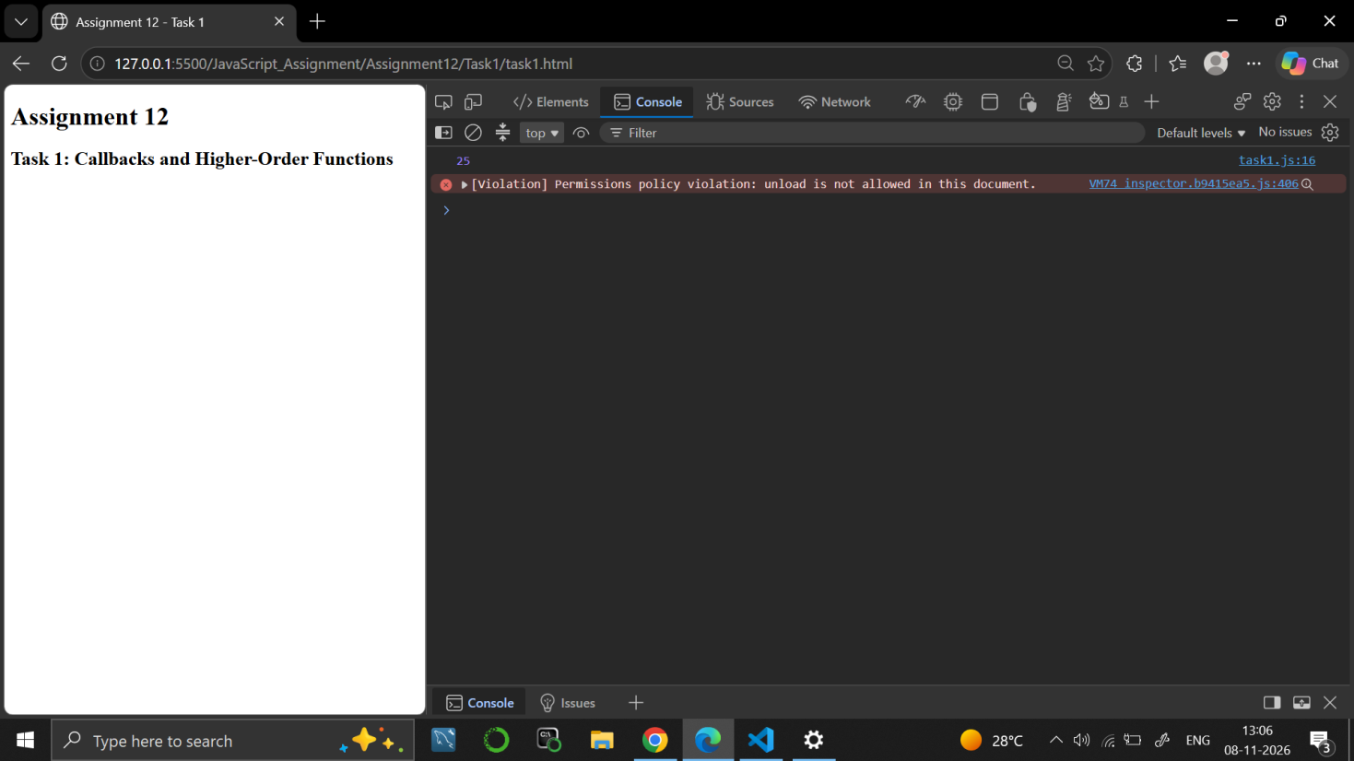

Task 2
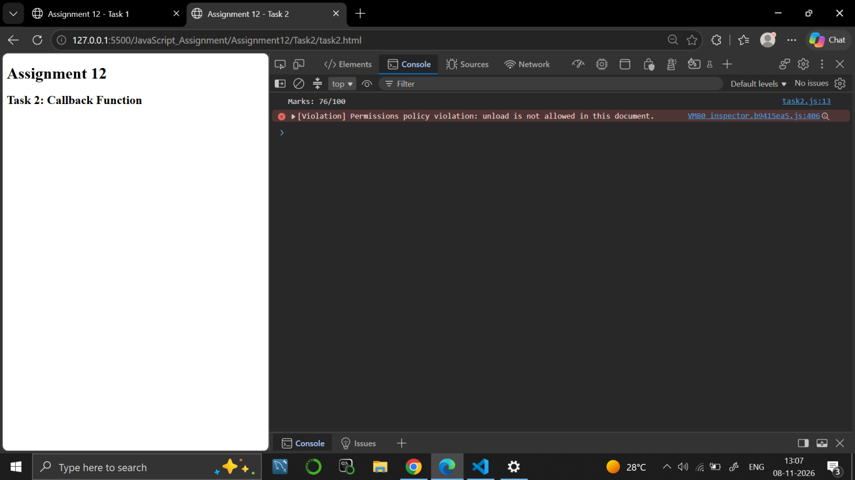

Task 3
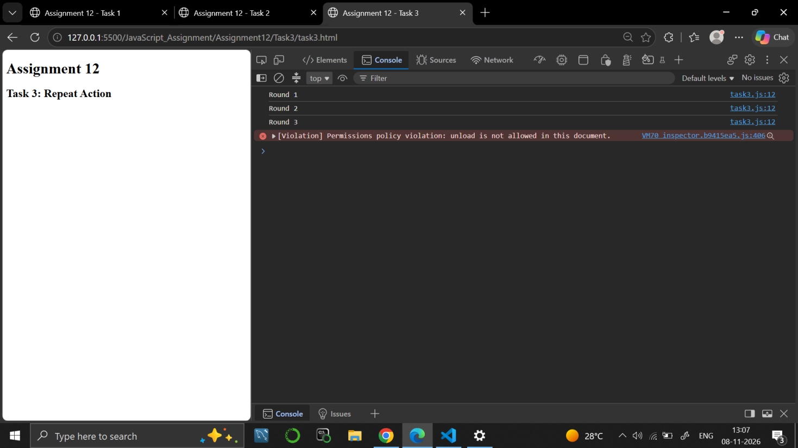

9. RESULT
JavaScript programs were written to pass functions as arguments and to call them as callbacks inside other functions.

10. VIVA-VOCE QUESTIONS
- What is a callback function?
- What is a higher-order function?
- Why can a function be passed as an argument in JavaScript?
- What does applyTwice() do with the function it receives?
- How is a callback useful in repeatAction()?

EXPERIMENT NO. 13
Course: BCS354

1. EXPERIMENT TITLE
Reduce, Some, Every and Map

2. AIM
To use reduce, some, every and map on arrays, and to keep the original array unchanged.

3. SOFTWARE / TOOLS REQUIRED
Web browser (Google Chrome / Microsoft Edge / Firefox) with the developer console (F12); Node.js; a code editor such as VS Code.

4. THEORY
reduce() combines all the items of an array into one value using a function and a starting value. some() returns true if at least one item passes a test, and every() returns true only if all items pass the test. map() creates a new array by applying a function to every item. map() does not change the original array.

5. ALGORITHM / PROCEDURE
Task 1
- Start.
- Create the array prices with 120, 45 and 300.
- Use reduce with the starting value 0 to add every price to the sum.
- Print the total.
- Stop.
Task 2
- Start.
- Create the array marks with 72, 85, 30 and 90.
- Use some to check whether any mark is below 40 and store the answer in below40.
- Use every to check whether all marks are 35 or more and store the answer in above35.
- Print both answers with their labels.
- Stop.
Task 3
- Start.
- Create the array marks with 72, 85, 64 and 90.
- Use map to create newMarks in which every mark is increased by 5.
- Print newMarks.
- Print the original marks array.
- Stop.

6. PROGRAM / QUERIES / COMMANDS
Task 1
– task1.html
<!DOCTYPE html>
<html lang="en">

<head>
<meta charset="UTF-8">
<meta name="viewport" content="width=device-width, initial-scale=1.0">
<title>Assignment 13 - Task 1</title>
</head>

<body>

<h1>Assignment 13</h1>
<h2>Task 1: Reduce Method</h2>

<script src="task1.js"></script>

</body>

</html>

– task1.js
// Name: Dhruv Saxena
// Roll No: BSC2025626
// Assignment: 13 - Task 1

let prices = [120, 45, 300];

let total = prices.reduce((sum, price) => {
return sum + price;
}, 0);

console.log("Total Price:", total);

Task 2
– task2.html
<!DOCTYPE html>
<html lang="en">

<head>
<meta charset="UTF-8">
<meta name="viewport" content="width=device-width, initial-scale=1.0">
<title>Assignment 13 - Task 2</title>
</head>

<body>

<h1>Assignment 13</h1>
<h2>Task 2: Some and Every Methods</h2>

<script src="task2.js"></script>

</body>

</html>

– task2.js
// Name: Dhruv Saxena
// Roll No: BSC2025626
// Assignment: 13 - Task 2

let marks = [72, 85, 30, 90];

let below40 = marks.some(mark => mark < 40);

let above35 = marks.every(mark => mark >= 35);

console.log("Any mark below 40:", below40);
console.log("All marks are 35 or more:", above35);

Task 3
– task3.html
<!DOCTYPE html>
<html lang="en">

<head>
<meta charset="UTF-8">
<meta name="viewport" content="width=device-width, initial-scale=1.0">
<title>Assignment 13 - Task 3</title>
</head>

<body>

<h1>Assignment 13</h1>
<h2>Task 3: Map Method</h2>

<script src="task3.js"></script>

</body>

</html>

– task3.js
// Name: Dhruv Saxena
// Roll No: BSC2025626
// Assignment: 13 - Task 3

let marks = [72, 85, 64, 90];

let newMarks = marks.map(mark => mark + 5);

console.log("New Marks:", newMarks);

console.log("Original Marks:", marks);

7. INPUT
No user input is taken. All values are fixed inside the programs: prices 120, 45 and 300 in Task 1; marks 72, 85, 30 and 90 in Task 2; marks 72, 85, 64 and 90 in Task 3.

8. OUTPUT
Task 1
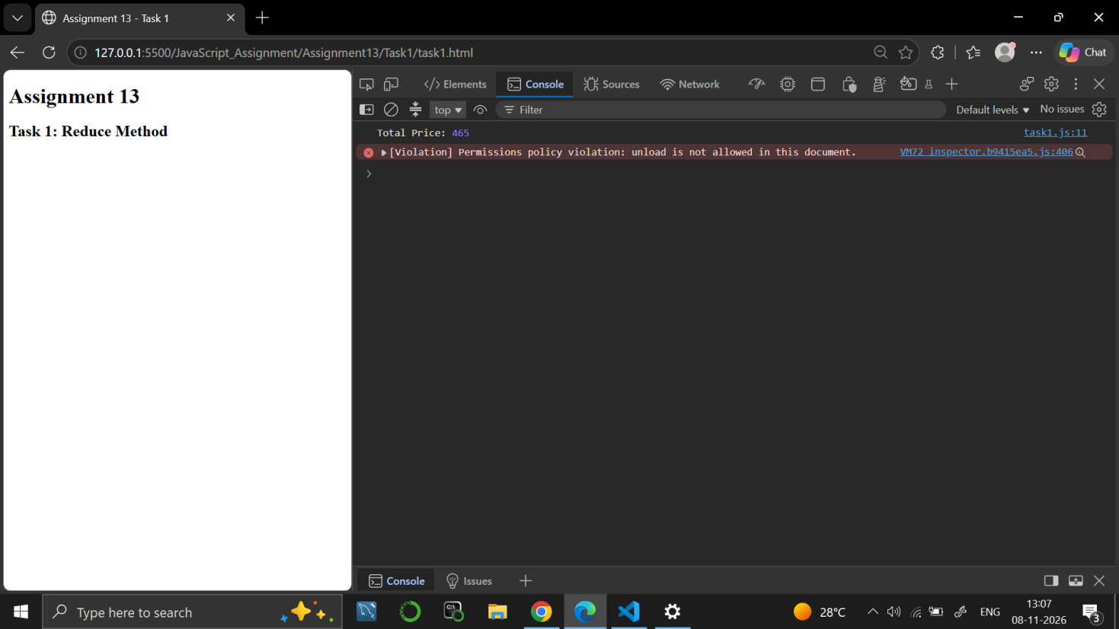

Task 2
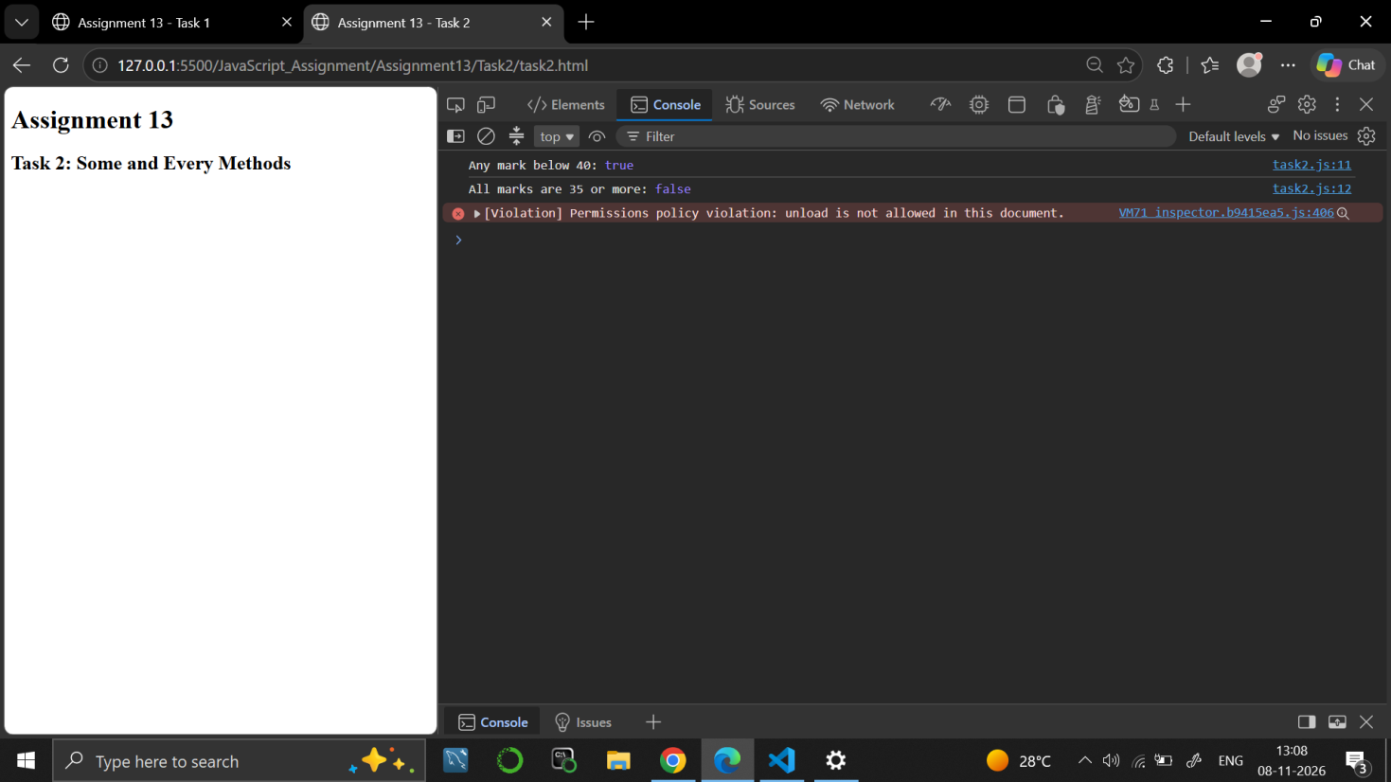

Task 3
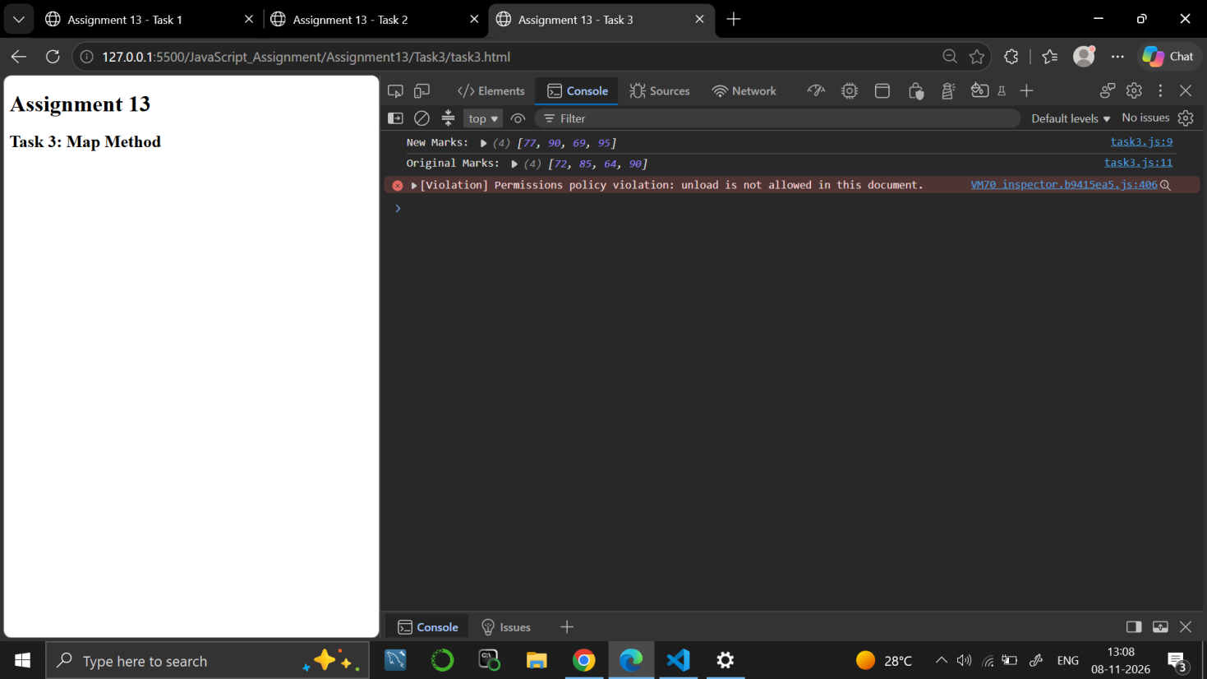

9. RESULT
JavaScript programs were written to use reduce, some, every and map on arrays, with the original array kept unchanged.

10. VIVA-VOCE QUESTIONS
- What does the reduce() method do?
- What is the difference between some() and every()?
- What does map() return?
- Does map() change the original array?
- Why is 0 given as the starting value in reduce()?

EXPERIMENT NO. 14
Course: BCS354

1. EXPERIMENT TITLE
Timers and Intervals

2. AIM
To run code after a delay with setTimeout, to cancel a timer, and to repeat code with setInterval.

3. SOFTWARE / TOOLS REQUIRED
Web browser (Google Chrome / Microsoft Edge / Firefox) with the developer console (F12); Node.js; a code editor such as VS Code.

4. THEORY
setTimeout() runs a function once after a delay given in milliseconds, and clearTimeout() cancels it using the id that setTimeout() returns. setInterval() runs a function again and again after every interval, and clearInterval() stops it. JavaScript finishes the current code first and runs timer callbacks afterwards, even when the delay is 0.

5. ALGORITHM / PROCEDURE
Task 1
- Start.
- Print "Start".
- Use setTimeout with a delay of 0 to schedule a function that prints "Timer done".
- Print "End".
- Note the order in which the three lines appear.
- Stop.
Task 2
- Start.
- Use setTimeout with a delay of 1000 milliseconds to schedule the message "Not shown" and keep its id in timerId.
- Cancel the timer with clearTimeout(timerId).
- Print "Cancelled".
- Stop.
Task 3
- Start.
- Set count = 0.
- Use setInterval with 200 milliseconds: in each call increase count by 1 and print "Tick" with count.
- When count is 3, stop the interval with clearInterval.
- Stop.

6. PROGRAM / QUERIES / COMMANDS
Task 1
– task1.html
<!DOCTYPE html>
<html lang="en">
<head>
<meta charset="UTF-8">
<meta name="viewport" content="width=device-width, initial-scale=1.0">
<title>Task 1 - setTimeout</title>
</head>
<body>

<h1>JavaScript setTimeout</h1>

<script src="task1.js"></script>

</body>
</html>

– task1.js
// Name: Dhruv Saxena
// Roll No: BCS2025626
// Assignment 14 - Task 1

console.log("Start");

setTimeout(() => {
console.log("Timer done");
}, 0);

console.log("End");

Task 2
– task2.html
<!DOCTYPE html>
<html lang="en">
<head>
<meta charset="UTF-8">
<meta name="viewport" content="width=device-width, initial-scale=1.0">
<title>Task 2 - clearTimeout</title>
</head>
<body>

<h1>JavaScript clearTimeout</h1>

<script src="task2.js"></script>

</body>
</html>

– task3.js
// Name: Dhruv Saxena
// Roll No: BCS2025626
// Assignment 14 - Task 2

let timerId = setTimeout(() => {
console.log("Not shown");
}, 1000);

clearTimeout(timerId);

console.log("Cancelled");

Task 3
– task3.html
<!DOCTYPE html>
<html lang="en">
<head>
<meta charset="UTF-8">
<meta name="viewport" content="width=device-width, initial-scale=1.0">
<title>Task 3 - setInterval</title>
</head>
<body>

<h1>JavaScript setInterval</h1>

<script src="task3.js"></script>

</body>
</html>

– task3.js
// Name: Dhruv Saxena
// Roll No: BCS2025626
// Assignment 14 - Task 3

let count = 0;

let intervalId = setInterval(() => {
count++;

console.log("Tick", count);

if (count === 3) {
clearInterval(intervalId);
}
}, 200);

7. INPUT
No user input is taken. All values are fixed inside the programs: delay 0 in Task 1; delay 1000 milliseconds in Task 2; interval 200 milliseconds and stop count 3 in Task 3.

8. OUTPUT
Task 1
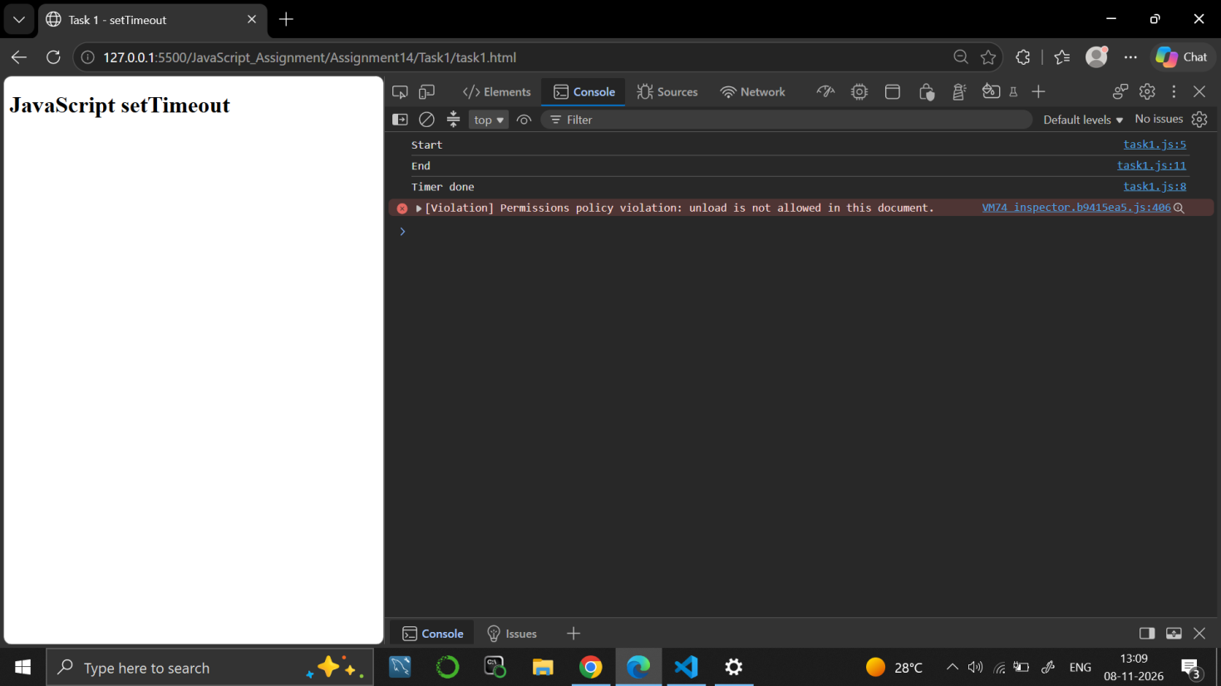

Task 2
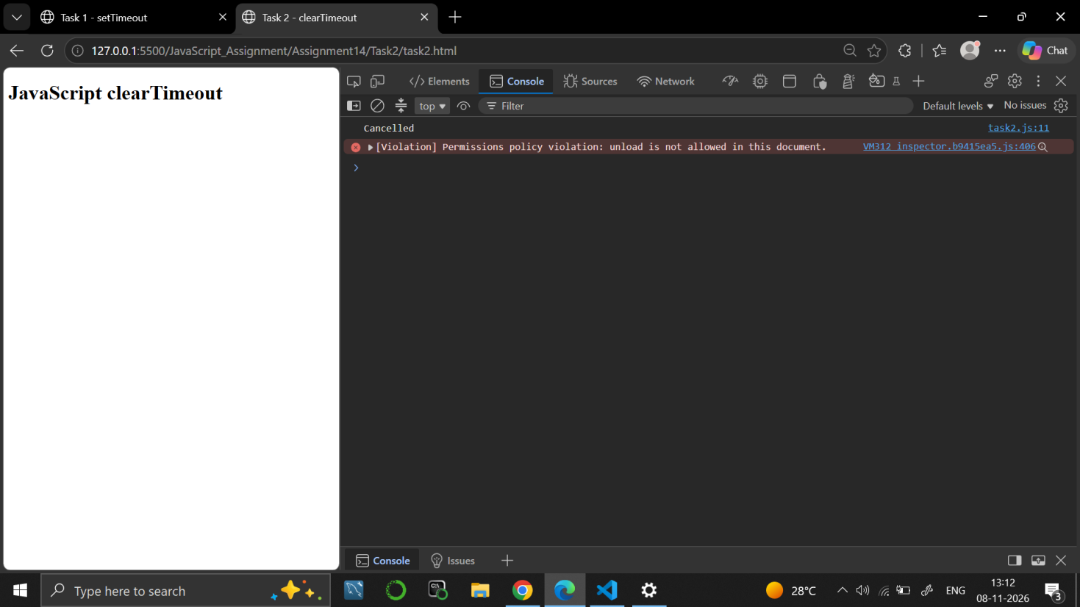

Task 3
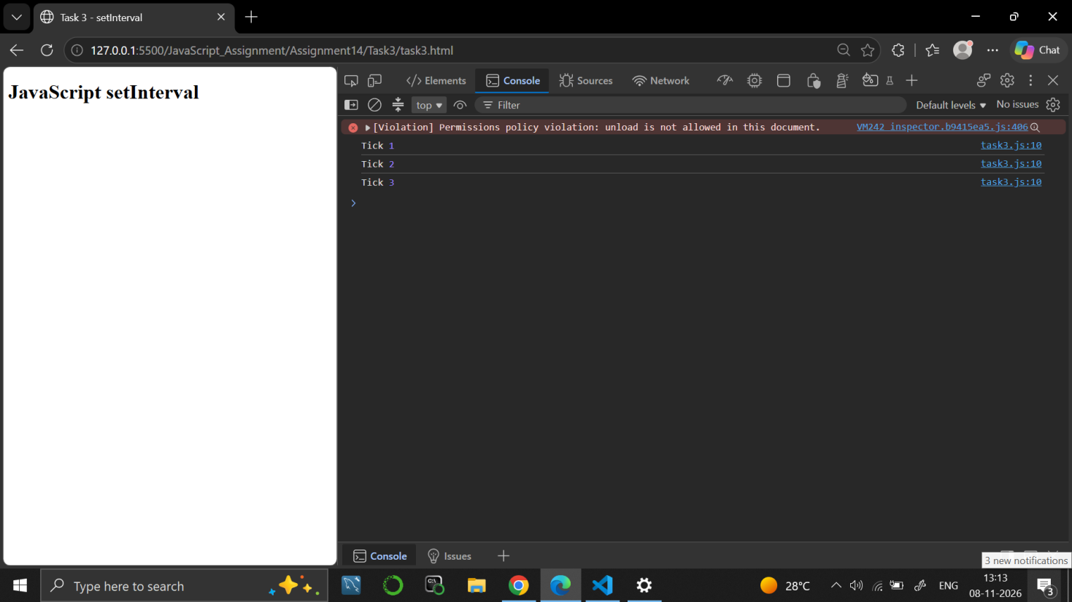

9. RESULT
JavaScript programs were written to run code after a delay with setTimeout, to cancel a timer with clearTimeout and to repeat code with setInterval and stop it with clearInterval.

10. VIVA-VOCE QUESTIONS
- What is the use of setTimeout()?
- How do you cancel a timer?
- What is the difference between setTimeout() and setInterval()?
- Why does a timer with delay 0 run after the other lines of code?
- How is setInterval() stopped?

EXPERIMENT NO. 15
Course: BCS354

1. EXPERIMENT TITLE
Promises and async/await with Local Data

2. AIM
To create a Promise that resolves or rejects, to use async/await with try and catch, and to load local data as a Promise.

3. SOFTWARE / TOOLS REQUIRED
Web browser (Google Chrome / Microsoft Edge / Firefox) with the developer console (F12); Node.js; a code editor such as VS Code.

4. THEORY
A Promise represents a value that will be available later. It is resolved when the work succeeds and rejected when it fails. then() handles the resolved value and catch() handles the error. An async function always returns a Promise, and the await keyword waits for a Promise to finish inside it. Errors from an awaited Promise are handled with try and catch.

5. ALGORITHM / PROCEDURE
Task 1
- Start.
- Define checkMarks(marks) that returns a new Promise.
- Inside it, if marks is between 0 and 100, resolve with marks; otherwise reject with Error("Marks out of range").
- Call checkMarks(80) and use then to print the value.
- Stop.
Task 2
- Start.
- Define checkMarks(marks) in the same way, using resolve and reject.
- Call checkMarks(120).
- Use catch to print error.message when the Promise is rejected.
- Stop.
Task 3
- Start.
- Define checkMarks(marks) in the same way.
- Define the async function run() with a try block that prints await checkMarks(65) and then awaits checkMarks(-5).
- In the catch block, print "Caught:" with error.message.
- Call run().
- Stop.
Task 4
- Start.
- Define getUsers() that returns a Promise which resolves after 100 milliseconds with an array of three users (id and name: Asha, Rohan, Meera).
- Define the async function showUsers() that awaits getUsers().
- Use forEach to print the name of each user.
- Call showUsers().
- Stop.

6. PROGRAM / QUERIES / COMMANDS
Task 1
– task1.html
<!DOCTYPE html>
<html lang="en">
<head>
<meta charset="UTF-8">
<meta name="viewport" content="width=device-width, initial-scale=1.0">
<title>Task 1 - Promise Resolve</title>
</head>
<body>

<h1>Promise Resolve</h1>

<script src="task1.js"></script>

</body>
</html>

– task1.js
// Name: Dhruv Saxena
// Roll No: BCS2025626
// Assignment 15 - Task 1

function checkMarks(marks) {
return new Promise((resolve, reject) => {
if (marks >= 0 && marks <= 100) {
resolve(marks);
}
else {
reject(new Error("Marks out of range"));
}
});
}

checkMarks(80)
.then((result) => {
console.log(result);
});

Task 2
– task2.html
<!DOCTYPE html>
<html lang="en">
<head>
<meta charset="UTF-8">
<meta name="viewport" content="width=device-width, initial-scale=1.0">
<title>Task 2 - Promise Reject</title>
</head>
<body>

<h1>Promise Reject</h1>

<script src="task2.js"></script>

</body>
</html>

– task2.js
// Name: Dhruv Saxena
// Roll No: BCS2025626
// Assignment 15 - Task 2

function checkMarks(marks) {
return new Promise((resolve, reject) => {
if (marks >= 0 && marks <= 100) {
resolve(marks);
}
else {
reject(new Error("Marks out of range"));
}
});
}

checkMarks(120)
.catch((error) => {
console.log(error.message);
});

Task 3
– task3.html
<!DOCTYPE html>
<html lang="en">
<head>
<meta charset="UTF-8">
<meta name="viewport" content="width=device-width, initial-scale=1.0">
<title>Task 3 - Async Await</title>
</head>
<body>

<h1>Async Await with Try and Catch</h1>

<script src="task3.js"></script>

</body>
</html>

– task3.js
// Name: Dhruv Saxena
// Roll No: BCS2025626
// Assignment 15 - Task 3

function checkMarks(marks) {
return new Promise((resolve, reject) => {
if (marks >= 0 && marks <= 100) {
resolve(marks);
}
else {
reject(new Error("Marks out of range"));
}
});
}

async function run() {
try {
console.log(await checkMarks(65));

await checkMarks(-5);
}
catch (error) {
console.log("Caught:", error.message);
}
}

run();

Task 4
– task4.html
<!DOCTYPE html>
<html lang="en">
<head>
<meta charset="UTF-8">
<meta name="viewport" content="width=device-width, initial-scale=1.0">
<title>Task 4 - Local Users</title>
</head>
<body>

<h1>Local Users Data</h1>

<script src="task4.js"></script>

</body>
</html>

– task4.js
// Name: Dhruv Saxena
// Roll No: BCS2025626
// Assignment 15 - Task 4

function getUsers() {
return new Promise((resolve) => {
setTimeout(() => {
const users = [
{ id: 1, name: "Asha" },
{ id: 2, name: "Rohan" },
{ id: 3, name: "Meera" }
];

resolve(users);
}, 100);
});
}

async function showUsers() {
const users = await getUsers();

users.forEach((user) => {
console.log(user.name);
});
}

showUsers();

7. INPUT
No user input is taken. All values are fixed inside the programs: marks 80 in Task 1; marks 120 in Task 2; marks 65 and -5 in Task 3; the users Asha, Rohan and Meera in Task 4.

8. OUTPUT
Task 1
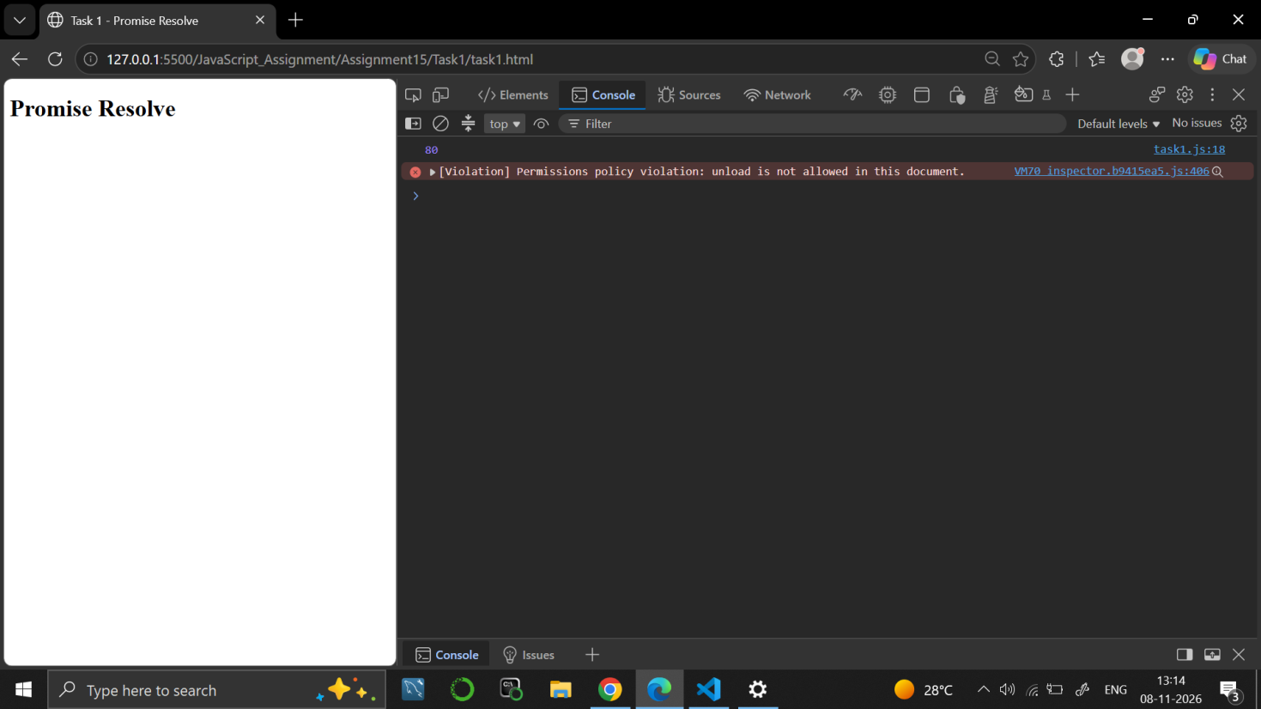

Task 2
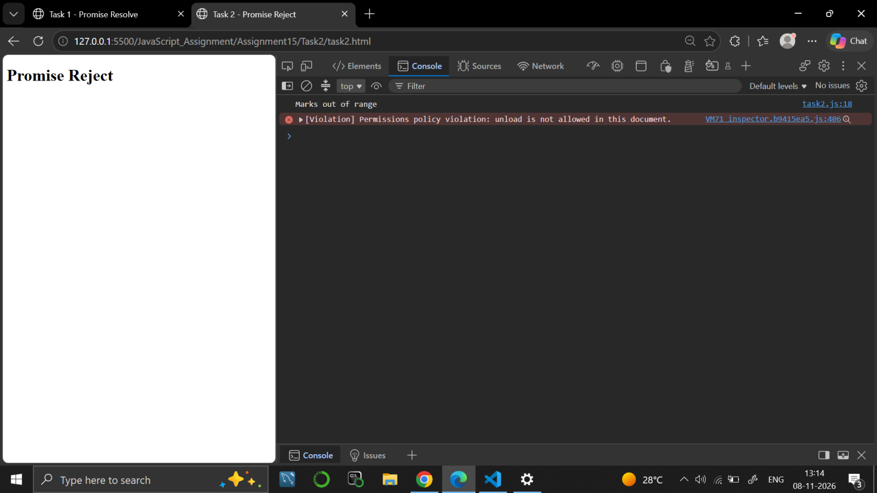

Task 3
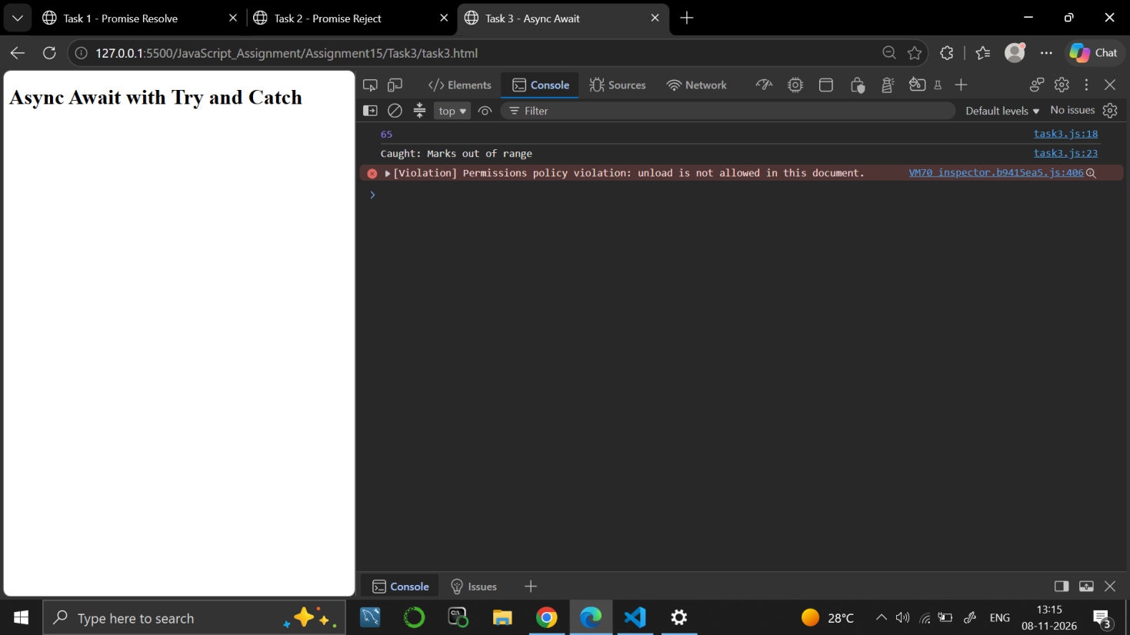

Task 4
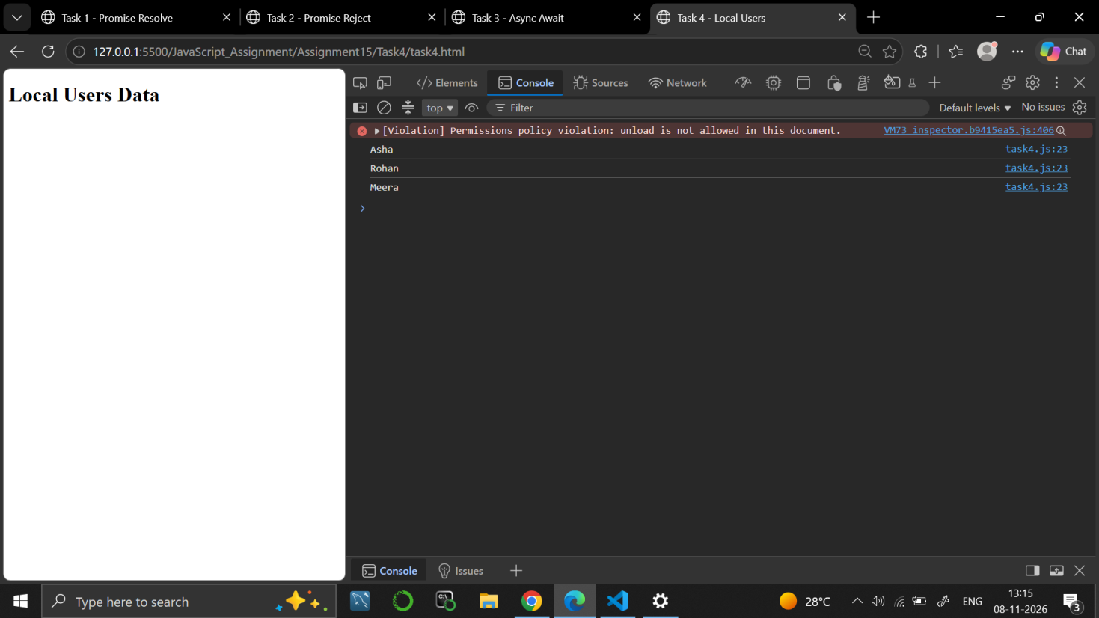

9. RESULT
JavaScript programs were written to create Promises that resolve or reject, to use async/await with try and catch, and to load local data as a Promise.

10. VIVA-VOCE QUESTIONS
- What is a Promise?
- What is the difference between resolve and reject?
- What does the await keyword do?
- What is the use of try and catch with async/await?
- What does an async function return?

