
INTRODUCTION TO PROGRAMMING USING JAVA LAB (BCS351)
B.Tech CSE 3rd SEMESTER

SUBMITTED TO: | SUBMITTED BY:
Mr. Laraib Ahmad | Dhruv Saxena  Section: C  ID: BCS2025626

INDEX
Name: Dhruv Saxena Roll No.: BCS2025626 Section: C
SN. | PROGRAM NAME | PAGE | DATE | SIGNATURE
1 | Hello World, Variables and Arithmetic Operations | 3
2 | Decisions and Loops with Numbers | 8
3 | Star and Number Patterns using Nested Loops | 13
4 | Writing Functions (nCr, nPr, maxOf) | 19
5 | Arrays: Traversal, Sum, Max, and Count Conditions | 24
6 | Arrays: Reverse Printing, Min Value, and Duplicates | 29
7 | Counting Steps and Time Complexity Analysis | 34
8 | Matrices: Transpose and Row Sums | 39
9 | Matrices: Rows and Columns Operations | 45
10 | Switch Statement and ArrayList Manipulation | 51
11 | Bubble Sort and Selection Sort Algorithms | 57
12 | Insertion Sort and Shift Counting | 63
13 | Strings: Built-in Methods, Reversal, and Palindromes | 69
14 | Characters: Counting Vowels, Letters and Positions | 74
15 | StringBuilder Class Methods (append, insert, delete) | 79

EXPERIMENT NO. 1
Course: BCS351

1. EXPERIMENT TITLE
Hello World, Variables and Arithmetic Operations

2. AIM
To print text, store values in variables and calculate with arithmetic operators.

3. SOFTWARE / TOOLS REQUIRED
Java Development Kit (JDK 8 or higher); an IDE (Eclipse / IntelliJ IDEA / VS Code / NetBeans) or the command line (javac and java).

4. THEORY
Every Java program starts execution from the main method inside a class. System.out.println() prints text followed by a new line. A variable stores a value and has a data type such as int, double, char or String. The arithmetic operators are +, -, *, / and % (remainder). When two int values are divided, the result is also an int, so the decimal part is dropped.

5. ALGORITHM / PROCEDURE
Task 1
- Start.
- Print "Hello World".
- Print "Welcome to Java".
- Stop.
Task 2
- Start.
- Declare int roll = 101, double percentage = 84.5, char section = 'B' and String name = "Asha".
- Print each value after its label (Roll, Percentage, Section, Name).
- Stop.
Task 3
- Start.
- Declare int a = 17 and int b = 5.
- Calculate a + b, a - b, a * b, a / b and a % b.
- Print each result after its label (Sum, Difference, Product, Quotient, Remainder).
- Stop.

6. PROGRAM / QUERIES / COMMANDS
Task 1 – task1.java
public class task1 {
public static void main(String[] args) {
System.out.println("Hello World");
System.out.println("Welcome to Java");
}
}

//Output//
// Hello World
// Welcome to Java

Task 2 – task2.java
public class task2 {
public static void main(String[] args) {
int roll = 101;
double percentage = 84.5;
char section = 'B';
String name = "Asha";

System.out.println("Roll: "+ roll);
System.out.println("Percentage: "+percentage);
System.out.println("Section: " +section);
System.out.println("Name: "+name);
}
}
//Output//
// Roll: 101
// Percentage: 84.5
// Section: B
// Name: Asha

Task 3 – task3.java
public class task3 {
public static void main(String[] args) {
int a = 17;
int b = 5;
System.out.println("Sum: " +(a + b));
System.out.println("Difference: " +(a - b));
System.out.println("Product: " +(a * b));
System.out.println("Quotient: " +(a / b));
System.out.println("Remainder: "+(a % b));
}
}

// Output //
// Sum: 22
// Difference: 12
// Product: 85
// Quotient: 3
// Remainder: 2

7. INPUT
No user input is taken. All values are fixed inside the programs: roll = 101, percentage = 84.5, section = 'B', name = "Asha"; a = 17, b = 5.

8. OUTPUT
Task 1
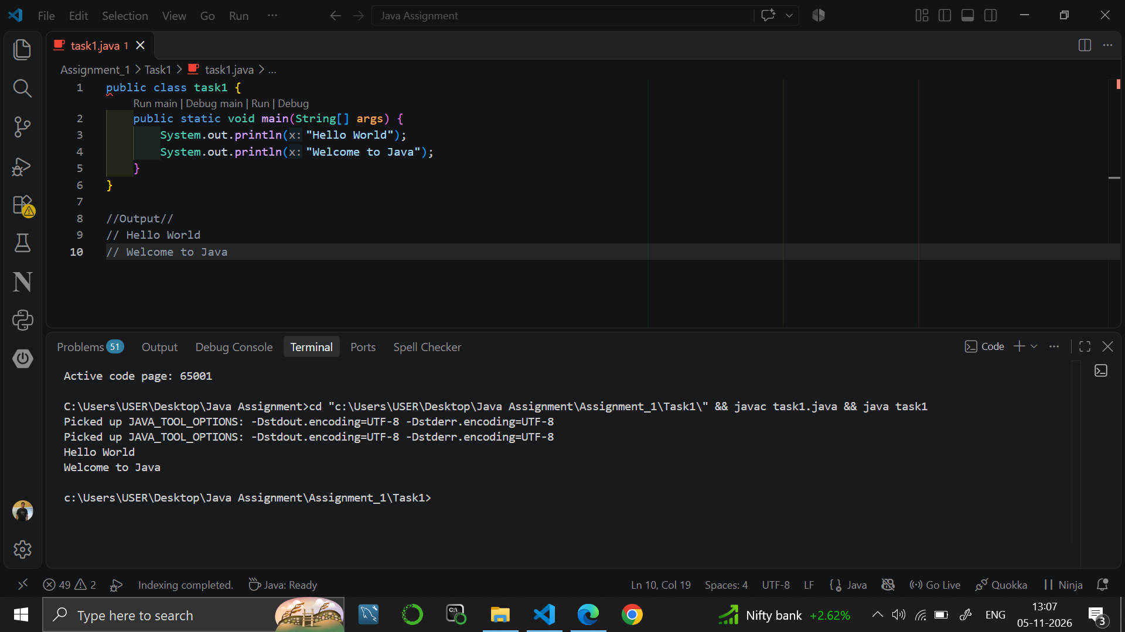

Task 2
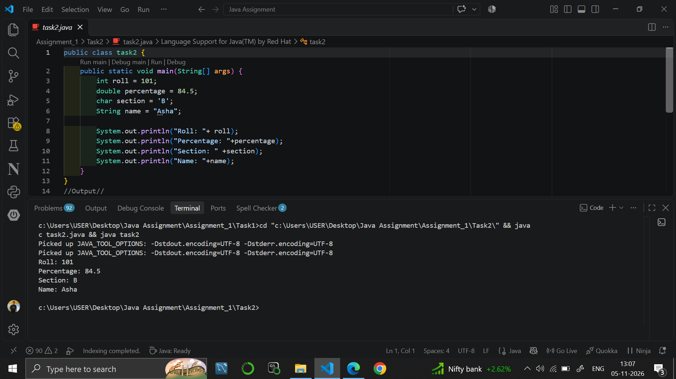

Task 3
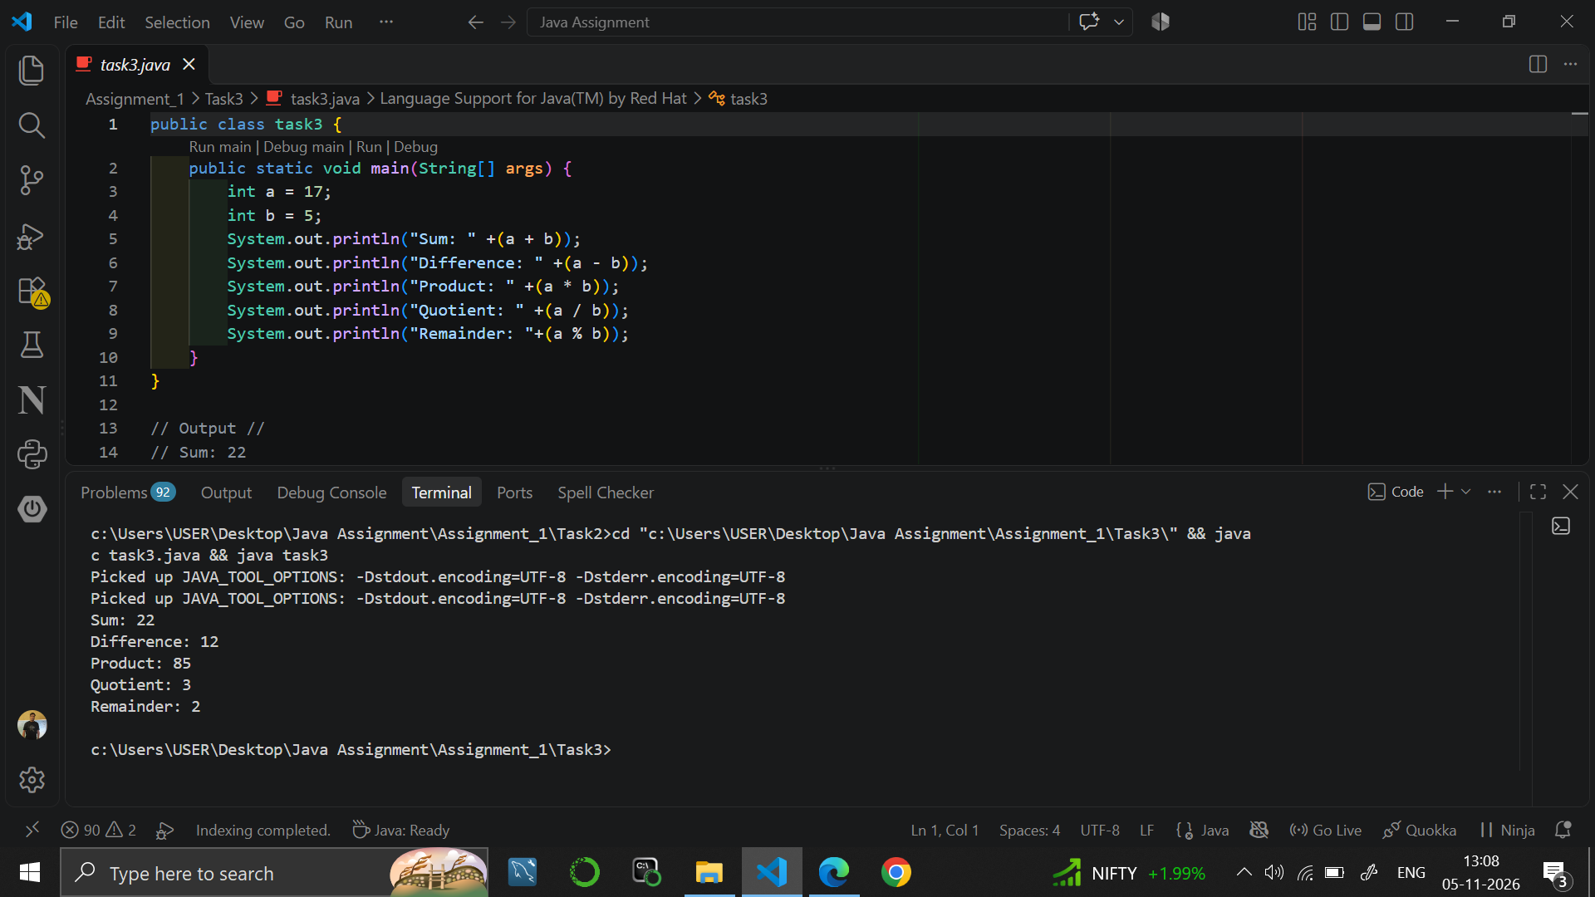

9. RESULT
Java programs were written to print text, to store values in variables of different data types, and to perform the five arithmetic operations on two integers.

10. VIVA-VOCE QUESTIONS
- What is the role of the main method in a Java program?
- Name the data types used in this experiment.
- Why does 17 / 5 give 3 and not 3.4?
- What does the % operator do?
- What is the difference between System.out.println() and System.out.print()?

EXPERIMENT NO. 2
Course: BCS351

1. EXPERIMENT TITLE
Decisions and Loops with Numbers

2. AIM
To use if, else if and loops to make decisions and repeat steps with whole numbers.

3. SOFTWARE / TOOLS REQUIRED
Java Development Kit (JDK 8 or higher); an IDE (Eclipse / IntelliJ IDEA / VS Code / NetBeans) or the command line (javac and java).

4. THEORY
Decision statements (if-else and the else-if ladder) run a block of code depending on a condition. The logical operators && (AND) and || (OR) combine conditions. A for loop repeats a block a fixed number of times using an initialisation, a condition and an update. The remainder operator % is commonly used to test divisibility.

5. ALGORITHM / PROCEDURE
Task 1
- Start.
- Store 27 in n.
- If n % 2 == 0, print n followed by "is even".
- Otherwise, print n followed by "is odd".
- Stop.
Task 2
- Start.
- Store 83 in marks.
- If marks >= 90, print "Grade: A".
- Else if marks >= 75, print "Grade: B".
- Otherwise, print "Grade: C".
- Stop.
Task 3
- Start.
- Store 2024 in year.
- If (year % 4 == 0 and year % 100 != 0) or year % 400 == 0, print "Leap year".
- Otherwise, print "Not a leap year".
- Stop.
Task 4
- Start.
- Set fact = 1.
- Repeat for i = 1 to 5: fact = fact * i.
- Print "Factorial of 5 is " followed by fact.
- Stop.

6. PROGRAM / QUERIES / COMMANDS
Task 1 – task1.java
public class task1 {
public static void main(String[] args) {
int n = 27;

if (n % 2 == 0) {
System.out.println(n + " is even");
} else {
System.out.println(n + " is odd");
}
}
}

// Output //
// 27 is odd

Task 2 – task2.java
public class task2 {
public static void main(String[] args) {
int marks = 83;

if (marks >= 90) {
System.out.println("Grade: A");
}
else if (marks >= 75) {
System.out.println("Grade: B");
}
else {
System.out.println("Grade: C");
}
}
}

//Output//
// Grade: B

Task 3 – task3.java
public class task3 {
public static void main(String[] args) {
int year = 2024;

if ((year % 4 == 0 && year % 100 != 0) || year % 400 == 0) {
System.out.println("Leap year");
}
else {
System.out.println("Not a leap year");
}
}
}
//Output//
// Leap year

Task 4 – task4.java
public class task4 {
public static void main(String[] args) {
int fact = 1;
for (int i = 1; i <= 5; i++) {
fact = fact * i;
}
System.out.println("Factorial of 5 is " +fact);
}
}
//Output//
//Factorial of 5 is 120

7. INPUT
No user input is taken. All values are fixed inside the programs: n = 27; marks = 83; year = 2024; the factorial is calculated for 5.

8. OUTPUT
Task 1
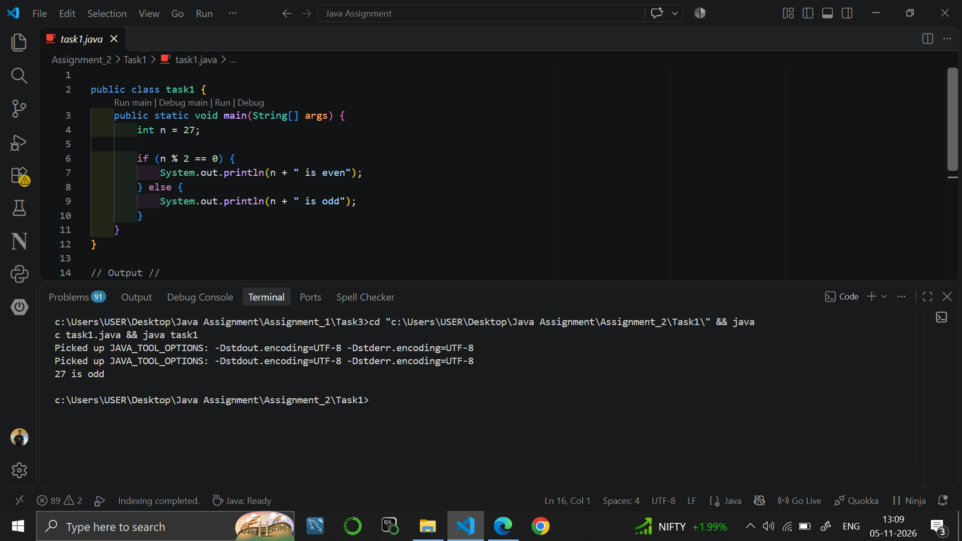

Task 2
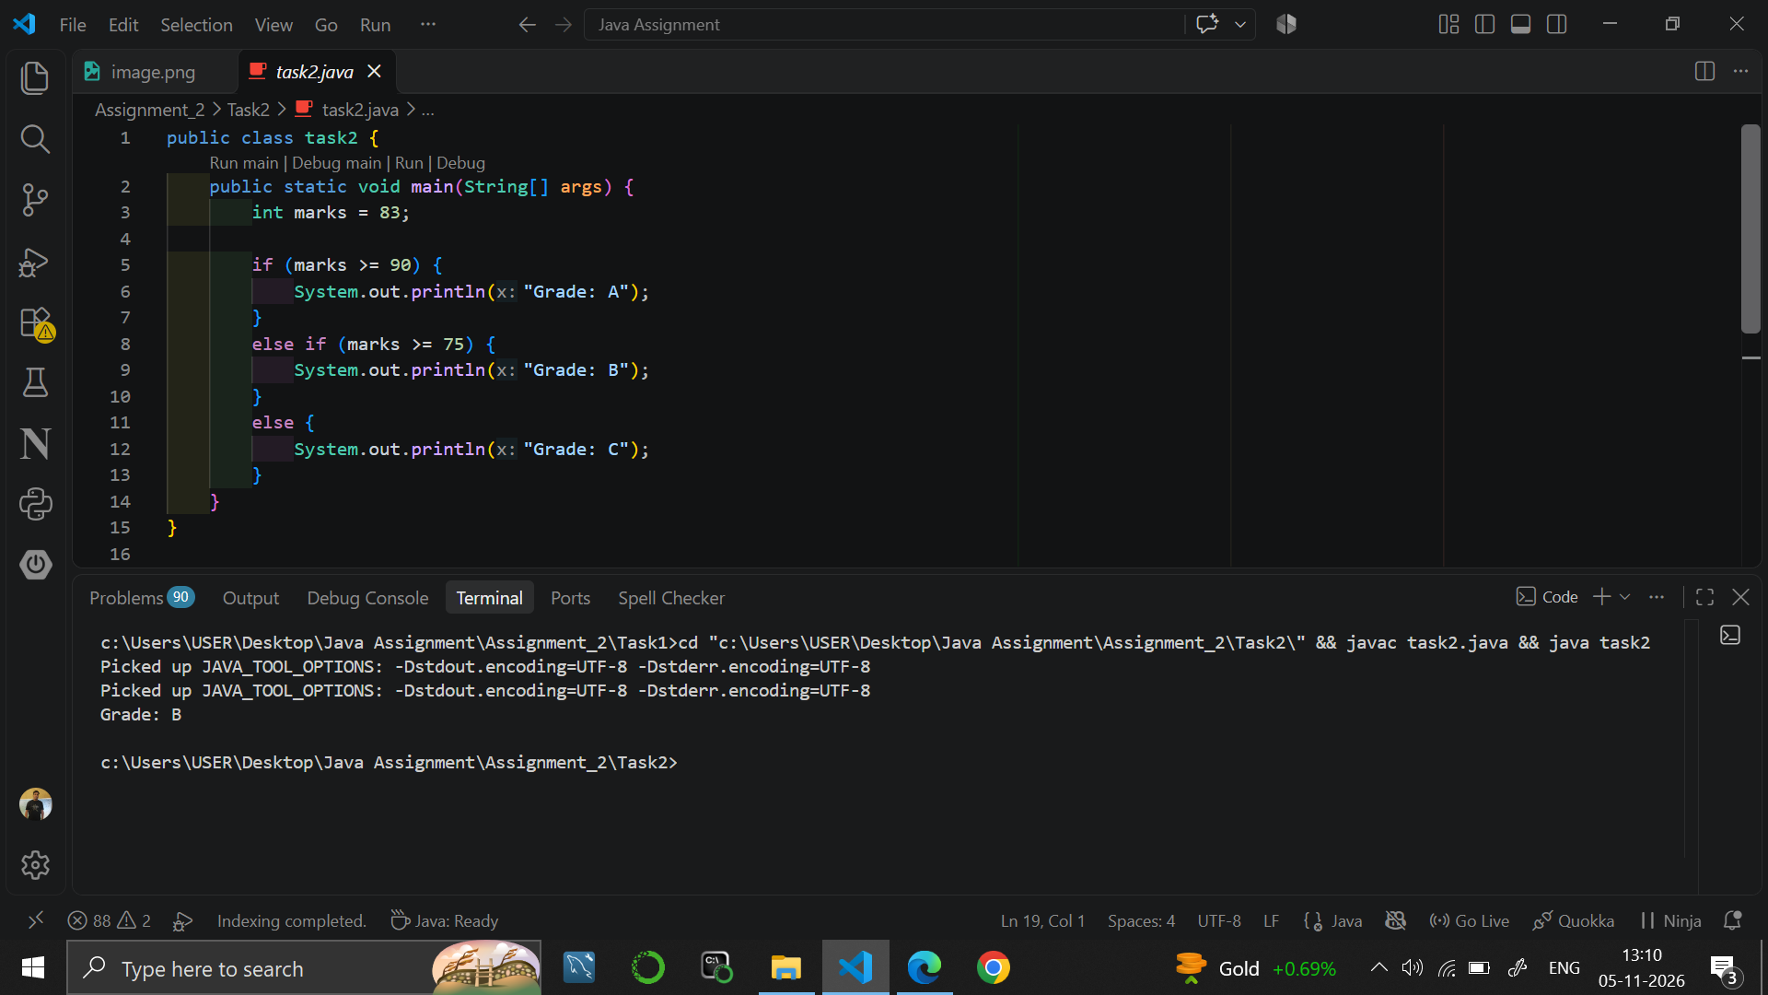

Task 3
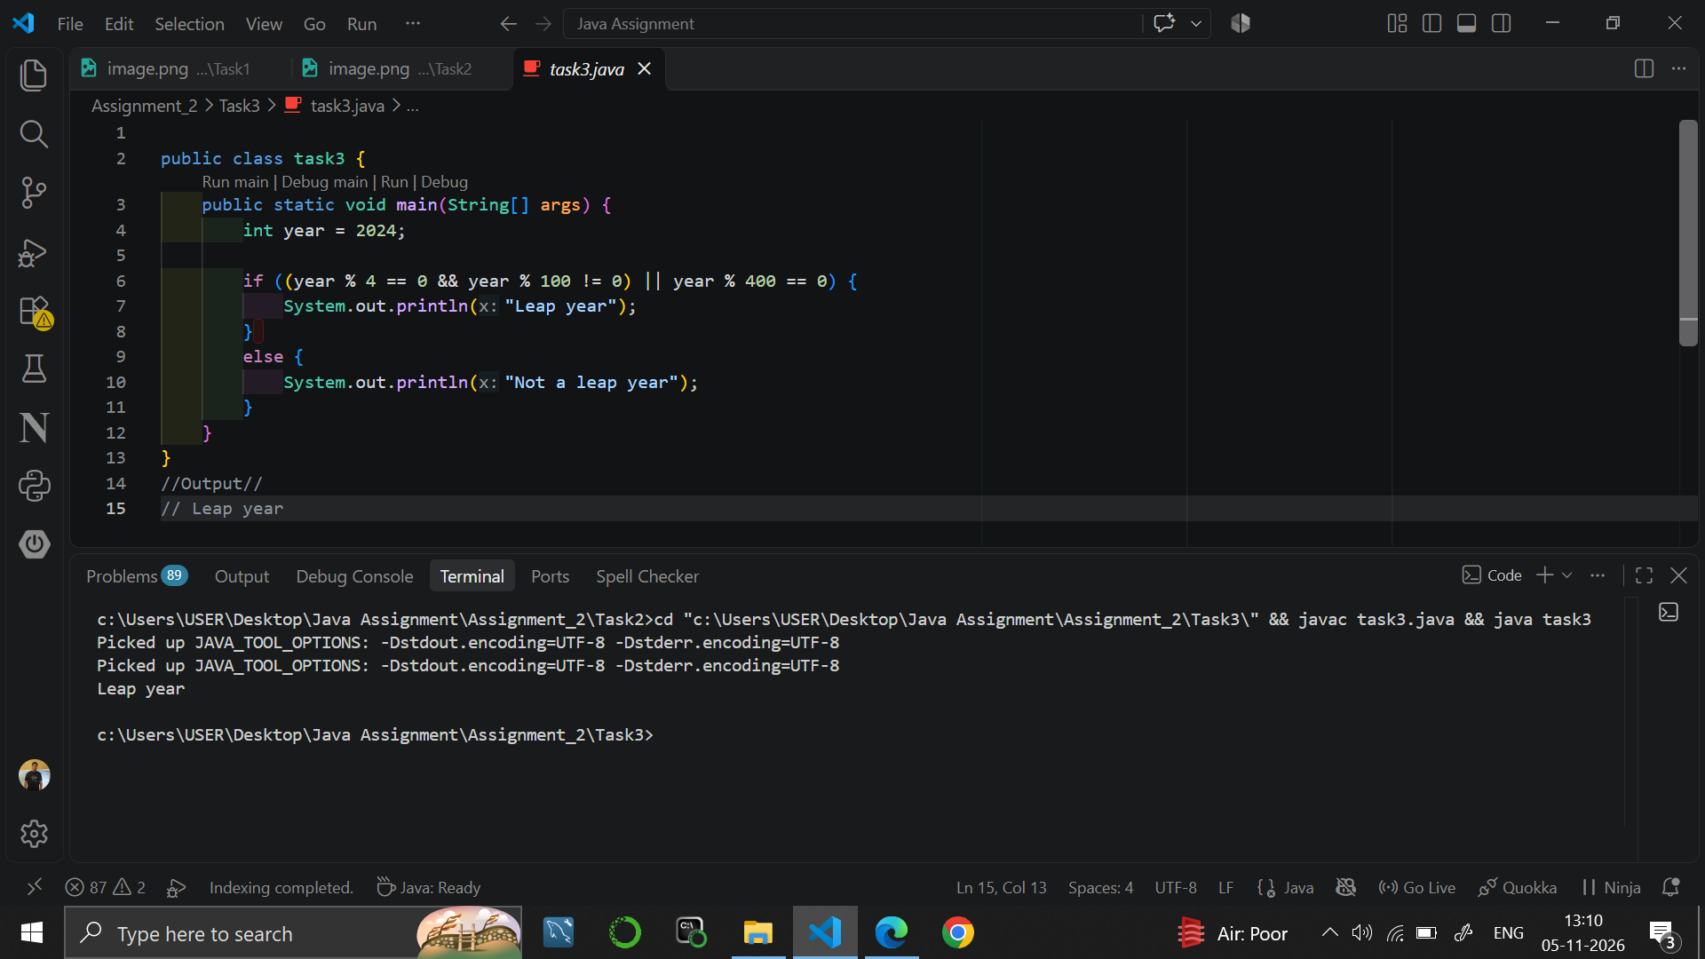

Task 4
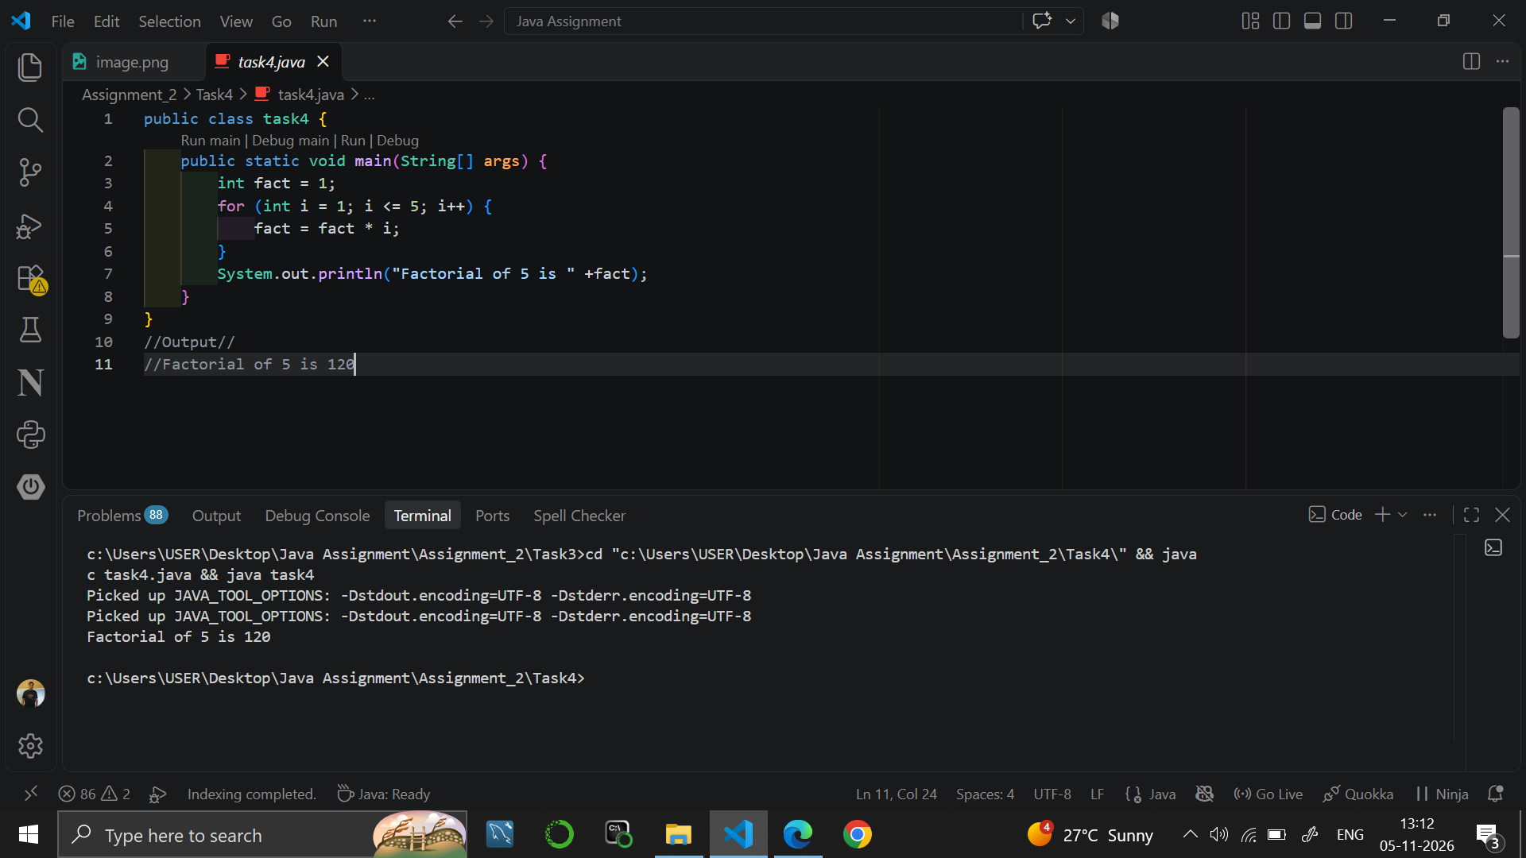

9. RESULT
Java programs were written to check even/odd, to assign a grade with an else-if ladder, to check a leap year, and to find a factorial using a for loop.

10. VIVA-VOCE QUESTIONS
- What is the difference between if-else and an else-if ladder?
- How do you check whether a number is even or odd?
- What is the rule for a leap year?
- What are the three parts of a for loop?
- Why is the variable fact initialised to 1 and not 0?

EXPERIMENT NO. 3
Course: BCS351

1. EXPERIMENT TITLE
Star and Number Patterns using Nested Loops

2. AIM
To use a loop inside another loop to print stars and numbers in rows.

3. SOFTWARE / TOOLS REQUIRED
Java Development Kit (JDK 8 or higher); an IDE (Eclipse / IntelliJ IDEA / VS Code / NetBeans) or the command line (javac and java).

4. THEORY
A nested loop is a loop placed inside another loop. The outer loop controls the rows and the inner loop controls the items printed in each row. System.out.print() prints without moving to a new line, and System.out.println() with no argument moves to the next line after a row is complete. Changing the limit of the inner loop gives different shapes.

5. ALGORITHM / PROCEDURE
Task 1
- Start.
- Repeat for i = 1 to 4 (rows).
- Repeat for j = 1 to 4 and print "*".
- After the inner loop, move to a new line.
- Stop.
Task 2
- Start.
- Repeat for i = 1 to 4 (rows).
- Repeat for j = 1 to i and print "*".
- After the inner loop, move to a new line.
- Stop.
Task 3
- Start.
- Repeat for i = 1 to 4 (rows).
- Repeat for j = 1 to i and print j followed by a space.
- After the inner loop, move to a new line.
- Stop.
Task 4
- Start.
- Repeat for i = 4 down to 1 (rows).
- Repeat for j = 1 to i and print "*".
- After the inner loop, move to a new line.
- Stop.

6. PROGRAM / QUERIES / COMMANDS
Task 1 – task1.java
public class task1 {
public static void main(String[] args) {

for(int i = 1; i <= 4; i++) {
for(int j = 1; j <= 4; j++) {
System.out.print("*");
}
System.out.println();
}
}
}
//Output//
// ****
// ****
// ****
// ****

Task 2 – task2.java
public class task2 {
public static void main(String[] args) {

for(int i = 1; i <= 4; i++) {
for(int j = 1; j <= i; j++) {
System.out.print("*");
}
System.out.println();
}
}
}

//Output
// *
// **
// ***
// ****

Task 3 – task3.java
public class task3 {
public static void main(String[] args) {

for(int i = 1; i <= 4; i++) {
for(int j = 1; j <= i; j++) {
System.out.print(j + "");
}
System.out.println();
}
}
}

//Output
// 1
// 1 2
// 1 2 3
// 1 2 3 4

Task 4 – task4.java
public class task4 {
public static void main(String[] args) {

for(int i = 4; i >= 1; i--) {
for(int j = 1; j <= i; j++) {
System.out.print("*");
}
System.out.println();
}
}
}

//Output
// ****
// ***
// **
// *

7. INPUT
No user input is taken. All values are fixed inside the programs: the number of rows is 4 in every pattern.

8. OUTPUT
Task 1
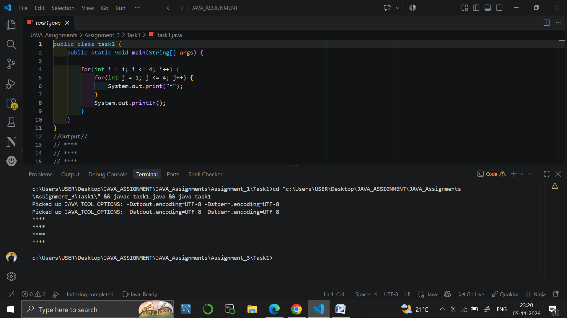

Task 2
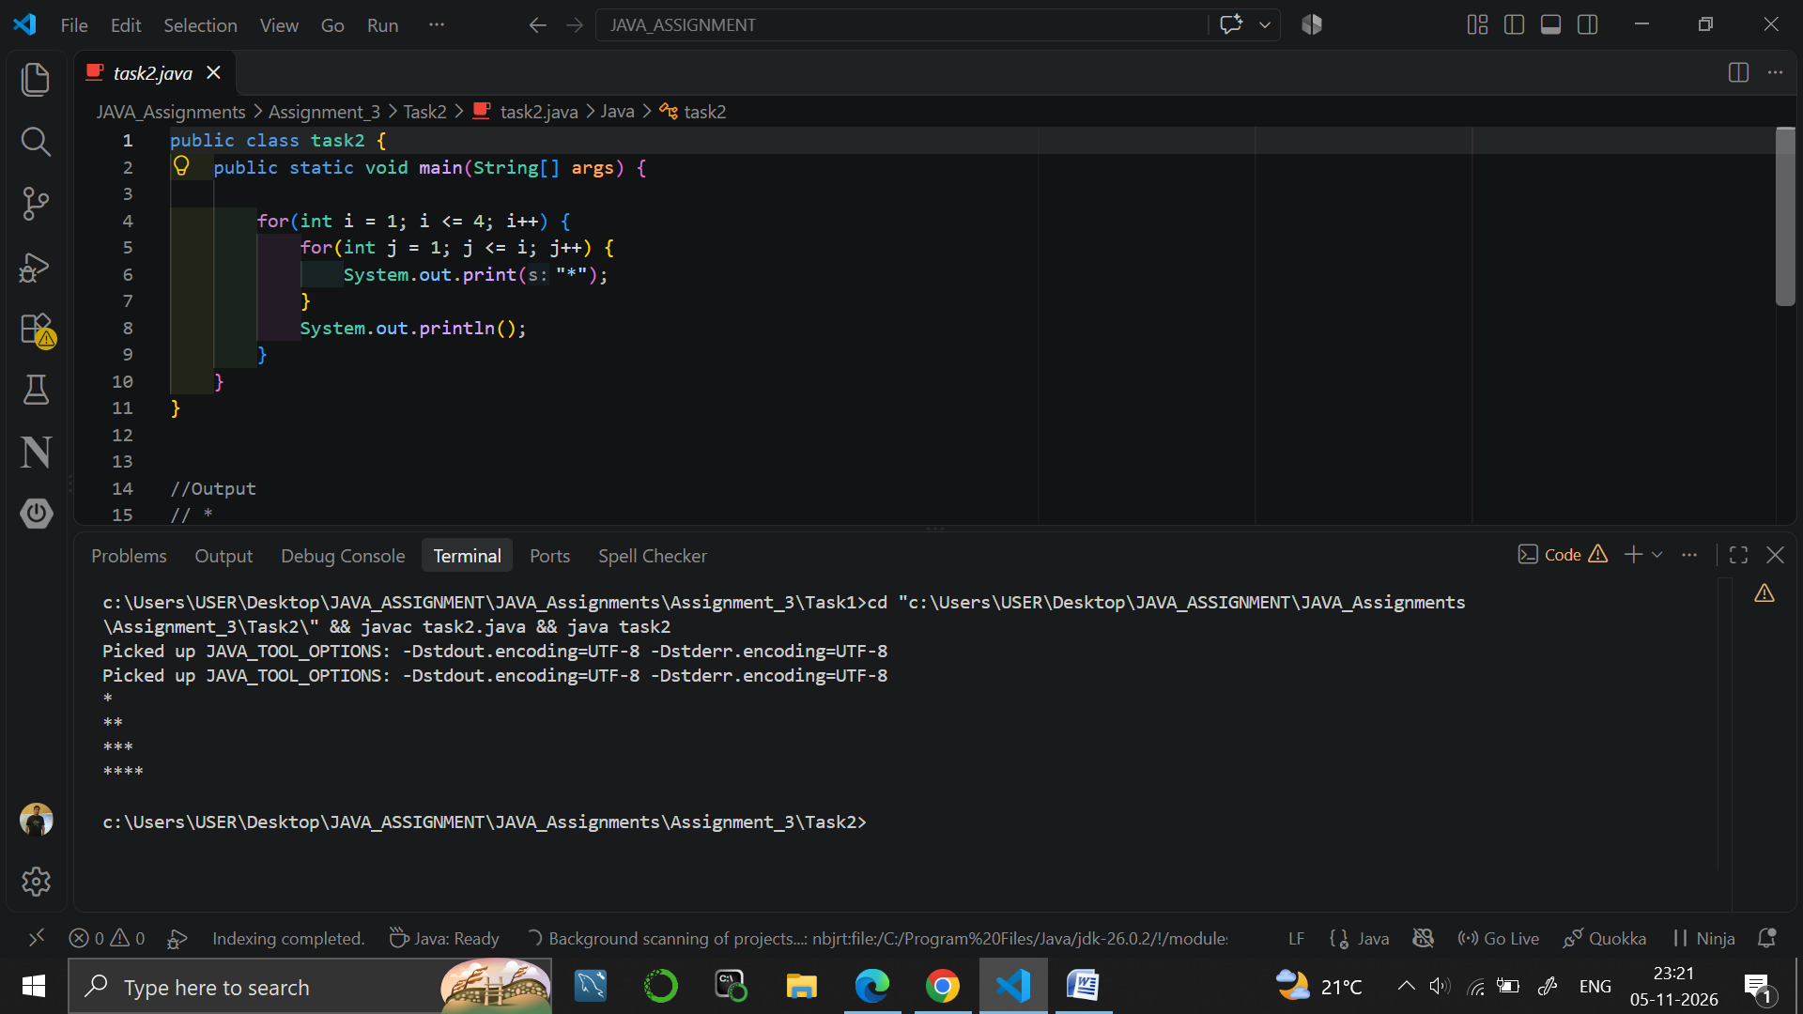

Task 3
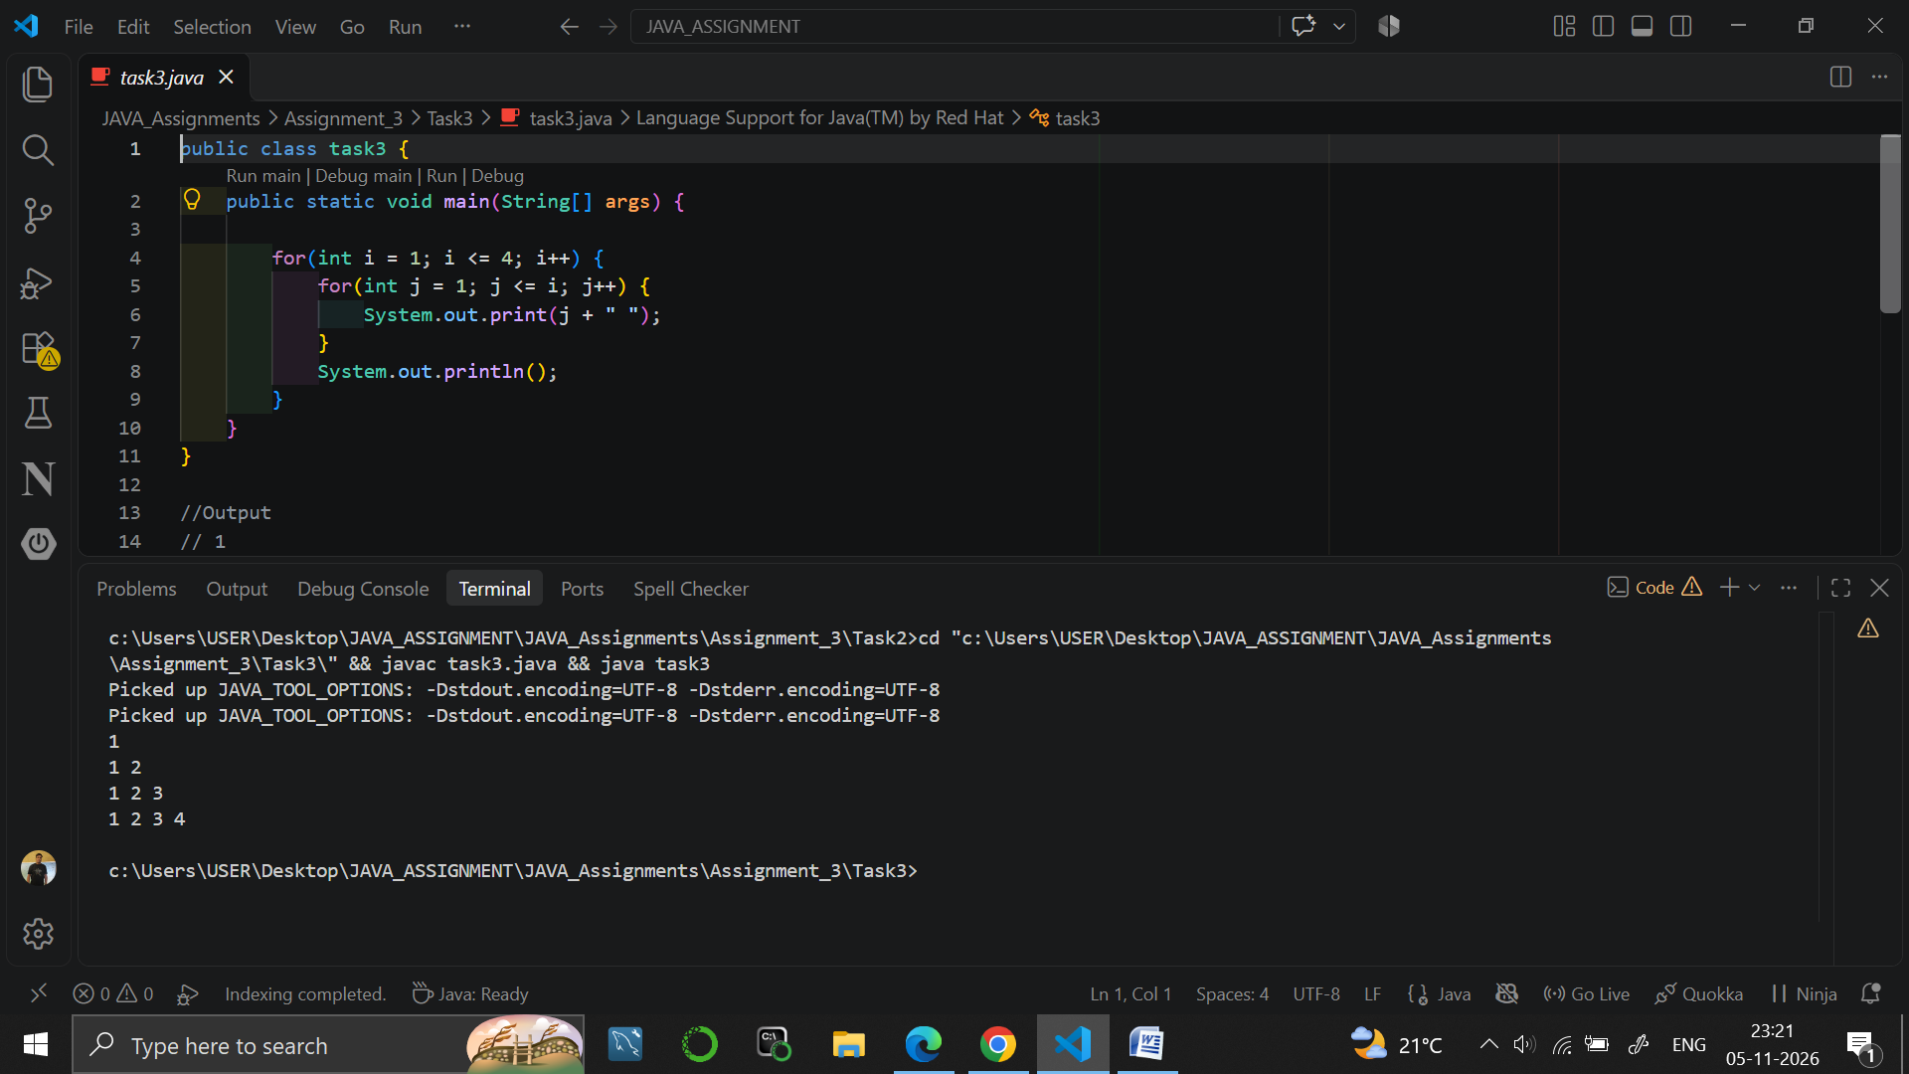

Task 4
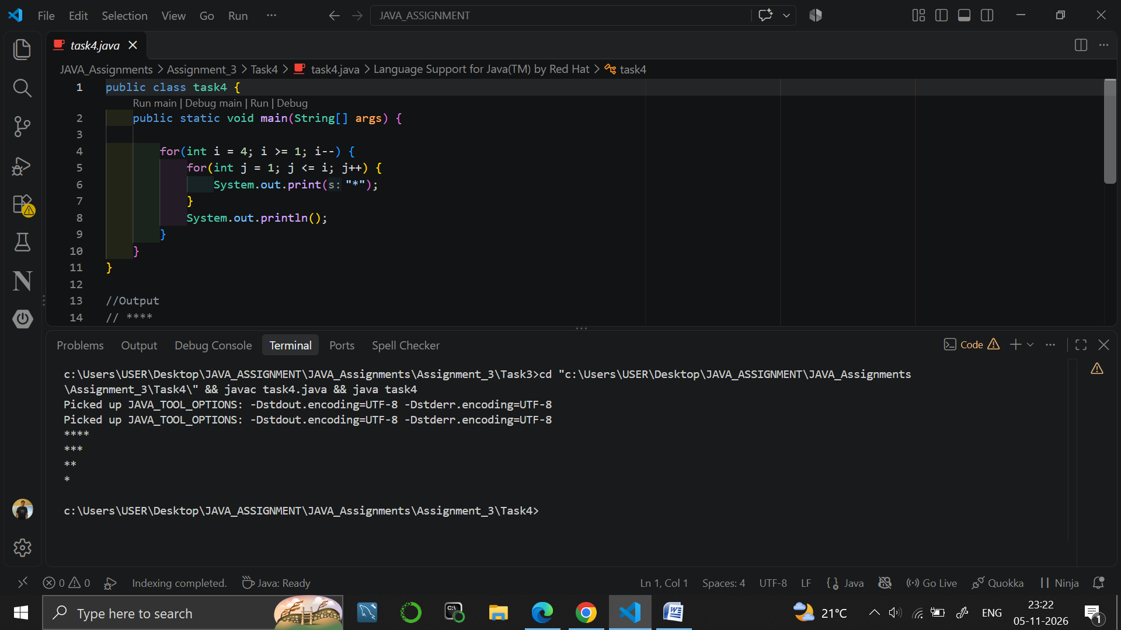

9. RESULT
Java programs were written to print a square of stars, a right triangle of stars, a number triangle and an upside-down triangle of stars using nested loops.

10. VIVA-VOCE QUESTIONS
- What is a nested loop?
- What is the role of the outer loop and the inner loop in a pattern program?
- What is the difference between print() and println()?
- How does the upside-down triangle program differ from the right triangle program?
- How many times does the inner loop body run in Task 2 in total?

EXPERIMENT NO. 4
Course: BCS351

1. EXPERIMENT TITLE
Writing Functions (nCr, nPr, maxOf)

2. AIM
To write functions with parameters and return values, and to call them from main.

3. SOFTWARE / TOOLS REQUIRED
Java Development Kit (JDK 8 or higher); an IDE (Eclipse / IntelliJ IDEA / VS Code / NetBeans) or the command line (javac and java).

4. THEORY
A function (method) is a named block of code that performs a task. It can take parameters and return a value using the return statement. A static method can be called from main without creating an object. Reusing one function inside another (for example fact inside nCr) avoids repeated code. The formulas used are nCr = n! / (r! * (n-r)!) and nPr = n! / (n-r)!.

5. ALGORITHM / PROCEDURE
Task 1
- Start.
- Define fact(n): set factorial = 1, repeat for i = 1 to n multiplying factorial by i, and return factorial.
- Define nCr(n, r): return fact(n) / (fact(r) * fact(n - r)).
- In main, call nCr(5, 2).
- Print "5C2 = " followed by the result.
- Stop.
Task 2
- Start.
- Define fact(n) to return n factorial using a loop.
- Define nPr(n, r): return fact(n) / fact(n - r).
- In main, call nPr(5, 2).
- Print "5P2 = " followed by the result.
- Stop.
Task 3
- Start.
- Define maxOf(a, b): if a > b return a, otherwise return b.
- In main, call maxOf(14, 9).
- Print "Larger: " followed by the result.
- Stop.

6. PROGRAM / QUERIES / COMMANDS
Task 1 – task1.java
public class task1 {
static int fact(int n) {
int factorial = 1;

for(int i = 1; i <= n; i++) {
factorial = factorial * i;
}
return factorial;
}
static int nCr(int n, int r) {
return fact(n) / (fact(r) * fact(n - r));
}
public static void main(String[] args) {
System.out.println("5C2 = "+ nCr(5, 2));
}
}

//Output
// 5C2 = 10

Task 2 – task2.java
public class task2 {
static int fact(int n) {
int factorial = 1;
for(int i = 1; i <= n; i++) {
factorial = factorial * i;
}
return factorial;
}
static int nPr(int n, int r) {
return fact(n) / fact(n - r);
}
public static void main(String[] args) {
System.out.println("5P2 = " + nPr(5, 2));
}
}
//output
//5P2 = 20

Task 3 – task3.java
public class task3 {
static int maxOf(int a, int b) {

if(a > b) {
return a;
}
else {
return b;
}
}

public static void main(String[] args) {

System.out.println("Larger: " + maxOf(14, 9));

}
}

//Output
// Larger: 14

7. INPUT
No user input is taken. All values are fixed inside the programs: n = 5 and r = 2 for nCr and nPr; the numbers 14 and 9 for maxOf.

8. OUTPUT
Task 1
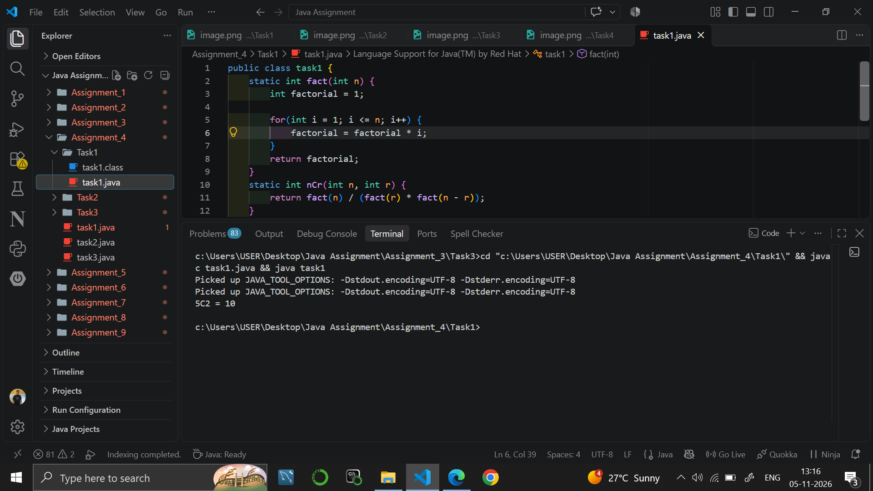

Task 2
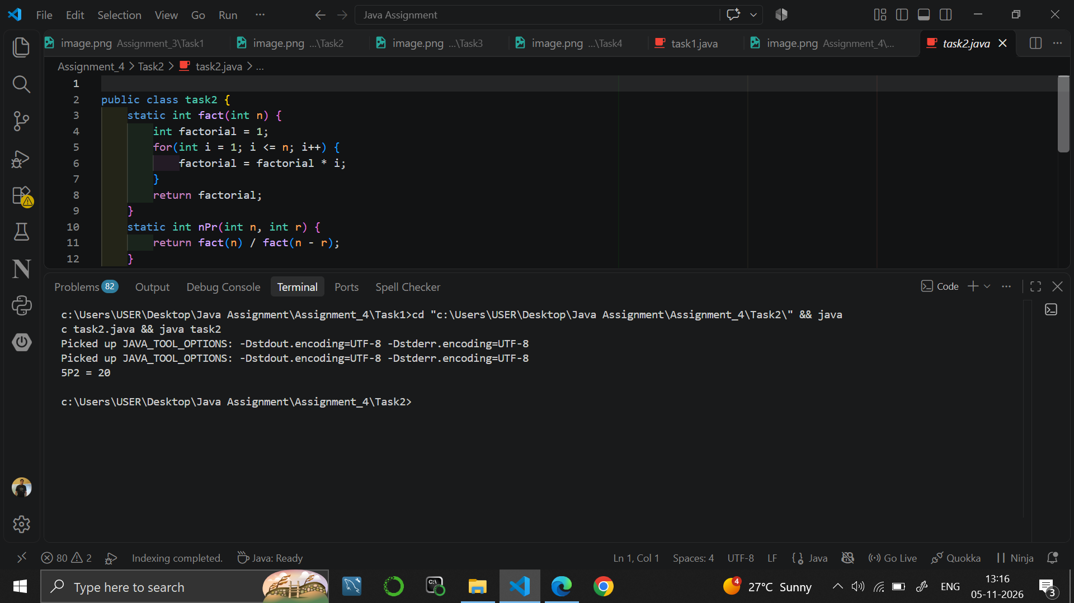

Task 3
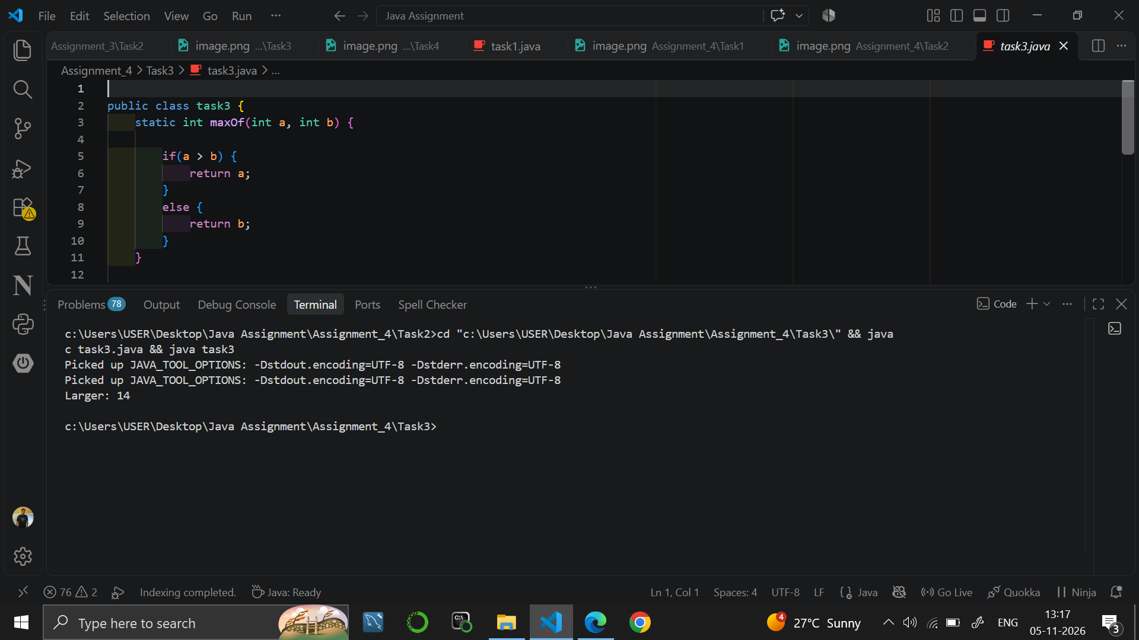

9. RESULT
Java programs were written using functions with parameters and return values to find nCr, nPr and the larger of two numbers.

10. VIVA-VOCE QUESTIONS
- What is a function and why is it used?
- What is the meaning of the keyword static in a method?
- How does fact() get reused inside nCr() and nPr()?
- What is the formula for nCr and nPr?
- What does the return statement do?

EXPERIMENT NO. 5
Course: BCS351

1. EXPERIMENT TITLE
Arrays: Traversal, Sum, Max, and Count Conditions

2. AIM
To create an array, visit every element with a loop, and add up or count the values.

3. SOFTWARE / TOOLS REQUIRED
Java Development Kit (JDK 8 or higher); an IDE (Eclipse / IntelliJ IDEA / VS Code / NetBeans) or the command line (javac and java).

4. THEORY
An array stores many values of the same type in one variable. Elements are accessed by an index that starts from 0, and arr.length gives the number of elements. Traversal means visiting every element, normally with a for loop from 0 to arr.length - 1. During traversal we can calculate the sum, find the largest value or count the values that satisfy a condition.

5. ALGORITHM / PROCEDURE
Task 1
- Start.
- Create arr = {3, 4, 5}.
- Repeat for i = 0 to arr.length - 1.
- Print "Index ", i, ": " and arr[i].
- Stop.
Task 2
- Start.
- Create arr = {12, 45, 7, 33, 21}; set sum = 0 and largest = arr[0].
- Repeat for each index i: add arr[i] to sum; if arr[i] > largest, set largest = arr[i].
- Print "Sum: " followed by sum.
- Print "Largest: " followed by largest.
- Stop.
Task 3
- Start.
- Create arr = {5, 12, 2, 14, 7}; set count = 0.
- Repeat for each index i: if arr[i] > 10, increase count by 1.
- Print "Count greater than 10: " followed by count.
- Stop.

6. PROGRAM / QUERIES / COMMANDS
Task 1 – task1.java
public class task1 {
public static void main(String[] args) {

int arr[] = {3, 4, 5};

for(int i = 0; i < arr.length; i++) {
System.out.println("Index " + i + ": " + arr[i]);
}

}
}
//output
// Index 0: 3
// Index 1: 4
// Index 2: 5

Task 2 – task2.java
public class task2 {
public static void main(String[] args) {

int arr[] = {12, 45, 7, 33, 21};

int sum = 0;
int largest = arr[0];

for(int i = 0; i < arr.length; i++) {

sum = sum + arr[i];

if(arr[i] > largest) {
largest = arr[i];
}
}

System.out.println("Sum: " + sum);
System.out.println("Largest: " + largest);

}
}

//Output
// Sum: 118
// Largest: 45

Task 3 – task3.java
public class task3 {
public static void main(String[] args) {

int arr[] = {5, 12, 2, 14, 7};

int count = 0;

for(int i = 0; i < arr.length; i++) {

if(arr[i] > 10) {
count++;
}
}

System.out.println("Count greater than 10: " + count);

}
}

//Output
//Count greater than 10: 2

7. INPUT
No user input is taken. All values are fixed inside the programs: arr = {3, 4, 5} in Task 1; arr = {12, 45, 7, 33, 21} in Task 2; arr = {5, 12, 2, 14, 7} in Task 3.

8. OUTPUT
Task 1
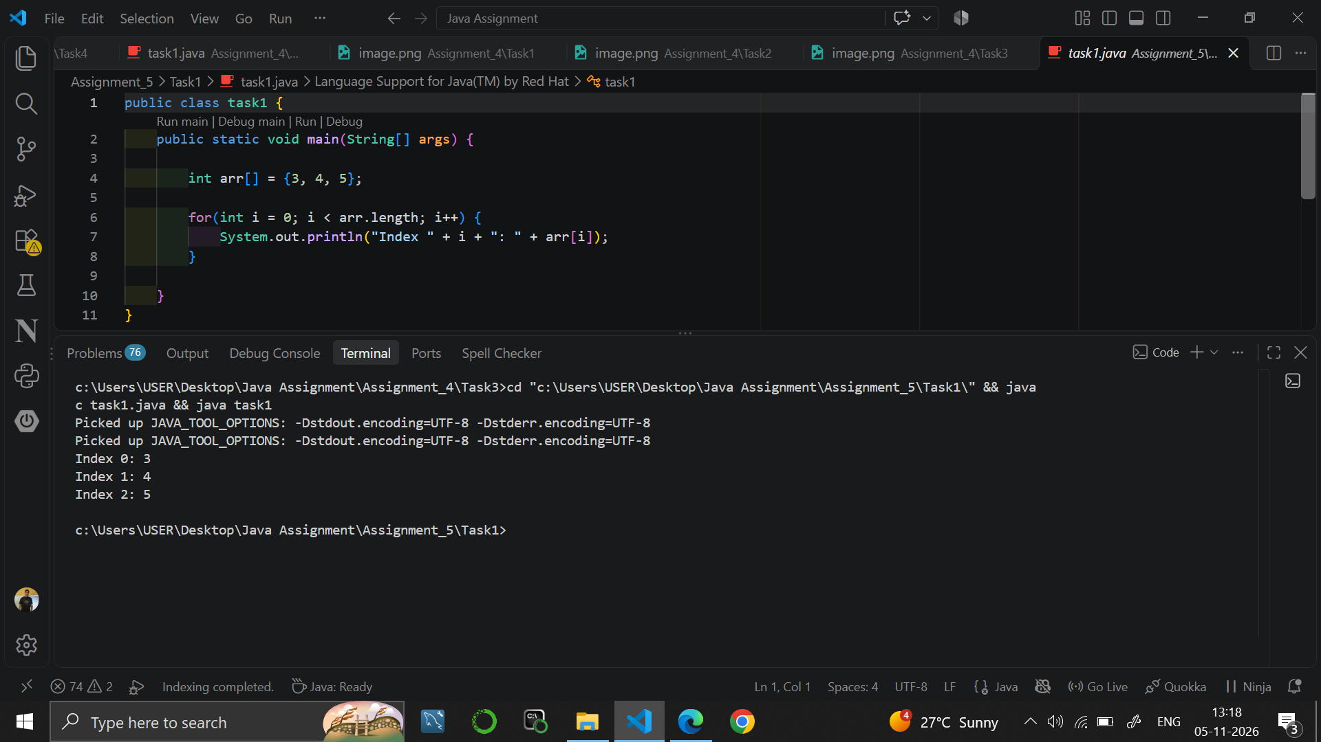

Task 2
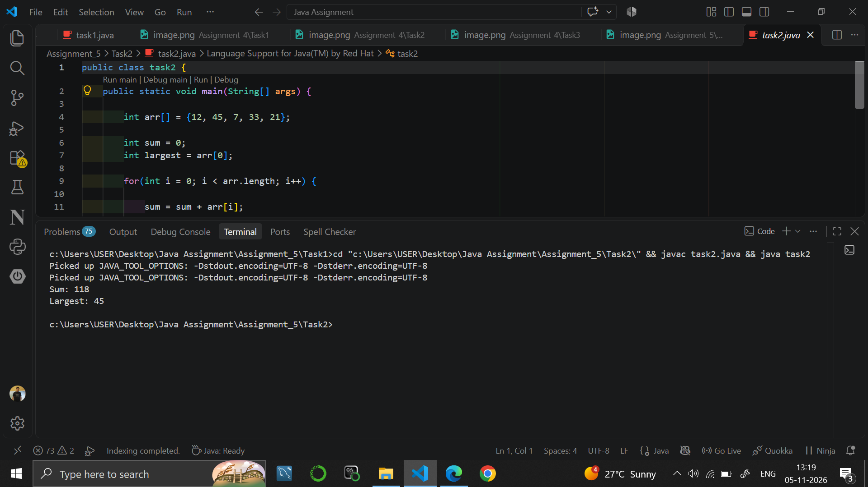

Task 3
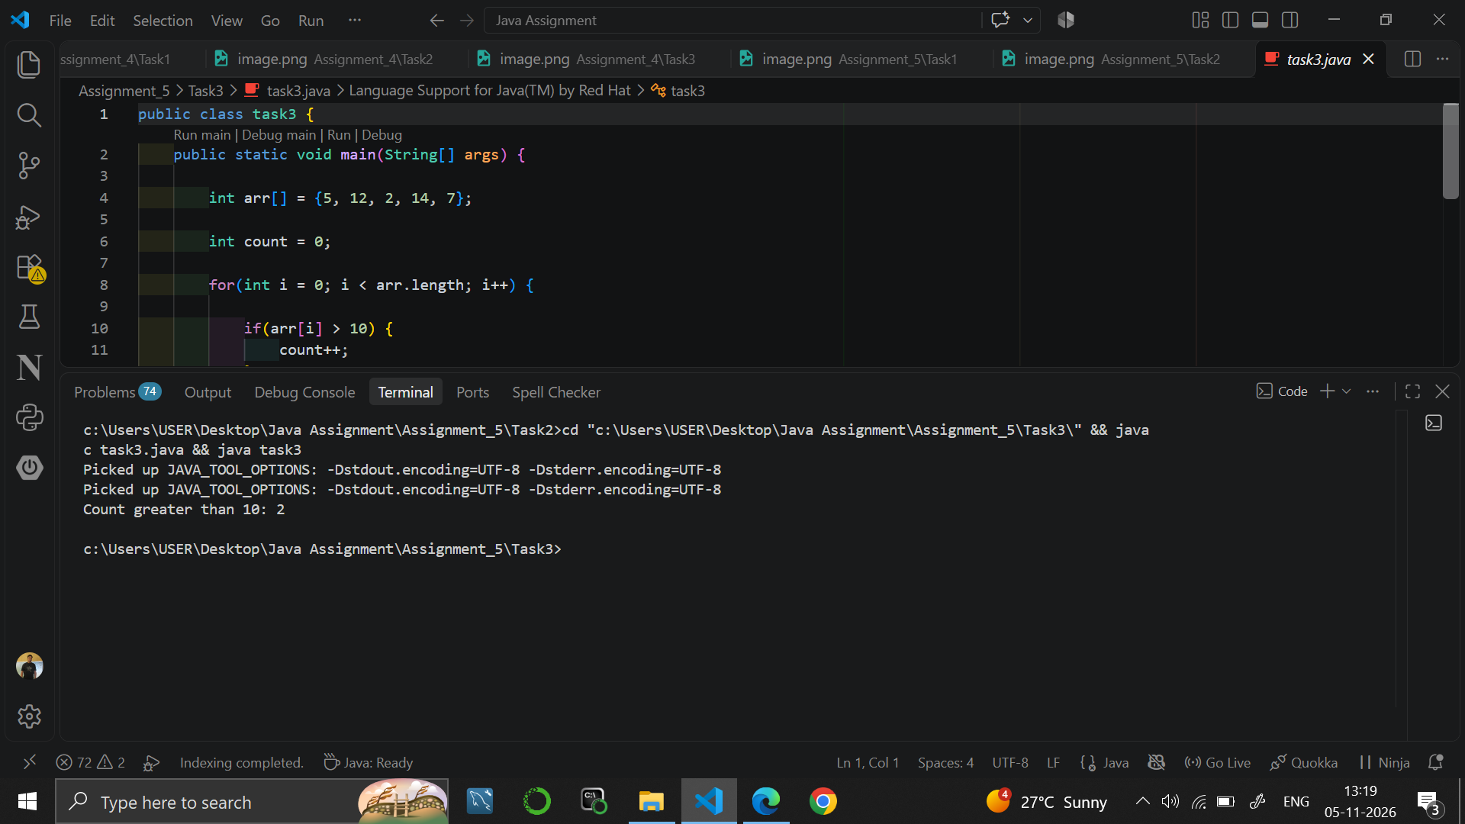

9. RESULT
Java programs were written to traverse an array, to find the sum and the largest value, and to count the elements greater than 10.

10. VIVA-VOCE QUESTIONS
- What is an array?
- What is the first index of an array in Java?
- What does arr.length give?
- Why is largest initialised with arr[0]?
- How do you count the elements that satisfy a condition?

EXPERIMENT NO. 6
Course: BCS351

1. EXPERIMENT TITLE
Arrays: Reverse Printing, Min Value, and Duplicates

2. AIM
To print an array in reverse order, find the smallest value, and check an array for repeated values.

3. SOFTWARE / TOOLS REQUIRED
Java Development Kit (JDK 8 or higher); an IDE (Eclipse / IntelliJ IDEA / VS Code / NetBeans) or the command line (javac and java).

4. THEORY
An array can be traversed from the last index to the first by running a loop backwards. The smallest value is found by keeping a variable for the minimum and updating it when a smaller element is found. To detect a repeated value, every element is compared with all the elements after it using nested loops. A boolean flag and the break statement are used to stop once a repeat is found.

5. ALGORITHM / PROCEDURE
Task 1
- Start.
- Create arr = {10, 20, 30, 40, 50}.
- Repeat for i = arr.length - 1 down to 0.
- Print arr[i] on its own line.
- Stop.
Task 2
- Start.
- Create arr = {2, 5, 1, 8, 3, 4}; set smallest = arr[0] and index = 0.
- Repeat for each index i: if arr[i] < smallest, set smallest = arr[i] and index = i.
- Print "Smallest: ", smallest, " at index " and index.
- Stop.
Task 3
- Start.
- Create arr = {4, 9, 2, 9, 7}; set found = false.
- Repeat for each index i, and for each j = i + 1 to the end: if arr[i] == arr[j], print "Repeated value: " followed by arr[i], set found = true and break.
- Stop the outer loop as soon as found is true.
- If found is still false, print "No repeated value".
- Stop.

6. PROGRAM / QUERIES / COMMANDS
Task 1 – task1.java
public class task1 {
public static void main(String[] args) {

int arr[] = {10, 20, 30, 40, 50};

for(int i = arr.length - 1; i >= 0; i--) {
System.out.println(arr[i]);
}

}
}

//Output
// 50
// 40
// 30
// 20
// 10

Task 2 – task2.java
public class task2 {
public static void main(String[] args) {

int arr[] = {2, 5, 1, 8, 3, 4};

int smallest = arr[0];
int index = 0;

for(int i = 0; i < arr.length; i++) {

if(arr[i] < smallest) {
smallest = arr[i];
index = i;
}
}

System.out.println("Smallest: " + smallest + " at index " + index);

}
}

// Output
// Smallest: 1 at index 2

Task 3 – task3.java
public class task3 {
public static void main(String[] args) {
int arr[] = {4, 9, 2, 9, 7};
boolean found = false;
for(int i = 0; i < arr.length; i++) {
for(int j = i + 1; j < arr.length; j++) {

if(arr[i] == arr[j]) {
System.out.println("Repeated value: " + arr[i]);
found = true;
break;
}
}
if(found) {
break;
}
}
if(!found) {
System.out.println("No repeated value");
}

}
}
//Output
// Repeated value: 9

7. INPUT
No user input is taken. All values are fixed inside the programs: arr = {10, 20, 30, 40, 50} in Task 1; arr = {2, 5, 1, 8, 3, 4} in Task 2; arr = {4, 9, 2, 9, 7} in Task 3.

8. OUTPUT
Task 1
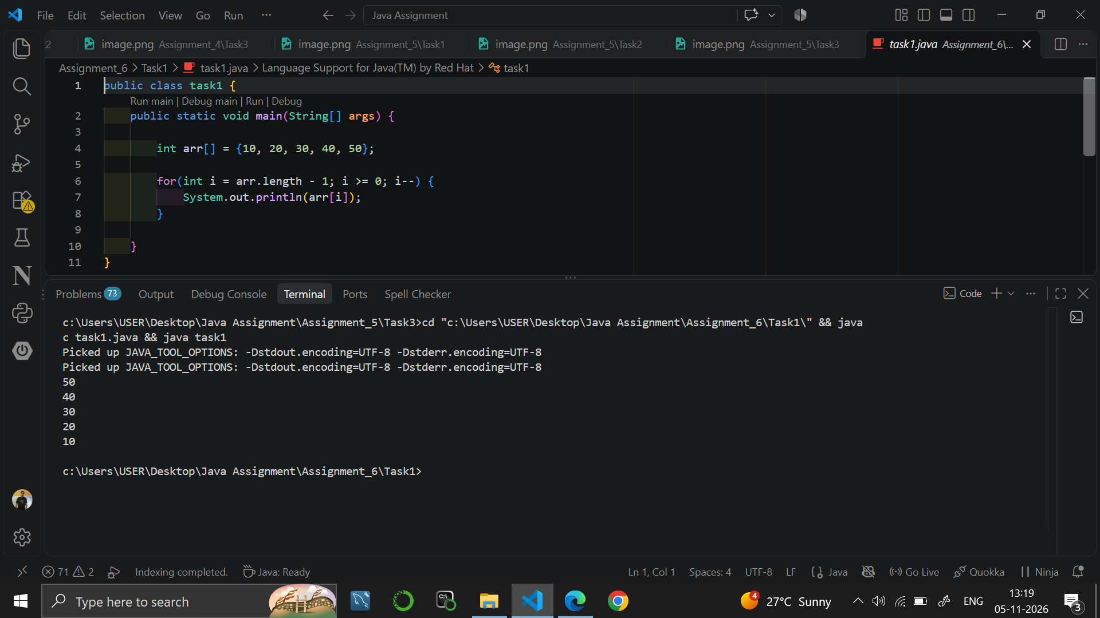

Task 2
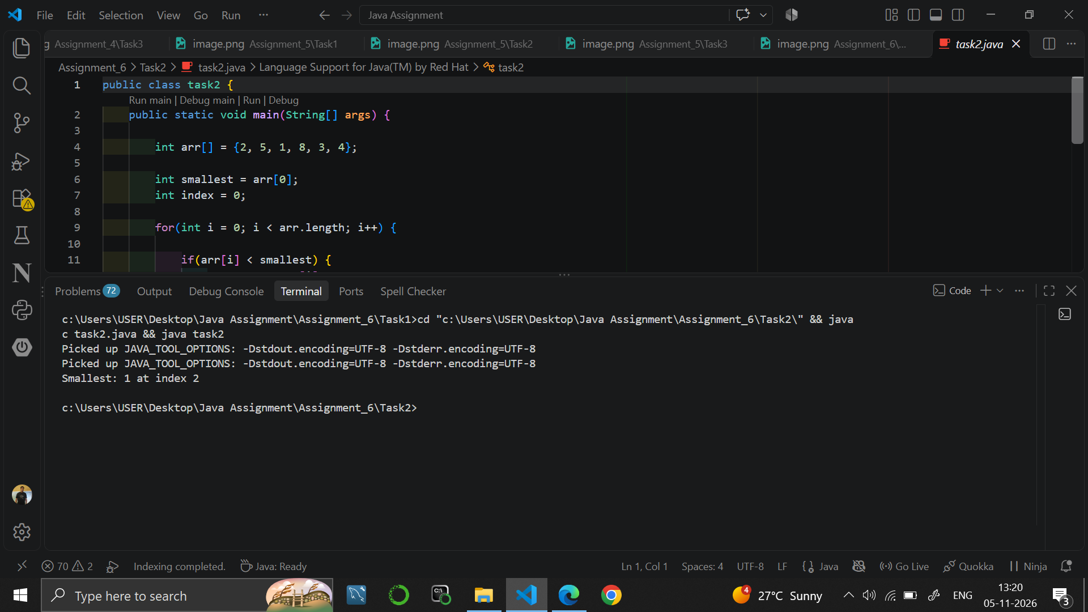

Task 3
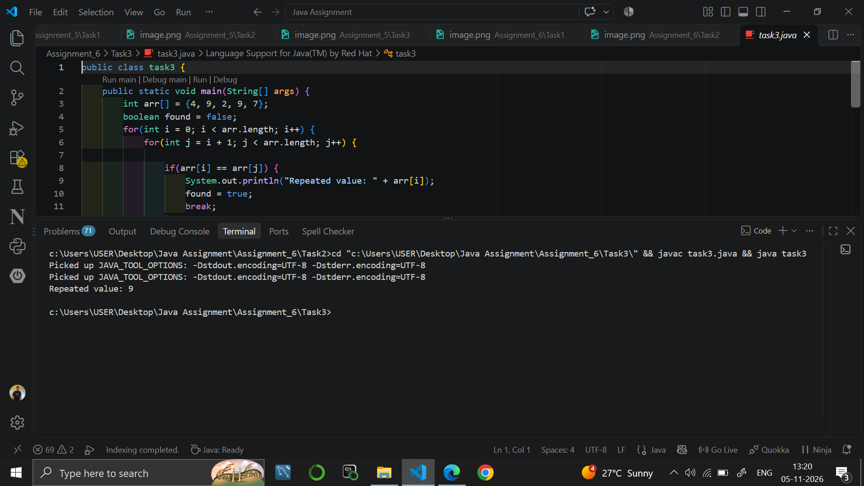

9. RESULT
Java programs were written to print an array in reverse, to find the smallest value with its index, and to detect a repeated value using nested loops.

10. VIVA-VOCE QUESTIONS
- How do you traverse an array in reverse order?
- How do you find the smallest element of an array?
- Why are nested loops used to find a duplicate?
- What is the use of the boolean variable found?
- What does the break statement do?

EXPERIMENT NO. 7
Course: BCS351

1. EXPERIMENT TITLE
Counting Steps and Time Complexity Analysis

2. AIM
To count the steps a program takes, and to write its time complexity as a comment.

3. SOFTWARE / TOOLS REQUIRED
Java Development Kit (JDK 8 or higher); an IDE (Eclipse / IntelliJ IDEA / VS Code / NetBeans) or the command line (javac and java).

4. THEORY
Time complexity describes how the number of steps of a program grows with the input size n. A single loop that runs n times is O(n). Two nested loops that each run n times give O(n^2). A loop that halves the value in every step runs about log2(n) times and is O(log n). A counter variable can be used to count the steps in a program.

5. ALGORITHM / PROCEDURE
Task 1
- Start.
- Set steps = 0.
- Repeat for i = 1 to 10 and increase steps by 1 each time.
- Print "Steps: " followed by steps.
- Stop. (Time complexity: O(n))
Task 2
- Start.
- Set steps = 0.
- Repeat for i = 1 to 10; inside it repeat for j = 1 to 10 and increase steps by 1.
- Print "Steps: " followed by steps.
- Stop. (Time complexity: O(n^2))
Task 3
- Start.
- Set n = 1024 and steps = 0.
- While n > 1: set n = n / 2 and increase steps by 1.
- Print "Halving steps: " followed by steps.
- Stop. (Time complexity: O(log n))

6. PROGRAM / QUERIES / COMMANDS
Task 1 – task1.java
public class task1 {
public static void main(String[] args) {

int steps = 0;

// Time Complexity: O(n)
for(int i = 1; i <= 10; i++) {
steps++;
}

System.out.println("Steps: " + steps);

}
}

// Output
// Steps: 10

Task 2 – task2.java
public class task2 {
public static void main(String[] args) {

int steps = 0;

// Time Complexity: O(n^2)
for(int i = 1; i <= 10; i++) {

for(int j = 1; j <= 10; j++) {
steps++;
}
}

System.out.println("Steps: " + steps);

}
}

//output
// Steps: 100

Task 3 – task3.java
public class task3 {
public static void main(String[] args) {

int n = 1024;
int steps = 0;

// Time Complexity: O(log n)
while(n > 1) {
n = n / 2;
steps++;
}

System.out.println("Halving steps: " + steps);

}
}

//Output
// Halving steps: 10

7. INPUT
No user input is taken. All values are fixed inside the programs: loop limit 10 in Task 1 and Task 2; n = 1024 in Task 3.

8. OUTPUT
Task 1
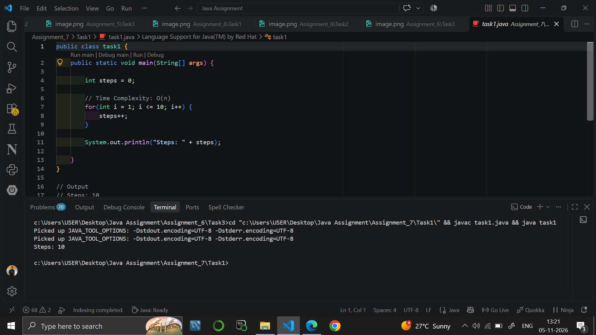

Task 2
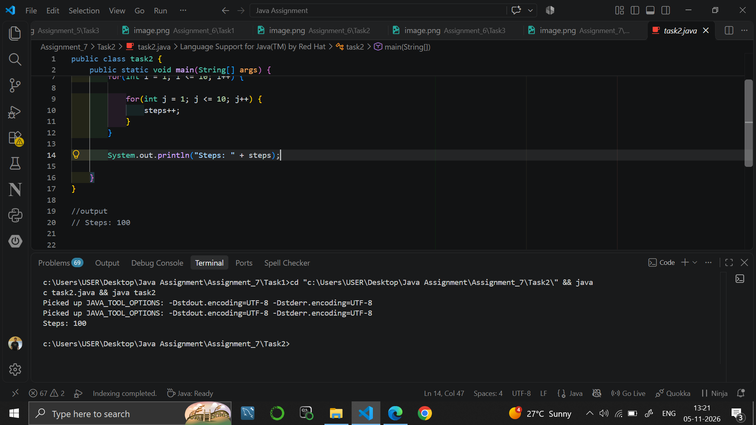

Task 3
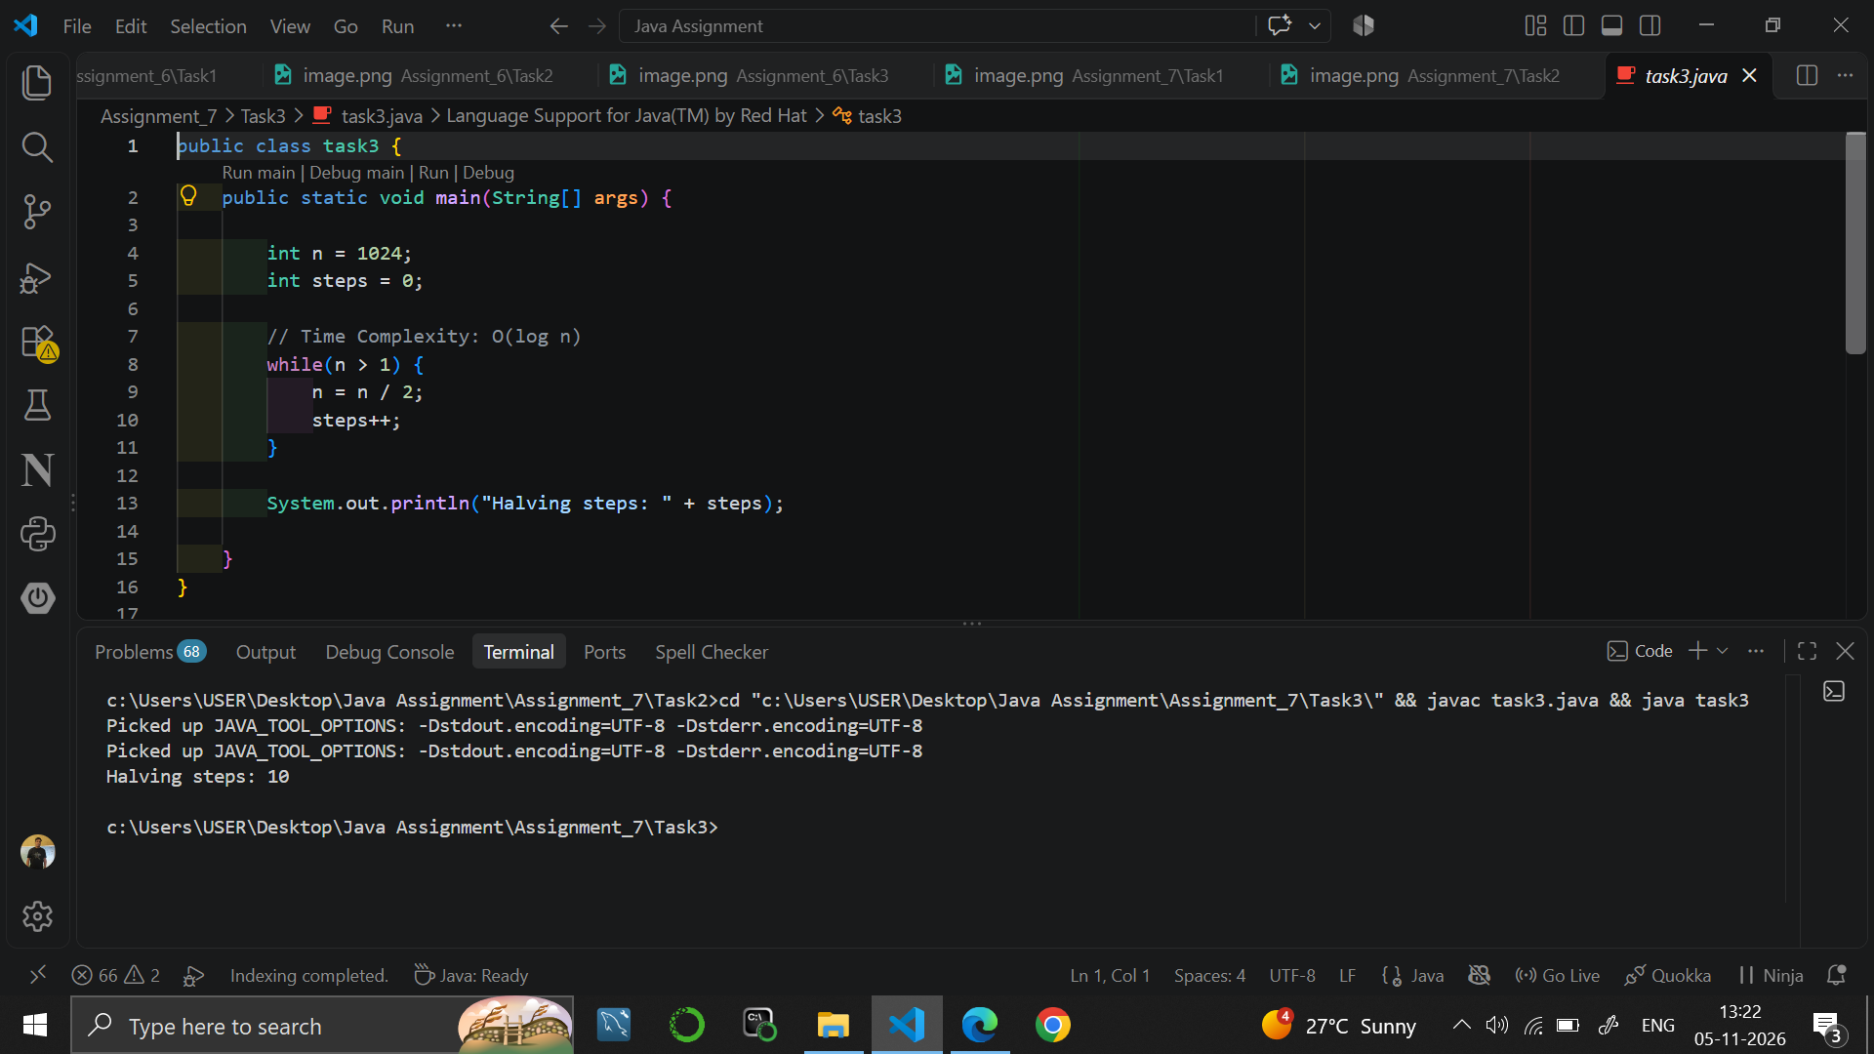

9. RESULT
Java programs were written to count the steps of a single loop, a nested loop and a halving loop, and their time complexities were written as comments.

10. VIVA-VOCE QUESTIONS
- What is time complexity?
- What is the time complexity of a single loop running n times?
- Why is a nested loop O(n^2)?
- Why does a loop that halves n run about log n times?
- What does Big-O notation represent?

EXPERIMENT NO. 8
Course: BCS351

1. EXPERIMENT TITLE
Matrices: Transpose and Row Sums

2. AIM
To create two-dimensional arrays, visit them row by row, and build a new matrix from one.

3. SOFTWARE / TOOLS REQUIRED
Java Development Kit (JDK 8 or higher); an IDE (Eclipse / IntelliJ IDEA / VS Code / NetBeans) or the command line (javac and java).

4. THEORY
A two-dimensional array stores data in rows and columns and is accessed as m[row][column]. Nested loops are used to fill and print it: the outer loop moves over the rows and the inner loop over the columns. The transpose of a matrix is a new matrix in which rows and columns are swapped, so element m[i][j] becomes transpose[j][i]. A row sum is found by adding all the elements of one row.

5. ALGORITHM / PROCEDURE
Task 1
- Start.
- Create a matrix m with 3 rows and 4 columns and set num = 1.
- For each row i and each column j, set m[i][j] = num and increase num by 1.
- Print the matrix row by row, with a space after each number and a new line after each row.
- Stop.
Task 2
- Start.
- Create the 3 x 3 matrix m = {{1,2,3},{4,5,6},{7,8,9}} and an empty 3 x 3 matrix transpose.
- For each i and j, set transpose[j][i] = m[i][j].
- Print the transpose row by row, with a space after each number.
- Stop.
Task 3
- Start.
- Create the 3 x 3 matrix m = {{1,2,3},{4,5,6},{7,8,9}}.
- For each row i: set sum = 0, add m[i][j] for every column j.
- Print "Row ", i + 1, " sum: " and sum.
- Stop.

6. PROGRAM / QUERIES / COMMANDS
Task 1 – task1.java
public class task1 {
public static void main(String[] args) {

int m[][] = new int[3][4];

int num = 1;

for(int i = 0; i < 3; i++) {

for(int j = 0; j < 4; j++) {
m[i][j] = num;
num++;
}
}

for(int i = 0; i < 3; i++) {

for(int j = 0; j < 4; j++) {
System.out.print(m[i][j] + "");
}

System.out.println();
}

}
}

//Output
// 1 2 3 4
// 5 6 7 8
// 9 10 11 12

Task 2 – task2.java
public class task2 {
public static void main(String[] args) {

int m[][] = {
{1, 2, 3},
{4, 5, 6},
{7, 8, 9}
};

int transpose[][] = new int[3][3];

for(int i = 0; i < 3; i++) {

for(int j = 0; j < 3; j++) {
transpose[j][i] = m[i][j];
}
}

for(int i = 0; i < 3; i++) {

for(int j = 0; j < 3; j++) {
System.out.print(transpose[i][j] + "");
}

System.out.println();
}

}
}

//Output
// 1 4 7
// 2 5 8
// 3 6 9

Task 3 – task3.java
public class task3 {
public static void main(String[] args) {

int m[][] = {
{1, 2, 3},
{4, 5, 6},
{7, 8, 9}
};

for(int i = 0; i < 3; i++) {

int sum = 0;

for(int j = 0; j < 3; j++) {
sum = sum + m[i][j];
}

System.out.println("Row " + (i + 1) + " sum: " + sum);
}

}
}

//Output
// Row 1 sum: 6
// Row 2 sum: 15
// Row 3 sum: 24

7. INPUT
No user input is taken. All values are fixed inside the programs: a 3 x 4 matrix filled with the numbers 1 to 12 in Task 1; the 3 x 3 matrix {{1,2,3},{4,5,6},{7,8,9}} in Task 2 and Task 3.

8. OUTPUT
Task 1
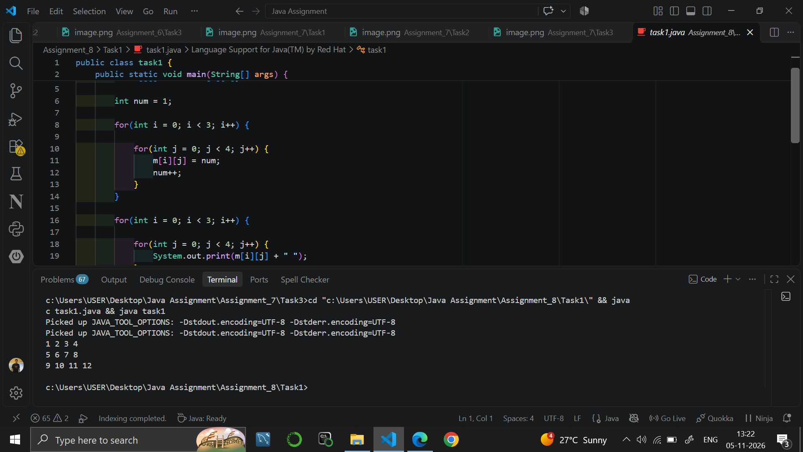

Task 2
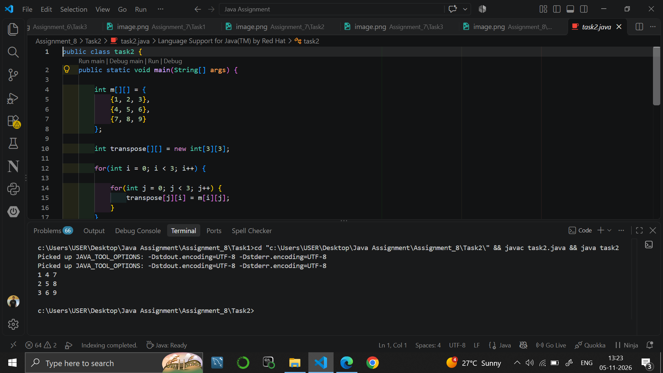

Task 3
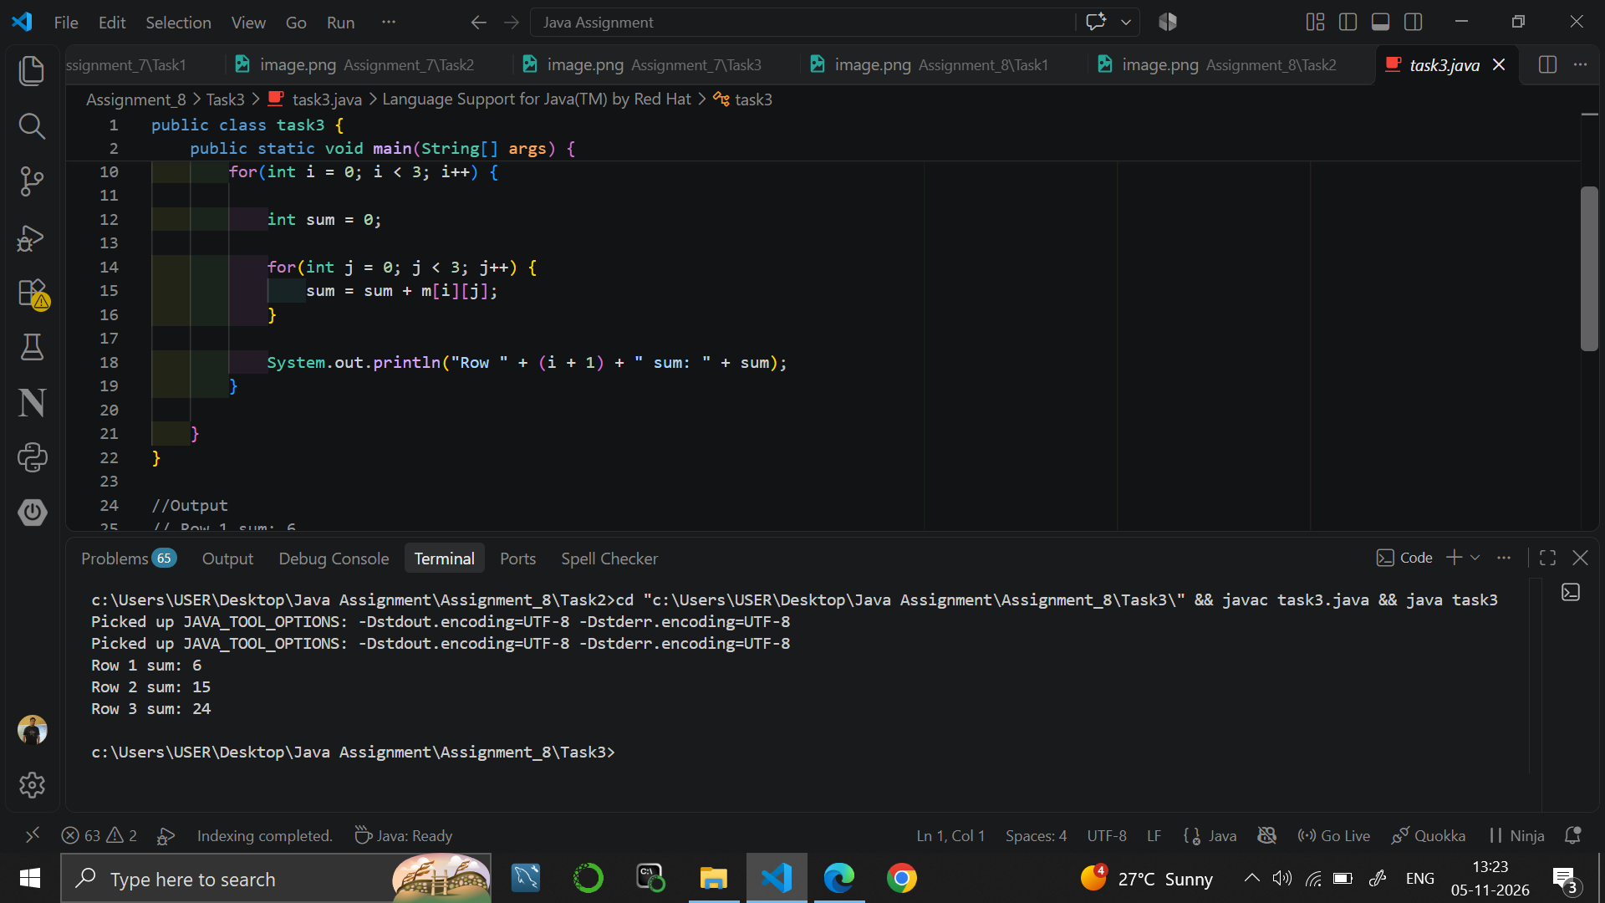

9. RESULT
Java programs were written to fill and print a matrix, to find the transpose of a matrix and to find the sum of each row.

10. VIVA-VOCE QUESTIONS
- What is a two-dimensional array?
- How do you declare a matrix with 3 rows and 4 columns?
- What is the transpose of a matrix?
- Why are two nested loops needed to print a matrix?
- How is the sum of a row calculated?

EXPERIMENT NO. 9
Course: BCS351

1. EXPERIMENT TITLE
Matrices: Rows and Columns Operations

2. AIM
To visit the rows and columns of a matrix with nested loops to print, add and count its values.

3. SOFTWARE / TOOLS REQUIRED
Java Development Kit (JDK 8 or higher); an IDE (Eclipse / IntelliJ IDEA / VS Code / NetBeans) or the command line (javac and java).

4. THEORY
In a matrix m, the first row is m[0] and the last row of a 3 x 3 matrix is m[2]. To add the values of a column, the column index stays fixed in the outer loop while the row index changes in the inner loop. To count values that satisfy a condition, every element is visited with nested loops and a counter is increased when the condition is true.

5. ALGORITHM / PROCEDURE
Task 1
- Start.
- Create the 3 x 3 matrix m = {{1,2,3},{4,5,6},{7,8,9}}.
- Print "First row: ", then print m[0][j] and a space for j = 0 to 2, then a new line.
- Print "Last row: ", then print m[2][j] and a space for j = 0 to 2, then a new line.
- Stop.
Task 2
- Start.
- Create the 3 x 3 matrix m.
- For each column j: set sum = 0, add m[i][j] for every row i.
- Print "Column ", j + 1, " sum: " and sum.
- Stop.
Task 3
- Start.
- Create the 3 x 3 matrix m and set count = 0.
- For each row i and each column j: if m[i][j] > 5, increase count by 1.
- Print "Values greater than 5: " followed by count.
- Stop.

6. PROGRAM / QUERIES / COMMANDS
Task 1 – task1.java
public class task1 {
public static void main(String[] args) {

int m[][] = {
{1, 2, 3},
{4, 5, 6},
{7, 8, 9}
};

System.out.print("First row: ");

for(int j = 0; j < 3; j++) {
System.out.print(m[0][j] + "");
}

System.out.println();

System.out.print("Last row: ");

for(int j = 0; j < 3; j++) {
System.out.print(m[2][j] + "");
}

System.out.println();
}
}

//Output
// First row: 1 2 3
// Last row: 7 8 9

Task 2 – task2.java
public class task2 {
public static void main(String[] args) {

int m[][] = {
{1, 2, 3},
{4, 5, 6},
{7, 8, 9}
};

for(int j = 0; j < 3; j++) {

int sum = 0;

for(int i = 0; i < 3; i++) {
sum = sum + m[i][j];
}

System.out.println("Column " + (j + 1) + " sum: " + sum);
}
}
}

//Output
// Column 1 sum: 12
// Column 2 sum: 15
// Column 3 sum: 18

Task 3 – task3.java
public class task3 {
public static void main(String[] args) {

int m[][] = {
{1, 2, 3},
{4, 5, 6},
{7, 8, 9}
};

int count = 0;

for(int i = 0; i < 3; i++) {

for(int j = 0; j < 3; j++) {

if(m[i][j] > 5) {
count++;
}
}
}

System.out.println("Values greater than 5: " + count);
}
}
//Output
// Values greater than 5: 4

7. INPUT
No user input is taken. All values are fixed inside the programs: the 3 x 3 matrix {{1,2,3},{4,5,6},{7,8,9}} in all three tasks.

8. OUTPUT
Task 1
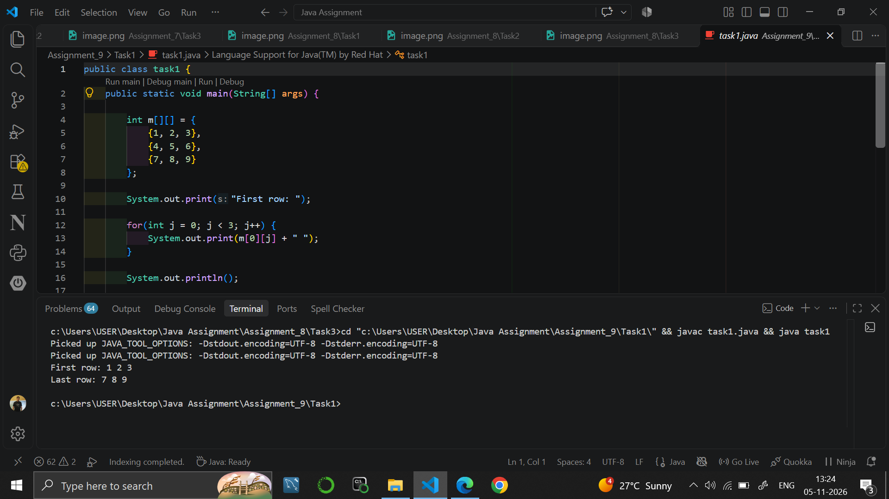

Task 2
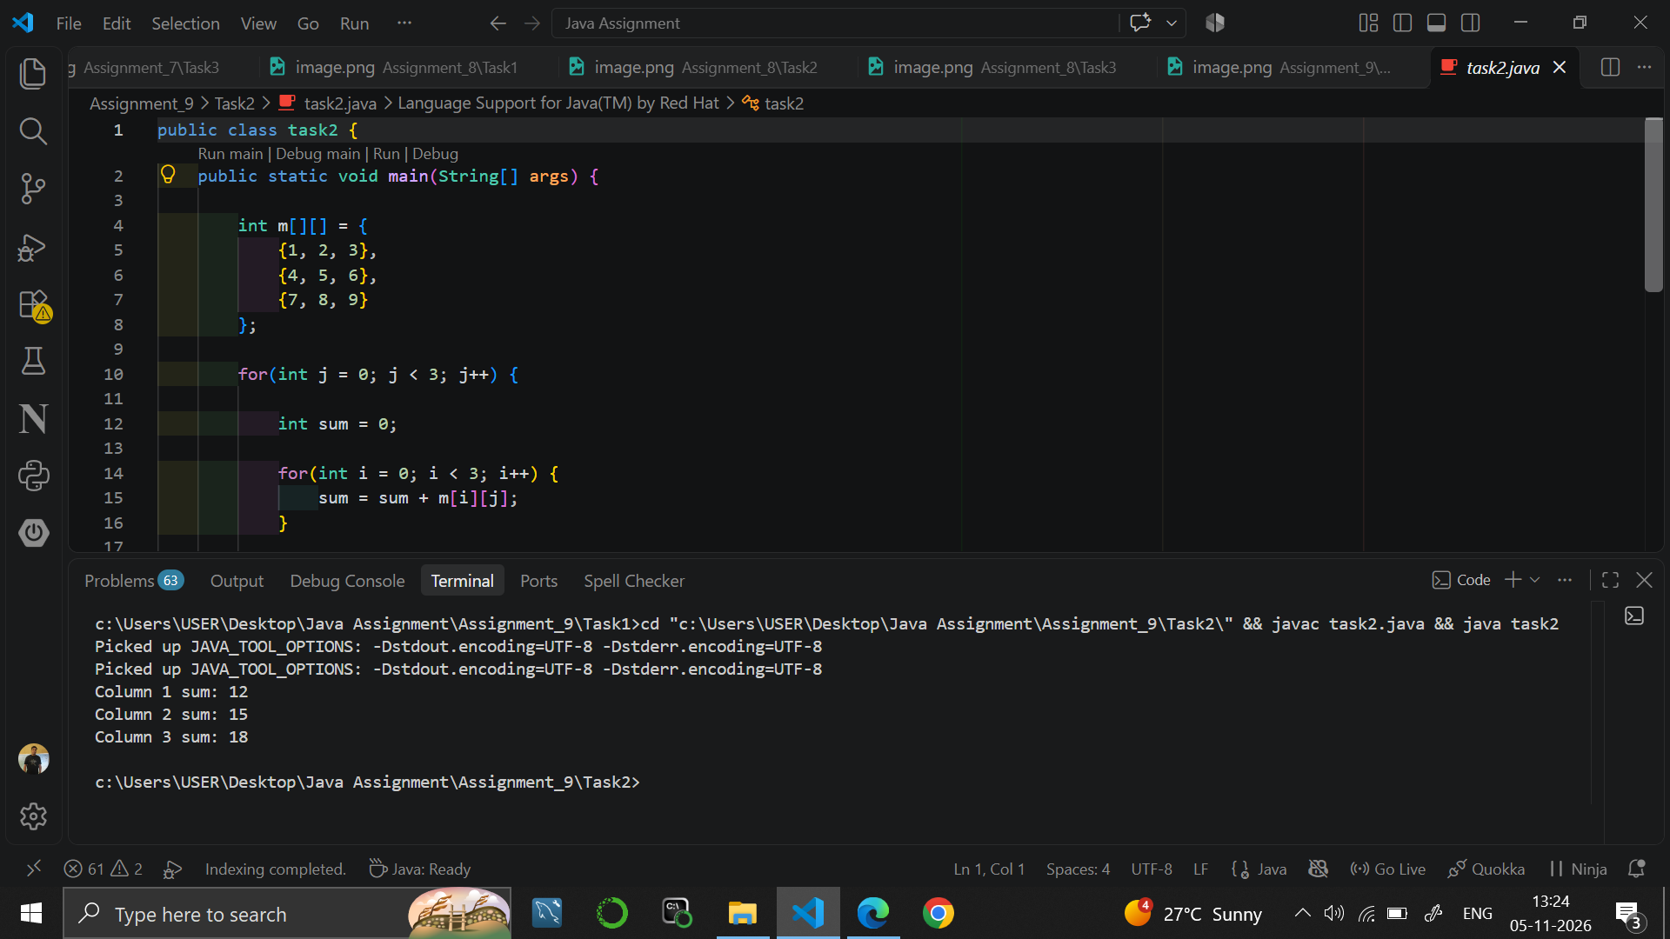

Task 3
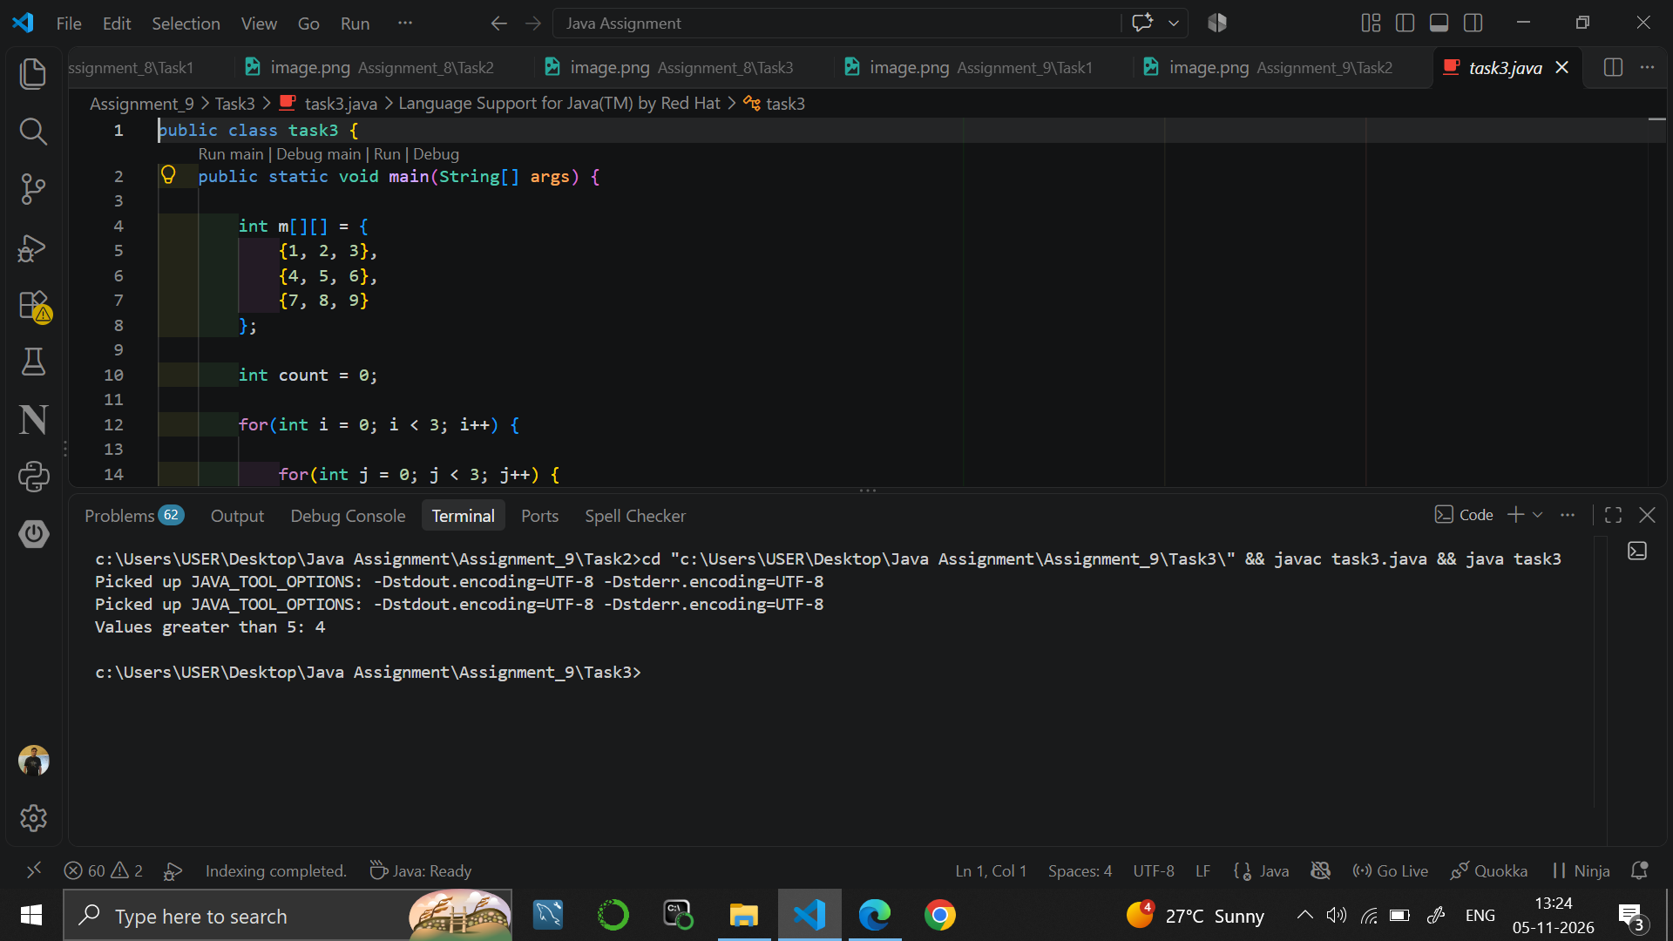

9. RESULT
Java programs were written to print the first and last rows of a matrix, to find the sum of each column and to count the values greater than 5.

10. VIVA-VOCE QUESTIONS
- How do you access the first row of a matrix?
- How is a column sum different from a row sum in the code?
- What does m.length represent for a two-dimensional array?
- How do you count the elements of a matrix that are greater than a given value?
- What is the number of elements in a 3 x 3 matrix?

EXPERIMENT NO. 10
Course: BCS351

1. EXPERIMENT TITLE
Switch Statement and ArrayList Manipulation

2. AIM
To choose a branch with a switch statement, and to store and change a list of numbers in an ArrayList.

3. SOFTWARE / TOOLS REQUIRED
Java Development Kit (JDK 8 or higher); an IDE (Eclipse / IntelliJ IDEA / VS Code / NetBeans) or the command line (javac and java).

4. THEORY
The switch statement selects one block of code from several cases based on the value of a variable. The break statement ends a case, and default runs when no case matches. ArrayList is a resizable list from java.util. Its main methods are add() to insert a value, get(index) to read a value, set(index, value) to change a value, remove(index) to delete a value and size() to get the number of elements.

5. ALGORITHM / PROCEDURE
Task 1
- Start.
- Store 3 in day.
- Use switch on day: case 1 prints Monday, case 2 prints Tuesday, case 3 prints Wednesday; each case ends with break.
- In the default case, print "Invalid day".
- Stop.
Task 2
- Start.
- Import java.util.ArrayList and create an ArrayList of Integer named list.
- Add 10, 20, 30 and 40 using add().
- Print the whole list.
- Print "Size: " followed by list.size().
- Print "Item at index 2: " followed by list.get(2).
- Stop.
Task 3
- Start.
- Create an ArrayList of Integer named list and add 10, 20, 30 and 40.
- Use set(1, 25) to change the value at index 1 to 25.
- Use remove(3) to delete the element at index 3.
- Print the list.
- Print "Size: " followed by list.size().
- Stop.

6. PROGRAM / QUERIES / COMMANDS
Task 1 – task1.java
public class task1 {
public static void main(String[] args) {

int day = 3;

switch(day) {

case 1:
System.out.println("Monday");
break;

case 2:
System.out.println("Tuesday");
break;

case 3:
System.out.println("Wednesday");
break;

default:
System.out.println("Invalid day");
}

}
}

//output
// Wednesday

Task 2 – task2.java
import java.util.ArrayList;

public class task2 {
public static void main(String[] args) {

ArrayList<Integer> list = new ArrayList<>();

list.add(10);
list.add(20);
list.add(30);
list.add(40);

System.out.println(list);

System.out.println("Size: " + list.size());

System.out.println("Item at index 2: " + list.get(2));

}
}

//Output
// [10, 20, 30, 40]
// Size: 4
// Item at index 2: 30

Task 3 – task3.java
import java.util.ArrayList;

public class task3 {
public static void main(String[] args) {

ArrayList<Integer> list = new ArrayList<>();

list.add(10);
list.add(20);
list.add(30);
list.add(40);

list.set(1, 25);

list.remove(3);

System.out.println(list);

System.out.println("Size: " + list.size());

}
}

//output
// [10, 25, 30]
// Size: 3

7. INPUT
No user input is taken. All values are fixed inside the programs: day = 3 in Task 1; list values 10, 20, 30, 40 in Task 2 and Task 3.

8. OUTPUT
Task 1
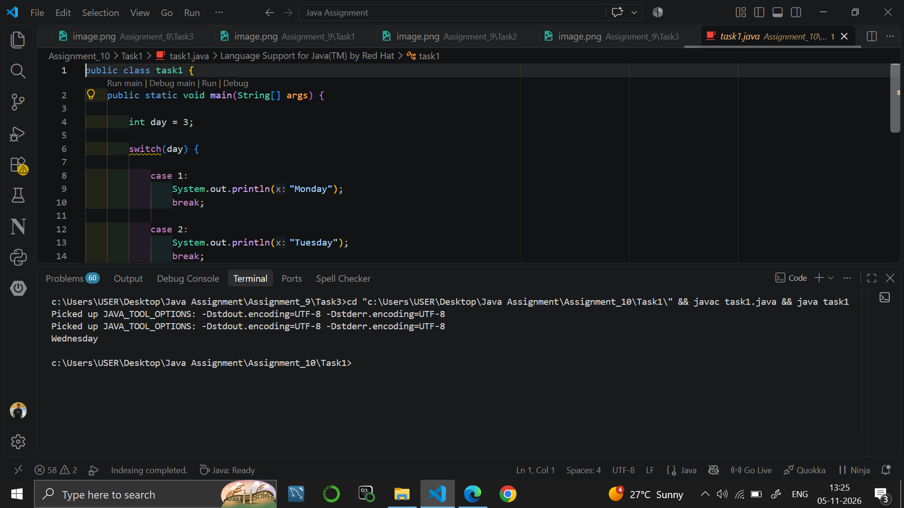

Task 2
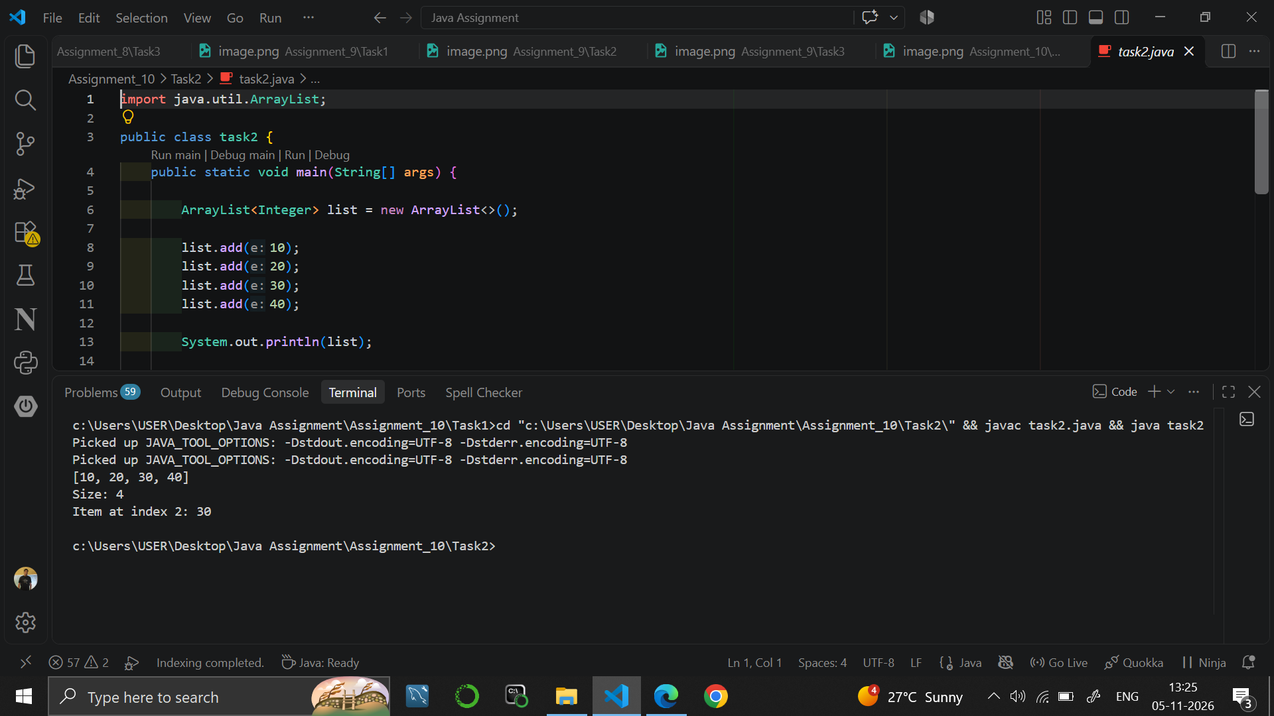

Task 3
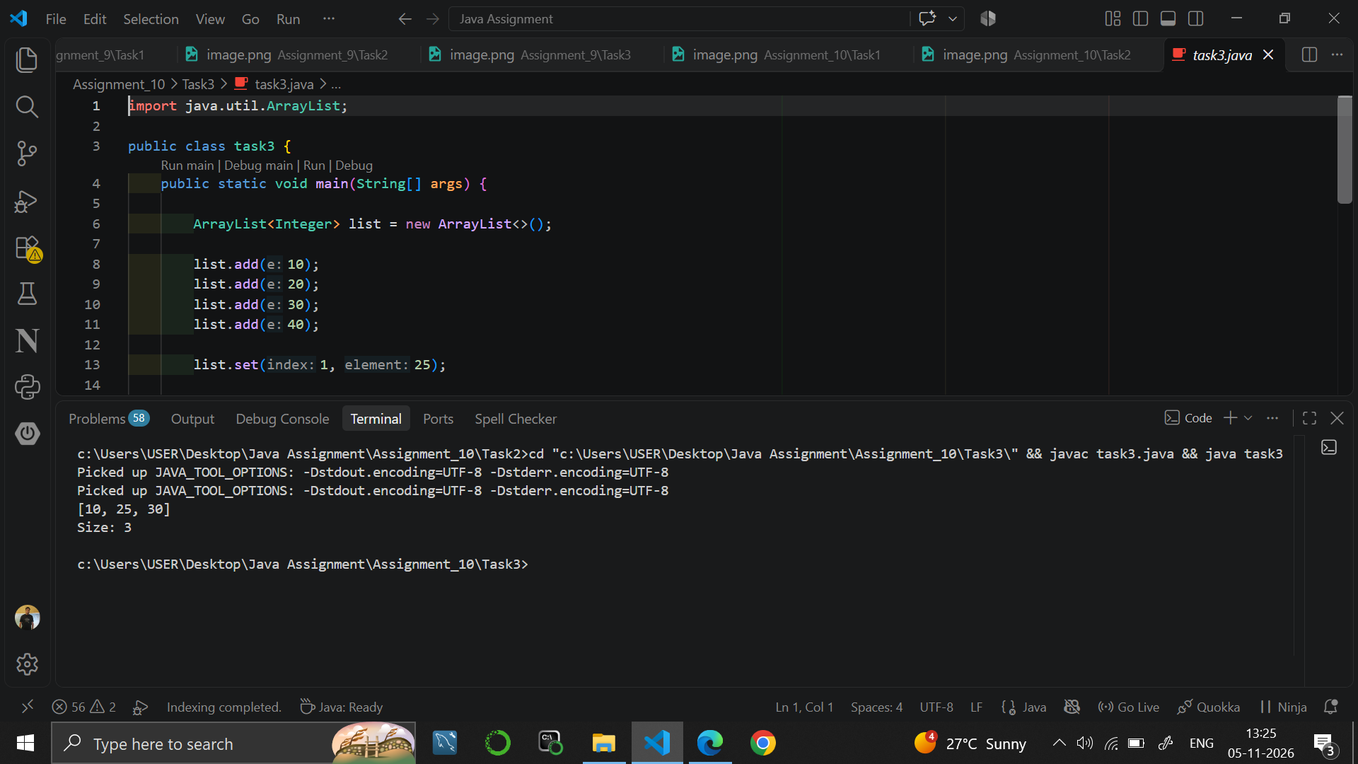

9. RESULT
Java programs were written to print a day name using a switch statement and to add, read, change and remove elements of an ArrayList.

10. VIVA-VOCE QUESTIONS
- What is the use of the break statement in a switch?
- What is the purpose of the default case?
- What is the difference between an array and an ArrayList?
- What do the methods set() and remove() do in an ArrayList?
- How do you find the number of elements in an ArrayList?

EXPERIMENT NO. 11
Course: BCS351

1. EXPERIMENT TITLE
Bubble Sort and Selection Sort Algorithms

2. AIM
To sort small arrays with bubble sort and selection sort, and to count the swaps.

3. SOFTWARE / TOOLS REQUIRED
Java Development Kit (JDK 8 or higher); an IDE (Eclipse / IntelliJ IDEA / VS Code / NetBeans) or the command line (javac and java).

4. THEORY
Bubble sort repeatedly compares neighbouring elements and swaps them if they are in the wrong order, so the largest value moves to the end in every pass. Selection sort finds the smallest element in the unsorted part and swaps it into its correct position. Both sorting methods have a time complexity of O(n^2). Arrays.toString() converts an array into a printable string.

5. ALGORITHM / PROCEDURE
Task 1 (Bubble Sort)
- Start.
- Create arr = {5, 1, 4, 2, 8}.
- Repeat for i = 0 to arr.length - 2.
- Repeat for j = 0 to arr.length - 2 - i: if arr[j] > arr[j + 1], swap them using a temporary variable.
- Print "Sorted: " followed by Arrays.toString(arr).
- Stop.
Task 2 (Selection Sort)
- Start.
- Create arr = {64, 25, 12, 22, 11}.
- Repeat for i = 0 to arr.length - 2: set minIndex = i.
- For j = i + 1 to the end: if arr[j] < arr[minIndex], set minIndex = j.
- Swap arr[i] with arr[minIndex].
- Print "Sorted: " followed by Arrays.toString(arr).
- Stop.
Task 3 (Counting swaps)
- Start.
- Create arr = {5, 1, 4, 2, 8} and set swaps = 0.
- Perform the same bubble sort passes as in Task 1.
- Each time two values are swapped, increase swaps by 1.
- Print "Swaps: " followed by swaps.
- Stop.

6. PROGRAM / QUERIES / COMMANDS
Task 1 – task1.java
import java.util.Arrays;

public class task1 {
public static void main(String[] args) {

int arr[] = {5, 1, 4, 2, 8};

for(int i = 0; i < arr.length - 1; i++) {

for(int j = 0; j < arr.length - 1 - i; j++) {

if(arr[j] > arr[j + 1]) {

int temp = arr[j];
arr[j] = arr[j + 1];
arr[j + 1] = temp;

}
}
}

System.out.println("Sorted: " + Arrays.toString(arr));

}
}
//Output
// Sorted: [1, 2, 4, 5, 8]

Task 2 – task2.java
import java.util.Arrays;

public class task2 {
public static void main(String[] args) {

int arr[] = {64, 25, 12, 22, 11};

for(int i = 0; i < arr.length - 1; i++) {

int minIndex = i;

for(int j = i + 1; j < arr.length; j++) {

if(arr[j] < arr[minIndex]) {
minIndex = j;
}
}

int temp = arr[i];
arr[i] = arr[minIndex];
arr[minIndex] = temp;

}

System.out.println("Sorted: " + Arrays.toString(arr));

}
}

//Output
// Sorted: [11, 12, 22, 25, 64]

Task 3 – task3.java
public class task3 {
public static void main(String[] args) {

int arr[] = {5, 1, 4, 2, 8};

int swaps = 0;

for(int i = 0; i < arr.length - 1; i++) {

for(int j = 0; j < arr.length - 1 - i; j++) {

if(arr[j] > arr[j + 1]) {

int temp = arr[j];
arr[j] = arr[j + 1];
arr[j + 1] = temp;

swaps++;
}
}
}

System.out.println("Swaps: " + swaps);

}
}
//output
// Swaps: 4

7. INPUT
No user input is taken. All values are fixed inside the programs: arr = {5, 1, 4, 2, 8} in Task 1 and Task 3; arr = {64, 25, 12, 22, 11} in Task 2.

8. OUTPUT
Task 1
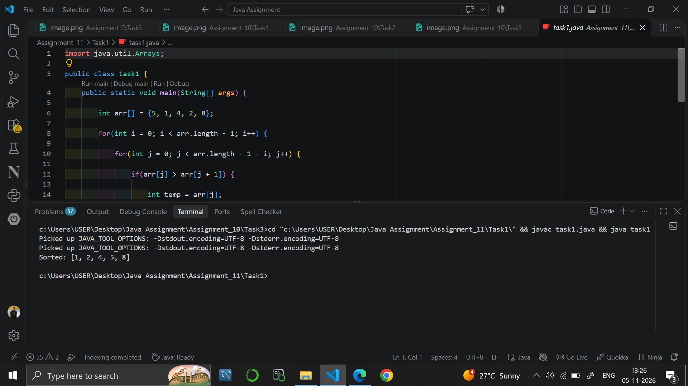

Task 2
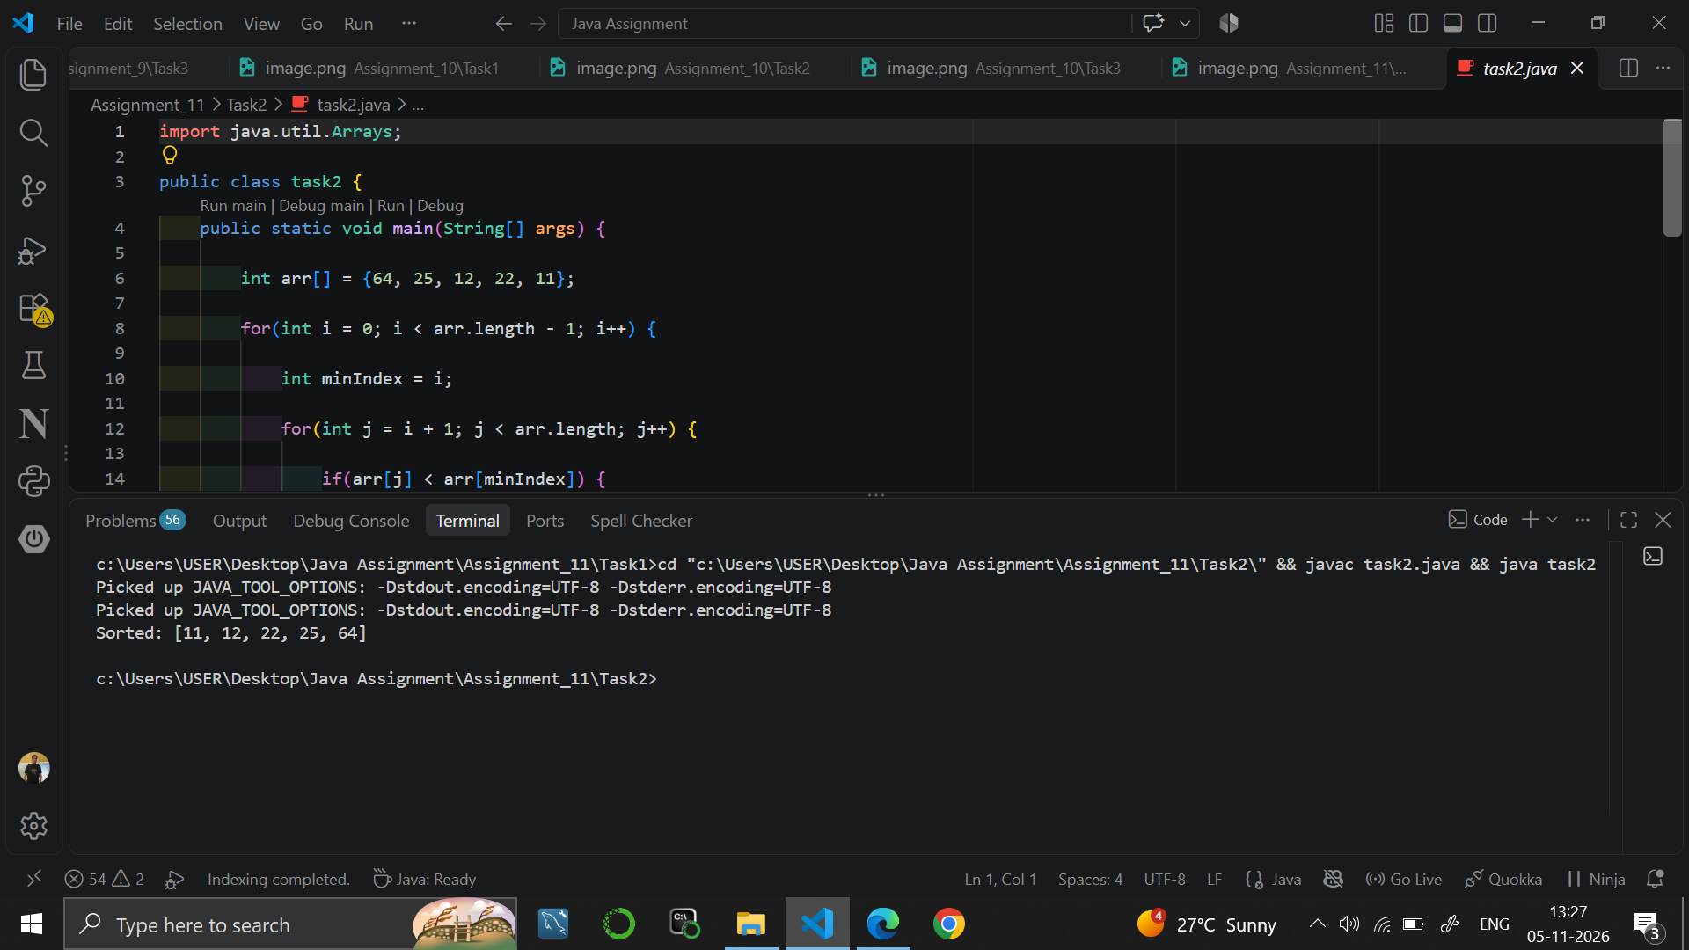

Task 3
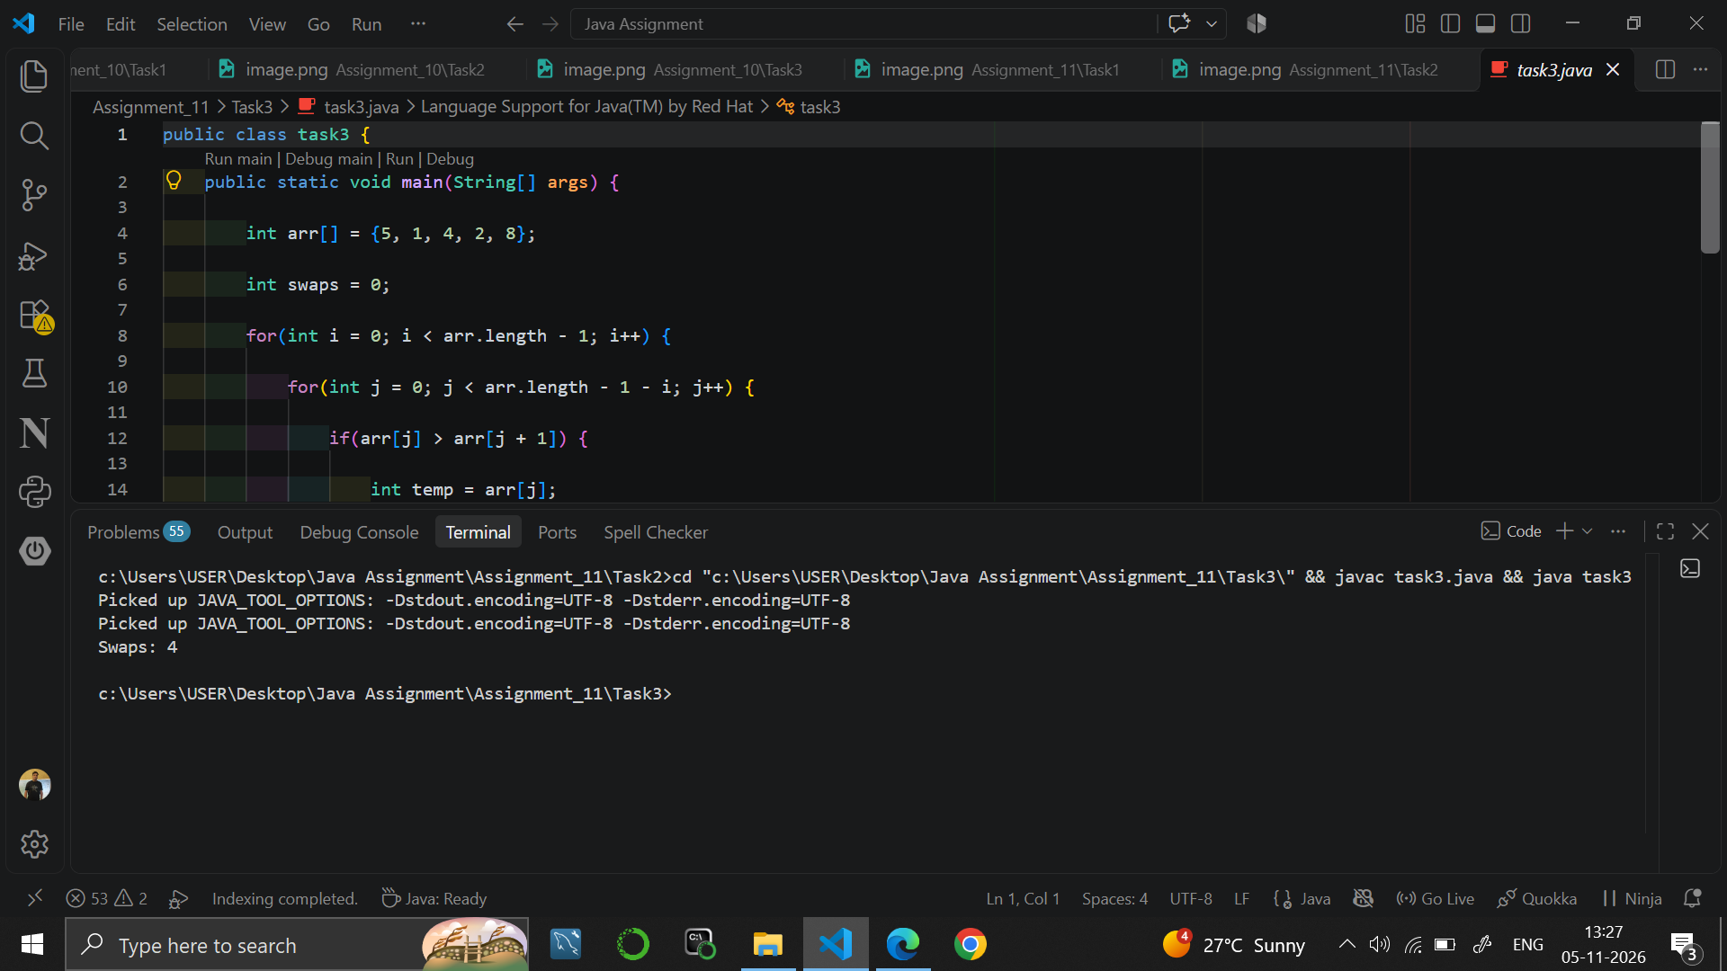

9. RESULT
Java programs were written to sort arrays in increasing order using bubble sort and selection sort, and to count the number of swaps made by bubble sort.

10. VIVA-VOCE QUESTIONS
- How does bubble sort work?
- How does selection sort work?
- What is the time complexity of bubble sort and selection sort?
- Why is a temporary variable used while swapping?
- What is the purpose of Arrays.toString()?

EXPERIMENT NO. 12
Course: BCS351

1. EXPERIMENT TITLE
Insertion Sort and Shift Counting

2. AIM
To sort small arrays with insertion sort and to count how many values are shifted.

3. SOFTWARE / TOOLS REQUIRED
Java Development Kit (JDK 8 or higher); an IDE (Eclipse / IntelliJ IDEA / VS Code / NetBeans) or the command line (javac and java).

4. THEORY
Insertion sort builds the sorted part of the array one element at a time. Each new element (the key) is compared with the elements on its left; larger elements are shifted one place to the right, and the key is placed in the gap. The worst case happens when the array is in reverse order, and the number of shifts is then n(n-1)/2. Its time complexity is O(n^2).

5. ALGORITHM / PROCEDURE
Task 1
- Start.
- Create arr = {7, 3, 5, 1}.
- Repeat for i = 1 to arr.length - 1: set key = arr[i] and j = i - 1.
- While j >= 0 and arr[j] > key: set arr[j + 1] = arr[j] and decrease j by 1.
- Set arr[j + 1] = key.
- Print "Sorted: " followed by Arrays.toString(arr).
- Stop.
Task 2
- Start.
- Create arr = {14, 3, 9, 21, 6}.
- Apply the same insertion sort steps as in Task 1.
- Print "Sorted: " followed by Arrays.toString(arr).
- Stop.
Task 3
- Start.
- Create arr = {6, 5, 4, 3, 2, 1} and set shifts = 0.
- Apply the insertion sort steps; each time a value is moved one place to the right, increase shifts by 1.
- Print "Shifts: " followed by shifts.
- Stop.

6. PROGRAM / QUERIES / COMMANDS
Task 1 – task1.java
import java.util.Arrays;

public class task1 {
public static void main(String[] args) {

int arr[] = {7, 3, 5, 1};

for(int i = 1; i < arr.length; i++) {

int key = arr[i];
int j = i - 1;

while(j >= 0 && arr[j] > key) {
arr[j + 1] = arr[j];
j--;
}

arr[j + 1] = key;
}

System.out.println("Sorted: " + Arrays.toString(arr));

}
}

//Output
// Sorted: [1, 3, 5, 7]

Task 2 – task2.java
import java.util.Arrays;

public class task2 {
public static void main(String[] args) {

int arr[] = {14, 3, 9, 21, 6};

for(int i = 1; i < arr.length; i++) {

int key = arr[i];
int j = i - 1;

while(j >= 0 && arr[j] > key) {
arr[j + 1] = arr[j];
j--;
}

arr[j + 1] = key;
}

System.out.println("Sorted: " + Arrays.toString(arr));

}
}

//Output
// Sorted: [3, 6, 9, 14, 21]

Task 3 – task3.java
public class task3 {
public static void main(String[] args) {

int arr[] = {6, 5, 4, 3, 2, 1};

int shifts = 0;

for(int i = 1; i < arr.length; i++) {

int key = arr[i];
int j = i - 1;

while(j >= 0 && arr[j] > key) {

arr[j + 1] = arr[j];
j--;
shifts++;
}

arr[j + 1] = key;
}

System.out.println("Shifts: " + shifts);

}
}

//Output
// Shifts: 15

7. INPUT
No user input is taken. All values are fixed inside the programs: arr = {7, 3, 5, 1} in Task 1; arr = {14, 3, 9, 21, 6} in Task 2; arr = {6, 5, 4, 3, 2, 1} in Task 3.

8. OUTPUT
Task 1
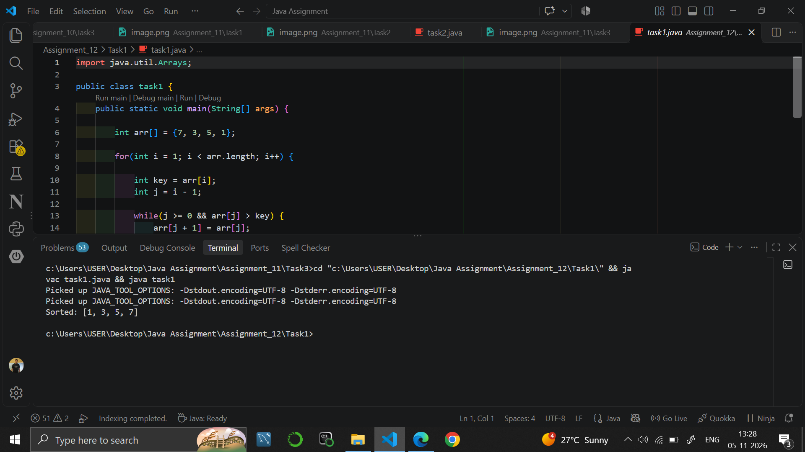

Task 2
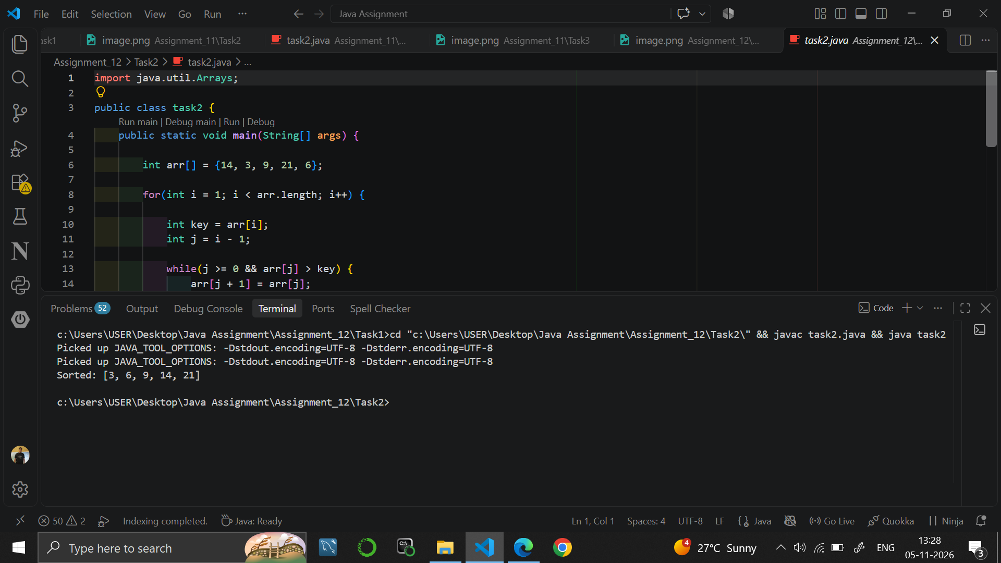

Task 3
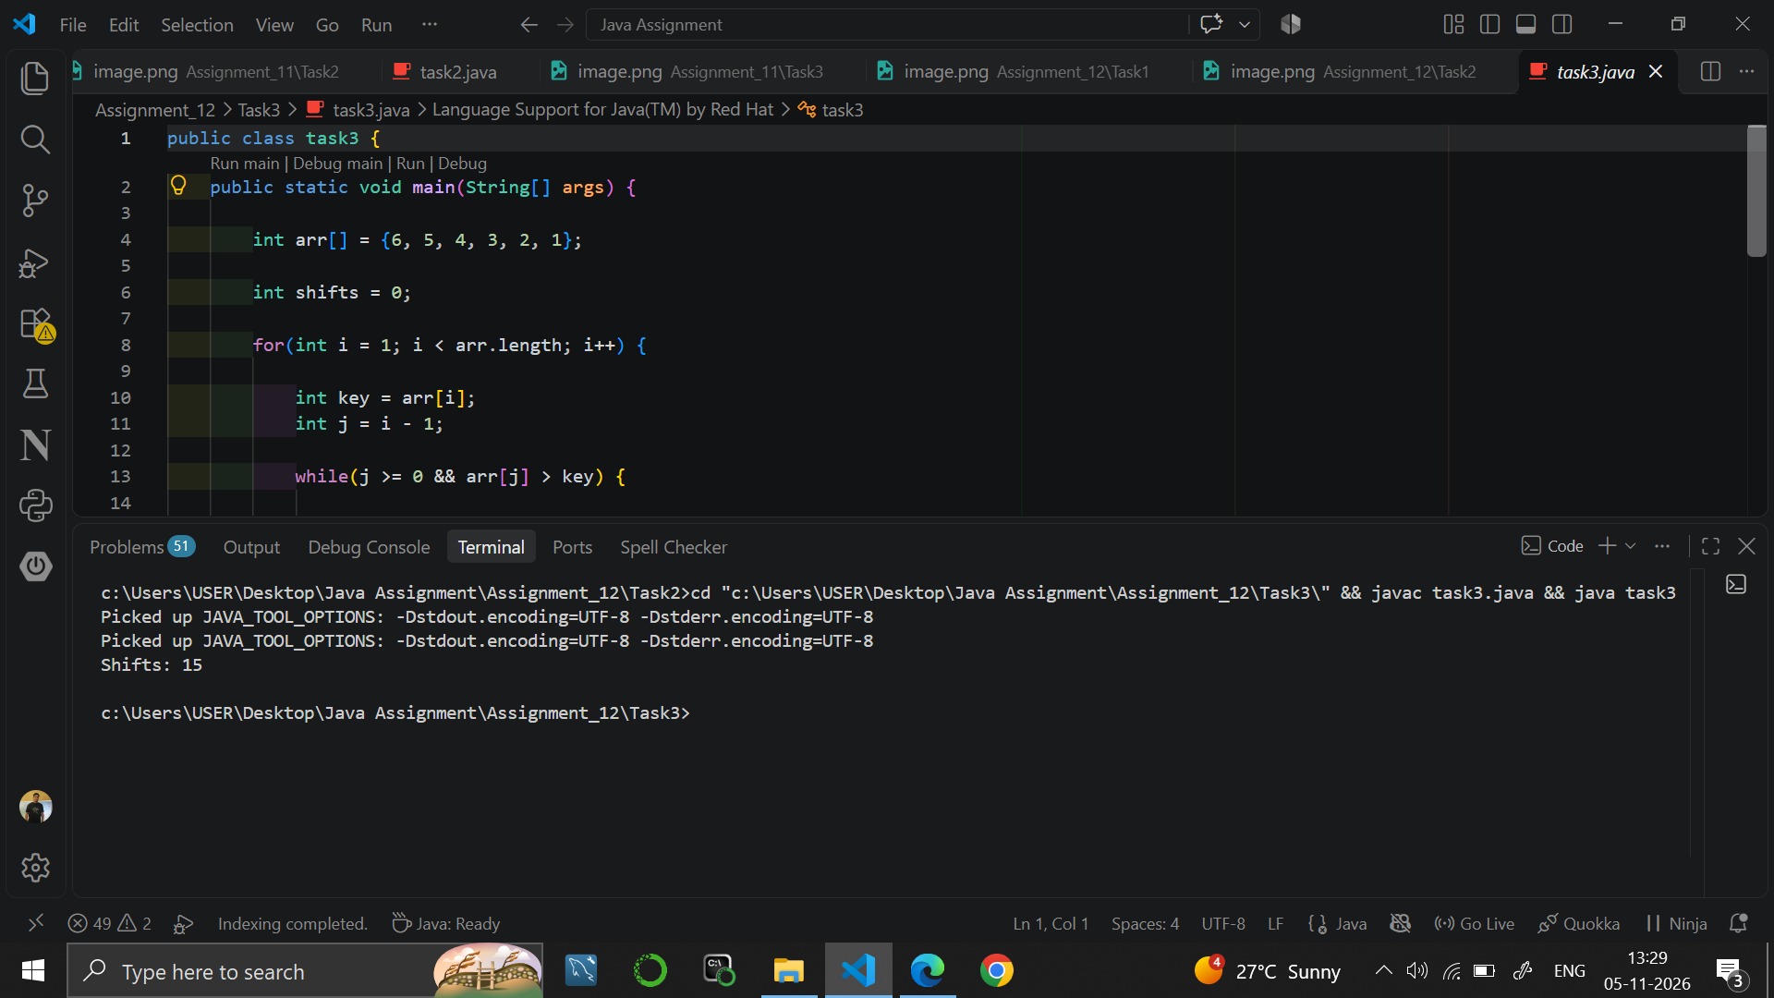

9. RESULT
Java programs were written to sort arrays in increasing order using insertion sort and to count the number of shifts.

10. VIVA-VOCE QUESTIONS
- How does insertion sort work?
- What is the key in insertion sort?
- In which case does insertion sort take the maximum number of shifts?
- What is the time complexity of insertion sort?
- How is insertion sort different from selection sort?

EXPERIMENT NO. 13
Course: BCS351

1. EXPERIMENT TITLE
Strings: Built-in Methods, Reversal, and Palindromes

2. AIM
To use common String methods, reverse a word, check a palindrome and print substrings.

3. SOFTWARE / TOOLS REQUIRED
Java Development Kit (JDK 8 or higher); an IDE (Eclipse / IntelliJ IDEA / VS Code / NetBeans) or the command line (javac and java).

4. THEORY
A String is a sequence of characters, and its characters are numbered from 0. Common methods are length() for the number of characters, indexOf() for the position of a character, toUpperCase() for capital letters, charAt(i) for the character at an index and substring(start, end) for a part of the string. A palindrome reads the same from both ends. Strings are compared by content with equals().

5. ALGORITHM / PROCEDURE
Task 1
- Start.
- Store "Programming" in word.
- Print "Length: " followed by word.length().
- Print "Position of g: " followed by word.indexOf('g').
- Print "Upper case: " followed by word.toUpperCase().
- Stop.
Task 2
- Start.
- Store "Java" in word and set reversed to an empty string.
- Repeat for i = word.length() - 1 down to 0: add word.charAt(i) to reversed.
- Print "Reversed: " followed by reversed.
- Stop.
Task 3
- Start.
- Store "racecar" in word and build its reverse in reversed using a loop and charAt().
- If word.equals(reversed), print the word followed by "is a palindrome".
- Otherwise, print the word followed by "is not a palindrome".
- Stop.
Task 4
- Start.
- Store "abc" in word.
- Repeat for i = 0 to word.length() - 1 (starting letter).
- Repeat for j = i + 1 to word.length(): print word.substring(i, j) on its own line.
- Stop.

6. PROGRAM / QUERIES / COMMANDS
Task 1 – task1.java
public class task1 {
public static void main(String[] args) {
String word = "Programming";

System.out.println("Length: " + word.length());
System.out.println("Position of g: " + word.indexOf('g'));
System.out.println("Upper case: " + word.toUpperCase());
}
}

//Output
// Length: 11
// Position of g: 3
// Upper case: PROGRAMMING

Task 2 – task2.java
public class task2 {
public static void main(String[] args) {
String word = "Java";
String reversed = "";

for (int i = word.length() - 1; i >= 0; i--) {
reversed = reversed + word.charAt(i);
}

System.out.println("Reversed: " + reversed);
}
}

//output
// Reversed: avaJ

Task 3 – task3.java
public class task3 {
public static void main(String[] args) {
String word = "racecar";
String reversed = "";

for (int i = word.length() - 1; i >= 0; i--) {
reversed = reversed + word.charAt(i);
}

if (word.equals(reversed)) {
System.out.println(word + " is a palindrome");
} else {
System.out.println(word + " is not a palindrome");
}
}
}

Task 4 – task4.java
public class task4 {
public static void main(String[] args) {
String word = "abc";

for (int i = 0; i < word.length(); i++) {
for (int j = i + 1; j <= word.length(); j++) {
System.out.println(word.substring(i, j));
}
}
}
}

//output
// a
// ab
// abc
// b
// bc
// c

7. INPUT
No user input is taken. All values are fixed inside the programs: word = "Programming" in Task 1; "Java" in Task 2; "racecar" in Task 3; "abc" in Task 4.

8. OUTPUT
Task 1
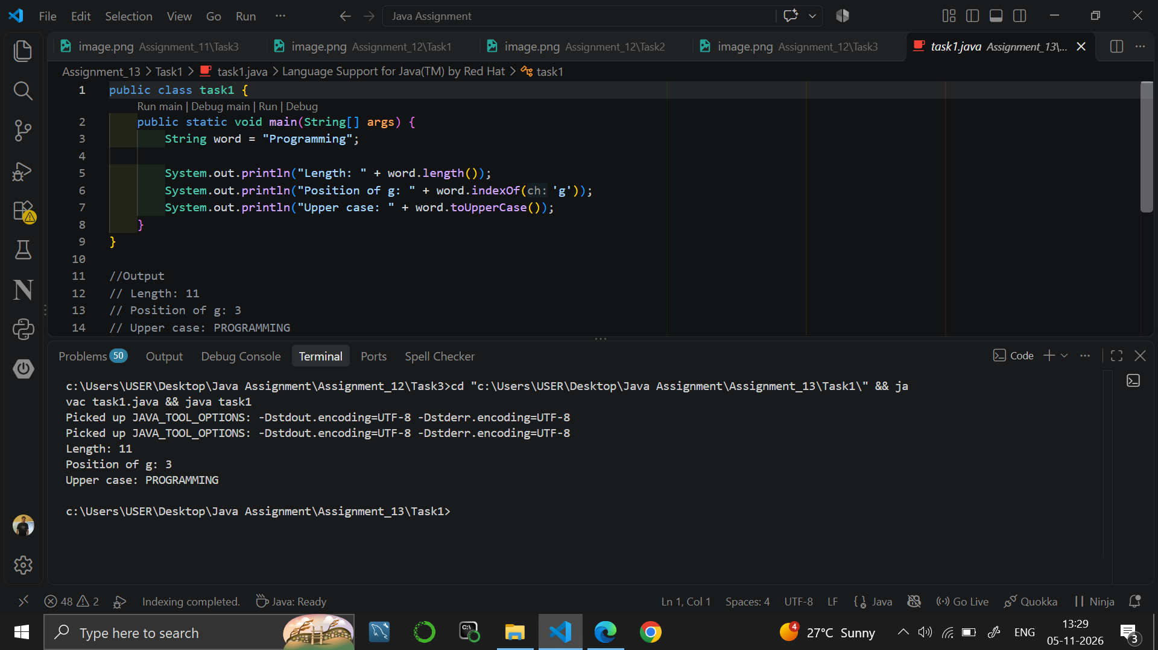

Task 2
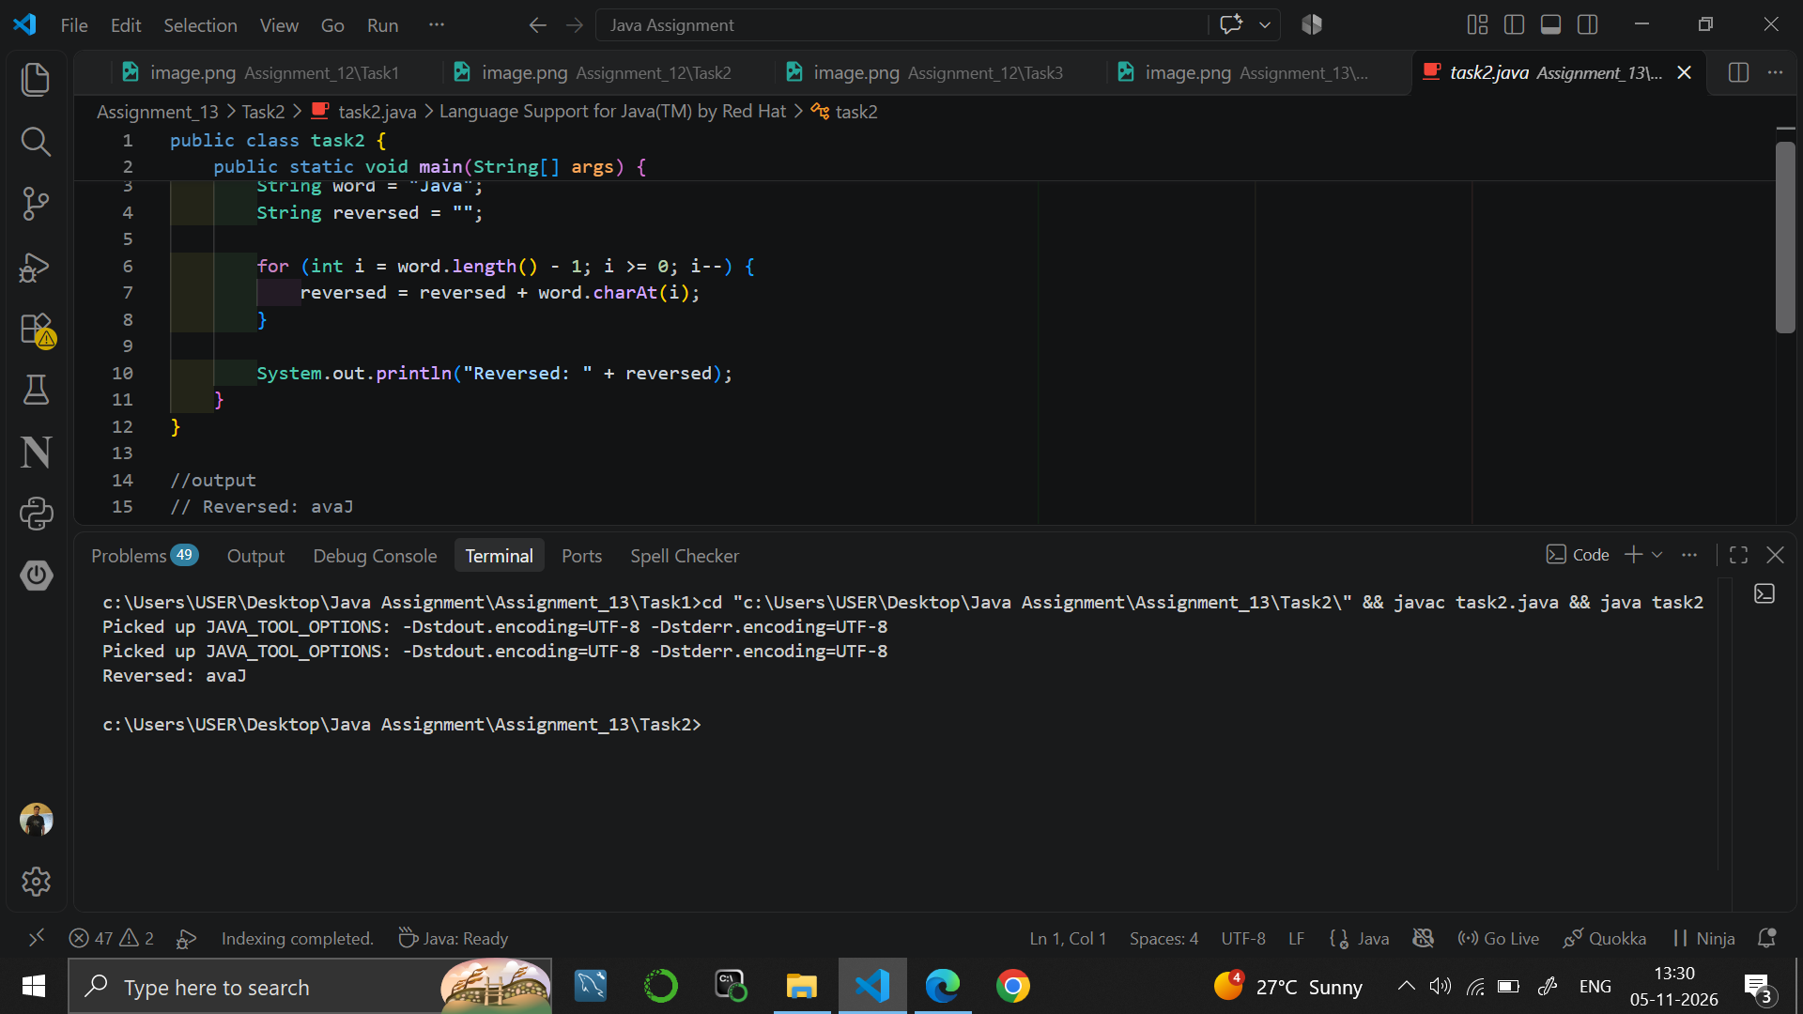

Task 3
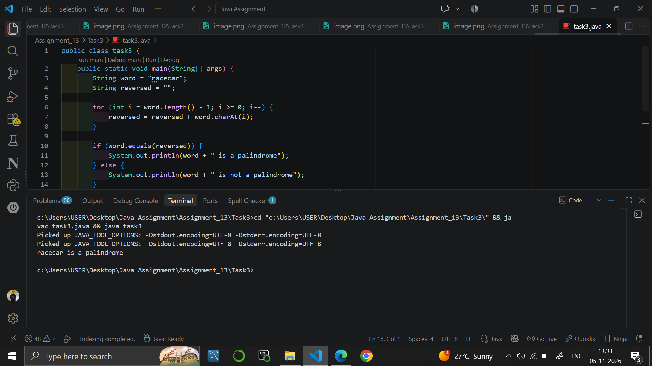

Task 4
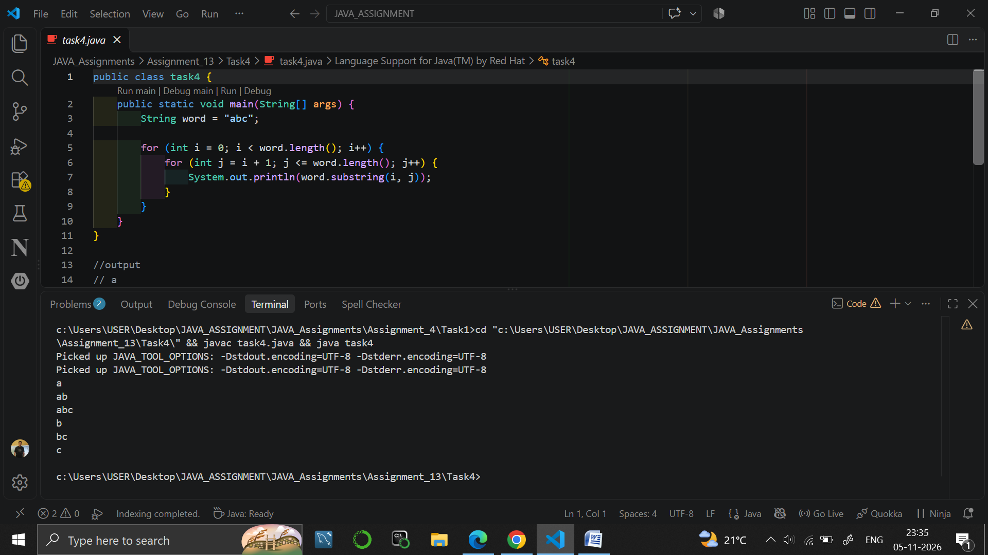

9. RESULT
Java programs were written to use String methods, to reverse a word, to check whether a word is a palindrome and to print all substrings of a word.

10. VIVA-VOCE QUESTIONS
- What does indexOf() return?
- How does charAt() work?
- What is a palindrome? Give an example.
- Why is equals() used to compare strings instead of ==?
- What do the two arguments of substring(i, j) mean?

EXPERIMENT NO. 14
Course: BCS351

1. EXPERIMENT TITLE
Characters: Counting Vowels, Letters and Positions

2. AIM
To use charAt to count vowels and a letter, and to print each letter with its position.

3. SOFTWARE / TOOLS REQUIRED
Java Development Kit (JDK 8 or higher); an IDE (Eclipse / IntelliJ IDEA / VS Code / NetBeans) or the command line (javac and java).

4. THEORY
The charAt(i) method returns the character at position i of a String, where positions start from 0. A loop from 0 to length() - 1 visits every character. The char type holds a single character written in single quotes, and characters can be compared using == and the logical operators. This is used to count vowels and to count how many times a given letter occurs.

5. ALGORITHM / PROCEDURE
Task 1
- Start.
- Store "programming" in s and set count = 0.
- Repeat for i = 0 to s.length() - 1: set ch = s.charAt(i).
- If ch is 'a', 'e', 'i', 'o' or 'u', increase count by 1.
- Print "Vowels: " followed by count.
- Stop.
Task 2
- Start.
- Store "programming" in s and set count = 0.
- Repeat for i = 0 to s.length() - 1: if s.charAt(i) == 'g', increase count by 1.
- Print "Count of g: " followed by count.
- Stop.
Task 3
- Start.
- Store "hello" in s.
- Repeat for i = 0 to s.length() - 1.
- Print i, ": " and s.charAt(i) on one line.
- Stop.

6. PROGRAM / QUERIES / COMMANDS
Task 1 – task1.java
public class task1 {
public static void main(String[] args) {
String s = "programming";
int count = 0;

for (int i = 0; i < s.length(); i++) {
char ch = s.charAt(i);

if (ch == 'a' || ch == 'e' || ch == 'i' ||
ch == 'o' || ch == 'u') {
count++;
}
}

System.out.println("Vowels: " + count);
}
}
//Output
//Vowels: 3

Task 2 – task2.java
public class task2 {
public static void main(String[] args) {
String s = "programming";
int count = 0;

for (int i = 0; i < s.length(); i++) {
if (s.charAt(i) == 'g') {
count++;
}
}

System.out.println("Count of g: " + count);
}
}

//Output
// Count of g: 2

Task 3 – task3.java
public class task3 {
public static void main(String[] args) {
String s = "hello";

for (int i = 0; i < s.length(); i++) {
System.out.println(i + ": " + s.charAt(i));
}
}
}

//Output
// 0: h
// 1: e
// 2: l
// 3: l
// 4: o

7. INPUT
No user input is taken. All values are fixed inside the programs: s = "programming" in Task 1 and Task 2; s = "hello" in Task 3.

8. OUTPUT
Task 1
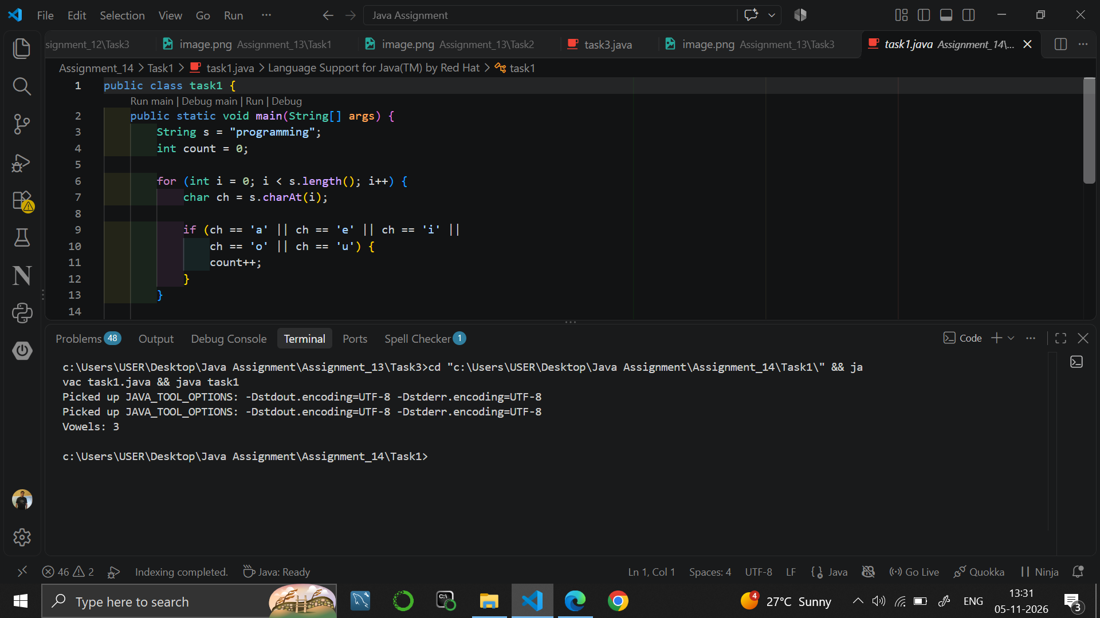

Task 2
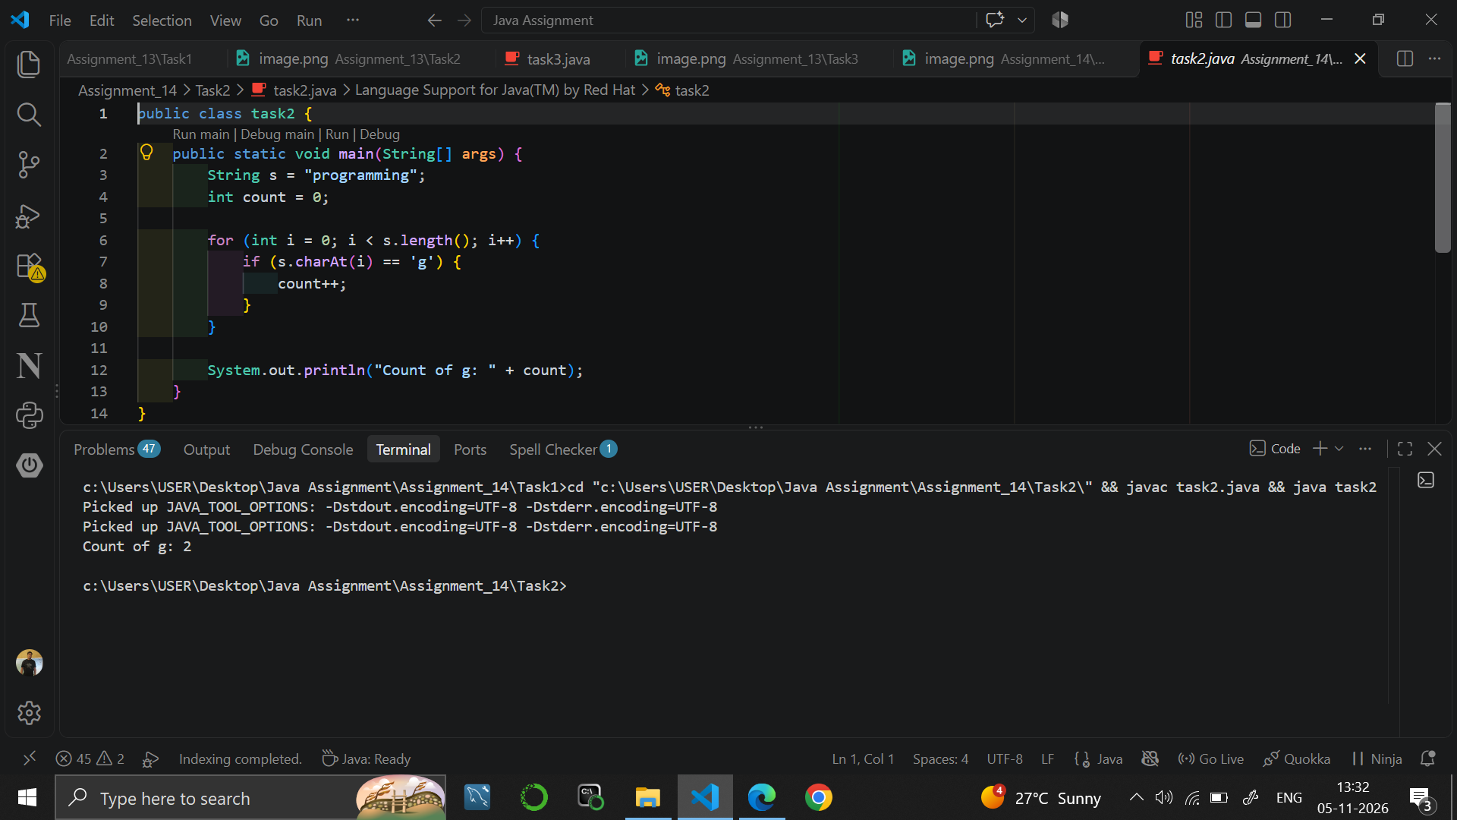

Task 3
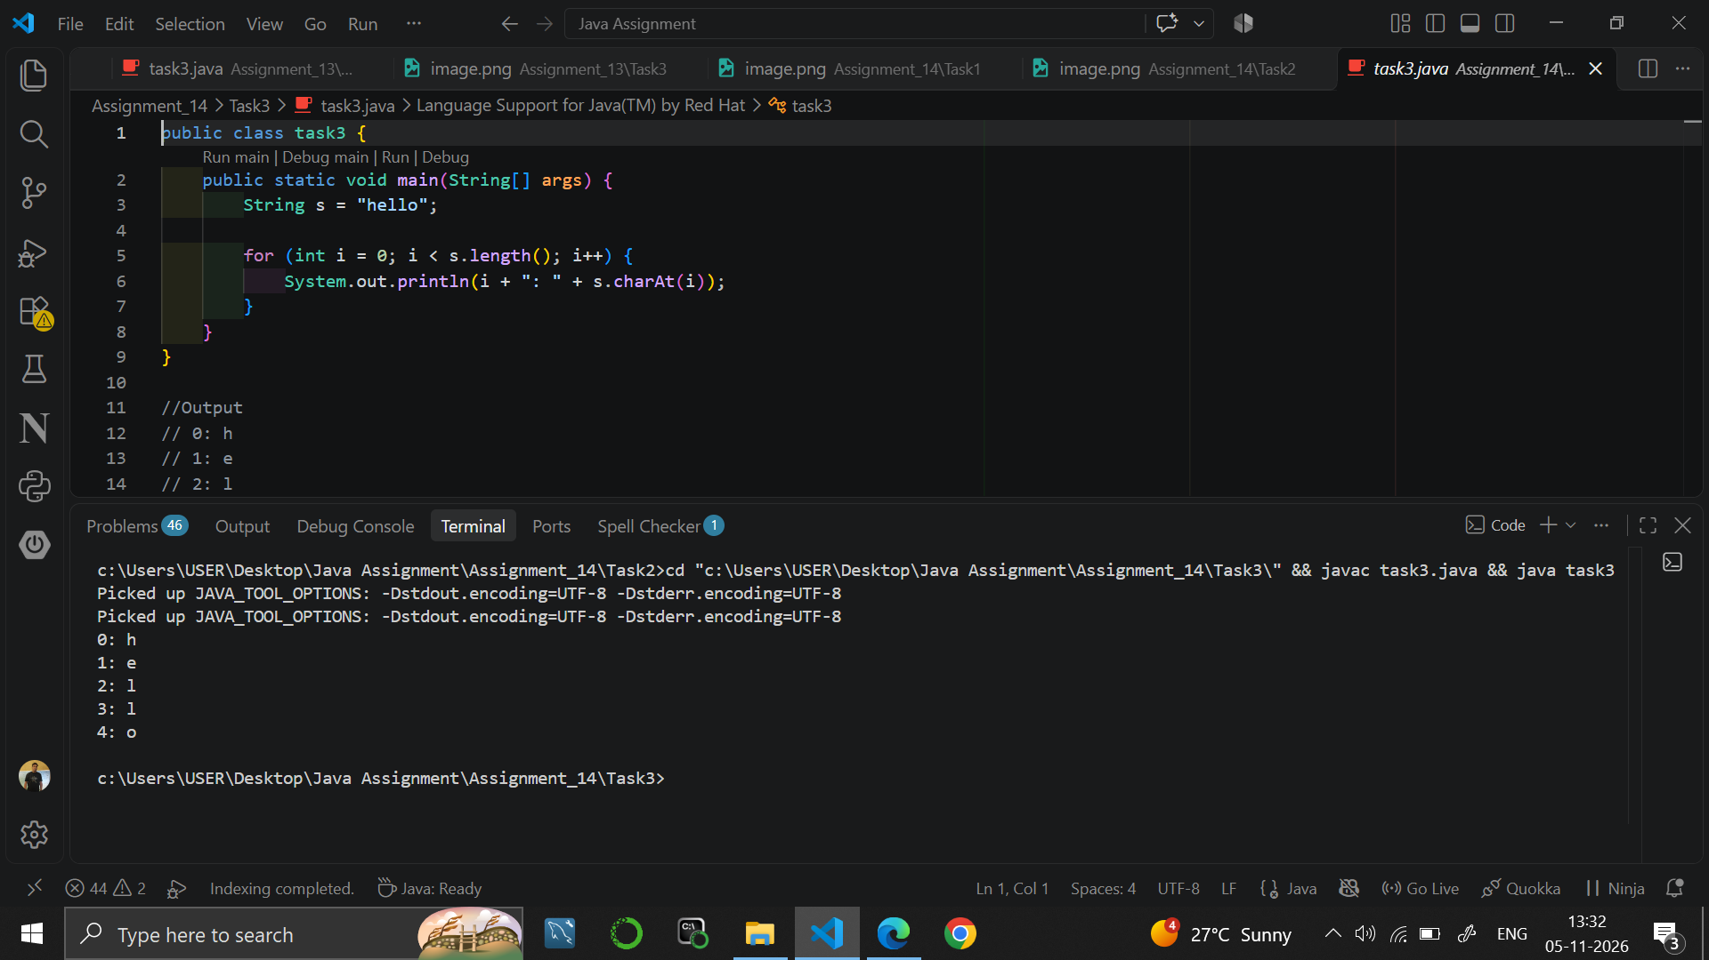

9. RESULT
Java programs were written to count the vowels of a string, to count the occurrences of a letter and to print every letter with its position.

10. VIVA-VOCE QUESTIONS
- What is the return type of charAt()?
- Why are characters written in single quotes?
- How do you count the vowels in a string?
- What is the index of the first character of a string?
- What is the difference between a char and a String?

EXPERIMENT NO. 15
Course: BCS351

1. EXPERIMENT TITLE
StringBuilder Class Methods (append, insert, delete)

2. AIM
To build and change text with StringBuilder, using append, insert and deleteCharAt.

3. SOFTWARE / TOOLS REQUIRED
Java Development Kit (JDK 8 or higher); an IDE (Eclipse / IntelliJ IDEA / VS Code / NetBeans) or the command line (javac and java).

4. THEORY
A String is immutable, so every change creates a new object. StringBuilder is a mutable class that changes the text in the same object, which is faster for repeated changes. Its important methods are append() to add text at the end, insert(index, text) to add text at a position, deleteCharAt(index) to remove one character and length() to get the number of characters.

5. ALGORITHM / PROCEDURE
Task 1
- Start.
- Create a StringBuilder sb with the text "Hello".
- Append " World" using sb.append().
- Print sb.
- Print "Length: " followed by sb.length().
- Stop.
Task 2
- Start.
- Create an empty StringBuilder sb.
- Repeat for i = 1 to 5: append i and then append ",".
- Remove the last comma using sb.deleteCharAt(sb.length() - 1).
- Print sb.
- Stop.
Task 3
- Start.
- Create a StringBuilder sb with the text "Java".
- Use sb.insert(0, "Hello ") to add text at index 0.
- Print sb.
- Stop.

6. PROGRAM / QUERIES / COMMANDS
Task 1 – task1.java
public class task1 {
public static void main(String[] args) {
StringBuilder sb = new StringBuilder("Hello");

sb.append(" World");

System.out.println(sb);
System.out.println("Length: " + sb.length());
}
}

//Output
// Hello World
// Length: 11

Task 2 – task2.java
public class task2 {
public static void main(String[] args) {
StringBuilder sb = new StringBuilder();

for (int i = 1; i <= 5; i++) {
sb.append(i);
sb.append(",");
}

sb.deleteCharAt(sb.length() - 1);

System.out.println(sb);
}
}
//Output
// 1,2,3,4,5

Task 3 – task3.java
public class task3 {
public static void main(String[] args) {
StringBuilder sb = new StringBuilder("Java");

sb.insert(0, "Hello ");

System.out.println(sb);
}
}

//Output
// Hello Java

7. INPUT
No user input is taken. All values are fixed inside the programs: "Hello" and " World" in Task 1; the numbers 1 to 5 in Task 2; "Java" and "Hello " in Task 3.

8. OUTPUT
Task 1
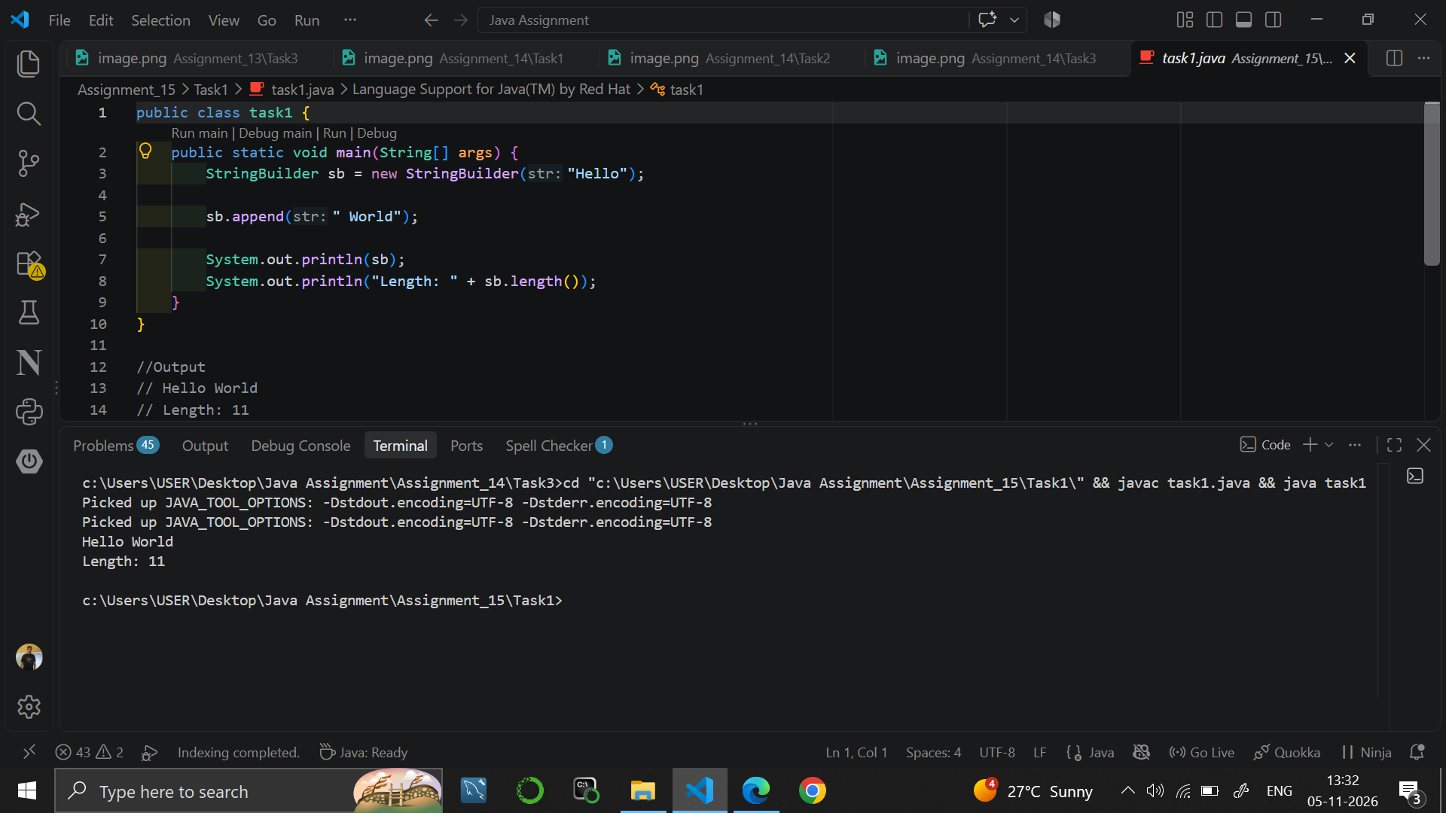

Task 2
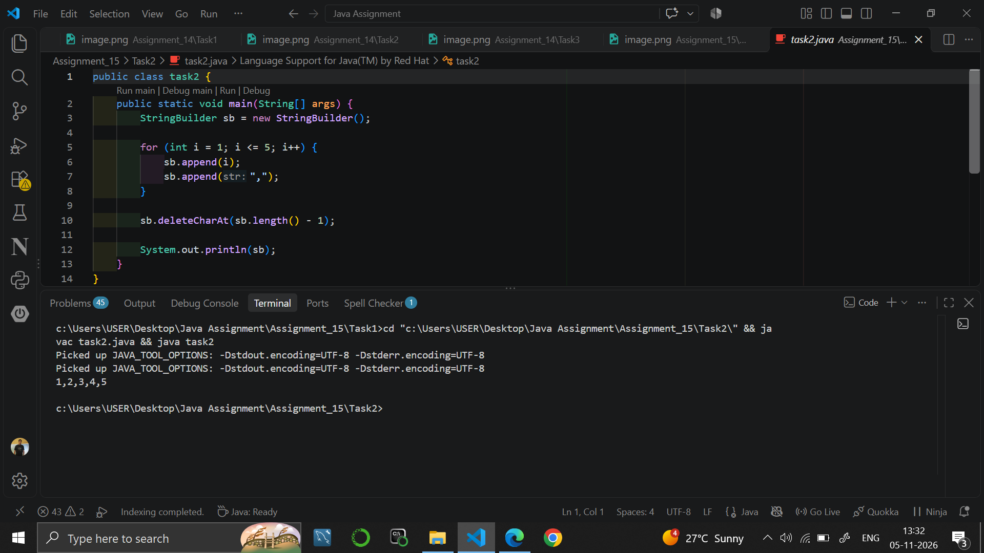

Task 3
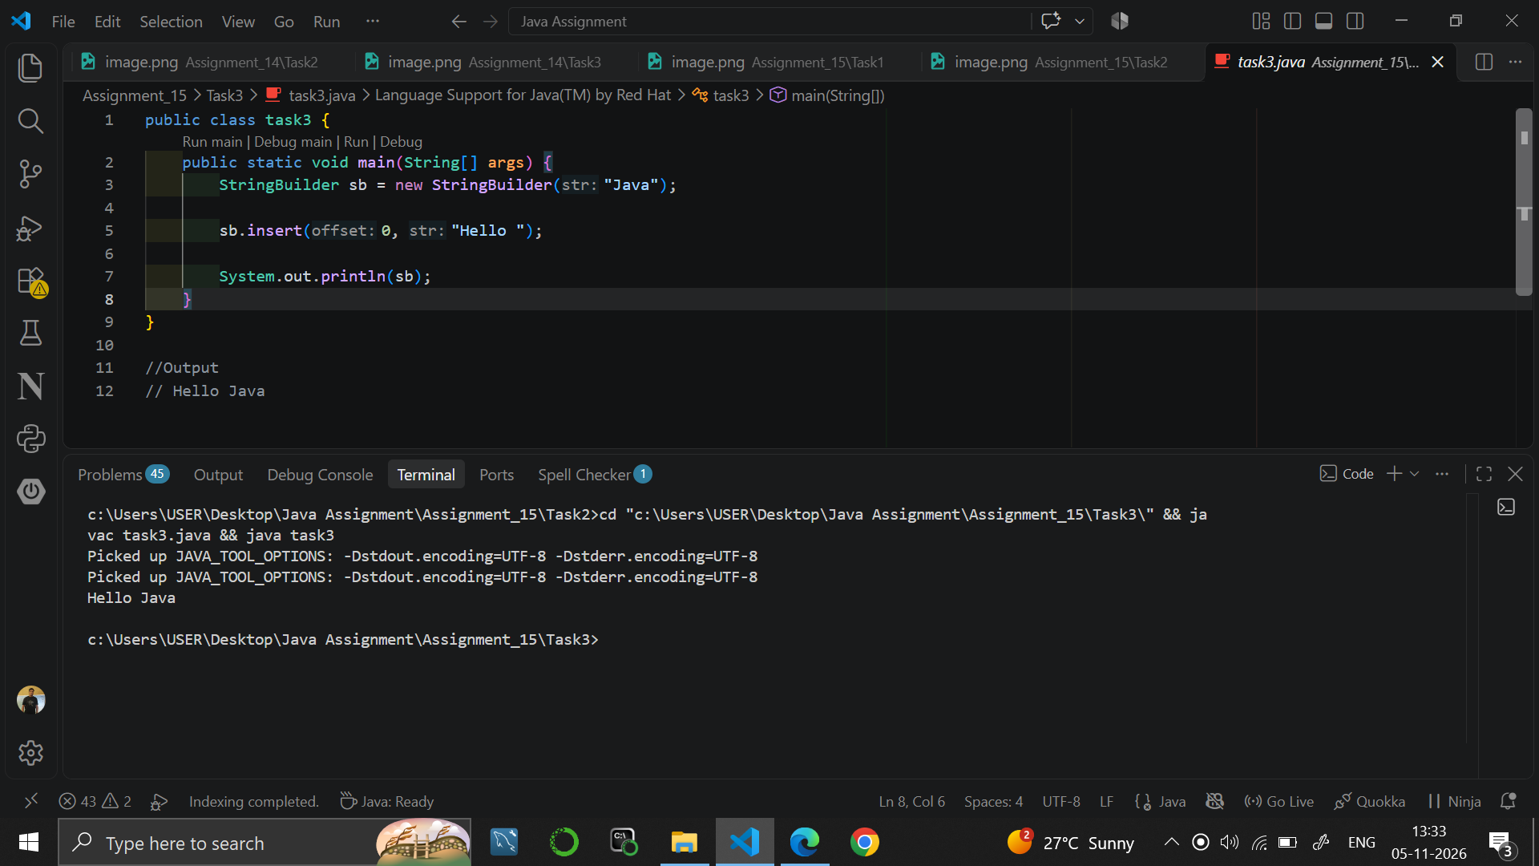

9. RESULT
Java programs were written to append, insert and delete characters using the StringBuilder class.

10. VIVA-VOCE QUESTIONS
- What is the difference between String and StringBuilder?
- What does the append() method do?
- How does insert(0, text) work?
- How is a character removed from a StringBuilder?
- Why is StringBuilder preferred for repeated modifications?

