车载机模块设计文档
- 卡类别分组功能
  - 卡类别分组是指将卡权限类别分组，以便在刷卡时车载机能不同的语音，现在可以支持的语音有：0-默认类别，1-教师卡、2-学生卡、3-职工卡、4-临时卡
  - 前台功能设计
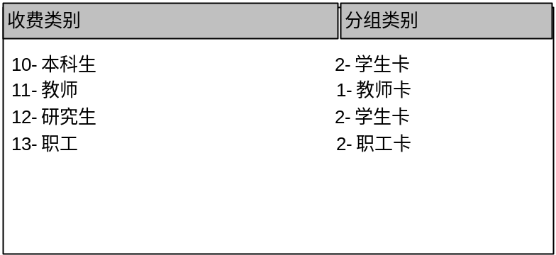
- 前台列出系统所有的收费类别
- 每种收费类别初始的分组类别是“0-默认类别”
- 操作员选择所有类别后，点保存“按钮”，前台生成文件cardgrp.dat，并上传到手持机上
- cardgrp.dat文件的格式：该文件定长256个字节，从第一字节开始依次表示每类卡的分组编号，系统没有的卡类别用默认分组类别“0”，以上图为例，文件16进制表示如下：
00 00 00 00 00 00 00 00 00 02 01 02 02 00 00 00
00 00 00 00 00 00 00 00 00 00 00 00 00 00 00 00
00 00 00 00 00 00 00 00 00 00 00 00 00 00 00 00
00 00 00 00 00 00 00 00 00 00 00 00 00 00 00 00
00 00 00 00 00 00 00 00 00 00 00 00 00 00 00 00
00 00 00 00 00 00 00 00 00 00 00 00 00 00 00 00
00 00 00 00 00 00 00 00 00 00 00 00 00 00 00 00
00 00 00 00 00 00 00 00 00 00 00 00 00 00 00 00
00 00 00 00 00 00 00 00 00 00 00 00 00 00 00 00
00 00 00 00 00 00 00 00 00 00 00 00 00 00 00 00
00 00 00 00 00 00 00 00 00 00 00 00 00 00 00 00
00 00 00 00 00 00 00 00 00 00 00 00 00 00 00 00
00 00 00 00 00 00 00 00 00 00 00 00 00 00 00 00
00 00 00 00 00 00 00 00 00 00 00 00 00 00 00 00
00 00 00 00 00 00 00 00 00 00 00 00 00 00 00 00
00 00 00 00 00 00 00 00 00 00 00 00 00 00 00 00

- 黑名单下载功能
  - 黑名单功能是将系统中所有挂失/解挂，冻结/解冻卡的记录按照版本号顺序保存到黑名单数据文件中（文件名blklst.dat），并上传到手持机
  - 前台向后台发起950996功能号生成黑名单文件，功能号参数见下表
功能号950996
 | 名称 | CPACK字段 | 说明
输入 | 操作员 | semp_no | 精确查询
输入 | 客户号 | lvol1
 | 名称 | CPACK字段 | 说明
 | 数据文件名 | vsmess

  - 前台下载黑名单文件并重命名为blklst.dat ，然后上传到手持机

