# Setting up AWS IoT Core A. Visit AWS IoT Core Console and select Manage - Things from the left menu, then click Register a thing button. B. Click Create a single thing button. C. Type “testThing” in the Name filed, then scroll down and click Next button.

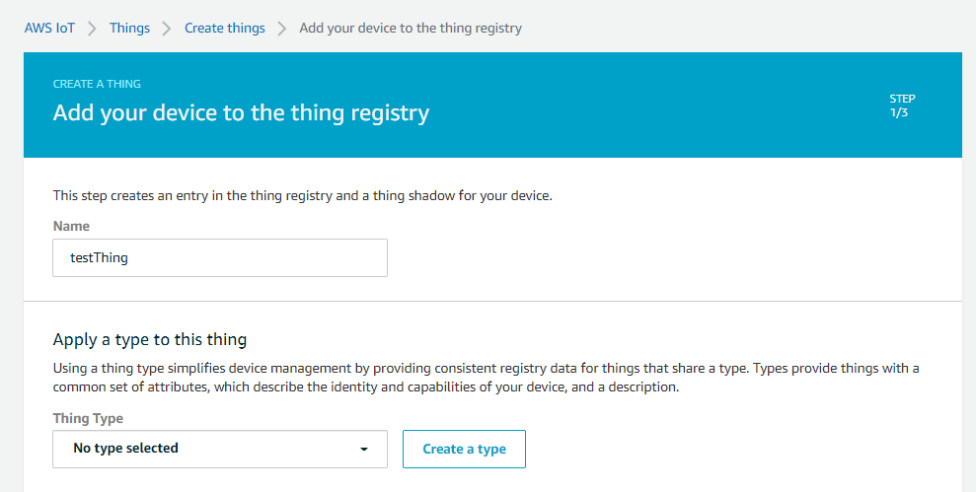  
**D. Click Create certificate button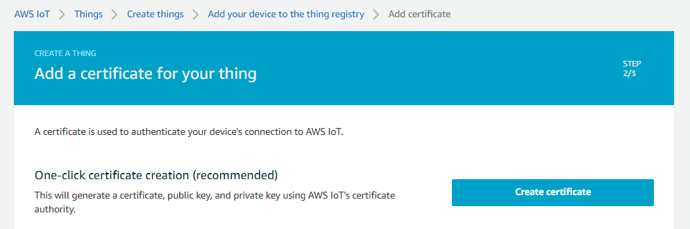 E. Download all of files and save them in a safe place. Make sure that you download private key and public key as they cannot be retrieved after you close this page.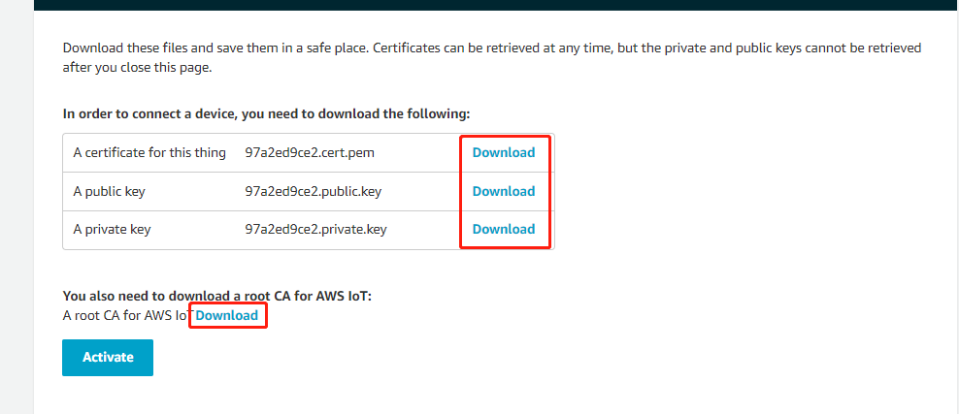 F. Regarding root CA for AWS IoT, download RSA 2048 bit key: Amazon Root CA 1.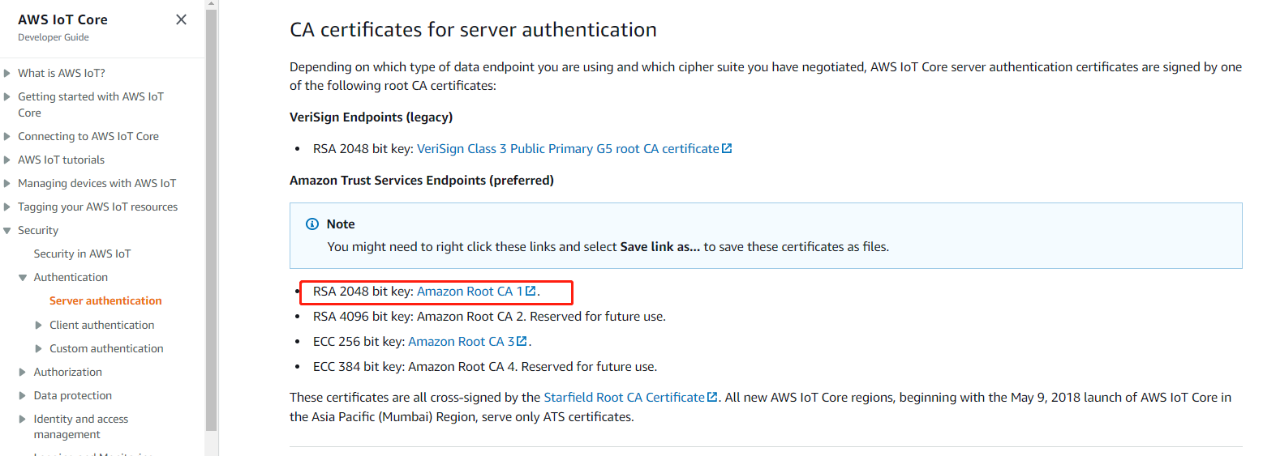 G. After making sure you have downloaded private key and public key (and certificate and Amazon root CA), scroll down and click Activate button, then click Done button.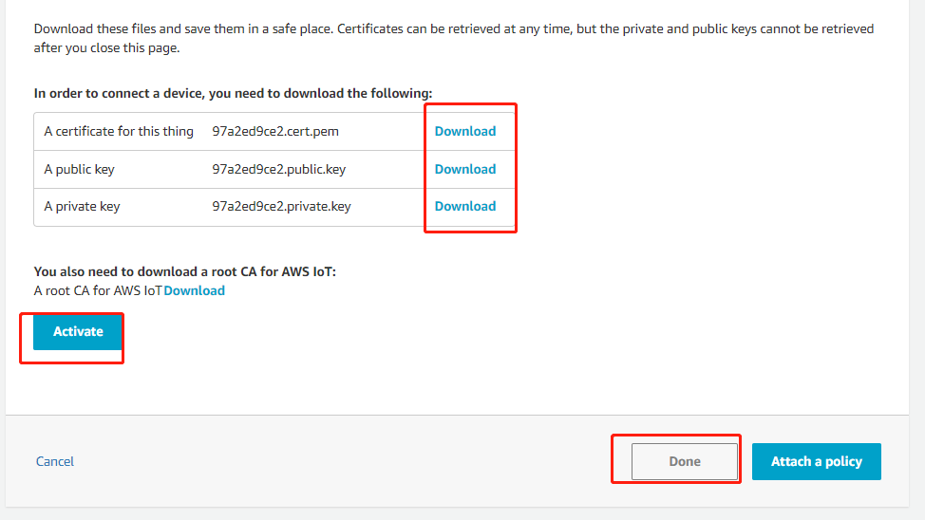 H. Select Secure - Policies from left menu and click Create policy button.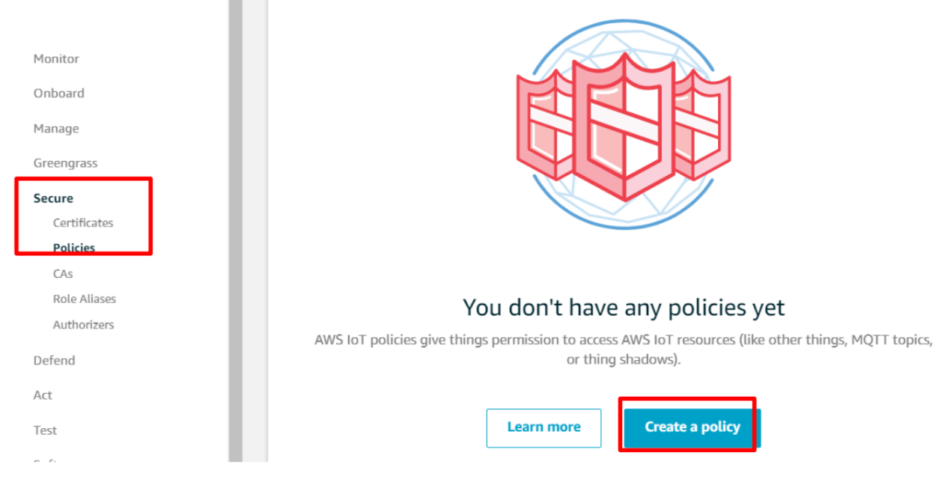 I. Type “iot:*” in the Action filed, “*” in the Resource ARN field, check Allow and click Create button.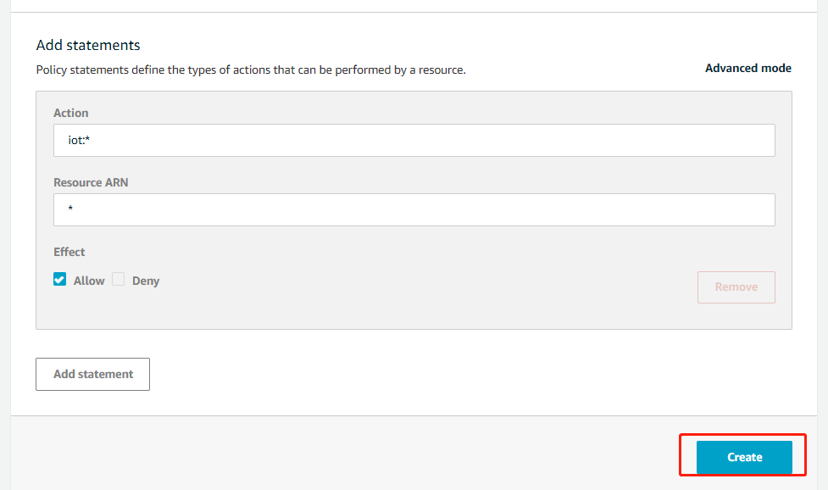 J. Click Secure - Certificates from left menu then click three dots menu on your certificate, and then click Attach policy.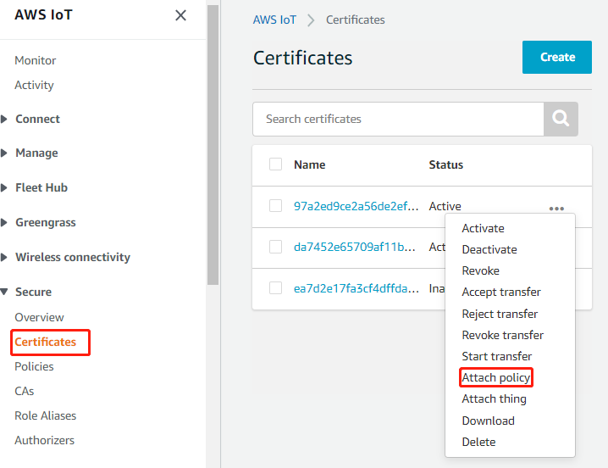 K. Check testPolicy you just created and click Attach button.**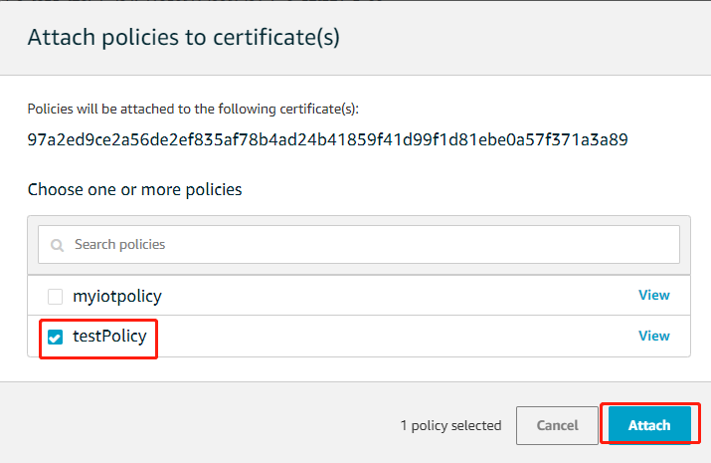  
**L.** Checking Your AWS EndpointVisit AWS IoT Core Console and select Settings from the left menu, then copy the Endpoint. You need this in later sections.  
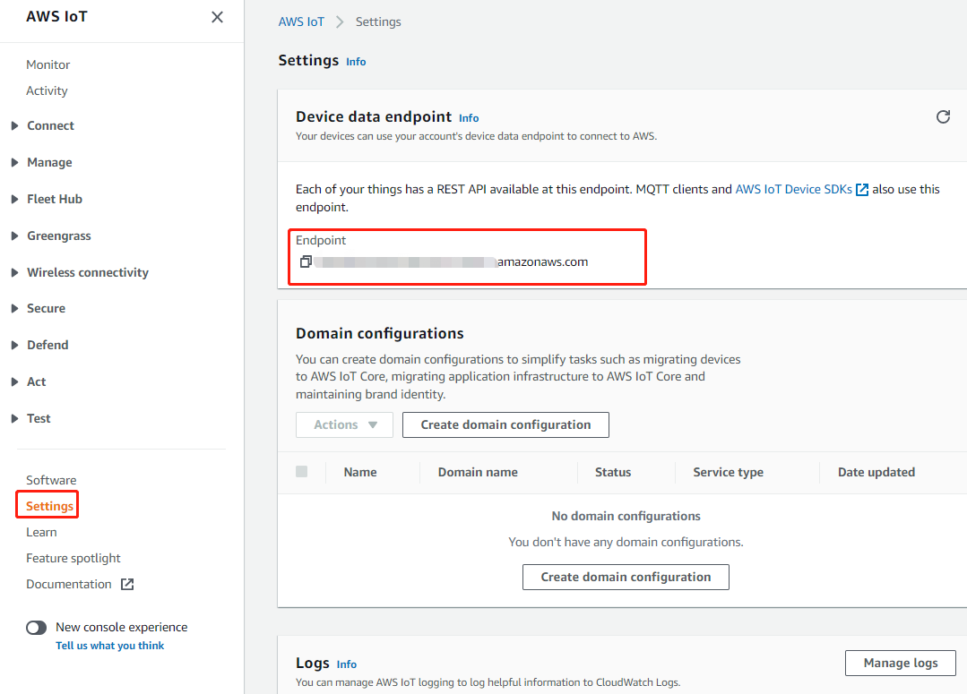

**How to use the demo**

1. According to the [AWS IoT Development Guide](https://docs.aws.amazon.com/iot/latest/developerguide/iot-gs.html), the developer shall obtain:

xxx.cert.pem

xxx.private.key

AmazonRootCA1.pem

xxx-ats.iot.us-east-2.amazonaws.com(endpoint)

Download the above certificate to replace the certificate and host in aws_test_cert.h

1. set your ssid and password in main.c

#define ROUTER_SSID "your ssid"

#define ROUTER_PWD "your password"

1. Subscribe

Subscribe to the topic "$aws/things/AiThinker-Kat/shadow/update" in the MQTT test client.

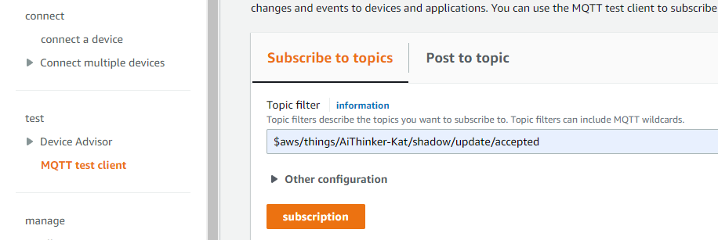

1. Publish

Publish to the topic "$aws/things/AiThinker-Kat/shadow/update/accepted" in the MQTT test client.

