**Результаты:**

scalar-valued:

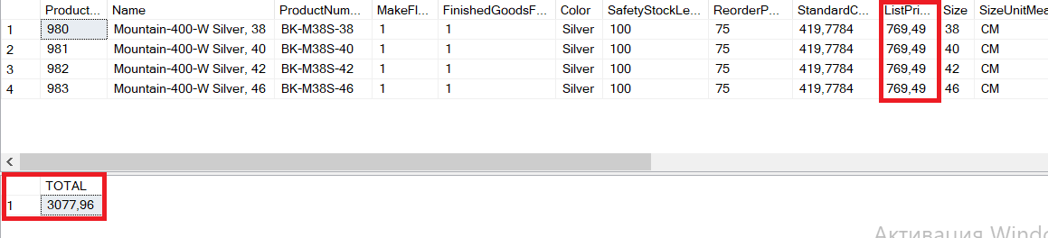

Inline table-valued:

1 – Cross apply

2 – Outer apply

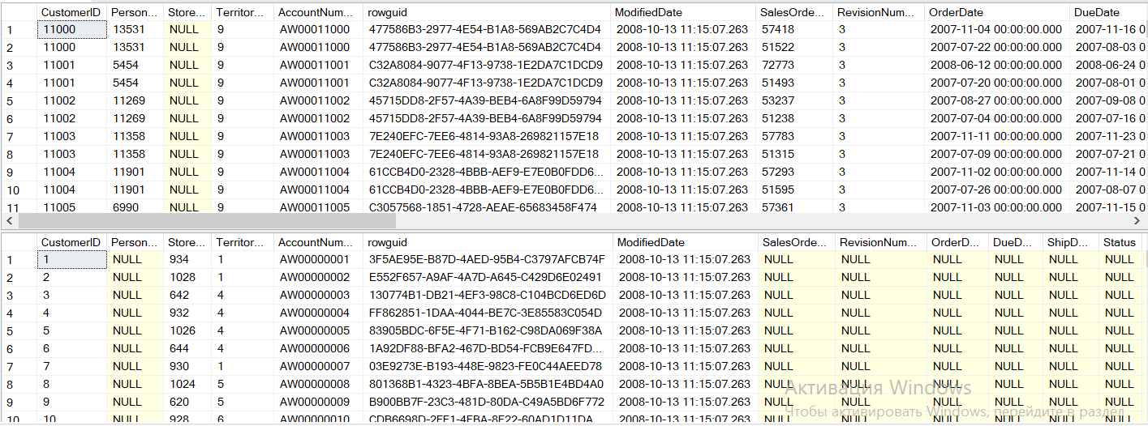

Multistatement table-valued:

1 – Cross apply

2 – Outer apply

