Game Design Document

Fill up the following document

1. Write the title of your project.

Alien’s escape!

1. What is the goal of the game?

To get to the door without colliding into the obsatcles and finishing before the timer runs out

1. Write a brief story of your game.

This alien is stuck at Earth and is in a collapsing buliding, the Alien has to get out before the buliding collapses (before the timer runs out)

1. Which are the playing characters of this game?

* Playing characters are the ones who respond to the user based on the input from the user.
* Cars, monkeys, dinos, wizards, etc., are the playing characters in the game.

|  |  |  |
| --- | --- | --- |
| Number | Character Name | What can this character do? |
| 1 | Alien | The Alien character is controlled by the left, right and up arrow key |
| 2 |  |  |
| 3 |  |  |
| 4 |  |  |
| 5 |  |  |
| 6 |  |  |
| 7 |  |  |
| 8 |  |  |

1. Which are the Non-Playing Characters of this game?

* Non-Playing characters are the ones that don't have an action or behavior when the user interacts with the game.
* Hurdles, stones, bananas, coins, etc., are non-playing characters in the game.

|  |  |  |
| --- | --- | --- |
| Number | Character Name | What can this character do? |
| 1 | tyres | Obstacle and when Alien collides with obstacle the game Is over |
| 2 | rocks | Obstacle and when Alien collides with obstacle the game Is over |
| 3 | bricks | Obstacle and when Alien collides with obstacle the game Is over |
| 4 |  |  |
| 5 |  |  |
| 6 |  |  |
| 7 |  |  |
| 8 |  |  |

Draw your imagination of this game. What does this game look like?

* Draw the game either on your computer or on paper.
* Add images of the game scenes to show each of the playing and non-playing characters at least once.

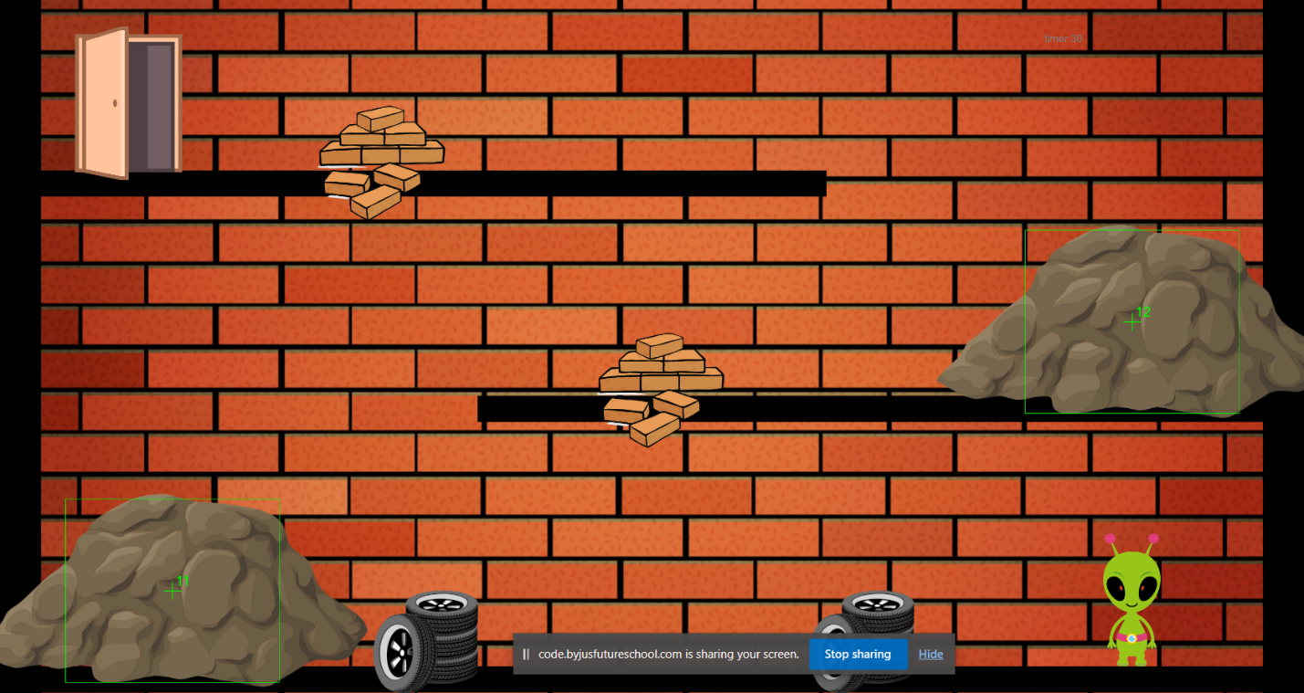

How do you plan to make your game engaging?

The game will have a time limit making so that the player has to escape as

Quick as posible but without dying. Only then will the player succeed