**Lab 1 Solution**

Due to a temporary block on Broadcom registration until January 21, I used an Amazon EC2 instance for Lab 1 instead. The instance runs the same Linux and "Ubuntu (64-bit)" version as the Broadcom VM. I will switch back to Broadcom’s VM once the registration is completed.

# A screenshot of EC2 instance

The Linux Ubuntu instance is spin up using GitHub for the repository.

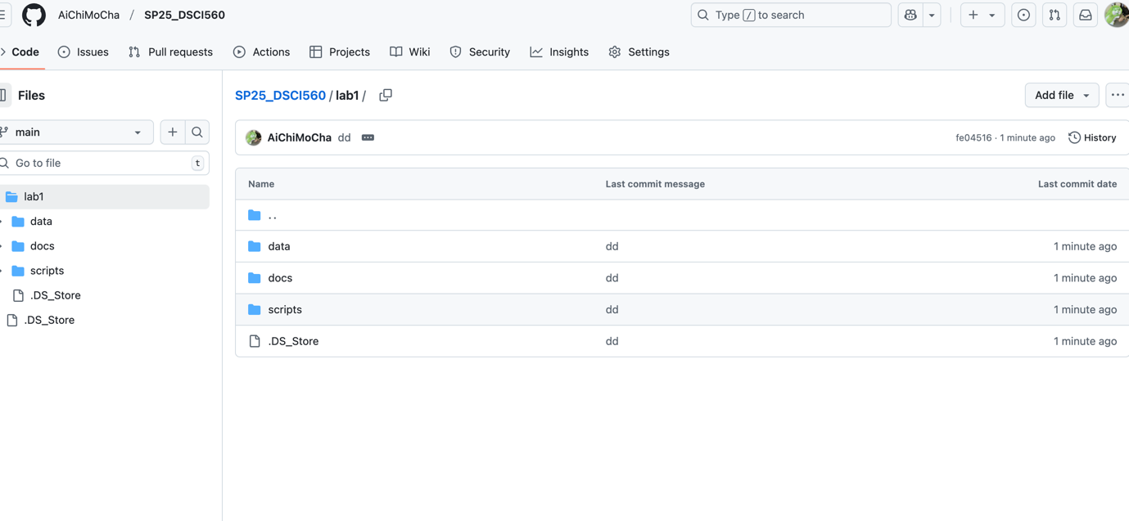

# **2.1. Get Familiar with Linux and Python**

## Playing around with Linux Terminal

**2.2. A basic Python Script**

Task1 details

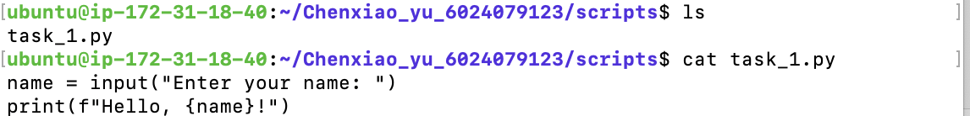

## **2.3. Web Scraping Task**

Task2 details(partial – full in github)

Task2

+ A snapshot of the webpage from where the data is to be scraped ([CNBC](https://www.cnbc.com/world/?region=world)).

Task2 output -- under “raw_data” folder named “web_data.html”(partial screenshot)

**2.4. Data Filtering Task**

Task3 code (partial screenshots)

Task3 running

Task3 outputs – market data

Task3 outputs – news data

